Write-Up: Cipher2

**Question:**In Neon City, the hacker "Cipher" hid a message in the digital artwork "Cyberpunk Dreams." Decrypt the Image to get details about his Most Significant work. The digital art-work had just one thing commented:

01010010 01000111 01000010 00100000 00111101 00100000 00110000 00110001 00110110

[Ignore Spaces while submitting The Flag]

**Walkthrough:**Decrypt the Binary and you will get:  
RGB = 016  
Read the question carefully its written: “**Most Significant** work”

Use MSB decoder with values: 016 for RGB to get the flag

(You can use: <https://georgeom.net/StegOnline/upload> )

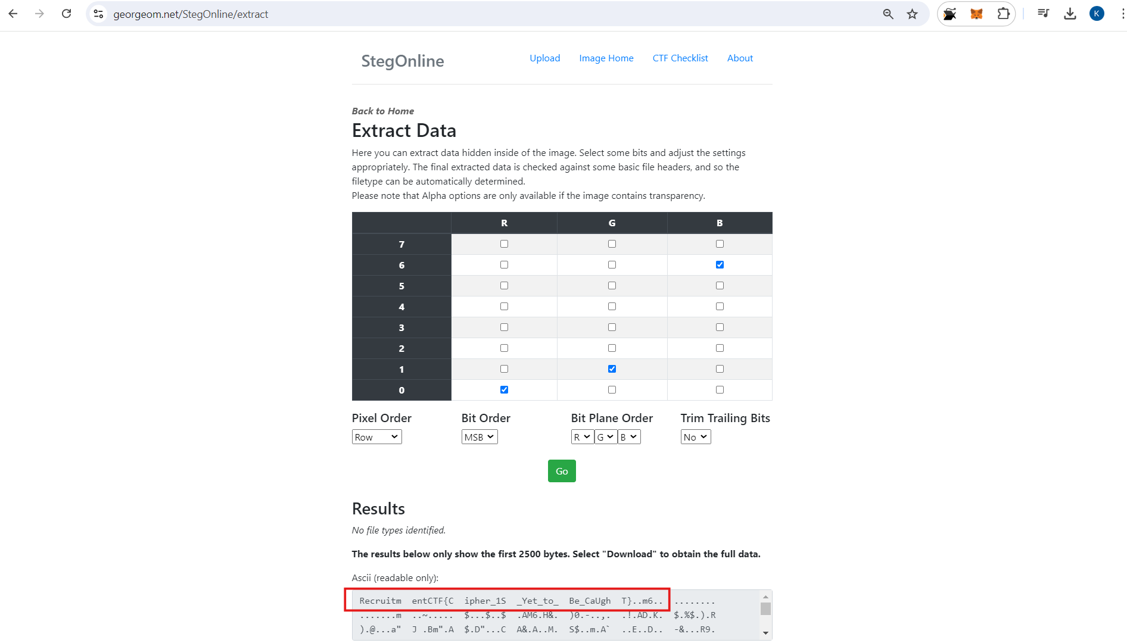

You will get your Flag: RecruitmentCTF{Cipher_1SYet_toBe_CaUghT}