Title: The Midnight Rendezvous

Description:

Detective Jane received an anonymous tip about a secret meeting between two infamous hackers. The message contained a strange text file titled "The Best of Times". Jane knew the hackers were experts in steganography, often hiding their messages in plain sight. The text file seemed ordinary at first glance, but Jane's experience told her the real message was cleverly concealed within the text.

Jane noticed something peculiar—the file was exactly 330k in size, which was unusual for such a short excerpt

Armed with her knowledge, Jane decided to look closer. She knew that hackers often used whitespace manipulation to encode messages. By analysing the patterns of spaces and indents, she hoped to uncover the hidden communication.

Can you help Detective Jane uncover the secret note hidden in the text file?

Solution:

1. Download the Text File: Provide a link to download the text file with the hidden message.
2. Online Tool: Use an online steganography tool that can detect zero-width characters. Here are a few suggestions:

<https://330k.github.io/misc_tools/unicode_steganography_iframe.html>

Zero Width Steganography

1. Extraction Process: Upload or paste the provided text file to one of the online steganography tools.

Use the tool to analyse the text and reveal the hidden message.

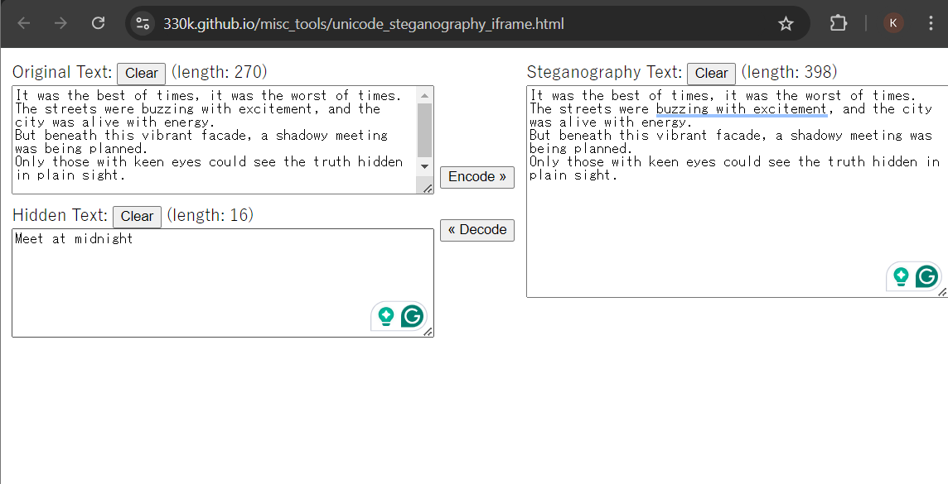

Hint: "Look for invisible characters in the text."

Hidden Message: The hidden message will be **RecruitmentCTF{Meet at midnight}.**