Domain: Web Exploitation

**Momo ColorLand**

Momo the puppy spent a day exploring a colourful website dedicated to color psychology. Fascinated by the vibrant hues and their psychological effects, Momo decided to take notes. Little did Momo know, his notes included a hidden message encoded in the website's HTML. Your task is to help Momo uncover this hidden message.

Visit the website where Momo is learning about colors and inspect it:

<https://momos-colour-land.ark0.pp.ua/>

What is the next color found in Momo’s notes that reveals the hidden detail about color and the place to study it more?

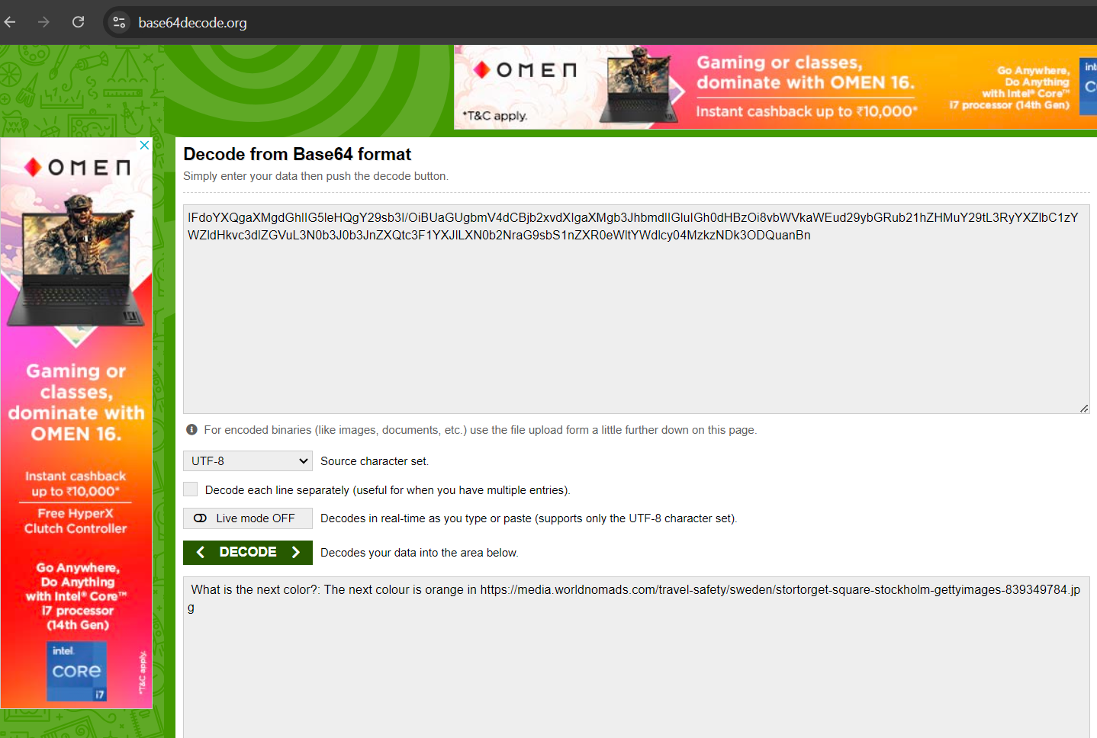

The decoded message will have a link to a picture.

(THIS IS WHERE THE FIRST PART OF THE QUESTION IS SOLVED)

Domain: OSINT

Question Part 2: Oh well that’s a surprise there’s a link to a colourful place? Time to get out your online microscopic LENS and COORDINATE with Momo and find the place linked to the previous colour.

(Hint Co-ordinate format should only be in DD)

The picture in the link:

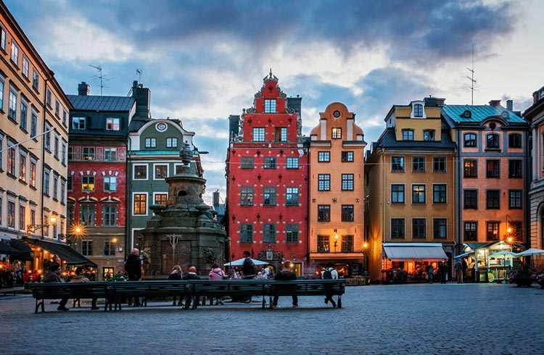

Now search the orange building as the previous hint stated the next color was orange up and find the place using google or google lens.

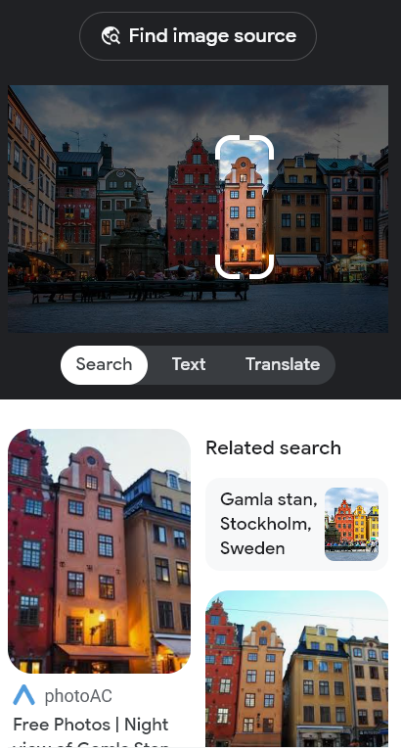

The picture shows Gamla stan,Stockholm,Sweden.

Now search the place up in google maps and find the coordinates

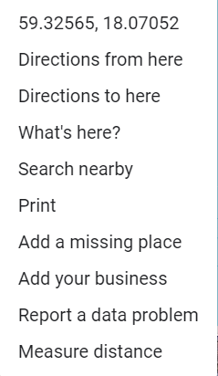

Lastly you have to keep in mind that the coordinates are in DD format not DMS or DMM

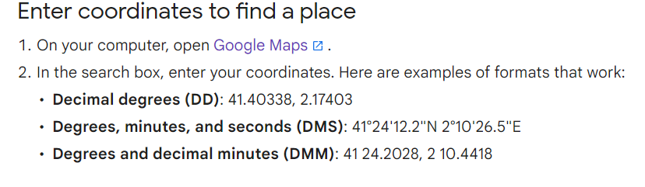

ANSWER

Format: RecruitmentCTF{00.00 , 00.00}

RecruitmentCTF{59.32 , 18.07}

Coordinates

59.3249967 18.0708198

59.32520082378125, 18.070657039959837