**Epistemus:** This image goes hard, feel free to run diagnostics.

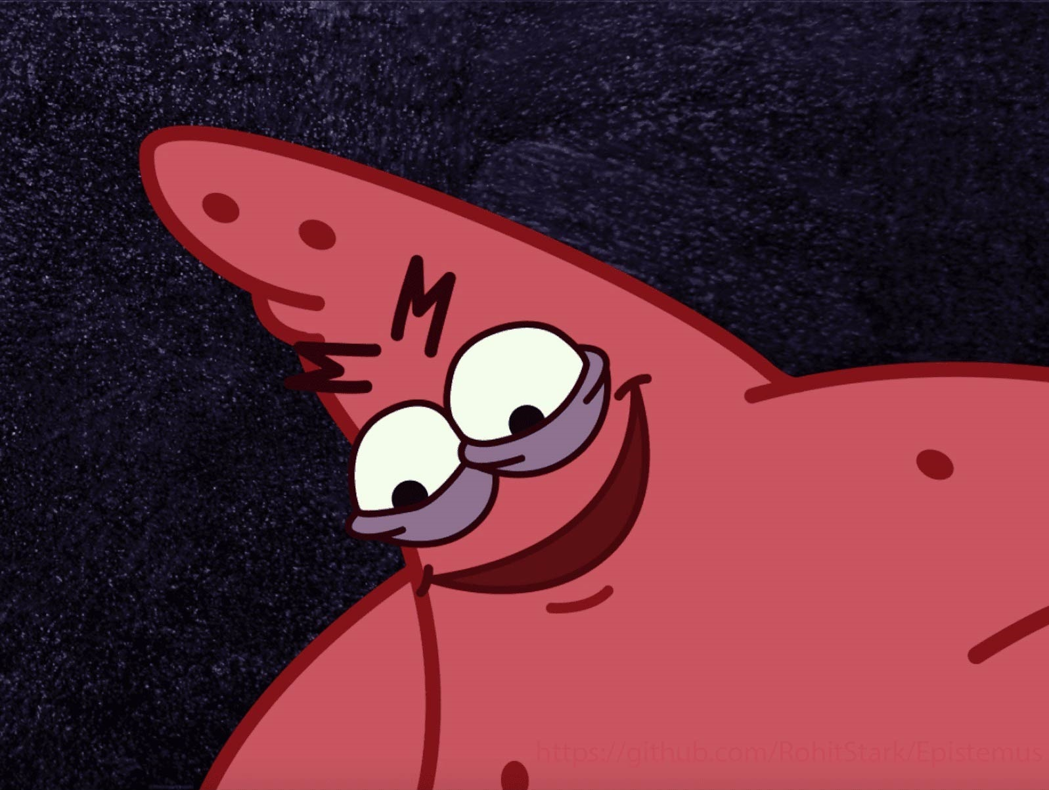

Here, we are given a photo of Patrick that seems to have a github link hiding in plain sight

We use stegsolve to accurately identify the link

The GitHub Repository contains one file to lead challengers astray and two important files to complete the challenge:

README.md contained the following line of text:

Arire tbaan tvir lbh hc Arire tbaan yrg lbh qbja Arire tbaan eha nebhaq naq qrfreg lbh Arire tbaan znxr lbh pel Arire tbaan fnl tbbqolr Arire tbaan gryy n yvr naq uheg lbh

Since it looks like the output of a well-known substitution cipher (ROT13), I decided to use the tool CyberChef by the GCHQ and immediately found out that this … is indeed a Rickroll

The something_in_the_way.rar file needs some password to extract the files within, but we do not seem to have that

There is another file named rightplace?.txt that contains:

I dｏｎ't ｔhiｎk tｈⅰs iｓ the ｒｉght plaｃe to be sｅaｒcｈіｎg ｆｏｒ ａｎｙtｈiｎg. Nothing bｕt emptiｎesｓ aｎｄ ⅴoіd. Liｔerally， ａ wastｅ οｆ time

At first look, it looks like some gibberish, but this is a classic case of Homoglyph Steganography.

Using the link: <http://holloway.co.nz/steg/>

This is indeed the password for the .rar file

After extracting, we find multiple copies of a file

One specific text file has the info we need, i.e,

Bomb – copy(69) ,we just have to ctrl F the file for ‘flag’ and voila

VishwaCTF{th1ng$_a43_n0t_wh4t_th3y_4lw4y$_$33m}

