Title : Memories

Category : Forensics

Scoring : Dynamic

Points : 500

Description : submit your flag in sha256. ex. vishwaCTF{sha256 of your answer} Ps:- the password closes one's mind magically (no punctuation, spaces or capital letters)

Flags : vishwaCTF{c6330396c766f55fb00116be19fc3e8dd65b052c24b52deb9b6b27cc1feb3b35}

Files : we have given a bmp image

Hints : How do you respond when someone asks who you are? Think grammatically.

Solves : 5

##solution:

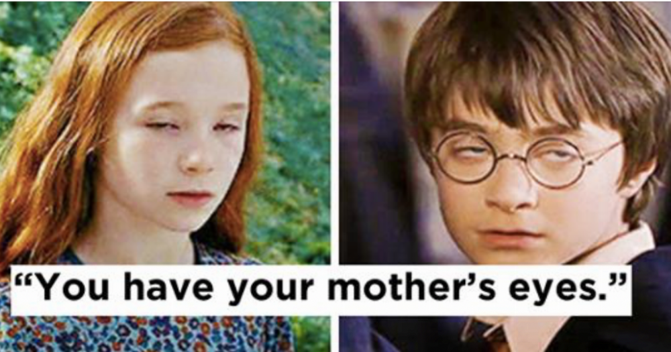

After seeing this image and the name of the challenge you might think this is related to harry potter and something related to memories (spell or some act).

If you search a bit you will get occlumency and legilimency as acts.  
now to extract the hidden image you must know various types of stegnography tools one of them is xiao stegnography

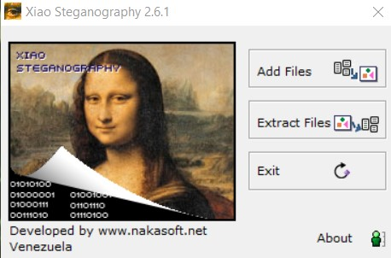

Now enter the given bmp file for extraction.

And type in the password- occlumency

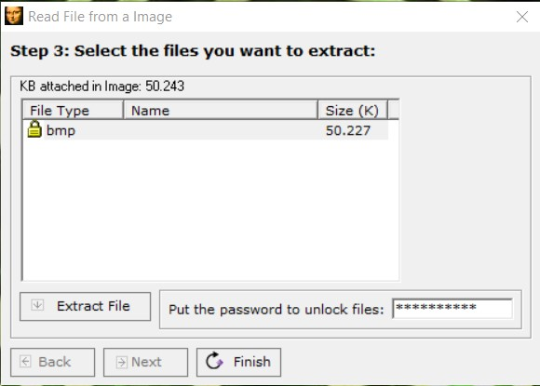

Click on Extract file, save the file you will get the extraction successful..

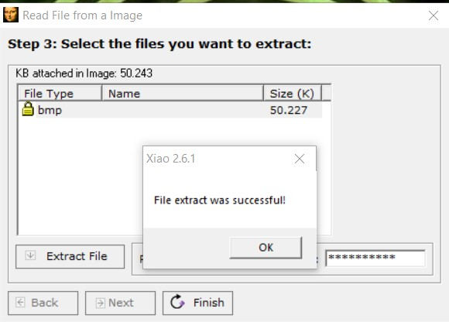

This is the hidden image you get..

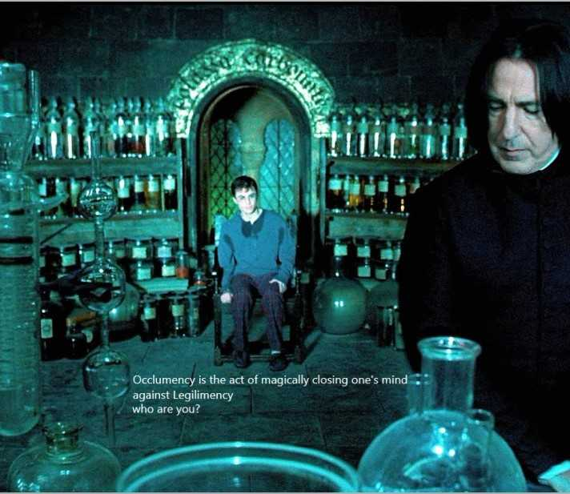

Think of you as a memory extractor and if someone asks you the question who are you give the answer in grammatical way….

iamalegilimen …..convert this to sha256 and submit the flag