DATA ANALYTICS EXPERIMENTS 1-10
Indian Agricultural Statistics - Crop Production Forecasting
Machine Learning Model to Forecast Crop Production Trends in India

Dataset size: 450,350 rows x 16 columns.
Number of crop categories: 115.
Historical period: 1997-2022.
Data source: local file crop-wise-area-production-yield.csv.
Total figures included in this report: 31.

Experiment 1: Understanding Business Objectives, Analytical Goals and Future Outcomes

Aim
To define the agricultural forecasting problem and establish the analytical objectives required to forecast crop production trends in India.

Objectives
- Define the agricultural business problem.
- Identify the analytical goals.
- Identify relevant agricultural variables.
- Define the forecasting methodology.
- Identify possible real-world applications.

Theory
Agricultural production forecasting uses historical crop statistics to estimate future production, supporting planning, procurement, storage and resource allocation.

Methodology / Procedure
Problem definition -> analytical objectives -> variable identification -> data requirements -> forecasting strategy -> decision-support objectives.

Generated Figures (3)
Exp1 Data Completeness
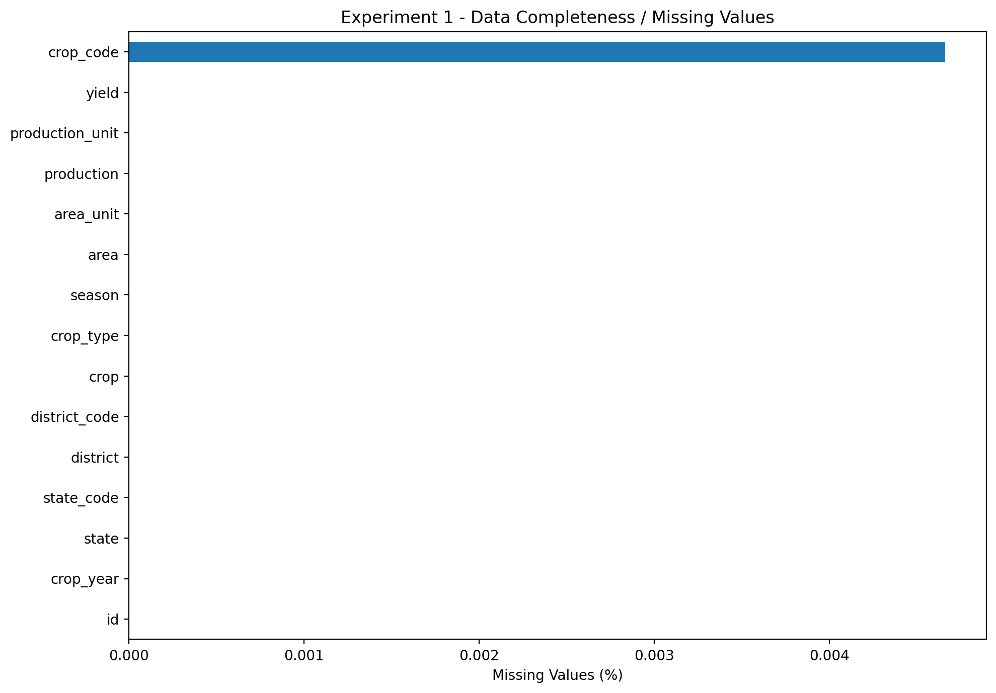
Description: This figure, titled 'Exp1 Data Completeness', was generated during the agricultural forecasting analysis. It should be interpreted together with the numerical results and methodology of the corresponding experiment.
Exp1 Dataset Scale
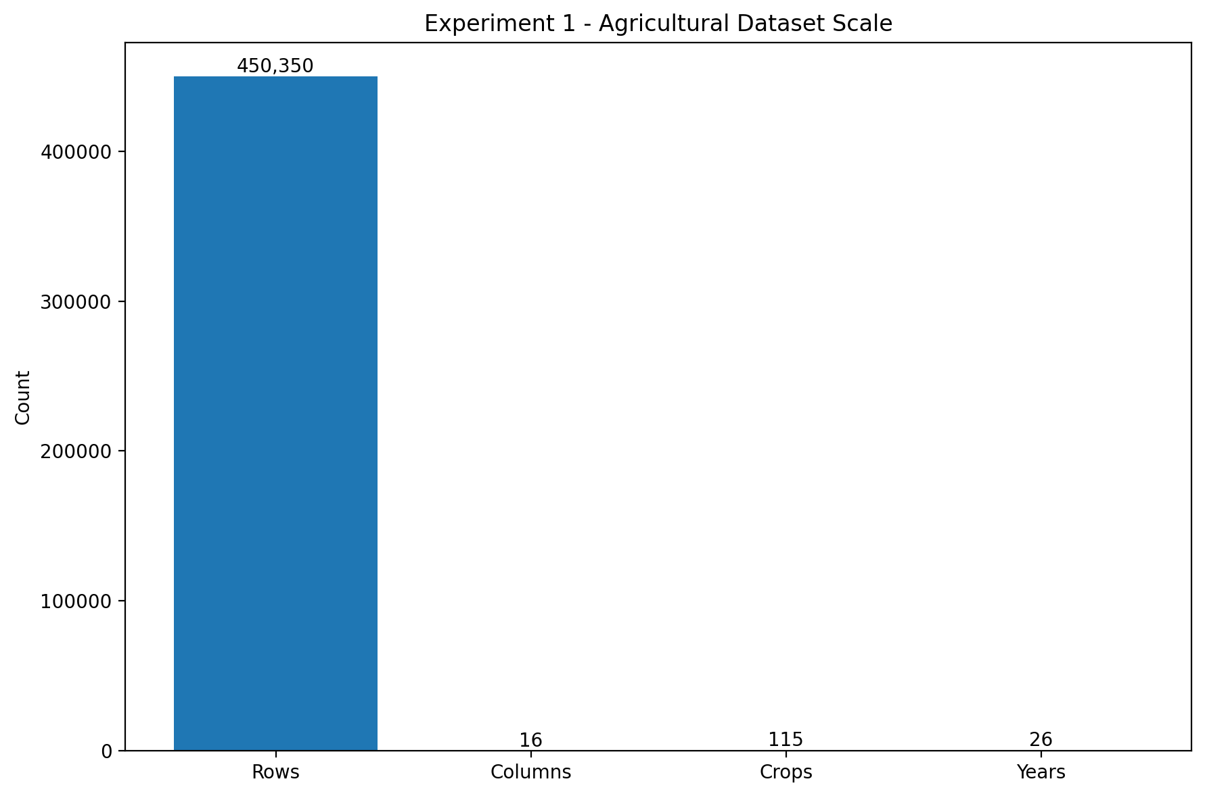
Description: This figure, titled 'Exp1 Dataset Scale', was generated during the agricultural forecasting analysis. It should be interpreted together with the numerical results and methodology of the corresponding experiment.
Exp1 Yearly Observations
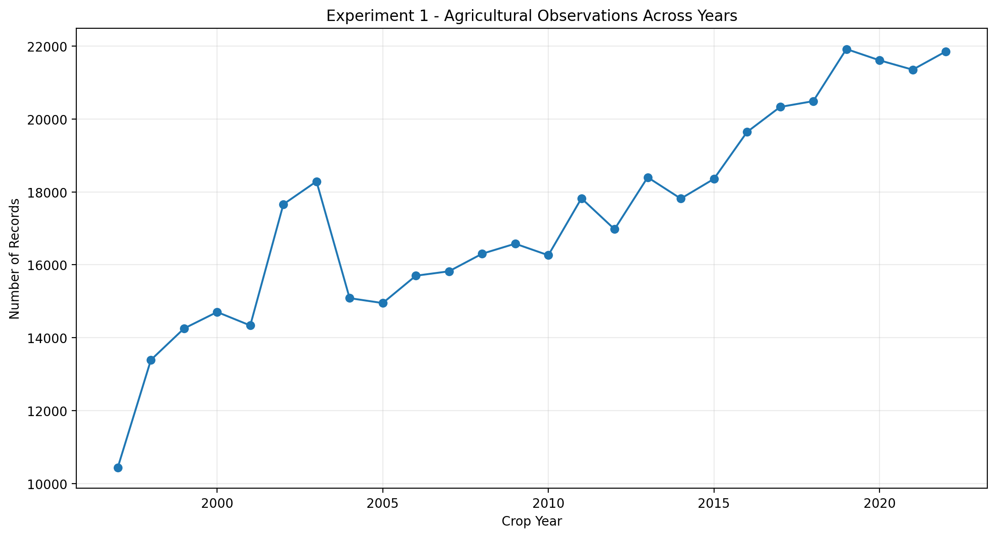
Description: This figure, titled 'Exp1 Yearly Observations', was generated during the agricultural forecasting analysis. It should be interpreted together with the numerical results and methodology of the corresponding experiment.

Actual Results
Rows analyzed: 450,350.
Forecasting observations: 4,852.

Observation / Interpretation
The results in this section are based on the outputs generated during execution of the corresponding experiment.

Experiment 2: Survey of the Data Source

Aim
To document the local crop dataset and confirm it covers production, area, yield, crop, season, state and district.

Objectives
- Load the local CSV.
- Inspect the schema.
- Compare variables and coverage.
- Confirm temporal/geographic resolution.
- Confirm suitability for forecasting.

Theory
Data-source evaluation is necessary because agricultural datasets differ in units, crop names, geographic coverage and time periods.

Methodology / Procedure
Local load -> schema inspection -> variable comparison -> source confirmation.

Generated Figures (3)
Exp2 Crop Type Composition
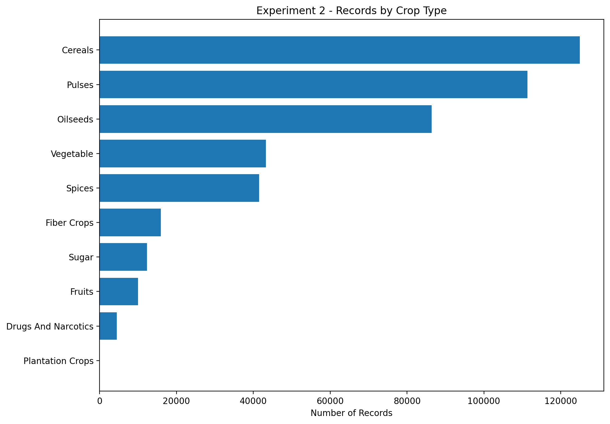
Description: This figure, titled 'Exp2 Crop Type Composition', was generated during the agricultural forecasting analysis. It should be interpreted together with the numerical results and methodology of the corresponding experiment.
Exp2 Season Coverage
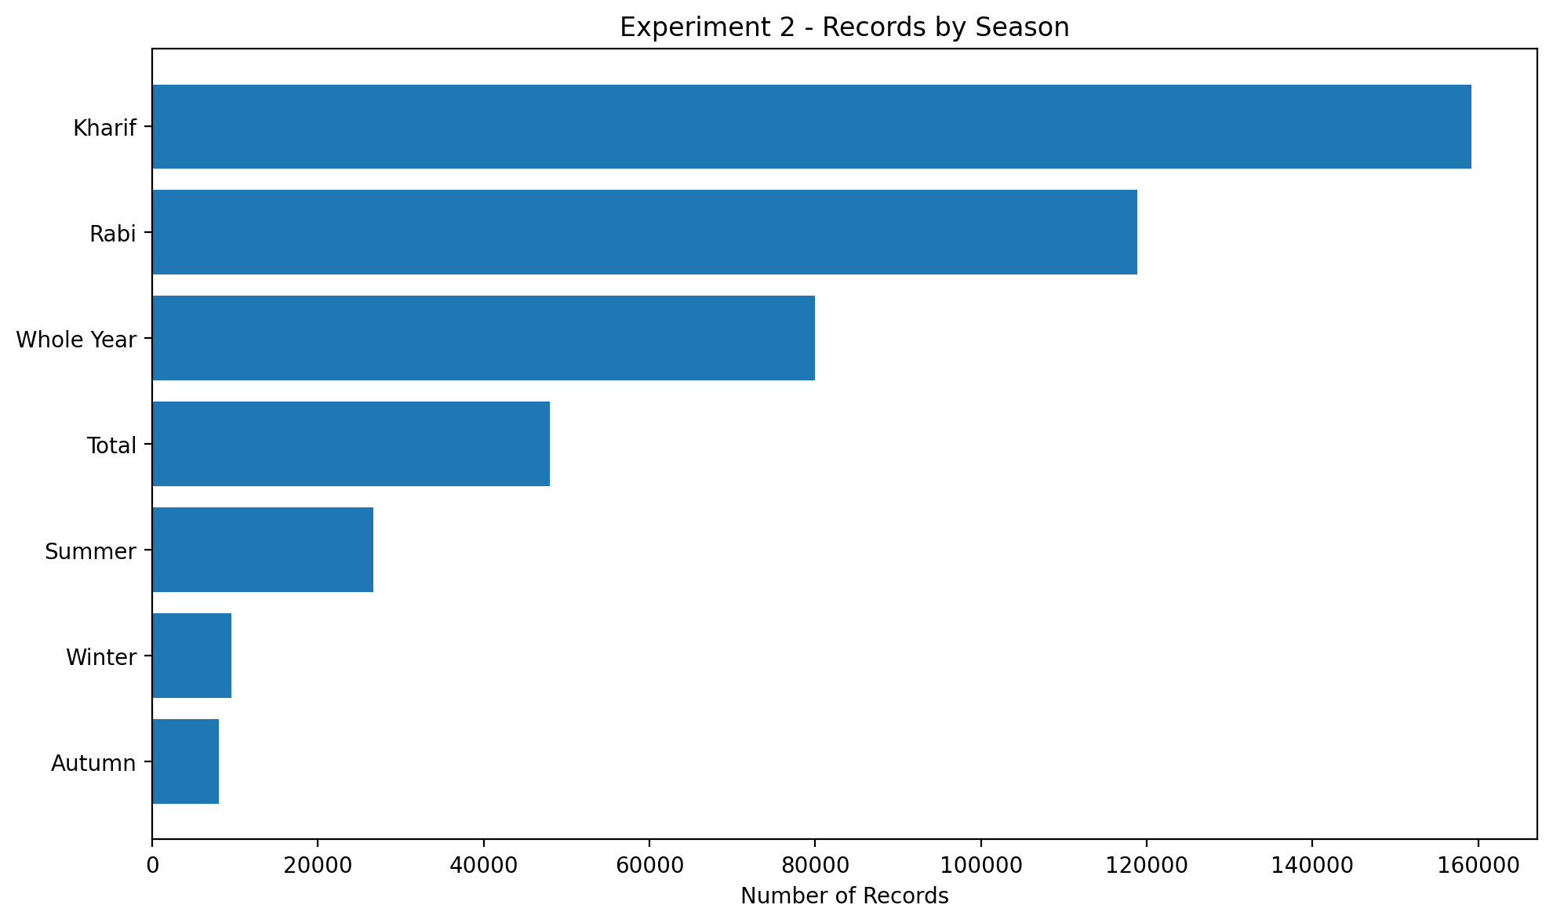
Description: This figure, titled 'Exp2 Season Coverage', was generated during the agricultural forecasting analysis. It should be interpreted together with the numerical results and methodology of the corresponding experiment.
Exp2 State Coverage
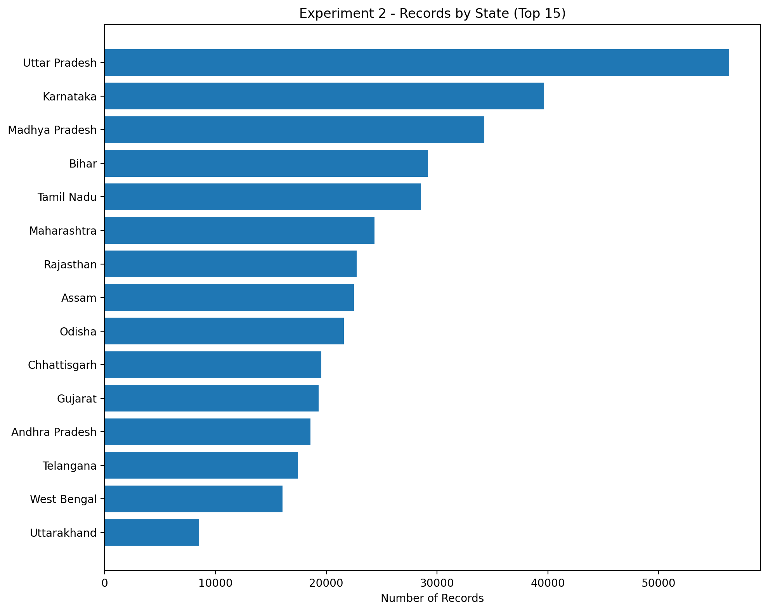
Description: This figure, titled 'Exp2 State Coverage', was generated during the agricultural forecasting analysis. It should be interpreted together with the numerical results and methodology of the corresponding experiment.

Actual Results
Local CSV based dataset acquisition and schema inspection were used.

Observation / Interpretation
The results in this section are based on the outputs generated during execution of the corresponding experiment.

Experiment 3: Data Exploration and Descriptive Analysis

Aim
To understand the structure, distribution and historical behaviour of the agricultural data.

Objectives
- Inspect the dataset.
- Calculate descriptive statistics.
- Analyze crop production.
- Analyze area and yield.
- Study historical trends.
- Identify skewness and outliers.

Theory
Exploratory Data Analysis provides understanding before modelling. Agricultural production often has large scale differences across crops.

Methodology / Procedure
Data cleaning -> descriptive statistics -> crop analysis -> trend analysis -> correlation -> distribution analysis.

Generated Figures (4)
Exp3 Correlation
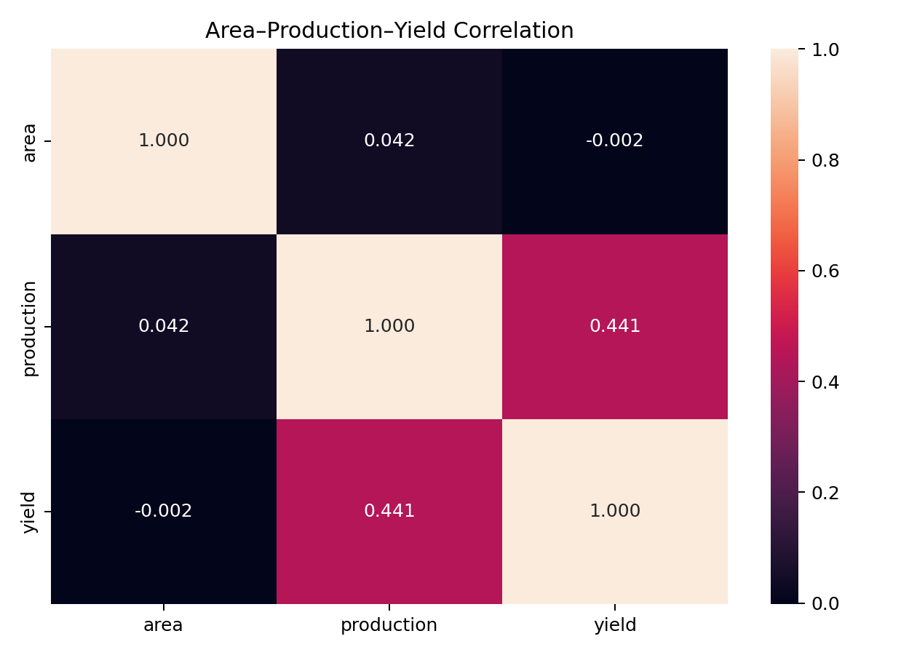
Description: This figure, titled 'Exp3 Correlation', was generated during the agricultural forecasting analysis. It should be interpreted together with the numerical results and methodology of the corresponding experiment.
Exp3 National Trend
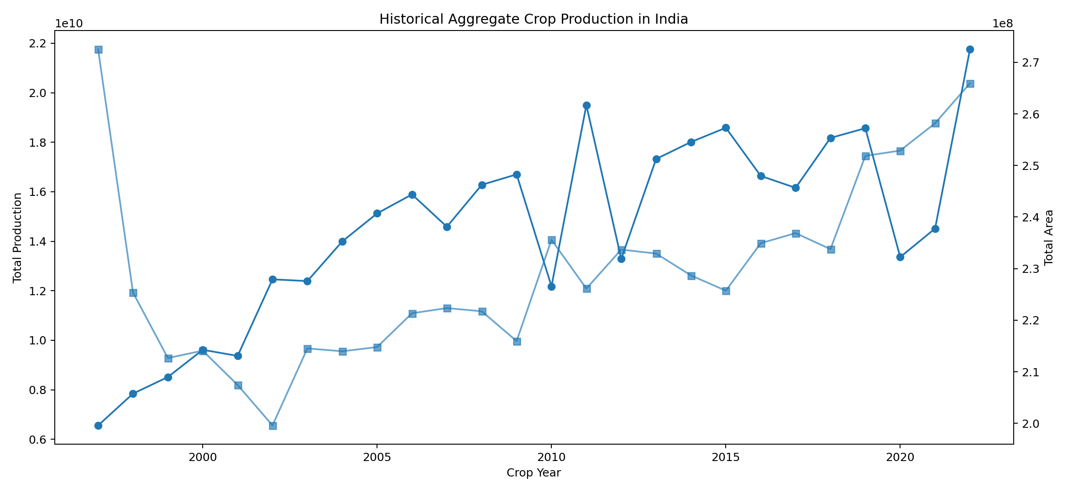
Description: This figure, titled 'Exp3 National Trend', was generated during the agricultural forecasting analysis. It should be interpreted together with the numerical results and methodology of the corresponding experiment.
Exp3 Top Crop Trends
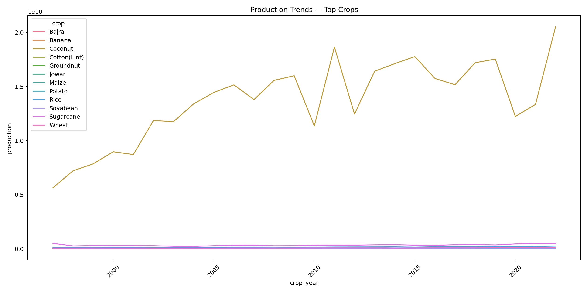
Description: This figure, titled 'Exp3 Top Crop Trends', was generated during the agricultural forecasting analysis. It should be interpreted together with the numerical results and methodology of the corresponding experiment.
Exp3 Univariate
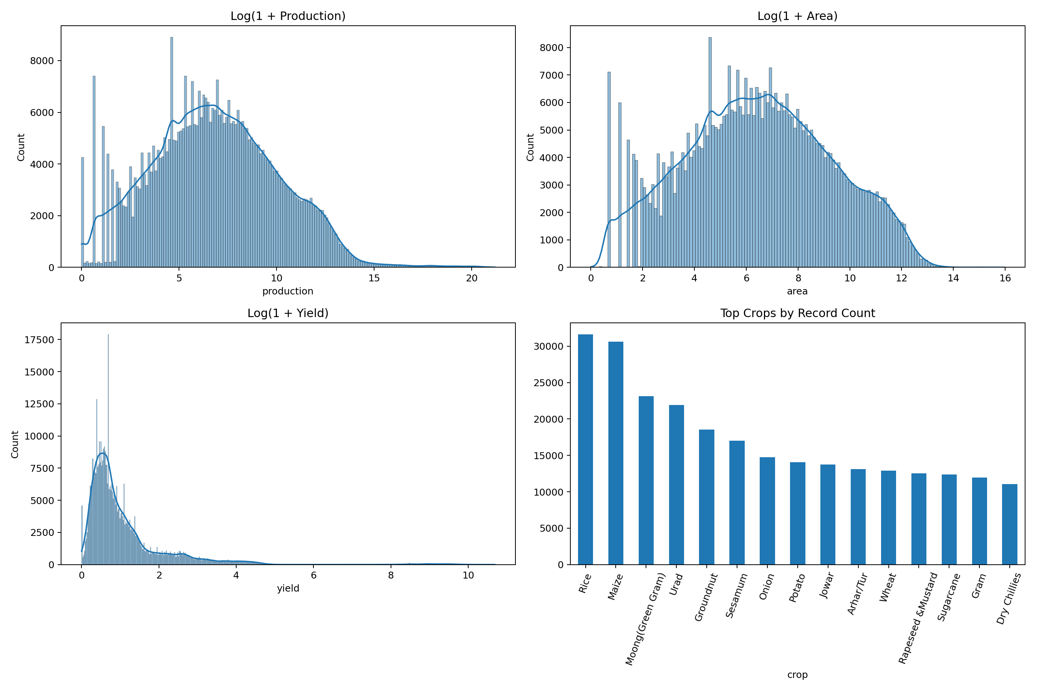
Description: This figure, titled 'Exp3 Univariate', was generated during the agricultural forecasting analysis. It should be interpreted together with the numerical results and methodology of the corresponding experiment.

Actual Results

Crop Production Summary
crop | count | sum | mean | median
Coconut | 3267 | 355931215035.0000 | 108947418.1313 | 17462500.0000
Sugarcane | 12367 | 9015962431.0290 | 729033.9153 | 29950.0000
Rice | 31596 | 4258304548.6574 | 134773.5330 | 48242.0000
Wheat | 12876 | 2388733819.6333 | 185518.3147 | 58654.5000
Maize | 30603 | 942699761.0690 | 30804.1617 | 3605.0000
Potato | 14081 | 816206311.3104 | 57965.0814 | 6034.0000
Cotton(Lint) | 8045 | 612768390.9130 | 76167.6061 | 4532.0000
Groundnut | 18552 | 339490414.1560 | 18299.3971 | 1511.6000
Jowar | 13754 | 291291991.0400 | 21178.7110 | 2400.0000
Bajra | 10320 | 270529204.7377 | 26214.0702 | 1601.0000
Banana | 5087 | 267702696.4430 | 52624.8666 | 11580.0000
Soyabean | 6125 | 265474048.7410 | 43342.7018 | 791.0000
Jute | 2101 | 258026826.7520 | 122811.4359 | 4691.0000
Onion | 14768 | 218736541.0689 | 14811.5209 | 2019.0000
Gram | 11975 | 199423312.5820 | 16653.3038 | 1299.0000

Observation / Interpretation
The analysis shows substantial differences in crop production scale. High-production crops are retained; logarithmic visualization makes smaller crops easier to compare.

Experiment 4: Feature Engineering, Variable Selection and Dimensionality Reduction

Aim
To construct predictive agricultural features and identify informative variables.

Objectives
- Create lag features.
- Calculate growth rates.
- Create rolling statistics.
- Evaluate Mutual Information.
- Apply feature selection.
- Perform PCA.

Theory
Lag and rolling features provide historical context. Mutual Information identifies dependency while PCA reduces dimensionality.

Methodology / Procedure
Lag creation -> growth features -> rolling statistics -> feature selection -> Mutual Information -> PCA.

Generated Figures (3)
Exp4 Feature Reduction
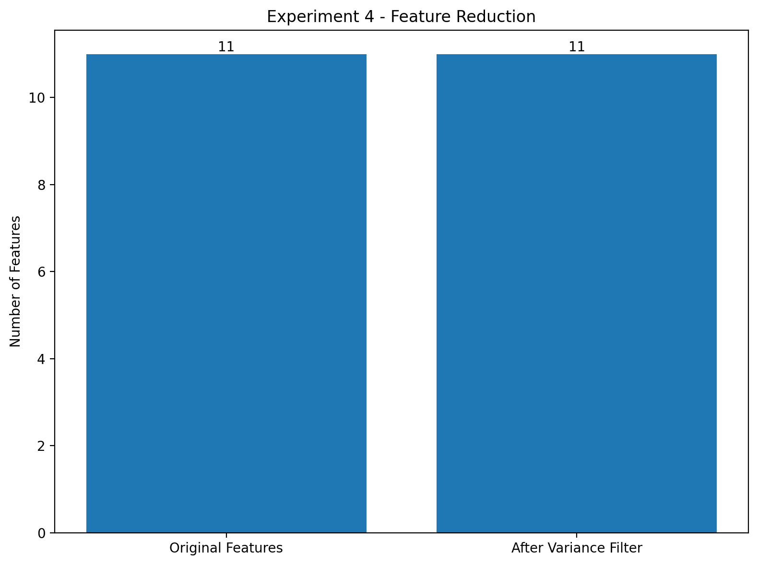
Description: This figure, titled 'Exp4 Feature Reduction', was generated during the agricultural forecasting analysis. It should be interpreted together with the numerical results and methodology of the corresponding experiment.
Exp4 Mutual Information
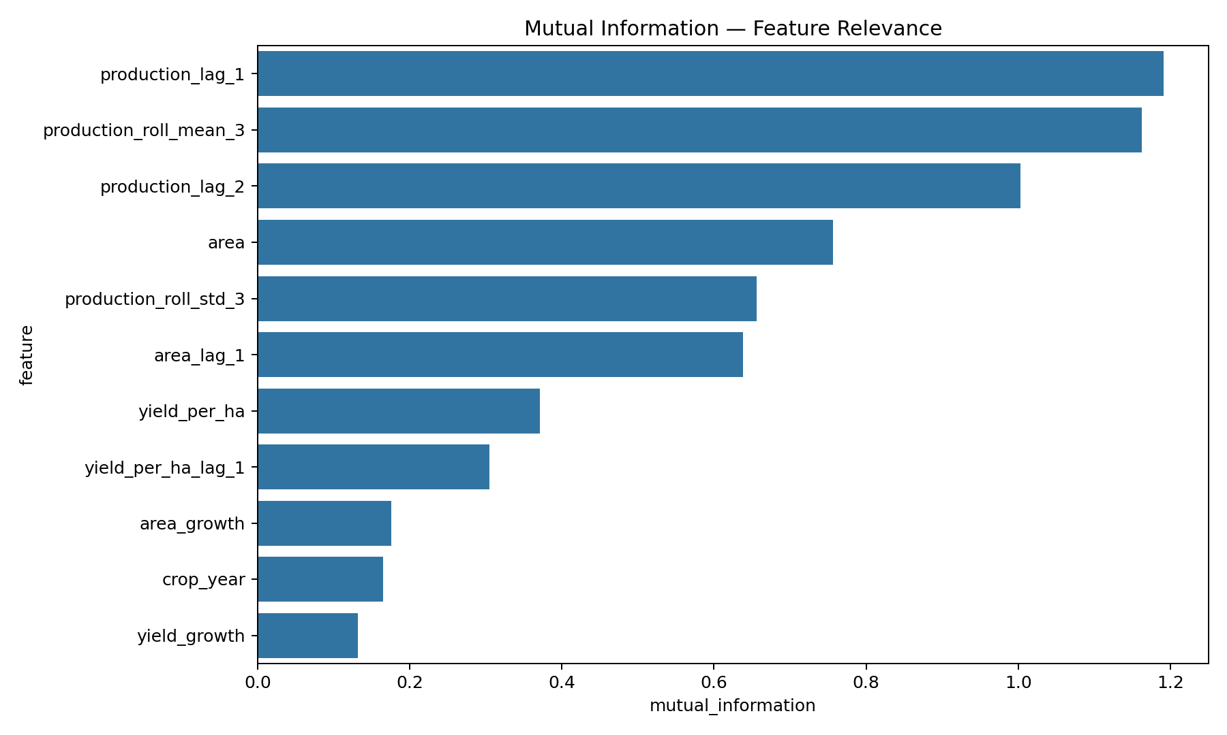
Description: This figure, titled 'Exp4 Mutual Information', was generated during the agricultural forecasting analysis. It should be interpreted together with the numerical results and methodology of the corresponding experiment.
Exp4 Pca
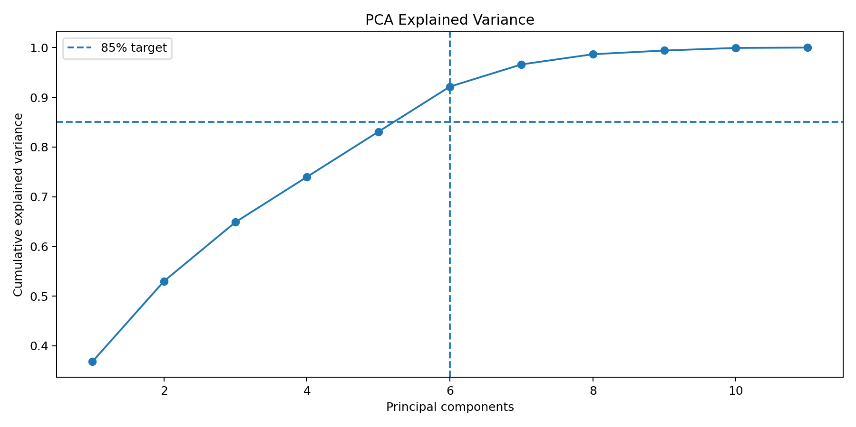
Description: This figure, titled 'Exp4 Pca', was generated during the agricultural forecasting analysis. It should be interpreted together with the numerical results and methodology of the corresponding experiment.

Actual Results

Mutual Information Results
feature | mutual_information
production_lag_1 | 1.1907
production_roll_mean_3 | 1.1622
production_lag_2 | 1.0031
area | 0.7565
production_roll_std_3 | 0.6563
area_lag_1 | 0.6386
yield_per_ha | 0.3712
yield_per_ha_lag_1 | 0.3049
area_growth | 0.1757
crop_year | 0.1649
yield_growth | 0.1323
PCA components required for 85% variance: 6.

Observation / Interpretation
The results in this section are based on the outputs generated during execution of the corresponding experiment.

Experiment 5: Hypothesis Testing, Visualization and Data-Driven Recommendations

Aim
To statistically evaluate relationships and differences within agricultural observations.

Objectives
- Perform Welch's t-test.
- Perform Mann-Whitney U tests.
- Perform ANOVA.
- Interpret p-values.
- Create analytical visualizations.

Theory
Hypothesis testing provides statistical evidence for differences between agricultural groups.

Methodology / Procedure
Hypothesis formulation -> statistical test -> p-value -> significance interpretation -> visualization.

Generated Figures (3)
Exp5 Correlation
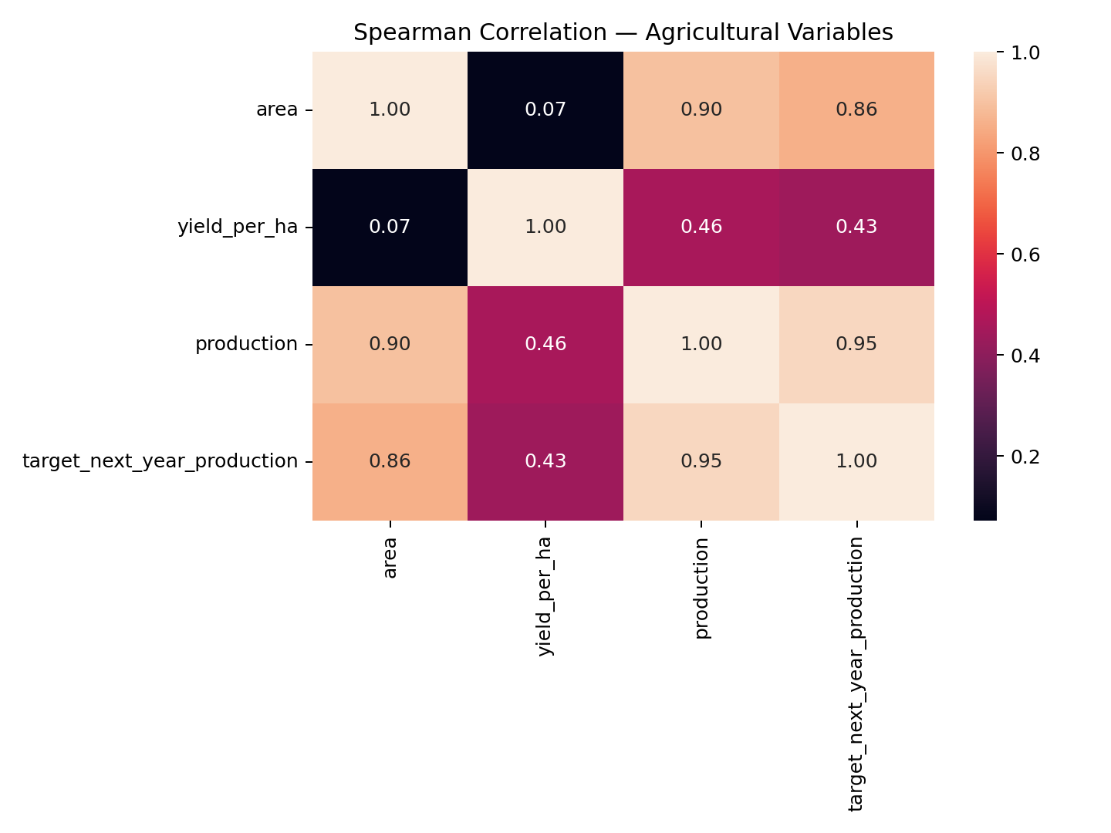
Description: This figure, titled 'Exp5 Correlation', was generated during the agricultural forecasting analysis. It should be interpreted together with the numerical results and methodology of the corresponding experiment.
Exp5 Dashboard
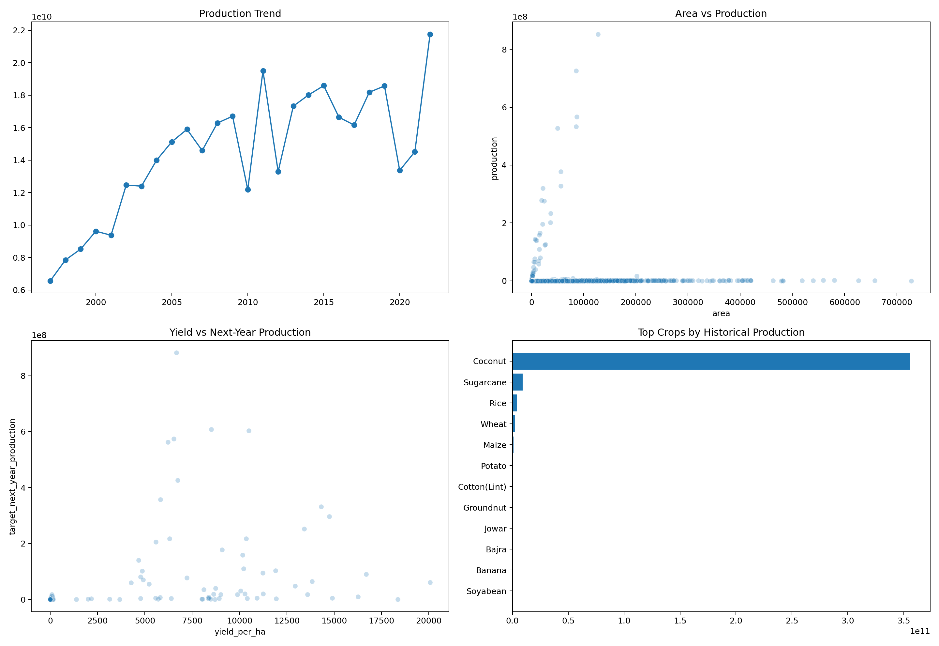
Description: This figure, titled 'Exp5 Dashboard', was generated during the agricultural forecasting analysis. It should be interpreted together with the numerical results and methodology of the corresponding experiment.
Exp5 Hypothesis Tests
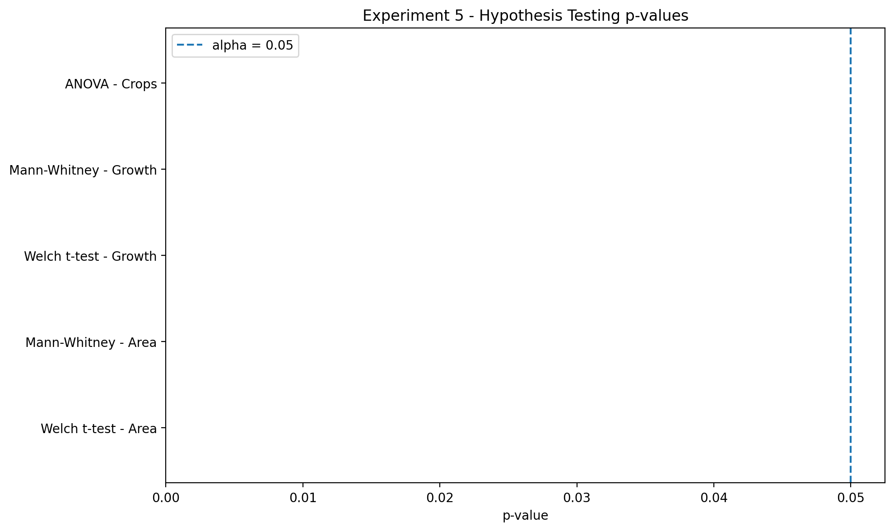
Description: This figure, titled 'Exp5 Hypothesis Tests', was generated during the agricultural forecasting analysis. It should be interpreted together with the numerical results and methodology of the corresponding experiment.

Actual Results

Hypothesis Testing Results
Statistical Test | p-value
Welch t-test - Area Groups | 0.0000
Mann-Whitney U - Area Groups | 0.0000
Welch t-test - Growth Groups | 0.0000
Mann-Whitney U - Growth Groups | 0.0000
ANOVA - Major Crops | 0.0000

Observation / Interpretation
The results in this section are based on the outputs generated during execution of the corresponding experiment.

Experiment 6: Identification of Traditional and Contemporary Statistical Methods

Aim
To compare traditional regression models with modern ensemble models.

Objectives
- Evaluate Linear Regression.
- Evaluate Ridge and Lasso.
- Evaluate SVR.
- Evaluate Random Forest.
- Evaluate Extra Trees.
- Evaluate Gradient Boosting.

Theory
Linear models provide interpretable baselines while ensemble methods capture non-linear relationships.

Methodology / Procedure
Train models -> generate predictions -> calculate MAE/RMSE/R2 -> compare models.

Generated Figures (3)
Exp6 Benchmark
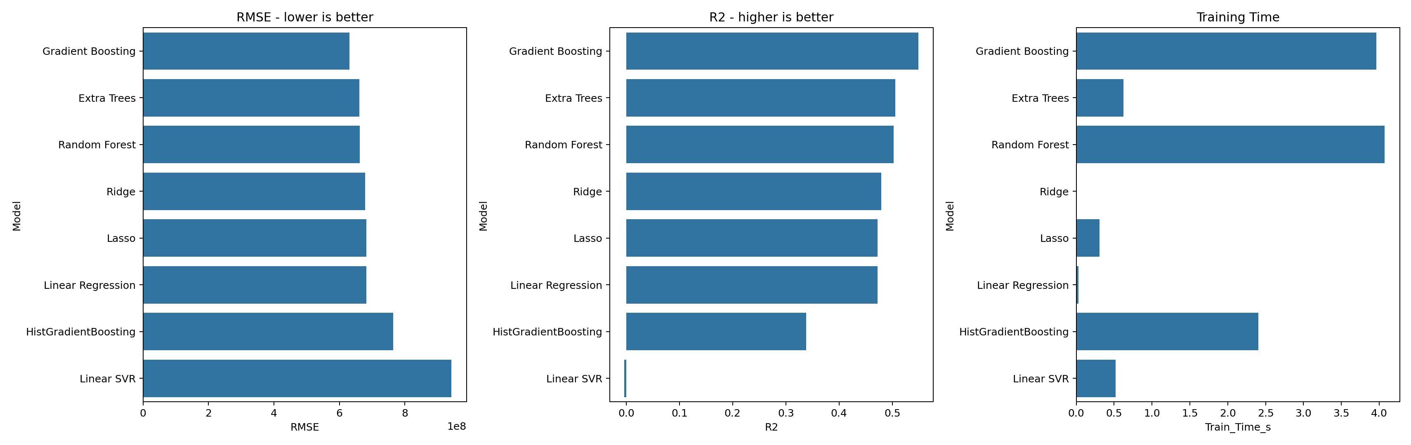
Description: This figure, titled 'Exp6 Benchmark', was generated during the agricultural forecasting analysis. It should be interpreted together with the numerical results and methodology of the corresponding experiment.
Exp6 Mae Comparison
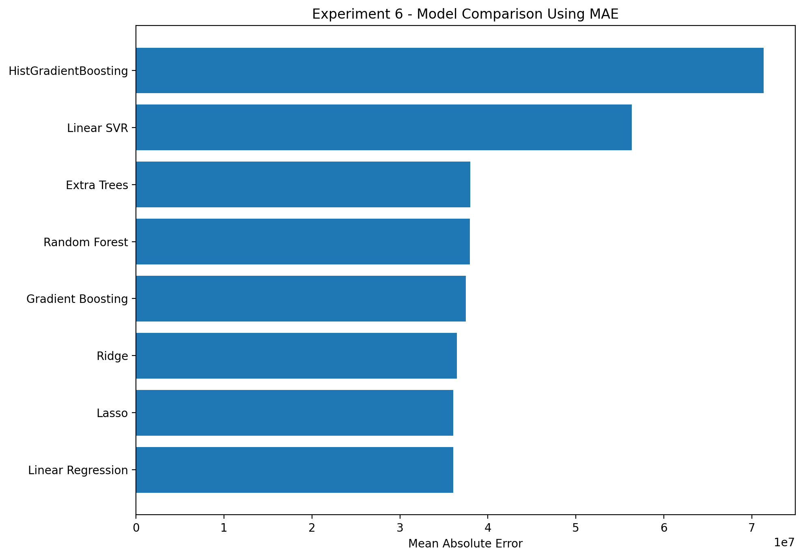
Description: This figure, titled 'Exp6 Mae Comparison', was generated during the agricultural forecasting analysis. It should be interpreted together with the numerical results and methodology of the corresponding experiment.
Exp6 Rmse R2 Tradeoff
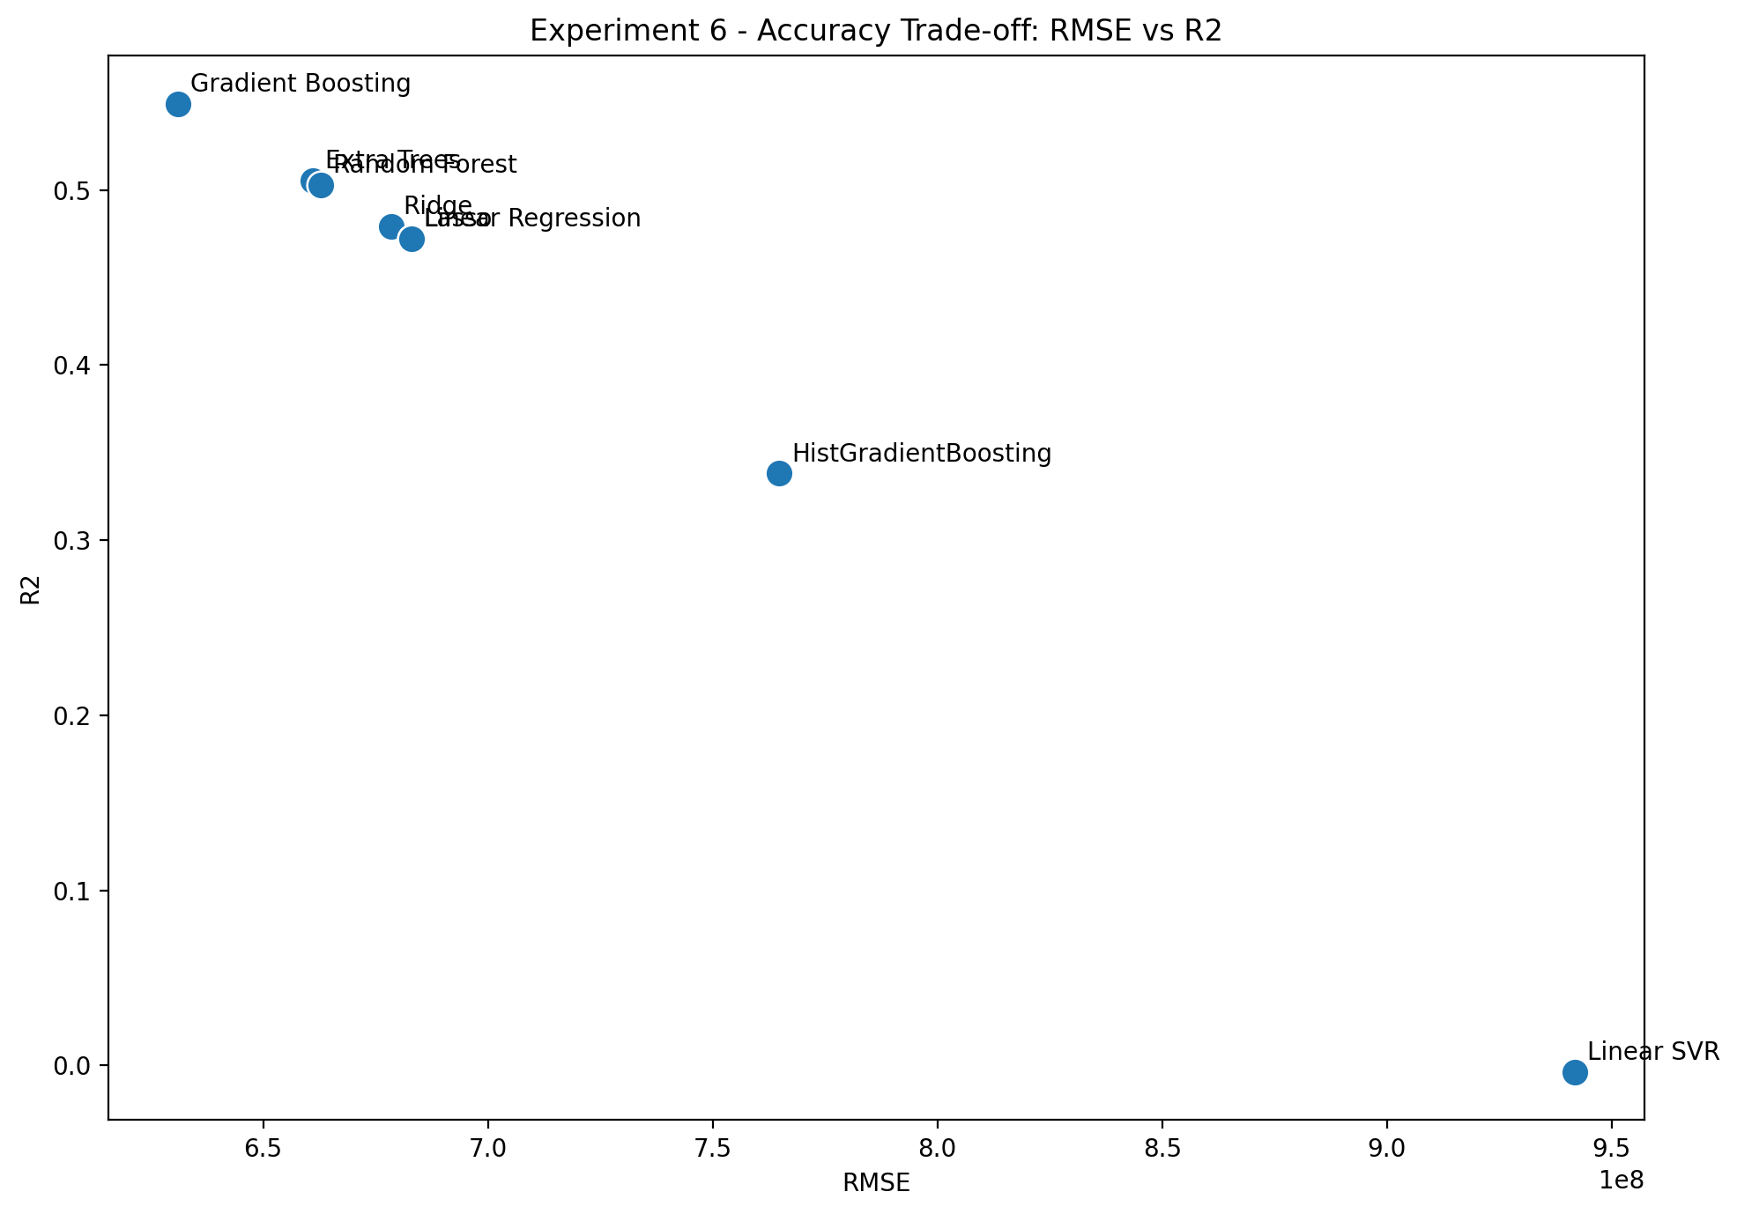
Description: This figure, titled 'Exp6 Rmse R2 Tradeoff', was generated during the agricultural forecasting analysis. It should be interpreted together with the numerical results and methodology of the corresponding experiment.

Actual Results

Model Benchmark Results
Model | MAE | RMSE | R2 | MAPE | Train_Time_s | Inference_us_per_sample
Gradient Boosting | 37481236.3952 | 631106504.3034 | 0.5493 | 114607504570310836879360.0000 | 3.9612 | 3.4027
Extra Trees | 37998436.9053 | 661012755.0322 | 0.5056 | 122028884356395167645696.0000 | 0.6234 | 145.2805
Random Forest | 37941217.1574 | 662831272.9364 | 0.5028 | 122671956920742763823104.0000 | 4.0684 | 141.3614
Ridge | 36456192.9084 | 678445840.8879 | 0.4791 | 129086777667383363371008.0000 | 0.0100 | 3.1205
Lasso | 36069874.8994 | 682968533.4988 | 0.4722 | 130235241368065344012288.0000 | 0.3057 | 2.0531
Linear Regression | 36069874.8952 | 682968533.5236 | 0.4722 | 130235241375005423960064.0000 | 0.0283 | 1.9340
HistGradientBoosting | 71360813.6665 | 764839547.7961 | 0.3380 | 191938544479367883390976.0000 | 2.4014 | 49.8079
Linear SVR | 56353298.7701 | 941740007.1721 | -0.0036 | 184605767060811218944.0000 | 0.5213 | 73.6625

Observation / Interpretation
The candidate models are compared using forecasting metrics; the strongest model is selected on predictive performance rather than complexity alone.

Experiment 7: Model Development

Aim
To develop and select a forecasting model using chronological validation.

Objectives
- Create chronological training and validation sets.
- Train candidate models.
- Compare validation performance.
- Select the strongest model.

Theory
Chronological validation prevents information from future periods from leaking into training.

Methodology / Procedure
Chronological split -> model training -> validation -> model selection.

Generated Figures (3)
Exp7 Chronological Split
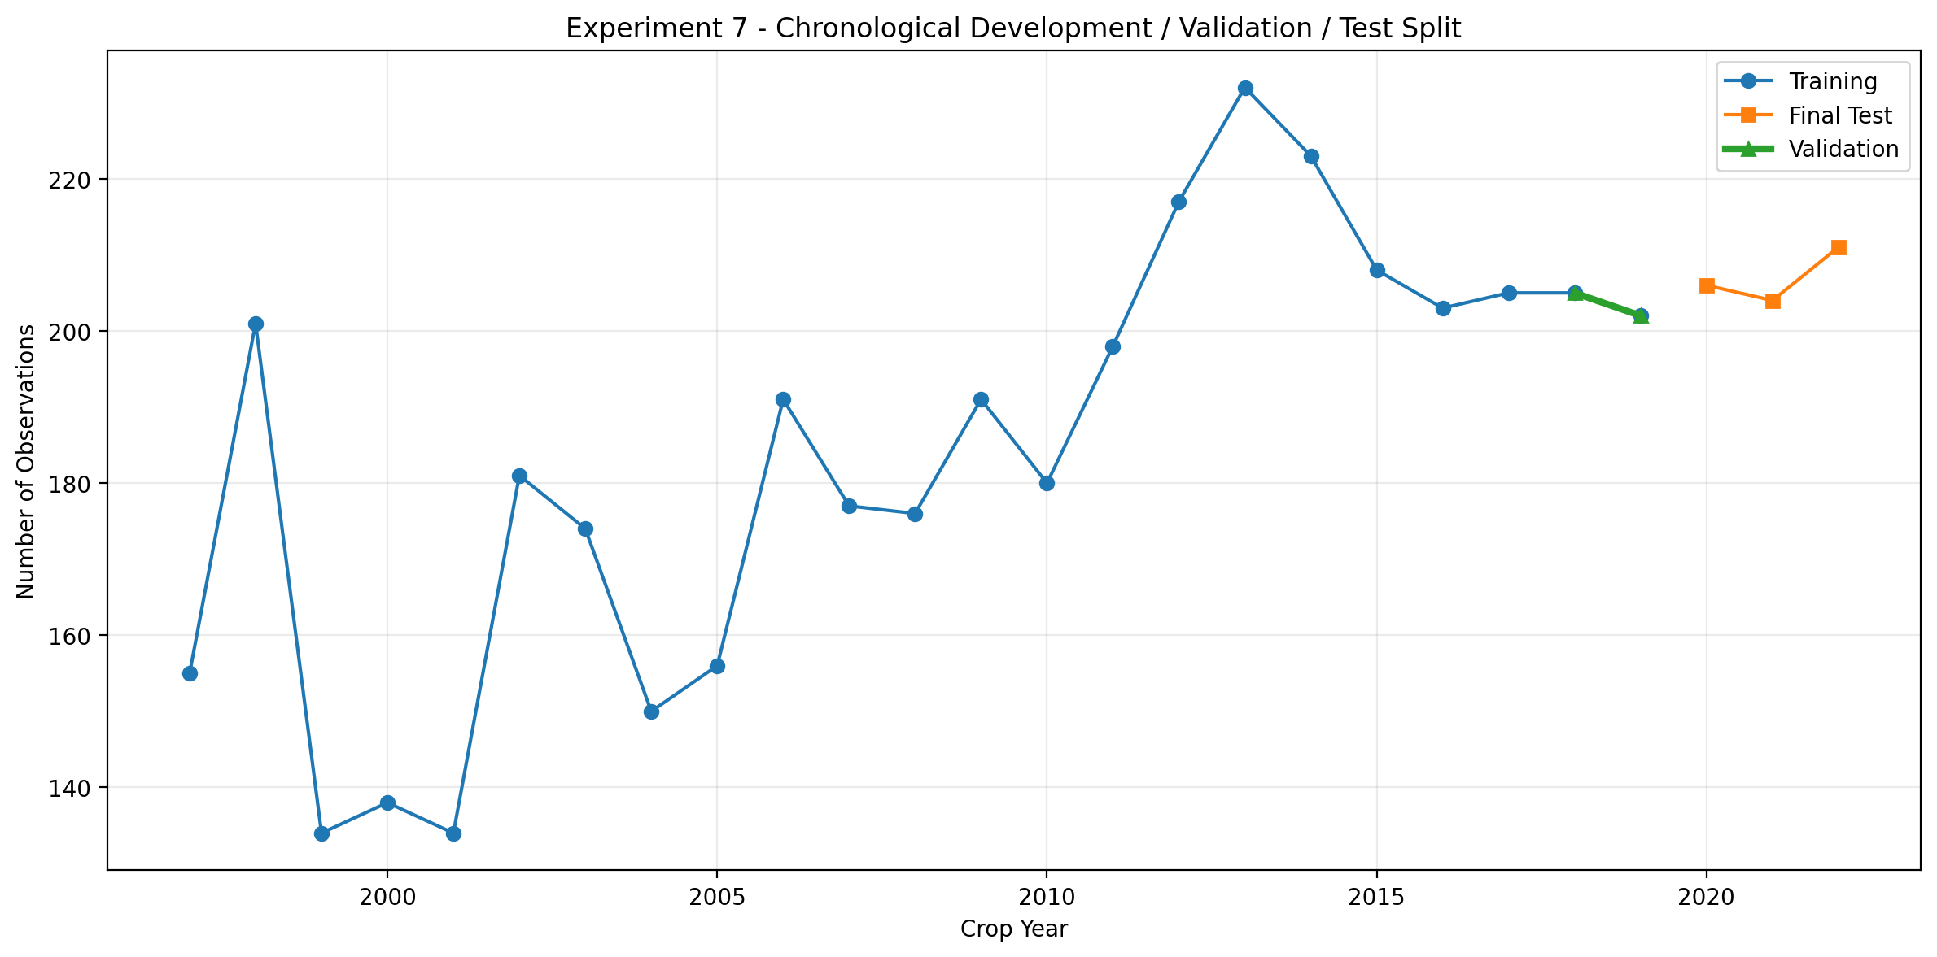
Description: This figure, titled 'Exp7 Chronological Split', was generated during the agricultural forecasting analysis. It should be interpreted together with the numerical results and methodology of the corresponding experiment.
Exp7 Validation R2
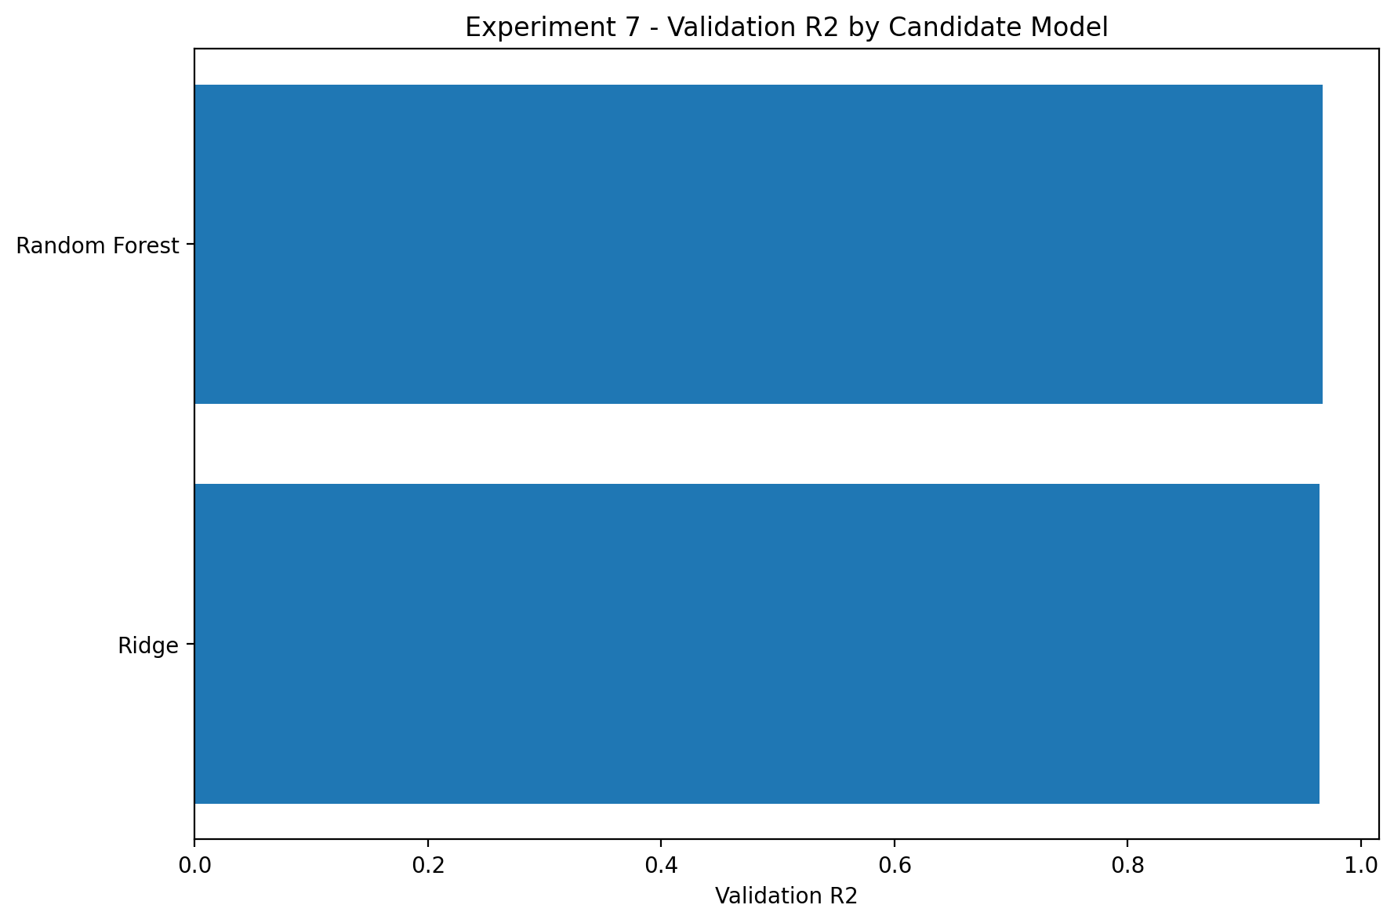
Description: This figure, titled 'Exp7 Validation R2', was generated during the agricultural forecasting analysis. It should be interpreted together with the numerical results and methodology of the corresponding experiment.
Exp7 Validation Rmse
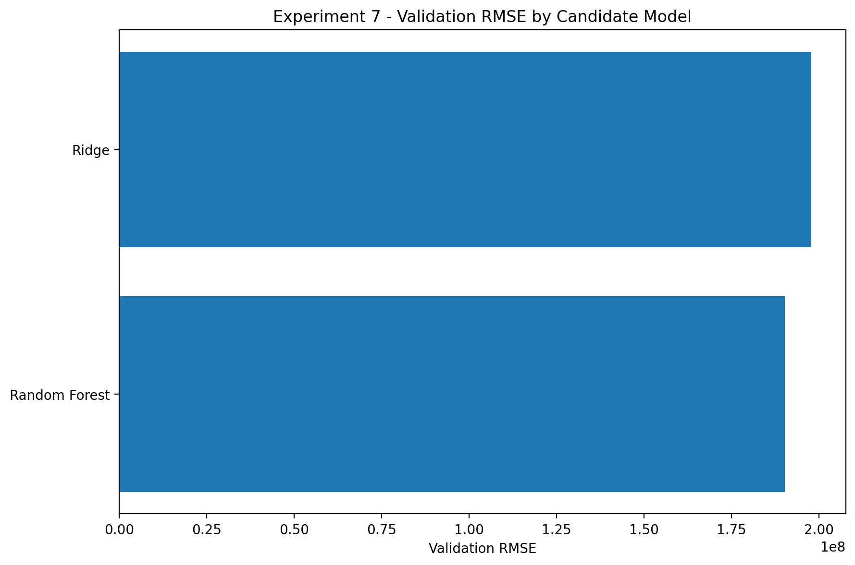
Description: This figure, titled 'Exp7 Validation Rmse', was generated during the agricultural forecasting analysis. It should be interpreted together with the numerical results and methodology of the corresponding experiment.

Actual Results
Selected model: Random Forest.

Validation Results
Model | Validation_MAE | Validation_RMSE | Validation_R2
Random Forest | 12080860.1858 | 190259305.2216 | 0.9669
Ridge | 13450231.1688 | 197793490.2126 | 0.9642

Observation / Interpretation
The results in this section are based on the outputs generated during execution of the corresponding experiment.

Experiment 8: Model Evaluation and Validation

Aim
To evaluate the selected model using time-aware validation and unseen future observations.

Objectives
- Perform TimeSeriesSplit.
- Calculate validation metrics.
- Evaluate future-period predictions.
- Analyze residuals.

Theory
Time-aware validation is important for forecasting because future information must not predict past observations.

Methodology / Procedure
TimeSeriesSplit -> validation -> final training -> independent test -> residual analysis.

Generated Figures (3)
Exp8 Cv Rmse
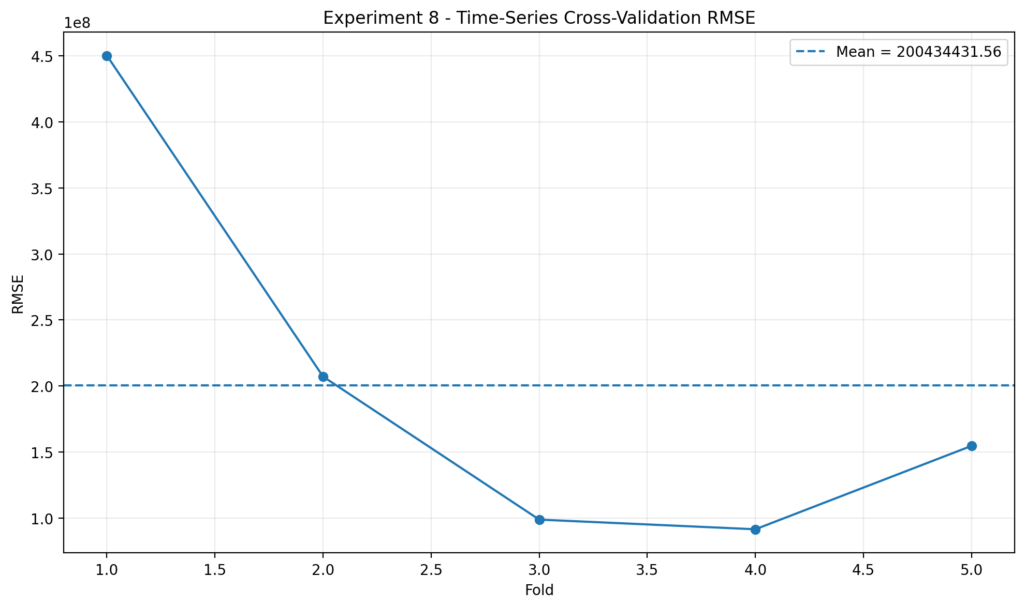
Description: This figure, titled 'Exp8 Cv Rmse', was generated during the agricultural forecasting analysis. It should be interpreted together with the numerical results and methodology of the corresponding experiment.
Exp8 Error By Year
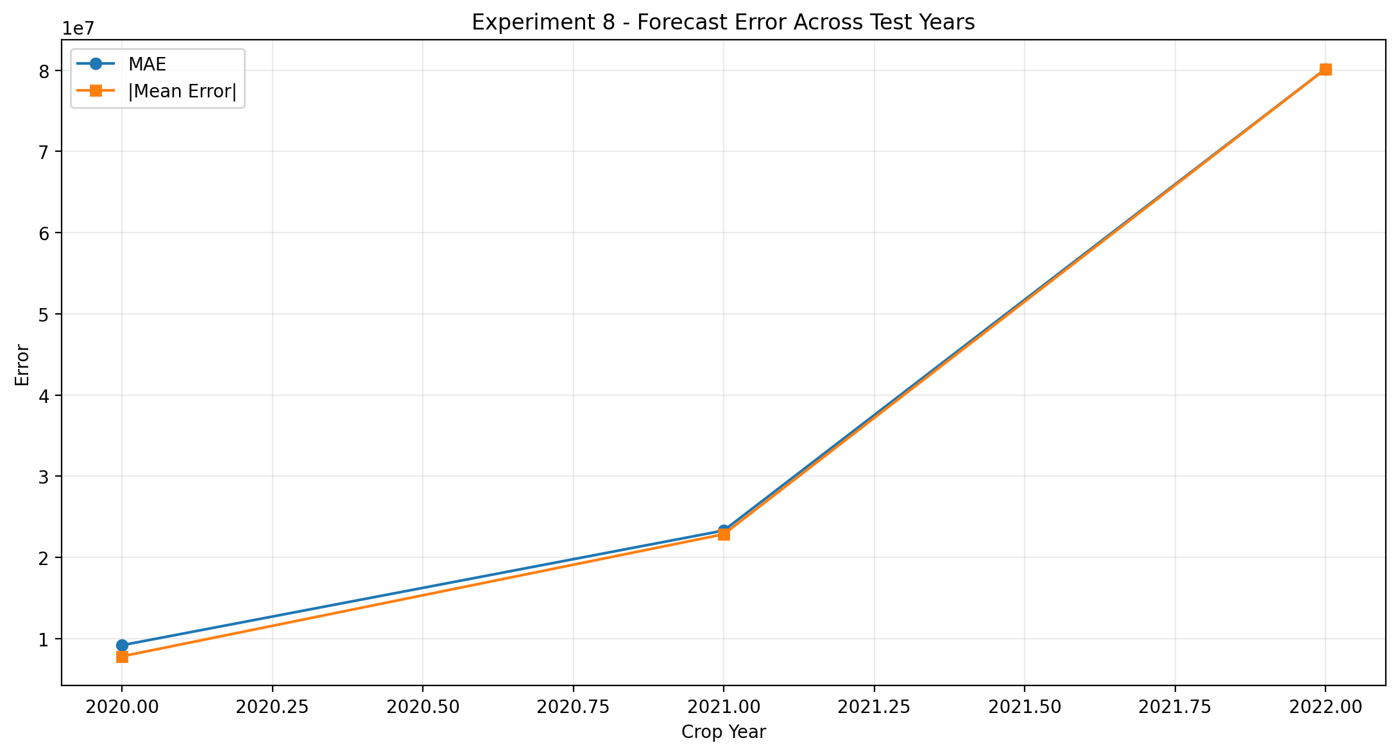
Description: This figure, titled 'Exp8 Error By Year', was generated during the agricultural forecasting analysis. It should be interpreted together with the numerical results and methodology of the corresponding experiment.
Exp8 Evaluation
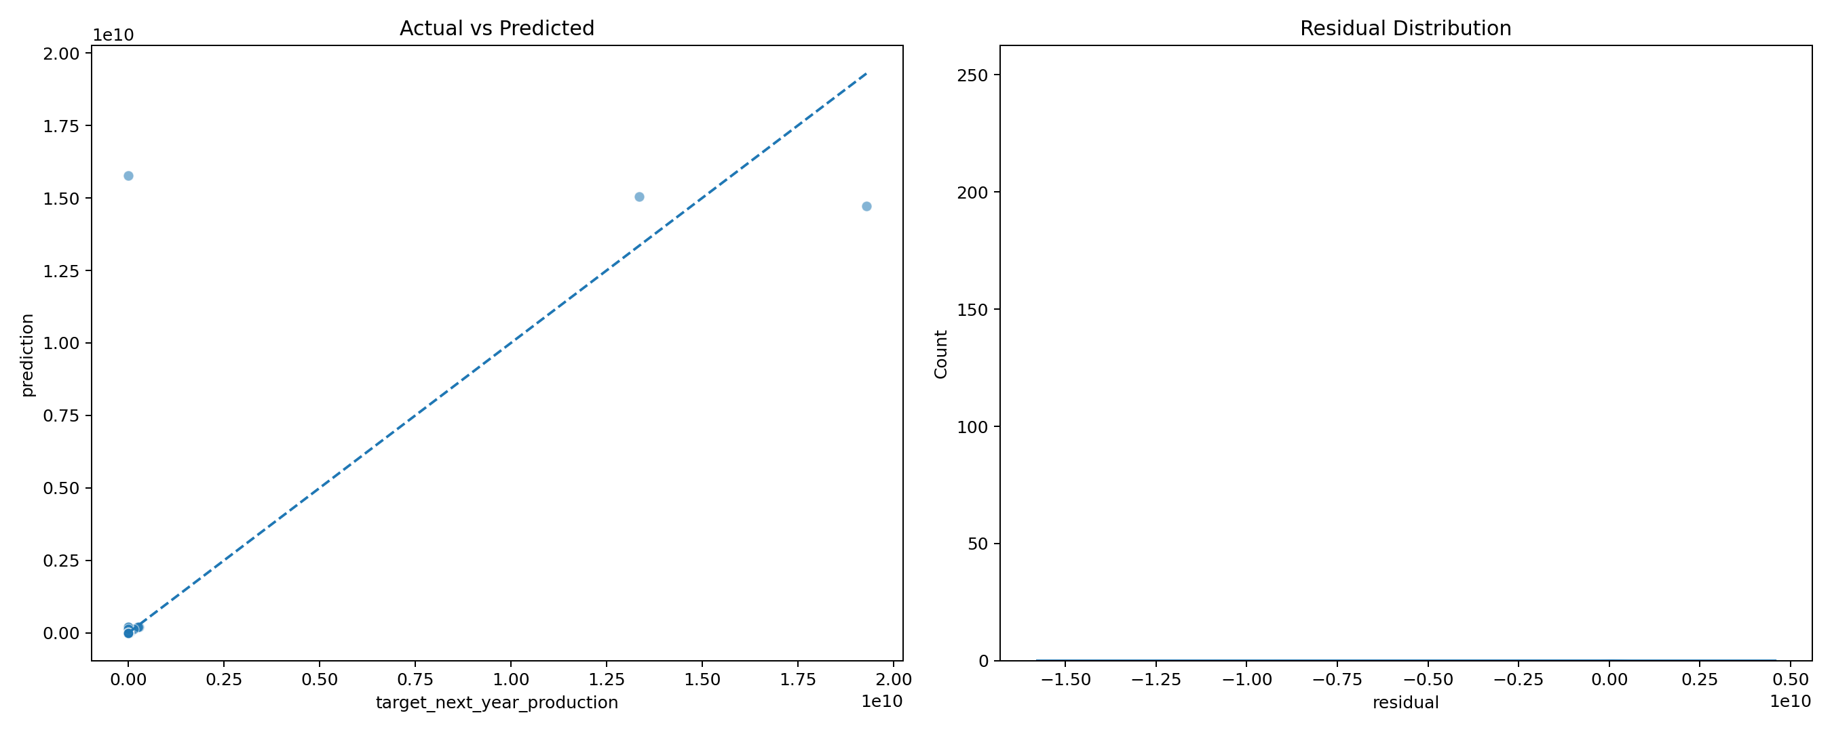
Description: This figure, titled 'Exp8 Evaluation', was generated during the agricultural forecasting analysis. It should be interpreted together with the numerical results and methodology of the corresponding experiment.

Actual Results

Final Test Metrics
MAE | RMSE | R2 | MAPE
37941217.1574 | 662831272.9364 | 0.5028 | 1667999.8620

Cross-Validation Results
Fold | Train_End_Year | Validation_Start_Year | Validation_End_Year | MAE | RMSE | R2
1.0000 | 2001.0000 | 2001.0000 | 2005.0000 | 34803925.7332 | 450254380.2481 | 0.8080
2.0000 | 2005.0000 | 2005.0000 | 2009.0000 | 15377983.4916 | 207095819.9601 | 0.9693
3.0000 | 2009.0000 | 2009.0000 | 2013.0000 | 6521494.1999 | 98758881.3177 | 0.9882
4.0000 | 2013.0000 | 2013.0000 | 2016.0000 | 6667782.9825 | 91443146.7468 | 0.9945
5.0000 | 2016.0000 | 2016.0000 | 2019.0000 | 9129666.5376 | 154619929.5173 | 0.9772

Observation / Interpretation
The results in this section are based on the outputs generated during execution of the corresponding experiment.

Experiment 9: Model Interpretation and Result Analysis

Aim
To understand important predictive variables and crop-level forecasting errors.

Objectives
- Calculate feature importance.
- Rank predictive variables.
- Analyze residuals.
- Analyze crop-level errors.
- Identify high-error crops.

Theory
Feature importance describes predictive usefulness, not causal influence.

Methodology / Procedure
Final model -> feature importance -> residual analysis -> crop-level error analysis.

Generated Figures (3)
Exp9 Crop Bias
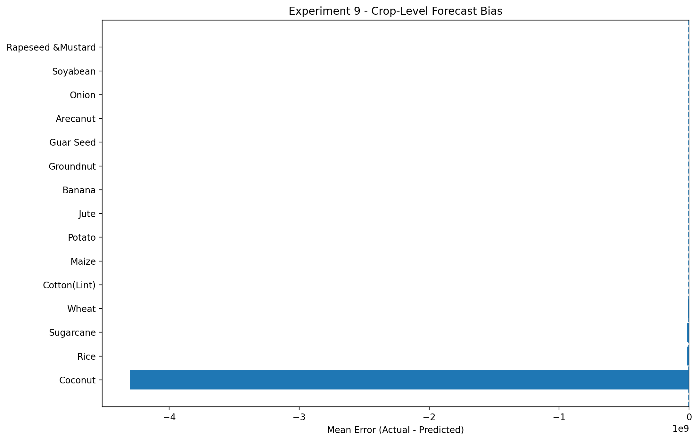
Description: This figure, titled 'Exp9 Crop Bias', was generated during the agricultural forecasting analysis. It should be interpreted together with the numerical results and methodology of the corresponding experiment.
Exp9 Crop Errors
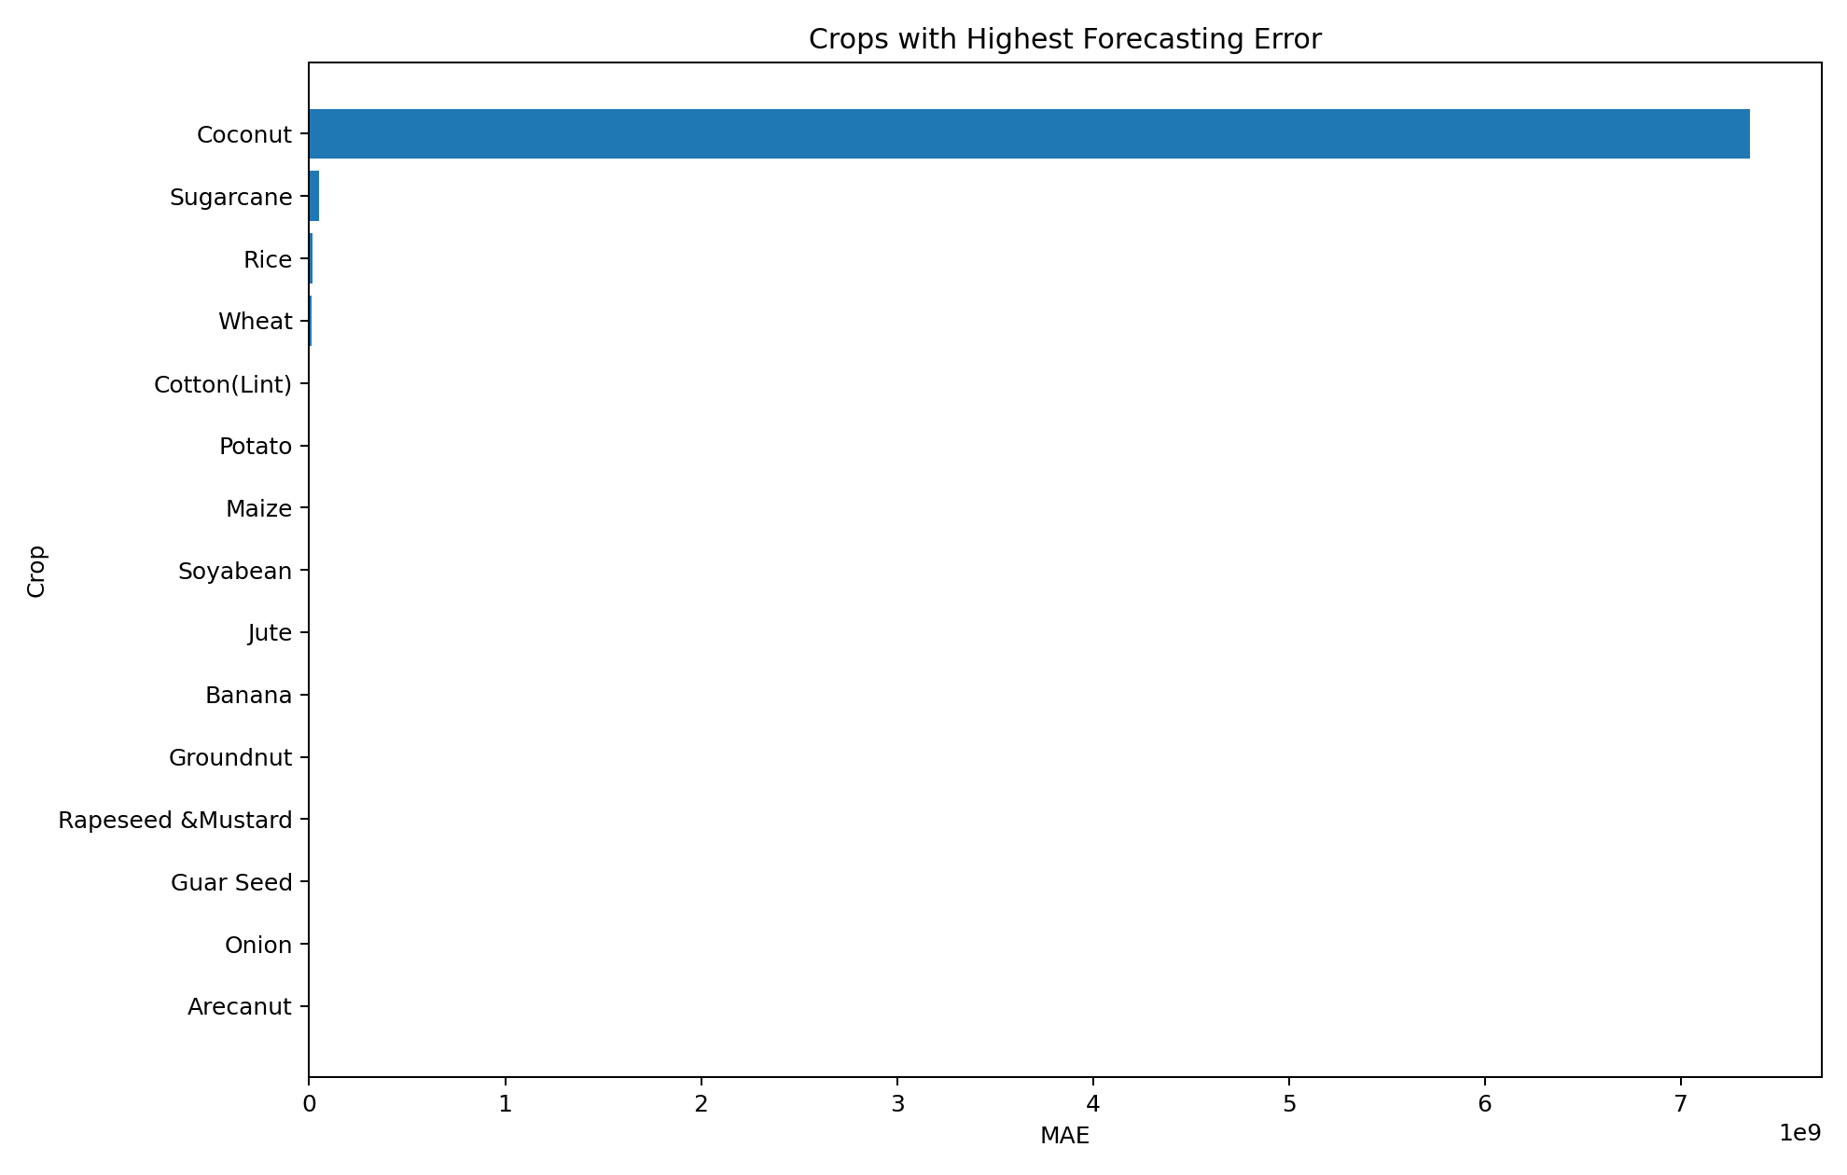
Description: This figure, titled 'Exp9 Crop Errors', was generated during the agricultural forecasting analysis. It should be interpreted together with the numerical results and methodology of the corresponding experiment.
Exp9 Importance
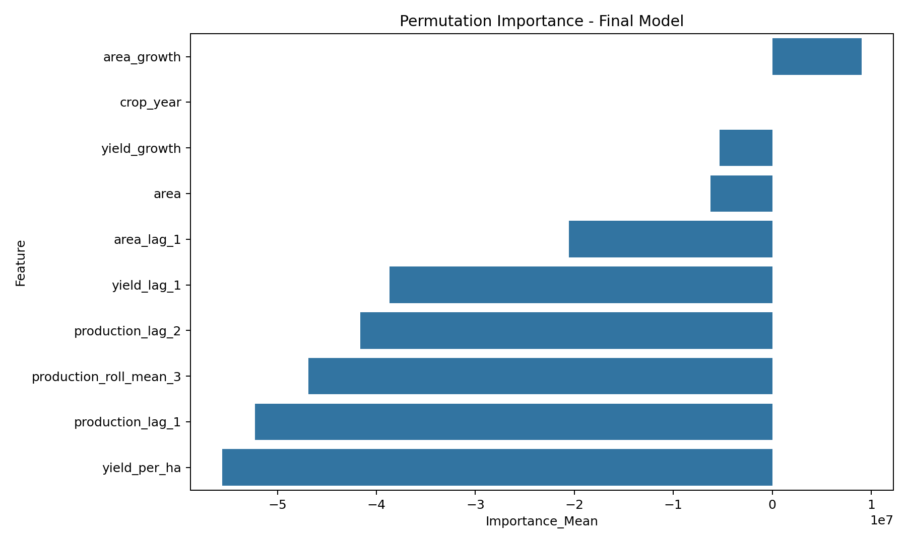
Description: This figure, titled 'Exp9 Importance', was generated during the agricultural forecasting analysis. It should be interpreted together with the numerical results and methodology of the corresponding experiment.

Actual Results

Feature Importance
Feature | Importance_Mean | Importance_SD
area_growth | 9007929.3634 | 5898363.6385
crop_year | 0.0000 | 0.0000
yield_growth | -5348297.5101 | 5271756.7243
area | -6221735.3787 | 6842965.0346
area_lag_1 | -20569394.0993 | 23413361.1918
yield_lag_1 | -38690083.3670 | 2740771.6323
production_lag_2 | -41628670.5897 | 292572.7450
production_roll_mean_3 | -46864677.8774 | 1676811.9664
production_lag_1 | -52280079.6774 | 2326906.9812
yield_per_ha | -55565944.6042 | 662053.4105

Crop-Level Errors
crop | MAE | Mean_Error | Observations
Coconut | 7352390952.9327 | -4300814960.1150 | 3
Sugarcane | 51362593.4223 | -16139916.0260 | 12
Rice | 17565711.0238 | -17287336.6204 | 18
Wheat | 9854529.7151 | -9325426.4361 | 14
Cotton(Lint) | 3864178.2995 | -3554281.2121 | 12
Potato | 3680374.7851 | -1853230.6330 | 18
Maize | 3465907.1000 | -3171896.0603 | 21
Soyabean | 2427573.6950 | -689166.1710 | 11
Jute | 1722092.9336 | -1707968.2880 | 6
Banana | 1656799.5559 | -1653998.0277 | 9
Groundnut | 1645092.8789 | -1634482.2365 | 21
Rapeseed &Mustard | 1413600.8712 | -395219.7752 | 15
Guar Seed | 1356497.7041 | -1356497.7041 | 6
Onion | 1263028.7087 | -731827.3464 | 15
Arecanut | 1229454.9115 | -796314.3697 | 9

Observation / Interpretation
Feature importance identifies useful predictors, while crop-level error analysis highlights where the model can be improved.

Experiment 10: Real-World Business Problem Solving with Data Analytics

Aim
To convert agricultural forecasting results into practical decision-support recommendations.

Objectives
- Identify important crops.
- Identify high-error crops.
- Compare feature groups.
- Perform ablation analysis.
- Generate monitoring priorities.

Theory
Predictive analytics becomes useful when forecasts can be converted into actionable agricultural decisions.

Methodology / Procedure
Forecast -> error analysis -> feature ablation -> risk prioritization -> recommendations.

Generated Figures (3)
Ablation Study
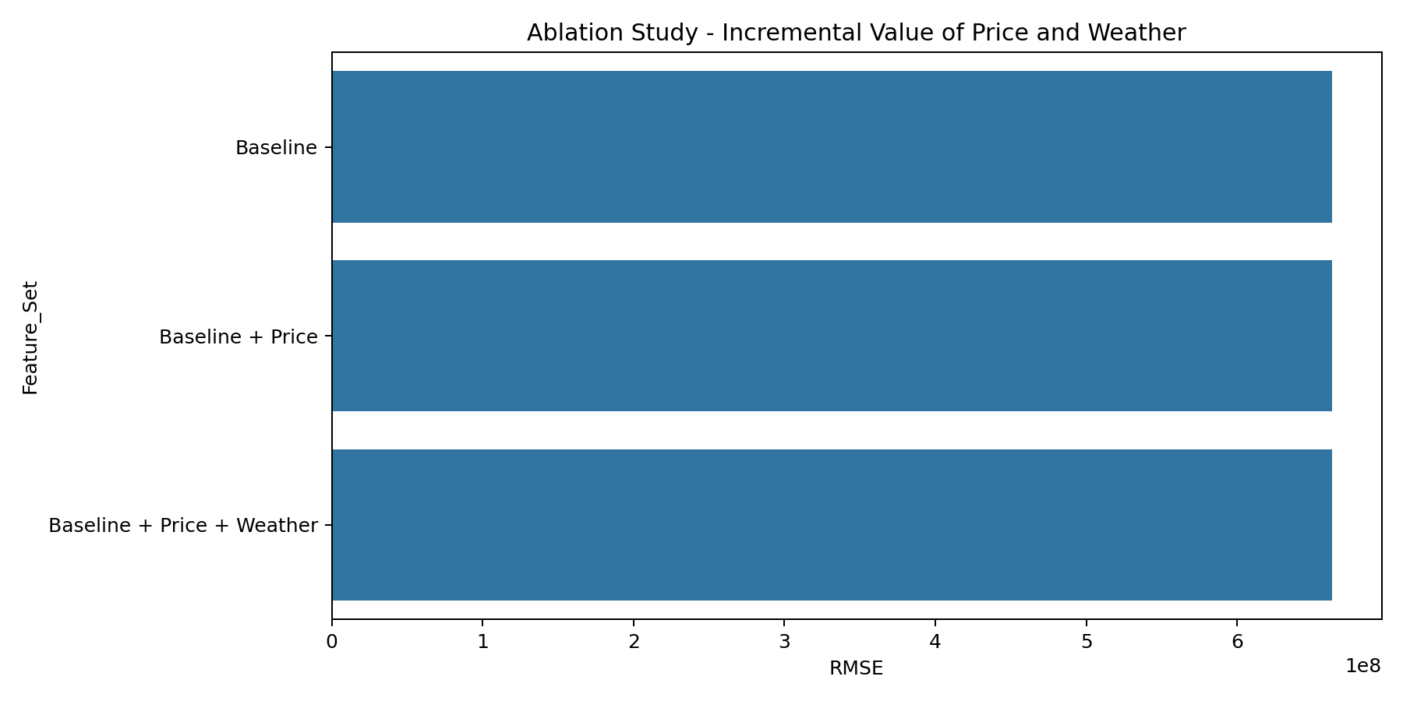
Description: This figure, titled 'Ablation Study', was generated during the agricultural forecasting analysis. It should be interpreted together with the numerical results and methodology of the corresponding experiment.
Exp10 Decision Matrix
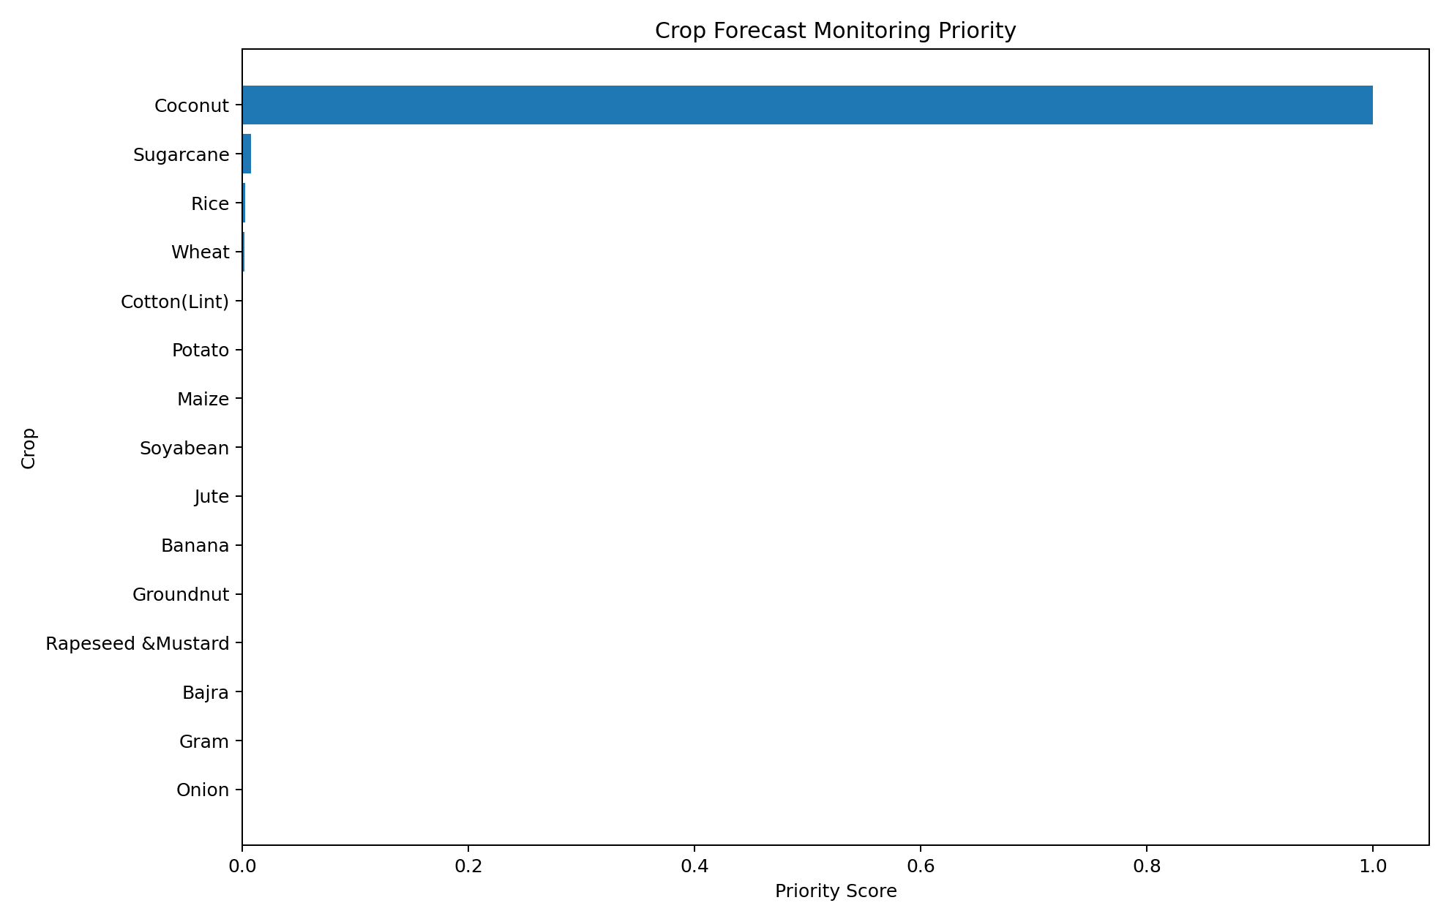
Description: This figure, titled 'Exp10 Decision Matrix', was generated during the agricultural forecasting analysis. It should be interpreted together with the numerical results and methodology of the corresponding experiment.
Exp10 Production Vs Forecast Risk
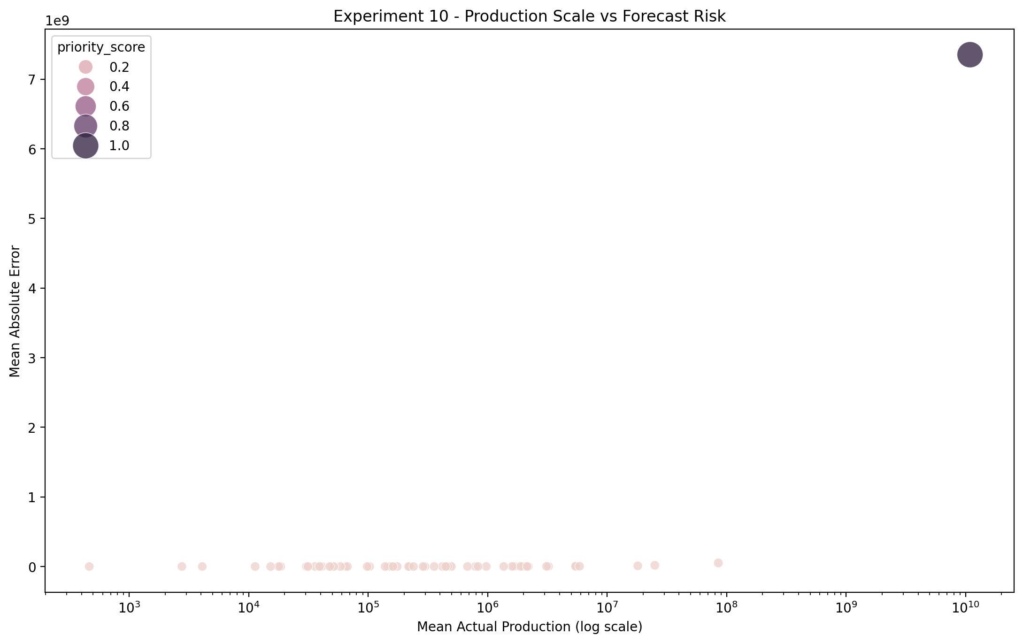
Description: This figure, titled 'Exp10 Production Vs Forecast Risk', was generated during the agricultural forecasting analysis. It should be interpreted together with the numerical results and methodology of the corresponding experiment.

Actual Results

Ablation Study
Feature_Set | Features | MAE | RMSE | R2
Baseline | area, yield_per_ha, production_lag_1, production_lag_2, area_lag_1, yield_lag_1, area_growth, yield_growth, production_roll_mean_3, crop_year | 37941217.1574 | 662831272.9364 | 0.5028
Baseline + Price | area, yield_per_ha, production_lag_1, production_lag_2, area_lag_1, yield_lag_1, area_growth, yield_growth, production_roll_mean_3, crop_year | 37941217.1574 | 662831272.9364 | 0.5028
Baseline + Price + Weather | area, yield_per_ha, production_lag_1, production_lag_2, area_lag_1, yield_lag_1, area_growth, yield_growth, production_roll_mean_3, crop_year | 37941217.1574 | 662831272.9364 | 0.5028

Decision Matrix
crop | mean_actual | mean_prediction | MAE | mean_error | observations | error_risk | production_scale | priority_score | action
Coconut | 10880579759.6667 | 15181394719.7816 | 7352390952.9327 | -4300814960.1150 | 3 | 1.0000 | 1.0000 | 1.0000 | High priority - investigate and monitor
Sugarcane | 85156414.6743 | 101296330.7003 | 51362593.4223 | -16139916.0260 | 12 | 0.0070 | 0.0078 | 0.0073 | Low priority - routine monitoring
Rice | 25068550.2601 | 42355886.8805 | 17565711.0238 | -17287336.6204 | 18 | 0.0024 | 0.0023 | 0.0024 | Low priority - routine monitoring
Wheat | 18044208.6118 | 27369635.0479 | 9854529.7151 | -9325426.4361 | 14 | 0.0013 | 0.0017 | 0.0015 | Low priority - routine monitoring
Cotton(Lint) | 5488593.1006 | 9042874.3127 | 3864178.2995 | -3554281.2121 | 12 | 0.0005 | 0.0005 | 0.0005 | Low priority - routine monitoring
Potato | 5428846.1855 | 7282076.8185 | 3680374.7851 | -1853230.6330 | 18 | 0.0005 | 0.0005 | 0.0005 | Low priority - routine monitoring
Maize | 5873306.6384 | 9045202.6987 | 3465907.1000 | -3171896.0603 | 21 | 0.0005 | 0.0005 | 0.0005 | Low priority - routine monitoring
Soyabean | 3230621.7859 | 3919787.9569 | 2427573.6950 | -689166.1710 | 11 | 0.0003 | 0.0003 | 0.0003 | Low priority - routine monitoring
Jute | 3111930.9050 | 4819899.1930 | 1722092.9336 | -1707968.2880 | 6 | 0.0002 | 0.0003 | 0.0003 | Low priority - routine monitoring
Banana | 1979456.1122 | 3633454.1399 | 1656799.5559 | -1653998.0277 | 9 | 0.0002 | 0.0002 | 0.0002 | Low priority - routine monitoring
Groundnut | 1676984.4301 | 3311466.6666 | 1645092.8789 | -1634482.2365 | 21 | 0.0002 | 0.0002 | 0.0002 | Low priority - routine monitoring
Rapeseed &Mustard | 1885003.5260 | 2280223.3012 | 1413600.8712 | -395219.7752 | 15 | 0.0002 | 0.0002 | 0.0002 | Low priority - routine monitoring
Bajra | 2189148.9543 | 3253981.2980 | 1170132.8486 | -1064832.3437 | 12 | 0.0002 | 0.0002 | 0.0002 | Low priority - routine monitoring
Gram | 2137818.2403 | 2932505.3227 | 1186136.4270 | -794687.0823 | 12 | 0.0002 | 0.0002 | 0.0002 | Low priority - routine monitoring
Onion | 1605188.0570 | 2337015.4034 | 1263028.7087 | -731827.3464 | 15 | 0.0002 | 0.0001 | 0.0002 | Low priority - routine monitoring
Arecanut | 1363728.8609 | 2160043.2306 | 1229454.9115 | -796314.3697 | 9 | 0.0002 | 0.0001 | 0.0002 | Low priority - routine monitoring
Guar Seed | 479694.0000 | 1836191.7041 | 1356497.7041 | -1356497.7041 | 6 | 0.0002 | 0.0000 | 0.0001 | Low priority - routine monitoring
Tapioca | 973637.4467 | 1769259.2523 | 824613.7800 | -795621.8057 | 12 | 0.0001 | 0.0001 | 0.0001 | Low priority - routine monitoring
Arcanut (Processed) | 789596.3333 | 1035455.4822 | 576464.9599 | -245859.1489 | 3 | 0.0001 | 0.0001 | 0.0001 | Low priority - routine monitoring
Jowar | 832150.4527 | 1329333.6297 | 550031.1092 | -497183.1770 | 18 | 0.0001 | 0.0001 | 0.0001 | Low priority - routine monitoring

Observation / Interpretation
Results are translated into decision-support recommendations by combining production importance with forecasting performance.

Complete Figure Inventory
The following table lists every image file discovered in report_outputs and included in the report.
Experiment | Figure File
Experiment 1 | exp1_data_completeness.png
Experiment 1 | exp1_dataset_scale.png
Experiment 1 | exp1_yearly_observations.png
Experiment 2 | exp2_crop_type_composition.png
Experiment 2 | exp2_season_coverage.png
Experiment 2 | exp2_state_coverage.png
Experiment 3 | exp3_correlation.png
Experiment 3 | exp3_national_trend.png
Experiment 3 | exp3_top_crop_trends.png
Experiment 3 | exp3_univariate.png
Experiment 4 | exp4_feature_reduction.png
Experiment 4 | exp4_mutual_information.png
Experiment 4 | exp4_pca.png
Experiment 5 | exp5_correlation.png
Experiment 5 | exp5_dashboard.png
Experiment 5 | exp5_hypothesis_tests.png
Experiment 6 | exp6_benchmark.png
Experiment 6 | exp6_mae_comparison.png
Experiment 6 | exp6_rmse_r2_tradeoff.png
Experiment 7 | exp7_chronological_split.png
Experiment 7 | exp7_validation_r2.png
Experiment 7 | exp7_validation_rmse.png
Experiment 8 | exp8_cv_rmse.png
Experiment 8 | exp8_error_by_year.png
Experiment 8 | exp8_evaluation.png
Experiment 9 | exp9_crop_bias.png
Experiment 9 | exp9_crop_errors.png
Experiment 9 | exp9_importance.png
Experiment 10 | ablation_study.png
Experiment 10 | exp10_decision_matrix.png
Experiment 10 | exp10_production_vs_forecast_risk.png

Overall Conclusion
The project developed an end-to-end agricultural forecasting pipeline covering data acquisition, preparation, exploratory analysis, feature engineering, statistical analysis, machine learning, validation, interpretation and practical decision support.
The analysis considers crop area, yield and historical production, with price/weather variables included only where compatible information is available.
Final selected model: Random Forest.

Final Model Performance
MAE | RMSE | R2 | MAPE
37941217.1574 | 662831272.9364 | 0.5028 | 1667999.8620

