

|  |
| --- |
| Money_Channel_Wireframe |
| 29/09/19 16:34 |
| **Author:** John Doe  **File name:** Money_Channel_Wireframe.vp  **Version** 1.0 |

|  |
| --- |
| Site Map |
|  |

|  |
| --- |
|  |

01. Site Map / Money_Channel_Wireframe 

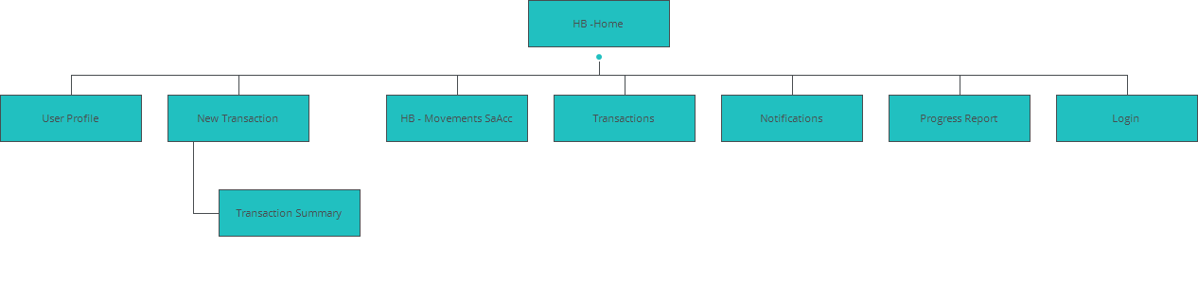

|  |
| --- |
| Screens |
|  |

|  |
| --- |
|  |

02. Screens / Money_Channel_Wireframe 

HB -Home

|  |
| --- |
|  |

Interactions

|  |  |
| --- | --- |
| 1 | **on Click:** goes to 'User Profile' 🡪 |
| 2 | **on Click:** goes to 'New Transaction' 🡪 |
| 3 | **on Click:** goes to 'HB - Movements SaAcc' 🡪 |
| 4 | **on Click:** goes to 'Transactions' 🡪 |

02. Screens / Money_Channel_Wireframe 

New Transaction

|  |
| --- |
|  |

Interactions

|  |  |
| --- | --- |
| 5 | **on Click:** When (verifyTransfer = 'clear') goes to 'Transaction Summary' with effect: fade 🡪 |

02. Screens / New Transaction 

Other states

|  |  |
| --- | --- |
|  |  |

02. Screens / Money_Channel_Wireframe 

Transaction Summary

|  |
| --- |
|  |

Interactions

|  |  |
| --- | --- |
| 6 | **on Click:** goes to 'New Transaction' 🡪 |
| 7 | **on Click:** goes to 'Transactions' 🡪 |

02. Screens / Transaction Summary 

Other states

|  |  |
| --- | --- |
|  |  |

02. Screens / Money_Channel_Wireframe 

Transactions

|  |
| --- |
|  |

Interactions

|  |  |
| --- | --- |
| 8 | **on Click:** goes to 'New Transaction' 🡪 |

02. Screens / Money_Channel_Wireframe 

HB - Movements SaAcc

|  |
| --- |
|  |

Interactions

|  |  |
| --- | --- |
| 10 | **on Click:** goes to 'New Transaction' 🡪 |

02. Screens / Money_Channel_Wireframe 

Notifications

|  |
| --- |
|  |

02. Screens / Money_Channel_Wireframe 

Progress Report

|  |
| --- |
|  |

02. Screens / Money_Channel_Wireframe 

Login

|  |
| --- |
|  |

02. Screens / Login 

Other states

|  |  |  |  |
| --- | --- | --- | --- |
|  | Interactions   |  |  | | --- | --- | | 11 | **on Click:** goes to 'HB -Home' 🡪 | |
|  | Interactions   |  |  | | --- | --- | | 12 | **on Click:** goes to 'HB -Home' 🡪 | |
|  | Interactions   |  |  | | --- | --- | | 13 | **on Click:** goes to 'HB -Home' 🡪 | |
|  | Interactions   |  |  | | --- | --- | | 14 | **on Click:** goes to 'HB -Home' 🡪 | |
|  | Interactions   |  |  | | --- | --- | | 15 | **on Click:** goes to 'HB -Home' 🡪 | |

02. Screens / Money_Channel_Wireframe 

User Profile

|  |
| --- |
|  |

|  |
| --- |
| Templates |
|  |

|  |
| --- |
|  |

03. Templates / Money_Channel_Wireframe 

960 grid - 12 columns

|  |
| --- |
|  |

03. Templates / Money_Channel_Wireframe 

960 grid - 16 columns

|  |
| --- |
|  |

03. Templates / Money_Channel_Wireframe 

Standard

|  |
| --- |
|  |

03. Templates / Money_Channel_Wireframe 

Template 1

|  |
| --- |
|  |

Interactions

|  |  |
| --- | --- |
| 16 | **on Click:** goes to 'Notifications' 🡪 |
| 17 | **on Click:** goes to 'Progress Report' 🡪 |
| 21 | **on Click:** goes to 'HB -Home' 🡪 |

|  |
| --- |
| Scenarios |
|  |

|  |
| --- |
|  |

04. Scenarios / Money_Channel_Wireframe 

default

|  |
| --- |
|  |

|  |
| --- |
| Data Masters |
|  |

|  |
| --- |
|  |

05. Data Masters / Money_Channel_Wireframe 

ChristopherAccount

|  |  |  |
| --- | --- | --- |
| Attribute name | Type | Values |
| TransferAmount | text | values |
| totalChA | text | values |
| TransferDate | text | values |
| TransferOriginAcc | text | values |
| TransferDestinationAcc | text | values |
| TransferRecipientName | text | values |
| TransferConcept | text | values |

CurrentAccount

|  |  |  |
| --- | --- | --- |
| Attribute name | Type | Values |
| TransactionAmount | text | values |
| CurrentProfileTotal | text | values |
| TransactionDate | text | values |
| CurrentProfile | text | values |
| TransactionType | text | values |

SavingsAccount

|  |  |  |
| --- | --- | --- |
| Attribute name | Type | Values |
| TransferAmount | text | values |
| totalSA | text | values |
| TransferDate | text | values |
| TransferOriginAcc | text | values |
| TransferDestinationAcc | text | values |
| TransferRecipientName | text | values |
| TransferConcept | text | values |