Experimental Protocol
CorTec BIC Saline Impedance Characterization
Fixed 50 mL bath with 20 mL serial replacement
- Starting bath: 50.0 mL of 0.9% NaCl.
- Dilution step: remove 20.0 mL of well-mixed solution and replace with 20.0 mL distilled/deionized water.
- Each dilution multiplies NaCl concentration by 0.60 while returning the bath to 50.0 mL.
- Acquire approximately 20-50 repeated BIC impedance measurements at each concentration.

1. Objective
Primary objective. Characterize the usable impedance-measurement range of the CorTec BIC benchtop system as the conductivity of a saline bath is progressively reduced, and identify the range where measurements become unstable, invalid, saturated, or excessively high.
Application objective. Assess whether the BIC impedance measurement can provide a practical indicator of high-impedance or faulty-channel conditions. Saline dilution models a progressively less conductive electrode path and should be interpreted as a benchtop system-level test rather than a complete model of every possible implanted-channel failure mode.
Important: the measured BIC impedance includes both the saline path and the two Ag/AgCl electrode-electrolyte interfaces. Because electrode-interface impedance is chloride- and frequency-dependent, BIC impedance should not be interpreted as pure saline bulk resistance.

2. Experimental setup
- CorTec BIC benchtop unit with two externalized lead contacts/channels.
- Two standard Ag/AgCl EEG cup electrodes connected to the selected BIC leads.
- 50.0 mL of 0.9% NaCl physiological saline for the initial bath.
- Distilled or deionized water.
- Nonconductive vessel sized to maintain consistent electrode placement in a 50 mL bath.
- Volumetric cylinder, serological pipette, or syringe capable of reproducibly transferring 20.0 mL.
- Mechanical electrode holder maintaining 10 mm center-to-center electrode spacing and constant immersion depth/orientation.
- Temperature probe. Optional but recommended: calibrated conductivity meter.

3. Variables to control and record
Variable | Requirement / reason
NaCl concentration | Calculated from the serial dilution factor; record the nominal concentration at every step.
Temperature | Record for each concentration. Electrolyte conductivity is temperature-dependent.
Electrode spacing | Maintain 10 mm center-to-center throughout the experiment.
Immersion depth / exposed area | Keep constant. Changes alter both the solution current path and electrode-interface impedance.
Electrode orientation | Keep the same face-to-face/relative orientation for all measurements.
Electrode identity and condition | Use the same electrodes for one run and document replacement, cleaning, or visible changes.
Conductivity | If a conductivity meter is available, record measured conductivity at each concentration.
BIC configuration | Use the same firmware, measurement mode, channels, and impedance-test settings for the entire run.
Replicate number | Acquire 20-50 repeated BIC measurements at every concentration and retain individual values.
Measurement status | Record valid/invalid/over-range/error status as well as numerical values.

4. Fixed-volume serial dilution
At every dilution step, the bath volume is maintained at 50.0 mL. After thorough mixing, remove 20.0 mL of solution and replace it with 20.0 mL of distilled/deionized water.
Fraction of previous solution retained = (50 - 20) / 50 = 30 / 50 = 0.60
Therefore the concentration after each exchange is:
Cₙ = C₀ × (0.60)ⁿ
where C₀ = 0.900% NaCl and n is the number of completed 20 mL replacement steps. Equivalently, for one step:
Cₙ₊₁ = Cₙ × (Vtotal - Vremoved) / Vtotal = Cₙ × 0.60

5. Concentration schedule
Condition | NaCl (%) | Remove (mL) | DI water add (mL) | Bath volume (mL)
1 | 0.90000 | — | — | 50.0
2 | 0.54000 | 20.0 | 20.0 | 50.0
3 | 0.32400 | 20.0 | 20.0 | 50.0
4 | 0.19440 | 20.0 | 20.0 | 50.0
5 | 0.11664 | 20.0 | 20.0 | 50.0
6 | 0.06998 | 20.0 | 20.0 | 50.0
7 | 0.04199 | 20.0 | 20.0 | 50.0
8 | 0.02519 | 20.0 | 20.0 | 50.0
9 | 0.01512 | 20.0 | 20.0 | 50.0
10 | 0.00907 | 20.0 | 20.0 | 50.0
11 | 0.00544 | 20.0 | 20.0 | 50.0
12 | 0.00327 | 20.0 | 20.0 | 50.0
13 | 0.00196 | 20.0 | 20.0 | 50.0
14 | 0.00118 | 20.0 | 20.0 | 50.0
15 | 0.00000 | 50.0 | 50.0 | 50.0
Endpoint. After 14 20 mL replacement steps, the nominal concentration is 0.001% NaCl, which is close to the planned endpoint after which measurement in deionized water is performed.

6. Step-by-step measurement procedure
- Inspect the BIC benchtop unit, leads, connectors, and Ag/AgCl electrodes. Record channel and electrode identifiers.
- Add 50.0 mL of 0.9% NaCl to the nonconductive vessel. Record source/lot if relevant.
- Position the two Ag/AgCl electrodes 10 mm center-to-center using a fixture. Fix immersion depth and orientation so they cannot shift during dilution.
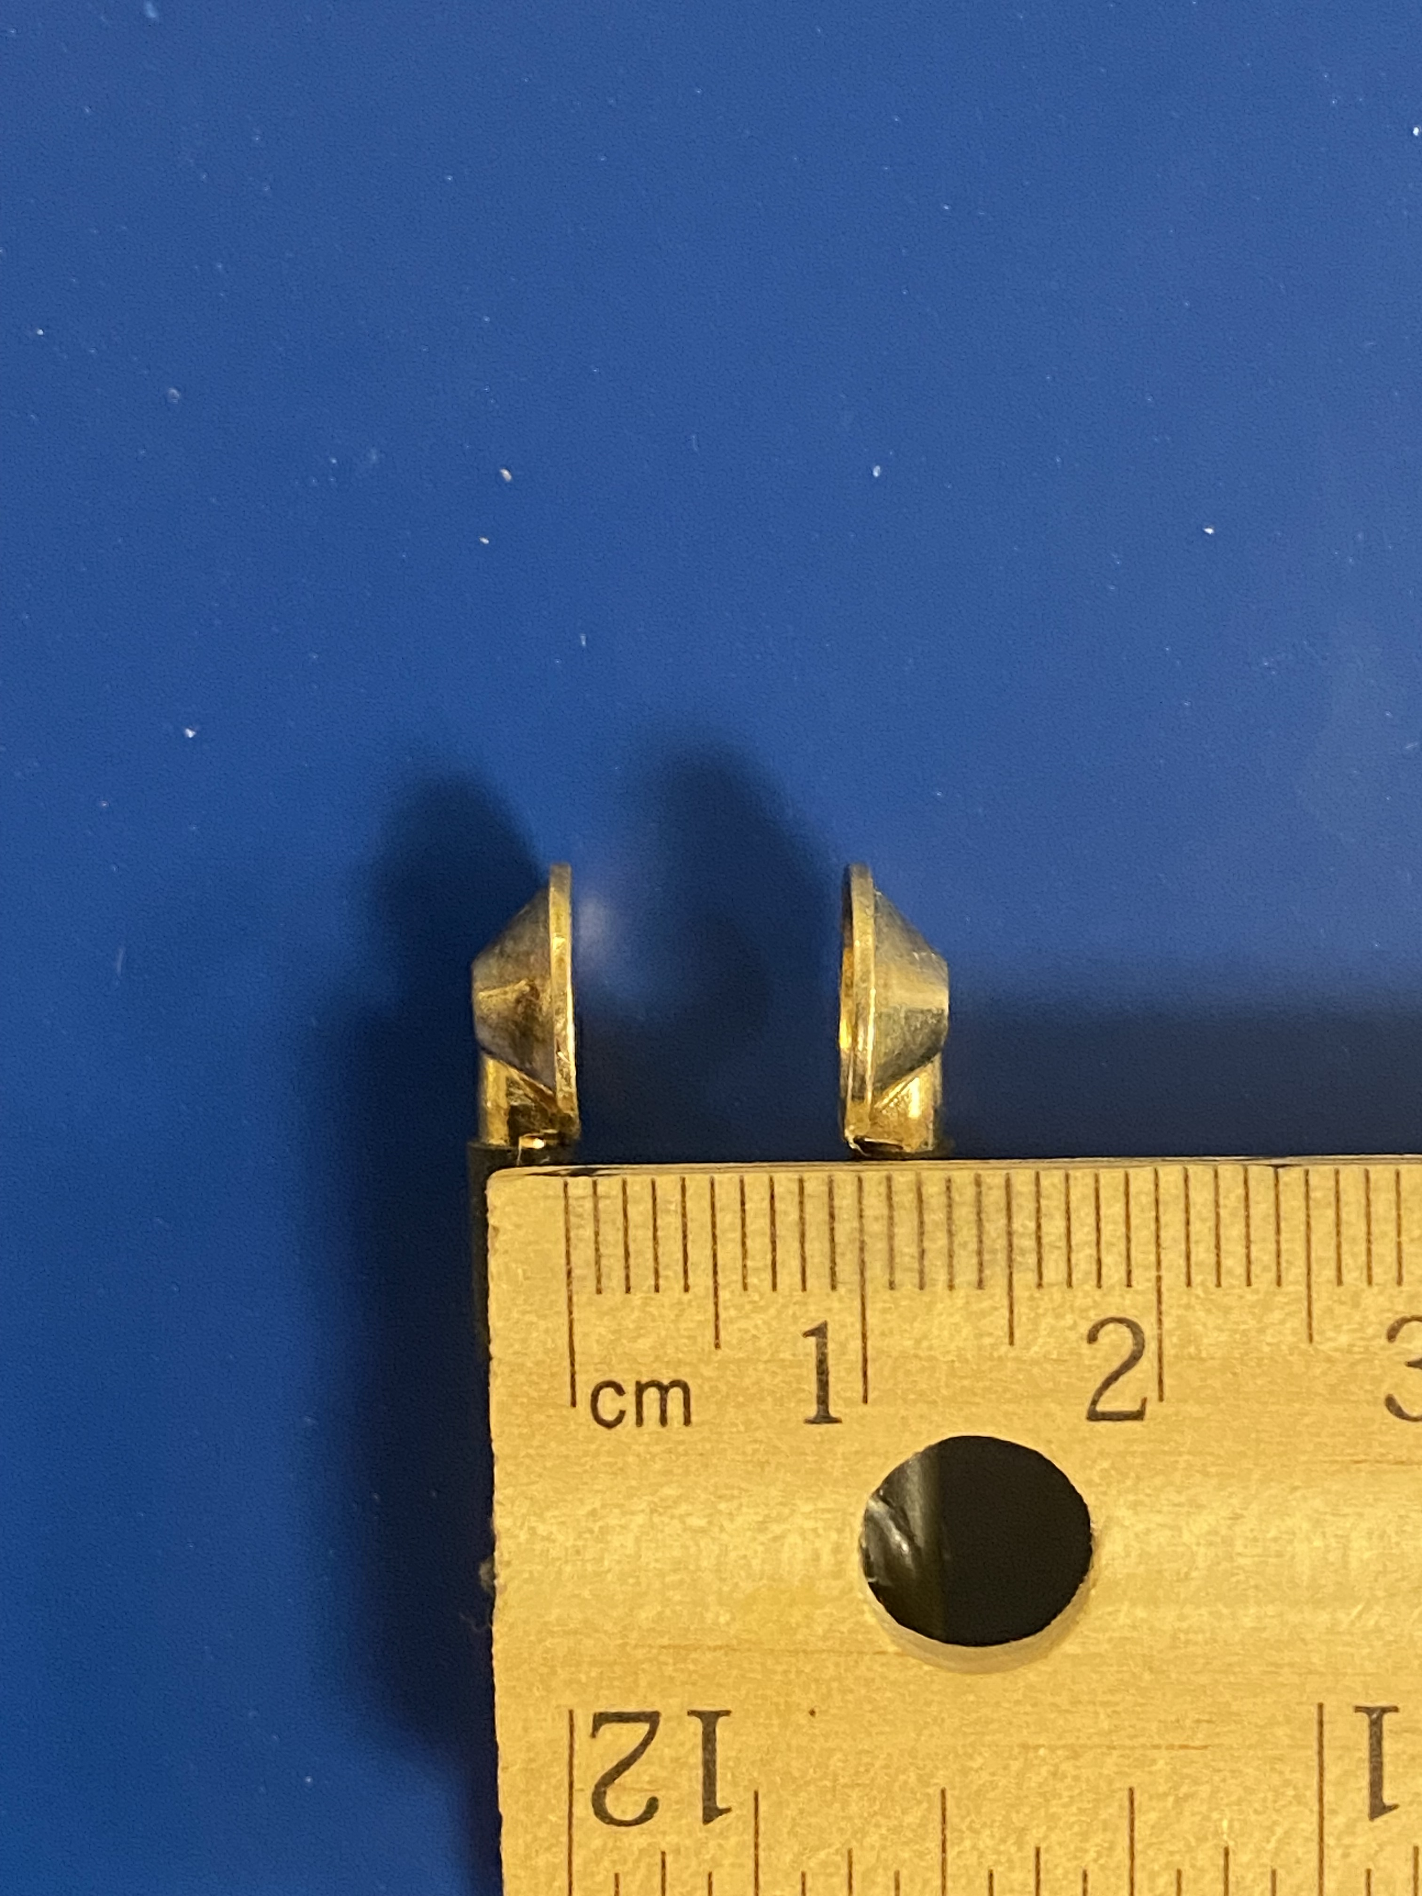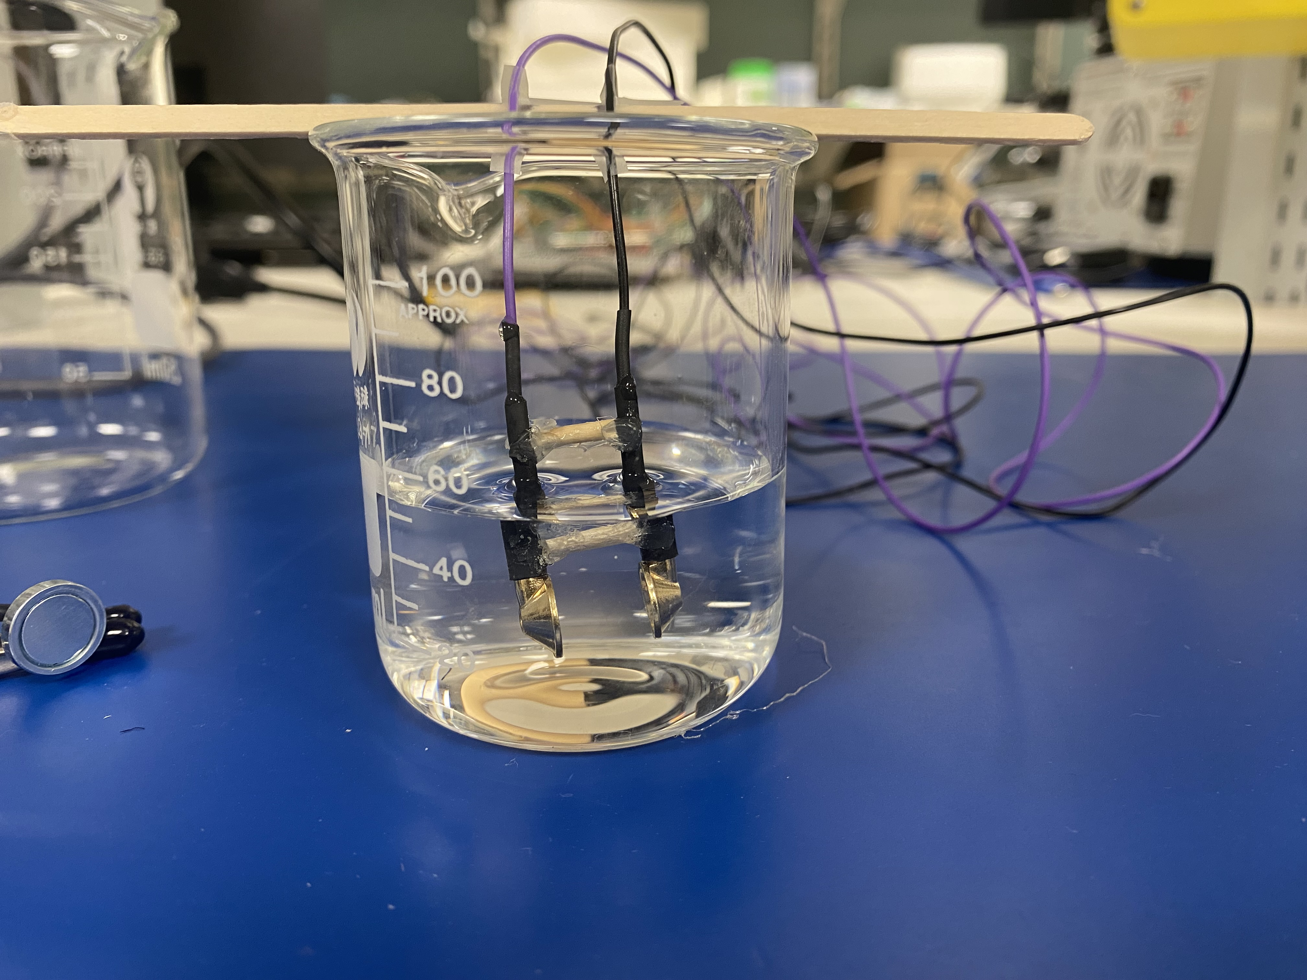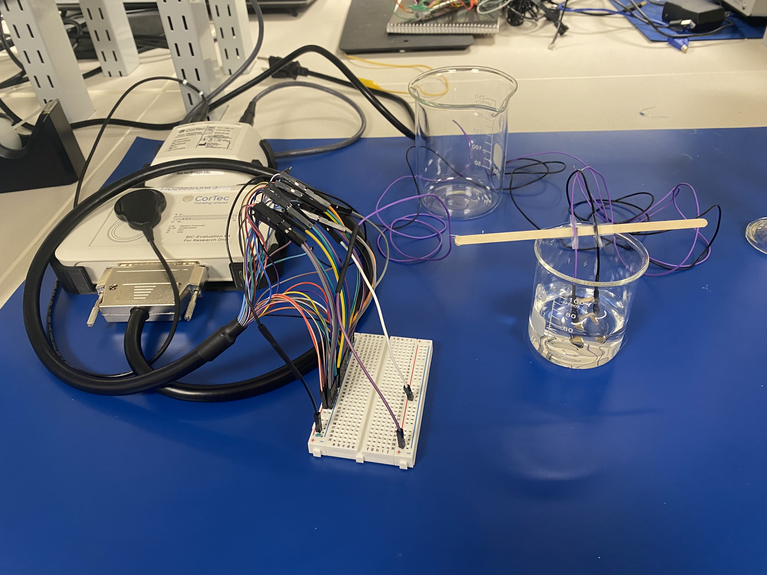
- Allow a consistent initial equilibration period (recommended: 2 minutes). Record temperature and, if available, conductivity.
- Acquire 20-50 repeated BIC impedance measurements. Record every individual value and status; do not retain only the mean.
- After the final replicate at the current concentration, mix the bath thoroughly. Remove exactly 20.0 mL of the well-mixed solution.
- Add exactly 20.0 mL distilled/deionized water, returning the bath to 50.0 mL and mix thoroughly.
- Acquire the next set of 20-50 BIC impedance measurements.
- Repeat the 20 mL removal/replacement cycle. If an invalid or over-range condition occurs, verify connections, electrode position, bath volume, and mixing, then repeat without changing the geometry.

