Elone_Agent Architecture & Technical Specification
Comprehensive End-to-End System Documentation & Flowchart Guide | Multi-Agent L1 Support Automation
📌 SYSTEM OVERVIEW: Elone_Agent is a deterministic multi-agent IT automation system engineered on top of LangGraph, FastAPI, and Open Knowledge Framework (OKF) disk-based stores. It features dynamic LLM provider fallback routing (Mistral Small, Gemini 2.5 Flash, Groq GPT-OSS), zero-network-overhead local subprocess execution, cross-SOP referral swapping, human-in-the-loop (HITL) approval gates, and multi-tier summarization resilience.

1. High-Level System Architecture & Execution Lifecycle
The Elone_Agent ecosystem automates Level-1 (L1) helpdesk and IT support operations by ingesting standard operating procedures (SOPs), triaging user requests, dynamically binding execution parameters, running deterministic CLI commands and enterprise API tools, and generating comprehensive reports. The high-level lifecycle transitions through 8 distinct stages:
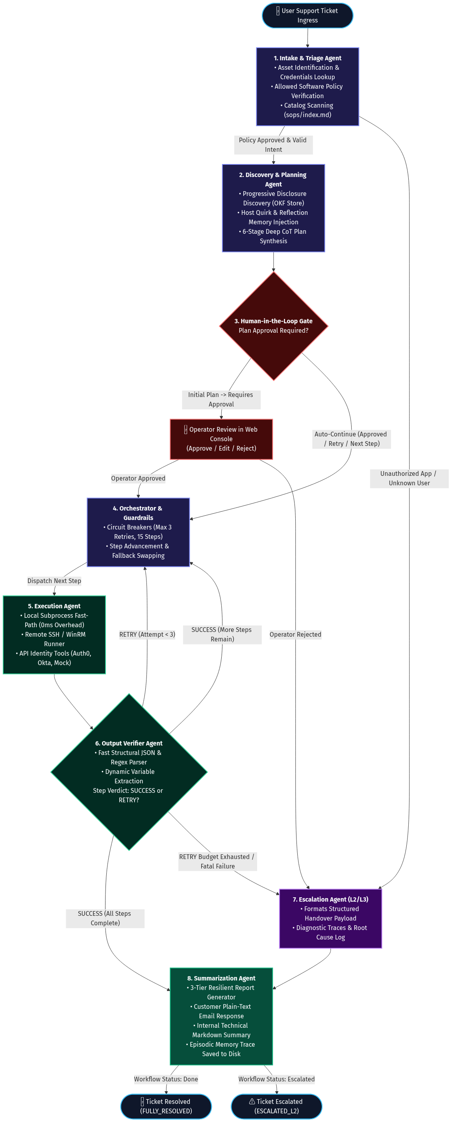
Figure 1.1: End-to-End High-Level System Lifecycle & Agent Coordination Flowchart
Stage | Module / Agent | Core Responsibility | Primary Technologies
1. Ingestion | ingestion_pipe/scheduler.py | Continuous SOP conversion & master catalog updating | SharePoint, PyMuPDF, OKF Engine
2. Ingress & Stream | server.py & frontend/ | FastAPI REST API & live SSE background streaming | FastAPI, Server-Sent Events, SPA UI
3. Intake & Triage | agents/intake/ | Asset credential lookup & security policy check | Pandas/CSV, Mistral Small, Gemini
4. Planning & CoT | agents/planner/ | Progressive disclosure discovery, reflection lookup & 6-Stage Deep CoT | OKF Knowledge Base, Jinja Binding
5. HITL Gate | graph.py & server.py | Pre-execution operator review & seamless auto-continue | LangGraph interrupt_before
6. Execution | agents/execution/ | Local fast-path, Remote SSH/WinRM, & API Tools | Subprocess, Paramiko, PyWinRM, Auth0/Okta
7. Result Verifier | agents/execution_result/ | Fast JSON parsing, regex extraction & variable binding | Regex, LLM Chain-of-Thought
8. Summarization | agents/summarization/ | Customer resolution email & engineering markdown log | Pydantic, Gemini Flash, Episodic Memory

2. SOP Ingestion & Knowledge Base Pipeline
To eliminate manual playbook engineering, the ingestion engine monitors enterprise repositories (SharePoint / Shared Documents and local upload directories) for raw procedure documents (.docx, .pdf, .txt, .xlsx, .pptx). It automatically transforms raw procedures into standardized Open Knowledge Framework (OKF) playbooks and updates the master catalog index (knowledge_base/sops/index.md).
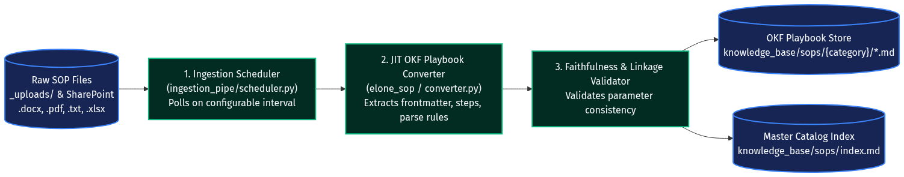
Figure 2.1: SOP Ingestion, Markdown Standardization & Catalog Indexing Pipeline
📌 OKF PLAYBOOK ARCHITECTURE: OKF playbooks feature frontmatter metadata (sop_id, title, category, required_entities) and structured markdown steps containing executable shell commands, API tool calls, timeout specifications, execute_if preconditions, and output_parse_instructions.

OKF Field | Type | Description | Example Value
sop_id | String | Unique deterministic SOP identifier | SOP-L1-APP-001
step_type | Enum | Execution protocol: command, tool_call, communication | command
command | String | Deterministic shell command with Jinja placeholders | tasklist | findstr /I {executable}
execute_if | String | Dynamic runtime precondition evaluated before execution | variables.app_running == true
parse_instruction | String | Rule governing variable extraction & success verdict | If stdout contains 'Code.exe', set variables.app_running = true

3. FastAPI Server & Event Streaming Engine
The application layer exposes a modern asynchronous REST API powered by FastAPI and a real-time web console. Execution runs within isolated background worker threads (Run instances), decoupling graph processing from HTTP request handlers.
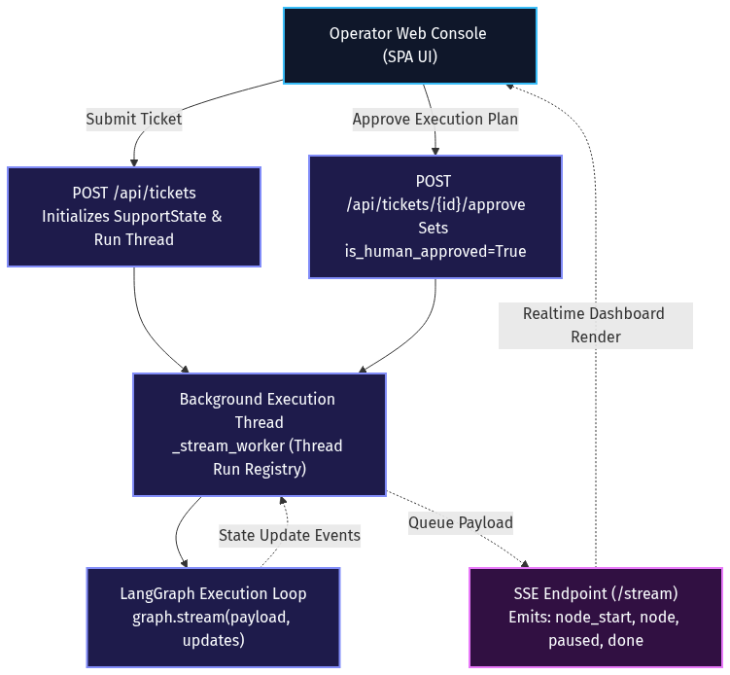
Figure 3.1: FastAPI Background Thread Run Registry & SSE Event Streaming
Endpoint | Method | Purpose | Response Schema
/api/tickets | POST | Submit ticket and launch async graph execution thread | {"thread_id": "AGT-xxx", "done": false}
/api/tickets/{id}/stream | GET | Real-time Server-Sent Events (SSE) telemetry stream | Event stream (node_start, node, paused, done)
/api/tickets/{id}/approve | POST | Human operator approval of synthesized execution plan | {"is_human_approved": true, "thread_id": ...}
/api/tickets/{id}/reject | POST | Human operator rejection with escalation reason | {"workflow_status": "escalated", ...}
/api/tickets/{id}/clarify | POST | Submit clarification answers for ambiguous tickets | {"user_response": "...", "workflow_status": ...}

4. Intake & Triage Agent Node
The Intake Agent (agents/intake/node.py) serves as the security and classification gatekeeper for the system. Upon receiving raw ticket input, it cross-references identity records in Asset Management - Sheet1.csv, validates software against Allowed_Applications.csv, and performs catalog matching against sops/index.md.
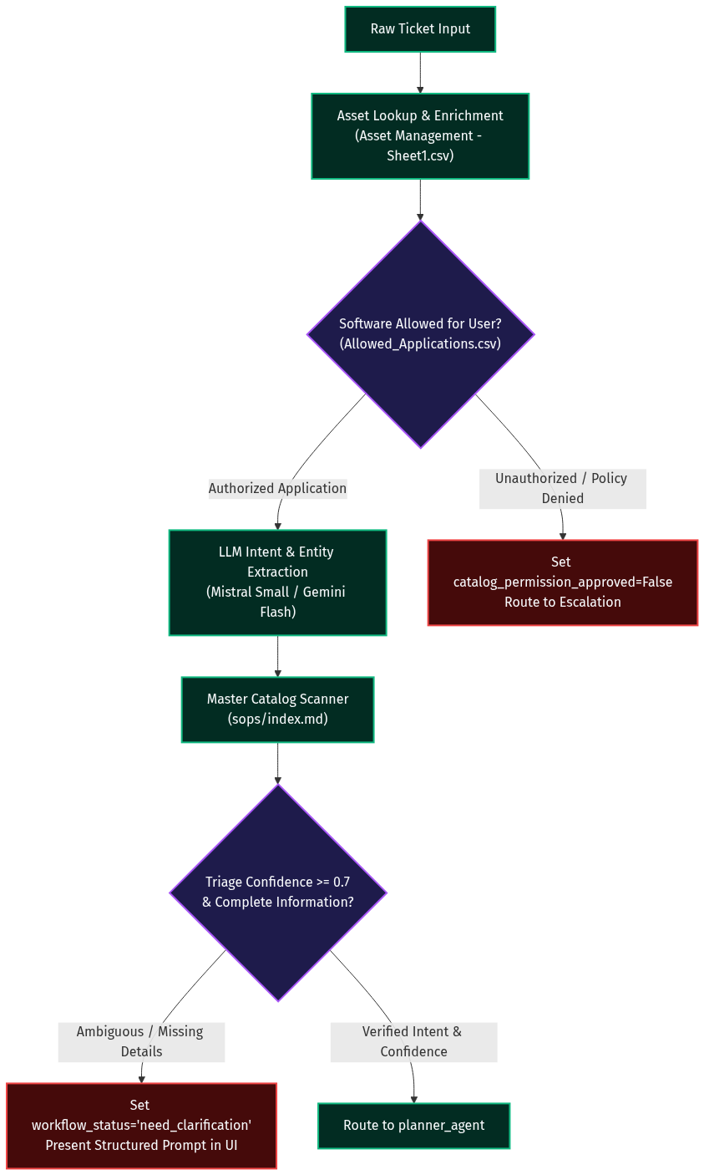
Figure 4.1: Intake Asset Lookup, Policy Enforcement & LLM Triage Decision Tree
📌 POLICY COMPLIANCE GATE: Security Guardrail: If an employee requests an unapproved application (cross-referenced with Allowed_Applications.csv) or if the caller's email cannot be found in Asset Management - Sheet1.csv, the agent sets catalog_permission_approved=False and immediately flags the ticket for L2 escalation without running arbitrary commands.

5. Unified Planner & Discovery Agent Node
The Planner Agent (agents/planner/node.py) constructs an executable, host-tailored plan from the retrieved OKF playbook. It leverages progressive disclosure discovery across category index files and global OKF markdown traversal, integrates host reflection memory (patterns/hosts/{hostname}.md), and performs 6-Stage Deep CoT placeholder binding.
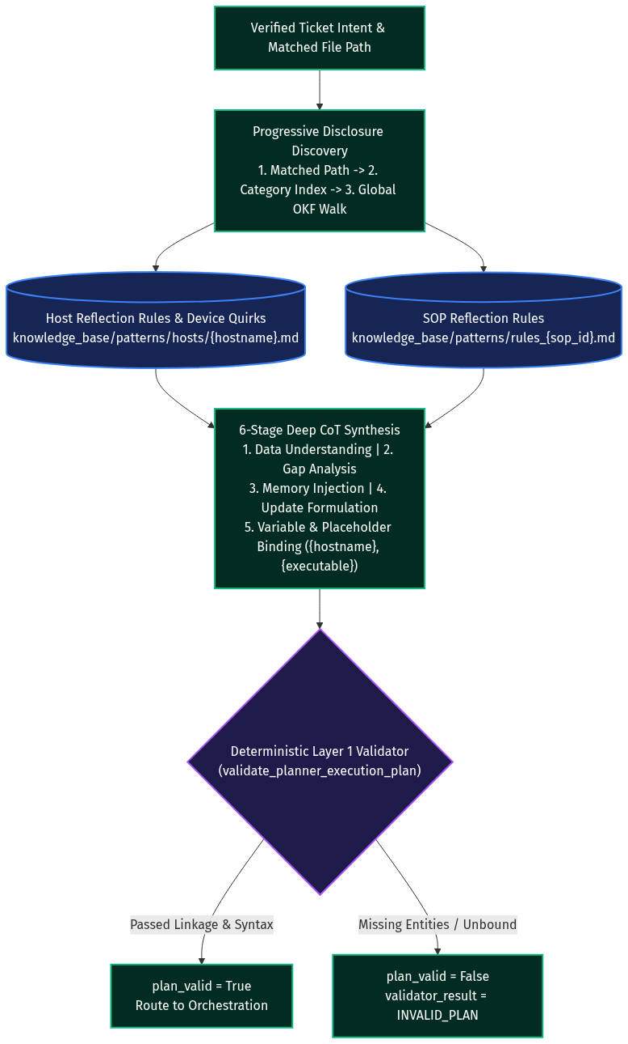
Figure 5.1: Progressive Disclosure Discovery & 6-Stage Deep CoT Assembly
Stage | Name | CoT Analysis Focus
Stage 1 | Data Understanding | Analyzes ticket intent, category, and target environment (Windows/Linux).
Stage 2 | Gap & Delta Analysis | Identifies required placeholders ({entities.hostname}, {entities.executable}).
Stage 3 | Memory Pattern Analysis | Retrieves host-specific quirks and verified recovery rules from patterns/hosts/.
Stage 4 | Update Formulation | Adjusts timeouts, step descriptions, and error detection rules.
Stage 5 | Final Verification | Deterministic Python validation of syntax and entity linkage before execution.

6. Orchestration Agent & Circuit Breakers
Acting as the central traffic controller, the Orchestration Agent (agents/orchestration/node.py) enforces strict circuit breakers, handles step-level retries with fallback swapping, advances steps on SUCCESS, and triggers cross-SOP referrals.
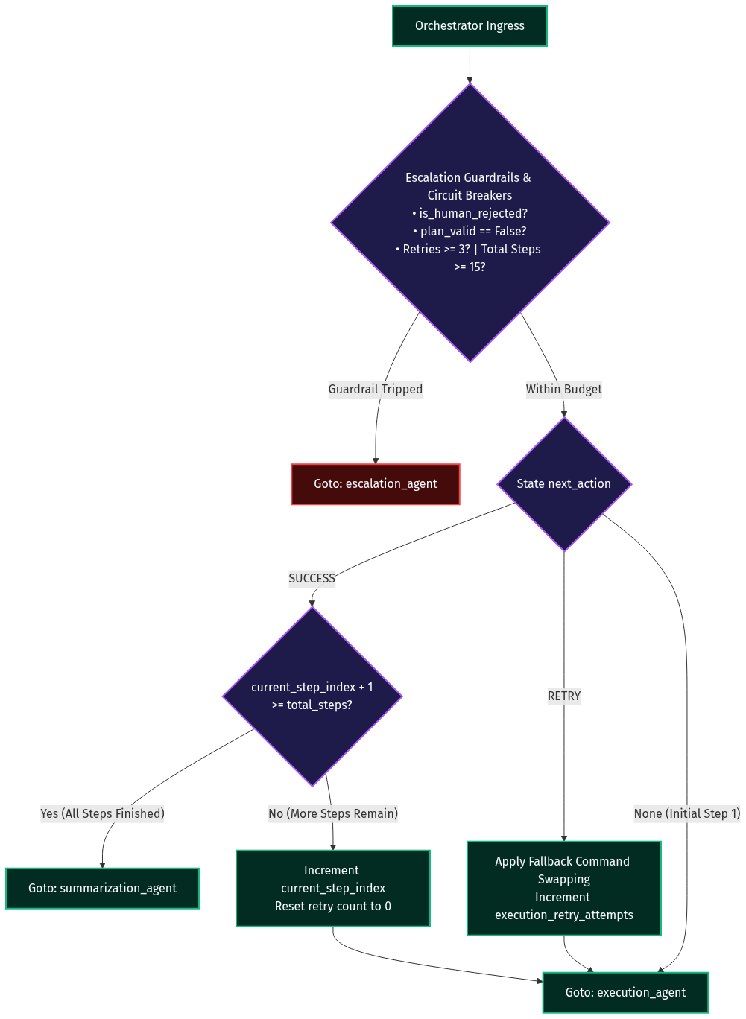
Figure 6.1: Orchestration State Machine & Circuit Breaker Guardrails
📌 CIRCUIT BREAKER SPECIFICATION: Circuit Breaker Guardrails: (1) Step Retry Limit: A step is permitted a maximum of 3 retries before escalation. (2) Execution Budget: A ticket cannot exceed 15 total step executions. (3) Deterministic Swapping: On retry, the orchestrator automatically substitutes fallback_command into the execution plan.

7. Execution Agent & Multi-Protocol Command Runner
The Execution Agent (agents/execution/node.py) deterministically executes commands and API tools across local workstations and remote endpoints. It features intelligent protocol routing and elevation detection.
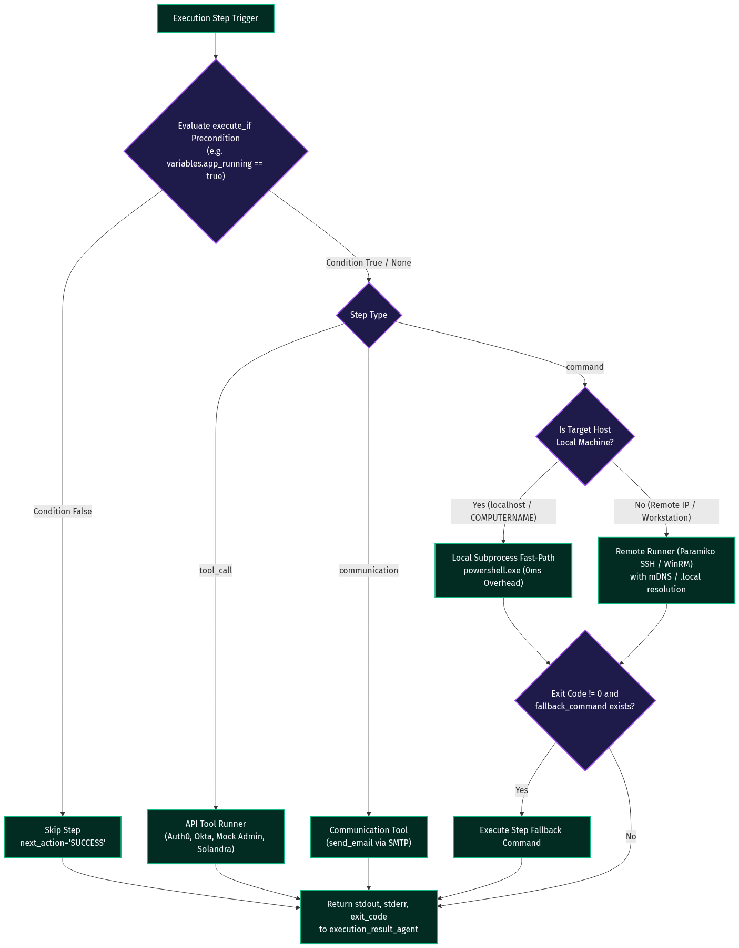
Figure 7.1: Multi-Protocol Command Runner (Local Fast-Path vs Remote SSH/WinRM vs API)
Target Destination | Protocol / Mechanism | Latency / Performance | Features
Local Machine (matches COMPUTERNAME) | Native subprocess.run | 0ms Network Overhead | Runs native powershell.exe with scheduled task elevation for system tools
Remote Windows/Linux Workstation | Paramiko SSH (Port 22) | Standard Network RTT | Automatic mDNS (.local) resolution and credential authentication
Remote Windows Lab Workstation | PyWinRM HTTP (Port 5985) | Standard Network RTT | NTLM / Basic authentication support with UTF-8 encoding configuration
Identity & Cloud Tools | REST API Client | < 100ms API Latency | Auth0, Okta, Mock Admin Console, and Solandra API integrations

8. Execution Result Verifier & Variable Extractor
The Execution Result Agent (agents/execution_result/node.py) analyzes execution output (stdout, stderr, exit code). It dynamically extracts runtime variables and evaluates conditional parse instructions.
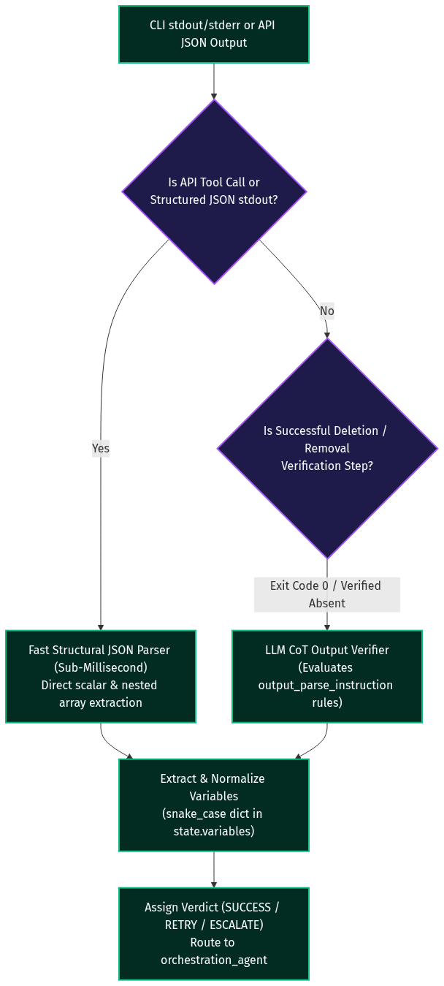
Figure 8.1: Fast Structural JSON Parsing & LLM Output Analysis Pipeline
📌 HYBRID EXTRACTION ARCHITECTURE: Hybrid Verification Architecture: For API JSON responses, structural dictionary lookups complete in < 1ms with 0 token cost. For complex CLI output with conditional parse rules, a Chain-of-Thought LLM analysis extracts snake_case state variables (e.g., PIDs, IPs, status flags) and determines the next_action verdict (SUCCESS, RETRY, or ESCALATE).

9. Escalation & 3-Tier Summarization Agents
The terminal phase of the workflow synthesizes user communication and engineering reports while updating episodic memory on disk.
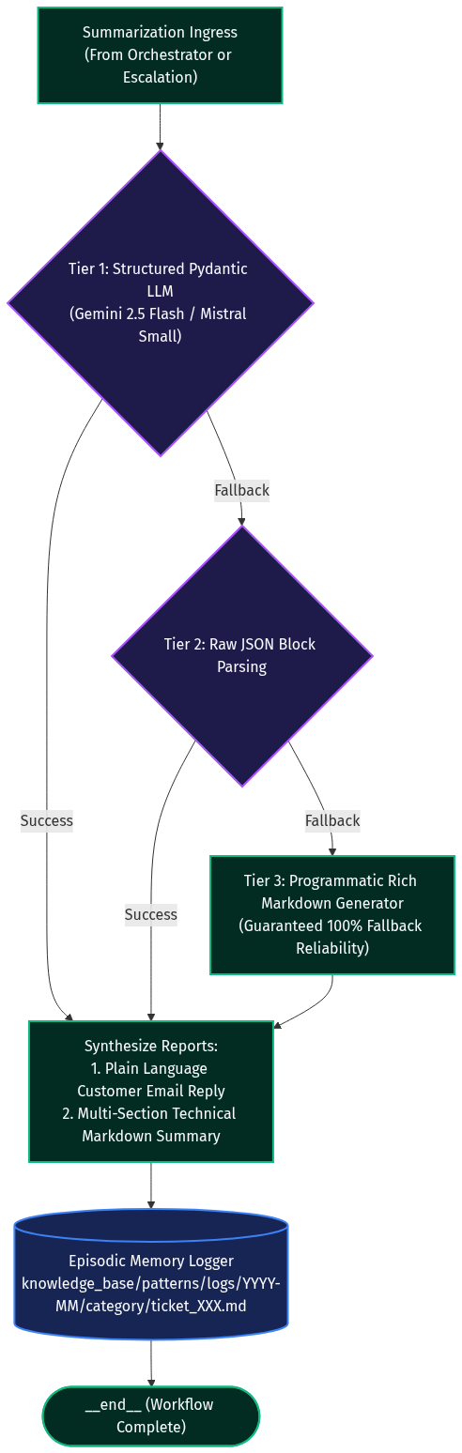
Figure 9.1: 3-Tier Resilient Summarization & Episodic Memory Logging
Summarization Tier | Mechanism | Resilience & Fallback Behavior
Tier 1: Structured Pydantic LLM | ChatGoogleGenerativeAI (Gemini 2.5 Flash) | Direct schema-enforced output generating customer reply and engineering markdown.
Tier 2: Raw JSON Parsing | Fallback LLM Invoke | Extracts JSON blocks using regular expressions if structured schema binding fails.
Tier 3: Programmatic Fallback | Deterministic Python Generator | 100% reliable programmatic fallback that guarantees a formatted customer email and technical report.

10. SupportState Schema & Data Contracts
The LangGraph workflow communicates through a centralized SupportState dictionary defined in shared/state.py. Key state fields across all agent nodes include:
State Key | Type | Scope | Description
ticket_raw | String | Global | Raw incoming customer problem statement.
entities | Dict[str, str] | Global | Extracted entities (email, hostname, executable, username).
variables | Dict[str, Any] | Dynamic | Runtime variables extracted by execution_result_agent.
execution_plan | Dict[str, Any] | Planner | Bound execution steps with commands and parse rules.
current_step_index | Integer | Orchestrator | 0-based index of the currently executing plan step.
execution_retry_attempts | Integer | Orchestrator | Active retry count for current step (max 3).
is_human_approved | Boolean | HITL | Tracks operator plan approval across graph iterations.
workflow_status | String | Global | Lifecycle status: pending, in_progress, completed, escalated, need_clarification.
customer_ticket_reply | String | Summarizer | Plain-language resolution email sent to end user.
internal_ticket_summary | String | Summarizer | Comprehensive Markdown engineering diagnostic report.

