Elone Agent — Complete System Documentation
Autonomous L1 IT Ingestion, Multimodal Splicing, JIT Playbook Compilation & Dual-Layer Guardrails
System Architecture: | Elone Autonomous Knowledge-to-Execution Engine
Core Capabilities: | Multimodal SOP Ingestion, 6-Stage CoT Reasoning, AST & LLM Validation, OWASP LLM10
Supported Formats: | PDF, DOCX, CSV, Excel, TXT, Markdown, Embedded UI Screenshots, Web URLs
Target Output: | Open Knowledge Format (OKF) Executable PowerShell & API Playbooks

Executive Architecture & Master End-to-End Flowchart
The Elone Agent is an enterprise-grade autonomous IT automation system. It bridges the gap between unstructured, human-authored Standard Operating Procedures (SOPs) and deterministic, executable PowerShell commands and REST API tool calls. The pipeline is divided into five rigorous phases: Pre-Ingestion Guardrails, Document-Order Multimodal Extraction, JIT 6-Stage CoT Playbook Compilation, Dual-Layer Validation with Auto-Retry, and Cryptographic Storage.

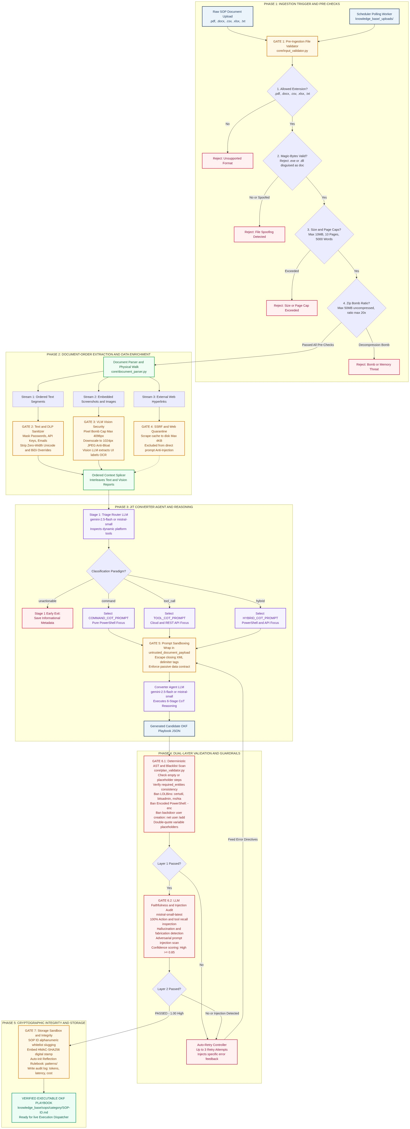
Figure 1: Master 5-Phase End-to-End Ingestion, Validation & Storage Flowchart

1. Ingestion Trigger & Multimodal Document-Order Parsing
Ingestion begins either via the background polling scheduler (scheduler.py) watching knowledge_base/_uploads/ or direct CLI invocation. Before any parsing occurs, Gate 1 enforces anti-spoofing magic-byte checks (%PDF-, PK Zip Header), hard size limits (<=10MB), decompression bomb limits (<=50MB uncompressed, <=20x ratio), and page quotas (<=10 pages). Once verified, the document is walked in its physical reading sequence so inline screenshots remain anchored directly to their corresponding text steps.

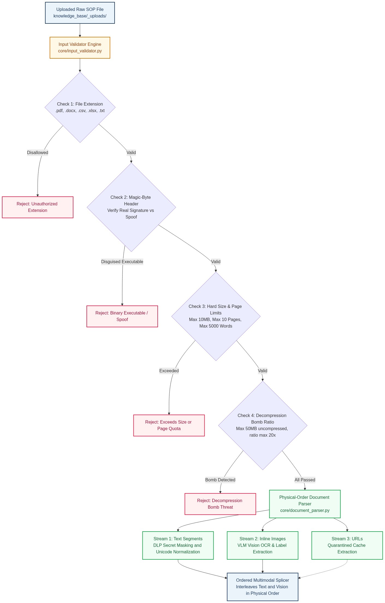
Figure 2: Section 1 — Pre-Ingestion File Checks & Multimodal Splicing Flow

2. JIT Converter Agent & 6-Stage Command CoT Reasoning
In Stage 1, the Triage Router probes available platform tools (list_available_platforms, get_platform_tools) to classify the document into COMMAND (pure PowerShell), TOOL_CALL (REST APIs), HYBRID, or UNACTIONABLE. In Stage 2, the Converter Agent wraps the text in an untrusted sandbox envelope (<untrusted_document_payload>) and enforces the 6-Stage Command Chain-of-Thought (CoT) Reasoning Mandate:
- Stage 1 (OS & Shell): Set target_os: windows, platform: system, and shell: powershell for every command step.
- Stage 2 (Diagnostic-First): Place non-destructive connectivity and query checks (Test-Connection, reg query) before destructive actions (reg delete, taskkill).
- Stage 3 (Entity Scoping): Harmonize dynamic ticket variables using double-brace placeholders ({{entities.hostname}}, {{entities.application}}).
- Stage 4 (stdout Parsing): Define deterministic stdout parsing rules in parse_instruction (e.g. set variables.ifeo_blocked = true).
- Stage 5 (Conditional Remediation): Bind execute_if to prior variables and declare fallback_command strings for resilient execution.
- Stage 6 (Noise Omission): Discard GUI setup instructions ('Open Command Prompt') and manual human checks to ensure 100% autonomous execution.

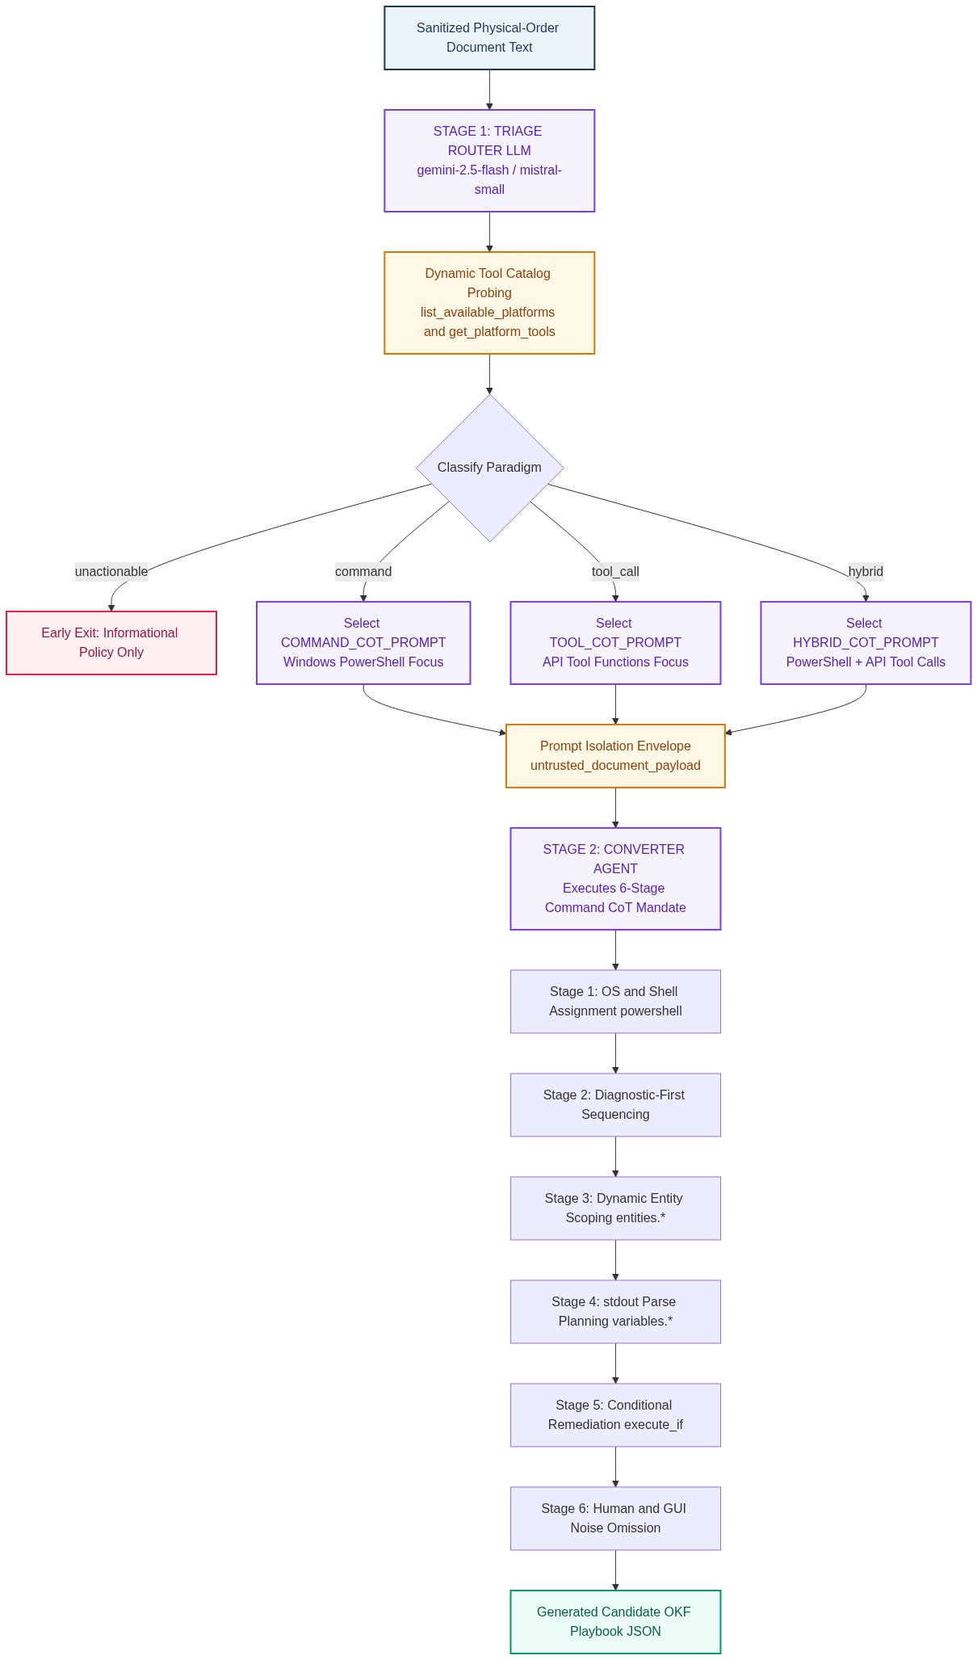
Figure 3: Section 2 — Triage Classification & 6-Stage Command CoT Synthesis

3. Dual-Layer Plan Validation & Self-Healing Guardrails
To guarantee zero execution errors and absolute safety on endpoints, candidate playbooks undergo dual-layer validation. Layer 1 executes in < 1ms using deterministic Python AST checks, enforcing entity quotation wrapping and blocking banned LOLBins (certutil, bitsadmin, mshta, powershell -enc, net user /add). Layer 2 utilizes Mistral Small 3 to perform an independent 6-point CoT faithfulness and prompt injection audit. If validation fails, the Auto-Retry Controller feeds surgical error directives back to the Converter Agent for automatic self-healing (up to 3 attempts).

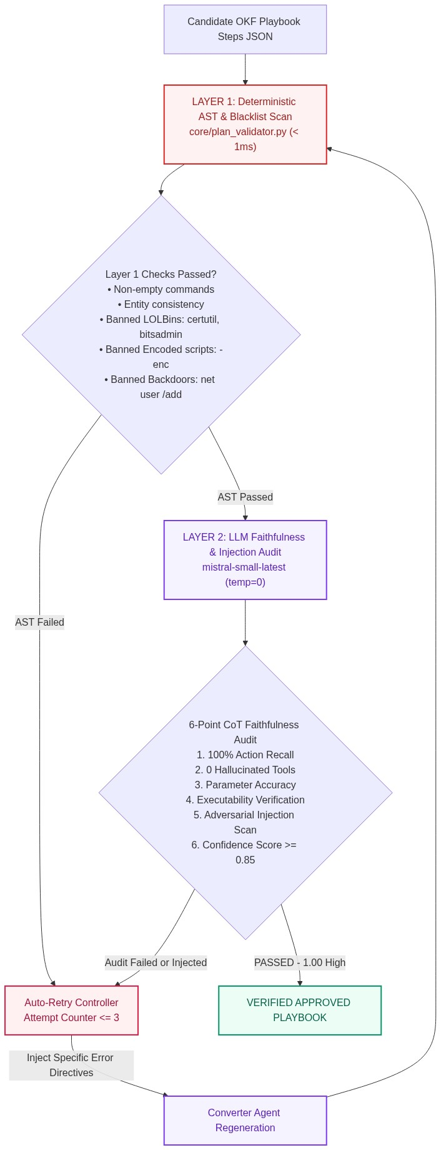
Figure 4: Section 3 — Dual-Layer Validation Gates & Auto-Retry Loop

4. OKF Playbook Specification, Cryptographic Signatures & Adaptive Memory
Approved playbooks are saved as Open Knowledge Format (OKF) markdown documents (knowledge_base/sops/{category}/{SOP-ID}.md). SOP IDs are sanitized to prevent directory traversal. To prevent post-approval disk tampering, a cryptographic HMAC-SHA256 digital stamp is embedded into the frontmatter. Concurrently, an adaptive Reflection Rulebook (knowledge_base/patterns/{category}/rules_{SOP-ID}.md) is auto-initialized to dynamically record runtime execution errors and corrective actions.

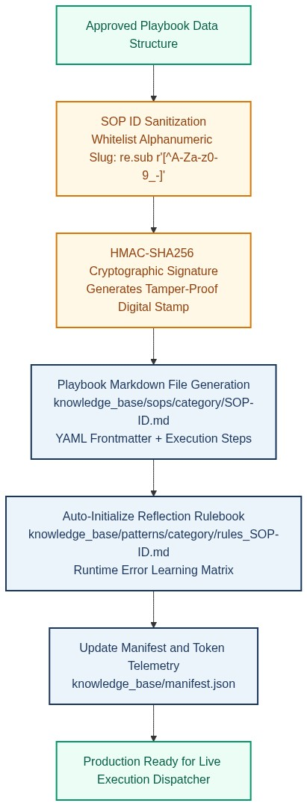
Figure 5: Section 4 — Storage Sandboxing, HMAC Signing & Reflection Rulebooks

5. Multi-Provider LLM Orchestration & Telemetry
The pipeline optimizes latency, cost, and reliability across distinct LLM roles: Gemini 2.5 Flash for planning and conversion, Mistral Small 3 for high-speed Layer 2 validation (~2.3s latency), and NVIDIA Vision for screenshot OCR. The integrated gemini_monitor tracks token consumption, latency, and daily budget limits on every execution.

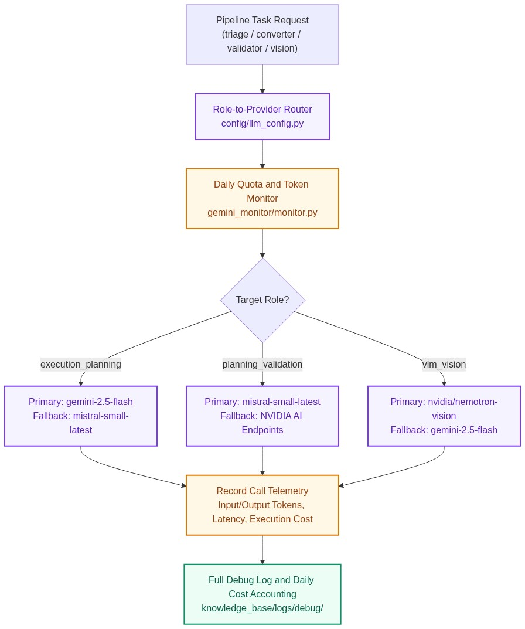
Figure 6: Section 5 — Multi-Model Role Routing, Quota Monitoring & Telemetry

6. Comprehensive Security, PII Protection & OWASP LLM 10 Compliance
Security is enforced at every layer of the architecture, satisfying all requirements of the OWASP Top 10 for LLM Applications (LLM01 Prompt Injection, LLM02 Sensitive Information Disclosure, LLM05 Improper Output Handling, LLM10 Unbounded Consumption). Real-time DLP redacts passwords, employee PII, and API tokens before AI transmission, while SSRF guards block internal cloud metadata IPs.

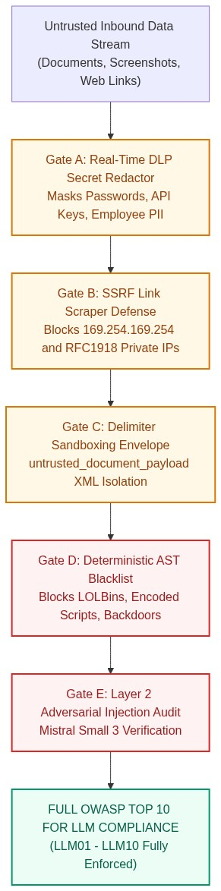
Figure 7: Section 6 — End-to-End Security Interceptors & DLP Quarantine

