SOP Ingestion Pipeline — Low-Level Architecture Flowchart
Complete End-to-End Decision Flow, Security Gates, Retry Loops & Validation Lifecycle
Diagram Type: | Interactive Mermaid Architectural Flowchart (High-Resolution Vector Render)
Lifecycle Scope: | Pre-Ingestion → Multimodal Parsing → Triage → JIT Conversion → Dual Validation → Storage
Interactive Viewer: | Open INGESTION_PIPELINE_INTERACTIVE_FLOWCHART.html for Full Pan & Zoom in Browser

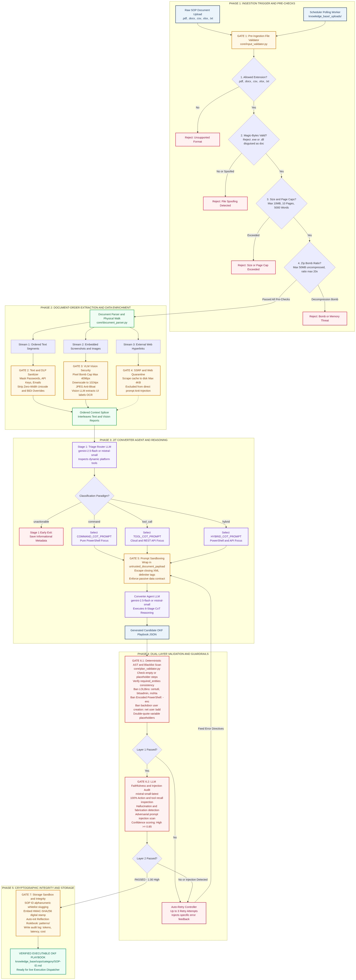
Figure 1: Complete Ingestion Pipeline Flowchart (Pre-Checks, Splicer, Reasoning, Guardrails & Retry Loops)

