Reset a Locked-Out User's Password via CoreID Admin Console
L1 Escalation Runbook — Solandra Corp IT Support
sop_id | SOL-PWD-RESET-L1-002
resolution_type | escalate_only
audience | L1 Support Agent (authorized admin)
required_role | CoreID: Password Reset Admin
org | Solandra Corp
application | CoreID Admin Console (mock)

Purpose
When a user's self-service password reset fails or the user has no working verification channel, the ticket escalates to L1. An authorized L1 agent with the Password Reset Admin role in CoreID resets the password directly from the admin console.
Because the agent's own CoreID session is already MFA-authenticated and role-gated, this flow does not send a one-time verification code to the user. That code-based check exists to authenticate an otherwise-unverified self-service claimant; an admin acting under an authenticated, role-scoped session establishes identity through the caller checklist instead (Step 3).

Procedure

Inputs
- Open ticket with the requester's employee ID and manager name on file
- Your own authenticated CoreID session with the Password Reset Admin role assigned
- Caller identity verification checklist (minimum 2 of 4 items matched)

Steps
Step 1: Ticket reviewed
Navigation: Ticketing system → open ticket → Requester Details panel
Confirm the ticket category reads Password Reset — Escalated, and note the requester's employee ID and manager name. ⚠️ Do not proceed if the ticket is missing a manager name — request it from the requester first.
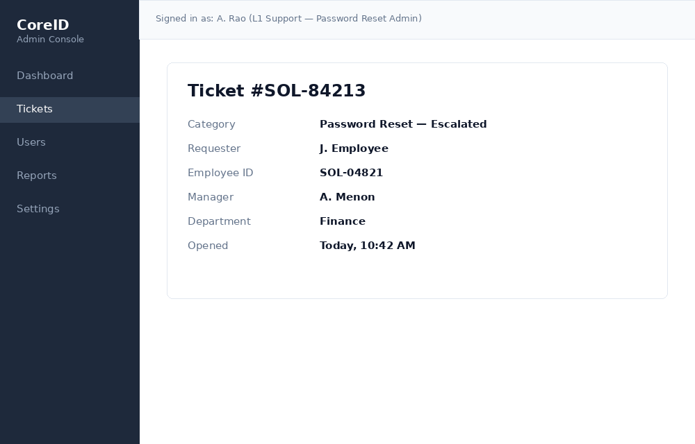
Step 2: User located and lock confirmed
Navigation: CoreID Admin Console → Users → Search bar
Search by employee ID. Confirm the account status badge shows Locked before continuing — do not reset a password on an account that isn't actually locked without further checks.
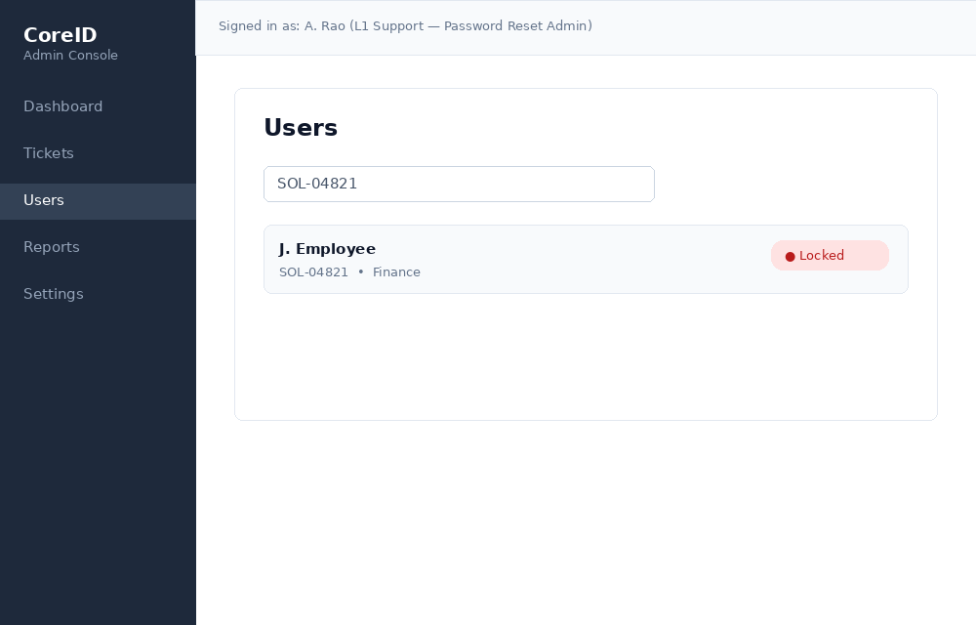
Step 3: Caller identity verified
Navigation: CoreID Admin Console → user profile → Identity Verification panel
Ask the caller for at least 2 of: employee ID, manager's name, department, or last 4 digits of the phone on file. ✅ Do not send a one-time code to the user — your own admin session already satisfies the authentication requirement; this checklist is what verifies the caller is who they claim to be. If fewer than 2 items match, stop and escalate to your team lead rather than proceeding.
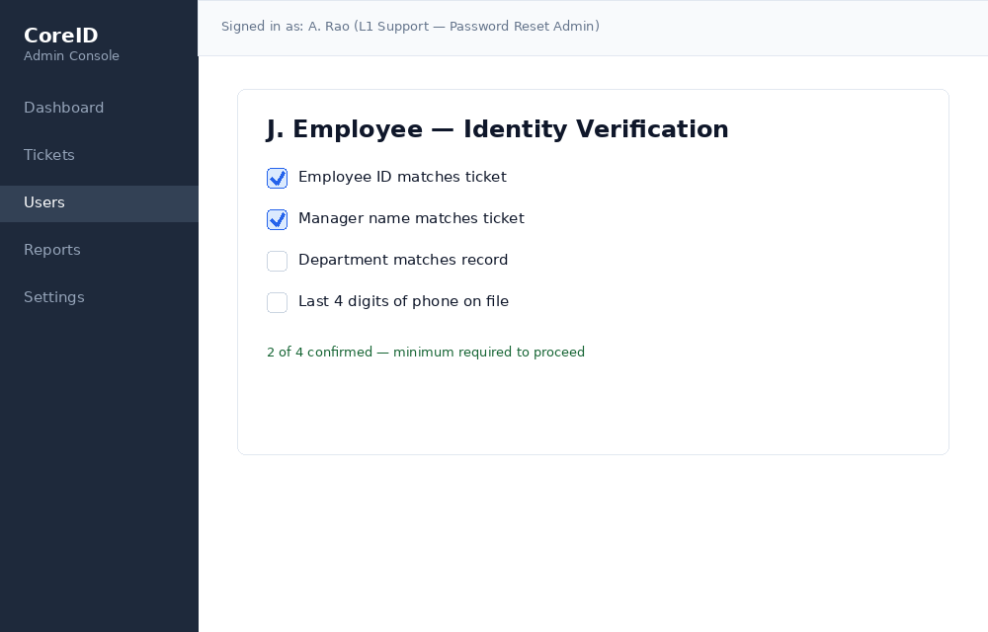
Step 4: Temporary password issued
Navigation: CoreID Admin Console → user profile → Reset Password
Select Generate Temporary Password. Leave Force change at next sign-in checked — this is the default and it must not be disabled.
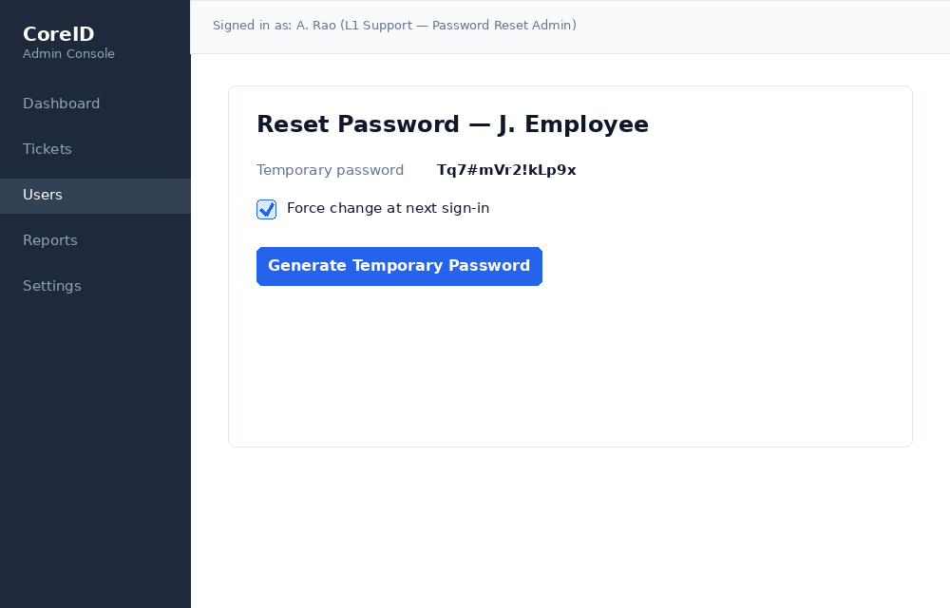
Step 5: Temporary password relayed securely
Navigation: Phone / voice channel — not logged in CoreID
Read the temporary password to the caller verbally over the verified phone line. Never send it by email, chat, or ticket comment in plain text. See CISA's guidance on requiring strong passwords for the reasoning behind credential-handling policy.
Step 6: Ticket resolved with audit note
Navigation: Ticketing system → ticket → Resolution notes
Log what was done (identity checks matched, temporary password issued, force-change enabled) and set the ticket to Resolved. This note is what satisfies the audit trail requirement — an admin-mediated reset with no note is a compliance gap.
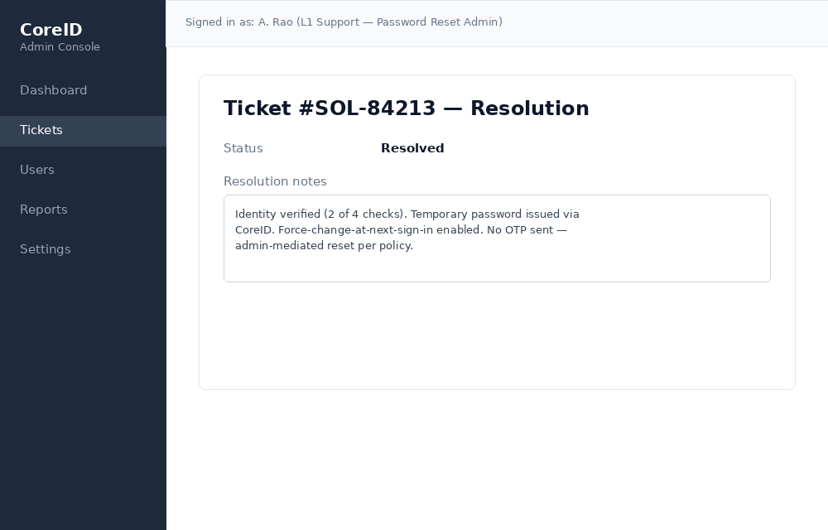

Outputs
- User account unlocked with a valid temporary password
- Force-change-at-next-sign-in flag enabled
- Ticket resolved with an audit note logged

FAQs
Q: What if the caller can't confirm at least 2 of the 4 identity items?
Do not issue a reset. Escalate to your team lead, or ask the requester to retry self-service once they regain access to a verified phone or email.
Q: Why doesn't this flow send a verification code the way self-service does?
The self-service code exists to authenticate an anonymous claimant with no other proof of identity. Here, identity is established two ways at once: your own CoreID session is already MFA-authenticated and scoped to the Password Reset Admin role, and the caller checklist independently confirms the requester is who they claim to be. Adding a code on top of that verifies nothing new — it would just be an unnecessary step to a channel the caller may not have working anyway, which is usually why the ticket was escalated in the first place.

