Reset Your Password via the Self-Service Portal

Purpose
Employees who forget their password can restore access in minutes through the self-service portal, without opening a helpdesk ticket.
Skipping the portal and calling the helpdesk directly adds ticket volume and delays access longer than the self-service flow.

Procedure

Inputs
- Company email address or employee ID
- Access to your registered mobile phone or backup email, for the verification code
- A modern web browser (Chrome, Edge, or Safari)

Steps
Step 1: Sign-in page opened
Navigation: Browser address bar → passwordreset.corp.example.com
Enter your company email address in the box, then select Next. ➡️ Trouble signing in? See the IT Help Center.
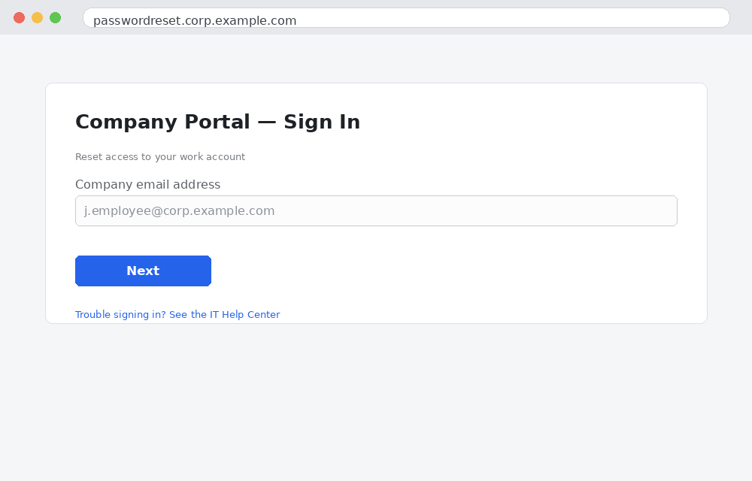
Step 2: Identity verified
Navigation: Verify Your Identity screen → Send code button
Pick SMS or email delivery, then enter the 6-digit code you receive. ⚠️ The code expires in 5 minutes — request a new one if it lapses.
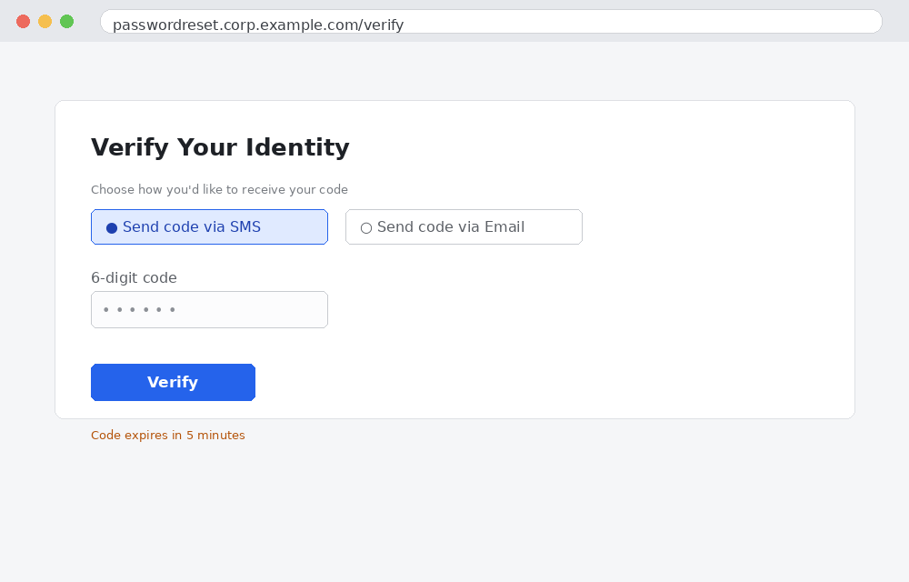
Step 3: New password set
Navigation: Create New Password screen → New Password / Confirm New Password fields
Enter a new password that meets the company Password Policy (NIST SP 800-63B), then select Reset Password.
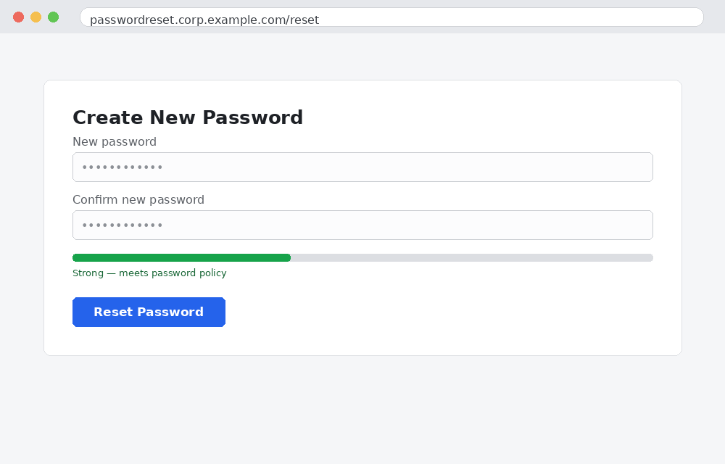
Step 4: Reset confirmed
A confirmation email arrives at your registered address. ✅ Sign in with the new password to confirm it worked.
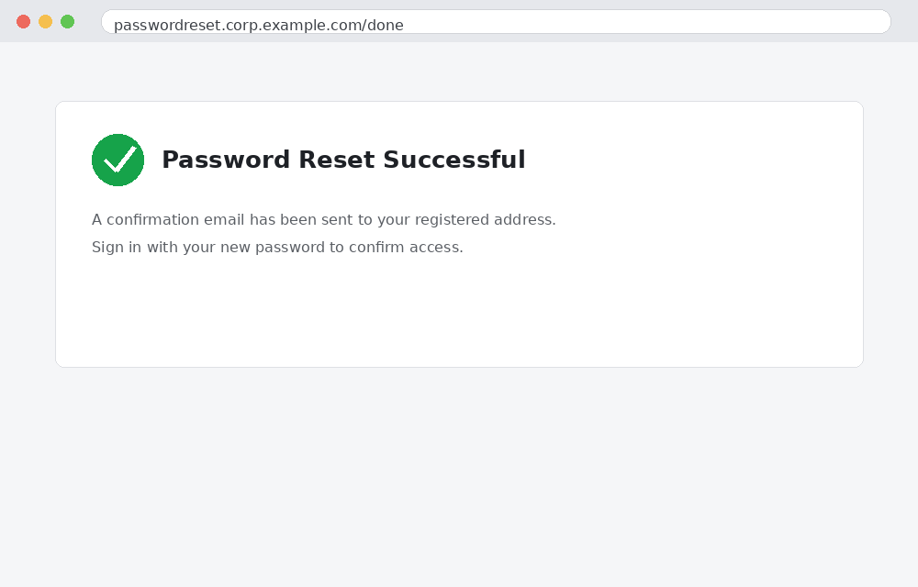

Outputs
- User successfully signs in with the new password
- Confirmation email received at the registered address
- ✅ No helpdesk ticket required

FAQs
Q: What if I don't receive the verification code?
Check your spam folder and wait two minutes before requesting a resend. If it still doesn't arrive, contact IT Support.
Q: What if I no longer have access to my registered phone or backup email?
Self-service reset isn't possible without a verification channel. Open a ticket with IT Support so they can verify your identity manually.

