Modern Cybersecurity & Systems Engineering Program
Module 1 — Lesson 4

Monitoring and Observability in Distributed Systems

Mission Context
The Monday morning NorthBridge incident has been resolved. The Customer Database was restarted, disk space was cleared, and login functionality was restored at 9:27 AM — twelve minutes after the engineering team was alerted.
But in the post-incident review, the team lead asks a question that changes the tone of the room:
"The database disk started filling up at 8:51 AM. The database crashed at 9:08 AM. The first customer complaint arrived at 9:15 AM. We were not alerted until 9:15 AM. Why did we find out from customers instead of from our own systems?"
This is the question that Lesson 4 answers. The NorthBridge infrastructure generated signals of the impending failure for seventeen minutes before a single customer was affected. But no one was watching those signals in a way that would have triggered an alert.
In this lesson, you will learn what monitoring and observability are, how the three telemetry signals — metrics, logs, and traces — work together to give engineers visibility into their systems, and why proactive monitoring is one of the most important capabilities a security engineering team can build.

Learning Objectives
By the end of this lesson you should be able to:
- Explain why monitoring is essential in modern distributed systems
- Describe the difference between monitoring and observability
- Identify and distinguish the three core telemetry signals: Metrics, Logs, and Traces
- Explain how telemetry flows through a monitoring pipeline from infrastructure to alert
- Describe the difference between reactive and proactive monitoring and why it matters

Story Scenario
It is 8:51 AM on Monday — twenty-four minutes before the first customer complaint, and seventeen minutes before the database crashes.
On the NorthBridge database server, disk usage is climbing. At 8:51 AM it crosses 85%. A monitoring system that was properly configured would note this and flag it as a warning condition. At 8:58 AM, disk usage crosses 95%. A properly configured system would escalate this to a critical alert and page an on-call engineer. At 9:04 AM, disk usage reaches 99.8%. The database begins logging errors. The process is seconds from crashing.
At 9:08 AM, the database crashes. At 9:15 AM, customers start calling.
None of this was detected. No alert fired. No engineer was paged. The monitoring configuration for disk usage on the database server had never been set up.
The NorthBridge team did not have a visibility problem. They had a monitoring configuration problem. The signals were there — disk usage, query latency, error rates — but no one had set up the system to watch them and raise the alarm.
By the end of this lesson, you will understand exactly what should have been configured, and why.

Concept 1 — Why Monitoring is Necessary
A modern distributed system like NorthBridge Bank contains dozens of components — servers, databases, load balancers, firewalls, network connections — all running simultaneously and all depending on each other. At any moment, any one of these components could begin to degrade.
Without monitoring, engineers have no visibility into the health of these systems except through customer complaints. By the time a customer complains, the failure has already occurred. The damage is already done.
Analogy: A car has a temperature gauge on the dashboard. It does not wait for the engine to seize before alerting the driver — it shows continuously rising temperature so the driver can pull over before the engine is damaged. Monitoring systems do the same for infrastructure.
Monitoring gives engineers a continuous view of system behaviour. Instead of reacting to failures after customers report them, engineers can detect the early warning signs of a failure and intervene before users are affected. This is the difference between reactive and proactive engineering.

Reactive vs proactive monitoring
Reactive monitoring means responding to failures after they have already affected users. The engineer receives a customer complaint, begins an investigation, traces the root cause, and then fixes it. This is what happened on Monday morning at NorthBridge.
Proactive monitoring means detecting the signals of an impending failure before users are affected. A disk usage alert fires at 95% capacity. An engineer receives the alert, investigates, clears the disk, and the database never crashes. No customer is ever affected.
The Monday morning NorthBridge incident was a reactive response to a failure that proactive monitoring would have prevented entirely. The disk filled over seventeen minutes — more than enough time to intervene.

Diagram 1 — The NorthBridge Monitoring Gap
This interactive diagram has five circles. Circle 1 shows 8:51 AM — disk at 85%, no alert, engineer unaware. Circle 2 shows 8:58 AM — disk at 95%, still no alert. Circle 3 shows 9:04 AM — disk at 99.8%, database writing errors. Circle 4 shows 9:08 AM — database crashes, three engineers scrambling. Circle 5 shows the same moment with proactive monitoring configured — alert fires at 8:51 AM, engineer responds calmly, database never crashes. Click each circle in sequence to follow the timeline.

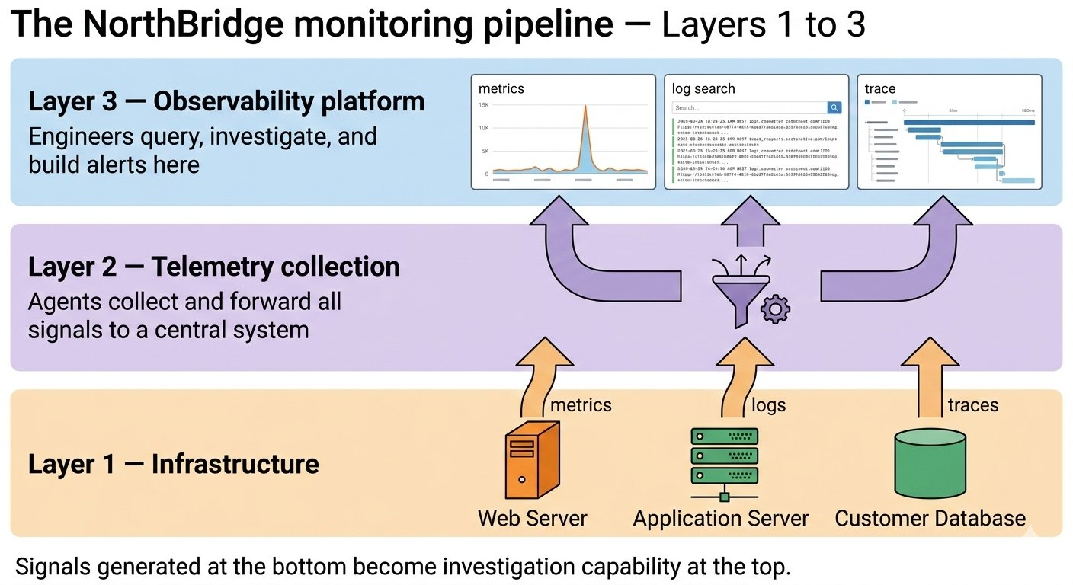

Concept 2 — Monitoring and Observability
Monitoring and observability are related but distinct concepts. Both involve watching system behaviour — but they answer different questions.

Monitoring
Monitoring is the practice of watching predefined metrics and raising alerts when they cross predefined thresholds. It is designed to detect known failure modes — problems the team has anticipated and configured alerts for.
Examples of monitoring at NorthBridge:
- Alert when database disk usage exceeds 90%
- Alert when login failure rate exceeds 5% of requests per minute
- Alert when any Web Server stops responding to health checks

Monitoring is excellent at catching the failures you expect. It is less useful for investigating failures you did not anticipate — because there is no pre-configured alert for something you never imagined would go wrong.

Observability
Observability goes further than monitoring. An observable system is one where engineers can ask arbitrary questions about its internal state — not just "did this threshold breach?" but "why did this specific request take 4,200 milliseconds when the average is 12 milliseconds?"
Analogy: A car's temperature gauge is monitoring — it watches one metric and alerts when it crosses a threshold. An aircraft cockpit is observability — hundreds of instruments showing altitude, engine health, fuel flow, navigation, weather, and airspeed simultaneously, giving the pilot the ability to diagnose any problem, not just the ones that were anticipated.
Observability is built on three types of telemetry data — signals that every component in a distributed system generates as it operates. Before we name them, it helps to understand what telemetry means.
Telemetry simply means data that a system sends about itself automatically and continuously. When the NorthBridge database server recorded its disk usage every minute — that was telemetry. The server was reporting on its own health. When it wrote those error log entries at 9:04 AM — that was also telemetry. Telemetry is how a system tells the outside world what is happening inside it.
These are metrics, logs, and traces.

Concept 3 — The Three Telemetry Signals
Every component in the NorthBridge infrastructure generates three types of signals as it operates. Together these signals give engineers complete visibility into what a system is doing, what has happened, and where a specific request spent its time.

Metrics
Metrics are numerical measurements collected at regular intervals over time. They answer quantitative questions: how much? how fast? how many?
At NorthBridge on Monday morning, the database server was generating disk usage metrics continuously. At 8:51 AM, the metric showed 85%. At 8:58 AM, 95%. These numbers told a precise story — but nobody was watching them.
- CPU usage across all servers
- Database query response time in milliseconds
- Number of login requests per second
- Disk usage as a percentage of total capacity

Logs
Logs are text records of events that components generate as they operate. Every time something significant happens — a request is received, an error occurs, a service starts or stops — a log entry is written.
The NorthBridge database server was writing critical log entries from 9:04 AM onwards as it ran out of disk space. The entries were precise:
[09:04:12] WARNING: disk usage at 99.1% — database write performance degraded
[09:07:58] CRITICAL: disk full — database process cannot write
[09:08:03] ERROR: database process exiting
These log entries were written to a file on the server. Nobody read them until after the crash.

Traces
Traces are records that follow a single request through every system it touches, measuring the time spent at each step. When a customer logs in, a trace shows: 12ms at the Web Server, 8ms at the Load Balancer, 290ms at the Application Server, and — if the database is struggling — 4,200ms waiting for the database to respond.
Traces are particularly powerful for diagnosing performance problems. When login requests started slowing down at 9:04 AM, a trace would have shown immediately that the bottleneck was at the database query step — pointing directly to the root cause.

The three signals work together — metrics tell you something is wrong, logs tell you what happened, traces tell you where in the request chain it happened:

Metrics | Logs | Traces
Numerical measurements over time | Text records of events and activity | End-to-end path of a single request
CPU usage: 94% at 09:08 AM | [09:08] ERROR: disk full on db-01 | Login request: 340ms Web → 290ms App → DB timeout
Database query time: 4,200ms (normal: 12ms) | [09:08] CRITICAL: database process exiting | Shows exactly where the 340ms was spent
Answers: how much? how fast? how many? | Answers: what happened and when? | Answers: where did the request slow down?

Diagram 2 — The Three Telemetry Signals
This interactive diagram has two circles. Circle 6 shows the Monitoring vs Observability analogy — a car dashboard with a single temperature gauge (Monitoring: one metric, one alert) alongside an aircraft cockpit with altitude, engine health, fuel flow, navigation, weather, and airspeed instruments (Observability: hundreds of instruments, diagnose any problem). Circle 7 shows the three telemetry signals side by side using NorthBridge Monday morning data: Metrics panel (disk usage climbing 85% to 99.8%), Logs panel (09:04 WARNING, 09:07 CRITICAL, 09:08 ERROR), and Traces panel (Web Server 8ms, App Server 11ms, Database 3,780ms).

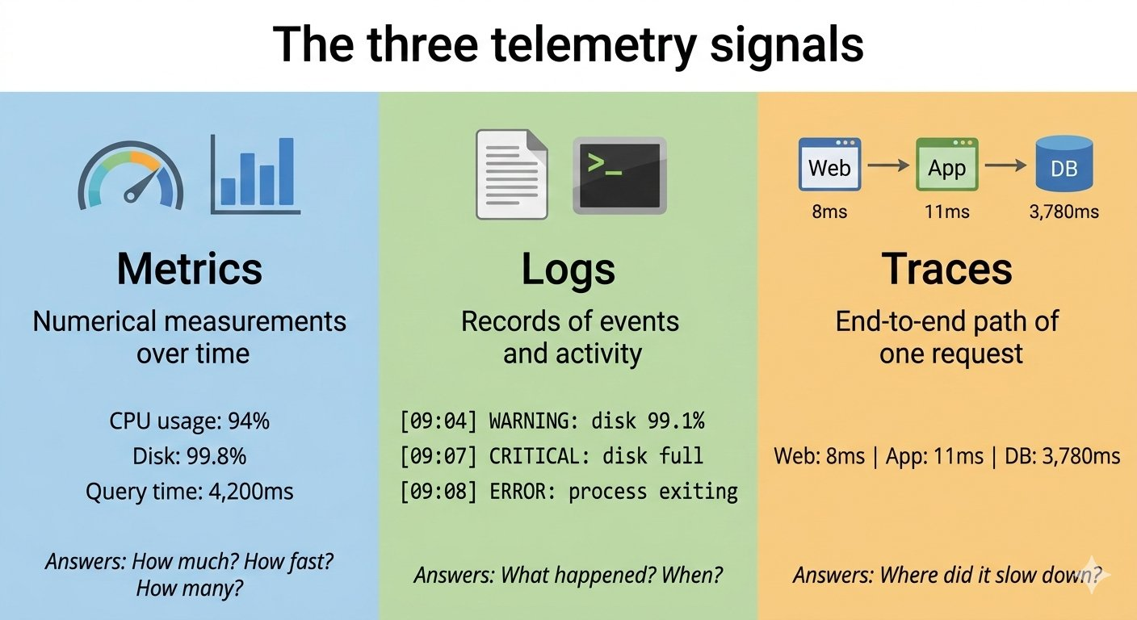

Concept 4 — The NorthBridge Monitoring Pipeline
Generating telemetry signals is only the first step. Those signals need to travel through a monitoring pipeline — a chain of systems that collect, store, analyse, and act on the data — before they can reach an engineer as a meaningful alert.
The NorthBridge monitoring pipeline has three layers covered in this lesson:

Layer 1 — Infrastructure (the signal sources)
Every component in the NorthBridge infrastructure generates telemetry. The database server generates disk usage metrics and writes error logs. The Application Server generates CPU metrics and request traces. The Web Servers generate access logs and latency metrics. This layer is the source of all visibility — if a component is not generating telemetry, it is invisible to the monitoring system.

Layer 2 — Telemetry collection
This layer has one job — take the signals that Layer 1 generates and forward them to a centralised system. But how does telemetry actually get from the server to the collector? The server is not going to pick up the phone and call someone. Something has to sit inside the server and do that job.
That something is called an agent. An agent is a small software program that runs quietly in the background on a server. You do not see it. You do not start it manually. It just runs. Its only job is to watch what the server is doing — collect the metrics, the logs, the traces — and send them out to the centralised collection system.
Analogy: Think of it like a reporter permanently stationed inside the server room. The reporter watches everything happening — every metric, every log entry, every trace — and files a report to the newsroom continuously, every few seconds. That newsroom is the Observability Platform. That reporter is the agent.
Agents run on each NorthBridge server — Database Server, App Server, and Web Server — collecting metrics, logs, and traces simultaneously and forwarding all three signal types through the collection layer to the Observability Platform. Without this layer, each server's telemetry stays local — trapped on the machine that generated it.

Layer 3 — Observability platform
The observability platform is where collected telemetry is stored, indexed, and made queryable. Engineers use it to search logs, plot metrics over time, visualise traces, and build dashboards. This is the layer that turns raw data into investigation capability. When an incident is in progress, the observability platform is where engineers spend most of their time.

Layers 4 and 5 of the monitoring pipeline — Alerting and Continuous Improvement — will be covered in Module 10 when you have the log analysis skills to work with them directly.

Diagram 3 — The NorthBridge Monitoring Pipeline (Layers 1–3)
This interactive diagram has three circles. Circle 8 shows the full three-layer pipeline overview — Layer 1 (Infrastructure: generates signals), Layer 2 (Collection: forwards signals), and Layer 3 (Observability Platform: stores and queries). Circle 9 shows how Layer 2 works when correctly configured — three server racks each with a robot agent holding metrics, logs, and traces, forwarding them through the Layer 2 collection funnel to the platform where an engineer is reading data. Circle 10 shows what happens when Layer 2 is missing — the same three servers and agents, but where the collection funnel was there is now an empty red dashed box labelled LAYER 2: NOT CONFIGURED. The telemetry flow arrows hit the empty space and stop. The platform screen is blank with a question mark. This is exactly what happened at NorthBridge on Monday morning.

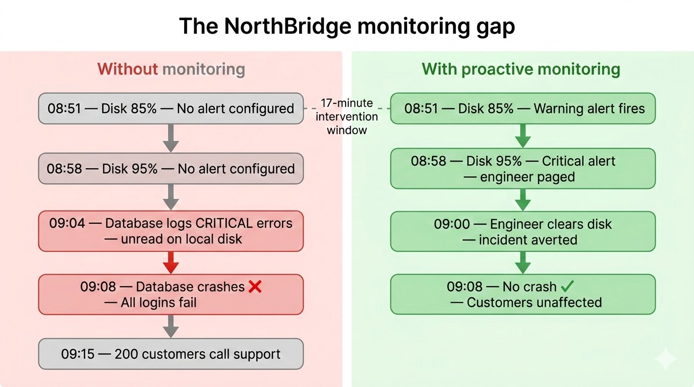

Engineering Thinking — What Should Have Been Configured
Now that you understand metrics, logs, and traces, you can answer the question the NorthBridge team lead asked in the post-incident review: what monitoring should have been configured to catch this failure before customers were affected?

The three alerts that would have prevented the Monday morning incident

- Disk usage alert at 85% — a warning-level alert when database server disk crosses 85% capacity. Severity: warning. Action: notify the on-call engineer. At NorthBridge, this would have fired at 8:51 AM — seventeen minutes before the crash.
- Disk usage alert at 95% — a critical-level alert escalating to a page to the on-call engineer. Severity: critical. Action: page immediately. This would have fired at 8:58 AM — ten minutes before the crash.
- Database query latency alert — an alert when average database query time exceeds 500ms. This would have fired at 9:04 AM as disk pressure began degrading write performance — four minutes before the crash, and early enough to identify the root cause immediately from the accompanying metrics.

A well-configured monitoring system does not eliminate incidents. It compresses the time between a failure beginning and an engineer knowing about it — from seventeen minutes of invisible degradation to under five minutes from first signal to page.

Engineering Exercise
The NorthBridge engineering team is setting up monitoring after the Monday morning incident. For each of the following system behaviours, identify: (1) which telemetry signal would capture it — metric, log, or trace — and (2) what alert threshold you would recommend configuring.

System behaviour to monitor | Signal type | Recommended alert
The number of failed login attempts per minute across all Web Servers
A specific error message appearing repeatedly in Application Server logs
How long each login request takes to complete end-to-end
The percentage of memory used by the Application Server process
A database connection being refused when the Application Server attempts to connect

For each row, think about what the signal type tells you: metrics measure quantities over time, logs record events, traces follow requests across services. The alert threshold should be set at the point where the behaviour is abnormal but before it becomes catastrophic.

Lesson Summary
In this lesson you learned how monitoring and observability give engineers the visibility they need to detect and respond to failures before customers are affected.

- Monitoring watches predefined metrics and raises alerts when thresholds are crossed — it detects the failures you anticipated
- Observability goes further — it gives engineers the ability to ask arbitrary questions about system behaviour using all available telemetry
- The three telemetry signals are metrics (numerical measurements), logs (event records), and traces (end-to-end request paths)
- Metrics answer: how much, how fast, how many. Logs answer: what happened and when. Traces answer: where in the chain did it slow down
- The monitoring pipeline moves telemetry from the infrastructure (Layer 1) through collection (Layer 2) to the observability platform (Layer 3)
- Proactive monitoring detects failures before customers are affected. Reactive monitoring responds after they already are
- The Monday morning NorthBridge incident could have been prevented with three correctly configured disk usage and latency alerts

The most important monitoring insight: the signals of a failure are almost always present before the failure occurs. Monitoring is the practice of watching those signals and acting on them in time.

Lesson Quiz
This quiz contains 15 questions. Read each question carefully before selecting your answer.

Section A — Concept Understanding
1. What is the primary purpose of monitoring in a distributed system?
A. To replace manual investigation when an incident occurs
B. To continuously observe system behaviour and detect problems before or as they occur
C. To automatically fix failures without engineer involvement
D. To record every customer transaction for compliance purposes
[Category: Concept Understanding]
2. What is the difference between monitoring and observability?
A. Monitoring and observability are the same thing — both watch predefined metrics
B. Monitoring detects known failure modes using predefined alerts; observability allows engineers to investigate any system behaviour using all available telemetry
C. Observability only applies to security incidents; monitoring applies to infrastructure health
D. Monitoring uses logs; observability uses metrics
[Category: Concept Understanding]
3. Which of the following best describes a metric?
A. A text record of a specific event that occurred on a server
B. A record showing the path a request took through multiple services
C. A numerical measurement collected at regular intervals, such as CPU usage or disk capacity
D. An alert that fires when a threshold is exceeded
[Category: Concept Understanding]
4. What is the difference between reactive and proactive monitoring?
A. Reactive monitoring uses metrics; proactive monitoring uses logs
B. Reactive monitoring detects problems before users are affected; proactive monitoring responds after customers complain
C. Reactive monitoring responds to failures after users are affected; proactive monitoring detects early warning signals before failures occur
D. There is no meaningful difference — both produce the same outcome
[Category: Concept Understanding]
5. What question do traces primarily answer that metrics and logs cannot?
A. How many requests per second is the system handling?
B. Where in the chain of services did a specific request slow down or fail?
C. What error messages has the database logged in the past hour?
D. When did the last disk usage threshold breach occur?
[Category: Concept Understanding]
Section B — System Architecture
6. In the NorthBridge monitoring pipeline, what is the role of Layer 2 — the telemetry collection layer?
A. To generate metrics, logs, and traces from the infrastructure components
B. To store, index, and make telemetry queryable for engineers
C. To collect telemetry signals from each server and forward them to a centralised system
D. To send alerts to the on-call engineering team when thresholds are breached
[Category: System Architecture]
7. A NorthBridge engineer opens the observability platform and plots database query time over a 24-hour period. She sees that query times spiked from 12ms to 4,200ms at exactly 9:04 AM on Monday. Which telemetry signal is she using?
A. A log — she is reading a text record of what happened
B. A trace — she is following a single request through the chain
C. A metric — she is viewing a numerical measurement plotted over time
D. An alert — the system flagged this automatically
[Category: System Architecture]
8. Why is Layer 1 — the infrastructure layer — described as the source of all visibility?
A. Because it contains the observability platform dashboard
B. Because if a component is not generating telemetry, it cannot be monitored — it is invisible to the monitoring system
C. Because all alerts are configured at the infrastructure layer
D. Because telemetry collection agents run only at this layer
[Category: System Architecture]
Section C — Troubleshooting Logic
9. The NorthBridge database disk started filling at 8:51 AM and the database crashed at 9:08 AM. If a disk usage alert had been configured at 85% capacity, at what time would it have fired, and how much time would engineers have had to intervene?
A. 9:08 AM — no time to intervene, the alert would fire at the moment of the crash
B. 8:51 AM — seventeen minutes before the crash, giving engineers time to clear disk space
C. 9:15 AM — after the first customer complaint, the same as without monitoring
D. 8:58 AM — ten minutes before the crash, when disk crossed 95%
[Category: Troubleshooting Logic]
10. After the Monday morning incident, an engineer checks the NorthBridge database server logs from that morning. She finds entries marked CRITICAL at 9:07 AM describing disk exhaustion. What does this tell the investigation?
A. The monitoring system detected the failure and alerted the team at 9:07 AM
B. The logs confirm the exact time and cause of the database failure — but they were not being forwarded to a centralised system, so no one saw them during the incident
C. The failure was caused by a logging configuration error, not disk exhaustion
D. The database was generating too many logs, which caused the disk to fill up
[Category: Troubleshooting Logic]
11. A NorthBridge engineer receives a metric alert showing that Application Server CPU usage has been above 95% for five minutes. Using the investigation framework from Lesson 3, what should the engineer do first?
A. Immediately restart the Application Server to reduce CPU usage
B. Check the Application Server logs and traces to understand what is causing the high CPU usage before making any changes
C. Increase the alert threshold to 99% so the alert does not fire again
D. Disable the monitoring alert to prevent it from distracting the team
[Category: Troubleshooting Logic]
12. The NorthBridge Load Balancer stops sending health check responses for Web Server 2. This event is recorded in the Load Balancer logs. Which combination of telemetry signals would give an engineer the most complete picture of what happened?
A. Logs only — the log entry contains all the information needed
B. Metrics only — CPU and memory usage will explain why Web Server 2 stopped responding
C. Logs and metrics together — logs show the event, metrics show whether resource exhaustion preceded it
D. Traces only — following a single request will identify the failed server
[Category: Troubleshooting Logic]
Section D — Scenario-Based Thinking
13. A NorthBridge security engineer notices that the number of failed login attempts has jumped from 2 per minute to 340 per minute over the past ten minutes. Which telemetry signal is she most likely reading, and what does this pattern suggest?
A. A trace — a single login request is taking much longer than usual
B. A metric — the failed login rate is a numerical measurement, and the spike suggests a potential credential stuffing or brute force attack
C. A log — error messages from the Application Server indicate a configuration problem
D. An alert — the monitoring system has already identified this as a security incident
[Category: Scenario-Based Thinking]
14. The NorthBridge observability platform shows that login requests have been taking 3,800ms on average for the past two minutes — twelve times the normal response time of 320ms. An engineer pulls a trace for one of these slow requests. The trace shows: Web Server 8ms, Load Balancer 4ms, Application Server 11ms, Database 3,780ms. What does this trace tell the engineer?
A. The Web Server is the bottleneck — 8ms is slower than the Load Balancer's 4ms
B. All components are equally responsible for the slow response
C. The database is the bottleneck — 3,780ms out of 3,803ms total is spent waiting for the database
D. The trace data is incorrect — the total should add up to exactly 3,800ms
[Category: Scenario-Based Thinking]
15. NorthBridge's monitoring system has been configured with a disk usage alert set at 99% capacity. A junior engineer argues this is fine because the alert will fire before the disk is completely full. A senior engineer says the threshold should be 85%. Who is correct and why?
A. The junior engineer — 99% still leaves some space, so the alert will fire in time
B. The senior engineer — by the time disk reaches 99%, there may only be seconds before the database crashes, not enough time for an engineer to investigate and intervene. An 85% threshold gives significantly more lead time.
C. Both are equally correct — the right threshold depends entirely on how fast the engineer can respond
D. Neither — disk usage should not be monitored with a simple threshold alert
[Category: Scenario-Based Thinking]

Answer Key — Lesson 4 Quiz
Module 1, Lesson 4 — Monitoring and Observability in Distributed Systems

# | Answer | Explanation
1 | B | Monitoring's primary purpose is continuous observation and early detection — not automatic repair (C) or replacing manual investigation (A). The goal is to surface signals of problems as early as possible.
2 | B | Monitoring watches predefined metrics and fires alerts for anticipated failures. Observability is broader — it gives engineers the ability to ask any question about system behaviour. Option (A) is incorrect: they are complementary, not identical.
3 | C | A metric is a numerical measurement: CPU percentage, disk capacity, query time in milliseconds. A text record of an event is a log (A). A request path record is a trace (B). An alert is triggered by a metric crossing a threshold but is not itself a metric (D).
4 | C | Reactive monitoring responds after customers report failures. Proactive monitoring detects early warning signals before customers are affected. Option (B) reverses the definitions. The Monday morning incident was a reactive response — proactive monitoring would have detected the disk usage climb before the crash.
5 | B | Traces follow a single request through every service it touches and record the time spent at each step. This makes them uniquely capable of identifying exactly where a request slowed down — something neither metrics (which average across all requests) nor logs (which record events without timing the full path) can do as precisely.
6 | C | Layer 2 is the collection layer — it gathers signals from each server and forwards them to a centralised system. Generating signals (A) happens at Layer 1. Making telemetry queryable (B) is Layer 3's role. Alerting is Layer 4 (not covered in this lesson).
7 | C | She is plotting a numerical measurement (query time in milliseconds) over time — this is a metric. A log (A) would be a text entry describing a specific event. A trace (B) would show the path of one individual request, not an aggregated time series.
8 | B | If a component does not generate telemetry — or if its telemetry is not collected — it is completely invisible to the monitoring system. No alerts can fire for it, no investigation can use its data. This is why instrumentation (making components generate telemetry) is a prerequisite for monitoring.
9 | B | Disk usage crossed 85% at 8:51 AM — seventeen minutes before the 9:08 AM crash. An 85% alert would have fired at that moment. Option (D) describes the 95% alert threshold, which would have fired at 8:58 AM — ten minutes before the crash, less lead time but still actionable.
10 | B | The log entries confirm the timing and cause of the failure precisely. But because the database server's logs were not being forwarded to a centralised log store, they were only discoverable after the fact. This illustrates why Layer 2 (telemetry collection) is critical — generating signals is useless if they are not forwarded.
11 | B | This is Step 3 of the investigation framework from Lesson 3 — investigate evidence before making changes. Restarting the server (A) without understanding the cause risks the problem recurring. The logs and traces will show whether the high CPU is caused by a traffic spike, a runaway process, or a dependency failure.
12 | C | Logs and metrics together provide the most complete picture. The log entry records the event (health check failure at a specific time). The metrics show whether CPU, memory, or disk exhaustion preceded the failure. Logs alone (A) cannot show the gradual resource trend. Traces alone (D) would only show requests that completed, not a server that stopped responding.
13 | B | Failed login rate is a numerical measurement over time — a metric. The spike from 2 to 340 per minute in ten minutes is a pattern consistent with an automated credential stuffing or brute force attack, where a tool submits large numbers of login attempts in a short window.
14 | C | The trace breaks down the 3,803ms total across all components. The database consumed 3,780ms — 99.4% of the total request time. The other components are functioning normally. This trace points the investigation directly at the database, exactly as described in the root cause analysis from Lesson 3.
15 | B | Alert thresholds must be set at a point that gives engineers enough time to investigate and respond. At 99% disk capacity, the time between alert and crash may be seconds. At 85%, the engineer has the full filling curve — potentially fifteen or more minutes — to diagnose and intervene. The right threshold is not the last moment before failure; it is the earliest moment that reliably indicates a problem.

Next Lesson Preview — Lesson 5: Technology Operations Teams
In this lesson you learned how monitoring and observability give engineers the visibility they need to detect failures before customers report them. You now understand metrics, logs, traces, and the monitoring pipeline that carries them from infrastructure to investigation platform.
But monitoring data only creates value if the right people are watching it and responding to it. Lesson 5 answers the question: who are those people?
Modern organisations operate multiple specialised teams to maintain, secure, and respond to their infrastructure. The Security Operations Centre, the Site Reliability Engineering team, the Network Operations Centre, and the DevOps team all play distinct roles — and all intersect with the monitoring signals you learned about in this lesson.
Lesson 5 introduces each of these teams, explains what they do, and shows how they collaborate during an incident like the Monday morning NorthBridge failure.

Coming up in Lesson 5: The NorthBridge incident team assembles — and the suspicious activity flagged in the monitoring logs is handed to a team that specialises in exactly this kind of signal.

