DESIGN AND ANALYSIS OF ALGORITHMS
Assignment 2 — GUI-Based Algorithm Implementation
Cybersecurity Attack Path Visualizer
Using Breadth-First Search and Depth-First Search
An educational graph-traversal simulator with step-by-step visualisation

Submitted by
ALBY MATHEW BIJU

Abstract
This project presents a desktop application that models a small enterprise computer network as an undirected, unweighted graph and visualises, step by step, how Breadth-First Search (BFS) and Depth-First Search (DFS) explore connectivity from a simulated compromised workstation to a target server. Both algorithms are implemented manually in Python over an adjacency-list representation; BFS uses a FIFO queue (collections.deque) and DFS uses an explicit LIFO stack. A Tkinter/ttk graphical interface lets the user choose source, target and algorithm, move forwards and backwards through every elementary operation, inspect the queue or stack, visited set and traversal order, and compare the paths found by the two algorithms. A built-in network editor allows devices and connections to be added and removed with full input validation. On the sample network BFS finds a 4-hop path while DFS finds a valid 6-hop path, illustrating that only BFS guarantees a minimum-hop route in an unweighted graph. Both algorithms run in O(V + E) time with O(V) auxiliary space. A suite of 41 automated unit tests, including 600 randomised graphs checked against an independent oracle, passed. The tool is strictly a simulation and performs no real network activity.

1. Problem Statement
Network defenders often reason about attack paths: if one device is compromised, which other devices can be reached through existing connections, and what is the shortest such route? This is fundamentally a graph-reachability question. Students learning BFS and DFS usually meet them as abstract procedures on unlabeled vertices, which makes it hard to see why their behaviour differs or why it matters. The problem addressed here is to build an interactive, visual and correct tool that applies BFS and DFS to a meaningful, security-themed network model, exposes each internal step of the algorithms, and makes their complexity and their path-quality guarantees concrete.

2. Objectives
- Represent a simulated network as an undirected, unweighted graph using an adjacency list, with validated device and connection editing.
- Implement BFS and DFS manually, with parent pointers for path reconstruction and correct handling of cycles, disconnected components and boundary cases.
- Provide a user-friendly, dark-themed GUI that visualises the queue or stack, visited set, current node and discovered path at every step, with Next, Previous, Run to completion, Auto-play and Reset controls.
- Explain and analyse the time and auxiliary-space complexity of both algorithms, distinguishing algorithmic space from the storage used for GUI playback.
- Verify correctness with automated tests covering normal, alternative and boundary inputs.

3. Existing Problem and Proposed Solution
Existing problem. Textbook diagrams of BFS and DFS are static and show only the final traversal tree. Generic online animators use unlabeled vertices, rarely let the learner step backwards, and seldom show why DFS can return a longer path. Professional attack-graph tools, on the other hand, are complex, rely on real vulnerability data and are unsuitable (and potentially unsafe) for a classroom.
Proposed solution. A self-contained Python application with no external dependencies that (i) uses a meaningful but entirely fictional enterprise network, (ii) records an immutable snapshot after every elementary algorithm operation so that the learner can move freely forwards and backwards, (iii) colour-codes the source, target, current vertex, frontier, visited vertices, examined edge and final path, (iv) explains each step in a sentence, and (v) compares BFS and DFS on the same input. The algorithm layer is separated from the interface so that it can be tested independently.

4. Software and Hardware Requirements
Category | Requirement
Operating system | Windows 10/11 (target platform); also runs on Linux and macOS
Language | Python 3.10 or newer (code is compatible with 3.9)
GUI toolkit | Tkinter and ttk (bundled with the standard python.org installer); Tkinter Canvas for drawing
Libraries | Standard library only: collections.deque, dataclasses, re, unittest
Testing | Python unittest framework
Processor / RAM | Any processor able to run Python 3; 4 GB RAM is ample
Display | 1280 × 720 or higher recommended (minimum window 1080 × 640)

5. Algorithm Explanation
Let the network be a graph G = (V, E), where V is the set of devices and E the set of connections. Because a connection lets traffic flow both ways and all links are treated equally, G is undirected and unweighted. The length of a path is therefore its number of edges (hops).

5.1 Breadth-First Search
BFS starts by placing the source in a FIFO queue and marking it visited. It repeatedly removes the vertex at the front of the queue and checks whether it is the target. If it is not, every neighbour that has not yet been visited is marked visited, given the current vertex as its parent, and appended to the back of the queue. Marking at enqueue time guarantees that no vertex enters the queue twice. The search stops when the target is dequeued (success) or the queue becomes empty (no path).
Why BFS finds a shortest path. Vertices enter the queue layer by layer: the source (distance 0), then all vertices at distance 1, then distance 2, and so on, because a vertex at distance d + 1 can only be discovered from a vertex at distance d, and FIFO order processes every distance-d vertex before any distance-(d + 1) vertex. A vertex's parent is fixed at its first discovery, which therefore comes from the closest possible layer. Following parent pointers from the target back to the source thus yields a path with the minimum number of edges.

5.2 Depth-First Search
DFS follows one branch as deeply as possible before backtracking. The implementation is iterative: the source is pushed onto a stack and marked visited. At each step the vertex on top of the stack is examined; if it has an unvisited neighbour, that neighbour is marked visited, given a parent and pushed (going deeper). If the top vertex has no unvisited neighbours left, it is popped (backtracking). Each vertex keeps an iterator over its adjacency list, so no list is rescanned. Search stops as soon as the target is pushed, at which point the stack holds exactly the source-to-target branch.
Why DFS does not guarantee a shortest path. DFS commits to the first unexplored neighbour it meets and may reach the target through a long detour before ever examining a shorter branch. In the sample network DFS travels Laptop-HR → Switch-A → WS-Dev → Switch-B → Router-Core → Firewall-Int → DB-Server (6 hops), whereas BFS finds Laptop-HR → Switch-A → Router-Core → Firewall-Int → DB-Server (4 hops). The DFS path is valid but 2 hops longer.
Cycles. Networks contain loops (for example Router-Core, Firewall-Int, Mail-Server, Web-Server, VPN-Gateway). Both algorithms consult the visited set before adding a vertex, so each vertex is processed at most once and the traversal always terminates.

6. Pseudocode
The pseudocode below corresponds line-for-line to the functions bfs and dfs in traversal_core.py (step-recording calls omitted).
Algorithm 1 — Breadth-First Search
BFS(G, s, t):
validate that G is non-empty and s, t are vertices of G
visited ← {s}; parent[s] ← NIL; Q ← empty queue; ENQUEUE(Q, s)
while Q is not empty:
u ← DEQUEUE(Q) // FIFO
if u = t:
return RECONSTRUCT(parent, s, t)
for each v in Adj[u]:
if v ∉ visited:
visited ← visited ∪ {v}; parent[v] ← u
ENQUEUE(Q, v)
return NO PATH

Algorithm 2 — Depth-First Search (iterative, explicit stack)
DFS(G, s, t):
validate that G is non-empty and s, t are vertices of G
visited ← {s}; parent[s] ← NIL; S ← [s]; next[s] ← iterator over Adj[s]
if s = t: return [s]
while S is not empty:
u ← TOP(S)
v ← NEXT(next[u]) // next neighbour of u, or NIL
if v = NIL: POP(S); continue // backtrack
if v ∈ visited: continue // skip, prevents cycling
visited ← visited ∪ {v}; parent[v] ← u
PUSH(S, v); next[v] ← iterator over Adj[v]
if v = t: return RECONSTRUCT(parent, s, t) // equals S
return NO PATH

RECONSTRUCT(parent, s, t):
path ← []; x ← t
while x ≠ NIL: prepend x to path; x ← parent[x]
return path

7. Flowchart / Algorithm Workflow
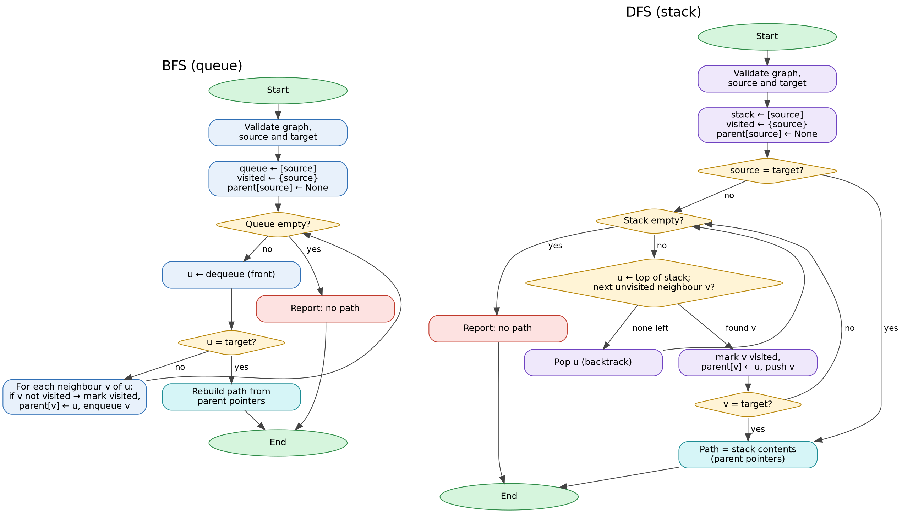
Figure 1 — Workflow of BFS (left) and iterative DFS (right) as implemented
At application level the workflow is: the user selects source, target and algorithm → inputs are validated → the core function runs once and returns a result containing an ordered list of immutable step snapshots → the GUI displays snapshot k and re-renders the canvas and panels whenever k changes (Next, Previous, Auto-play, Step Log selection, Run to completion).

8. Graph Representation
The class NetworkGraph stores the graph as a dictionary mapping each device name to a Python list of neighbour names (an adjacency list), plus a second dictionary holding each device's type (Workstation, Switch, Router, Firewall, Gateway or Server). Every undirected connection {a, b} is stored twice — b in a's list and a in b's list — so storage is O(V + E). Neighbours are kept in insertion order, which makes traversal results deterministic and reproducible during a demonstration.
The editing methods enforce the graph's invariants: device names are validated (1–20 characters, restricted character set, case-insensitive uniqueness), self-connections and duplicate connections in either direction are rejected, references to unknown devices raise a GraphError, removing a device also removes all its connections, and the network is capped at 30 devices for readability. A validate() method checks symmetry and the absence of self-loops and duplicates.
The default network has 14 devices and 16 connections: workstations (Laptop-HR, WS-Finance, WS-Dev), two switches, a core router, an internal firewall, a VPN gateway, five servers (Web, Mail, File, Backup-NAS and DB-Server) and an intentionally isolated Legacy-Kiosk. It contains several cycles and multiple routes from Laptop-HR to DB-Server (via the firewall, or via Switch-B, File-Server and Backup-NAS), which makes the BFS/DFS contrast visible.

9. GUI Design and Implementation
The program is split into two modules. traversal_core.py contains the graph class, BFS, DFS, path reconstruction and the sample network, with no GUI code. attack_path_visualizer.py contains only presentation logic in the class AttackPathVisualizerApp. The core returns a TraversalResult with a list of frozen TraversalStep dataclasses, each holding the action, current vertex, queue/stack contents, visited set, traversal order, tree edges, examined edge, final path (only on the last step) and a one-sentence explanation. The GUI never re-runs the algorithm while stepping; it only changes an index into this list.
The window uses the ttk “clam” theme restyled into a dark cybersecurity-dashboard palette and has three columns:
- Left panel (tabs). *Run*: source and target drop-downs, BFS/DFS selector, Generate Steps, Compare BFS vs DFS, Previous/Next, Run to completion, Auto-play with a delay slider, and Reset. *Network Editor*: add device, connect/disconnect, remove device, load sample, clear network.
- Centre. A Tkinter Canvas draws edges and labelled nodes (type abbreviation inside, name on a background plate beneath). A green ring marks the source and a red ring the target; fill colour shows state (purple current, amber in queue/on stack, blue visited, cyan path); a numbered badge shows traversal order; a dashed amber edge is the edge being examined and blue edges are parent pointers. Below the canvas, an explanation banner and a legend. Nodes can be dragged; sizes scale with the canvas.
- Right panel (tabs). *Trace*: step number, operation, current node, queue (front → back) or stack (bottom → top), visited set, traversal order and explanation, then the results (target reached, path, hops, vertices in path, visited count, adjacency entries examined) and the BFS-vs-DFS comparison. *Step Log*: a table of all steps; clicking a row jumps to it. *Concepts*: the theory and complexity analysis.
Input validation is handled by catching GraphError from the core and showing a message box (missing source/target, empty network, duplicate or self connection, invalid name). Changing the selection or editing the network resets the loaded traversal so stale steps are never shown. Keyboard shortcuts (← / → / Home / End) support live demonstration.

10. Complexity Analysis
Let V be the number of vertices (devices) and E the number of edges (connections).
Operation | Time | Auxiliary space | Reason
Graph storage (adjacency list) | — | O(V + E) | V keys; 2E neighbour entries
BFS | O(V + E) | O(V) | Queue, visited set and parent map each ≤ V
DFS (iterative) | O(V + E) | O(V) | Stack, visited, parent, iterators each ≤ V
Path reconstruction | O(V) | O(V) | Path has at most V vertices
GUI step history | O((V + E)·V) | O((V + E)·V) | O(V + E) snapshots × O(V) copied data

Time. In BFS each vertex is enqueued and dequeued at most once because it is marked visited when enqueued; queue operations on a deque are O(1), giving O(V). When a vertex is dequeued its adjacency list is scanned once. Over the whole run the scanned lists have total length at most the sum of degrees, which in an undirected graph is 2E, giving O(E). The total is O(V + E). DFS has the same structure: each vertex is pushed and popped at most once (O(V)), and each vertex's neighbour iterator advances through its list exactly once (O(E) in total), so DFS is also O(V + E). With an adjacency matrix both would be O(V²). The GUI reports the number of adjacency entries examined; the tests confirm it always equals the sum of degrees of the explored vertices and never exceeds 2E.
Space. Apart from the input graph, BFS stores the queue, the visited set and the parent map, each holding at most V vertices: O(V). DFS stores the stack (at most V vertices, since a vertex is pushed only once), the visited set, the parent map and one neighbour iterator per discovered vertex: O(V). The iterative design also avoids Python's recursion limit.
Algorithmic space versus GUI playback storage. To support Previous and Next, the program records a snapshot after every elementary operation. There are O(V + E) such operations and each snapshot copies O(V) data (queue/stack, visited set, order, tree edges), so the playback history needs O((V + E)·V) extra memory. This is a cost of the visualisation, not of BFS or DFS. The core functions accept record_steps=False; in that mode — used by the Compare feature and the randomised tests — only the O(V) auxiliary space applies.

11. Test Cases and Actual Results
Automated tests are in test_attack_path_visualizer.py (Python unittest). Every returned path is checked to start at the source, end at the target, use only existing edges and contain no repeated vertex. BFS hop counts are compared with an independently written shortest-distance oracle.
ID | Test case | Input | Expected | Actual
T1 | Reachable target | Sample network, Laptop-HR → DB-Server, BFS and DFS | Valid path for both | Pass
T2 | Multiple paths | Same input | BFS 4 hops; DFS 6 hops (longer) | Pass
T3 | Source = target | Switch-A → Switch-A | Path [Switch-A], 0 hops | Pass
T4 | Unreachable target | Laptop-HR → Legacy-Kiosk (isolated) | No path; whole component (13) explored | Pass
T5 | Disconnected graph | {A–B–C}, {X–Y–Z} | A→Z no path; X→Z valid path | Pass
T6 | Single-node graph | Solo → Solo | One-node path | Pass
T7 | Cyclic graphs | Complete graph K6; 30-vertex ring; triangle + island | Terminates; BFS hops 1, 15, 1 | Pass
T8 | Invalid source/target | Unknown, empty, None, non-string, wrong case | GraphError raised | Pass
T9 | BFS optimality | 300 random graphs (1–18 vertices) | Hops equal oracle distance | Pass
T10 | DFS validity | 300 random graphs | Found iff reachable; path valid; hops ≥ shortest | Pass
T11 | Empty graph | No devices | GraphError “network is empty” | Pass
T12 | Editor validation | Duplicate edge (both directions), self-loop, unknown device, bad names, 31st device | Rejected; graph unchanged and consistent | Pass
T13 | O(V + E) evidence | 100 random graphs + isolated target | Edge checks = Σ degrees of explored ≤ 2E | Pass
T14 | Step recording | Sample network | FIFO queue; DFS stack is a path; visited grows monotonically | Pass
T15 | GUI smoke tests (6) | Hidden Tk window | Startup, navigation, reset, DFS, no-path, errors, editor, compare | Pass

Execution summary. The suite was run with python -m unittest -v on Python 3.12.3 (Linux) under a virtual X display: 41 tests ran, 41 passed, 0 failures, 0 errors (about 0.6 s). Run without a display, 35 tests ran and passed and the 6 GUI tests were skipped automatically. The verbatim output is supplied in test_results.txt.
Measured behaviour on the sample network (source Laptop-HR):
Algorithm | Target | Found | Hops | Steps | Visited | Adjacency entries examined
BFS | DB-Server | Yes | 4 | 36 | 13 | 24
DFS | DB-Server | Yes | 6 | 18 | 8 | 15
BFS | Legacy-Kiosk | No | — | 47 | 13 | 32 (= 2E)
DFS | Legacy-Kiosk | No | — | 47 | 13 | 32 (= 2E)
BFS / DFS | Laptop-HR | Yes | 0 | 3 / 2 | 1 | 0

DFS reached the target with fewer steps and fewer visited vertices on this input but returned a longer path, while BFS explored more of the network to guarantee the minimum-hop path — a useful trade-off to discuss.

12. GUI Screenshots
The screenshots below are genuine captures of the running application. They were taken on Linux under a virtual X display (Xvfb), so the font is DejaVu Sans rather than the Windows Segoe UI; layout and behaviour are otherwise identical.
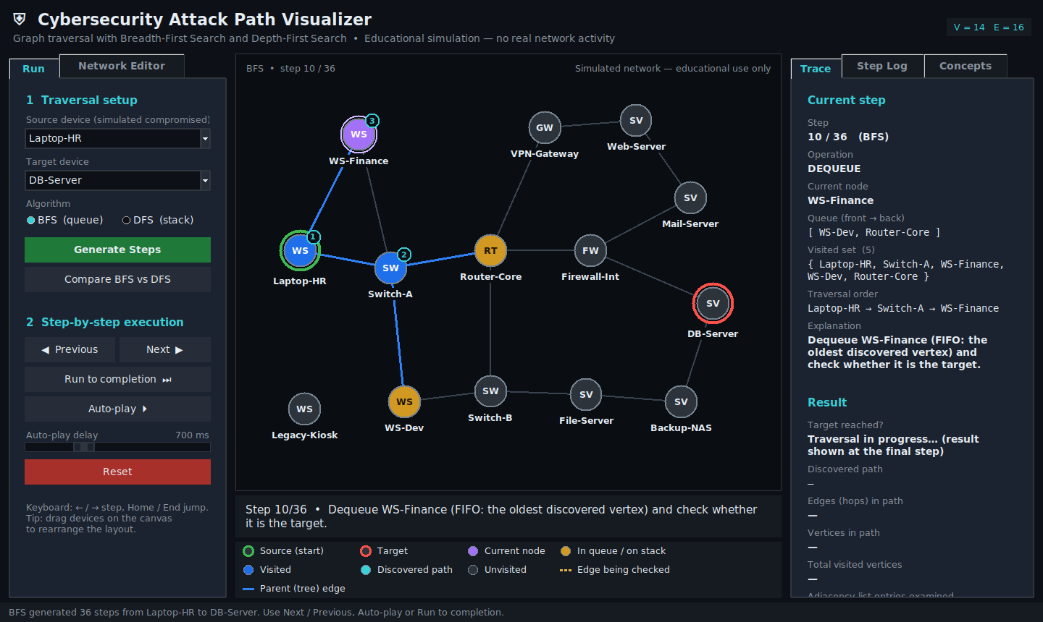
Figure 2 — BFS at step 10: WS-Finance is being processed (purple); WS-Dev and Router-Core wait in the queue (amber)
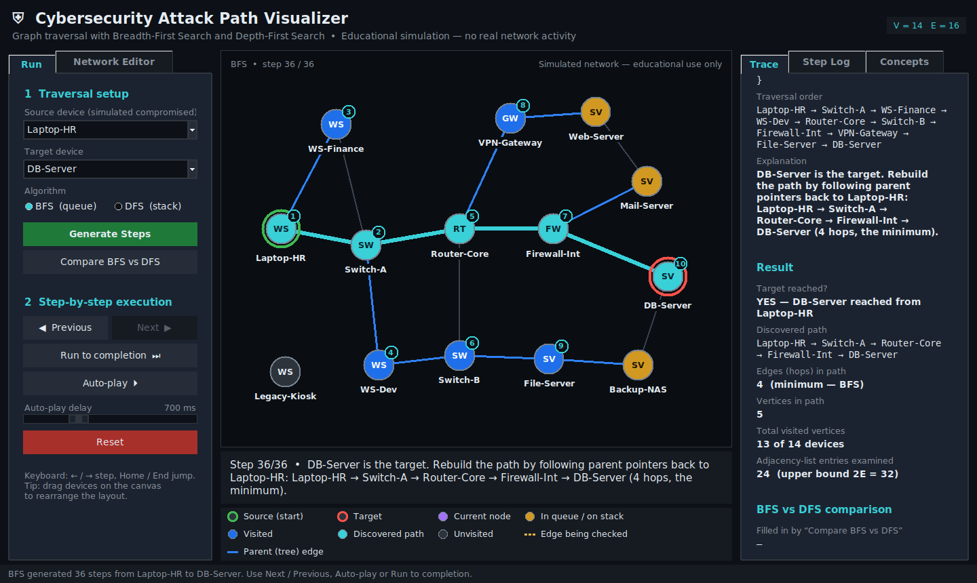  Figure 3 — BFS final step: 4-hop shortest path (cyan) | 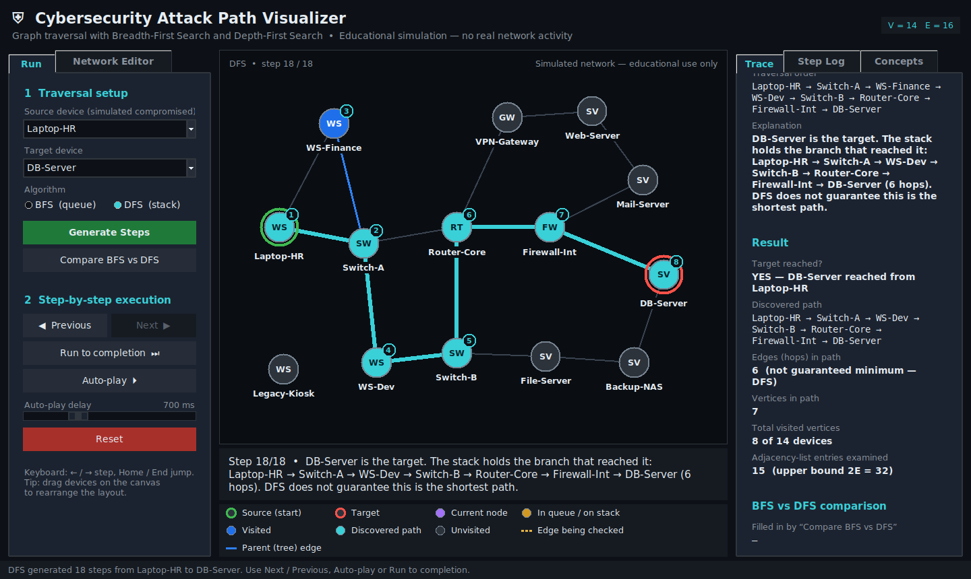  Figure 4 — DFS final step: valid but longer 6-hop path

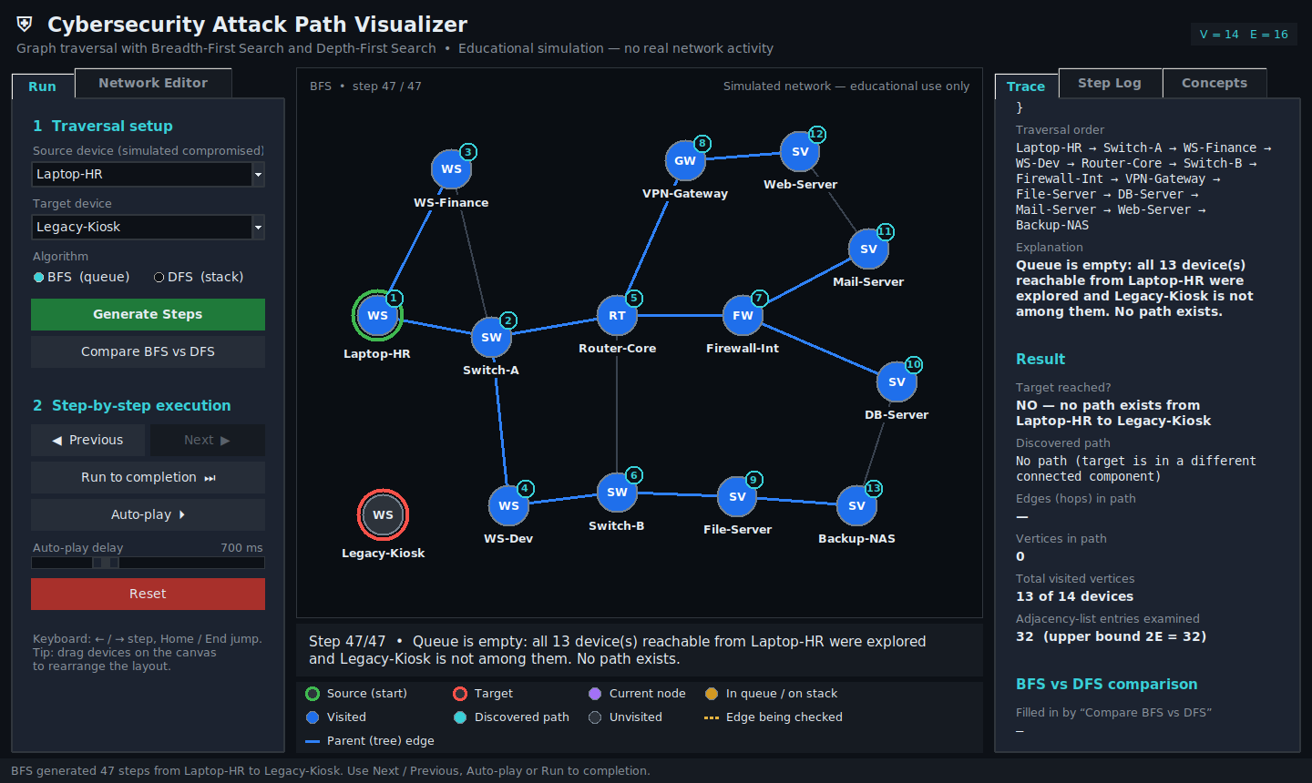  Figure 5 — Unreachable target: explicit “no path” result | 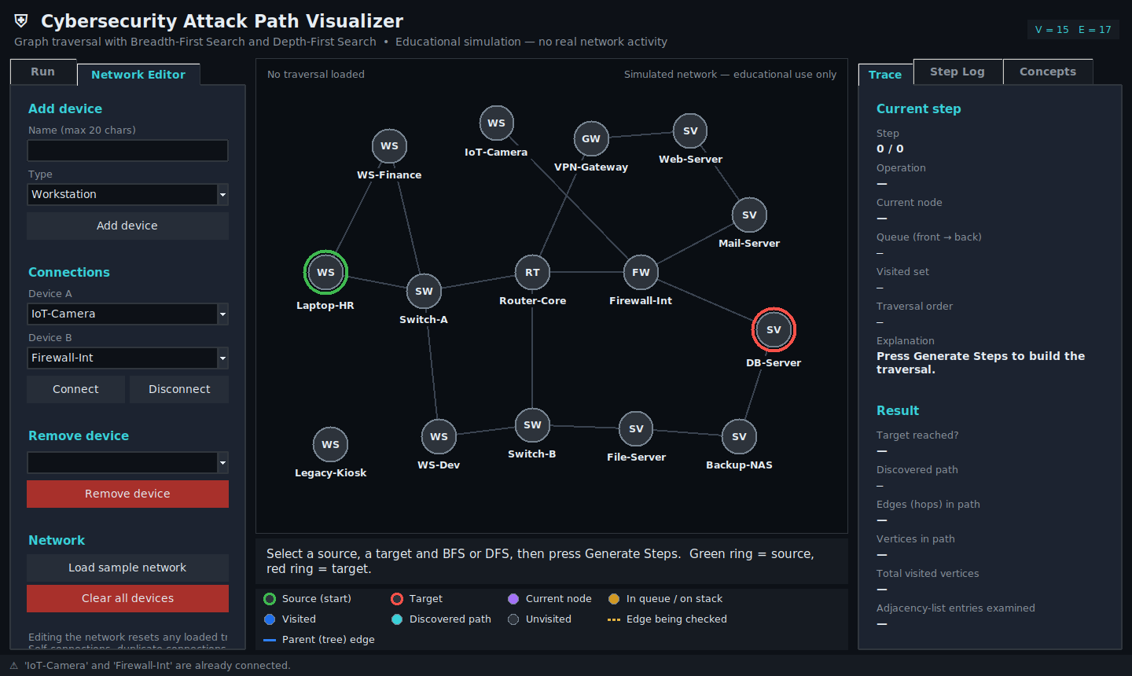  Figure 6 — Network editor: new device added; duplicate connection rejected (status bar)

13. Limitations
- The graph is unweighted and undirected, so it cannot model link cost, one-way firewall rules or vulnerability severity; BFS minimises hops, not risk.
- The network is limited to 30 devices for readability, and edited networks are not saved to disk.
- Node positions for user-added devices are chosen automatically; very dense graphs may still have crossing edges, although devices can be dragged.
- Step history stores full snapshots (Section 10), which suits this scale but not very large graphs. The GUI was verified on Linux with a virtual display; the Windows run is checked with the supplied checklist.

14. Future Enhancements
- Weighted edges with Dijkstra's algorithm, and directed edges to model firewall policy.
- Save and load networks as JSON; export the step trace as a report.
- Enumerate all simple attack paths, highlight articulation points using DFS low-link values, and add bidirectional BFS for comparison.

15. Conclusion
The project delivers a working, tested and documented GUI application that applies BFS and DFS to a meaningful cybersecurity-themed problem. The step-by-step visualisation makes the different data structures — FIFO queue versus LIFO stack — and their consequences directly visible: BFS expands in layers and always returns a minimum-hop path, whereas DFS dives down one branch and may return a longer one. Both run in O(V + E) time with O(V) auxiliary space on an adjacency list, and the implementation distinguishes this from the additional memory used purely for playback. Separating the algorithm layer from the interface allowed 41 automated tests, including 600 randomised oracle checks, to confirm correctness.

References
- T. H. Cormen, C. E. Leiserson, R. L. Rivest and C. Stein, Introduction to Algorithms, 3rd ed. MIT Press, 2009, Ch. 22 (Elementary Graph Algorithms).
- R. Sedgewick and K. Wayne, Algorithms, 4th ed. Addison-Wesley, 2011, Sec. 4.1 (Undirected Graphs).
- Python Software Foundation, “collections — Container datatypes (deque)”, Python 3 documentation, docs.python.org/3/library/collections.html.
- Python Software Foundation, “tkinter — Python interface to Tcl/Tk”, Python 3 documentation, docs.python.org/3/library/tkinter.html.

