Eoghan Leonard

Eoghan.leonard@connect.qut.edu.au

Abstract

This is the personal portfolio of work contributed  
 to group 94 during this semester

Personal Porfolio final

Eoghan Leonard

# Introduction

The last 5 weeks have been a relatively easier few weeks than the first 9 weeks of this semester for myself and another Information Systems student. The reason for this is our responsibility early on was assistance in the setup of the database and other logistics that fell inside our capabilities. For this last segment of the semester, the majority of the work was with the developers (CS students) as well as another IS member who has skills in the software. This meant that there was less hands on work for us to do. Instead of trying to help with the developing. We were assigned tasks, even though less intellectually demanding, still needed to be done. For myself this consisted of create large amounts of fake data to truly display the system to its full capacity. This includes making information for all of the tables, importing data, updating JIRA and finally editing the estimated times for the issues to the times that they actually took for an accurate log of our work. I chose to only display 4 artefacts as it was most logical to pile these activities into four different categories rather than for instance treating each table as a different element.

# Artefact 1

The first Artefact is the fake data that I had to create fake data for the database that has been completed. This artefact displays the completion of TaskID’s 5, 13 and 20. This artefact also includes work that was not on this release. In order to display the full functionality of the application, every data source needed to have fake data created for it. The fake data that I had to create were for the following tables:

* Property Owners
* Agents/staff
* Property’s
* Tenants

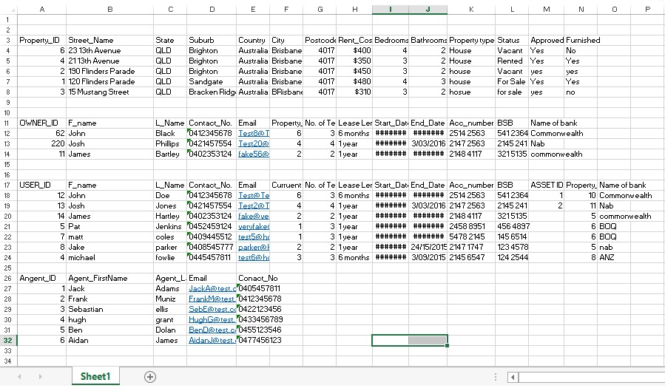The data was created in excel to be later imported into FileMaker. The Data that I created for the Properties had to be real addresses for many reasons. The primary reason was one of the great features of the application is being able to show a photo of the house that up for rent/sale. This relies on a real address and that the property has a photo stored against its address on Google Maps. I also had to make sure that the property ID’s matched up between the ‘Property’ table and the ‘Owners table’ as these fields are reliant on a link in the database. The following is a screenshot of all of the tables put into one large excel spread sheet just to show all of the data created in one space.

** Please ignore the hash symbol, the formatting for this spreadsheet did not like the dates **

The amount of data that was created for each table was relative to the need for large or small amount of data to show the capability.

# Artefact 2

The second task that I was assigned was importing these tables into the new version of our database. This is a similar process that I had to go through earlier on in the semester so I was familiar and comfortable taking on this task. In order for the full functionality of the application to be displayed, this data had to be imported with complete data accuracy. If any field did not match up with the way the database was set up, it would simply not work. The following process was repeated for all tables so I will only show once instance of the data importing.

Please note this process was in my previous portfolio but it was for a different data set and for a different reason. However the fields for this example are the same.

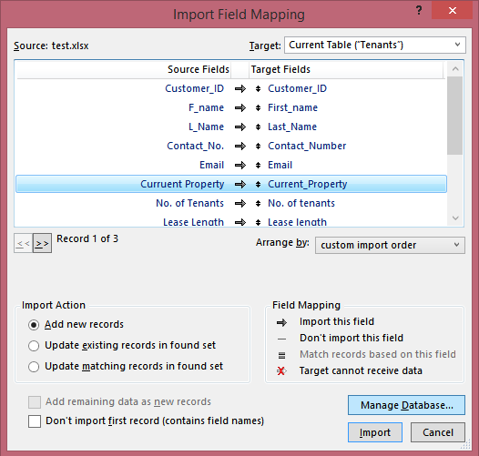

Great care was taken when matching up fields so that the application would run smoothly once this process was finished. This was repeated four times for the different tables and in the same fashion.

# Artefact 3

The third contribution I made was to check the JIRA profile for our group. Up to this point Virginia had done most of the work managing JIRA but I was assigned the task of checking all the task ID in JIRA against what our sprints and releases stated. This proved to be a fairly simple task but had to be done all the same. The team had apparently been quite active in updating JIRA but there were still tasks that needed to be edited and some tasks inputted. Unfortunately JIRA was down during the completion of this portfolio so I am not able to display the visual artefact of what I have done. Hopefully what I have explained s explicit enough. I waited as late as possible to see if JIRA would come back online but it did not. Here is the screenshot and time stamp of JIRA being down**.**

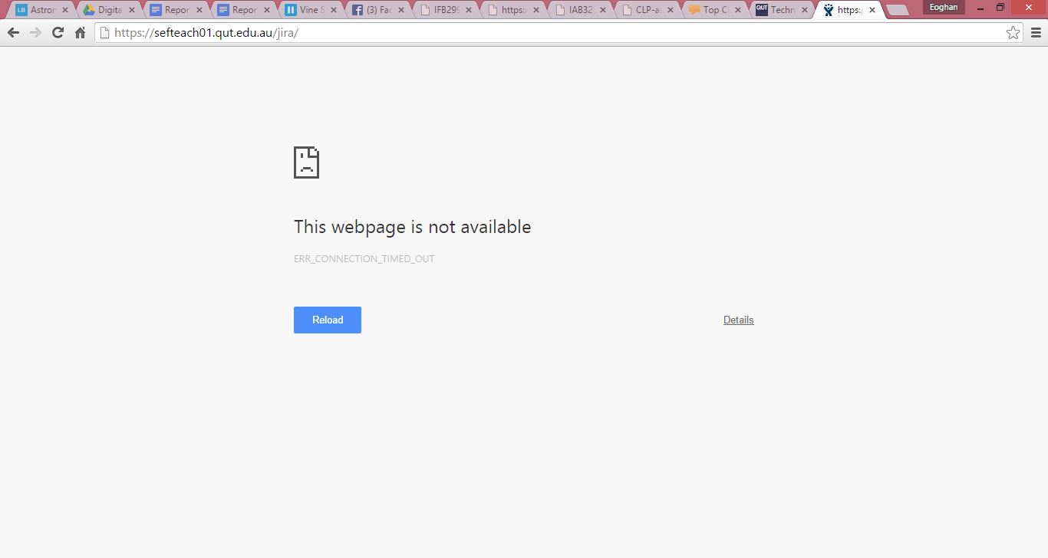



# **Artefact 4**

The fourth contribution I made to this project in the final weeks was again to do with JIRA. During the early stages of the assignment we were asked to give rough time estimations for each task. For example, creating the database was one task and was estimated at 3 hours. What we were required to do in JIRA was to input these tasks with time estimations to give a rough idea of the hours necessary to complete this tasks. It was quite common that when the tasks were completed, the time estimates that were originally given were wrong. So this tasks involved going through the tasks and the estimation and correcting them to give an accurate timeline of how long each task took and the overall time taken to complete the project. Once again JIRA was down at the completion of this tasks so I cannot get screenshots of the processes that I went through. But basically I would resolve the issue (Task) on JIRA and set the time that it took, then set the remaining time to zero hours. This indicated that the task was completed in a certain amount of time and that there is no more work to be done on that task.

# Artefact 5

# Conclusion

I have contributed, using my skills in formation technology, to this project. However I have been restricted with my limited knowledge on computer science. I have tried to apply my database logic and development knowledge to this task and believe it has made useful contribution so far.