V.P.C

* Create a VPC with two subnets (DevTeam and TestTeam) with 100 employees in each subnet. Make DevTeam subnet private and TestTeam subnet public. Create Ram-dev instance in DevTeam subnet and Mohan-test instance in TestTeam subnet. Connect with Mohan-test and create a folder.
* Ans:-

1. TestTeam subnet public-

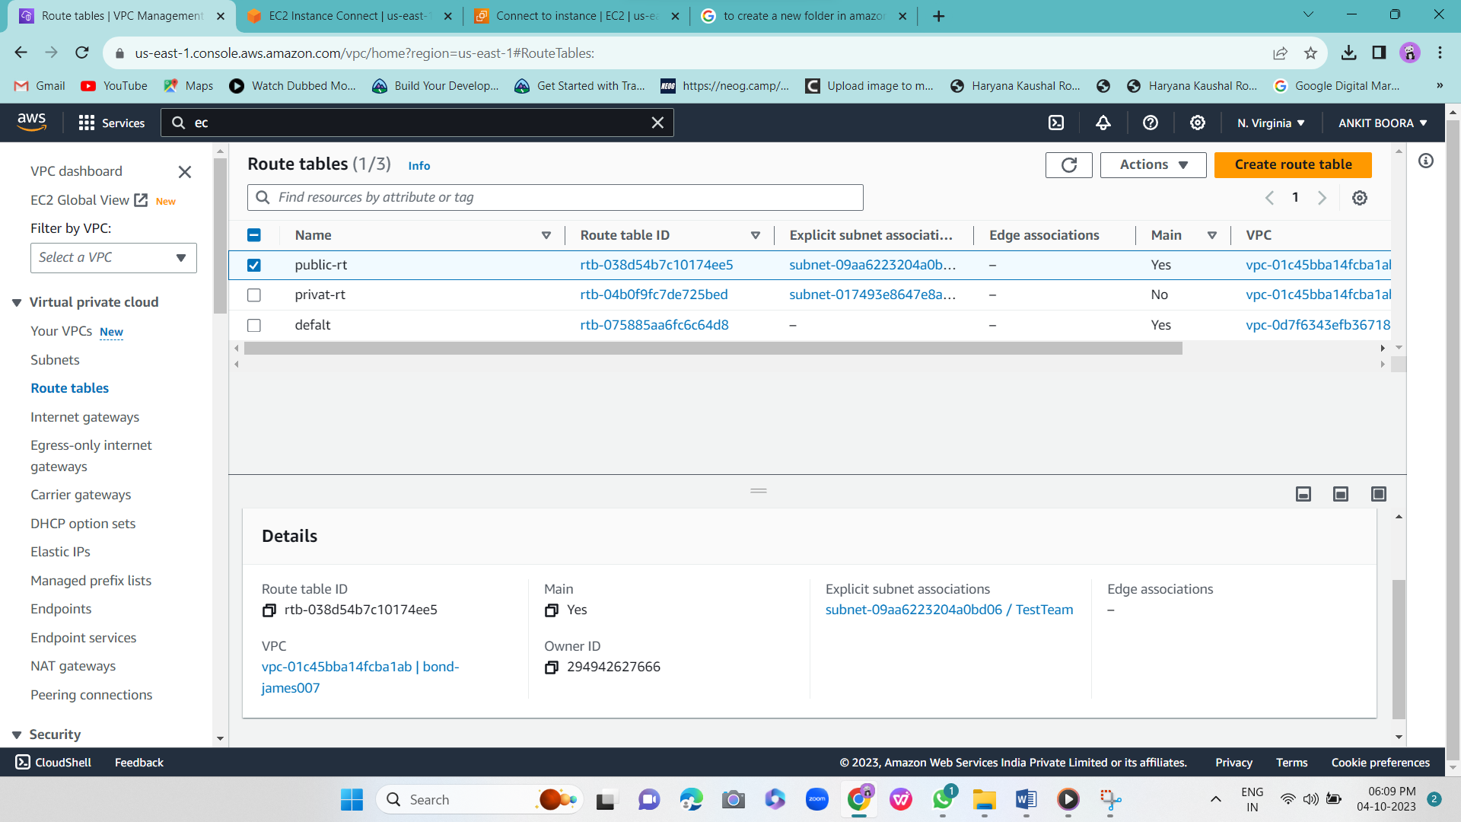

-Make DevTeam subnet private-

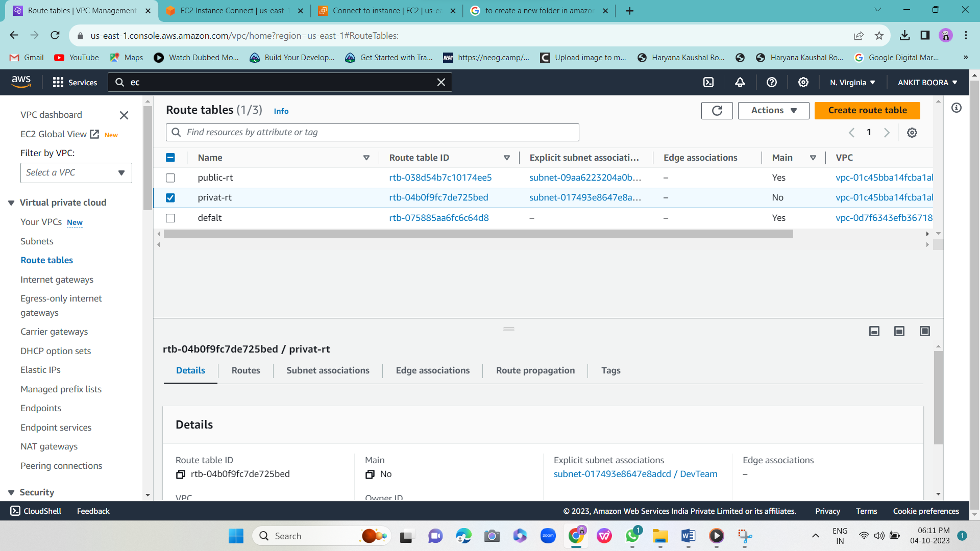

2-two subnets (DevTeam and TestTeam)-

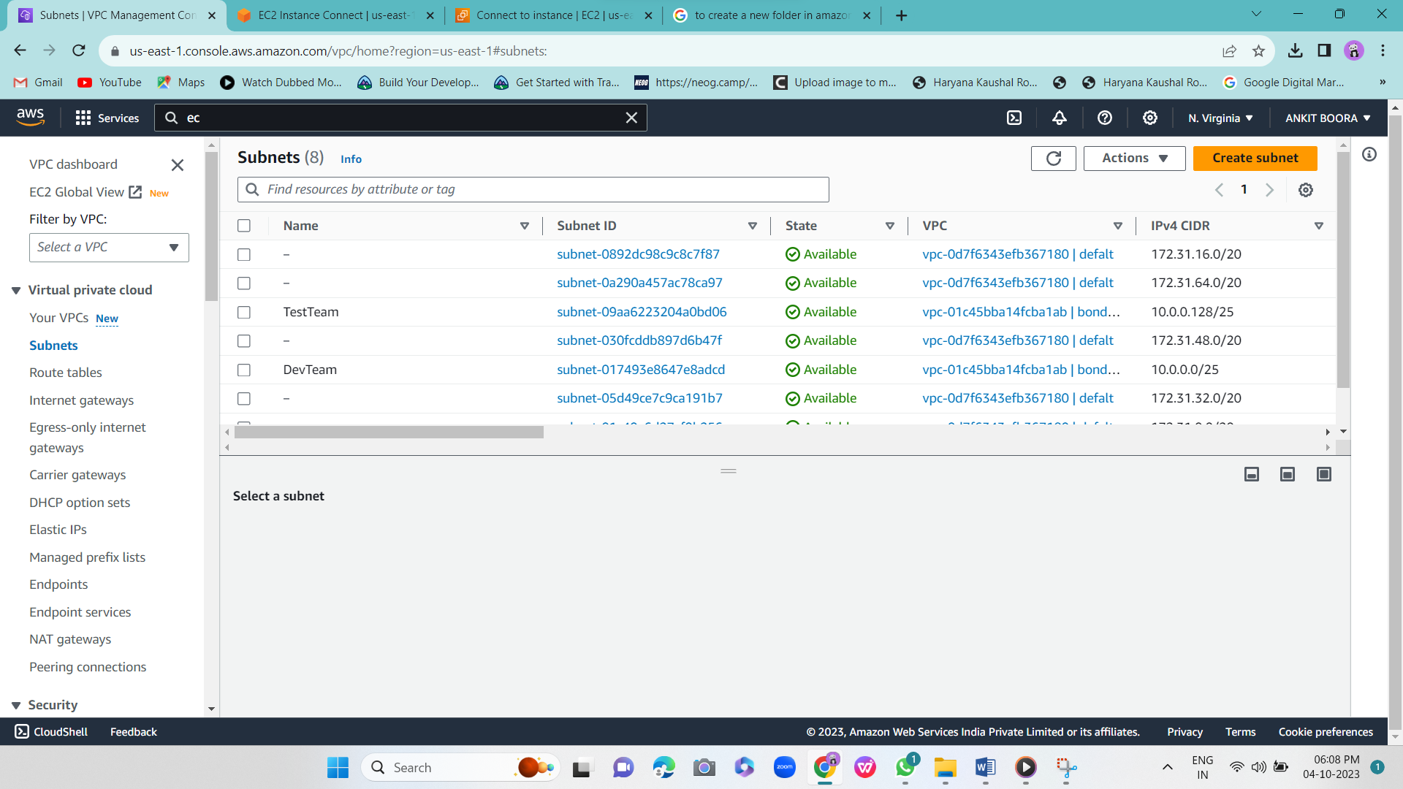

3-Connect with Mohan-test and create a folder

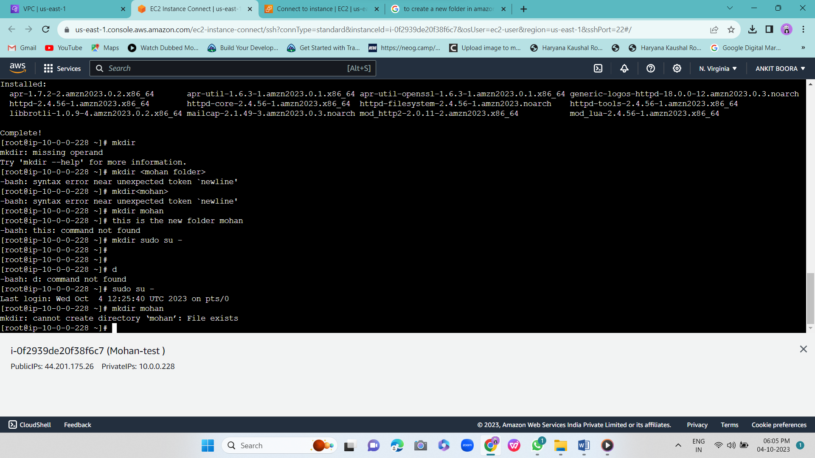

* Create a VPC (using IP 10.0.0.0) with 128 Ips, create 2 subnets. The public subnet should have 64 Ips and the private subnet should have 32 Ips. Implement NAT Gateway and VPN together.

Ans:-

A.public subnet should have 64 Ips and the private subnet should have 32 Ips—

A-

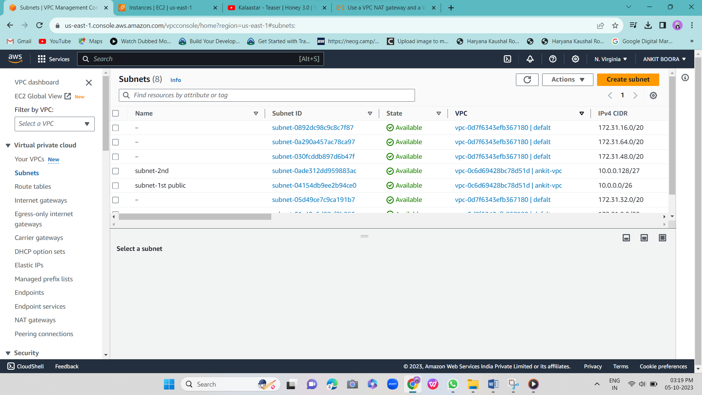

Q.3.Create 2 VPCs and use VPC peering connection to connect instance of one VPC to private instance of another VPC.

* Ans:-
* Step-1
* 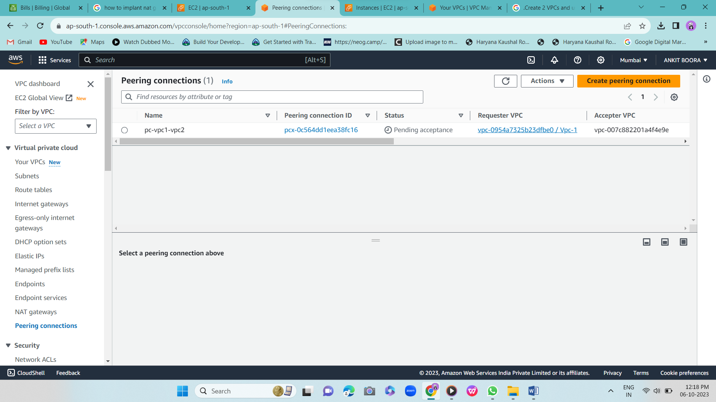
* Step-2
* 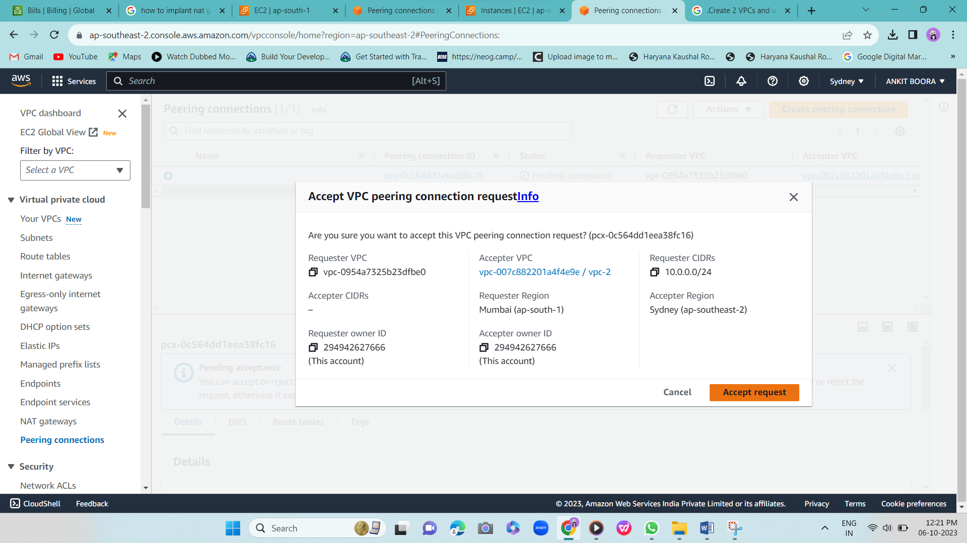
* Step-3
* 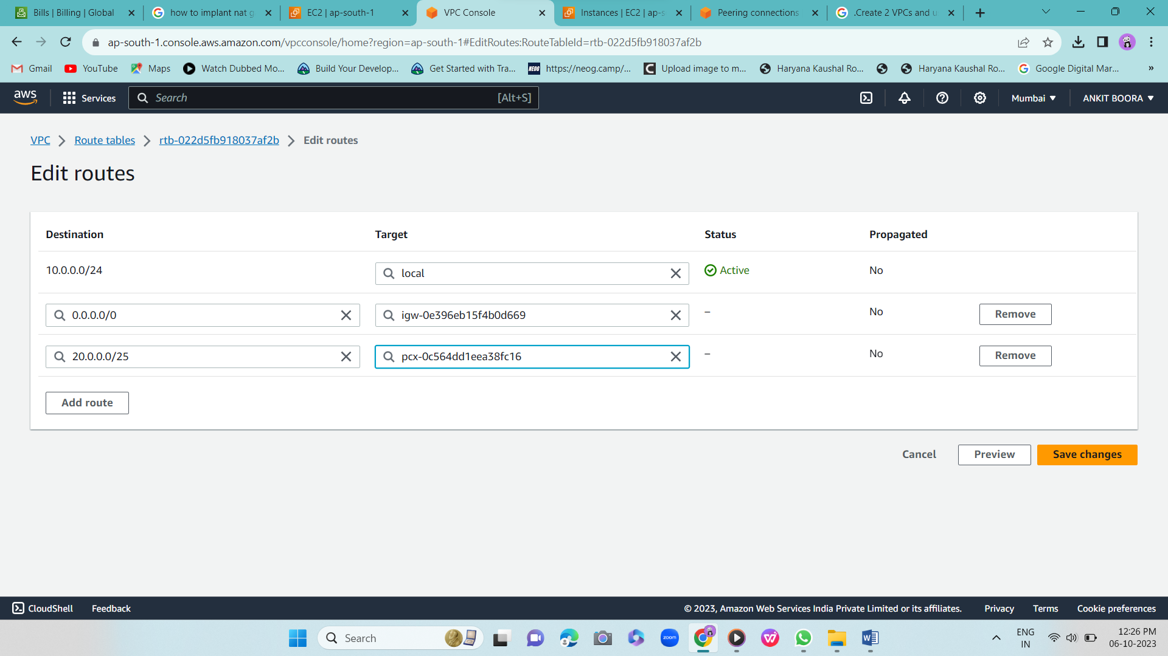
* Step-4
* 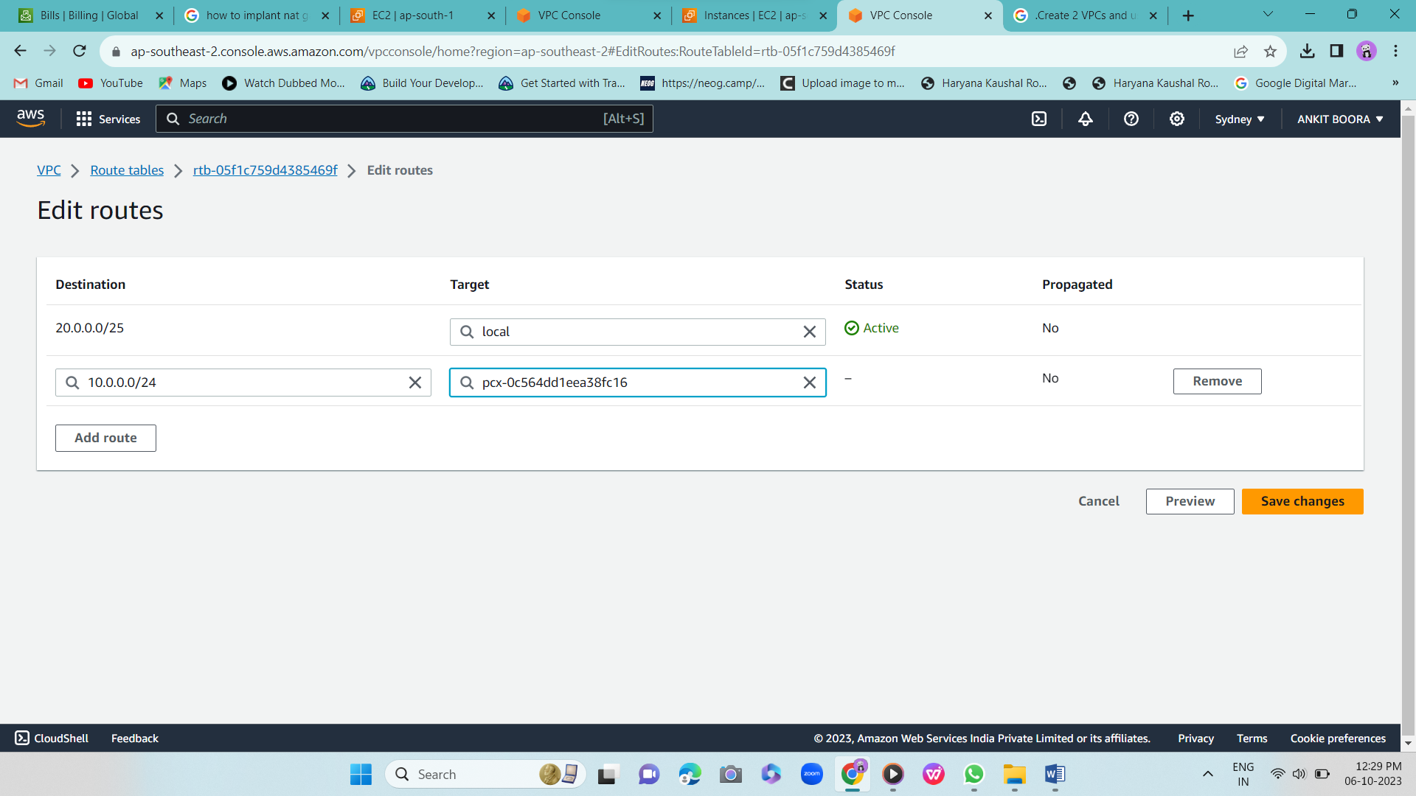
* Make short notes on: -

1. VPC
2. Subnet

Ans:-

1. VPC:- Virtual private clouds

  VPC sets aside logically isolated parts of a public cloud to create a virtual private environment.

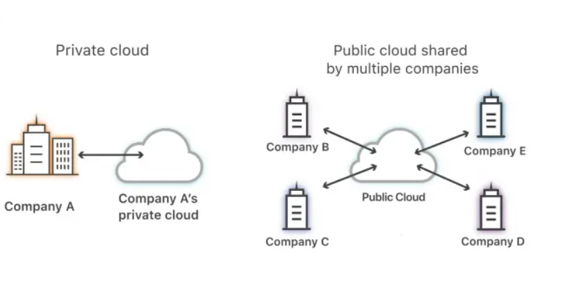

1. Subnet:-

Subnet is a network inside a network. Subnets make networks more efficient.

