SQL Server stored procedures are used to group one or more Transact-SQL statements into logical units. The stored procedure is stored as a named object in the SQL Server Database Server.

When you call a stored procedure for the first time, SQL Server creates an execution plan and stores it in the cache. In the subsequent executions of the stored procedure, SQL Server reuses the plan to execute the stored procedure very fast with reliable performance.

Creating a simple stored procedure

The following [SELECT](https://www.sqlservertutorial.net/sql-server-basics/sql-server-select/) statement returns a list of products from the products table in the BikeStores [sample database](https://www.sqlservertutorial.net/sql-server-sample-database/):

SELECT

product_name,

list_price

FROM

production.products

ORDER BY

product_name;

Code language: SQL (Structured Query Language) (sql)

To create a stored procedure that wraps this query, you use the CREATE PROCEDURE statement as follows:

CREATE PROCEDURE uspProductList

AS

BEGIN

SELECT

product_name,

list_price

FROM

production.products

ORDER BY

product_name;

END;

Code language: SQL (Structured Query Language) (sql)

In this syntax:

* The uspProductList is the name of the stored procedure.
* The AS keyword separates the heading and the body of the stored procedure.
* If the stored procedure has one statement, the BEGIN and END keywords surrounding the statement are optional. However, it is a good practice to include them to make the code clear.

Note that in addition to the CREATE PROCEDURE keywords, you can use the CREATE PROC keywords to make the statement shorter.

To compile this stored procedure, you execute it as a normal SQL statement in SQL Server Management Studio as shown in the following picture:

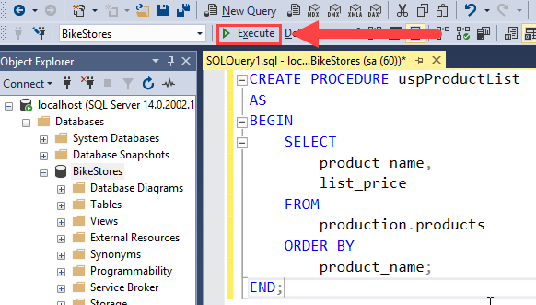

If everything is correct, then you will see the following message:

Commands completed successfully.

Code language: SQL (Structured Query Language) (sql)

It means that the stored procedure has been successfully compiled and saved into the database catalog.

You can find the stored procedure in the Object Explorer, under **Programmability > Stored Procedures** as shown in the following picture:

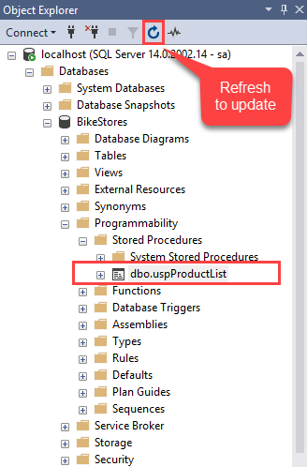

Sometimes, you need to click the **Refresh** button to manually update the database objects in the Object Explorer.

Executing a stored procedure

To execute a stored procedure, you use the EXECUTE or EXEC statement followed by the name of the stored procedure:

EXECUTE sp_name;

Code language: SQL (Structured Query Language) (sql)

Or

EXEC sp_name;

Code language: SQL (Structured Query Language) (sql)

where sp_name is the name of the stored procedure that you want to execute.

For example, to execute the uspProductList stored procedure, you use the following statement:

EXEC uspProductList;

Code language: SQL (Structured Query Language) (sql)

The stored procedure returns the following output:

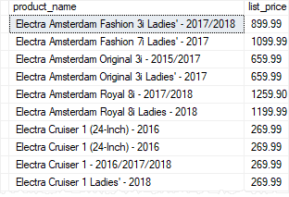

Modifying a stored procedure

To modify an existing stored procedure, you use the ALTER PROCEDURE statement.

First, open the stored procedure to view its contents by right-clicking the stored procedure name and select **Modify** menu item:

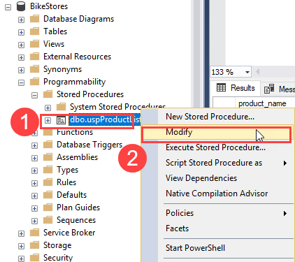

Second, change the body of the stored procedure by sorting the products by list prices instead of product names:

ALTER PROCEDURE uspProductList

AS

BEGIN

SELECT

product_name,

list_price

FROM

production.products

ORDER BY

list_price

END;

Code language: SQL (Structured Query Language) (sql)

Third, click the **Execute** button, SQL Server modifies the stored procedure and returns the following output:

Commands completed successfully.

Code language: SQL (Structured Query Language) (sql)

Now, if you execute the stored procedure again, you will see the changes taking effect:

EXEC uspProductList;

Code language: SQL (Structured Query Language) (sql)

The following shows the partial output:

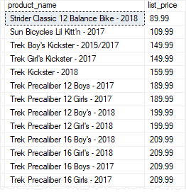

Deleting a stored procedure

To delete a stored procedure, you use the DROP PROCEDURE or DROP PROC statement:

DROP PROCEDURE sp_name;

Code language: SQL (Structured Query Language) (sql)

or

DROP PROC sp_name;

Code language: SQL (Structured Query Language) (sql)

where sp_name is the name of the stored procedure that you want to delete.

For example, to remove the uspProductList stored procedure, you execute the following statement:

DROP PROCEDURE uspProductList;