**SQL SERVER JOINS Tutorial with Examples: INNER, LEFT, RIGHT, OUTER**

We can retrieve data from more than one tables using the JOIN statement. There are mainly 4 different types of JOINS in SQL server. We will learn all JOINS in [SQL server](https://www.guru99.com/ms-sql-server-tutorial.html) with examples:

* INNER JOIN/simple join
* LEFT OUTER JOIN/LEFT JOIN
* RIGHT OUTER JOIN/RIGHT JOIN
* FULL OUTER JOIN

**INNER JOIN**

This type of SQL server JOIN returns rows from all tables in which the join condition is true. It takes the following syntax:

SELECT columns

FROM table_1

INNER JOIN table_2

ON table_1.column = table_2.column;

We will use the following two tables to demonstrate this:

**Students Table:**

[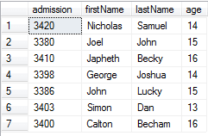](https://www.guru99.com/images/1/031519_0545_SQLSERVERJO1.png)

**Fee table:**

[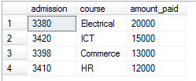](https://www.guru99.com/images/1/031519_0545_SQLSERVERJO2.png)

The following command demonstrates an INNER JOIN in SQL server with example:

SELECT Students.admission, Students.firstName, Students.lastName, Fee.amount_paid

FROM Students

INNER JOIN Fee

ON Students.admission = Fee.admission

The command returns the following

[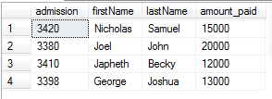](https://www.guru99.com/images/1/031519_0545_SQLSERVERJO3.png)

We can tell the students who have paid their fee. We used the column with common values in both tables, which is the admission column.

## LEFT OUTER JOIN

This type of join will return all rows from the left-hand table plus records in the right-hand table with matching values. For example:

SELECT Students.admission, Students.firstName, Students.lastName, Fee.amount_paid

FROM Students

LEFT OUTER JOIN Fee

ON Students.admission = Fee.admission

The code returns the following:

[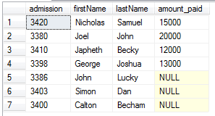](https://www.guru99.com/images/1/031519_0545_SQLSERVERJO4.png)

The records without matching values are replaced with NULLs in the respective columns.

## RIGHT OUTER JOIN

This type of join returns all rows from the right-hand table and only those with matching values in the left-hand table. For example:

SELECT Students.admission, Students.firstName, Students.lastName, Fee.amount_paid

FROM Students

RIGHT OUTER JOIN Fee

ON Students.admission = Fee.admission

The statement for OUTER JOINS SQL server returns the following:

[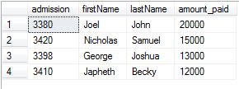](https://www.guru99.com/images/1/031519_0545_SQLSERVERJO5.png)

The reason for the above output is that all rows in the Fee table are available in the Students table when matched on the admission column.

## FULL OUTER JOIN

This type of join returns all rows from both tables with NULL values where the JOIN condition is not true. For example:

SELECT Students.admission, Students.firstName, Students.lastName, Fee.amount_paid

FROM Students

FULL OUTER JOIN Fee

ON Students.admission = Fee.admission

The code returns the following result for FULL OUTER JOINS queries in SQL:

[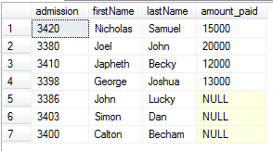](https://www.guru99.com/images/1/031519_0545_SQLSERVERJO6.png)