Introduction to SQL Server ANY operator

The ANY operator is a logical operator that compares a scalar value with a single-column set of values returned by a [subquery](https://www.sqlservertutorial.net/sql-server-basics/sql-server-subquery/).

The following shows the syntax of the ANY operator:

scalar_expression comparison_operator ANY (subquery)

Code language: SQL (Structured Query Language) (sql)

In this syntax:

* scalar_expression is any valid expression.
* comparison_operator is any comparison operator.
* subquery is a [SELECT](https://www.sqlservertutorial.net/sql-server-basics/sql-server-select/) statement which returns a result set of a single column with the data is the same as the data type of the scalar expression.

Suppose the subquery returns a list of values v1, v2, …,  vn. The ANY operator returns TRUE if any comparison (scalar_expression, vi) returns TRUE. Otherwise, it returns FALSE.

Note that the SOME operator is equivalent to the ANY operator.

SQL Server ANY operator example

See the following products table from the [sample database](https://www.sqlservertutorial.net/sql-server-sample-database/).

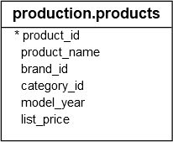

The following example finds the products that were sold with more than two units in a sales order:

SELECT

product_name,

list_price

FROM

production.products

WHERE

product_id = ANY (

SELECT

product_id

FROM

sales.order_items

WHERE

quantity >= 2

)

ORDER BY

product_name;

## Overview of the SQL Server ALL operator

The SQL Server ALL operator is a logical operator that compares a scalar value with a single-column list of values returned by a [subquery](https://www.sqlservertutorial.net/sql-server-basics/sql-server-subquery/).

The following illustrates the ALL operator syntax:

scalar_expression comparison_operator ALL ( subquery)

Code language: SQL (Structured Query Language) (sql)

In this syntax:

* The scalar_expression is any valid expression.
* The comparison_operator is any valid comparison operator including equal (=), not equal (<>), greater than (>), greater than or equal (>=), less than (<), less than or equal (<=).
* The subquery within the parentheses is a [SELECT](https://www.sqlservertutorial.net/sql-server-basics/sql-server-select/) statement that returns a result of a single column. Also, the data type of the returned column must be the same data type as the data type of the scalar expression.

The ALL operator (scalar_expression, v) evaluates to TRUE; v is a value in the single-column result.

If one of the pairs (scalar_expression, v) returns FALSE, then the ALL operator returns FALSE.

## SQL Server ALL operator examples

Consider the following products table from the [sample database](https://www.sqlservertutorial.net/sql-server-sample-database/).



The following statement returns a list average list prices of products for each brand:

SELECT

AVG (list_price) avg_list_price

FROM

production.products

GROUP BY

brand_id

ORDER BY

avg_list_price;

Code language: SQL (Structured Query Language) (sql)

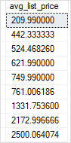

### **1) scalar_expression > ALL ( subquery )**

The expression returns TRUE if the scalar_expression is greater than the largest value returned by the subquery.

For example, the following query finds the products whose list prices are bigger than the average list price of products of all brands:

SELECT

product_name,

list_price

FROM

production.products

WHERE

list_price > ALL (

SELECT

AVG (list_price) avg_list_price

FROM

production.products

GROUP BY

brand_id

)

ORDER BY

list_price;

Code language: SQL (Structured Query Language) (sql)

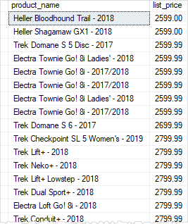

### **2) scalar_expression < ALL ( subquery )**

The expression evaluates to TRUE if the scalar expression is smaller than the smallest value returned by the subquery.

The following example finds the products whose list price is less than the smallest price in the average price list by brand:

SELECT

product_name,

list_price

FROM

production.products

WHERE

list_price < ALL (

SELECT

AVG (list_price) avg_list_price

FROM

production.products

GROUP BY

brand_id

)

ORDER BY

list_price DESC;

Code language: SQL (Structured Query Language) (sql)

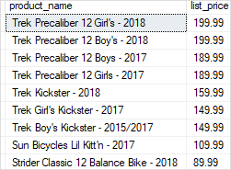

Similarly, you can take your own examples of using the ALL operator with one of the following comparison operators such as equal to (=), greater than or equal (>=), less than or equal to (<=), and not equal (<>).