Introduction to SQL Server DENSE_RANK() function

The DENSE_RANK() is a [window function](https://www.sqlservertutorial.net/sql-server-window-functions/) that assigns a rank to each row within a partition of a result set. Unlike the [RANK()](https://www.sqlservertutorial.net/sql-server-window-functions/sql-server-rank-function/) function, the DENSE_RANK() function returns consecutive rank values. Rows in each partition receive the same ranks if they have the same values.

The syntax of the DENSE_RANK() function is as follows:

DENSE_RANK() OVER (

[PARTITION BY partition_expression, ... ]

ORDER BY sort_expression [ASC | DESC], ...

)

Code language: SQL (Structured Query Language) (sql)

The DENSE_RANK() function is applied to the rows of each partition defined by the PARTITION BY clause, in a specified order, defined by ORDER BY clause. It resets the rank when the partition boundary is crossed.

The PARITION BY clause is optional. If you omit it, the function will treat the whole result set as a single partition.

SQL Server DENSE_RANK() function illustration

The following statements [create a new table](https://www.sqlservertutorial.net/sql-server-basics/sql-server-create-table/) named dense_rank_demo and [insert](https://www.sqlservertutorial.net/sql-server-basics/sql-server-insert/) some rows into that table:

CREATE TABLE sales.dense_rank_demo (

v VARCHAR(10)

);

INSERT INTO sales.dense_rank_demo(v)

VALUES('A'),('B'),('B'),('C'),('C'),('D'),('E');

SELECT * FROM sales.dense_rank_demo;

Code language: SQL (Structured Query Language) (sql)

The following statement uses both DENSE_RANK() and RANK() functions to assign a rank to each row of the result set:

SELECT

v,

DENSE_RANK() OVER (

ORDER BY v

) my_dense_rank,

RANK() OVER (

ORDER BY v

) my_rank

FROM

sales.dense_rank_demo;

Code language: SQL (Structured Query Language) (sql)

Here is the output:

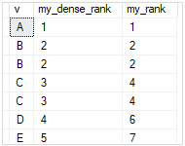

SQL Server DENSE_RANK() function examples

We will use the production.products table to demonstrate the DENSE_RANK() function:

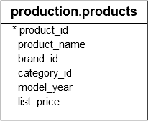

Using SQL Server DENSE_RANK() over a result set example

The following example uses the DENSE_RANK() function to rank products by list prices:

SELECT

product_id,

product_name,

list_price,

DENSE_RANK () OVER (

ORDER BY list_price DESC

) price_rank

FROM

production.products;

Code language: SQL (Structured Query Language) (sql)

Here is the output:

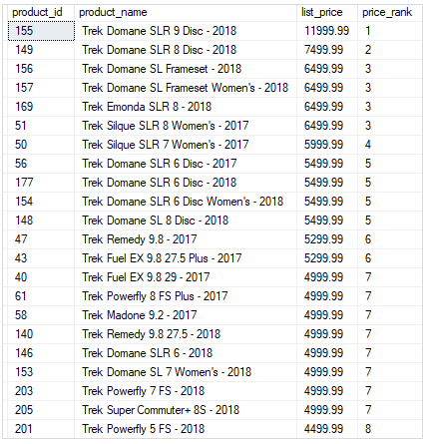

Using SQL Server DENSE_RANK() over partitions example

The following statement ranks products in each category by list prices. It returns only the top 3 products per category by list prices.

SELECT * FROM (

SELECT

product_id,

product_name,

category_id,

list_price,

DENSE_RANK () OVER (

PARTITION BY category_id

ORDER BY list_price DESC

) price_rank

FROM

production.products

) t

WHERE price_rank < 3;

Code language: SQL (Structured Query Language) (sql)

The following picture shows the output:

