SQL Server column alias

When you use the [SELECT](https://www.sqlservertutorial.net/sql-server-basics/sql-server-select/) statement to query data from a table, SQL Server uses the column names as the column headings for the output. See the following example:

SELECT

first_name,

last_name

FROM

sales.customers

ORDER BY

first_name;

Code language: SQL (Structured Query Language) (sql)

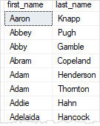

As clearly shown in the output, the first_name and last_name column names were used for the column headings respectively.

To get full names of customers, you can concatenate the first name, space, and the last name using the concatenation  + operator as shown in the following query:

SELECT

first_name + ' ' + last_name

FROM

sales.customers

ORDER BY

first_name;

Code language: SQL (Structured Query Language) (sql)

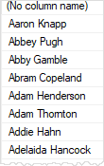

SQL Server returned the full name column as ( No column name) which is not meaningful in this case.

To assign a column or an expression a temporary name during the query execution, you use a column alias.

The following illustrates the column alias syntax:

column_name | expression AS column_alias

Code language: SQL (Structured Query Language) (sql)

In this syntax, you use the AS keyword to separate the column name or expression and the alias.

Because the AS keyword is optional, you can assign an alias to a column as follows:

column_name | expression column_alias

Code language: SQL (Structured Query Language) (sql)

Back to the example above, you can rewrite the query using a column alias:

SELECT

first_name + ' ' + last_name AS full_name

FROM

sales.customers

ORDER BY

first_name;

Code language: SQL (Structured Query Language) (sql)

Note that if the column alias contains spaces, you need to enclose it in quotation marks as shown in the following example:

SELECT

first_name + ' ' + last_name AS 'Full Name'

FROM

sales.customers

ORDER BY

first_name;

Code language: SQL (Structured Query Language) (sql)

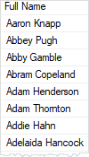

The following example shows how to assign an alias to a column:

SELECT

category_name 'Product Category'

FROM

production.categories;

Code language: SQL (Structured Query Language) (sql)

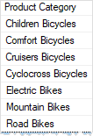

In this example, the product category column alias is much more clear than the category_name column name.

When you assign a column an alias, you can use either the column name or the column alias in the [ORDER BY](https://www.sqlservertutorial.net/sql-server-basics/sql-server-order-by/) clause as shown in the following example:

SELECT

category_name 'Product Category'

FROM

production.categories

ORDER BY

category_name;

SELECT

category_name 'Product Category'

FROM

production.categories

ORDER BY

'Product Category';

Code language: SQL (Structured Query Language) (sql)

Note that the ORDER BY clause is the very last clause to be processed therefore the column aliases are known at the time of sorting.

SQL Server table alias

A table can be given an alias which is known as correlation name or range [variable](https://www.sqlservertutorial.net/sql-server-stored-procedures/variables/).

Similar to the column alias, a table alias can be assigned either with or without the AS keyword:

table_name AS table_alias

table_name table_alias

Code language: SQL (Structured Query Language) (sql)

See the following example:

SELECT

sales.customers.customer_id,

first_name,

last_name,

order_id

FROM

sales.customers

INNER JOIN sales.orders ON sales.orders.customer_id = sales.customers.customer_id;

Code language: SQL (Structured Query Language) (sql)

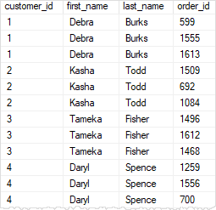

In this example, both the customers and the orders tables have a column with the same name customer_id, therefore, you need to refer to the column using the following syntax:

table_name.column_name

Code language: SQL (Structured Query Language) (sql)

such as:

sales.custoners.customer_id

sales.orders.customer_id

Code language: SQL (Structured Query Language) (sql)

If you did not do so, SQL server would issue an error.

The query above is quite difficult to read. Fortunately, you can improve its readability by using the table alias as follows:

SELECT

c.customer_id,

first_name,

last_name,

order_id

FROM

sales.customers c

INNER JOIN sales.orders o ON o.customer_id = c.customer_id;

Code language: SQL (Structured Query Language) (sql)

In this query, c is the alias for the sales.customers table and o is the alias for the sales.orders table.

When you assign an alias to a table, you must use the alias to refer to the table column. Otherwise, SQL Server will issue an error.