**Targeted Marketing Strategy for Term Deposit Acquisition**

Problem Statement:

**Business Use Case:** The bank is experiencing a drop in its income, and they have discovered that their customers are not depositing money as often as before. Term deposits are a type of savings account where people agree to keep their money in the bank for a specific period. This allows the bank to invest that money and make more profit. When customers have term deposits, the bank can also try to convince them to buy other products like investment funds or insurance, which can make the bank even more money. So, the bank wants to find out which customers are more likely to agree to a term deposit and focus their advertising and marketing efforts on those customers to increase their income.

**Data Science Problem Statement**

Predict if the client will subscribe to a term deposit based on the analysis of the marketing campaigns the bank performed.

**Evaluation Metric**

We will be using ROC-AUC for evaluation.

Understanding the dataset

**Data Set Information**

The data is related to direct marketing campaigns of a banking institution. The marketing campaigns were based on phone calls. Often, more than one contact to the same client was required, in order to access if the product (bank term deposit) would be subscribed ('yes') or not ('no') subscribed.

Goal: - The classification goal is to predict if the client will subscribe (yes/no) a term deposit (variable y).

**Features**

| Feature | Feature_Type | Description |
| --- | --- | --- |
| age | numeric | age of a person |
| job | Categorical, nominal | type of job ('admin.','blue-collar','entrepreneur','housemaid','management','retired','self-employed','services','student','technician','unemployed','unknown') |
| marital | categorical, nominal | marital status ('divorced','married','single','unknown'; note: 'divorced' means divorced or widowed) |
| education | categorical, nominal | ('basic.4y','basic.6y','basic.9y','high.school','illiterate','professional.course','university.degree','unknown') |
| default | Categorical, nominal | has credit in default? ('no','yes','unknown') |
| housing | categorical,  nominal | has housing loan? ('no','yes','unknown') |
| loan | categorical, nominal | has personal loan? ('no','yes','unknown') |
| contact | categorical, nominal | contact communication type ('cellular','telephone') |
| month | categorical, ordinal | last contact month of year ('jan', 'feb', 'mar', ..., 'nov', 'dec') |
| day_of_week | categorical, ordinal | last contact day of the week ('mon','tue','wed','thu','fri') |
| duration | numeric | last contact duration, in seconds . Important note: this attribute highly affects the output target (e.g., if duration=0 then y='no') |
| campaign | numeric | number of contacts performed during this campaign and for this client (includes last contact) |
| pdays | numeric | number of days that passed by after the client was last contacted from a previous campaign (999 means client was not previously contacted) |
| previous | numeric | number of contacts performed before this campaign and for this client |
| poutcome | categorical, nominal | outcome of the previous marketing campaign ('failure','nonexistent','success') |

**Target variable (desired output):**

| Feature | Feature_Type | Description |
| --- | --- | --- |
| y | binary | has the client subscribed a term deposit? ('yes','no') |

**Services & Tools:**

1. Visualization Tools: - Apache Superset
2. MLOps Tool: - Kubeflow
3. Programming Language: - Python
4. Machine Learning - Scikit Learn
5. Apache spark
6. Apache Airflow
7. Jupyter Notebook
8. Graphana
9. Ezpresto
10. Minio S3 storage

**Proposed Architecture:**

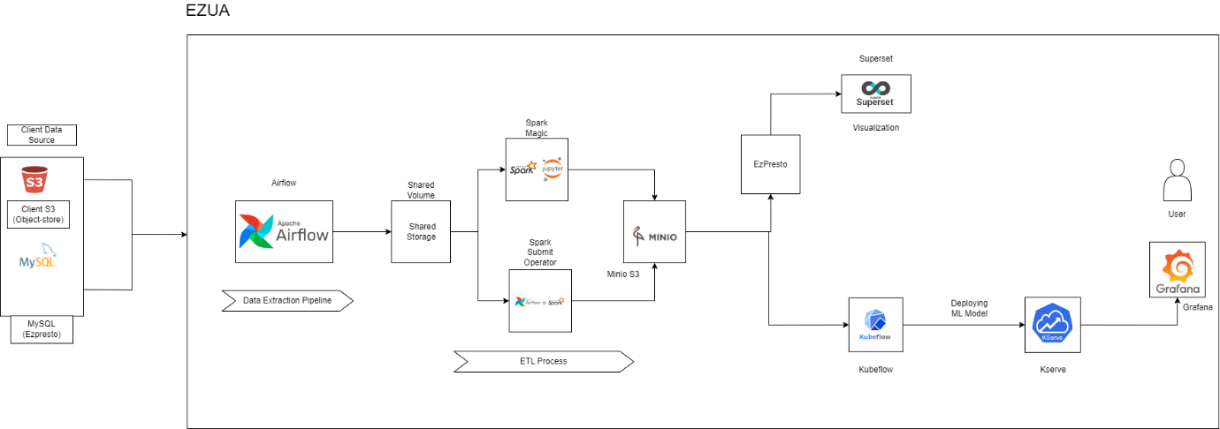

**Workflow:**

- Retrieve data from different client data sources, including S3 object store and SQL databases.  
- Utilize Airflow DAGs to extract data from client sources and store it in a shared storage system on our cluster.  
- Process the data using Spark, which can be invoked through Spark magic or within the Airflow DAG.  
- Upload the processed data to a Minio S3 object store.  
- Connect Minio to EzPresto for data visualization in Superset.  
- Perform model training and prediction using Kubeflow and its pipelines, executed within Jupyter notebooks.  
- Interpret the trained models using Kserve.  
- Visualize the data and results using Grafana.

**Airflow:**

Airflow is a powerful tool used for data extraction and the ETL (Extract, Transform, Load) process. In the context of this experiment, two DAGs (Directed Acyclic Graphs) are employed. The first DAG is responsible for data extraction, while the second DAG invokes Spark for data processing.

**DAG 1: Data Extraction:**

This DAG focuses on fetching files from various data sources belonging to customers and pushing them to shared volumes in our cluster. All the tasks within this DAG are implemented as Python operators. The data sources involved are Minio S3 (an object store) and a MySQL database.

This DAG comprises 5 tasks:

* **cleanup_export_dir:** This task clears the shared storage directory to ensure that any previously existing files are removed before the extraction process.
* **get_all_filepaths_from_s3_path:** This task retrieves all the files from the customer's S3 bucket in Minio S3.
* **split_mysql_tables_from_str:** This task extracts the table name(s) from which data is to be fetched. It takes a string input containing comma-separated table names and splits it into individual table names.
* **download_s3_file_to_shared_volume:** This task downloads the file from the S3 storage into the shared volume, making it locally available for further processing.
* **export_mysql_table_to_csv_shared_volume:** This task converts the specified SQL table into CSV format and stores it in the shared volume.

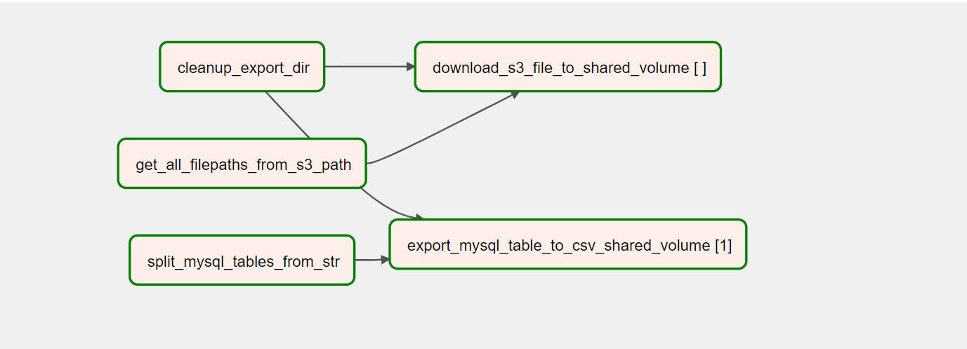

**DAG2: Invoking spark through Airflow**

This DAG is responsible for invoking a Spark application on a Kubernetes cluster and running Spark jobs. The SparkKubernetesOperator is utilized for this purpose.

The main task within this DAG is **spark_etl_submit**. This task creates a new Spark Application object on the Kubernetes cluster and executes the required jobs. The Spark job fetches files from the shared volume, performs the necessary processing, and loads the transformed data into Minio S3.

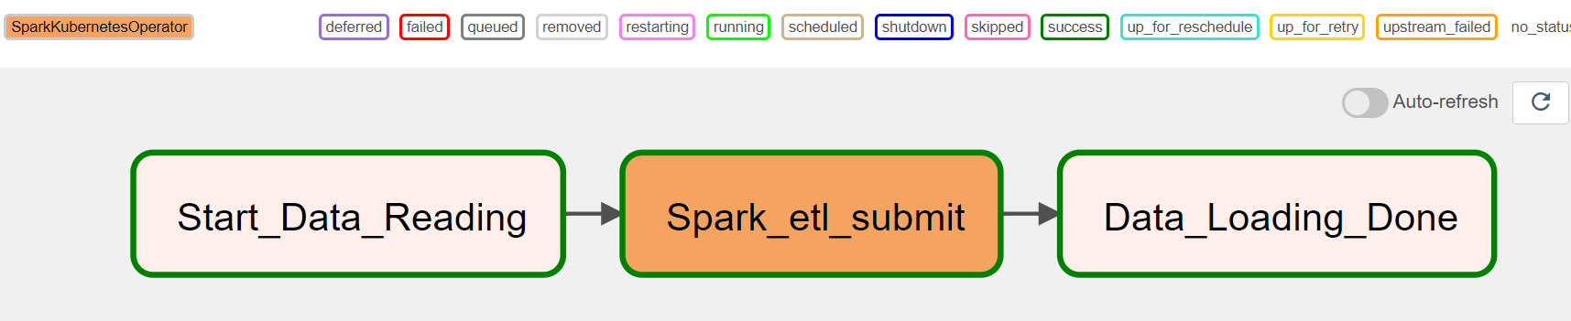

**Superset Dashboard:**

* **Proportion of Customers with Credit Default, Housing Loans, and Personal Loans**

1. Credit in Default: This refers to customers who have failed to repay their credit obligations on time, resulting in default. The percentage of customers with credit in default tells you how many people out of the total customer population have defaulted on their credit payments.

2. Housing Loans: This indicates whether customers have taken loans to finance their housing or real estate properties. The percentage of customers with housing loans tells you what portion of the customer base has borrowed money for housing purposes.

3. Personal Loans: This indicates whether customers have taken loans for personal use, such as for education, travel, or other personal expenses. The percentage of customers with personal loans tells you the proportion of customers who have taken loans for non-housing-related purposes.

By calculating the percentages, you can understand the prevalence of these financial arrangements among the customers in the dataset. For example, if 20% of customers have credit in default, it means that 20 out of every 100 customers in the dataset have failed to repay their credit obligations. Similarly, the percentages of housing loans and personal loans indicate the respective proportions of customers who have taken these types of loans.

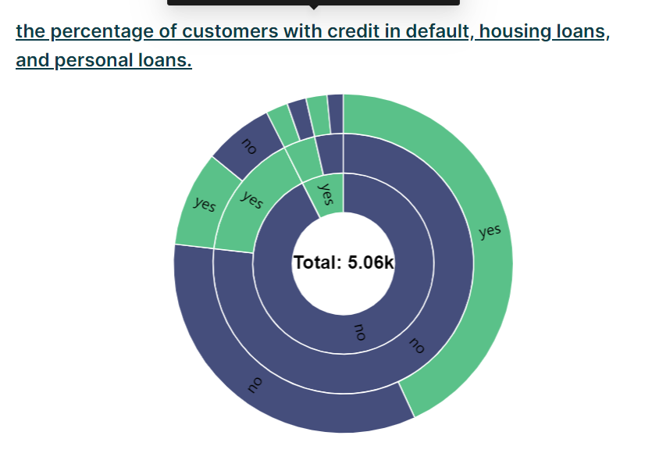

* **Monthly Day-of-the-week Heatmap**

A Heatmap is a graphical representation that uses color intensity to depict the frequency or density of data across two dimensions, such as months and days of the week. Each cell in the heatmap represents a combination of a month and a day, and the colour of the cell indicates the frequency or count of contacts that occurred on that specific day of the week within that month.

In simple words, the graph shows the busiest and least busy periods in terms of customer contacts. The darker or more intense colours represent higher frequencies, indicating that more contacts were made during those specific combinations of month and day of the week. On the other hand, lighter or less intense colours indicate lower frequencies, suggesting fewer contacts made on those days.

By looking at the graph, you can quickly identify patterns and trends in customer contacts over different months and days of the week. It helps in understanding when the bank had more interactions with customers and when the contact frequency was relatively lower. This information can be useful for scheduling future marketing campaigns, allocating resources, and making data-driven decisions based on the customer contact patterns.

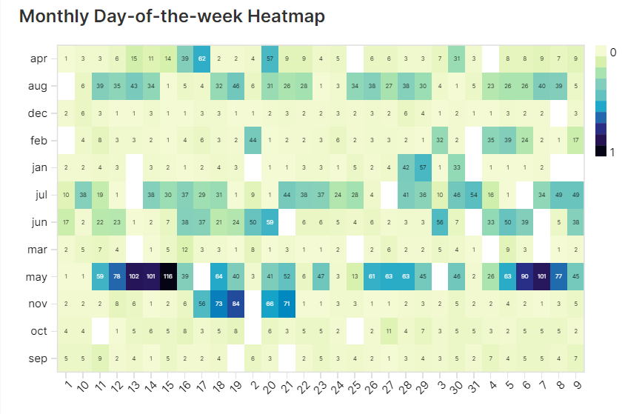

* **Job-Marital Status Count Chart**

The chart that represents the count of customers grouped by their job and marital status.

In simple words, this chart provides a visual representation of how many customers fall into different job categories based on their marital status. Each combination of job and marital status is represented by a separate column in the chart. The height of each bar represents the count or number of customers belonging to that specific job and marital status combination.  
  
For example, the chart can show the number of married customers who work in blue-collar jobs, the count of single customers who are students, or the quantity of divorced customers in management positions.  
  
The chart helps to understand the distribution and composition of customers across various job types and marital statuses. It allows you to compare and analyze the customer counts within different job and marital status categories, providing insights into the customer demographics and their relationship with job roles and marital status.

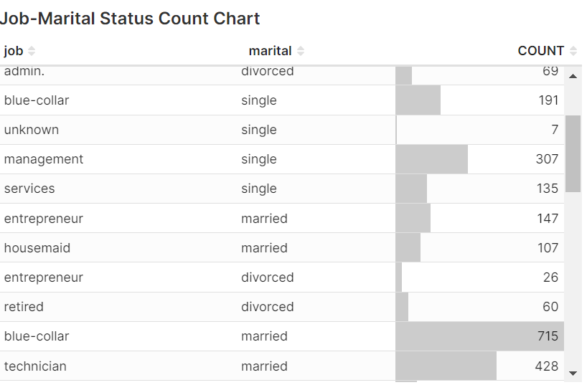

* **Previous Attempts to Outcome by Contact Type Graph:**

This graph illustrates how the outcome of previous marketing attempts is related to the number of previous attempts made, considering different contact types. It shows the success or failure of previous marketing campaigns based on the number of times customers were contacted before, categorized by the communication channel used (cellular or telephone).

By examining this graph, you can understand the effectiveness of previous marketing efforts based on the number of attempts and the contact type used. It helps in assessing whether certain contact types or a higher number of attempts have a positive impact on achieving successful outcomes from marketing campaigns.

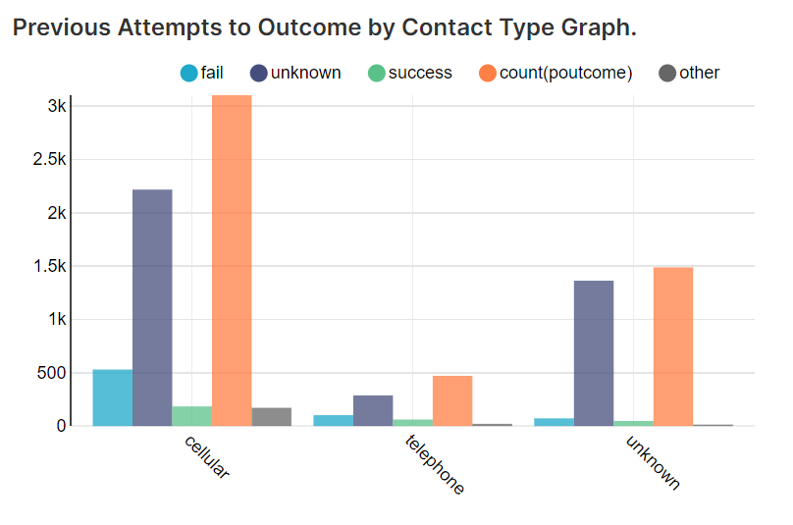

* [**Engagement Metrics and Term Deposit Acceptance: Insights from Previous Marketing Campaign**](https://superset.hpe-staging-ezaf.com/explore/?dashboard_page_id=289IRD9EZ2&slice_id=19):

The graph plots the average duration of calls and the number of contacts made. It categorizes the data based on the outcome of the previous marketing campaign, which could include categories like "Term Deposit Accepted" and "Term Deposit Not Accepted."

The significance of this graph lies in the insights it provides regarding the correlation between customer engagement during calls and their likelihood to agree to a term deposit. By analysing the data, the bank can identify patterns and trends in customer behaviour. For example, the graph may reveal that customers who had longer call durations were more likely to accept a term deposit, indicating a higher level of interest or engagement. Similarly, the number of contacts made can provide insights into customer responsiveness.

The graph helps the bank understand which customers are more receptive to term deposits and can guide their advertising and marketing efforts. By focusing on customers who had longer call durations and/or higher numbers of contacts in the previous campaign, the bank can target these customers with tailored advertisements and personalized offers related to term deposits. This targeted approach increases the chances of success in convincing these customers to agree to a term deposit, thereby potentially boosting the bank's income.

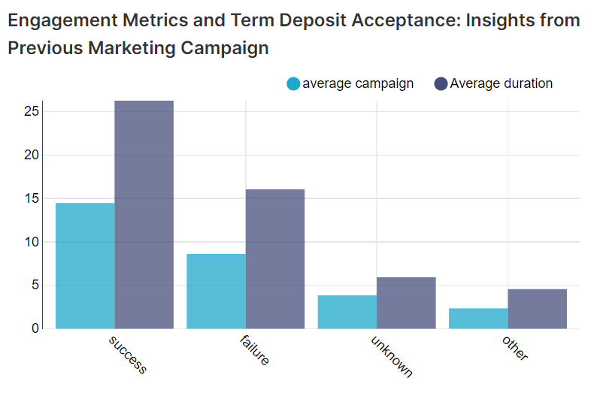

* [**Marital Status and Contact Strategy Analysis for Term Deposits**](https://superset.hpe-staging-ezaf.com/explore/?dashboard_page_id=l9O0nZB-6&slice_id=20)

The significance of this graph is to understand the effectiveness of the bank's contact strategy in relation to the customers' marital status and their response to term deposits. By analysing the data presented in this graph, the bank can gain insights into which marital status groups are more receptive to term deposit offers and which groups require more targeted marketing efforts.

Here's a breakdown of what this graph can help us understand:

Contact Strategy Evaluation: The graph allows the bank to evaluate its contact strategy's effectiveness in differentiating between marital status groups. It helps determine whether the bank is making an appropriate number of contacts with customers based on their marital status.

Marital Status Influence: The graph reveals how customers' marital status influences their response to term deposit offers. It helps identify any trends or patterns that may exist, such as whether married individuals are more likely to agree to a term deposit compared to unmarried individuals.

Targeted Marketing: Based on the graph's findings, the bank can tailor its advertising and marketing efforts to specific marital status groups that have shown a higher likelihood of agreeing to term deposits. This approach can optimize the bank's resources by focusing on the customer segments with higher conversion rates.

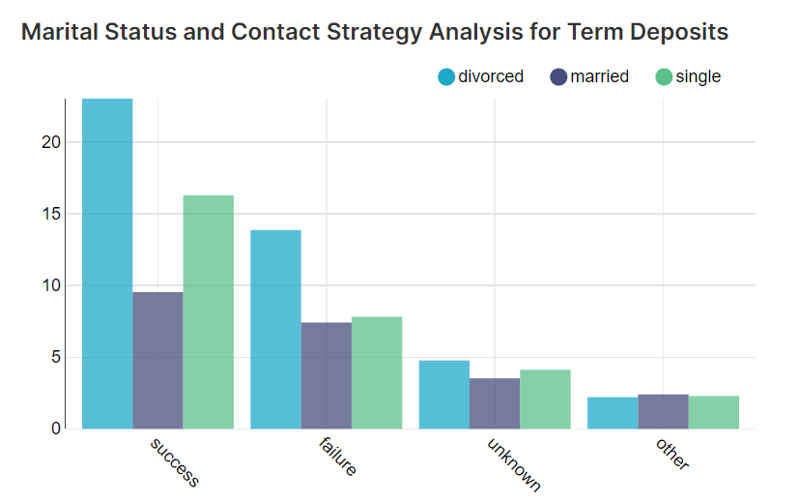

* [**Monthly Customer Engagement Duration (in mins)**](https://superset.hpe-staging-ezaf.com/explore/?dashboard_page_id=l9O0nZB-6&slice_id=21):

This graph refers to the measurement and analysis of the amount of time customers spend engaged with a particular product, service, or activity on a monthly basis, expressed in minutes.

This analysis looks at how long customers are actively involved or interacting with something over the course of a month. It measures the duration of customer engagement in terms of minutes spent.

By examining the monthly customer engagement duration, you can understand the level of interest or involvement customers have with a particular product, service, or activity. It helps in evaluating the extent to which customers are actively engaged and invested in what is being offered. This information can be valuable for identifying patterns, trends, or areas of improvement in customer engagement, and it can guide decisions related to marketing, product development, or customer satisfaction.

