**Week 3 Step 01 , 02 , 03**

### Step-01: Strings

#### Goals:

After taking this step, you will be able to:  
 1. interpret and implement Python programs using string operations and functions: *, +, len(), split(), join(), replace(), substrings, slicing, f strings.

#### What to Learn?

1. Using **BRef-01: Chapter 05** experiment and answer the following questions:
   1. What is string data type?

**arrays of bytes representing Unicode characters**

* 1. Which Python built-in function can be used to convert a data type to string? Try some examples in Python shell.

**You can convert a string to in when it has integers only and with**  **the function int()**

* 1. In Python (and some other programming languages), special characters can mean differently in a string. How one can specify these special characters in a Python program? List some of these characters and try the examples in Python shell.

**\n - Newline , \t- Horizontal tab , \r- Carriage return ,**  **\b- Backspace , \f- Form feed , \'- Single Quote , \"- double quote ,**  **\v -vertical tab , \N - N is the number for Unicode character** **\NNN - NNN is digits for Octal value , \xNN - NN is a hex value;**  
 **, \x is used to denote following is a hex value.** **,\a - bell sound, actually default chime**

* 1. How one can concatenate multiple strings? Make one string with your: First name, Last name, student number and group number.

**To concatenate you can use +**  
  **print(firstName + lastName + studentNumb + groupNumber)**  
 **Or you could use a f string**

* 1. What would be the result of multiplying a number with a string? Try three examples. What if the number is zero?

**If it's 0 it will print no string and if it would be greater than 1 it**  **will print it the amount of times . So string * 10 would print the**  **string 10 times.**

* 1. How can you extract specific character from a given string? How can you specify the first character? Last character? How can you get a slice if a string? Try with several examples in Python shell.

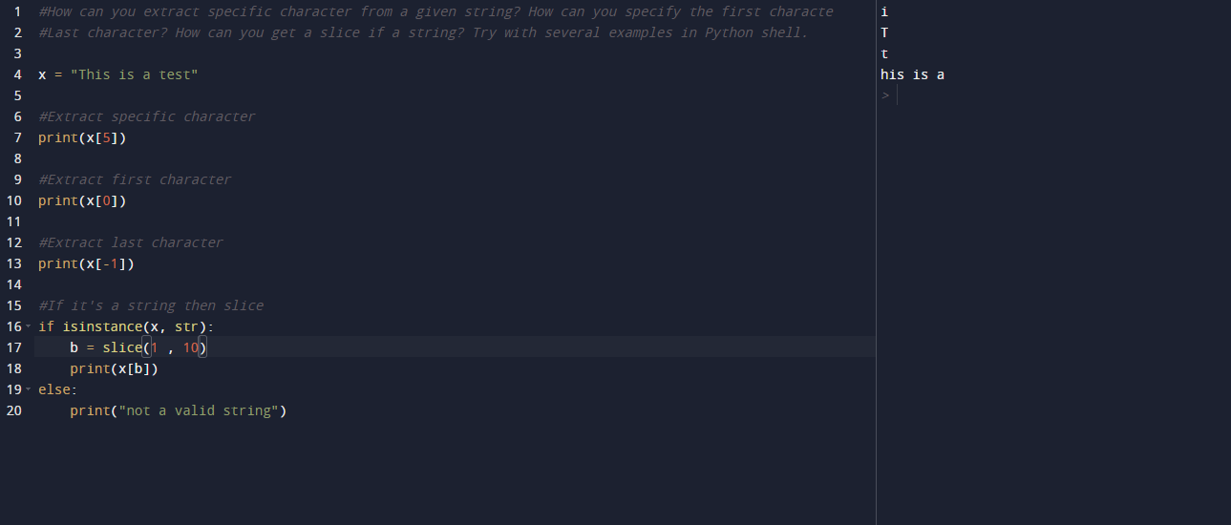

* 1. What are the functionality of functions: *len()*, *split()*, *join()*, *replace()*. Try two examples for each function in Python shell.

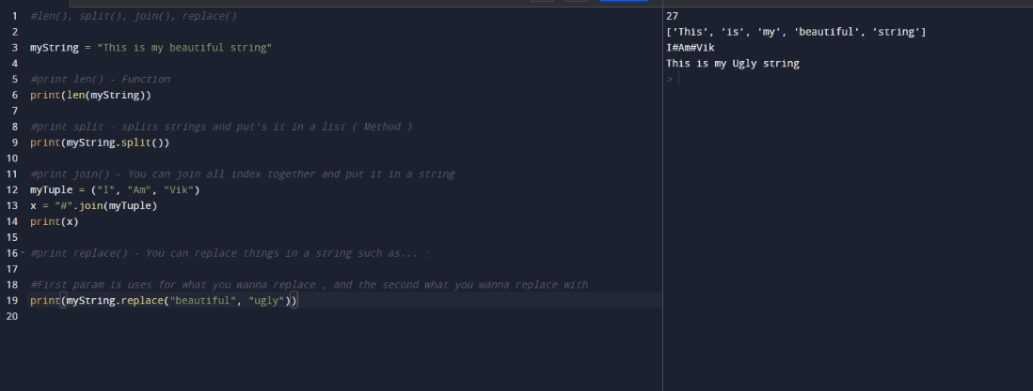

#### Exercises:

1. Ask the user to input a text. Print the length of the entered text.

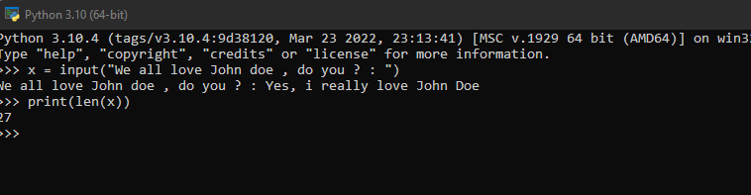

1. Ask the user to input a text. Replace the first character with a k and print the result.

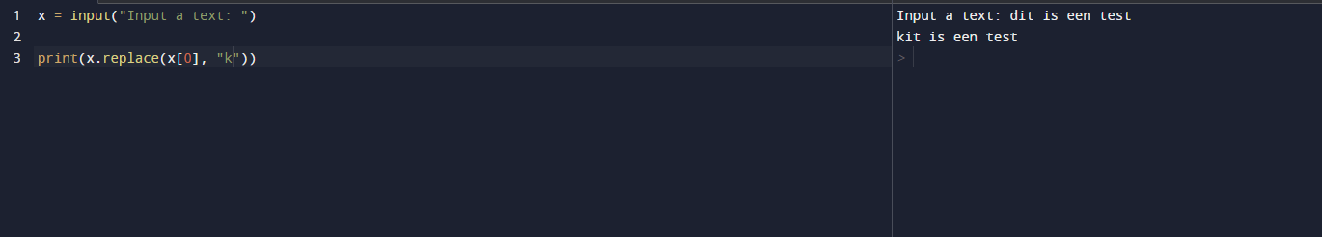

1. Make a variable with the text "this is a text". Remove all spaces from it. Print the result.



1. Ask the user to input a text. Capitalize the complete input. Print the result.



1. Ask the user to input a text. Remove all e characters from it. Print the result. Try to see what happens if the input doesn't contain an e.

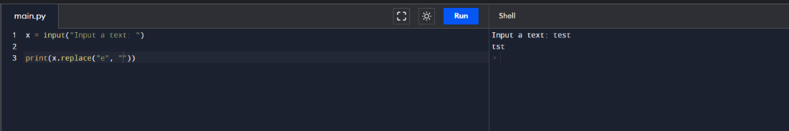

1. Ask the user to input a text. Count how many times the input contains the character i. Print the result.

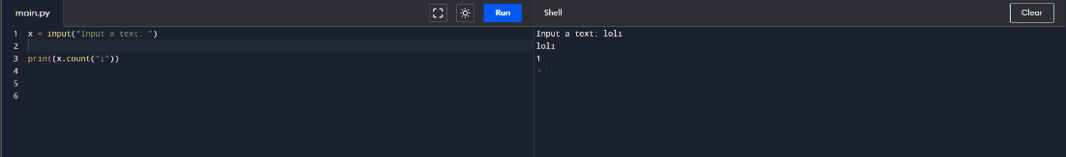

1. Ask the user to input two texts (two inputs). Print them together in one line using a f string.  
   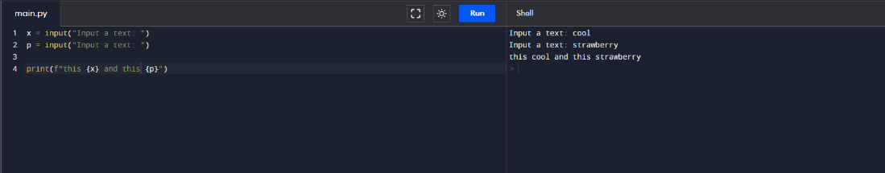

### Step-02: Looping with while

#### Goals:

After taking this step, you will be able to:

1. interpret and implement Python programs using while-loops.

#### What to Learn?

1. Using **BRef-01: Chapter 06** answer and experiment the following questions:
   1. A while loop consists of a condition and a body. Pick and example from **BRef-01: Chapter 06** and specify the condition and the body of the program.

* 1. Using while loop implement a program that prints a message (like Hello) for 10 times.

* 1. Using while loop implement a counter that counts down from 10 until 0. In each iteration, the program must print the value of the counter.  
     Graphical user interface, application, Teams

     Description automatically generatedWhat is break statement?   
     It breaks a loop. Example If condition is true ; break
  2. Implement a program that repeatedly asks the user to enter a character as input until the user enters q. If the user enters q the program will stop.   
     A screenshot of a computer screen

     Description automatically generated with medium confidence

#### Exercises:

1. Print the numbers 1 to 42 using a while loop.  
   Graphical user interface, application

   Description automatically generated
2. Print all odd numbers between 1 to 100 by using a while loopGraphical user interface

   Description automatically generated
3. Print the numbers from 10 to -10 using a while loop.
4. Ask the user to input a text. Print each character of the input on a new line using a while loop.
5. Ask the user to input a text. Print each character of the input that is the character e or a on a new line.
6. What will be the output of the given code?