Dossier – Basecamp { 2022 – 2023 }

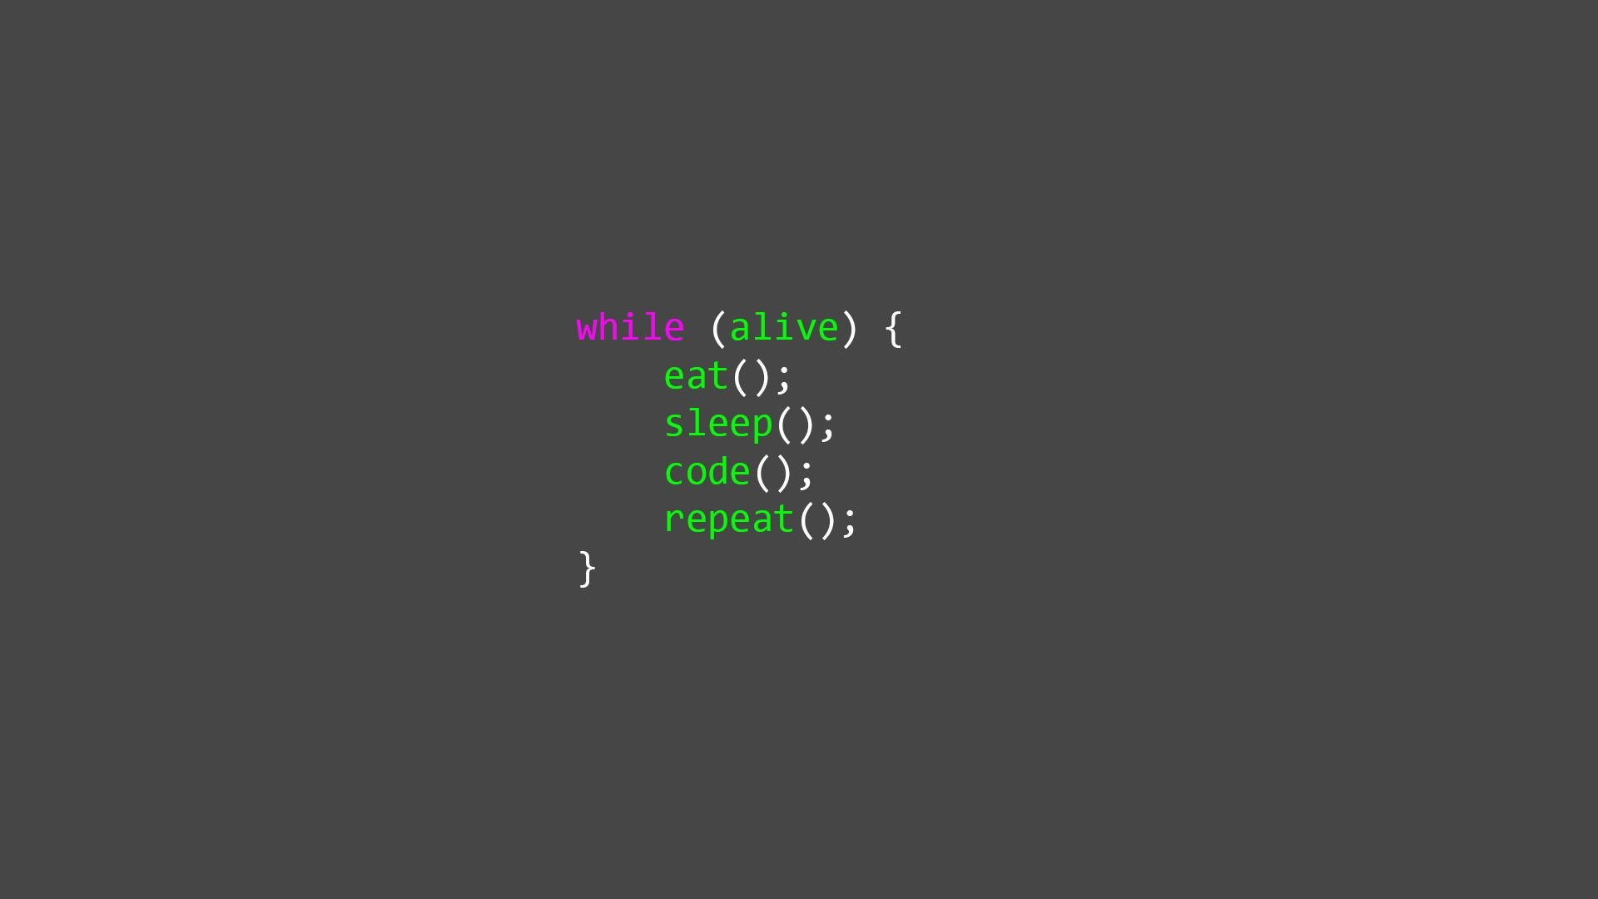

Naam: Viktor Stam  
Klas: CMI-BC11J

Teacher: Mr. Iersel, T.van  
Teacher: Miss. Okuyucu, C.

Website: <https://cyberwizard-v.dev/>  
Github: <https://github.com/Cyberwizard-V>

Table of Contents

Introduction – basecamp 2

Arch 1 – Week 1 3

Weekly reflection 5

Arch 1 - Week 2 5

Olivier’s feedback 6

Socal contract 9

Arch 1 - Week 3 10

Self Reflection/Progress 12

Peer feedback I got the feedback from Casper. I gave feedback to Olivier 12

Arch 1 - Week 4 { Challenge week } 15

Peer feedback 16

Self Reflection/Progress 30

Difficulties – Challenge week 30

What could go better? – Challenge week 30

Arch 2 - Week 5 30

Arch 2 - Week 6 38

Arch 2 - Week 7 39

Arch 2 - Week 8 – Challenge week 40

# Introduction – basecamp

In this document/dossier will be filled with lots of things such as..  
- Weekly reflection  
- Codegrade submissions  
- Self projects (with related context)  
- Tackling problems ( Reading, from peers or from the coach )  
   - Getting stuck with code errors  
   - Personal problems ( Motivation… )  
- Peer feedback  
  
This is for short what is in this dossier.

Why am I writing this dossier? Purpose?

## Arch 1 – Week 1

#### Introduction - start This was a lot of introduction type assignments. Really fun though, got to know my classmates more. We did a lot of fun stuff such as making pictures with the group on certain locations. We got information about “Studiepunten”. Did some questions (non code related). We also made groups on the first day. The groups purpose is , is for learning and helping each other. Codegrade – Week 1 I did not have much problems with the Codegrade assignments because I already know some coding. The hardest part was actually getting a little bit more used to the syntax. Sometimes a little bit learning from the book to know how it is supposed to be done. Codegrade assignment - A1_W1_A1

this was called a year converter. Very fun exercise learned some small syntax things in python. Nothing too special.

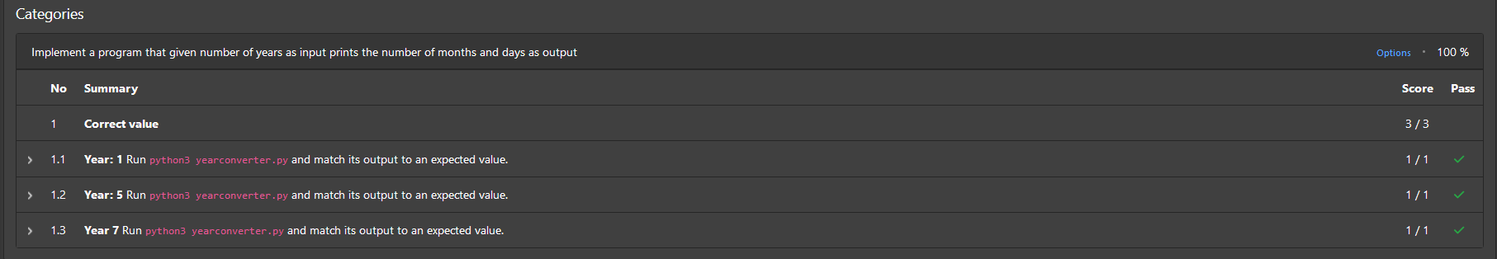

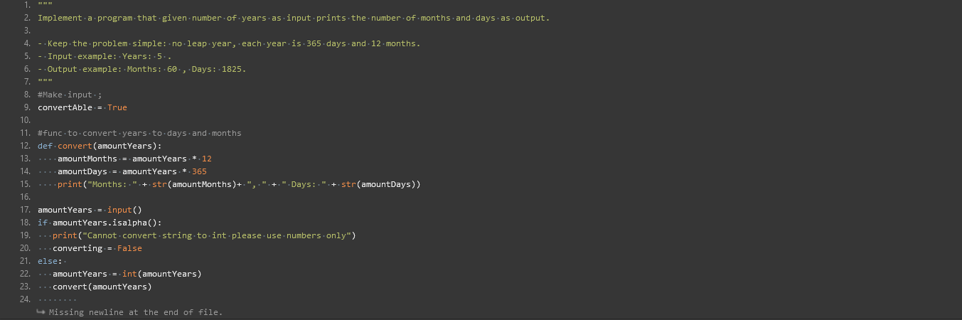

Codegrade assignment – A1_W1_P5

Four Digit Sum. Had some small problems with this. In the end it worked. I did it with a for loop here.  
Biggest issue I had was using the f string. Didn’t really know the syntax so I had to look it up.  
  
## Graphical user interface Description automatically generated Weekly reflection

Week 1 was pretty fun. Had some small issues. Week 1 was going pretty smoothly. I loved the introduction of python. Python is very fun to learn. Most of the issues I had was syntax issues. Also kinda stressed because I didn’t really read the book yet only chapter 1.

Self Reflection/Progress  
I already know coding but that doesn’t mean I know everything of course. In programming you will never know everything. I’ve learned that even if it is the basics or fundamentals that I already know I can still learn things about it. It would be my downfall if my mindset was in a way that says “Oh I know everything”.

Arch 1 - Week 2  
  
Introduction - Start week 2

In this week we talked about “Basic Computers” , How to learn in an efficient way , Explanation about peer evaluation and we worked on step 01 , 02 ,03 for that week. Codegrade exercises for this week as well. In this week I will also talk about some personal progress and my journey on learning to learn.

Learning efficient  
I watched the video about how to learn. There was a video in the reader that I watched . Very interesting. He was talking about why we didn’t learn to learn in the beginning when we started school. So the big question is... How do i learn efficient now ? I basically convert all the smart words to dumb words so anybody would understand. In that way it’s easier to understand. I also use the Pomodoro technique for studying.   
  
Codegrade assignments W2   
I only write about the ones I was stuck with for a little bit longer. I learned some new things. Built-in methods / functions like ord(). Used some regex aswell.   
  
A1_W2_P7 – Chessboard colors  
The idea was that the user gave an input with coords of a chessboard. I had to determine if that square is black or white. I didn’t know about ord() yet. I had minor problems with this one.  
  
  
  
Self Reflection/Progress  
I used my learning technique. Did some code grade. Went through it pretty smoothly. Sadly code grade had an update so I have to resubmit my code. I don’t really have much self reflection for this week because I didn’t have any problems with the things we are learning to today.  
  
  
  
Peer feedback  
I got the feedback from Olivier. I gave feedback to Casper

Olivier’s feedback

Olivier: You ask if I need help. When you where late you said it in the discord. You bring a positive attitude.  
  
Olivier: I didn’t need help yet but you showed you were willing to help. It didn’t seem you where struggling with anything thus didn’t need help. It looks like everything is going really smooth. If you offer to help me you ask if I want answers but recommend trying it myself.

Olivier: You know a lot of coding basics so don’t need much help or feedback You are a nice calm person There wasn’t much to give an opinion on  
  
Olivier: We don’t each other long enough to really know strengths and weaknesses. We didn’t had a disagreement yet Didn’t have problems or meetings yet  
  
  
  
  
Olivier: Didn’t need to adapt yet No idea Willing to help No idea

Olivier: Didn’t happen yet

## Socal contract

**Sussy Baka**

Social contract

*(Jevayro Entingh, Jayden Weeks, Casper Onderdijk, Olivier de Lange, Viktor Stam)*

1. **Als je vragen hebt of je loopt ergens tegen aan stel zo in de “question” channel**

Vragen ronde is om 16:00 – 16:30, Join voice chat hiervoor

1. **Als je verhinderd/te laat of niet aanwezig bent laat dat zo spoedig mogelijk weten aan de groep.**

Als het kan een uur van te voren of voor de les

1. **Vrijdagen doen we de peer feedback**
2. **Niet pesten**

Behandel elkaar met respect en als er wat is zoek contact met elkaar op

Arch 1 - Week 3

Introduction - Start week 3

In this week we talked about Strings, Loops and self-reflection. I worked a little bit on my Dossier and had a very fun Workshop. The week was going pretty smoothly. I had less struggle with Discipline and Motivation. Further I worked on step 01, 02, 03. We had coaching as well with the coach peer. Some extra fun exercises.

Course of action

I worked mainly on understanding loops and techniques to learn more efficient. What did I do to understand loops more ? I have watched tutorials, visualize them on paper, try to explain it to someone without programming knowledge. This week I had a little bit of a problem with the truth table exercise because I did not understand how truth tables worked. Jeffrey explained the logic behind it and made it make sense.  
  
Most fun exercises this week

1. Fibonacci sequence

Why was the Fibonacci sequence fun? I love gaining knowledge and these type of exercises really make me think hard on how to do things. This exercise made me think and learn.  
  
2. Out of the book Chapter 1

There was a fun little program that was showed in chapter 1. I wrote it and ran the code. So the idea of the program was that you can enter a URL of a website and a date (ex. 20131212) . When filling in the two inputs it would open up a browser and show that website in the state on that date. For example you can see how YouTube looked in 2013 or 2016… whatever you choose ;

How does it work? As you can see the requests module and web browser module are being used in the program. Web browser module is a default module but requests is not. To use the package manager (pip) was not really a problem {pip install {module name} } so I had to install requests. So why do we need a site URL? With requests we can get Data back from the URL. The data is being used again for the web browser module to open up the link. We get data back in JSON. I loved this exercise very much because I was kind of discovering new things about what you can do in Python. I already knew about requests , JSON data etc… But still very fun to do! I would definitely recommend trying this fun exercise.

3. A1_W3_P7 – Truth table

Had a little bit of a problem understanding the Truth table that’s why I didn’t know how to code it in the beginning. Jeffrey explained it to me and with that I could make the assignment. So I had to first understand what was happening before I code of course.

Self Reflection/Progress

In this week I learned a lot about for loops , especially nested for loops. It is much easier to realise now than before because of the exercises. I code a lot because I love it but I realise more that documentation is very important when creating code.

Peer feedback  
I got the feedback from Casper. I gave feedback to Olivier  
**This feedback is for:**   
Viktor

**This feedback is from :**   
Casper Onderdijk

**1. Motivation**

Within the learning team you work on your own assignments, but you can collaborate or help each other. This makes your study programme a less lonely journey. The small group that surrounds you will help you conquering the challenges of the study programme. This can help your motivation and the motivation of others.

* 1. You contribute positively to the learning team

( x ) 4 – very well

* 1. You stick to things you agreed to do

( x ) 4 – very well

* 1. You motivate fellow students

( x ) 4 – very well

Viktor helps out where he can. And gives feedback.

**2. Shared responsibilities**

By sharing experiences and helping each other where possible, you feel more connected to the study programme and each other. In a well-functioning learning team all team members experience shared responsibilities.

2.1 You actively participate when a team member needs help

( x ) 4 – very well

2.2 You indicate to others what you need in order to successfully finish your tasks

( x ) 4 – very well

2.3 You challenge yourself when you are doing your tasks

( x ) 4 – very well

* 1. You help others to challenge themselves when doing the tasks

( x ) 1 – not yet

What I already said viktor helps out where he can. He gives feedback when he is asked.

**3. Open communication**

In a well-functioning learning team, team members can share ideas, wishes, motives and insecurities with each other.

3.1 You ask for feedback on your work/actions/results

( x ) 3 - well

3.2 You give others room to talk

( x ) 3 - well

* 1. You listen with an open mind to what others have to say

( x ) 3 - well

1.4 You give your opinion on matters  
 ( x ) 3 - well

When you are struggling with something or cant figure it out you go around and ask for help. And when we are brainstorming something you give your idea’s/opinion

**4. Respect differences**

A learning team where team members have different qualities, skills and fields of expertise and uses this where possible, is a powerful team because the team members feel respected

* 1. You contribute in a positive way to dealing with the strengths and weaknesses of different team members

( x ) 4 – very well

* 1. If you disagree with something, you let others know in a respectful manner   
     (with arguments and in a calm voice)

( x ) 4 – very well

* 1. You have a positive contribution to the feeling of trust within the team. You discuss issues within the team during team meetings or you talk directly to the person it concerns.

( x ) 4 – very well

You respect everyone in and outside our group. If we discuss something and you have a different view on it you discuss it on a respectful manner.

**5. Flexibility**

During BaseCamp things will run differently than planned. In a well-functioning learning team there is always room for improvement and development.

* 1. If things suddenly have to be done differently, you adapt and cooperate

(  x ) 3 - well

* 1. You have no problem with making mistakes

(  x ) 3 - well

* 1. You share what you’ve learned with your team members and teachers

(  x ) 3 - well

* 1. Je bent nieuwsgierig en probeert nieuwe dingen uit.

(  x ) 3 - well

When you learned something new you share it with others. And you always looking for something new to learn.

**6. Taking initiatives**

Sometimes you have to look beyond the beaten track of you have an idea how to do things differently. A well-functioning learning team provides room for initiatives and new ideas. This helps you move forward as a student and as a learning team.

* 1. You share your ideas or support a team member in sharing their ideas

(  x ) 3 - well

* 1. You make helpful suggestions in team meetings

(  x ) 3 - well

* 1. You explore new or different possibilities by yourself and share these with your team

(  x ) 3 - well

You suggest new things we can do for an assignment/problem

Read the feedback other have provided. Write down key things you could use for your further development

Arch 1 - Week 4 { Challenge week }

Introduction - Start week 4

In this week we had challenge week. You could choose between the challenge or back on track. I chose the Challenge because I didn’t need to do back on track due to that I already finished everything. The challenge was to make a text based game in a pair. Me and Jeffrey started making the game together.

Starting the file – Text based game

In the beginning we focused on making the systems such as.. SoundSystem, Typesystem, clearconsole system, inventory system , choose system , tiny choose system, maze choose system and a status effect system. These were the building blocks for beginning to make the game. We then made the first stage “Hell”.

Peer feedback

**This feedback is for:**   
<Viktor>

**This feedback is from:**   
<Jeffrey>

**1. Motivation**

You contribute positively to the learning team

(   ) 1 – not yet     (   ) 2 – can do more    (   ) 3 - well    ( ) 4 – very well   ( X  ) 5 – too much

You stick to things you agreed to do

(   ) 1 – not yet     (   ) 2 – can do more    (   ) 3 - well    ( x ) 4 – very well     (   ) 5 – too much

You motivate fellow students

(   ) 1 – not yet     (   ) 2 – can do more    (   ) 3 - well    ( x ) 4 – very well     (   ) 5 – too much

We both decided on working on the project and we went all out we spent too much time on the assignment. Eventually because of the motivation we had like double the time needed.

**2. Shared responsibilities**

You actively participate when a team member needs help

(   ) 1 – not yet     (   ) 2 – can do more    (  ) 3 - well    ( X  ) 4 – very well     (   ) 5 – too much

You indicate to others what you need in order to successfully finish your tasks

(   ) 1 – not yet     (   ) 2 – can do more    (   ) 3 - well    ( X  ) 4 – very well     (   ) 5 – too much

You challenge yourself when you are doing your tasks

(   ) 1 – not yet     (   ) 2 – can do more    ( ) 3 - well    ( X  ) 4 – very well     (   ) 5 – too much

You help others to challenge themselves when doing the tasks

( ) 1 – not yet     ( ) 2 – can do more    ( X  ) 3 - well    (   ) 4 – very well     (   ) 5 – too much

There was no particular moment we used to challenge each other, but both did evenly as much for the assignment. Also, always inspired me to get better and learn the codes and gave me the opportunity to code blocks by myself

**3. Open communication**

You ask for feedback on your work/actions/results

(   ) 1 – not yet     (   ) 2 – can do more    ( x  ) 3 - well    (   ) 4 – very well     (   ) 5 – too much

You give others room to talk

(   ) 1 – not yet     (   ) 2 – can do more    (   ) 3 - well    ( x  ) 4 – very well     (   ) 5 – too much

You listen with an open mind to what others have to say

(   ) 1 – not yet     (   ) 2 – can do more    (   ) 3 - well    ( x  ) 4 – very well     (   ) 5 – too much

You give your opinion on matters  
( ) 1 – not yet     (   ) 2 – can do more    (   ) 3 - well    ( x  ) 4 – very well     (   ) 5 – too much

I quite often asked Viktor for his input too and he was always open to hear from me. Besides that, we also reviewed each other’s parts and gave tips to improve.

**4. Respect differences**

You contribute in a positive way to dealing with the strengths and weaknesses of different team members

(   ) 1 – not yet     (   ) 2 – can do more    ( ) 3 - well    (  x ) 4 – very well     (   ) 5 – too much

If you disagree with something, you let others know in a respectful manner

(   ) 1 – not yet     (   ) 2 – can do more    (   ) 3 - well    ( x) 4 – very well     (   ) 5 – too much

You have a positive contribution to the feeling of trust within the team. You discuss issues within the team during team meetings or you talk directly to the person it concerns.

(   ) 1 – not yet     (   ) 2 – can do more    ( ) 3 - well    ( x  ) 4 – very well     (   ) 5 – too much

Everything was pretty much perfect and with the parts someone else was lacking, he had my back. If I had any problems with any part it was always easy to discuss and change.

**5. Flexibility**

If things suddenly have to be done differently, you adapt and cooperate

(   ) 1 – not yet     (   ) 2 – can do more    (   ) 3 - well    ( x) 4 – very well     (   ) 5 – too much

You have no problem with making mistakes

(   ) 1 – not yet     (   ) 2 – can do more    (   ) 3 - well    ( x ) 4 – very well     (   ) 5 – too much

You share what you’ve learned with your team members and teachers

(   ) 1 – not yet     (   ) 2 – can do more    (   ) 3 - well    ( x  ) 4 – very well     (   ) 5 – too much

Je bent nieuwsgierig en probeert nieuwe dingen uit.

(   ) 1 – not yet     (   ) 2 – can do more    (   ) 3 - well    ( x  ) 4 – very well     (   ) 5 – too much

Viktor always were open to learn new things, he also used a lot of new pip installs for the game and showed me how things work whenever he found something new.

**6. Taking initiatives**

You share your ideas or support a team member in sharing their ideas

(   ) 1 – not yet     (   ) 2 – can do more    ( ) 3 - well    ( x) 4 – very well     (   ) 5 – too much

You make helpful suggestions in team meetings

(   ) 1 – not yet     (   ) 2 – can do more    ( ) 3 - well    ( x  ) 4 – very well     (   ) 5 – too much

You explore new or different possibilities by yourself and share these with your team

(   ) 1 – not yet     (   ) 2 – can do more    ( ) 3 - well    ( x  ) 4 – very well     (   ) 5 – too much

Viktor always worked well on his own. He always explained how to tackle things and everything.

#### ***Code of systems – Challenge week***

import os

import time

import sys

from time import sleep

from pygame import mixer

gameInventory = []

playerStats = [0, 0, 0, 0, 0]

hitpoints = 5

hints = 0

*def* intro():

    typeSys(*f*"""

      __    ____  _____  _  _  ____    _  _  _____  __  __

     /__\  (  _ \(  _  )( \/ )( ___)  ( \/ )(  _  )(  )(  )

    /(__)\  ) _ < )(_)(  \  /  )__)    \  /  )(_)(  )(__)(

   (__)(__)(____/(_____)  \/  (____)   (__) (_____)(______)""", 0.0001)

    playerName = input("\n Please input your name : ")

    if playerName.isalpha():

        clearConsole()

        typeSys(*f*"\nWelcome to the game {playerName}", 0.01)

        typeSys(*f*"""\n

You suddenly feel a warm feeling in your back and collapse to the floor.

Your view is getting hazy and slowly fading away. The only thing you see before the last lights

go out is a silhouette of a person running away. A million questions rush into your head.

Who is this person? Why me? Why is the floor so floory? Right before you die you swore to find out who killed you. \n\n\n""", 0.001)

        input("Press enter to continue...")

        clearConsole()

    else:

        print("\nInvalid name; please use characters only, no spaces!\n\n")

        playerName = input("Please input your name : ")

*# Console clearen voor de woord rader*

*def* clearConsole():

    command = 'clear'

    if os.name in ('nt', 'dos'):  *# If Machine is running on Windows, use cls*

        command = 'cls'

    os.system(command)

*def* clearConsoleEnt():

    input("\nPress enter to continue...")

    command = 'clear'

    if os.name in ('nt', 'dos'):  *# If Machine is running on Windows, use cls*

        command = 'cls'

    os.system(command)

*def* chooseSys(*Op1*, *Op2*, *Op3*, *Op4*, *Choices*="Choices", *Menu*="Menu", *Back*="Back" ):

    Options = [Op1, Op2, Op3, Op4, Menu, Back]

    print(*f*"""

\033[1m{Choices} \033[0m

 \033[1m─────────────────────────     \033[0m

\033[1m\033[95m1\033[0m {Options[0]}\t\t     \033[0m

\033[1m\033[96m2\033[0m {Options[1]}\t\t    \033[0m

\033[1m\033[93m3\033[0m {Options[2]}\t\t   \033[0m

\033[1m\033[91m4\033[0m {Options[3]}\t\t\033[0m

 \033[1m─────────────────────────\n\033[0m

\033[1m5 {Options[4]}\t\t    6 {Options[5]} \033[0m

 \033[1m─────────────────────────\n\033[0m

 """, )

    try:

     z = *int*(input("Enter a number you'd like to choose: "))

     if z == 1 or z == 2 or z == 3 or z == 4 or z == 5 or z == 6:

        text = Options[(z-1)]

        return text

    except:

        typeSys("\nNot an option loser\n\n")

        clearConsoleEnt()

*def* chooseMaze(*Op1*, *Op2*, *Op3*, *Op4*, *Choices*="Choices", *Menu*="Menu"):

    Options = [Op1, Op2, Op3, Op4, Menu]

    print(*f*"""

\033[1m{Choices} \033[0m

 \033[1m─────────────────────────     \033[0m

\033[1m\033[95m1\033[0m {Options[0]}\t\t     \033[0m

\033[1m\033[96m2\033[0m {Options[1]}\t\t    \033[0m

\033[1m\033[93m3\033[0m {Options[2]}\t\t   \033[0m

\033[1m\033[91m4\033[0m {Options[3]}\t\t\033[0m

 \033[1m─────────────────────────\n\033[0m

 \033[1m5 {Options[4]}\t\t \033[0m

 \033[1m─────────────────────────\n\033[0m

 """)

    try:

     z = *int*(input("Enter a number you'd like to choose: "))

     if z == 1 or z == 2 or z == 3 or z == 4 or z == 5:

        text = Options[(z-1)]

        return text

    except:

        typeSys("\nYou are lost aren't you\n\n")

        clearConsoleEnt()

*def* menu(*Op1* = "Inventory", *Op2* = "playerStatus",*Op3* = "Map", *op4* = "Back"):

    menuOptions = [Op1, Op2, Op3, op4]

    while True:

        clearConsole()

        print(*f*"""

Me    |Health: {hitpoints}

──────────────────

\033[95m1\033[0m {menuOptions[0]}

\033[96m2\033[0m {menuOptions[1]}

\033[93m3\033[0m {menuOptions[2]}

──────────────────

\033[1m4\033[0m {menuOptions[3]}\n

""")

        z = input("Type the option you want: ").lower()

        if z == "inventory" or z == "1":

            clearConsole()

            while True:

                print(*f*"""

Inventory

──────────────────""")

                print(*f*"{gameInventory}")

                inventoryCheck = input("Type the item name you'd like to inspect or enter q to quit inventory: ").lower()

                if inventoryCheck == "q":

                        break

                if inventoryCheck in gameInventory:

                    if inventoryCheck == "adoption papers":

                        clearConsole()

                        print(*f*"""

Adooption papers

──────────────────""")

                        typeSys("\nIt is a picture of me in the adoption papers!\n\n")

                        typeSys("You become sad.")

                        gameInventory.remove("adoption papers")

                        typeSys("\nYou discard the adoption papers\n\n")

                        playerStats[1] += 1

                    elif inventoryCheck == "car keys":

                        clearConsole()

                        print(*f*"""

Car keys

──────────────────""")

                        typeSys("\nI wish I had a car\n\n")

                    elif inventoryCheck == "picture of your mom":

                        clearConsole()

                        print(*f*"""

My mom?

──────────────────""")

                        typeSys("\nShe looks oddly familiar...\n\n")

                    elif inventoryCheck == "gun":

                        clearConsole()

                        print(*f*"""

Pew thingy

──────────────────""")

                        typeSys("\nPew Pew Pew Pow, you're dead\n\n")

                    elif inventoryCheck == "mysterious note":

                        clearConsole()

                        print(*f*"""

Mysterious note

──────────────────""")

                        typeSys("\nThe note reads:\n")

                        typeSys(*f*"""

Home is like \033[1mrandom waters\033[0m.

It is \033[1mright\033[0m to go \033[1mup\033[0m,

you \033[1mleft\033[0m me on read.

I don't know what it means though.

""")

                    elif inventoryCheck == "diving suit":

                        clearConsole()

                        print(*f*"""

Diving suit

──────────────────""")

                        typeSys("\nLooks like a tight suit. This might help me diving in the water.\n\n")

                    elif inventoryCheck == "lab coat":

                        clearConsole()

                        print(*f*"""

Lab coat

──────────────────""")

                        typeSys("\nSmells like the scientist outside... Now I can steal his identity!\n\n")

                    elif inventoryCheck == "fishbowl":

                        clearConsole()

                        print(*f*"""

Fishbowl

──────────────────""")

                        typeSys("\nA cozy bowl. I shouldn't pee on the floor.\n\n")

                    elif inventoryCheck == "snow":

                        clearConsole()

                        print(*f*"""

Snow

──────────────────""")

                        typeSys("\nIt is made out of snowman flesh\n\n")

                    elif inventoryCheck == "notebook":

                        clearConsole()

                        print(*f*"""

notebookXSproMAX 12 Lite XXL limited edition GOLD PLATED camera screen 15 xs xxs android phone notebook laptop gtx 5000

──────────────────""")

                        typeSys(*f*"""

Wow it is the new notebookXSproMAX 12 Lite XXL limited edition GOLD PLATED camera screen 15 xs xxs android phone notebook laptop gtx 5000!! there is a note on the back of it

password: jazz""")

                    elif inventoryCheck == "jar of milk":

                        clearConsole()

                        print(*f*"""

Jar of milk

──────────────────""")

                        inputInventory = input("\nThe jar of milk seems to be glowing bright, would you like to drink it? (Y/N) ").lower()

                        print("\n\n")

                        if inputInventory == "y":

                            clearConsole()

                            gameInventory.remove("jar of milk")

                            playerStats[0] += 1

                            typeSys("\nYou feel the power of the milk flowing through your bloodstream. You have gained fire resistance\n\n")

                            typeSys("\033[93mjar of milk has been removed from your inventory\033[0m\n\n")

                            clearConsoleEnt()

                        elif inputInventory == "n":

                            continue

                    elif inventoryCheck == "strange vial":

                        clearConsole()

                        print(*f*"""

Strange vial

──────────────────""")

                        inputInventory = input("\nIt smells like the vial which got White deranged. Do you still want to consume it? (Y/N) ").lower()

                        print("\n\n")

                        if inputInventory == "y":

                            clearConsole()

                            gameInventory.remove("strange vial")

                            playerStats[4] += 1

                            typeSys("\n\nYou feel the power of breathing. You can breathe oxygen?\n")

                            typeSys("\033[93m'strange vial' has been removed from your inventory\033[0m\n\n")

                            clearConsoleEnt()

                        elif inputInventory == "n":

                            continue

                        else:

                            typeSys("\nL bozo, this is not a valid input\n\n")

                            clearConsoleEnt()

                print("")

                CQuit = input("Do you want continue looking in your inventory? (Y/N) ").lower()

                if CQuit == "y":

                    clearConsole()

                    continue

                else:

                    break

        elif z == "status effect" or z == "2":

            clearConsole()

            print(*f*"""

Status effects

──────────────────

""")

            if playerStats[0] == 1:

                print("Fire resistance")

            if playerStats[1] == 1:

                print("Sad")

            if playerStats[2] >= 1:

                print("Determined")

            if playerStats[3] >= 1:

                print("Pilot")

            if playerStats[4] == 1:

                print("Oxygen breather")

            clearConsoleEnt()

        elif z == "map" or z == "3":

            clearConsole()

            typeSys(*f*"""\nYou havent found a map yet,

syke there are no maps in the game...\n\n""")

            clearConsoleEnt()

            continue

        elif z == "back" or z == "4":

            clearConsole()

            break

        else:

            typeSys("\nNot an option loser\n\n")

            clearConsoleEnt()

*def* typeSys(*xWords*, *time* = 0.0):

    for char in xWords:

        sleep(time)

        sys.stdout.write(char)

        sys.stdout.flush()

*def* gameMap(*location*):

    maps = [*f*"""    #######    /##################################################### #####

########

    (#                                                                               #/

    (#                                                                               #/

    ##                                                                               ##

    ##                                                                               ##

##/                                                                               (##

##                                                                                 ##

##                                                                                 ##

##                                      /                                          ##

##                                    ,*///                                        ##

##                                    ///////                                      ##

##                                    ////////                                     ##

##                                    /////////                                    ##

##                /,                /*/////////*/                                  ##

##/               //                //////////////                                /##

###              ///               ///////////////*/     ///                      ###

###            .////               /////***//////////   ////*                     ###

###           ./////   //////     //////****//////////  /////                     ###

###           //////  ////////// //////******.////////////////                    ###

*##         ///////////////////////////******,,///////////////,/   ,/       /.    ##*

*#/       .///////////////////////////*********////////////////// ////     ///    (#,

    #.      /*//////**//////////////////*************/***/////////////////.  ////*/   #

    ##    /,////////***//////*////////*******************,*//*******//////////////*/ ##

    ##  /*////////******,///,**/,****,*****************************************//////##

    (# //////////********,,.***************************************************.*/////#

    *##(##********************************************************************#*##(/

            ,   *#*******************************************************(######.

                    ,(#########################################(/.                  """,  *f*""" map 2"""]

    print(maps[location])

*def* playSound(*soundPath*, *volume* = 0.01):

*#Instantiate mixer*

    mixer.init()

*#Load audio file*

    mixer.music.load(soundPath)

    mixer.music.set_volume(volume)

*#Play the music*

    mixer.music.play()

*def* tinyChooseSys(*Op1*, *Op2*, *Choices*="Choices", *Menu*="Menu", *Back*="Back" ):

    Options = [Op1, Op2, Menu, Back]

    print(*f*"""

\033[1m{Choices} \033[0m

 \033[1m─────────────────────────     \033[0m

\033[1m\033[95m1\033[0m {Options[0]}\t\t     \033[0m

\033[1m\033[96m2\033[0m {Options[1]}\t\t    \033[0m

 \033[1m─────────────────────────\n\033[0m

\033[1m3 {Options[2]}\t\t    4 {Options[3]} \033[0m

 \033[1m─────────────────────────\n\033[0m

 """, )

    try:

     z = *int*(input("Enter a number you'd like to choose: "))

     if z == 1 or z == 2 or z == 3 or z == 4:

        text = Options[(z-1)]

        return text

    except:

        typeSys("\nNot an option loser\n\n")

        clearConsoleEnt()

*# hidden status effect, gameplay chaanges based on actions.*

We worked a lot on this game. Jeffrey did about 50 hours. I did about 40-45 hours.

#### ***Hour registration – Challenge week – Jeffrey, Viktor***

Day 1

On the first day we mainly spent time on learning the basics of what was needed for tackling the challenge head on. These were the things we watched/ researched on day 1, which took around 1 hour.

type game tutorial

<https://www.youtube.com/watch?v=DEcFCn2ubSg>

colours in terminal

<https://www.geeksforgeeks.org/print-colors-python-terminal/>

<https://stackoverflow.com/questions/287871/how-do-i-print-colored-text-to-the-terminal>

*Research*

- def() function

- time module

- additional while and for loops

After the research we did we made a rough sketch for our game in a word document, the story line etc. and just brainstorming, which took around 3 hours in total. Underneath I’ve pasted a picture of the document.

After this we decided to take a break for the day.

Day 2

On day 2 we wanted to start the assignment and making the functions etc. How we did it together was from discord and screen sharing. Before this assignment everything was still blurry how functions worked and the loops as well. So, the first day we just put our ideas together and tried to make as many functions we came up with for our game. This was mainly coded by Viktor with me as input, which took around 5 hours

Day 3

On day 3 we still didn’t finish the functions we wanted to make. However, on the third day Viktor suggested me to code everything and he would be the person giving ideas for new functions. I think this was a really nice way for me to learn, due to me having little experience in coding compared to him. This took around 5 hours again. After day 3 we basically finished all the functions we wanted to use.

Day 4

Day 4 was mainly getting the story together and putting the functions in there. We also imported a few different pips to make it easier to work together, like “live share”. This pip made us able to work in the same file together. I also had some problems with my Python. This problem was caused due to an assignment in week 2, This made me install python from the windows store (I did it myself not, the assignment didn’t tell me to do that specifically). This caused the directory to be installed in the wrong places and had to install Python again. How we worked was mainly making a rough layout of the code and after that editing it with print statements etc. On day 4 I roughly spent 10 hours on the Challenge. It doesn’t get much better, I believe I pretty much spent 10 hours every day on the challenge from here on out.

Day 5

On day 5 we finished our first level. Originally, we were planning to have 5 levels, but we decided to scrap one level. This was due to the amount of time we both already put into the game. We both mainly coded and were bug fixing it at the same time. I believe on day 5 I spent another 10 to 12 hours on the game. After day 5 we finalized the first stage and started a little bit on the second stage already.

Day 6

On day 6 we realized we needed to work more efficient. On day 6 I pretty much got the hang of everything perfectly and knew exactly what everything meant. This way we both finished the second stage quickly, which ended up being twice as long as stage one in code lines. This also took us around 7- 10 hours.

Day 7

On the 7th day we wanted to both work on the last level. However, due to private circumstances Viktor couldn’t work much on this day. This was no problem whatsoever, due to all the functions being finished already. On day 7 I spent well over 12 hours on the game. This was also due to having a creative block. It was hard thinking of many more concepts in the game, after putting all our heart into the first two levels. However, in day 7 I managed to finish the rough layout of the loops and level. We just needed to put some more details in.

Day 8

On the 8th day we managed to finish the third level together and even put in the fourth level. The third level was really well made and only took around 3 hours of work together. After that Viktor took over and I decided to take a day off, due to my mother’s birthday. After getting home we still both did some more minor bug fixes and final touches to the project. I think I spent around 6 hours on day 8 on the challenge.

Day 9

This was the last day; the whole project was pretty much finished already. We used this day mainly for play testing and looking for bugs. This day we also put the final cherry on top. Fixing the bugs and testing it also took around 4 hours.

#### ***Total hours – Challenge week***

In total I have spent roughly 40 to 45 hours on the game with Jeffrey.  
  
We of course would love you to play the game. You can download here: <https://github.com/Cyberwizard-V/AboveYou>

#### ***Game docs – Challenge week***

This was to make sure we had all the things that is needed in the game. Some things don’t match up with the story because we had to scrap some things due to the fact that the game was getting to big and we already had too much hours in. We of course loved making the game and learned a lot from this.

Self Reflection/Progress

This was a fun experience to work together with Jeffrey we had lots of fun and learned a lot of things from each other. Sometimes we had problems but we could fix it very quickly due to that the structure is very clear from the start. We kept the structure so we could both understand what we were doing. We did a lot of live share coding ( coding together in 1 editor ). I never really did a project like this and I would love another project of course.

Difficulties – Challenge week

The biggest difficulty for us was creating the storing and making of. We tried to make it very easy for the user to understand how you could play… We re made texts a bit so it’s more logical for the user/player as well. Other difficulties were “Time”. Because we had such a big idea of the game it took a long time to make. We even had to scrap a Stage. In the end we made it pretty much bug free and the game worked pretty well.

What could go better? – Challenge week

The things that could go better I think is more about the code. It could be more efficient. Texts could’ve been written before making the game but we made it up when making the game.

Arch 2 - Week 5

Introduction - Start week 5

This week was kind of vague because we had challenge week before. We learned about functions, lists and tuples. I also did code review. Also finished all the steps of this week.

Course of action

I mainly was reading things out of the book about lists, tuples and functions. I learned some extra stuff about functions with *args and about recursion. Recursion was pretty interesting but I couldn't see a reason to use a recursive function. This week wasn’t all interesting. I did some side projects for myself with PHP and some Websocket learning.

Fun self learning project - Websockets

Github: <https://github.com/Cyberwizard-V/Websocket-learning>

Server.py  
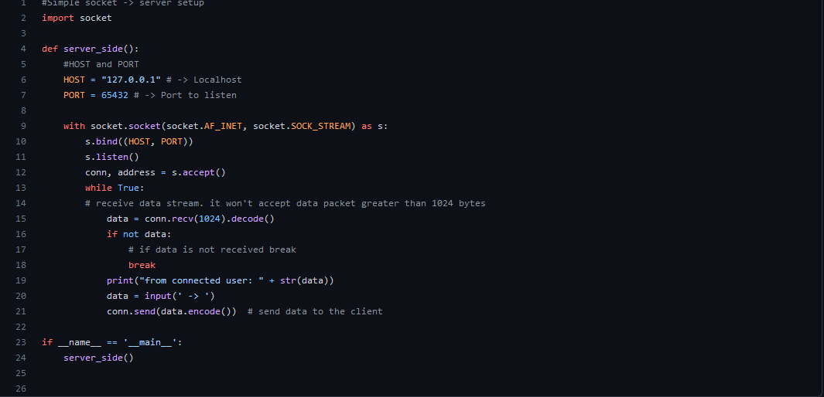

Client.py  
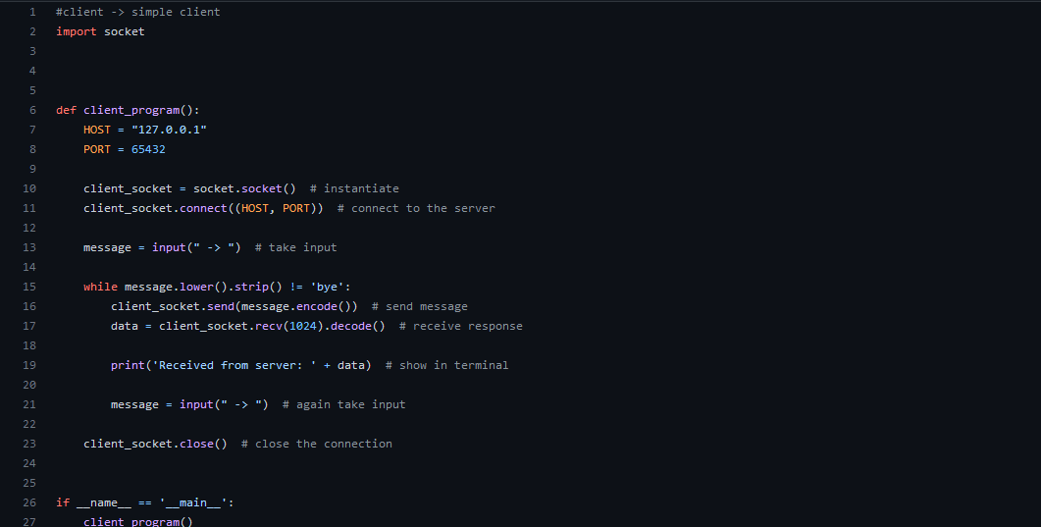

This was a fun project. What is basically does for now is that the terminals can talk to each other.

Codegrade – problems, difficulties

I did not really have problems with week5 only the assignment because it wouldn’t accept the code (output) because it wasn’t exact and sometimes I couldn’t think straight for some reason.

Self progression / reflection

I progressed this week a lot on theory about python. Very interesting to see. I wish this week gone a little bit more smoothly like previous weeks. The reason I think for it was is because I was still with challenge week in my head.

Code review – Casper’s code

Short introduction. We both made hangman with python for Hogeschool Rotterdam. This was a fun exercise/program to make. He implemented it in the challenge week text based game as a puzzle.   
  
Does the code do what it's supposed to do?

His code works fine. It is supposed to play hangman and it does. It sadly doesn’t show a real hangman maybe that is a little extra but still a finishing touch.

Is it clear what the code should do? Can you figure out from the code what the command would be?

I know what the code is and what it supposed to do but not entirely because of the lack of comments. I can see that the function is called hangman puzzle so from that I can determine that it is a hangman puzzle. Further I can see some preset words he hardcoded in a list to for the puzzle itself.

Can the solution be simpler?

It is always possible to make the solution simpler. For here I think it was coded the right way.

Are there redundant variables?

Not really redundant variables the only thing I see is that his variable names are not really that good. He doesn’t use camelCasing. Sometimes that is confusing for the reader.

Logical names for the variables?

Well he used ‘Swa’ as a variable name or as key name in a for loop which isn’t really good.

Unnecessary if statements?

-

Has any wrong input been caught?

-

Code review – Casper’s review for me

**From Casper**

**To Viktor**

I looked through Viktor’s code and found it pretty good there are not many things that need improvement. The code is clean and readable. However I found some small things that could be changed like variable names and some unnecessary variables.

* **Does the code do what it's supposed to do?**

Yes it works and it acts like a hangman puzzle

* **Is it clear what the code should do? Can you figure out from the code what the command would be?**

Yes the functions and actions are clear there are some comments to support the functions

* **Can the solution be simpler?**

No I have tried some other solutions but there isn't anyway shorter as far as I know

* **Are there redundant variables?**

Not really but I found one I think could be improved

#Functie voor degene die het woord kiest

def kiesWoord():

print("Wordchooser, Choose a word: ")

woordKiezer = input().upper()

woord = list(woordKiezer)

return woord

instead of assigning list(woordkiezer) to woord I would return list(woordkiezer).

* **Logical names for the variables?**

Yes and no most of the variables have logical names but some could be improved like I would rename some of the variables like leegwoord = list(""). I would call it something like collection_word_letters

* **Unnecessary if statements?**

No all the if statements that are made are necesarry.

* Has any wrong input been caught?

No

F

Peer evaluation

<viktor>

**This feedback is from :**   
<jayden>

**1. Motivation**

Within the learning team you work on your own assignments, but you can collaborate or help each other. This makes your study programme a less lonely journey. The small group that surrounds you will help you conquering the challenges of the study programme. This can help your motivation and the motivation of others.

* 1. You contribute positively to the learning team

(   ) 1 – not yet     (   ) 2 – can do more    (   ) 3 - well    (  x ) 4 – very well     (   ) 5 – too much ( )

* 1. You stick to things you agreed to do

(   ) 1 – not yet     (   ) 2 – can do more    (  x ) 3 - well    (   ) 4 – very well     (   ) 5 – too much ( )

* 1. You motivate fellow students

(   ) 1 – not yet     (   ) 2 – can do more    (   x) 3 - well    (   ) 4 – very well     (   ) 5 – too much ( )

You haven’t motivated me directly but this weekend when u asked something in discord I got motivated to start working on my school stuff again because I kind of forgot.

**2. Shared responsibilities**

By sharing experiences and helping each other where possible, you feel more connected to the study programme and each other. In a well-functioning learning team all team members experience shared responsibilities.

2.1 You actively participate when a team member needs help

(   ) 1 – not yet     (   ) 2 – can do more    (  ) 3 - well    (   x) 4 – very well     (   ) 5 – too much ( )

2.2 You indicate to others what you need in order to successfully finish your tasks

(   ) 1 – not yet     (   ) 2 – can do more    (   x) 3 - well    (   ) 4 – very well     (   ) 5 – too much ( )

2.3 You challenge yourself when you are doing your tasks

(   ) 1 – not yet     (   ) 2 – can do more    (   x) 3 - well    (   ) 4 – very well     (   ) 5 – too much ( )

* 1. You help others to challenge themselves when doing the tasks

(   ) 1 – not yet     (x   ) 2 – can do more    (   ) 3 - well    (   ) 4 – very well     (   ) 5 – too much ( )

We haven’t worked much together the last week but that is because of me but at the end when I asked you for help u didn’t say no u tried to help me

**3. Open communication**

In a well-functioning learning team, team members can share ideas, wishes, motives and insecurities with each other.

3.1 You ask for feedback on your work/actions/results

(   ) 1 – not yet     (   x) 2 – can do more    (  ) 3 - well    (   ) 4 – very well     (   ) 5 – too much ( )

3.2 You give others room to talk

(   ) 1 – not yet     (   ) 2 – can do more    ( x  ) 3 - well    ( )) 4 – very well     (   ) 5 – too much ( )

* 1. You listen with an open mind to what others have to say

(   ) 1 – not yet     (   ) 2 – can do more    (   ) 3 - well    ( x  ) 4 – very well     (   ) 5 – too much ( )

3.4 You give your opinion on matters  
 (   ) 1 – not yet     (   ) 2 – can do more    (   ) 3 - well    ( x  ) 4 – very well     (   ) 5 – too much ( )

I don’t know if you ask for feedback because we don’t really work together btu when we discussed something in class u listened well and came with suggestions about something on discord

**4. Respect differences**

A learning team where team members have different qualities, skills and fields of expertise and uses this where possible, is a powerful team because the team members feel respected

* 1. You contribute in a positive way to dealing with the strengths and weaknesses of different team members

(   ) 1 – not yet     (  x ) 2 – can do more    (   x) 3 - well    (   ) 4 – very well     (   ) 5 – too much

* 1. If you disagree with something, you let others know in a respectful manner   
     (with arguments and in a calm voice)

(   ) 1 – not yet     (   ) 2 – can do more    (  x ) 3 - well    (   x) 4 – very well     (   ) 5 – too much ( )

* 1. You have a positive contribution to the feeling of trust within the team. You discuss issues within the team during team meetings or you talk directly to the person it concerns.

(   ) 1 – not yet     (   ) 2 – can do more    (   x) 3 - well    (   ) 4 – very well     (   ) 5 – too much ( )

I feel like if someone asks u something you are good at explaining how it works

**5. Flexibility**

During BaseCamp things will run differently than planned. In a well-functioning learning team there is always room for improvement and development.

* 1. If things suddenly have to be done differently, you adapt and cooperate

(   ) 1 – not yet     (   ) 2 – can do more    ( x  ) 3 - well    (   ) 4 – very well     (   ) 5 – too much ( )

* 1. You have no problem with making mistakes

(   ) 1 – not yet     (   ) 2 – can do more    (   x) 3 - well    (   ) 4 – very well     (   ) 5 – too much ( )

.

* 1. You share what you’ve learned with your team members and teachers

(   ) 1 – not yet     (   x) 2 – can do more    (   ) 3 - well    (   ) 4 – very well     (   ) 5 – too much ( )

* 1. Je bent nieuwsgierig en probeert nieuwe dingen uit.

(   ) 1 – not yet     (   ) 2 – can do more    ( x  ) 3 - well    (   ) 4 – very well     (   ) 5 – too much ( )

I don’t really know how you work yet but I feel like you don’t really have problems with making mistakes and u like to try new things in your code

**6. Taking initiatives**

Sometimes you have to look beyond the beaten track of you have an idea how to do things differently. A well-functioning learning team provides room for initiatives and new ideas. This helps you move forward as a student and as a learning team.

* 1. You share your ideas or support a team member in sharing their ideas

(   ) 1 – not yet     (  x ) 2 – can do more    (   ) 3 - well    (   ) 4 – very well     (   ) 5 – too much ( )

* 1. You make helpful suggestions in team meetings

(   ) 1 – not yet     (   ) 2 – can do more    (   ) 3 - well    (  x ) 4 – very well     (   ) 5 – too much ( )

* 1. You explore new or different possibilities by yourself and share these with your team

(   ) 1 – not yet     (   ) 2 – can do more    (   x) 3 - well    (   ) 4 – very well     (   ) 5 – too much ( )

I think you do well in sharing your ideas not with me but with the others and when something must be done u take the initiative in the discord

Read the feedback other have provided. Write down key things you could use for your further development

Arch 2 - Week 6

Introduction - Start week 6

I mostly learned about functions, dictionaries and Sets. The way we can use them, manipulate them in our favour. My thoughts on it was more on the data analysing side but instead it was more a sorting data kind of thing. This start week topics are very interesting and I think it get’s harder at this point.

Course of action

I focused myself on the steps of this week because these kind of topics are kind of hard to understand sometimes. I found myself kind of stuck sometimes with time and efficiency. My own rule is, Consistency is key to learning new things. To get comfortable with new things. So every now I write a program on my whiteboard and strafe to keep up with the program.

Code grade

I finished everything of week 6. It wasn’t very hard though I found the Assignment very interesting and fun to make because I could actually see data go in and out. Saved in the JSON file as well it was very satisfying for me. This also kind of boosted me into more motivation.

A2W6A1 – Address book

Passed almost on everything except for the styling of code. It is way too much of a hassle sometimes to go and fix that.  
  
Feedback – peer evaluation

-

Self progression / reflection

For self progression this week I want to say that I think I improved more at working better for sure and have created a consistency with working on school and programming overall. Sadly this week still wasn’t very smooth for me because at the end of the week I got very sick ( Covid )

Arch 2 - Week 7

Introduction - Start week 7 ( Sick )

This week will be very different from the other ones because the whole week I was sick I got covid. A very difficult and hard week for me. I couldn’t do anything this week due to how heavy covid was for me. I will talk about how I dealt with it in this week.

Lows

This week was definitely a “Low” one for me, meaning the worst week I have had over the other weeks. How did I deal with this? Of course I was worried with things like “What if I get behind very much?”. The main focus was getting better at the moment and I did everything to get my rest so I could be better and catch up again. So after being very sick the whole week and weekend I decided to focus everything into resting. That was the right thing to do. After I got my rest I had to catch up little things of week 6. I did them after the week and then I made a tiny start for week 7. Luckily we had vacation so I made most of the things in vacation.

Arch 2 - Week 8 – Challenge week

Introduction - Start week 8

We had challenge week and it was quite fun. We made the challenge in pairs and this time I was with Olivier. The challenge wasn’t that hard. It was super fun because we had to work with a Raspberry Pi 4.   
The challenge was to setup the Raspberry Pi 4 with the SenseHAT sensors and send weather data to a API. ( Humidity, Pressure, Temperature )

Day 1 – Challenge week – A2  
On the first day we setup the RBP. We had to setup the SSH and VNC. With SSH we could connect to the RBP terminal and with VNC we could basically see the whole system UI. Further we set the RPB up so we don’t need a monitor anymore and that we can connect with our own Laptops via VNC. We then played with the SenseHAT emulator a bit and made a banana. We uploaded the code and ran it so our LCD on the RPB shows a banana.

Day 2 – Challenge week – A2 – Phase 1 [Completed]  
Then the next phase was getting data and displaying it on the SenseHAT. This was very simple because of the SenseHAT module that could be used. With the module we used we could get the temperature, humidity, pressure. Then display it with a build in function of SenseHAT. So essentially what we accomplished was displaying the data we needed. This completes Phase 1.

Day 3-4 – Challenge week – A2 – Phase 2 [Completed]  
These next phases were also pretty simple for me. We had to send data to the server with a API. This took longer than expected because Olivier didn’t know anything about API’s, Requests, HTTP headers…. I already made the code so I could explain to him how you work with API’s , What methods are etc. I had him make some code for himself so he also could understand of course. With the API we had to make a “Node”. A Node is a place were we could save our data to. We the proceeded to do POST request with he data we had and used the module Schedule to let the script run every 10 seconds or so. This took the longest I think because we had to figure out how the API worked.

Day 5 – Challenge week – A2 – Phase 3 [Completed]  
This week was not that hard as well. We only had a little bit of problems with sorting our data in the right way. We then made a menu in Python so the user could choose what kind of data he or she wanted to see. Then we visualized the data with Graphs with another module. This completes Phase 3

Self progression/reflection

The challenge week was going pretty smoothly and did not really have problems. The only problems I had for the week was getting back into it because I had covid a week before this. Further I learned a lot about API’s as well in Python.

Arch 3 - Week 9

Introduction - Start week 9 – A3

The first day of the week we had online lessons so I started with making the assignment of week 9 and got it done pretty early. We are now learning about Classes. Object orientated. This is a fun introduction to it.

Day 2 – Week 9  
On day 2 I finished the step that needed to be made and almost all of the codegrade problems, assignment. The only problem I did not make was problem 4 because I don’t really have a solution in my head yet.

Day 3-4 – Week 9  
These days I mostly were focused on the dossier and trying to finish it. I had a great conversation with Thomas about the Dossier and gave me amazing tips for things to put in the Appendix, How to write things a bit better and some extra’s. Lovely advice and gave me a little bit more oversight of what needed to be done.