Notes for Platform Testing – 2/1/26
- Invite emails, reminder emails, and Login Verification emails ...
  - Confirm that links work – the links in the emails do NOT work. We have to figure this out. Did not work in phone, computer, nothing. Copying the links were a pain (see below)
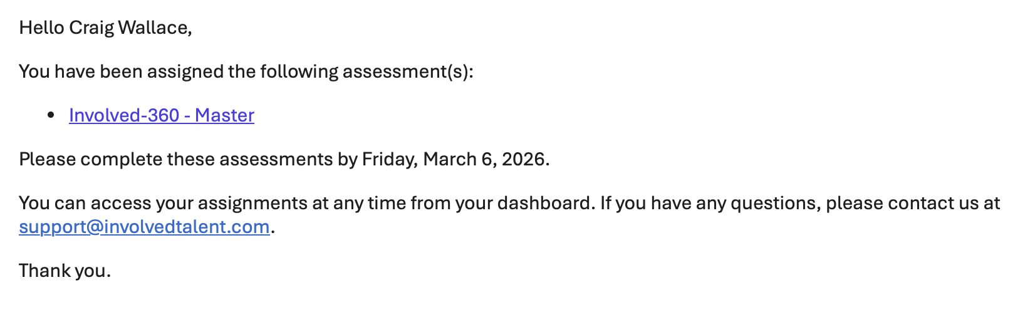
This link needs to work 100%
And David’s link WORKED in gmail, but NOT in Outlook. This has to work in Outlook as clients will mostly be using this. This worked for me with non-Gmail accounts in Outlook.
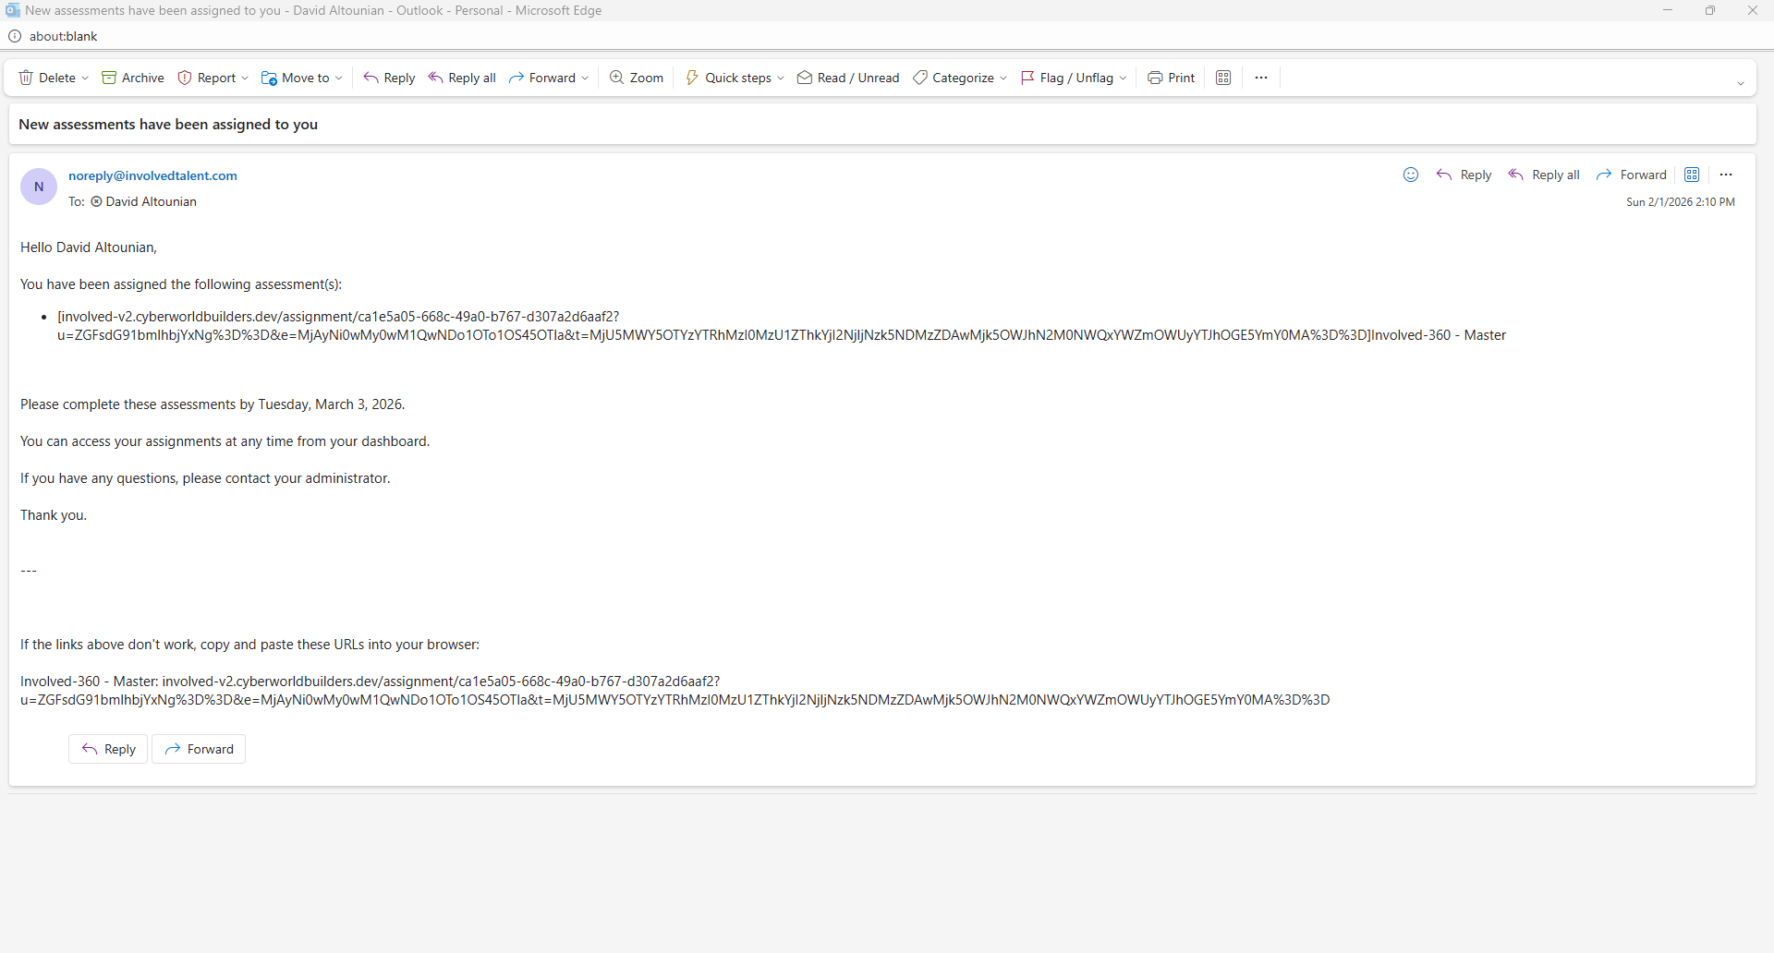
  - Some emails were not received. David told me he never received this one. Need easy way to check this:
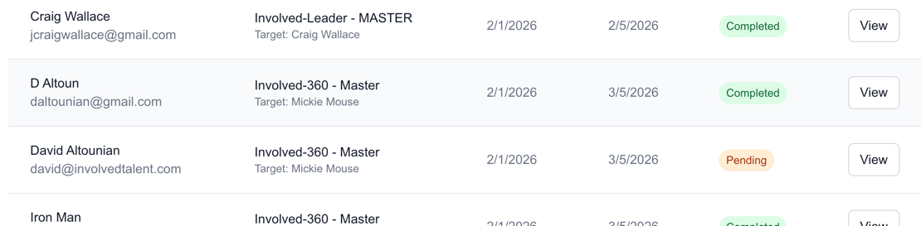
  - Check if there is a link specifically for the reminder email (assuming same as original, but can’t tell as I have to wait on reminder)
  - Remove assessment name in the URL part of email (see below). It seems that you need to copy this and you don’t. the current view introduces user error.
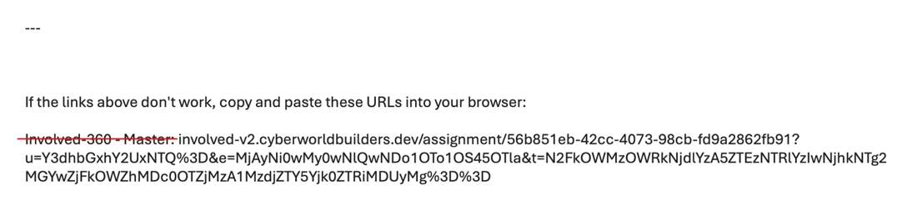
  - Redo the core email and reminder email templates, plus language about saving email and instructions. – Craig to provide text.
  - The Log In verification email link WORKS. So figure out why this one works and the ones above do not work. I am using the same mail systems (outlook, gmail, yahoo, apple) and this issue is uniform.
  - 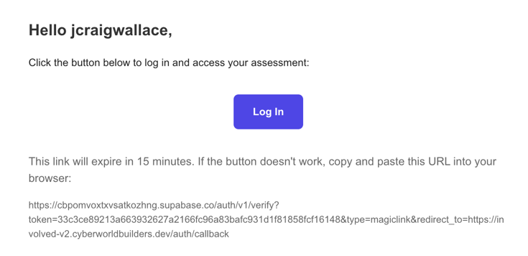
This link in email works!
- ‘Create X Assignments’ button when assigning assessments.
  - Add verification - add a second step: “Are you sure? This will send invites for assessments.”
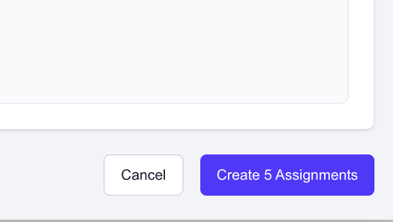
This button – once clicked you have to verify you want to send assignments
- Numbering for Dimensions is still messed up (see screenshot). I thought this was fixed.
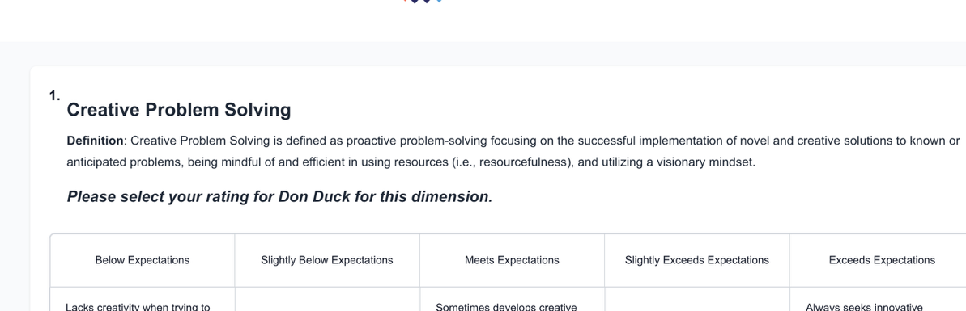
Here is number problem.
- Need a better message after completing the assessment (see screenshot), Sometimes I get one janky one and then another that is great. Not sure logic here. We need one the like second option, so they can return to their dashboard, especially if they have to do multiple assessments.
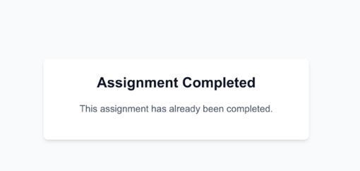 VS 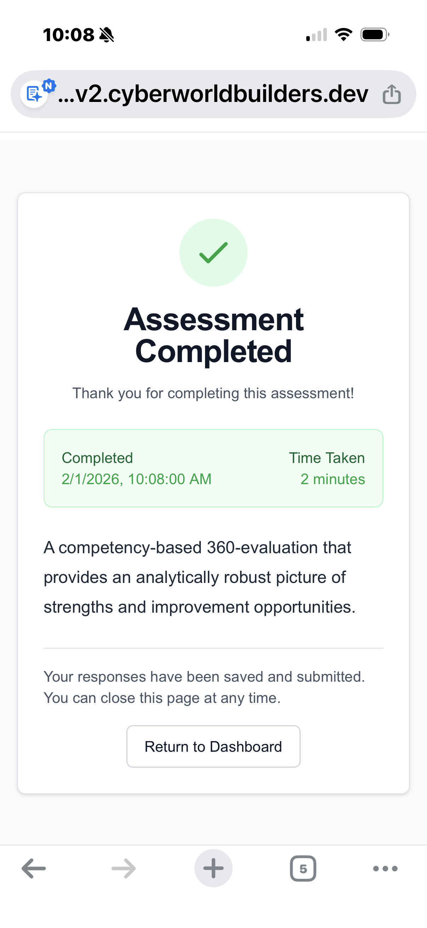

- Mobile has to work and look better – OR we block and force people to do on computer or tablet.
Mobile view looks awful and has to be fixed. Was like the below for Chrome, Safari, DuckDuck
  - Really hard to select the rating I intend as well – functionality was jacked as well as display.
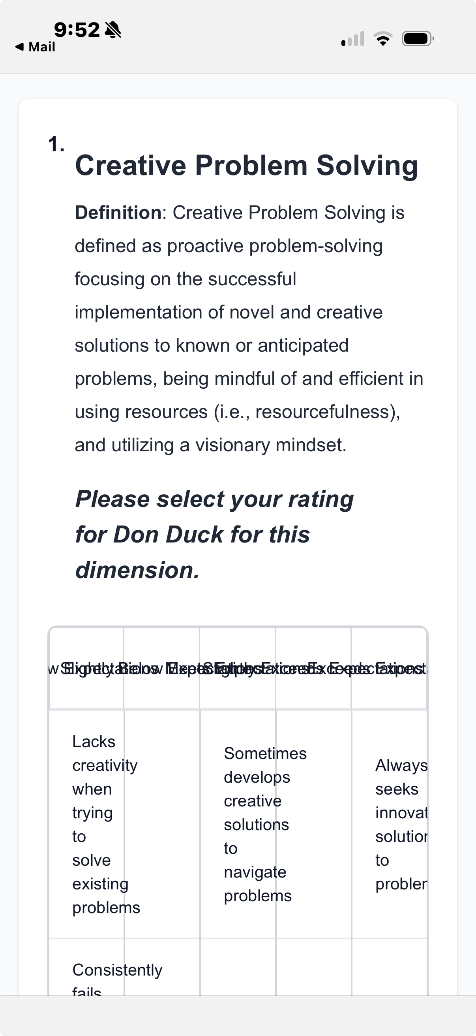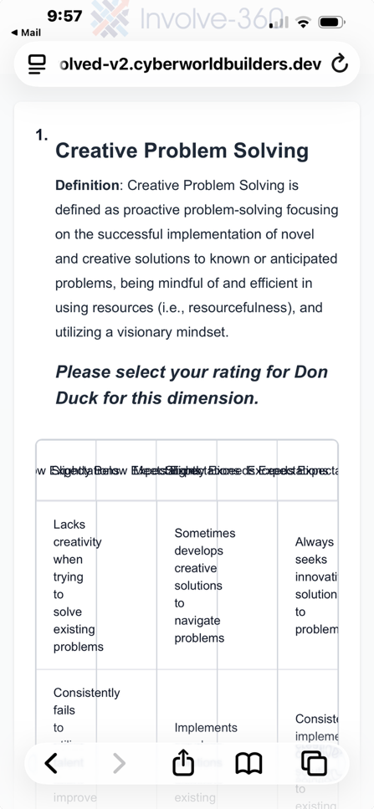
- Think through the experience for someone with multiple assignments at one time.
  - What would this look like on their dashboard?
- Clarify how the password function works for a member (see screenshot). Why is this there? Can we use it? Remove signup and social signup stuff on login

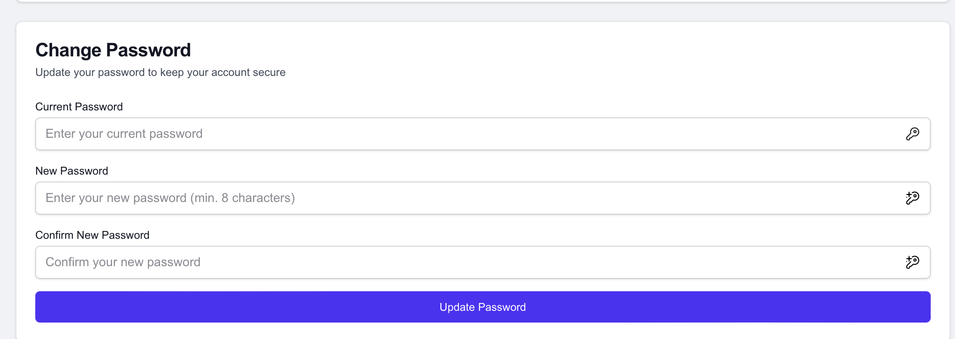
- How do I add edit assignments:
- For example, if I left someone off and need to add them a day later, so their data goes into same assignment batch and will calculate with others. Don’t see option for that. Even tried this and it kept the single new assignment separate.
- Adding someone to existing survey AFTER it has launched – see screen shot below, and dig into legacy Digital Ocean Code to see:
- 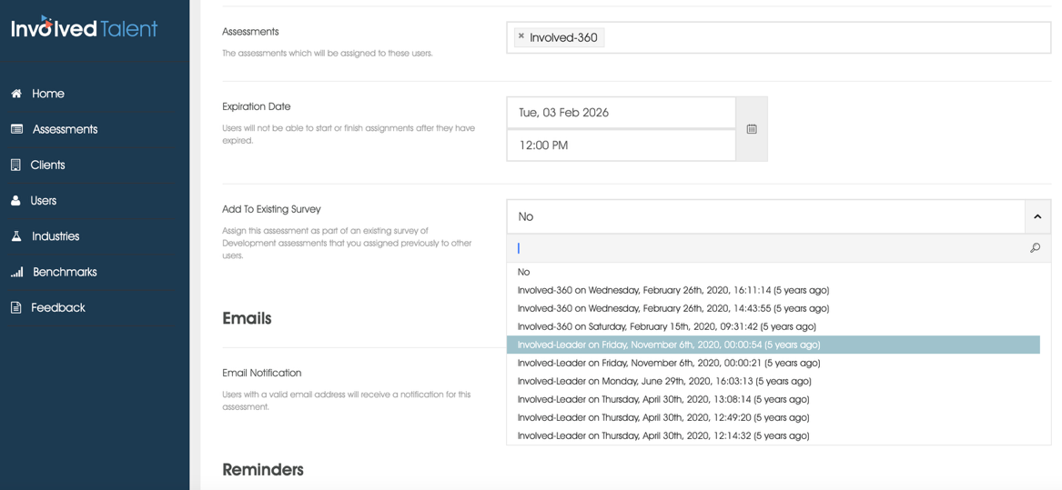
- Reports Failed for me in New Tester Client – Phase 3
Error: “Failed to get report.” I notice on your video you have complete data for all reports. I did not … Maybe this matters? For example, I have 5 of 7 complete data points. Reports should still generate without 100% completion rate.
  - What does this mean:
  - 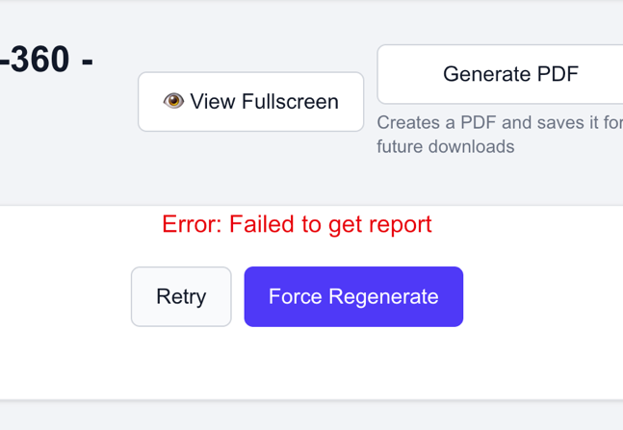
  - System says “no data” when I click “Force Generate.”
  - And then I got this:
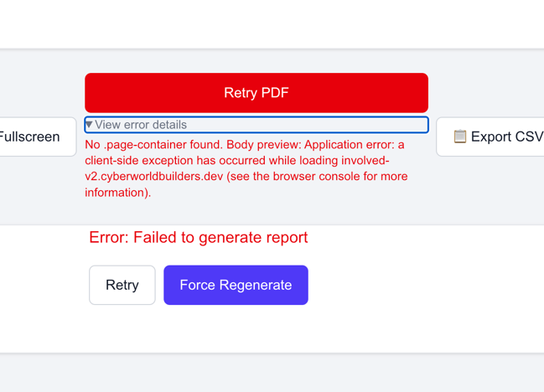
  - 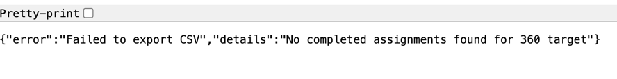
- 360 Reports for your client – looking pretty solid! Few tweaks needed as you acknowledge in your video
- How do we handle multiple assignments to a single person – one email, several, and how to return to dashboard once they have completed the assessment. What happens if they log out and come back a day or two later to finish assessments – how do they access?
- How do I edit an assignment – extend due date, delete an assignment, change target, etc?
- How do I delete assessments?
- Lots to work on.
  - Client experience has to be improved – this has to be super easy for clients to complete the assessments – from initial email to taking several.
  - Assigning users and groups seems to work.
  - 360 Reports are broken: full data, recording data, where did data go, CSV export does not work. I think this has to do with NOT having 100% response rate (i.e., not everyone did their assessment). We need to address this and get it fixed.
  - Bulk PDF generation? How do we click – ‘generate all pdfs’? for a given client and data collection?

***********************
Email template for assignments:

Hello [name],

You have been assigned the following assessment(s):
[Assessment name(s) with link]

Please click the link above to take you to the dashboard to log in. Please complete your assignments by [date].

You can access your assignments at any time from your dashboard (link).

SAVE this email and BOOKMARK your login page. If you have been assigned multiple assessments, this will help you navigate to the login page.

If you have any questions, please contact us at: support@involvedtalent.com

Thank you!

-Involved Talent Team
© 2026 Involved Talent

REMINDER EMAIL TEMPLATE:
Hello, [name]
This is a reminder to complete your assessments, which will expire [date].
You have been assigned to complete:
[assessment name(s) with link]
You can login using this link to complete them:
[login-link]
© 2026 Involved Talent

Login Page: Remove access to signup and just put Forgot password.

