**Cybex API Server user manual**

Contents

1 Overview 3

2 Topology 3

3 cyb-signer 4

3.1 Setup in Linux 4

3.1.1 Prerequisite software 4

3.1.2 Download cyb-signer source code and build the artefact 4

3.1.3 Configure your cyb-signer 5

3.1.4 Start and stop cyb-signer 5

3.1.5 Sign transaction 5

3.2 Setup in Windows 7

4 API Server 8

# Overview

This document is to guide user to set up local cyb-signer and explain steps to use cybex API Server.

# Topology

The transactional operation is required to sign with user’s private key before sending to API server. User can use the response message from cyb-signer and send the exact content to API server.

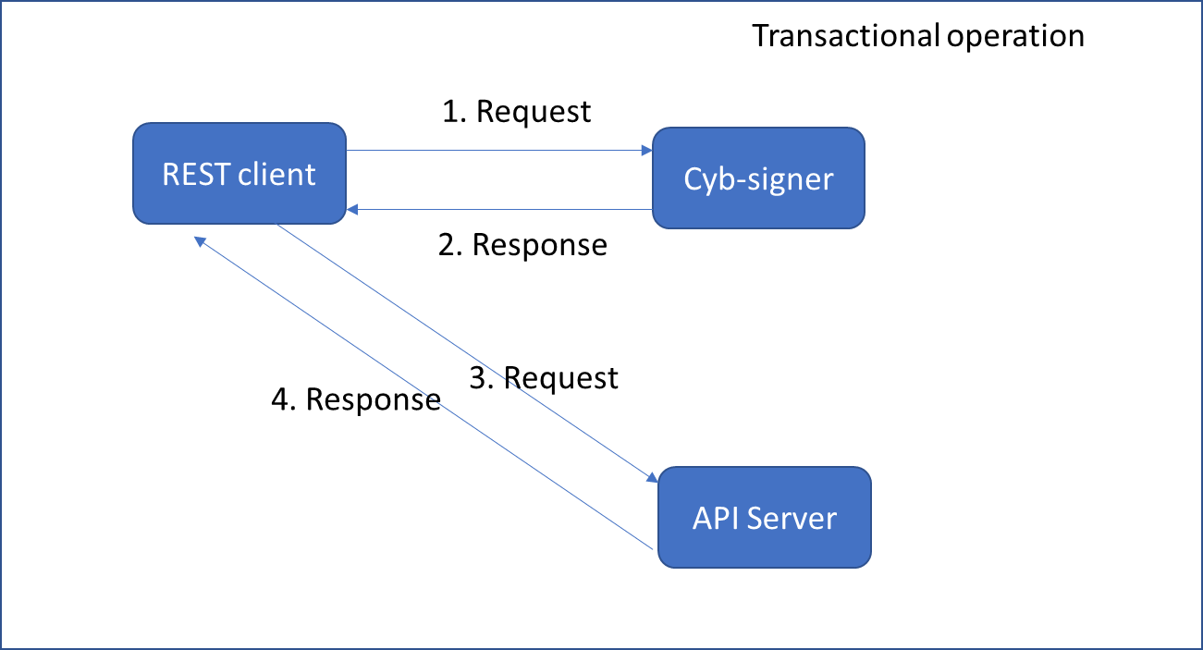

However, non-transactional operation can be sent to API server directly via REST.

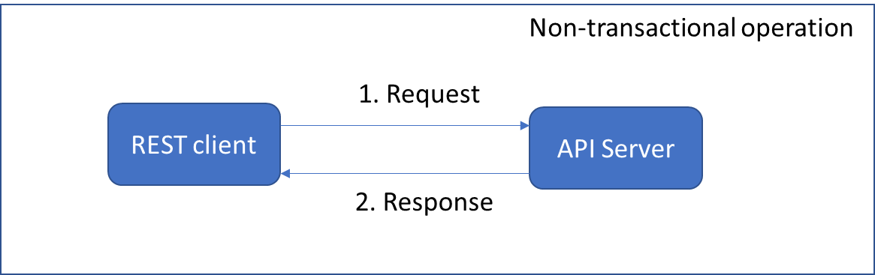

Following table lists all latest supported operations.

|  |  |
| --- | --- |
| **Type** | **Name** |
| Transactional | Create new order |
| Create cancel order |
| Create cancel-all order |
| Non-transactional | Query order status |
| Query trade status |
| Get reference data |
| Get user’s position |
| Get asset pair’s order book |
| Get asset pair’s candle stick info |

# cyb-signer

This section is to guide user to set up their local cyb-signer step by step. The program is to create a REST server with user’s private key in your local computer. This could avoid expose user’s private key to other party while keeping the transaction signing process simple. User could use any REST client to sign a transaction easily.

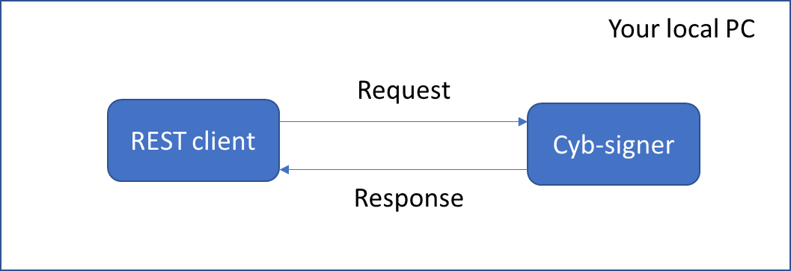

## Setup in Linux

In following section, it will show you how to set up in Linux environment. All screen shots were captured from Ubuntu 16.04.

### Prerequisite software

Some software are required to install in order to proceed further.

OpenJDK: 11 or later

Git: 2.7 and later

Maven: 3.0 and later

### Download cyb-signer source code and build the artefact

The full source code is in public github repository: <https://github.com/CybexDex/cyb-signer.git>

Please use “git clone” command to download it to your local PC.

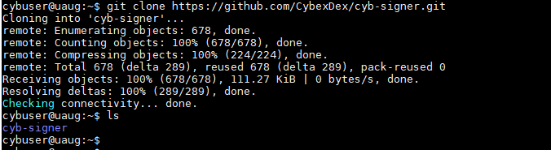

### Configure your cyb-signer

All parameters present in the file local_env under “cyb-signer/scripts” folder.

Following are example for your reference:

SIGNER_SERVER_PORT=8090 (an available port in your local pc)

PRIVATE_KEY=5JicqQ9tcwYoFGXPtFvdM3jAmwEz6Qi1zsuT7muNXCrRND2XXXX (your private key)

ACCOUNT_ID=1.2.40xxx (your account id in cybex)

API_SERVER_ADDRESS=api.cybex.io (this is the same for everyone)

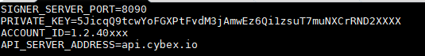

### Start and stop cyb-signer

You could use start.sh/stop.sh to launch/stop cyb-signer. At the time of start, the script will use maven to build the download source. When you build it for the first time, it takes a little longer since maven will download necessary artefacts. Once cyb-signer starts, you don’t need to restart it unless you want to change parameters.

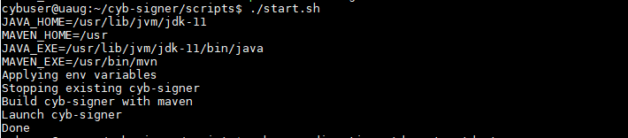



To increase security of signing, the cyb-signer and your REST-client must be in the same computer. cyb-signer will reject http request not using localhost in the url. For example, following request will fail: http://192.168.1.10:8090/signer/v1/newOrder.

### Sign transaction

Now you could use your REST client to send request message to cyb-signer to sign your transaction.

* Create New Order

POST <http://localhost:8090/signer/v1/newOrder>

|  |  |
| --- | --- |
| Parameter | Example value |
| assetPair | ETH/USDT, EOS/USDT |
| price | 146.67 |
| quantity | 10 |
| side | buy or sell |

|  |  |
| --- | --- |
| Example |  |
| Request | curl --data '{"assetPair": "ETH/USDT","price": 146.67,"quantity": 10,"side": "buy"}' http://localhost:8090/signer/v1/newOrder |
| Response | {  "transactionType" : "NewLimitOrder",  "transactionId" : "40c275d77233c5761472673bd0532150dde723a0",  "refBlockNum" : 18956,  "refBlockPrefix" : 507092400,  "txExpiration" : 1546919505,  "fee" : {  "assetId" : "1.3.0",  "amount" : 55  },  "seller" : "1.2.40658",  "amountToSell" : {  "assetId" : "1.3.27",  "amount" : 1466699999  },  "minToReceive" : {  "assetId" : "1.3.2",  "amount" : 10000000  },  "expiration" : 1546991999,  "signature" : "1c7a00b61039b6bc1ace93916446207a28a69e60a97fbd6b26  7518754a13e7adca463239452b0e00aa90b71b30a57ea4d65fa4cee44a30ab  2c7841fb5cd0145913",  "fill_or_kill" : 0  } |

* Create Cancel Order

POST <http://localhost:8090/signer/v1/cancelOrder>

|  |  |
| --- | --- |
| Parameter | Example value |
| originalTransactionId | 88cecaa11b8584fb21243cd57ed2227e7c181452 |

|  |  |
| --- | --- |
| Example |  |
| Request | curl --data '{"originalTransactionId": "88cecaa11b8584fb21243cd57ed2227e7c181452"}' http://localhost:8090/signer/v1/cancelOrder |
| Response | {  "transactionType" : "Cancel",  "transactionId" : "e3a8b5c5afd2daa038707aa2e9e2d60701d726c0",  "originalTransactionId" : "88cecaa11b8584fb21243cd57ed2227e7c181452",  "refBlockNum" : 18956,  "refBlockPrefix" : 507092400,  "txExpiration" : 1546950595,  "orderId" : "0",  "fee" : {  "assetId" : "1.3.0",  "amount" : 5  },  "feePayingAccount" : "1.2.40658",  "signature" : "1c313f1f34c7975e3999d483ddf1d2d2322751593b82f3f087f  987e95a03b1639d696e2348105f2a9070c11c974b2c94ed616d955  59108d7714f516fa5ee55d559"  } |

* Create CancelAll

POST <http://localhost:8090/signer/v1/cancelAll>

|  |  |
| --- | --- |
| Parameter | Example value |
| assetPair | ETH/USDT. Use “CYB/CYB” to cancel all your open orders no matter what asset pairs they are in. |

|  |  |
| --- | --- |
| Example |  |
| Request | curl --data '{"assetPair": "ETH/USDT"}' http://localhost:8090/signer/v1/cancelAll |
| Response | {  "transactionType" : "CancelAll",  "transactionId" : "9616b03391ccf0107c58326f2674c4b51a7bf284",  "refBlockNum" : 18956,  "refBlockPrefix" : 507092400,  "txExpiration" : 1547007167,  "fee" : {  "assetId" : "1.3.0",  "amount" : 50  },  "seller" : "1.2.40658",  "sellAssetId" : "1.3.2",  "recvAssetId" : "1.3.27",  "signature" : "1c3435fd231625f61a516e44bcb193f6344441974cf76def07  1ea01e82a1a2d0043e44ee28993d523fa13bad5445a297cdeef6f0b6a8650  7e8cbba7841ec6a9010"  } |

## Setup in Windows

You could refer to 3.1 for most of setup except for script to start cyb-signer in Windows. Once you configure in local_env file, you could use “start.bat” to launch it. When you want to shut it down, simply close the window.

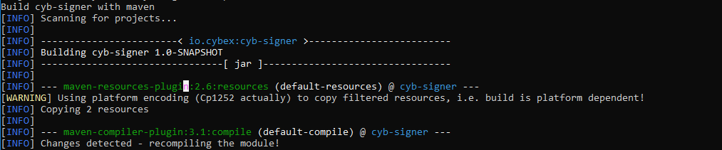

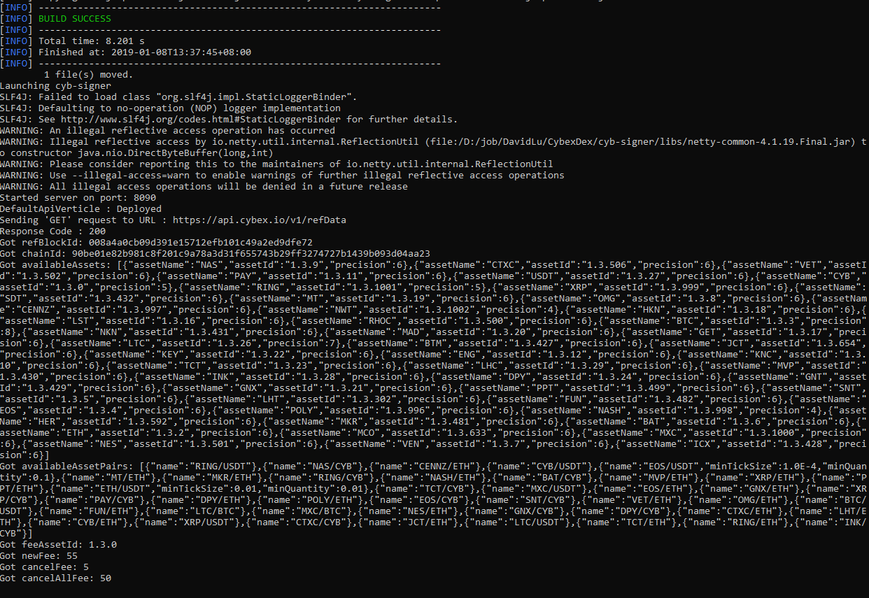

# API Server

As described in section 2, the API server is used to execute a lot of transactions and queries on behalf of users. User could navigate and have a test via swagger UI server: <https://cybexdex.github.io/apiExplorer>

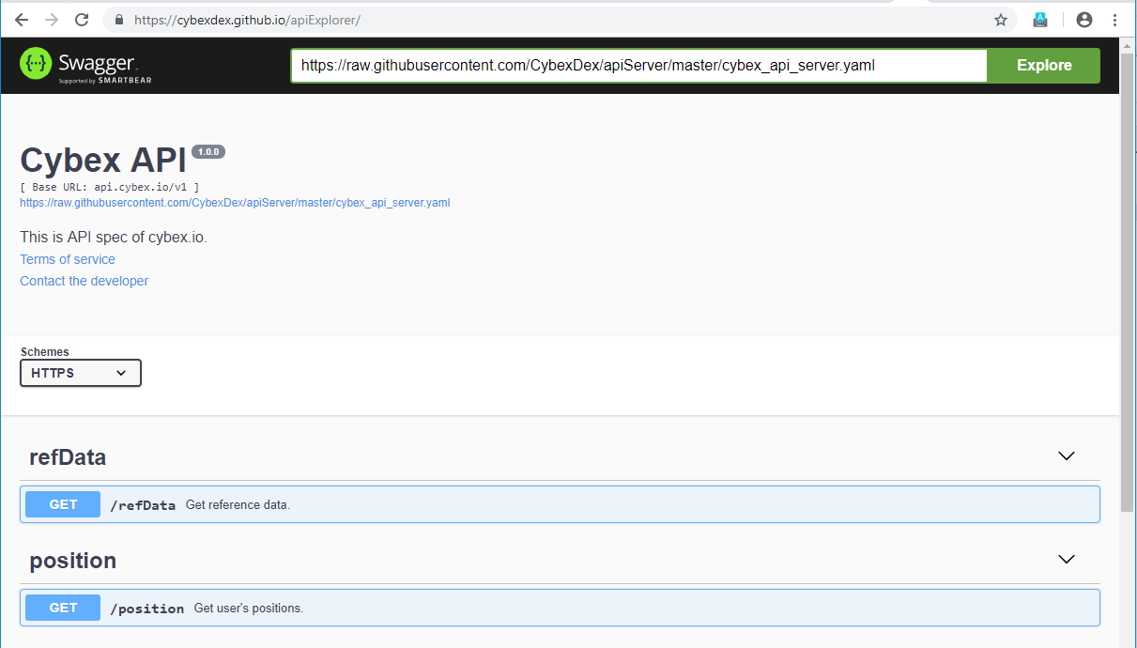

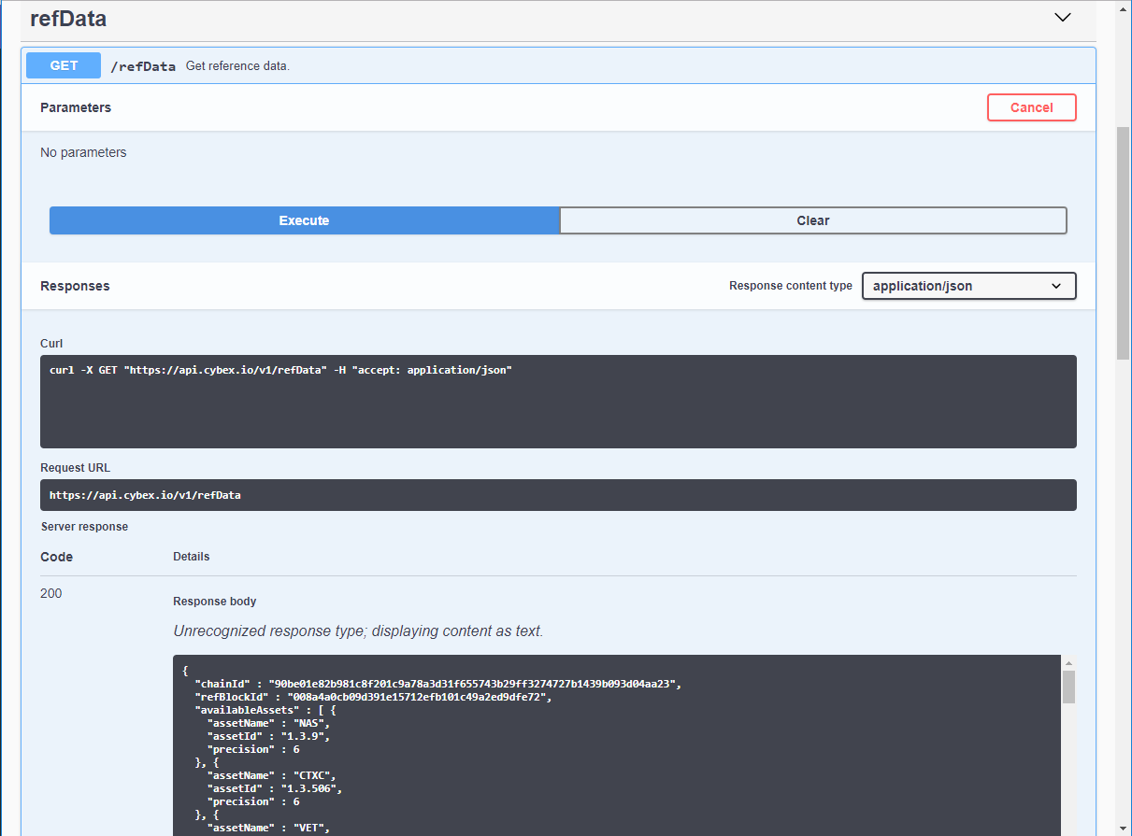

In the next few pages, all API and examples will be illustrated.

* Query reference data

GET <https://api.cybex.io/v1/refData>

It will return some static data regarding exchange, e.g. chain id, reference block id, available assets, available asset pairs and fee info.

|  |  |
| --- | --- |
| Parameter | Example value |
| N/A |  |

|  |  |
| --- | --- |
| Example |  |
| Request | curl https://api.cybex.io/v1/refData |
| Response | {  "chainId" : "90be01e82b981c8f201c9a78a3d31f655743b29ff3274727b1439b093d04aa23",  "refBlockId" : "008a4a0cb09d391e15712efb101c49a2ed9dfe72",  "availableAssets" : [{  "assetName" : "ETH",  "assetId" : "1.3.2",  "precision" : 6  }, {  "assetName" : "USDT",  "assetId" : "1.3.27",  "precision" : 6  }, {  "assetName" : "CYB",  "assetId" : "1.3.0",  "precision" : 5  }, {  "assetName" : "EOS",  "assetId" : "1.3.4",  "precision" : 6  },  ......  ],  "availableAssetPairs" : [{  "name" : "EOS/USDT",  "minTickSize" : 0.0001,  "minQuantity" : 0.1  }, {  "name" : "ETH/USDT",  "minTickSize" : 0.01,  "minQuantity" : 0.01  }  ......  ],  "fees" : {  "feeAssetId" : "1.3.0",  "newFee" : 55,  "cancelFee" : 5,  "cancelAllFee" : 50  }  } |

* Execute transaction

POST https://api.cybex.io/v1/transaction

User needs to put the return content from cyb-signer in the content of this post message.

|  |  |
| --- | --- |
| Parameter | Example value |
| Json content | The exact response from cyb-signer. It could be New, Cancel or CancelAll orders. |

|  |  |
| --- | --- |
| Example |  |
| Request | curl --data '{ "transactionType": "NewLimitOrder", "transactionId": "040c6466dc0cebb8de40520ebb7346fe0e446b35", "refBlockNum": 18956, "refBlockPreix": 507092400, "txExpiration": 1546926850, "fee": { "assetId": "1.3.0", "amount": 55 }, "seller": "1.2.40658", "amountToSell": { "assetId": "1.3.27", "amount": 277000 }, "minToReceive": { "assetId": "1.3.4", "amount": 100000 }, "expiration": 1546991999, "signature": "1b477931ebb89b39f7e1f1953c9ead66f1c93eee8183f4334729e8  f19dceab2a5000af53728952dd73bc3636ab0663cc8f0293714d4c4  ed8f3399c5a50b9da2816", "fill_or_kill": 0}' https://api.cybex.io/v1/transaction |
| Positive Response | {  "Status": "Successful",  "orderSequence": 529016,  "signature": "1b477931ebb89b39f7e1f1953c9ead66f1c93eee8183f4334729e8f1  9dceab2a5000af53728952dd73bc3636ab0663cc8f0293714d4c4ed8f3399c5a50b9  da2816",  "time": "2019-01-08T05:53:19.049071Z"  } |
| Negative Response | {  "Status" : "Failed",  "Code" : 1005,  "Message" : "Duplicated transaction",  "signature" : "1b477931ebb89b39f7e1f1953c9ead66f1c93eee8183f4334729e8f19dceab2a  5000af53728952dd73bc3636ab0663cc8f0293714d4c4ed8f3399c5a50b9da28  16"  } |

* Query order status

GET https://api.cybex.io/v1/order

Use this api to query order statuses.

|  |  |  |  |
| --- | --- | --- | --- |
| Parameter | Type | Mandatory | Example value |
| accountName | STRING | YES | Your-account-name |
| reverse | BOOL | NO | If it is true, the most recent record will be shown at the beginning. By default, it is true. |
| assetPair | STRING | NO | Asset pair filter. E.g. ETH/USDT |
| orderStatus | STRING | NO | Order status filter. E.g. FILLED. Use comma as delimiter to include more than one statuses. E.g. FILLED, OPEN |
| startTime | STRING | NO | Beginning time of your query, format must be YYYY-MM-DDTHH:mm:ss.ssssssZ. E.g. 2018-01-07T01:20:48.647910Z |
| endTime | STRING | NO | End time of your query, format must be YYYY-MM-DDTHH:mm:ss.ssssssZ. E.g. 2019-01-07T01:20:48.647910Z |
| start | INT | NO | Number where result will be shown from |
| limit | INT | NO | Max number of results returned |
| transactionId | STRING | NO | Query by transaction id |

|  |  |
| --- | --- |
| Example |  |
| Request | curl 'https://api.cybex.io/v1/order?accountName=XXXX&reverse=true&orderStatus=FILLED,CANCELED' |
| Positive Response | [ {  "accountName" : "XXXX",  "orderSequence" : 529016,  "orderStatus" : "FILLED",  "assetPair" : "EOS/USDT",  "side" : "buy",  "price" : 2.77,  "quantity" : 0.1,  "filledQuantity" : 0.102437,  "averagePrice" : 2.7041010572,  "transactionId" : "040c6466dc0cebb8de40520ebb7346fe0e446b35",  "createTime" : "2019-01-08T05:53:19.046342Z",  "lastUpdateTime" : "2019-01-08T05:53:21.806097Z"  }, {  "accountName" : "XXXX",  "orderSequence" : 169409,  "orderStatus" : "FILLED",  "assetPair" : "EOS/USDT",  "side" : "buy",  "price" : 2.77,  "quantity" : 0.1,  "filledQuantity" : 0.100264,  "averagePrice" : 2.762706455,  "transactionId" : "e447bca7d48412d8fc4aecc91224d008a4946145",  "createTime" : "2019-01-03T01:33:39.501859Z",  "lastUpdateTime" : "2019-01-03T01:33:42.722457Z"  }] |

* Query trade

GET https://api.cybex.io/v1/trade

Use this api to query trades.

|  |  |  |  |
| --- | --- | --- | --- |
| Parameter | Type | Mandatory | Example value |
| accountName | STRING | YES | Your-account-name |
| reverse | BOOL | NO | If it is true, the most recent record will be shown at the beginning. By default, it is true. |
| assetPair | STRING | NO | Asset pair filter. E.g. ETH/USDT |
| startTime | STRING | NO | Beginning time of your query, format must be YYYY-MM-DDTHH:mm:ss.ssssssZ. E.g. 2018-01-07T01:20:48.647910Z |
| endTime | STRING | NO | End time of your query, format must be YYYY-MM-DDTHH:mm:ss.ssssssZ. E.g. 2019-01-07T01:20:48.647910Z |
| start | INT | NO | Number where result will be shown from |
| limit | INT | NO | Max number of results returned |

|  |  |
| --- | --- |
| Example |  |
| Request | curl 'https://api.cybex.io/v1/trade?accountName=XXXXXX&reverse=true' |
| Positive Response | [ {  "accountName" : "XXXX",  "orderSequence" : 529016,  "chainOrderId" : 395937330,  "assetPair" : "EOS/USDT",  "side" : "buy",  "orderPrice" : 2.77,  "orderQuantity" : 0.1,  "tradePrice" : 2.7041010572,  "tradeQuantity" : 0.102437,  "blockTime" : "2019-01-08T05:53:21.000000Z"  }, {  "accountName" : "XXXX",  "orderSequence" : 169409,  "chainOrderId" : 384202079,  "assetPair" : "EOS/USDT",  "side" : "buy",  "orderPrice" : 2.77,  "orderQuantity" : 0.1,  "tradePrice" : 2.762706455,  "tradeQuantity" : 0.100264,  "blockTime" : "2019-01-03T01:33:42.000000Z"  }, {  "accountName" : "XXXX",  "orderSequence" : 792863,  "chainOrderId" : 382273197,  "assetPair" : "ETH/USDT",  "side" : "sell",  "orderPrice" : 143.1,  "orderQuantity" : 0.01,  "tradePrice" : 143.1799,  "tradeQuantity" : 0.01,  "blockTime" : "2019-01-02T07:52:54.000000Z"  } ] |

* Query user’s position

GET https://api.cybex.io/v1/position

User uses it to query his current position.

|  |  |  |  |
| --- | --- | --- | --- |
| Parameter | Type | Mandatory | Example value |
| accountName | STRING | YES | Your-account-name |

|  |  |
| --- | --- |
| Example |  |
| Request | curl 'https://api.cybex.io/v1/position?accountName=XXXX' |
| Positive Response | {  "accountName" : "XXXX",  "positions" : [ {  "assetName" : "CYB",  "quantity" : 3290.30569  }, {  "assetName" : "ETH",  "quantity" : 0.377978  }, {  "assetName" : "USDT",  "quantity" : 4.376498  }, {  "assetName" : "EOS",  "quantity" : 0.202701  } ],  "time" : "2019-01-08T06:19:42.025291Z"  } |

* Query order book for an asset pair

GET https://api.cybex.io/v1/orderBook

User uses it query order book.

|  |  |  |  |
| --- | --- | --- | --- |
| Parameter | Type | Mandatory | Example value |
| assetPair | STRING | YES | E.g. ETH/USDT, EOS/USDT |
| limit | INT | YES | Number of levels |

|  |  |
| --- | --- |
| Example |  |
| Request | curl 'https://api.cybex.io/v1/orderBook?assetPair=ETH/USDT&limit=3' |
| Positive Response | {  "assetPair" : "ETH/USDT",  "bids" : [ [ "146.31", "5.0", "731.55" ], [ "146.3", "3.192823", "467.110114" ], [ "146.28", "3.0", "438.84" ] ],  "asks" : [ [ "146.36", "3.902031", "571.062364" ], [ "146.39", "3.19903", "468.306001" ], [ "146.41", "3.742901", "547.960743" ] ],  "time" : "2019-01-08T06:22:37.47311Z"  } |

* Query candle stick

GET https://api.cybex.io/v1/klines

Use it to query asset pair’s candle stick.

|  |  |  |  |
| --- | --- | --- | --- |
| Parameter | Type | Mandatory | Example value |
| assetPair | STRING | YES | E.g. ETH/USDT, EOS/USDT |
| interval | ENUM | YES | 1m, 3m, , 5m, 15m, 30m, 1h, 2h, 4h, 6h, 8h, 12h, 1d, 3d, 1w, 1M |
| startTime | LONG | NO | Beginning time of the query in epoch time. |
| endTime | LONG | NO | End time of the query in epoch time. |
| limit | INT | NO | Level to be shown |

|  |  |
| --- | --- |
| Example |  |
| Request | curl 'https://api.cybex.io/v1/klines?assetPair=EOS/USDT&interval=1m&limit=2' |
| Positive Response | [  [  1546928820000, // Open time  "2.70150000", // Open price  "2.70240000", // High  "2.70150000", // Low  "2.70200000", // Close  "282.91000000", //Volume  1546928879999, // Close time  "764.40811500", // Quote asset volume  3, // Number of trades  "64.45000000", // Taker buy base asset volume  "174.16968000", // Taker buy quote asset volume  "0" // Reserved  ],  [  1546928880000,  "2.70200000",  "2.70200000",  "2.70160000",  "2.70160000",  "163.48000000",  1546928939999,  "441.70876800",  2,  "163.48000000",  "441.70876800",  "0"  ]  ] |