Article
C3 Ligand Is Higher in One Peritoneal Single-Cell Cohort, without a Replicated Ligand–Receptor Excess
Author names, affiliations, and correspondence are to be completed by the authors.
Abstract
This is an exploratory reanalysis of public matrices, not a confirmatory mechanism study. On nine primary Visium sections the screening universe was 1000 single-gene pairs. Five pairs were named before the summaries were read and were judged by the same retention rule. None of the 1000 was retained. A weighted score still had a negative median excess at 150 μm. A second question was written only after class means from GSE183904 had been seen: whether seven class-mean products were higher in three peritoneal tumors than in primary tumors. Four of those seven had q = 0.027 inside the list. Both C3 products were among the four, and the increase was carried by C3, not by macrophage C3AR1 (Spearman 0.01 within 25 primary tumors). That q value does not correct for choosing the list after seeing the data. A class-mean product is a pair of expression averages, not evidence that a ligand binds a receptor or that an axis is active. A published peritoneal study has reported C3–C3AR1 crosstalk between THBS2-positive fibroblasts and SPP1-positive macrophages; that blockade is not repeated here. GSE308231 did not significantly replicate the products. With three versus three samples the smallest one-sided p is 0.05, so p = 0.10 means the test is underpowered, not that the products are absent. The spatial result and the peritoneal single-cell result are separate questions.
Keywords: gastric cancer; peritoneal metastasis; spatial transcriptomics; Visium; C3; C3AR1; SPP1
1. Introduction
Gastric cancer remains a leading cause of cancer death worldwide [1]. Peritoneal metastasis is one of the routes that narrows surgery and systemic treatment [2,3]. Model systems and trial designs for this pattern of spread are still incomplete [4,5], and the cellular immunology has been assembled largely from bulk tissue and from single-cell suspensions [6].
Primary gastric adenocarcinoma is heterogeneous [7]. The stromal cells in that heterogeneity sit in a wider immune microenvironment [8]. Fibroblasts are not one state [9], and gastric tumors contain subsets linked to invasion and treatment resistance [10,11]. Macrophages are treatment targets in other cancers [12]. Those descriptions do not measure the products tested here.
Complement can promote or restrain tumor growth [13]. SPP1-high macrophages form one pole across cancers [14], with an SPP1–CD44 interaction reported in triple-negative breast cancer [15] and a collagen–CD44 axis in a poor-prognosis gastric subtype [16]. TGF-β-linked neutrophil traps have been tied to gastric peritoneal metastasis [17]. STAT3 is active in gastric cancer [18,19], including a link from MELK to macrophage polarization [20], and CCL2 has been implicated in a liver premetastatic niche [21]. On the Visium series used here, CCL2-positive fibroblasts were reported next to STAT3-activated macrophages [22]. That result is not re-derived. The prespecified CCL2–CCR2 score was not retained. In peritoneal metastases, THBS2-positive matrix fibroblasts have been reported to recruit SPP1-positive macrophages through C3 and C3AR1, and blocking that axis improved immune-checkpoint blockade in in vivo models [23]. The tests below do not repeat that blockade, and they do not identify those fibroblast or macrophage states.
Spatial transcriptomics places gene expression back onto a tissue section [24,25]. Platforms differ in resolution, and a Visium spot is not a cell [26,27]. Mixture models such as cell2location can assign finer cell types inside a spot [28]. That model was not run. Spots were summarized with marker scores and with non-negative least squares of four programs.
Public single-cell cohorts already separate primary gastric cancer from metastatic sites, but not in the same way. GSE183904 contains many primary tumors and three peritoneal tumors [29]. GSE163558 profiles organ-specific metastases and contributes one peritoneal sample to the contrast used here [30]. GSE228598 profiles macrophages from tumor and from peritoneal fluid [31]. Ascites single-cell profiles record therapy-associated change and are not solid implants [32]. An immunosuppressive peritoneal microenvironment has been described in another surgical series [33], and a further single-cell study followed differentiation and drug-resistance programs in peritoneal metastasis [34]. GSE308231 is a public count matrix without an accompanying journal article [35]. No public series supplies eight or more paired primary–peritoneal Visium sections.
Two questions were kept separate. The first was locked before the spatial summaries were interpreted: on nine primary Visium sections, does a fibroblast–macrophage ligand–receptor score exceed a coordinate null often enough to be retained? It does not. The second question was specified after class means from GSE183904 had been seen: are seven class-mean products higher in peritoneal tumor than in primary tumor? Multiplicity for that second question was handled only inside the list of seven, by the Benjamini–Hochberg procedure [36]. Count matrices were processed in Scanpy [37]. The spatial pair list was the single-gene subset of the CellChat human table [38].
2. Results
2.1. Primary Visium Sections Do Not Retain a Fibroblast–Macrophage Excess
Table 1 lists the cohorts and the contrast each one can support. These contrasts are not one mechanism. The Visium test uses primary sections only. The peritoneal statements use single-cell class means. Nine primary sections from GSE251950 entered the spatial ranking. GC6-PM (GSM7990479) is named as a metastasis in the series, but the GEO tissue field does not name the peritoneum, and the published Visium analysis of this series used the nine primary sections [22]. It was scored with the same locked rules and was not added to the nine-section median. On that section the C3–C3AR1 weighted score was 0.922 against a null 95th percentile of 0.925, so the section stayed out of the nine-section median. No marker-set or normalization sweep was run after the rules were locked.
Table 1. Cohorts and the contrast used in this study.
Accession | Material used here | Contrast | What it can support
GSE251950 | 9 primary Visium sections; GC6-PM scored apart | Section-level spatial null | Primary interface only
GSE183904 | 3 peritoneal tumors, 26 primary tumors | Label permutation of samples | Patient-level products
GSE308231 | 3 peritoneal and 3 primary tumors | Separate 3-versus-3 permutation | Replication, not pooled
GSE163558 | 1 peritoneal sample, 3 primary tumors | Direction only | No p value
GSE228598 | 28 ascites or washing samples | Description | Not a solid-implant test

Macrophage-high spots touched a fibroblast-high neighbor in 0.81–0.94 of cases. The label-shuffle 95th percentile was 0.95–0.97 on every section, including GC6-PM (Figure 1A). Observed contact sat below the null. The formal screen was the full list of 1000 single-gene pairs, not a second test limited to five pairs. The five prespecified pairs sit inside those 1000 and used the same 5-of-9 and leave-one-out bar. None of the 1000 was retained. Three pairs reached 5 of 9 and then failed leave-one-out: APP–CD74, CD99–CD99, SEMA4D–PLXNB2. Retained pairs: 0. CCL2–CCR2, C3–C3AR1, SPP1–CD44, TGFB1–TGFBR1, and TGFB1–TGFBR2 did not clear the bar (Figure 1B).
2.2. A Weighted Score Removes Zeros and Does Not Create a Positive Excess
The first section summary was a median. Many spots contributed a structural zero, so several prespecified medians were zero even when a minority of spots carried signal. The weighted readout replaces that median with a mean weighted by the product of fibroblast and macrophage proportions. At 150 μm the median excess, defined as the section score minus the 95th percentile of a ligand-shift null, was below zero for all nine pairs (Figure 1C, Table 2). On the nine sections, 64 of 81 pair-by-section excesses were negative at 150 μm (Figure 1D). Bootstrap intervals of that median lay entirely below zero for C3–C3AR1, CD99–CD99, SPP1–CD44, TGFB1–TGFBR2. APP–CD74 had the largest absolute score and a wide interval that crossed zero. Changing the radius to 100, 200, or 300 μm did not produce a positive median excess across the panel (Figure 1E). The single exception of a positive point estimate was TGFB1–TGFBR1 at 100 μm, on the order of 0.0001, and it was not selected after the fact. C3–C3AR1 had a median zero-weight fraction of about three quarters, and CCL2–CCR2 was higher still, so those weighted scores are carried by a minority of spots. Table 2 contains all nine pairs in this weighted panel.
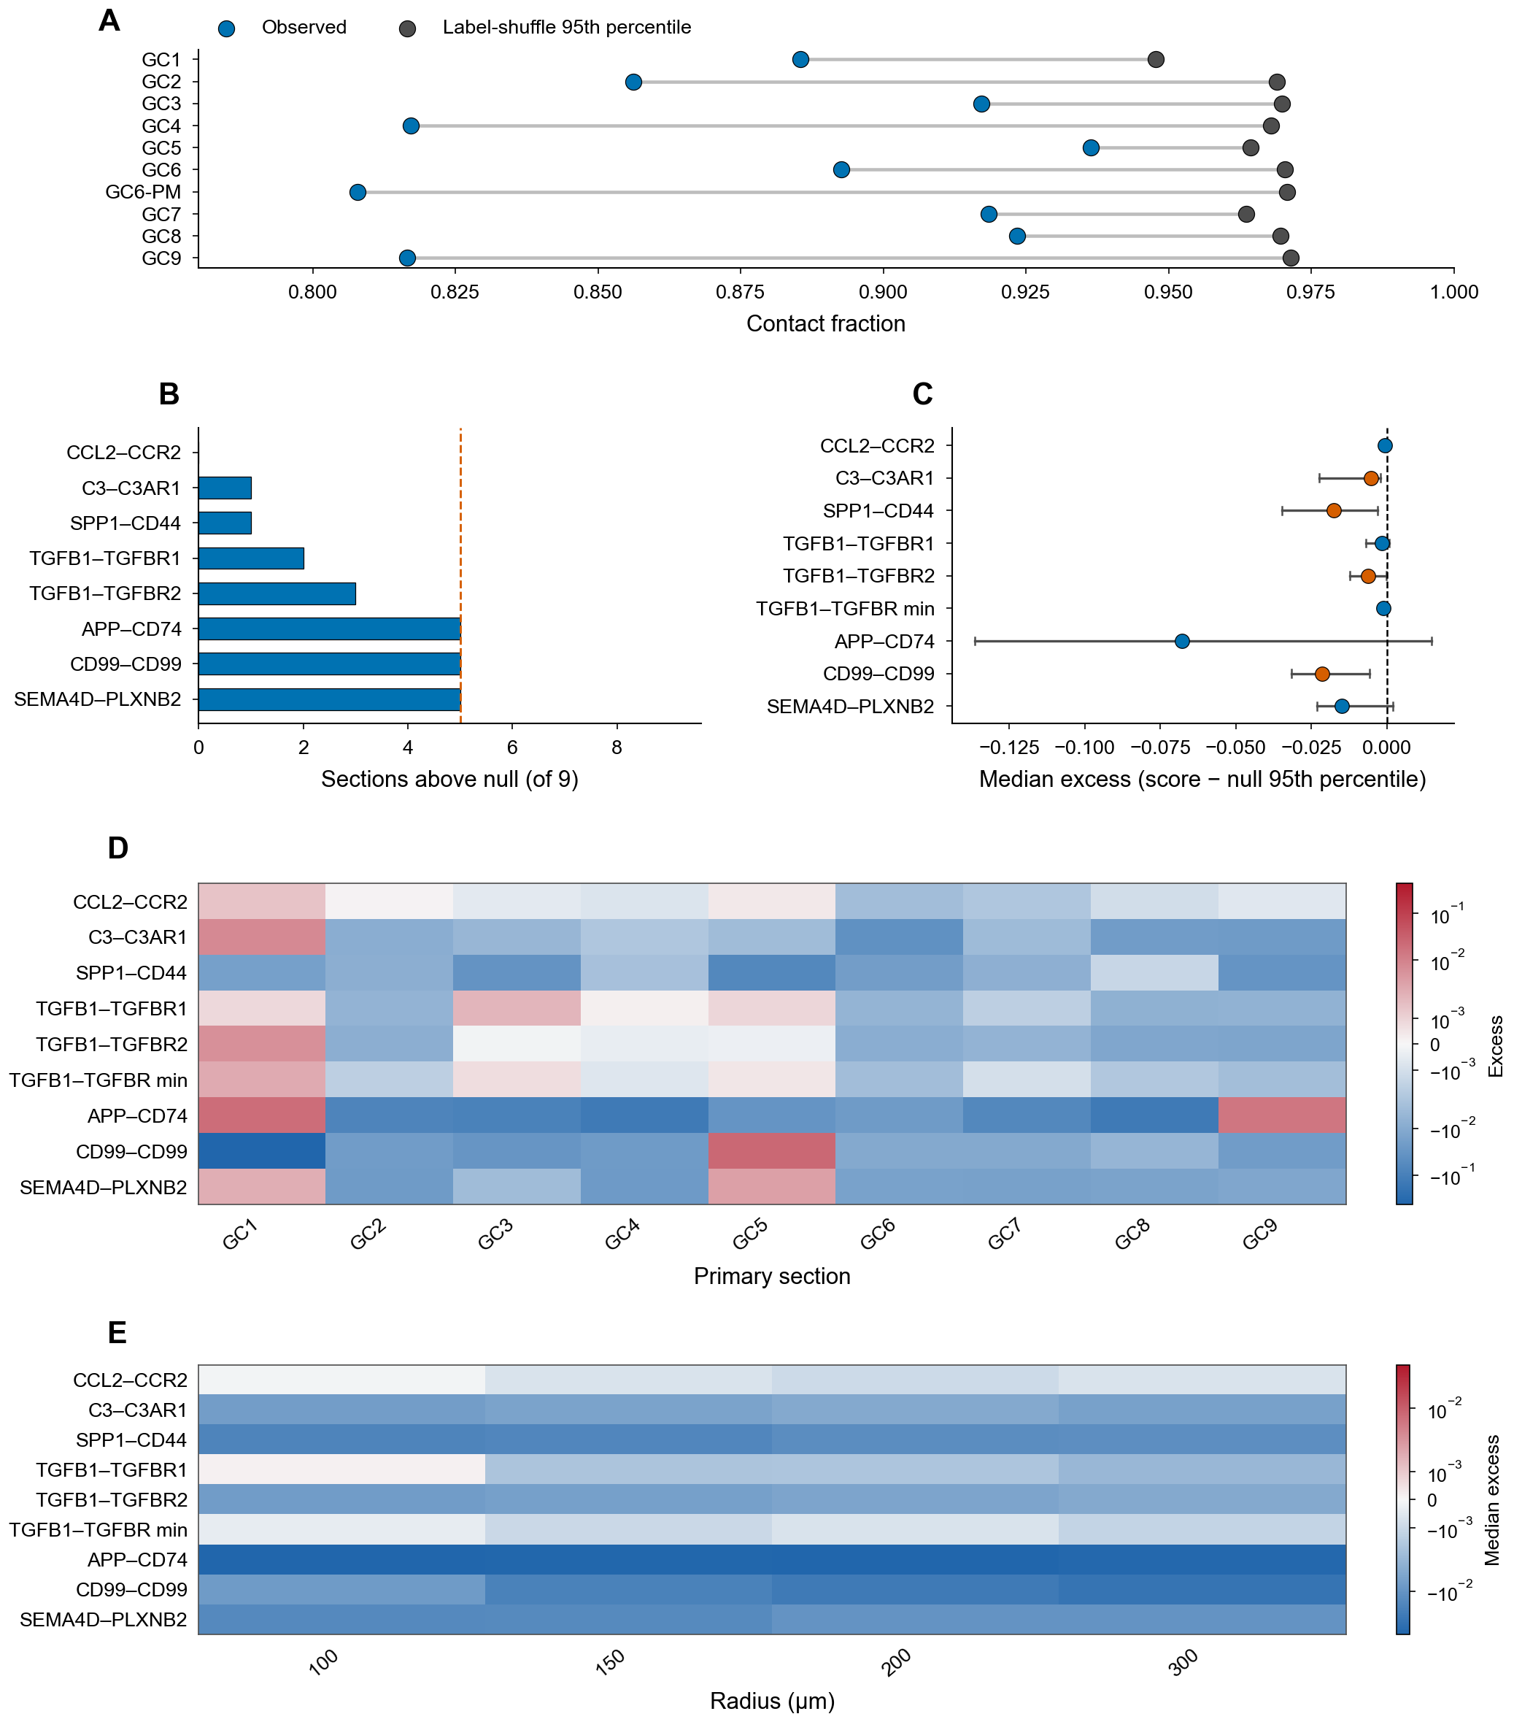
Figure 1. Primary Visium sections. (A) Contact between a macrophage-high spot and a fibroblast-high neighbor. Blue, observed. Gray, 95th percentile of 200 label shuffles. The line joins the two values on the same section. GC6-PM is shown and is not counted as peritoneum. (B) Primary sections, out of 9, whose ligand–receptor score exceeded the coordinate null. The dashed line is 5. (C) Median excess at 150 μm. The point is the nine-section median and the bar is its bootstrap interval. The dashed line is 0. Orange means the interval lies entirely below 0. (D) Excess on each primary section at 150 μm. Rows stay in the prespecified order. (E) Median excess at 100, 150, 200, and 300 μm. In D and E the color is a symmetric log scale centered at 0, so small excesses remain visible. Values are not clipped.
Table 2. Weighted fibroblast–macrophage score at 150 μm on nine primary sections. Excess is the section score minus the ligand-shift null 95th percentile. The interval is the bootstrap interval of the nine-section median. The last column is the weighted-score permutation, not the retention count in Figure 1B.
Pair | Median score | Median excess | Bootstrap interval | Sections with p ≤ 0.05
CCL2–CCR2 | 0.012 | -0.001 | -0.002 to 0.000 | 2/9
C3–C3AR1 | 0.222 | -0.005 | -0.022 to -0.002 | 1/9
SPP1–CD44 | 0.088 | -0.018 | -0.035 to -0.003 | 0/9
TGFB1–TGFBR1 | 0.100 | -0.002 | -0.007 to 0.001 | 4/9
TGFB1–TGFBR2 | 0.133 | -0.006 | -0.012 to -0.000 | 1/9
TGFB1–TGFBR min | 0.060 | -0.001 | -0.002 to 0.000 | 3/9
APP–CD74 | 2.625 | -0.068 | -0.136 to 0.015 | 2/9
CD99–CD99 | 1.780 | -0.021 | -0.032 to -0.006 | 1/9
SEMA4D–PLXNB2 | 0.277 | -0.015 | -0.023 to 0.002 | 2/9

2.3. In GSE183904 the C3 Increase Is Mostly the Ligand
Cells were labeled by the highest of four marker programs when that program was positive and strictly above the other three. A class with fewer than 20 cells was left missing. Primary sample 22 fell below that count for fibroblasts and epithelial cells, so those denominators are 25 rather than 26. Figure 2A shows the log2 ratio of peritoneal to primary class medians. Fibroblast C3 was 2.03 versus 0.37, epithelial C3 was 0.96 versus 0.03, and macrophage C3AR1 was 0.57 versus 0.34. Macrophage SPP1 was 0.73 versus 0.21. Figure 2B is the one paired donor, sample 36 against sample 38, on the seven products. The heatmap already shows that the C3 class ratios are large and the macrophage C3AR1 ratio is not.
The seven products in Figure 2C and Table 3 are exploratory. They were named after the class means had been inspected. Multiplying two class means does not show that the ligand and receptor occupy the same neighborhood, that a communication model was fit, or that the receptor was perturbed. Both C3 products use macrophage C3AR1, so they are not two independent receptor findings. Within 25 primary tumors, fibroblast C3 and macrophage C3AR1 had a Spearman correlation of 0.01, and epithelial C3 and macrophage C3AR1 had a Spearman correlation of −0.07 (Figure 3A,B). The receptor does not rise with the ligand inside primary tumors. One donor is paired: sample 38 minus sample 36 was 1.200 for the fibroblast C3 product and 1.177 for the epithelial C3 product. The epithelial CCL2 product differed by 0.006 in that same donor. These are differences, not p values.
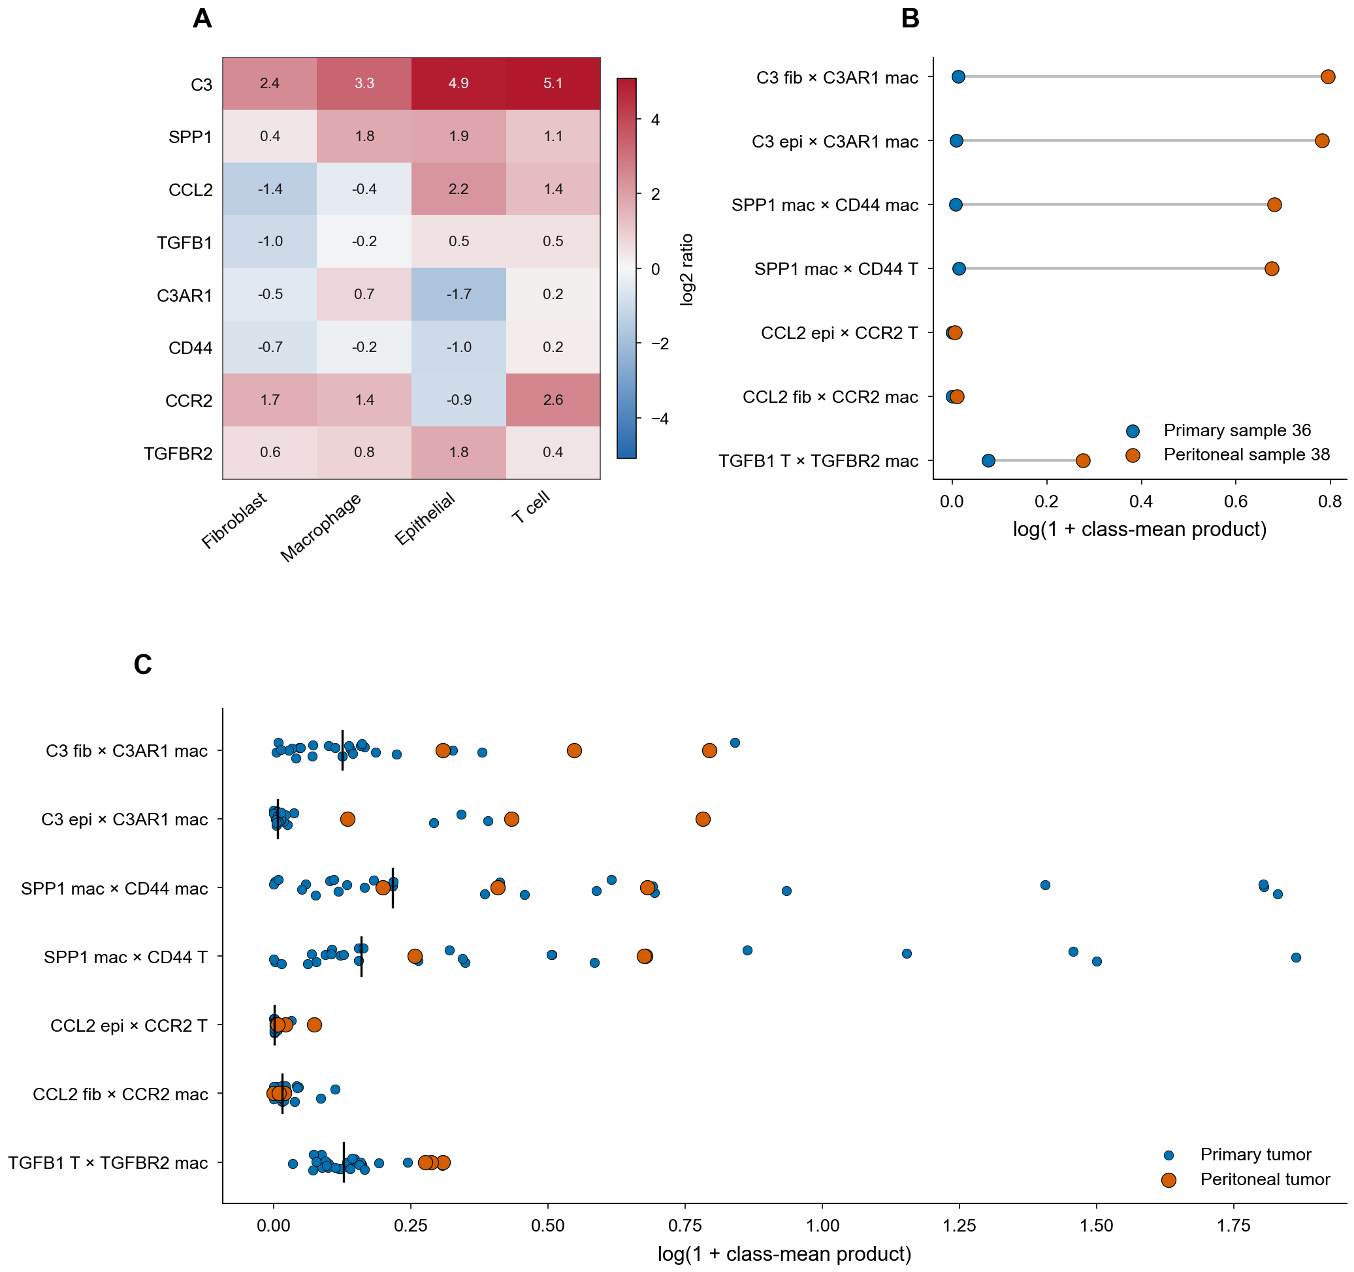
Figure 2. GSE183904 class means. (A) log2 ratio of the peritoneal median to the primary median. Rows are genes and columns are the four programs. Numbers are the ratios. Color is centered at 0 and is not clipped. Blank cells are non-positive medians. (B) The paired donor. Blue, primary sample 36. Orange, peritoneal sample 38. The axis is log(1 + product). (C) All samples. Blue, primary tumors. Orange, peritoneal tumors. The black bar is the primary median.
Table 3. GSE183904 products. The statistic is the peritoneal median minus the primary median. p is a one-sided exact label permutation. q is Benjamini–Hochberg within these seven rows only. Fibroblast and epithelial products use 3276 combinations. Macrophage and T-cell products use 3654.
Product | Peritoneal | Primary | Above | p | q
C3 fib × C3AR1 mac | 0.730 | 0.132 | 3/3 | 0.015 | 0.027
C3 epi × C3AR1 mac | 0.542 | 0.007 | 3/3 | 0.004 | 0.027
SPP1 mac × CD44 mac | 0.505 | 0.242 | 2/3 | 0.420 | 0.490
SPP1 mac × CD44 T | 0.964 | 0.172 | 3/3 | 0.094 | 0.131
CCL2 epi × CCR2 T | 0.021 | 0.001 | 3/3 | 0.015 | 0.027
CCL2 fib × CCR2 mac | 0.009 | 0.015 | 1/3 | 0.797 | 0.797
TGFB1 T × TGFBR2 mac | 0.332 | 0.136 | 3/3 | 0.014 | 0.027

Macrophage STAT3 transcript medians were 0.641 and 0.481 (difference 0.161, one-sided p = 0.010). The p value is the fraction of ways to label 3 of the 29 macrophage samples as peritoneal in which the median difference is at least as large as observed. That count is C(29, 3) = 3654. Macrophage SOCS3 was 0.695 versus 0.852 and was not higher (one-sided p = 0.885). Epithelial STAT3 was also higher (0.693 versus 0.484, p = 0.015, n = 3 peritoneal and 25 primary samples with at least 20 epithelial cells). STAT3 and SOCS3 were not entered into the seven-row q value, and this p value was not adjusted further. The measurement is a transcript mean, not phosphorylation and not a blockade (Figure 3C,D).
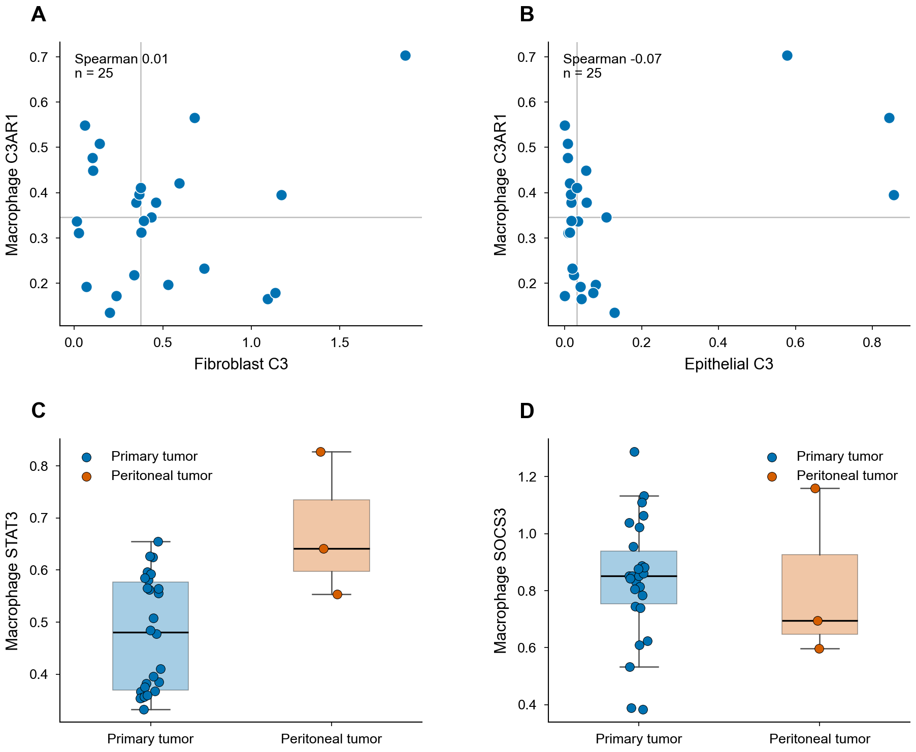
Figure 3. Ligand, receptor, and two transcripts in GSE183904. (A, B) Primary tumors with at least 20 cells in each class. (C, D) Macrophage transcript means. Blue, primary tumors. Orange, peritoneal tumors. The black bar is the group median.
2.4. The Products Are Not Significantly Higher in a Second Solid-Tumor Series
GSE308231 used the same seven products, the same class rule, and its own permutation. It was not pooled with GSE183904, and it was not treated as a prespecified validation cohort. The platform is SeekOne, the series is not described as paired patients, and three versus three can produce a one-sided p no smaller than 0.05. All seven q values were above 0.35 (Figure 4A,B, Table 4). Failure to cross that floor is not proof that the products are equal. The epithelial C3 product was higher in all three peritoneal samples than in all three primary samples, but one swap of labels preserved the median difference, so p = 0.10. Fibroblast C3 itself was higher in every peritoneal sample than in every primary sample. That ligand pattern was not a second locked endpoint. Macrophage C3AR1 and macrophage STAT3 were not higher. A cross-cohort meta-analysis was not done, because the platforms and the pairing are not the same.
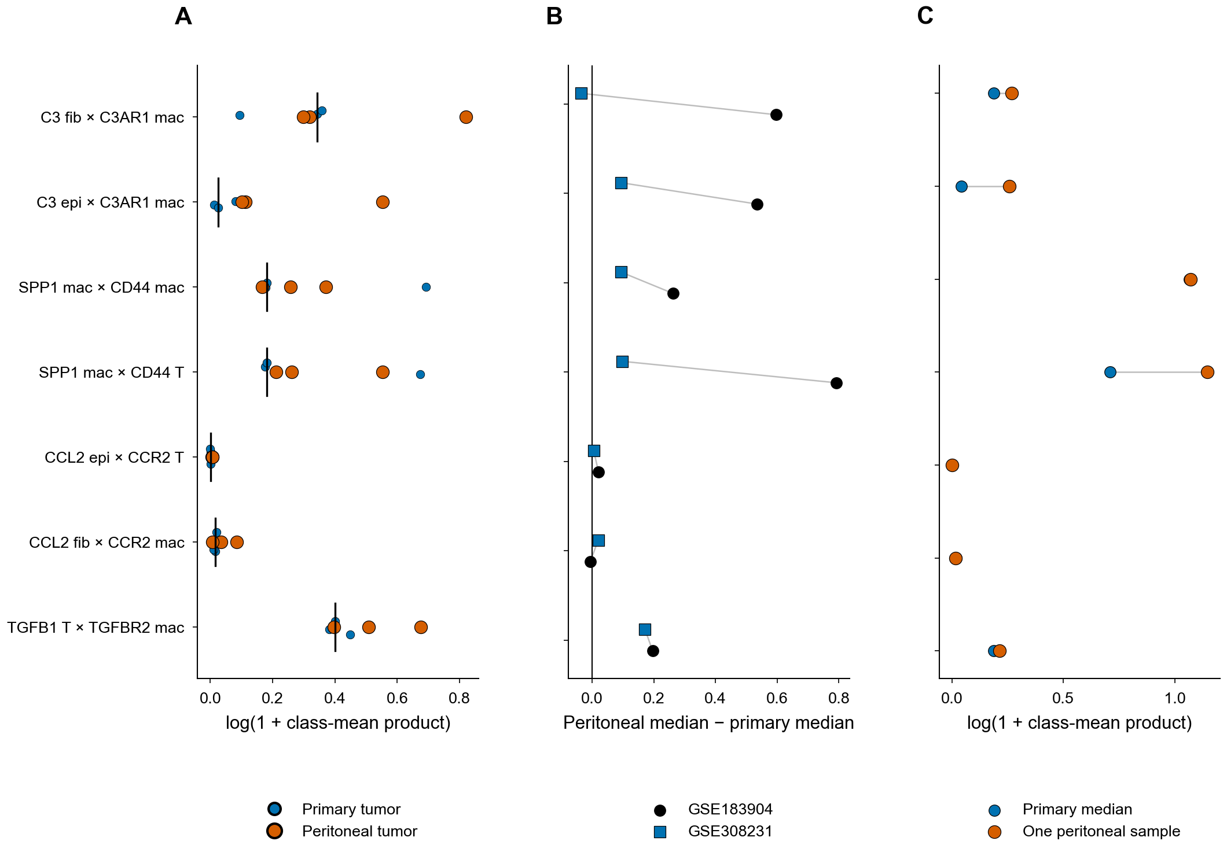
Figure 4. Replication cohorts, kept separate. (A) GSE308231 class-mean products. Blue, primary tumors. Orange, peritoneal tumors. The black bar is the primary median. (B) Peritoneal median minus primary median. Circles, GSE183904. Squares, GSE308231. No interval is drawn. (C) GSE163558. Blue, median of three primary tumors. Orange, the single peritoneal sample. The axis is log(1 + product). No p value was calculated.
Table 4. GSE308231, three versus three. q is Benjamini–Hochberg within these seven rows. The permutation floor is 0.05.
Product | Peritoneal | Primary | Above | p | q
C3 fib × C3AR1 mac | 0.375 | 0.410 | 1/3 | 0.700 | 0.700
C3 epi × C3AR1 mac | 0.119 | 0.026 | 3/3 | 0.100 | 0.350
SPP1 mac × CD44 mac | 0.293 | 0.200 | 2/3 | 0.500 | 0.583
SPP1 mac × CD44 T | 0.298 | 0.200 | 3/3 | 0.300 | 0.420
CCL2 epi × CCR2 T | 0.006 | 0.001 | 3/3 | 0.100 | 0.350
CCL2 fib × CCR2 mac | 0.036 | 0.016 | 2/3 | 0.200 | 0.350
TGFB1 T × TGFBR2 mac | 0.664 | 0.492 | 2/3 | 0.200 | 0.350

GSE163558 contributes one peritoneal sample, P1, against three primary tumors. Its epithelial C3 product was 0.294 against a primary median of 0.042 (Figure 4C). No p value was assigned. In GSE228598, fibroblast C3 could be summarized for 13 of 28 fluid samples (median 2.43). Across all 28, median epithelial C3 was 0.92 and median macrophage C3AR1 was 0.83. The series has no primary-tumor arm, so these medians were not entered into the solid-tumor permutation. Ascites and a solid implant are different materials [31,32].
3. Discussion
The spatial result is the one the locked rule can support. Contact was common in absolute terms and still below a label shuffle, because a 150 μm neighborhood on this lattice often reaches a fibroblast-high spot once macrophage-high spots are defined as the top quartile. A large score such as APP–CD74 can remain large after the ligand map is shifted. Absolute abundance is not spatial excess. The weighted mean was added so that a structural zero would not be mistaken for a negative biological result. It removed the zero medians and left the excess negative at the prespecified radius and at the neighboring radii. That is a stable negative readout on nine primary sections. It is not a test of peritoneal tissue.
The peritoneal products are a different, exploratory question. The Benjamini–Hochberg adjustment was computed only inside the seven rows. It does not undo the fact that the seven rows were chosen after the class means were known, so q = 0.027 is a description of that list, not a confirmatory p value. Four rows reach that q: both C3 products, the epithelial CCL2 product, and the T-cell TGFB1 product (Table 3). The two C3 products share macrophage C3AR1. The fold from primary to peritoneal tumor is much larger for C3 than for C3AR1, and within primary tumors the ligand and the receptor do not move together. The supported statement is that the C3 ligand is higher in this one cohort. It is not that a C3–C3AR1 axis is active. The CCL2 epithelial product is numerically higher and absolutely small. The TGFB1 product uses T cells, not the fibroblast–macrophage pair in the spatial screen. SPP1 × CD44 on macrophages is the comparison suggested by macrophage polarity and by a breast-cancer interaction [14,15], and it is not higher here. Li and colleagues reported a peritoneal stroma–myeloid niche in which THBS2-positive fibroblasts act through C3–C3AR1 [23]. The class-mean products here do not identify THBS2, do not define SPP1-positive macrophages as that study did, and do not include a receptor blockade. A higher C3 ligand in GSE183904 is not a replication of that experiment.
GSE308231 does not significantly replicate the products, and its size does not let a negative call stand in for a precise null. It does show a higher fibroblast C3 ligand in all three peritoneal samples. Calling that ligand pattern a new significant test would change the endpoint after seeing the split. The epithelial product is higher in every peritoneal sample and still has p = 0.10. GSE163558 is one sample. GSE228598 is fluid. The ascites series records peritoneal fluid [32]. The other peritoneal series [33,34] were not reanalyzed here. None of them is a paired solid implant. A negative primary-interface result cannot be joined to a higher peritoneal C3 ligand and read as one mechanism: the first measurement is spatial and limited to primary sections, and the second is a single-cell class mean. Lee and colleagues have already reported CCL2–STAT3 spatial crosstalk in GSE251950 [22]. The present prespecified CCL2–CCR2 score was not retained, macrophage SOCS3 was not higher, and epithelial STAT3 moved with macrophage STAT3. Those observations do not add phosphorylated STAT3, and they do not make the earlier paper a peritoneal C3 result. NicheNet was not run. cell2location was not run [28].
A spatial claim about peritoneal implants needs paired primary and peritoneal sections from more patients. Protein-level C3 and C3AR1, and a receptor perturbation, are outside this study. Marker weights are a coarse mixture model, so the weighted excess is reported against a coordinate null. Visium spots follow the 55 μm spot and 100 μm pitch of that assay, not a 20–50 μm cell neighborhood [27].
4. Materials and Methods
4.1. Cohorts
GSE251950 supplied the Visium sections. Nine primary sections entered the ranking. GC6-PM was excluded from that ranking. GSE183904 supplied peritoneal tumors GSM5573484, GSM5573485, and GSM5573503 (samples 19, 20, and 38) and 26 primary tumors. Sample 38 and sample 36 are the paired donor. Peritoneal normal sample 37 was excluded. GSE308231 supplied GSM9240670–GSM9240672 as primary tumors and GSM9240673–GSM9240675 as peritoneal tumors. GSE163558 supplied P1 (GSM5004187) against primary tumors PT1–PT3 (GSM5004180–GSM5004182); adjacent mucosa, lymph node, ovary, and liver were not part of the contrast. GSE228598 supplied 28 peritoneal-fluid samples. The GEO record does not split malignant ascites from peritoneal washing, and patient 15 is absent. Cohorts were not pooled. No new patients were enrolled.
4.2. Visium Scores
Spots were kept when they were in tissue, detected at least 200 genes, and had a mitochondrial fraction of at most 25%. Counts were normalized to 10,000 and log-transformed with a pseudocount of 1 [37]. Fibroblast markers were DCN, LUM, COL1A1, and FAP. Macrophage markers were CD68, CSF1R, C1QA, and C1QB. Those marker genes were not used as the ligands or receptors under test. High spots were at or above the section’s 75th percentile. An interface spot was a macrophage-high spot with at least one fibroblast-high neighbor inside 150 μm. The spot score was receptor expression times the mean ligand on those neighbors. The section summary was the median. Sections with fewer than 10 interface spots would have been dropped; none were. Contact used 200 label shuffles, seed 20261002, and the 95th percentile of that null. The ligand–receptor null shuffled coordinates 200 times. The section p value was (1 + the number of nulls at least as large as the observed score) / 201. Retention required at least 5 of 9 primary sections above the null, and at least 5 of the remaining 8 after each section was left out. The pair universe was the CellChat human table restricted to single-gene symbols, 1000 pairs [38]. Underscore complexes were excluded. Five pairs were prespecified: CCL2–CCR2, C3–C3AR1, SPP1–CD44, TGFB1–TGFBR1, and TGFB1–TGFBR2.
4.3. Weighted Interface
Each spot was decomposed by non-negative least squares into fibroblast, macrophage, epithelial, and T-cell programs, using the markers above plus EPCAM, KRT8, KRT18, and KRT19 for epithelium and CD3D, CD3E, and TRAC for T cells. Coefficients were scaled to sum to 1. The weight was the product of the fibroblast and macrophage proportions. The section score was the weighted mean, not the median. The null translated the ligand map by 200, 300, 400, or 500 μm at a random angle, 200 times, seed 20261004. A shifted coordinate counted only when the nearest real spot after the inverse shift was within 60 μm. Radii of 100, 150, 200, and 300 μm were summarized. The primary radius remained 150 μm. This readout did not replace the retention rule, and it was not used to choose a friendlier radius. cell2location was not run [28].
4.4. Class-Mean Products
For the single-cell cohorts, integer counts were library-normalized to 10,000 and log-transformed. Duplicate gene symbols were summed before normalization. A cell took the class with the highest marker mean when that mean was positive and strictly above the second class; otherwise it was unlabeled. Class means with fewer than 20 cells were missing. The seven products were C3 on fibroblasts or epithelial cells times C3AR1 on macrophages, SPP1 on macrophages times CD44 on macrophages or T cells, CCL2 on epithelial cells times CCR2 on T cells, CCL2 on fibroblasts times CCR2 on macrophages, and TGFB1 on T cells times TGFBR2 on macrophages. The statistic was the peritoneal median minus the primary median, one-sided for a higher peritoneal value. q values were computed inside those seven tests only [36]. Products that use a fibroblast or epithelial mean omit primary sample 22, so the permutation count is C(28, 3) = 3276. Products that use macrophage and T-cell means use all 26 primary samples, so the count is C(29, 3) = 3654. The paired donor was reported as sample 38 minus sample 36, which is a difference and not a p value. STAT3 and SOCS3 used the full-transcriptome library size and were not part of the seven-row adjustment. GSE308231 used the same products and a separate permutation. GSE163558 was descriptive. GSE228598 was not compared with a primary arm.
5. Conclusions
Nine primary Visium sections did not retain a fibroblast–macrophage ligand–receptor excess, and a weighted score did not turn that excess positive. In one single-cell cohort, GSE183904, exploratory C3 products were higher in three peritoneal tumors because the C3 ligand was higher. That list was chosen after the class means were seen, and the within-list q value is not a confirmatory test. A second cohort of three versus three did not significantly replicate the products and was too small to exclude them. The two results stay separate. They do not establish a C3–C3AR1 axis, and they do not retest a reported receptor blockade in peritoneal models [23].
Author Contributions
To be completed by the authors.
Funding
To be completed by the authors.
Institutional Review Board Statement
Not applicable. The study used de-identified public matrices from the Gene Expression Omnibus. No new patients were enrolled.
Informed Consent Statement
Not applicable.
Data Availability Statement
GSE251950, GSE183904, GSE308231, GSE163558, and GSE228598 are available from the Gene Expression Omnibus. Raw count matrices were not redeposited. Analysis scripts, seeds, and processed summary tables are in the public repository https://github.com/Cybing521/gastric-peritoneal-spatial-analysis. Scanpy 1.12.3 was used for the matrix objects. The permutation counts and seeds are stated in the Methods.
Acknowledgments
To be completed by the authors.
Conflicts of Interest
To be completed by the authors.
References
1. Bray, F.; Laversanne, M.; Sung, H.; Ferlay, J.; Siegel, R.L.; Soerjomataram, I.; Jemal, A. Global cancer statistics 2022: GLOBOCAN estimates of incidence and mortality worldwide for 36 cancers in 185 countries. CA Cancer J. Clin. 2024, 74, 229–263. https://doi.org/10.3322/caac.21834
2. Smyth, E.C.; Nilsson, M.; Grabsch, H.I.; van Grieken, N.C.; Lordick, F. Gastric cancer. Lancet 2020, 396, 635–648. https://doi.org/10.1016/S0140-6736(20)31288-5
3. Manzanedo, I.; Pereira, F.; Pérez-Viejo, E.; Serrano, Á. Gastric cancer with peritoneal metastases: Current status and prospects for treatment. Cancers 2023, 15, 1777. https://doi.org/10.3390/cancers15061777
4. Li, Z.; Wang, J.; Wang, Z.; Xu, Y. Towards an optimal model for gastric cancer peritoneal metastasis: Current challenges and future directions. eBioMedicine 2023, 92, 104601. https://doi.org/10.1016/j.ebiom.2023.104601
5. Gwee, Y.X.; Chia, D.K.A.; So, J.; Ceelen, W.; Yong, W.P.; Tan, P.; Ong, C.J.; Sundar, R. Integration of genomic biology into therapeutic strategies of gastric cancer peritoneal metastasis. J. Clin. Oncol. 2022, 40, 2830. https://doi.org/10.1200/JCO.21.02745
6. Yao, X.; Ajani, J.A.; Song, S. Molecular biology and immunology of gastric cancer peritoneal metastasis. Transl. Gastroenterol. Hepatol. 2020, 5, 57. https://doi.org/10.21037/tgh.2020.02.08
7. Cancer Genome Atlas Research Network Comprehensive molecular characterization of gastric adenocarcinoma. Nature 2014, 513, 202–209. https://doi.org/10.1038/nature13480
8. Binnewies, M.; Roberts, E.W.; Kersten, K.; Chan, V.; Fearon, D.F.; Merad, M.; Coussens, L.M.; Gabrilovich, D.I.; Ostrand-Rosenberg, S.; Hedrick, C.C.; et al. Understanding the tumor immune microenvironment (TIME) for effective therapy. Nat. Med. 2018, 24, 541–550. https://doi.org/10.1038/s41591-018-0014-x
9. Sahai, E.; Astsaturov, I.; Cukierman, E.; DeNardo, D.G.; Egeblad, M.; Evans, R.M.; Fearon, D.; Greten, F.R.; Hingorani, S.R.; Hunter, T.; et al. A framework for advancing our understanding of cancer-associated fibroblasts. Nat. Rev. Cancer 2020, 20, 174–186. https://doi.org/10.1038/s41568-019-0238-1
10. Ham, I.H.; Lee, D.; Hur, H. Role of cancer-associated fibroblast in gastric cancer progression and resistance to treatments. J. Oncol. 2019, 2019, 6270784. https://doi.org/10.1155/2019/6270784
11. Li, X.; Sun, Z.; Peng, G.; Xiao, Y.; Guo, J.; Wu, B.; Li, X.; Zhou, W.; Li, J.; Li, Z.; et al. Single-cell RNA sequencing reveals a pro-invasive cancer-associated fibroblast subgroup associated with poor clinical outcomes in patients with gastric cancer. Theranostics 2022, 12, 620–638. https://doi.org/10.7150/thno.60540
12. Mantovani, A.; Marchesi, F.; Malesci, A.; Laghi, L.; Allavena, P. Tumour-associated macrophages as treatment targets in oncology. Nat. Rev. Clin. Oncol. 2017, 14, 399–416. https://doi.org/10.1038/nrclinonc.2016.217
13. Roumenina, L.T.; Daugan, M.V.; Petitprez, F.; Sautès-Fridman, C.; Fridman, W.H. Context-dependent roles of complement in cancer. Nat. Rev. Cancer 2019, 19, 698–715. https://doi.org/10.1038/s41568-019-0210-0
14. Bill, R.; Wirapati, P.; Messemaker, M.; Roh, W.; Zitti, B.; Duval, F.; Kiss, M.; Park, J.C.; Saal, T.M.; Hoelzl, J.; et al. CXCL9:SPP1 macrophage polarity identifies a network of cellular programs that control human cancers. Science 2023, 381, 515–524. https://doi.org/10.1126/science.ade2292
15. Liu, F.; Zhang, J.; Gu, X.; Guo, Q.; Guo, W. Single-cell transcriptome sequencing reveals SPP1-CD44-mediated macrophage–tumor cell interactions drive chemoresistance in TNBC. J. Cell. Mol. Med. 2024, 28, e18525. https://doi.org/10.1111/jcmm.18525
16. Yang, Y.; Sun, H.; Yu, H.; Wang, L.; Gao, C.; Mei, H.; Jiang, X.; Ji, M. Tumor-associated fibrosis and active collagen-CD44 axis characterize a poor-prognosis subtype of gastric cancer and contribute to tumor immunosuppression. J. Transl. Med. 2025, 23, 123. https://doi.org/10.1186/s12967-025-06070-9
17. Zhang, F.; Yan, Y.; Cao, X.; Guo, C.; Wang, K.; Lv, S. TGF-β-driven LIF expression influences neutrophil extracellular traps (NETs) and contributes to peritoneal metastasis in gastric cancer. Cell Death Dis. 2024, 15, 218. https://doi.org/10.1038/s41419-024-06594-w
18. Yu, H.; Lee, H.; Herrmann, A.; Buettner, R.; Jove, R. Revisiting STAT3 signalling in cancer: New and unexpected biological functions. Nat. Rev. Cancer 2014, 14, 736–746. https://doi.org/10.1038/nrc3818
19. Ashrafizadeh, M.; Zarrabi, A.; Orouei, S.; Zarrin, V.; Rahmani Moghadam, E.; Zabolian, A.; Mohammadi, S.; Hushmandi, K.; Gharehaghajlou, Y.; Makvandi, P.; et al. STAT3 pathway in gastric cancer: Signaling, therapeutic targeting and future prospects. Biology 2020, 9, 126. https://doi.org/10.3390/biology9060126
20. Su, P.; Yu, T.; Zhang, Y.; Huang, H.; Chen, M.; Cao, C.; Kang, W.; Liu, Y.; Yu, J. Upregulation of MELK promotes chemoresistance and induces macrophage M2 polarization via CSF-1/JAK2/STAT3 pathway in gastric cancer. Cancer Cell Int. 2024, 24, 287. https://doi.org/10.1186/s12935-024-03453-8
21. Cui, Y.; Chang, Y.; Ma, X.; Sun, M.; Huang, Y.; Yang, F.; Li, S.; Zhuo, W.; Liu, W.; Yang, B.; et al. Ephrin A1 stimulates CCL2 secretion to facilitate premetastatic niche formation and promote gastric cancer liver metastasis. Cancer Res. 2025, 85, 263–276. https://doi.org/10.1158/0008-5472.CAN-24-1254
22. Lee, S.H.; Lee, D.; Choi, J.; Oh, H.J.; Ham, I.H.; Ryu, D.; Lee, S.Y.; Han, D.J.; Kim, S.; Moon, Y.; et al. Spatial dissection of tumour microenvironments in gastric cancers reveals the immunosuppressive crosstalk between CCL2+ fibroblasts and STAT3-activated macrophages. Gut 2025, 74, 714–727. https://doi.org/10.1136/gutjnl-2024-332901
23. Li, Y.; Zheng, Y.; Huang, J.; Nie, R.C.; Wu, Q.N.; Zuo, Z.; Yuan, S.; Yu, K.; Liang, C.C.; Pan, Y.Q.; et al. CAF-macrophage crosstalk in tumour microenvironments governs the response to immune checkpoint blockade in gastric cancer peritoneal metastases. Gut 2025, 74, 350–363. https://doi.org/10.1136/gutjnl-2024-333617
24. Ståhl, P.L.; Salmén, F.; Vickovic, S.; Lundmark, A.; Navarro, J.F.; Magnusson, J.; Giacomello, S.; Asp, M.; Westholm, J.O.; Huss, M.; et al. Visualization and analysis of gene expression in tissue sections by spatial transcriptomics. Science 2016, 353, 78–82. https://doi.org/10.1126/science.aaf2403
25. Williams, C.G.; Lee, H.J.; Asatsuma, T.; Vento-Tormo, R.; Haque, A. An introduction to spatial transcriptomics for biomedical research. Genome Med. 2022, 14, 68. https://doi.org/10.1186/s13073-022-01075-1
26. Moses, L.; Pachter, L. Museum of spatial transcriptomics. Nat. Methods 2022, 19, 534–546. https://doi.org/10.1038/s41592-022-01409-2
27. Maynard, K.R.; Collado-Torres, L.; Weber, L.M.; Uytingco, C.; Barry, B.K.; Williams, S.R.; Catallini, J.L., 2nd; Tran, M.N.; Besich, Z.; Tippani, M.; et al. Transcriptome-scale spatial gene expression in the human dorsolateral prefrontal cortex. Nat. Neurosci. 2021, 24, 425–436. https://doi.org/10.1038/s41593-020-00787-0
28. Kleshchevnikov, V.; Shmatko, A.; Dann, E.; Aivazidis, A.; King, H.W.; Li, T.; Elmentaite, R.; Lomakin, A.; Kedlian, V.; Gayoso, A.; et al. Cell2location maps fine-grained cell types in spatial transcriptomics. Nat. Biotechnol. 2022, 40, 661–671. https://doi.org/10.1038/s41587-021-01139-4
29. Kumar, V.; Ramnarayanan, K.; Sundar, R.; Padmanabhan, N.; Srivastava, S.; Koiwa, M.; Yasuda, T.; Koh, V.; Huang, K.K.; Tay, S.T.; et al. Single-cell atlas of lineage states, tumor microenvironment, and subtype-specific expression programs in gastric cancer. Cancer Discov. 2022, 12, 670–691. https://doi.org/10.1158/2159-8290.CD-21-0683
30. Jiang, H.; Yu, D.; Yang, P.; Guo, R.; Kong, M.; Gao, Y.; Yu, X.; Lu, X.; Fan, X. Revealing the transcriptional heterogeneity of organ-specific metastasis in human gastric cancer using single-cell RNA sequencing. Clin. Transl. Med. 2022, 12, e730. https://doi.org/10.1002/ctm2.730
31. Sullivan, K.M.; Li, H.; Yang, A.; Zhang, Z.; Munoz, R.R.; Mahuron, K.M.; Yuan, Y.C.; Paz, I.B.; Von Hoff, D.; Han, H.; et al. Tumor and peritoneum-associated macrophage gene signature as a novel molecular biomarker in gastric cancer. Int. J. Mol. Sci. 2024, 25, 4117. https://doi.org/10.3390/ijms25074117
32. Huang, X.Z.; Pang, M.J.; Li, J.Y.; Chen, H.Y.; Sun, J.X.; Song, Y.X.; Ni, H.J.; Ye, S.Y.; Bai, S.; Li, T.H.; et al. Single-cell sequencing of ascites fluid illustrates heterogeneity and therapy-induced evolution during gastric cancer peritoneal metastasis. Nat. Commun. 2023, 14, 822. https://doi.org/10.1038/s41467-023-36310-9
33. Kim, H.; Kwon, M.; Lee, S.K.; Son, S.M.; Lee, O.J.; Man Yoon, S.; Kim, H.K.; Yang, Y.; Lee, K.H.; Han, H.S. Distinct immunosuppressive tumor microenvironment in gastric cancer with peritoneal metastasis. J. Gastric Cancer 2025, 25, 605–620. https://doi.org/10.5230/jgc.2025.25.e46
34. Peng, H.; Jiang, L.; Yuan, J.; Wu, X.; Chen, N.; Liu, D.; Liang, Y.; Xie, Y.; Jia, K.; Li, Y.; et al. Single-cell characterization of differentiation trajectories and drug resistance features in gastric cancer with peritoneal metastasis. Clin. Transl. Med. 2024, 14, e70054. https://doi.org/10.1002/ctm2.70054
35. Gene Expression Omnibus. GSE308231. Available online: https://www.ncbi.nlm.nih.gov/geo/query/acc.cgi?acc=GSE308231 (accessed on 4 October 2026).
36. Benjamini, Y.; Hochberg, Y. Controlling the false discovery rate: A practical and powerful approach to multiple testing. J. R. Stat. Soc. Ser. B (Stat. Methodol.) 1995, 57, 289–300. https://doi.org/10.1111/j.2517-6161.1995.tb02031.x
37. Wolf, F.A.; Angerer, P.; Theis, F.J. SCANPY: Large-scale single-cell gene expression data analysis. Genome Biol. 2018, 19, 15. https://doi.org/10.1186/s13059-017-1382-0
38. Jin, S.; Guerrero-Juarez, C.F.; Zhang, L.; Chang, I.; Ramos, R.; Kuan, C.H.; Myung, P.; Plikus, M.V.; Nie, Q. Inference and analysis of cell-cell communication using CellChat. Nat. Commun. 2021, 12, 1088. https://doi.org/10.1038/s41467-021-21246-9

