Effects of High-Definition Transcranial Direct Current Stimulation on Cognitive Function in Male Inpatients with Alcohol Dependence: A Randomized Sham-Controlled Trial
Author names and degrees: see Author Completion Checklist (end of manuscript).
Department of Psychiatry, The Second Affiliated Hospital of Xinxiang Medical University (Henan Psychiatric Hospital), Xinxiang, Henan, China
Corresponding author: see Author Completion Checklist (end of manuscript).
Running title: HD-tDCS for AUD cognition
Keywords: alcohol dependence; transcranial direct current stimulation; cognition; dorsolateral prefrontal cortex; randomized controlled trial
Prior abstract presentation: None reported.
Clinical trial registration: Not prospectively registered before enrollment (2019). Retrospective registration with disclosure of the registration date is planned before final upload; see Author Completion Checklist.

Abstract
Background: Alcohol dependence features cognitive deficits that may increase relapse risk. High-definition tDCS (HD-tDCS) can focally engage the dorsolateral prefrontal cortex (DLPFC) via a 4×1 ring montage, but sham-controlled cognitive batteries in alcohol dependence remain scarce relative to craving and relapse endpoints.
Objective/Hypothesis: We tested whether 14 daily sessions of bilateral 4×1 HD-tDCS over the DLPFC improve cognition relative to sham HD-tDCS and routine care in male inpatients with alcohol dependence.
Methods: In this single-blind three-arm trial, 85 male inpatients were randomized to routine care (n=29), active HD-tDCS (n=28), or sham HD-tDCS (n=28); 77 were analyzed (n=29/21/27) after data verification, comprising every randomized participant who has a week-4 assessment. Bilateral 4×1 sessions (±1.0 mA, 20 min) targeted F3/F4 after detoxification. Primary outcomes were TMT-B, VFT, and HVLT-R. Analyses included post-intervention tests, baseline-adjusted ANCOVA, change scores, FDR correction, Cohen's d (95% CI), and Hedges g; permutation tests, bootstrap confidence intervals, and a worst-case analysis for the three participants without a week-4 assessment were added at revision.
Results: Active HD-tDCS surpassed sham and control on TMT-B, VFT, and HVLT-R (omnibus FDR q<0.05; versus sham d=-0.96 [-1.56, -0.36], 1.05 [0.44, 1.66], and 1.30 [0.67, 1.93]; g=-0.94/1.03/1.28). ANCOVA confirmed group effects (partial η²=0.19-0.31), as did change scores and sensitivity analyses (ANCOVA P≤0.0003). MMSE and DST did not differ; sham equaled control. Permutation and bootstrap analyses agreed with the parametric results, and the primary conclusions were unchanged under worst-case imputation for the three participants without a week-4 assessment.
Conclusion(s): Bilateral HD-tDCS produced greater domain-specific cognitive improvement than sham, with parallel advantage over routine care. Preregistered multicenter confirmation is needed.
Highlights
• Bilateral 4x1 HD-tDCS beat sham on TMT-B, VFT, and HVLT-R in AUD
• Active-vs-sham effects were large (Cohen d 0.96-1.30; Hedges g similar)
• Conclusions held under permutation, bootstrap and worst-case imputation
• MMSE and digit span showed no significant between-group differences
• Preregistered multicenter replication with relapse follow-up is needed
Introduction
Alcohol dependence is marked by impaired control over drinking and by enduring deficits in executive function, attention, and learning and memory (1-5). These deficits can undermine treatment engagement and abstinence (1, 6). Because prefrontal circuits that support cognitive control are implicated in alcohol use disorder (4, 7, 8), noninvasive stimulation of the dorsolateral prefrontal cortex (DLPFC) is a candidate strategy for restoring frontally mediated cognition during early recovery.
Transcranial direct current stimulation (tDCS) can modulate cortical excitability at low cost and with a favorable safety profile (9-12). In alcohol use disorder, however, most randomized trials have prioritized craving, relapse, or cue reactivity (8, 13, 14, 15, 16, 17, 18). Cognitive endpoints remain heterogeneous across substance-use studies and are sensitive to montage, dose, and outcome choice (19). After ten sessions of conventional left-DLPFC sponge-electrode tDCS, Dayal et al. (20) observed no tDCS-by-time interaction on neuropsychological performance in recently detoxified inpatients, whereas earlier DLPFC work reported behavioral, FAB, or cognitive improvement (7, 21).
Methodologically, electrode montage determines how much current reaches the intended cortex. Conventional bipolar sponge electrodes (typically ~25–35 cm²) distribute current over broad frontocortical territories. High-definition tDCS (HD-tDCS) instead uses a 4×1 ring of small gel electrodes to constrain the electric field beneath the center electrode and increase focality over the DLPFC (22). In the present protocol, bilateral rings placed the anode at F3 (returns FP1, F7, C1, C3) and the cathode at F4 (returns FP2, F8, C2, C4), delivering ±1.0 mA for 20 min once daily across 14 consecutive sessions (Figure 2). That combination—focal 4×1 geometry, bilateral DLPFC targeting, and a two-week inpatient dose—defines the stimulation contribution tested here. Prior HD-tDCS work in alcohol use disorder has emphasized craving or metabolic readouts rather than a full standardized neuropsychological battery (18).
We conducted a single-blind, three-arm randomized trial in male inpatients with alcohol dependence to test whether 14 daily sessions of bilateral 4×1 HD-tDCS over the DLPFC produce greater cognitive improvement than sham HD-tDCS or routine inpatient care alone. Prespecified primary outcomes were Trail Making Test Part B (TMT-B), verbal fluency (VFT), and Hopkins Verbal Learning Test-Revised (HVLT-R). The Mini-Mental State Examination (MMSE) and Digit Span Test (DST) were secondary outcomes.
Methods and Materials
Study design
This single-blind, single-center randomized trial compared routine inpatient care, routine care plus active HD-tDCS, and routine care plus sham HD-tDCS in male inpatients with DSM-5 alcohol dependence.
Participants
Male inpatients were recruited from Henan Psychiatric Hospital (The Second Affiliated Hospital of Xinxiang Medical University) between October 2019 and October 2020. Inclusion criteria were age 18–55 years, right-handedness, junior high school education or above, and written informed consent. Exclusion criteria included major neurological disease, prior cognitive behavioral therapy, intracranial surgery, pacemaker or metallic implants, and severe medical comorbidity.
Eighty-five participants were randomized 1:1:1 to routine care (n=29), active HD-tDCS (n=28), or sham HD-tDCS (n=28). Three participants discontinued the intervention early because of hospital discharge (1 active, 2 sham) and therefore have no week-4 cognitive assessment; 82 records with a week-4 assessment were on file. After removal of five erroneous active-arm records and reassignment of one retained record to sham, 77 participants entered the primary analysis (active n=21, sham n=27, control n=29). The primary analysis therefore contains every randomized participant who has a week-4 assessment, with one record per participant; the three participants without a week-4 assessment contribute no outcome data and were addressed in a worst-case analysis rather than being treated as having no improvement. The study was approved by the institutional ethics committee (approval number: see Author Completion Checklist). All participants and their guardians provided written informed consent. Participant flow is summarized in Figure 1 and Supplementary Table S1.
During database consolidation after intervention completion, 82 records with a week-4 assessment were on file (active 27, sham 26, control 29). Five erroneous active-arm records were identified: four cross-arm misentries whose valid copies already sat in the sham file, and one duplicate active-arm row for a participant whose retained record was reassigned to the sham arm according to the original randomization log. Removing the five erroneous active-arm rows and applying that reassignment yielded the primary analysis set of n=77 (active 21, sham 27, control 29; Figure 1). Because each removed row duplicated a participant who was already represented in the sham arm, removing them discarded no participant outcome and changed no participant's allocation; the correction changed the number of records per participant, not the set of participants with data. No participant contributed more than one analyzed record. Sensitivity analyses that moved or dropped the reassigned record, or that analyzed all five ambiguous participants in the active arm as recorded, are reported in Statistical analysis and Results.
Randomization and allocation
The randomization sequence was generated with a random number table at a 1:1:1 allocation ratio. The mechanism used to conceal the upcoming assignment from enrollment staff was not documented in the archived protocol and could not be reconstructed from the available records; this is stated explicitly as a trial limitation rather than left to inference (see Author Completion Checklist). The sequence was therefore not verifiably concealed from enrolment staff.
Procedures
After benzodiazepine-assisted detoxification, participants received routine inpatient care alone (control), routine care plus active HD-tDCS, or routine care plus sham HD-tDCS. The control arm did not receive equivalent device-contact time; active and sham arms each completed 14 additional 20-min stimulation sessions. Stimulation was delivered with a Soterix MXN-9 HD-tES device in direct-current (DC) mode using bilateral 4×1 ring montages: F3 anode with return electrodes at FP1, F7, C1, and C3; F4 cathode with return electrodes at FP2, F8, C2, and C4 (Figure 2). Electrode positions are named with the standard 10-20 scalp nomenclature; each 4×1 ring places one central electrode with four surrounding return electrodes over one hemisphere, and the electrode-scalp interface was prepared with conductive gel rather than saline-soaked sponge pads. Intensity was ±1.0 mA for 20 min once daily for 14 sessions (12, 22). Active stimulation used continuous direct current throughout each session. Sham stimulation applied current only during the first and last 30 s of each session, and the ramp periods were not disclosed to participants. Electrode size/material and session-adherence verification details are listed in the Author Completion Checklist.
Routine inpatient care
All three arms received the same routine inpatient treatment for alcohol dependence, consisting of benzodiazepine-assisted withdrawal management followed by supportive inpatient care. No arm received structured cognitive training, neurofeedback, or any other neuromodulation during the study period. The routine-care arm was never exposed to the stimulation device and therefore did not receive the additional 20-min device-contact time that the active and sham arms completed on 14 occasions. Because all three arms improved on the cognitive battery during hospitalization, the between-arm contrast rather than the within-arm change is the interpretable quantity: improvement common to all arms reflects the natural course of early abstinence under routine care (26), whereas the active-versus-sham contrast isolates the effect of the delivered current. The specific withdrawal medications, dosing schedule, and any psychological interventions delivered during hospitalization are listed in the Author Completion Checklist.
Outcome measures
Cognitive outcomes were assessed at baseline (week 2 of hospitalization) and post-intervention (week 4). The MMSE (23) was used for global cognitive screening. TMT-B measured attention and set shifting; DST assessed working memory; VFT assessed executive control; and HVLT-R assessed verbal learning and memory.
Statistical analysis
Analyses were performed on the cleaned individual-level analysis dataset, which contains one record per participant with a week-4 assessment. The original analyses used SPSS 22.0; all statistics reported here were independently recomputed from the individual-level records in Python (SciPy 1.17 and statsmodels 0.14) and cross-checked against the original output. Data are presented as mean±SD. Within-group pre-to-post changes were evaluated with paired t-tests. Between-group comparisons at each time point used one-way ANOVA when variances were homogeneous (Levene's test) and Welch's ANOVA otherwise, with LSD or Games-Howell pairwise comparisons accordingly. To separate stimulation-specific benefit from partial recovery during inpatient care, baseline-to-post-intervention change scores were compared across groups using the same procedures, and analysis of covariance (ANCOVA) tested group differences in each post-intervention score with its baseline value as covariate; homogeneity of regression slopes was verified through group-by-baseline interaction terms. TMT-B, VFT, and HVLT-R were prespecified primary outcomes and MMSE and DST secondary outcomes. Benjamini-Hochberg false discovery rate (FDR) correction was applied across the five post-intervention omnibus tests. Change-score and ANCOVA families were reported with nominal P values as confirmatory parallel analyses. For primary contrasts, Cohen's d was reported with large-sample 95% confidence intervals together with Hedges g correction (24). Pearson correlation examined all twenty associations between four drinking characteristics and five baseline cognitive measures as an exploratory analysis, with Benjamini-Hochberg correction applied across the twenty tests. Sensitivity analyses reassigned the reclassified participant to the active arm, excluded that participant, or analyzed all five ambiguous participants in the active arm as recorded; the minimum detectable d at 80% power for n=21 versus n=27 is 0.83. In response to reviewer comments, three further analyses were added to the re-analysed dataset during the present revision and are reported as such: permutation tests (10,000 label permutations, seed 20261027) for the omnibus three-group comparison and, in a restricted form within the active and sham arms, for the active-versus-sham contrast; bootstrap percentile confidence intervals (10,000 resamples, seed 20261027) for the active-versus-sham mean difference in post-intervention scores and in change scores; and a worst-case analysis for the three participants without a week-4 assessment, which imputed their missing week-4 scores at progressively larger offsets in the direction unfavourable to the active arm and identified the offset at which the active-versus-sham comparison would lose significance, together with a deterministic extreme case imputing the worst observed active-arm score and the best observed sham-arm scores. Multiple imputation was not possible because the baseline covariates of the three participants are absent from the de-identified dataset, so no imputation model could be fitted; the offset and extreme-case analyses were used instead. Two-sided P<0.05 denoted nominal significance; multiplicity-adjusted inference used q<0.05. No interim analyses were conducted.
Integrity of the blind
Blinding applied to participants in the active and sham arms through an identical electrode setup and a sham protocol that delivered brief current at the beginning and end of each session. The routine-care arm was unblinded by design because no device sessions were delivered. Outcome assessors were not blinded. Sham credibility and expectancy ratings were not collected.
Outcome hierarchy, sample size, and multiple testing
TMT-B, VFT, and HVLT-R were prespecified as primary cognitive outcomes based on their relevance to executive control, set shifting, and verbal learning and memory in alcohol dependence. MMSE and DST were designated secondary outcomes reflecting global screening and working memory, respectively. Associations between drinking characteristics and baseline cognition were declared exploratory.
No formal a priori sample-size calculation was documented in the original protocol. For a two-sided α=0.05 comparison of active n=21 versus sham n=27, the minimum detectable Cohen's d at 80% power is 0.83. Observed active-versus-sham effects on the primary outcomes exceeded this threshold. Observed post hoc power estimates are reported only as descriptive complements (TMT-B 89.8%, VFT 94.2%, HVLT-R 99.2%) and were not used for inferential claims.
Benjamini-Hochberg false discovery rate (FDR) correction was applied across all five post-intervention omnibus between-group tests, and primary outcomes remained significant at FDR-adjusted q<0.05. The same correction was applied across the twenty exploratory correlation tests. Change-score and ANCOVA families were treated as confirmatory parallel analyses and are reported with nominal P values. This study was not prospectively registered, so no analysis plan was registered or published before enrolment. The outcome hierarchy and the analysis framework reported here were fixed before the present re-analysis of the de-identified dataset was run, and every reported value was recomputed from the individual-level records. The permutation, bootstrap, and worst-case analyses described in Statistical analysis were added during this revision in response to reviewer comments and are identified as such in Results. No interim analyses were planned or conducted; the trial ran to completion.
Safety monitoring
Systematic adverse-event ascertainment using structured tDCS safety checklists was not prespecified in the original study protocol (25). Session tolerability was monitored through routine inpatient clinical observation during each 20-min session, including inquiry about scalp tingling, skin redness, headache, and discomfort. Serious adverse events would have been recorded in medical records and reported to the ethics committee according to institutional policy.
Results
A total of 77 participants were included in the primary analysis (Figure 1; Supplementary Table S1), comprising every randomized participant who has a week-4 assessment.
Baseline characteristics
The three groups did not differ in age, education, or drinking history (all P>0.05; Table 1).
Table 1. Sociodemographic and drinking characteristics (mean±SD)
Variable | Active (n=21) | Sham (n=27) | Control (n=29) | F | P
Age (years) | 36.48±6.49 | 35.52±9.12 | 38.14±7.66 | 0.78 | 0.461
Education (years) | 11.00±2.97 | 11.11±2.68 | 10.69±2.88 | 0.17 | 0.848
Age at first drink | 16.14±3.61 | 15.78±3.06 | 15.14±3.54 | 0.57 | 0.569
Duration of use (years) | 20.33±5.83 | 19.70±8.40 | 22.66±6.69 | 1.32 | 0.274
Dependence duration (years) | 7.24±5.04 | 5.19±3.48 | 7.03±5.30 | 1.52 | 0.225
Prior abstinence attempts | 3.62±2.89 | 4.44±2.68 | 4.72±3.52 | 0.82 | 0.446

Cognitive scores at baseline and post-intervention
No baseline differences were observed across groups for MMSE, TMT-B, DST, VFT, or HVLT-R (all P>0.05). Baseline and post-intervention means are summarized in Table 2.
Table 2. Cognitive scores at baseline and post-intervention (mean±SD)
Measure | Time | Active | Sham | Control | F | P
MMSE | Baseline | 27.05±1.77 | 26.11±1.45 | 26.59±1.78 | 1.87 | 0.162
 | Post | 28.62±1.40 | 27.78±1.45 | 27.76±1.50 | 2.61 | 0.080
TMT-B (s) | Baseline | 158.29±61.87 | 181.78±82.18 | 164.93±78.06 | 0.64 | 0.531
 | Post | 99.62±39.65 | 146.70±55.29 | 137.21±66.85 | 4.45 | 0.015
DST | Baseline | 12.38±1.94 | 12.22±2.24 | 12.28±2.37 | 0.03 | 0.970
 | Post | 13.95±2.06 | 13.11±2.03 | 13.34±2.72 | 0.81 | 0.450
VFT | Baseline | 19.48±5.21 | 18.26±4.49 | 18.79±6.50 | 0.29 | 0.751
 | Post | 23.81±4.09 | 19.70±3.77 | 20.45±5.62 | 5.10 | 0.008
HVLT-R | Baseline | 20.48±6.20 | 18.30±4.10 | 19.31±6.75 | 0.84 | 0.437
 | Post | 27.71±5.48 | 21.15±4.69 | 22.97±6.02 | 8.96 | <0.001

Within-group pre-post changes
Paired t-tests indicated cognitive improvement in all three groups during inpatient care, consistent with partial recovery during early abstinence. Gains were most pronounced in the active group for TMT-B, VFT, and HVLT-R. Baseline and post-intervention means are shown in Table 2; between-group change scores are reported in Table 3.
Change-score analyses
Because all groups improved during inpatient care, change-score analyses were used to determine whether the magnitude of improvement differed across groups. Significant differences were observed for TMT-B (F=6.079, P=0.004), VFT (F=4.835, P=0.009), and HVLT-R (F=9.710, P<0.001), but not for MMSE or DST (Table 3). Post hoc comparisons confirmed greater change in the active group than in the sham group on TMT-B (P=0.010), VFT (P=0.003), and HVLT-R (P<0.001), and greater change than the control group on the same measures (P=0.001, P=0.022, and P=0.002, respectively). Sham and control groups did not differ on change scores.
Table 3. Baseline-to-post-intervention change scores (mean Δ±SD) across groups
Measure | Active (n=21) | Sham (n=27) | Control (n=29) | F | P
MMSE | 1.57±1.12 | 1.67±1.33 | 1.17±1.2 | 1.27 | 0.288
TMT-B | -58.67±28.34 | -35.07±31.53 | -27.72±34.05 | 6.08 | 0.004
DST | 1.57±1.03 | 0.89±1.53 | 1.07±1.83 | 1.21 | 0.303
VFT | 4.33±3.65 | 1.44±2.12 | 1.66±4.33 | 4.83 | 0.009
HVLT-R | 7.24±3.32 | 2.85±3.1 | 3.66±4.15 | 9.71 | <0.001

Post-intervention between-group comparisons
Significant group differences were observed for TMT-B (F=4.454, P=0.015, q=0.025), VFT (F=5.099, P=0.008, q=0.020), and HVLT-R (F=8.958, P<0.001, q<0.001), but not for MMSE (P=0.080, q=0.100) or DST (P=0.450, q=0.450; Table 2). All three prespecified primary outcomes remained significant after Benjamini-Hochberg FDR correction.
Post hoc comparisons showed that the active group outperformed the sham group on TMT-B (P=0.002), VFT (P=0.001), and HVLT-R (P<0.001), and surpassed the control group on the same measures (P=0.026, P=0.024, and P=0.006, respectively). For active versus sham, Cohen's d was -0.96 [-1.56, -0.36] for TMT-B, 1.05 [0.44, 1.66] for VFT, and 1.30 [0.67, 1.93] for HVLT-R (Hedges g=-0.94, 1.03, and 1.28); versus control, d was -0.66 [-1.23, -0.08], 0.67 [0.09, 1.24], and 0.82 [0.23, 1.40], respectively (95% confidence intervals in brackets). Sham and control groups did not differ on any outcome. Levene tests for post-intervention primary outcomes were nonsignificant (all P>0.10); Kruskal-Wallis tests yielded the same significance pattern.
Sensitivity analyses that reassigned the reclassified participant to the active arm, excluded that participant, or analyzed all five ambiguous participants in the active arm as recorded preserved the primary ANCOVA conclusions for TMT-B, VFT, and HVLT-R (all ANCOVA P≤0.0003; active-versus-sham |d| range across sets 0.89–1.46). In the most conservative as-recorded set (active n=26, sham n=22), active-versus-sham d remained -1.20/1.14/0.89.
Robustness of the primary contrasts
The active-versus-sham contrast on the three primary outcomes was unchanged under analyses that do not rely on the normality and equal-variance assumptions of the t-test. Permutation tests (10,000 permutations) gave omnibus P=0.016 for TMT-B, P=0.006 for VFT, and P=<0.001 for HVLT-R, and restricted-permutation P=0.0016, P=0.0010, and P=0.0002 for the active-versus-sham contrast, matching the parametric results. Bootstrap percentile confidence intervals (10,000 resamples) for the active-minus-sham difference in change scores excluded zero for all three primary outcomes (TMT-B -23.59 s, 95% CI -40.43 to -7.51; VFT 2.89 points, 95% CI 1.21 to 4.64; HVLT-R 4.39 points, 95% CI 2.65 to 6.22) and included zero for both secondary outcomes (MMSE -0.10, 95% CI -0.77 to 0.57; DST 0.68, 95% CI -0.03 to 1.42). Leave-one-participant-out re-analysis kept the active-versus-sham comparison significant for every one of the 77 possible removals (TMT-B P <0.001–0.004; VFT P <0.001–0.002; HVLT-R P <0.001), so no single participant drives the result. The three participants without a week-4 assessment were addressed by a worst-case analysis. Imputing their missing week-4 scores at offsets in the direction unfavourable to the active arm, the active-versus-sham comparison lost significance only when the imputed values were pushed to 3.55 standard deviations for TMT-B (imputed active-arm score 240.38 s against an imputed sham-arm score of -49.57 s), 4.0 standard deviations for VFT (7.43 against 34.79 points), and 5.5 standard deviations for HVLT-R (-2.42 against 46.93 points). Each of those imputations lies outside the range the instrument can take (a negative TMT-B completion time and an HVLT-R score above the 36-point maximum are not attainable), so the conclusion cannot be overturned by any physically possible outcome for these three participants. In the deterministic extreme case, in which the missing active-arm participant was assigned the worst observed active-arm score and the two missing sham-arm participants the best observed sham-arm scores, the active-versus-sham comparison remained significant for all three primary outcomes (TMT-B P=0.010, VFT P=0.013, HVLT-R P=<0.001).
Baseline-adjusted between-group comparisons (ANCOVA)
As a confirmatory analysis, ANCOVA on post-intervention scores with baseline performance as covariate showed group effects for TMT-B (F(2,73)=16.67, P<0.001, partial η²=0.31), VFT (F(2,73)=8.55, P<0.001, partial η²=0.19), and HVLT-R (F(2,73)=13.91, P<0.001, partial η²=0.28); MMSE and DST remained nonsignificant (Table 4). Adjusted means placed the active group ahead of both comparison arms on all three primary outcomes, and homogeneity of regression slopes held for every model (all interaction P>0.11). The convergence of ANCOVA, change-score, and unadjusted post-intervention analyses indicates that the findings are not attributable to baseline imbalances.
Table 4. Analysis of covariance on post-intervention cognitive scores (adjusted means)
Measure | Active (n=21) | Sham (n=27) | Control (n=29) | F (df) | P | Partial η²
MMSE | 28.31 | 28.04 | 27.73 | 1.89 (2,73) | 0.159 | 0.05
TMT-B | 107.04 | 137.89 | 140.04 | 16.67 (2,73) | <0.001 | 0.31
DST | 13.88 | 13.16 | 13.35 | 1.41 (2,73) | 0.250 | 0.04
VFT | 23.36 | 20.05 | 20.45 | 8.55 (2,73) | <0.001 | 0.19
HVLT-R | 26.81 | 21.88 | 22.94 | 13.91 (2,73) | <0.001 | 0.28

Correlation analyses
Pearson correlation analyses examined 20 drinking-cognition pairs (four drinking characteristics x five baseline cognitive measures). Of these, 4 were nominally significant (all P<0.05), and 2 survived Benjamini-Hochberg correction across the twenty tests: longer cumulative alcohol-use duration was positively correlated with baseline TMT-B completion time (r=0.42, q=0.003); longer dependence duration was positively correlated with baseline TMT-B completion time (r=0.33, q=0.037). Because higher TMT-B completion times indicate slower set shifting, both associations reflect greater cognitive impairment with longer alcohol exposure. The remaining nominally significant associations (dependence duration with verbal fluency (r=-0.27); prior abstinence attempts with verbal fluency (r=-0.23)) did not survive correction (q=0.128, q=0.209).
Safety and tolerability
Structured adverse-event collection was not prespecified (25). No serious stimulation-related events requiring trial discontinuation were reported during routine inpatient monitoring. Clinicians asked about scalp tingling, skin redness, headache, and discomfort after sessions, but responses were not recorded in a structured database. One active and two sham participants discontinued before completing all 14 sessions (Figure 1).
Table 5. Safety monitoring and session completion
Item | Active (n=21) | Sham (n=27) | Control (n=29)
Early discontinuation before 14 sessions (study level; Figure 1) | 1 | 2 | 0
Structured adverse-event collection | No | No | No
Informal session tolerability monitoring | Yes | Yes | N/A
Routine clinical monitoring | Yes | Yes | Yes

Discussion
In this three-arm inpatient trial, bilateral 4×1 HD-tDCS over the DLPFC produced greater improvement than sham on a prespecified cognitive battery (TMT-B, VFT, and HVLT-R), with parallel advantage over routine care. Baseline characteristics were comparable. Of 85 randomized participants, 77 entered the primary analysis after removal of erroneous active-arm records and reassignment of one retained record to the sham arm according to the randomization log (Supplementary Table S1). The three participants discharged early before week 4 were without outcome data; the worst-case analysis showed that the primary conclusions do not depend on their outcomes, and permutation and bootstrap analyses gave the same answer as the parametric tests.
The active-versus-sham contrast was large and consistent across analytic frameworks. Change-score, post-intervention, and baseline-adjusted ANCOVA models all showed group effects on the three primary outcomes (partial η²=0.19-0.31), and sensitivity analyses that altered assignment of ambiguous records preserved those ANCOVA conclusions. All arms improved to some degree during detoxification and supportive care (26); the sham-controlled excess improvement therefore isolates stimulation-specific benefit from nonspecific inpatient recovery.
Sham HD-tDCS did not differ from routine care on primary outcomes. All three arms shared the same inpatient withdrawal management and supportive care, and all three improved on the cognitive battery during hospitalization; the sham-versus-control comparison therefore shows that the device-contact and session structure shared by the active and sham arms was insufficient, under the present dose, to produce measurable cognitive gains beyond routine treatment. Because the control arm did not receive matched device-contact time, this equivalence does not prove that sham current is cognitively inert, and it cannot separate the effect of the delivered current from any effect of daily device contact. The active-versus-sham contrast, in which both arms received identical device contact, is the estimate that isolates the delivered current.
Improvement concentrated on TMT-B, VFT, and HVLT-R, whereas MMSE and DST showed no group differences. We interpret this as a domain-selective behavioral profile under focal bilateral DLPFC HD dosing (7, 8, 22). Near-ceiling baseline MMSE scores (mean 26-27 of 30) also left little room to detect further change on that secondary screen. Psychometric endpoints were chosen a priori; the trial was not designed to localize mechanism with imaging or spectroscopy.
Neighboring HD-tDCS work in alcohol use disorder has focused on craving and prefrontal metabolites: adjunctive left-DLPFC HD-tDCS with naltrexone altered Glx without a between-group craving effect (18). Conventional sponge-electrode DLPFC tDCS trials have reported craving, relapse, P3/FAB screening, or mixed neuropsychological batteries (7, 15, 17, 20, 21), but not a full sham-controlled standardized battery under bilateral 4×1 HD dosing. The present study therefore complements those endpoints by asking whether a focal, multi-session HD montage improves prespecified neuropsychological scores during inpatient detoxification.
Exploratory correlations across twenty drinking-cognition pairs yielded two associations that survived Benjamini-Hochberg correction: longer cumulative alcohol-use duration (r=0.42, q=0.003) and longer dependence duration (r=0.33, q=0.037) tracked slower baseline TMT-B times. Cumulative exposure may therefore weigh particularly on set shifting; this pattern requires replication in larger cohorts.
Generalizability is bounded by the single-center male inpatient sample (active n=21 after verification), unblinded assessors, unmatched device-contact in the routine-care arm, and absence of prospective registration. Allocation concealment was not documented in the archived protocol and could not be reconstructed, so the possibility that enrolment staff anticipated the upcoming assignment cannot be excluded; with three arms and 85 participants this is a design-level weakness that no statistical adjustment can remove. The three participants who were discharged early before week 4 contributed no outcome data; the worst-case analysis indicates that the primary conclusions do not depend on their outcomes, but the trial would have been better served by a complete-case accounting in which all randomized participants are followed to a common assessment point. Observed active-versus-sham effects exceeded the minimum detectable d of 0.83 at 80% power for n=21 versus n=27. Change-score and ANCOVA analyses reduce concerns about baseline imbalance but do not eliminate residual confounding.
Fourteen sessions of bilateral HD-tDCS over the DLPFC were associated with greater sham-controlled improvement on a standardized cognitive battery in male inpatients with alcohol dependence. Preregistered multicenter trials with matched attention controls, objective biomarkers, structured safety monitoring, and relapse follow-up will determine whether these cognitive gains translate into durable clinical benefit.
Acknowledgments
The authors thank the clinical staff and participants at Henan Psychiatric Hospital.
Financial Disclosures
The authors report no biomedical financial interests or potential conflicts of interest.
Funding: see Author Completion Checklist.
Author contributions: see Author Completion Checklist.
Data availability: The de-identified individual-level analysis dataset, the statistical analysis scripts, and the derived result tables are deposited in a public repository (https://github.com/Cybing521/hd-tdcs-aud-cognition; a permanent DOI will be assigned at the point of submission) and are listed in Supplementary Table S6. The repository contains no direct identifiers: participant names were removed at source and replaced with hashed study identifiers, and the de-identification procedure is documented in the de-identification report distributed with the dataset. Identifiable records remain with the originating institution and are not redistributed.
Code availability: All statistical analysis scripts used to produce every number reported here, together with the de-identified analysis tables and the derived result tables, are available in the public repository cited under Data availability. The scripts run on Python 3.14 with SciPy 1.17, statsmodels 0.14, and openpyxl 3.1, and regenerate the result tables and figures from the de-identified tables without manual steps.
Trial registration: This study was not prospectively registered before participant enrollment (2019). Retrospective registration with disclosure of the registration date is planned before journal submission, and the registration identifier and date will be added here. Because no prospective protocol or analysis plan was registered, all analyses reported in this manuscript are post hoc with respect to registration; the outcome hierarchy and the analysis framework were fixed before the present re-analysis was run, and the additional robustness analyses added during revision are identified as such in the Methods and Results.
Declaration of Generative AI and AI-Assisted Technologies
During preparation of this work, the authors used generative AI tools for literature monitoring, language editing, and manuscript formatting. After using these tools, the authors reviewed and edited the content as needed and take full responsibility for the published article.
References
1. Stavro K, Pelletier J, Potvin S. Widespread and sustained cognitive deficits in alcoholism: a meta-analysis. Addict Biol. 2013;18(2):203-213. doi:10.1111/j.1369-1600.2011.00418.x.
2. Ellingson JM, Fleming KA, Vergés A, et al. Working memory as a moderator of impulsivity and alcohol involvement. Addict Behav. 2014;39(11):1622-1631. doi:10.1016/j.addbeh.2014.01.004.
3. Christiansen P, Bloor JF. Individualised but not general alcohol Stroop predicts alcohol use. Drug Alcohol Depend. 2014;134:410-413. doi:10.1016/j.drugalcdep.2013.10.021.
4. Weiland BJ, Sabbineni A, Calhoun VD, et al. Reduced left executive control network functional connectivity is associated with alcohol use disorders. Alcohol Clin Exp Res. 2014;38(9):2445-2453. doi:10.1111/acer.12505.
5. Bernardin F, Maheut-Bosser A, Paille F. Cognitive impairments in alcohol-dependent subjects. Front Psychiatry. 2014;5:78. doi:10.3389/fpsyt.2014.00078.
6. Chen J, Qian MC, Lin M, et al. Factors associated with relapse among patients with alcohol dependence during the maintenance phase of abstinence. Journal of Clinical Psychiatry. 2020;30(3):189-191. [In Chinese].
7. da Silva MC, Conti CL, Klauss J, et al. Behavioral effects of transcranial direct current stimulation induced dorsolateral prefrontal cortex plasticity in alcohol dependence. J Physiol Paris. 2013;107(6):493-502. doi:10.1016/j.jphysparis.2013.07.003.
8. Camchong J, Roediger D, Fiecas M, et al. Frontal tDCS reduces alcohol relapse rates by increasing connections from left dorsolateral prefrontal cortex to addiction networks. Brain Stimul. 2023;16(4):1032-1040. doi:10.1016/j.brs.2023.06.011.
9. Boggio PS, Sultani N, Fecteau S, et al. Prefrontal cortex modulation using transcranial DC stimulation reduces alcohol craving: a double-blind, sham-controlled study. Drug Alcohol Depend. 2008;92(1-3):55-60. doi:10.1016/j.drugalcdep.2007.06.011.
10. Stagg CJ, Nitsche MA. Physiological basis of transcranial direct current stimulation. Neuroscientist. 2011;17(1):37-53. doi:10.1177/1073858410386614.
11. Park CH, Chang WH, Park JY, et al. Transcranial direct current stimulation increases resting state interhemispheric connectivity. Neurosci Lett. 2013;539:7-10. doi:10.1016/j.neulet.2013.01.047.
12. Fregni F, El-Hagrassy MM, Pacheco-Barrios K, et al. Evidence-based guidelines and secondary meta-analysis for the use of transcranial direct current stimulation in neurological and psychiatric disorders. Int J Neuropsychopharmacol. 2021;24(4):256-313. doi:10.1093/ijnp/pyaa051.
13. den Uyl TE, Gladwin TE, Wiers RW. Transcranial direct current stimulation, implicit alcohol associations and craving. Biol Psychol. 2015;105:37-42. doi:10.1016/j.biopsycho.2014.12.004.
14. Klauss J, Penido Pinheiro LC, Silva Merlo BL, et al. A randomized controlled trial of targeted prefrontal cortex modulation with tDCS in patients with alcohol dependence. Int J Neuropsychopharmacol. 2014;17(11):1793-1803. doi:10.1017/S1461145714000984.
15. Klauss J, Anders QS, Felippe LV, et al. Multiple sessions of transcranial direct current stimulation reduced craving and relapses for alcohol use: a randomized placebo-controlled trial in alcohol use disorder. Front Pharmacol. 2018;9:716. doi:10.3389/fphar.2018.00716.
16. Dubuson M, Kornreich C, Vanderhasselt MA, et al. Transcranial direct current stimulation combined with alcohol cue inhibitory control training reduces the risk of early alcohol relapse: a randomized placebo-controlled clinical trial. Brain Stimul. 2021;14(6):1531-1543. doi:10.1016/j.brs.2021.10.386.
17. Bollen Z, Dormal G, Maurage P. How should transcranial direct current stimulation be used in populations with severe alcohol use disorder? A clinically oriented systematic review. Clin EEG Neurosci. 2022;53(4):287-301. doi:10.1177/15500594211001212.
18. Kumar S, Khanra S, Roy C, Munda SK. Effect of adjunctive high-definition transcranial direct current stimulation (HD-tDCS) to oral naltrexone on craving, brain glutamate-glutamine (Glx) at left dorsolateral prefrontal cortex (DLPFC) in alcohol use disorder: a randomized sham-controlled HD-tDCS-fMRS study. J ECT. 2026. doi:10.1097/YCT.0000000000001257.
19. Zhang X, Huang M, Yu Y, et al. Is transcranial direct current stimulation effective for cognitive dysfunction in substance use disorders? A systematic review. Brain Sci. 2024;14(8):754. doi:10.3390/brainsci14080754.
20. Dayal P, Kaloiya G, Verma R, et al. Effects of transcranial direct-current stimulation (tDCS) treatment sessions on neuropsychological functioning among detoxified inpatients with alcohol dependence: a randomized sham-controlled clinical trial. Alcohol Treat Q. 2023;41(4):474-487. doi:10.1080/07347324.2023.2243237.
21. Nakamura-Palacios EM, de Almeida Benevides MC, da Penha Zago-Gomes M, et al. Auditory event-related potentials (P3) and cognitive changes induced by frontal direct current stimulation in alcoholics according to Lesch alcoholism typology. Int J Neuropsychopharmacol. 2012;15(5):601-616. doi:10.1017/S1461145711001040.
22. Kuo HI, Bikson M, Datta A, et al. Comparing cortical plasticity induced by conventional and high-definition 4×1 ring tDCS: a neurophysiological study. Brain Stimul. 2013;6(4):644-648. doi:10.1016/j.brs.2013.04.006.
23. Zhang MY, He YL. Handbook of Psychiatric Rating Scales. Changsha: Hunan Science and Technology Press; 2015:280-283. [In Chinese].
24. Cohen J. Statistical power analysis for the behavioral sciences. 2nd ed. Hillsdale (NJ): Lawrence Erlbaum Associates; 1988.
25. Brunoni AR, Amadera J, Berbel B, et al. A systematic review on reporting and assessment of adverse effects associated with transcranial direct current stimulation. Int J Neuropsychopharmacol. 2011;14(8):1133-1145. doi:10.1017/S1461145710001690.
26. Wang SJ, Wang CS, Zhang H, et al. Improvement in cognitive function after standardized treatment in patients with alcohol dependence. Journal of Psychiatry. 2020;33(3):214-216. [In Chinese].
Figure and Table Legends
Figure 1. CONSORT participant flow diagram for the three-arm randomized trial (85 randomized; 77 analyzed: control n=29; active HD-tDCS n=21; sham HD-tDCS n=27).
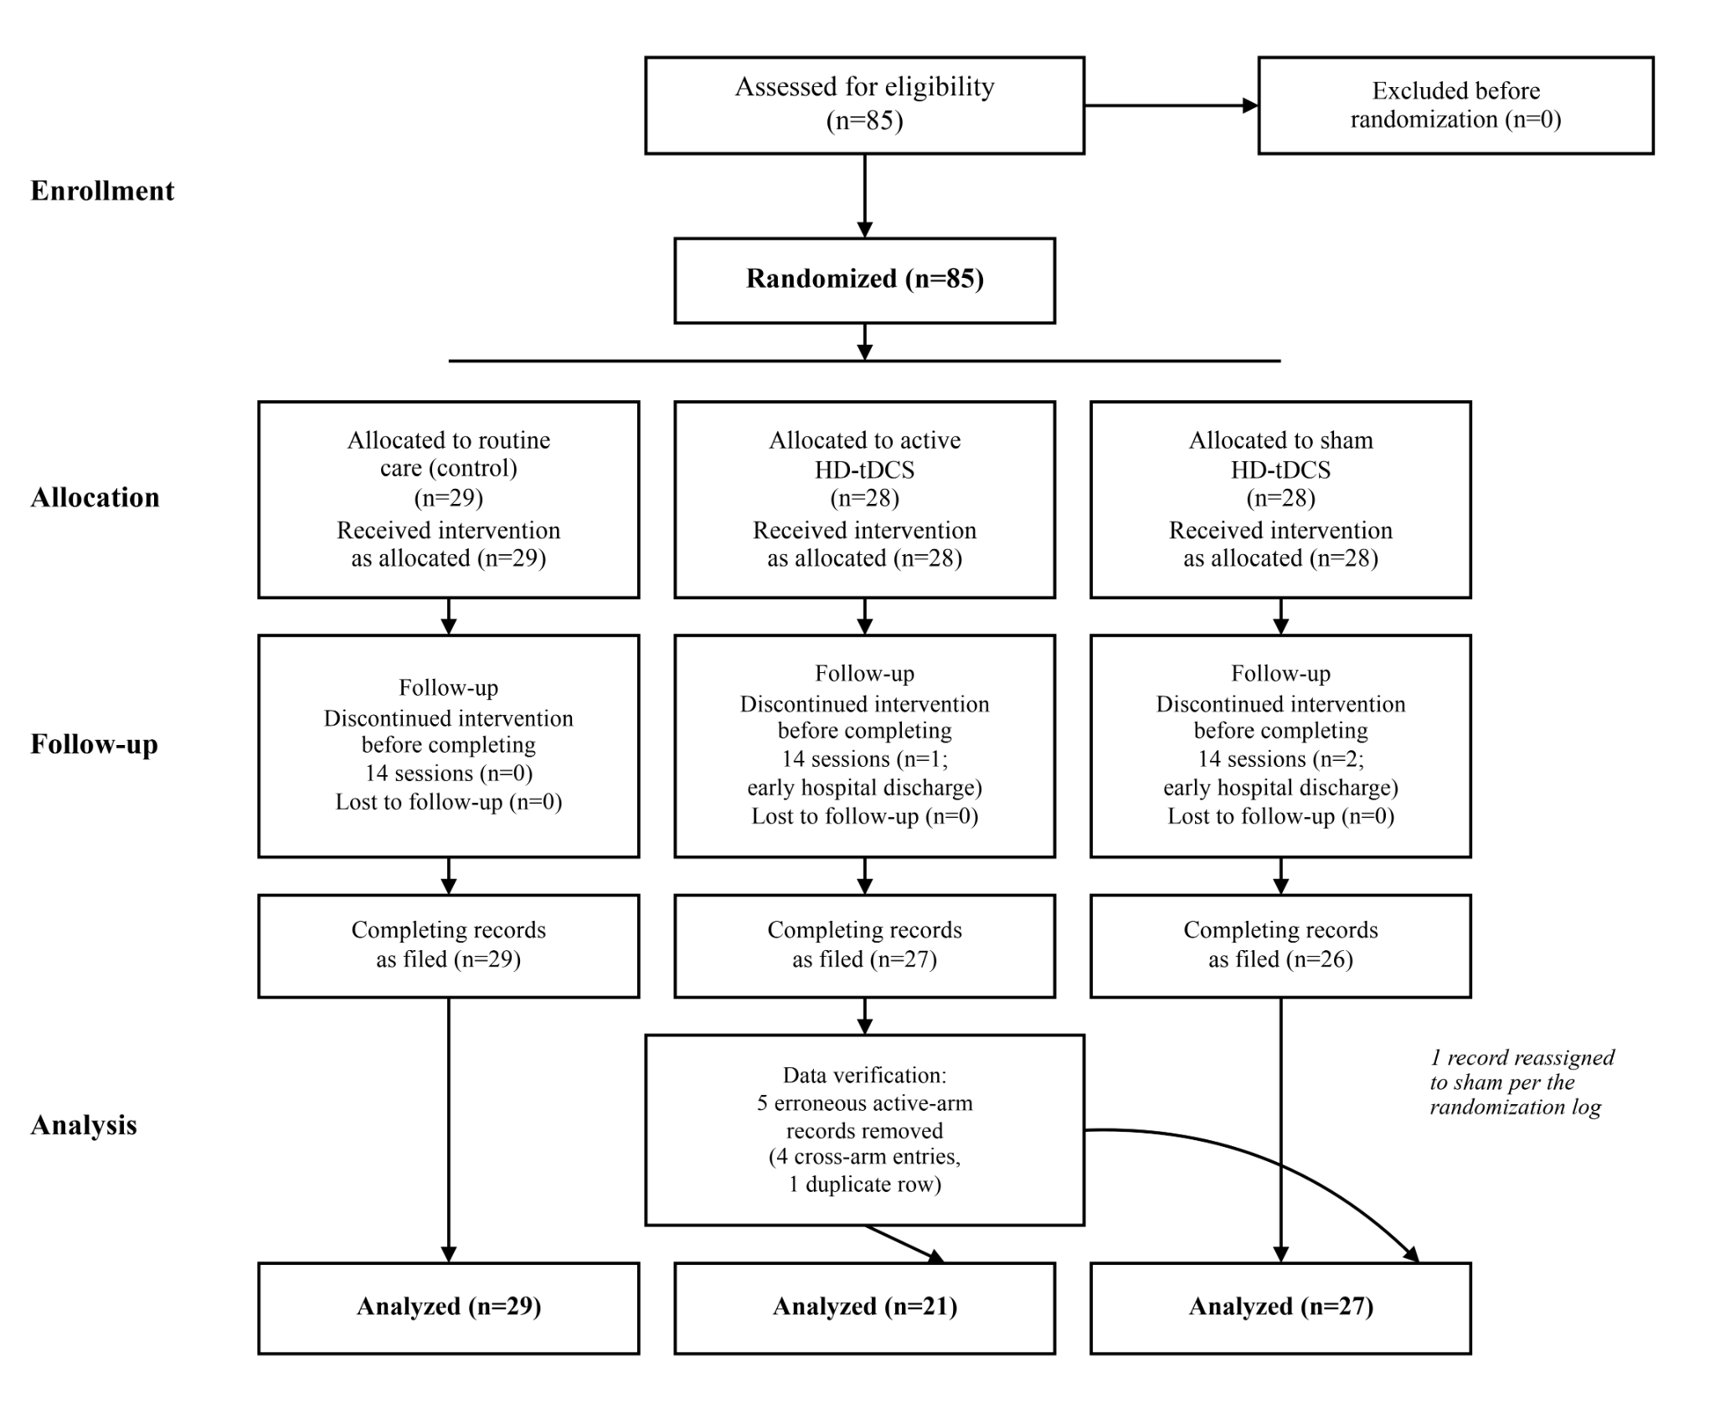
Figure 2. Bilateral 4×1 HD-tDCS montage (F3 anode / F4 cathode with listed return electrodes).
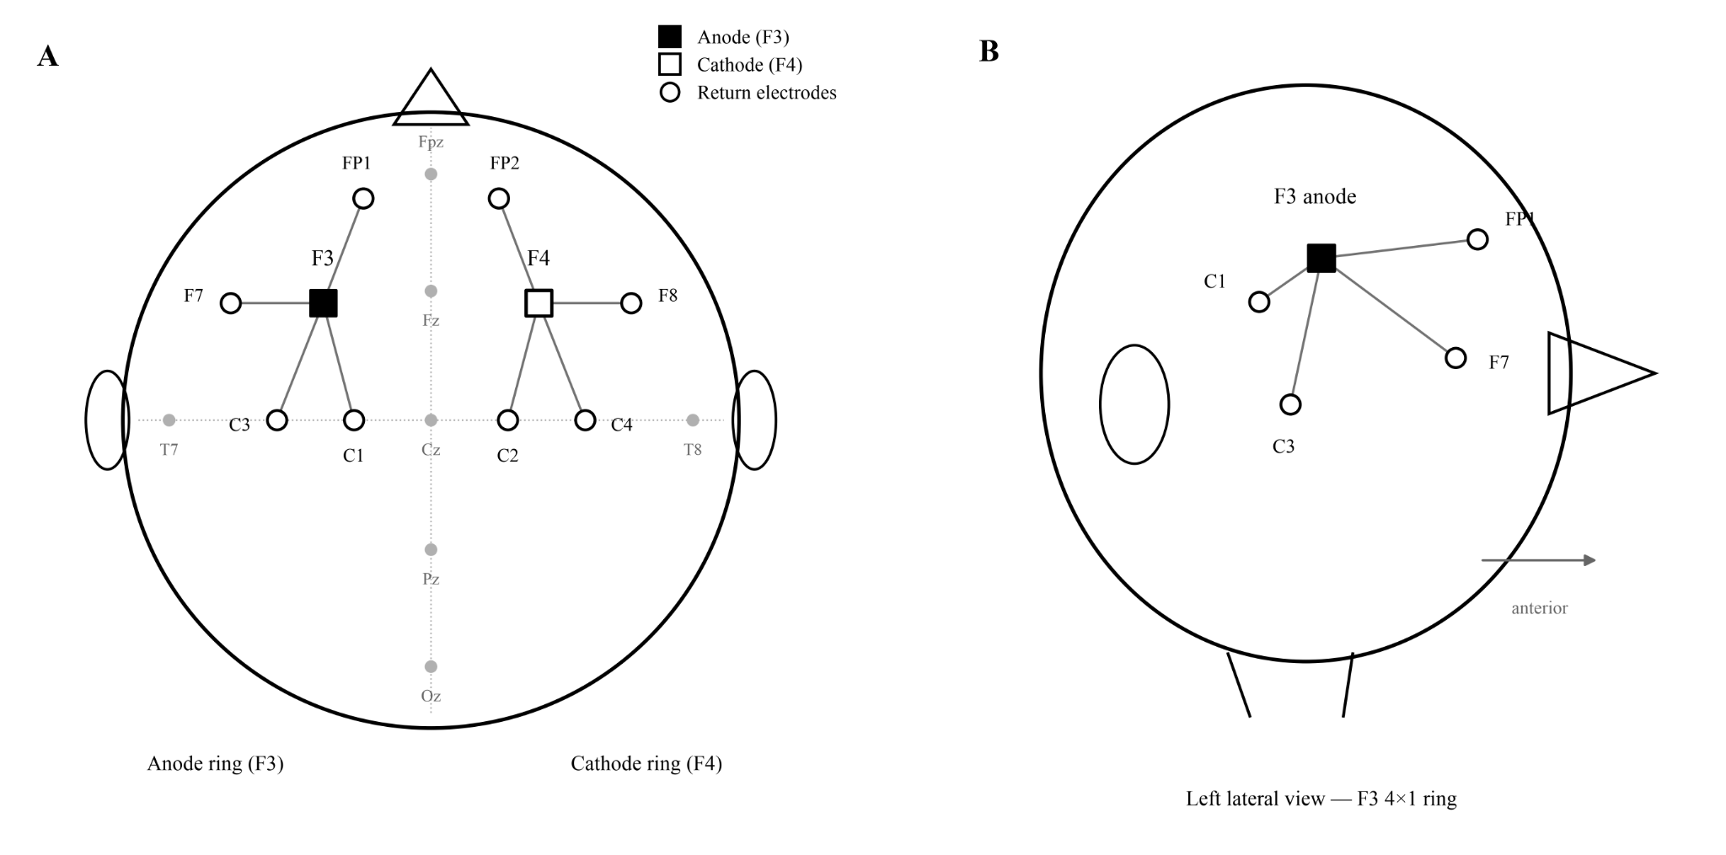
Figure 3. Post-intervention primary outcomes (TMT-B, VFT, HVLT-R) with individual observations.
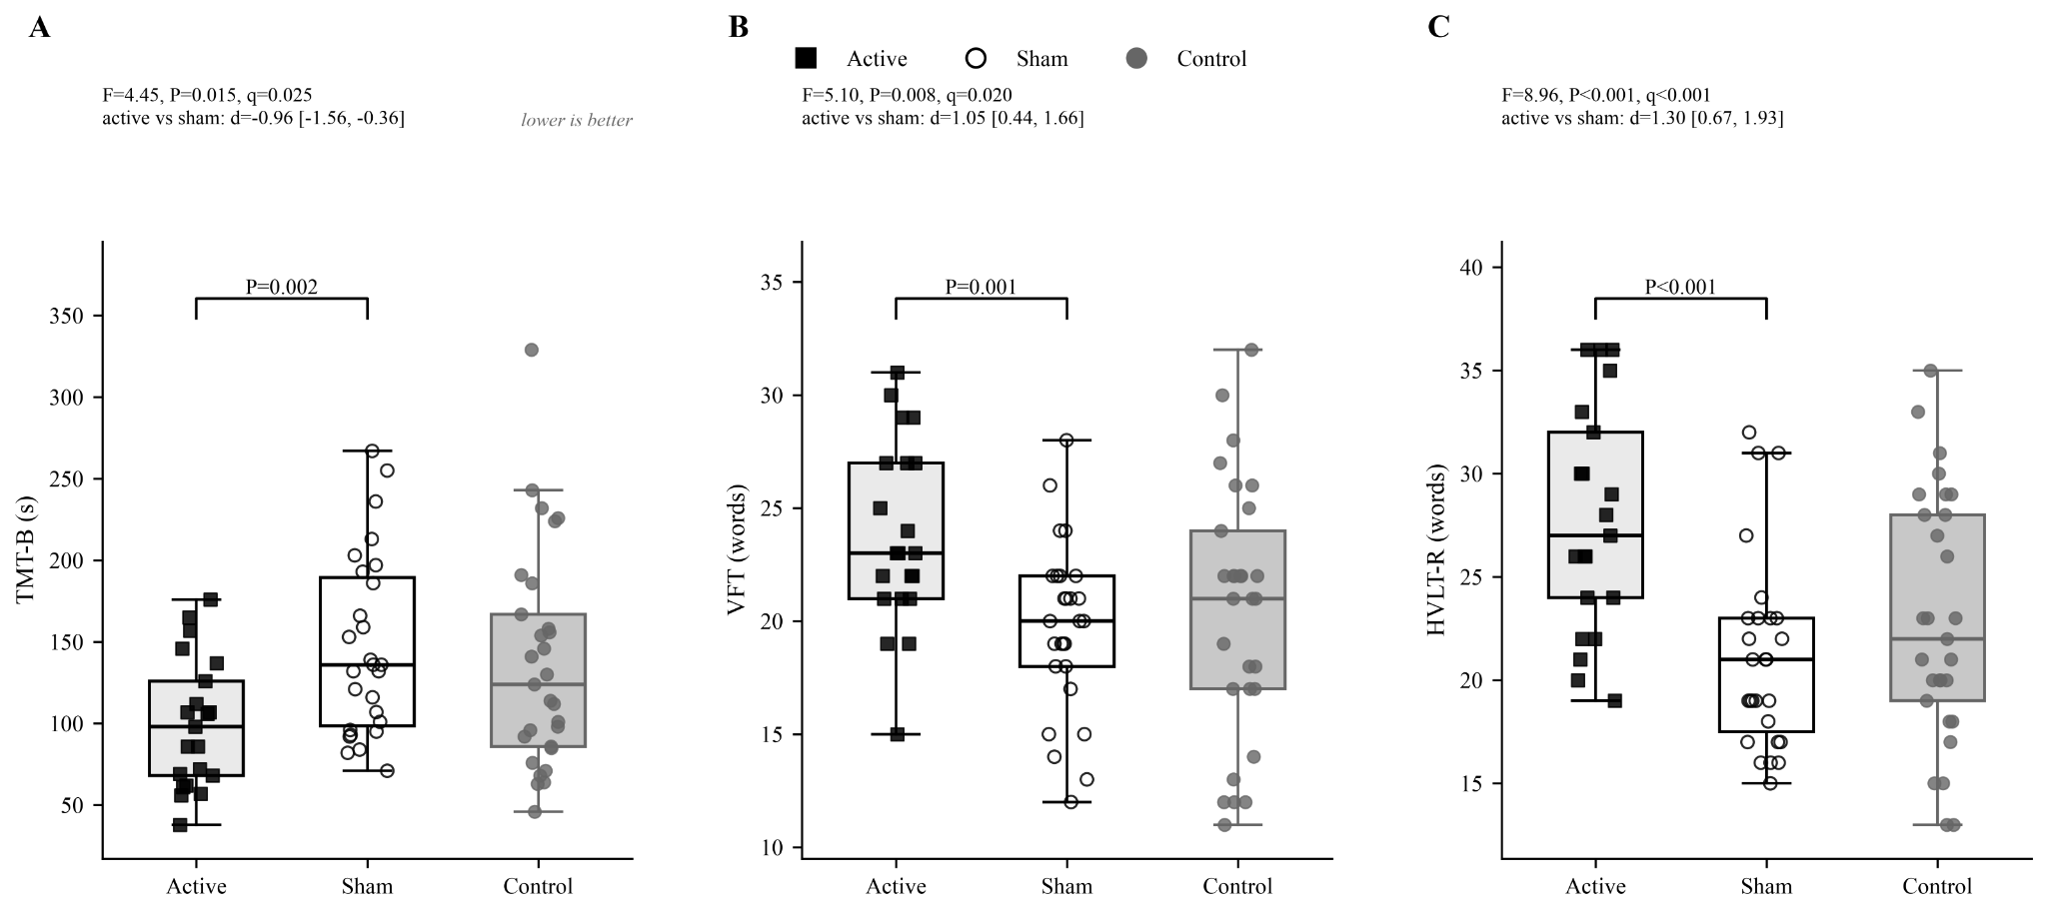
Figure 4. Baseline-to-post trajectories for primary outcomes (mean±95% CI).
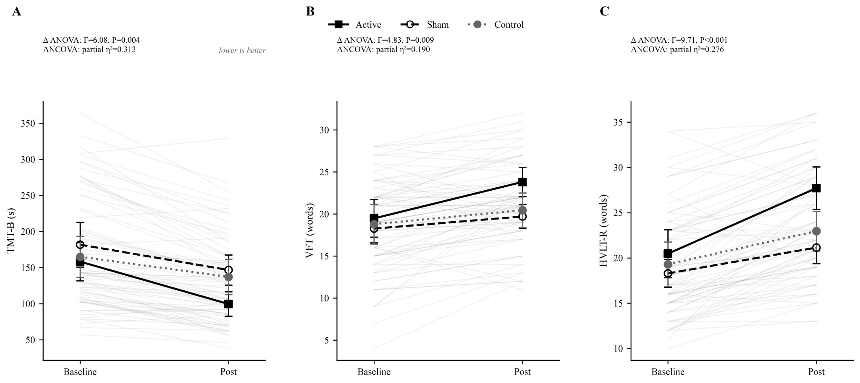
Table 1. Sociodemographic and drinking characteristics (mean±SD) in active (n=21), sham (n=27), and control (n=29) groups.
Table 2. Cognitive scores at baseline and post-intervention (mean±SD) across groups.
Table 3. Baseline-to-post-intervention change scores (mean change±SD) across groups.
Table 4. Baseline-adjusted (ANCOVA) post-intervention comparisons: adjusted group means with F, P, and partial eta-squared for each outcome.
Table 5. Safety monitoring and session completion.
Supplementary Table S1. Analysis-set row reconciliation (cleaning and reassignment).
Supplementary Material
Supplementary Table S1. Analysis-set row reconciliation
Row-level cleaning followed the original randomization log: erroneous active-arm entries were removed, and one retained record was reassigned to the sham arm before the primary complete-case analysis.
Supplementary Table S1a. Sample-size flow (control / active / sham)
Step | Control | Active | Sham | Total
Randomized (allocation) | 29 | 28 | 28 | 85
Discontinued intervention (early discharge) | 0 | 1 | 2 | 3
Completing records on file | 29 | 27 | 26 | 82
Erroneous active-arm rows removed | 0 | 5 | 0 | 5
Retained record reassigned active→sham | 0 | −1 | +1 | 0
Primary analysis set | 29 | 21 | 27 | 77

Supplementary Table S1b. Records removed from or reassigned out of the active arm
Participant ID (de-identified label) | Action
Lei Ang | Removed one duplicate row; retained the record for age 38 years and reassigned it to the sham group.
Lu Chao | Removed the erroneous active-group entry and retained the correct sham-group record.
Hu Shengfei | Removed the erroneous active-group entry and retained the correct sham-group record.
Wang Bingjie | Removed the erroneous active-group entry and retained the correct sham-group record.
Zhang Yinjie | Removed the erroneous active-group entry and retained the correct sham-group record.

Author Completion Checklist
• Author names, degrees, affiliations, and corresponding-author contact details
• Ethics approval number
• Funding statement and CRediT contributions
• Retrospective trial registration number and registration date (enrolled 2019; not prospectively registered)
• Allocation-concealment mechanism (e.g., sealed envelopes or central allocation)
• Electrode diameter/material, current density, ramp parameters, and adherence verification
• Adverse-event counts from chart review, if available

