Effects of High-Definition Transcranial Direct Current Stimulation on Cognitive Function in Male Inpatients with Alcohol Dependence: A Randomized Sham-Controlled Trial
Author names and degrees: see Author Completion Checklist (end of manuscript).
Department of Psychiatry, The Second Affiliated Hospital of Xinxiang Medical University (Henan Psychiatric Hospital), Xinxiang, Henan, China
Corresponding author: see Author Completion Checklist (end of manuscript).
Running title: HD-tDCS for AUD cognition
Keywords: alcohol dependence; transcranial direct current stimulation; cognition; dorsolateral prefrontal cortex; randomized controlled trial
Prior abstract presentation: None reported.
Clinical trial registration: Not prospectively registered before enrollment (2019). Retrospective registration with disclosure of the registration date is planned before final upload; see Author Completion Checklist.

Abstract
Background: Alcohol dependence features cognitive deficits that may increase relapse risk. High-definition tDCS (HD-tDCS) can focally engage the dorsolateral prefrontal cortex (DLPFC) via a 4×1 ring montage, but sham-controlled cognitive batteries in alcohol dependence remain scarce relative to craving and relapse endpoints.
Objective/Hypothesis: We tested whether 14 daily sessions of bilateral 4×1 HD-tDCS over the DLPFC improve cognition relative to sham HD-tDCS and routine care in male inpatients with alcohol dependence.
Methods: In this single-blind three-arm trial, 85 male inpatients were randomized to routine care (n=29), active HD-tDCS (n=28), or sham HD-tDCS (n=28); 77 were analyzed (n=29/21/27) after data verification. Bilateral 4×1 sessions (±1.0 mA, 20 min) targeted F3/F4 after detoxification. Primary outcomes were TMT-B, VFT, and HVLT-R. Analyses included post-intervention tests, baseline-adjusted ANCOVA, change scores, FDR correction, Cohen's d (95% CI), and Hedges g.
Results: Active HD-tDCS surpassed sham and control on TMT-B, VFT, and HVLT-R (omnibus FDR q<0.05; versus sham d=-0.96 [-1.56, -0.36], 1.05 [0.44, 1.66], and 1.30 [0.67, 1.93]; g=-0.94/1.03/1.28). ANCOVA confirmed group effects (partial η²=0.19-0.31), as did change scores and sensitivity analyses (ANCOVA P≤0.0003). MMSE and DST did not differ; sham equaled control.
Conclusion(s): Bilateral HD-tDCS produced greater domain-specific cognitive improvement than sham, with parallel advantage over routine care. Preregistered multicenter confirmation is needed.

Highlights
• Bilateral 4x1 HD-tDCS beat sham on TMT-B, VFT, and HVLT-R in AUD
• Active-vs-sham effects were large (Cohen d 0.96-1.30; Hedges g similar)
• ANCOVA and sensitivity analyses confirmed primary-outcome group effects
• MMSE and digit span showed no significant between-group differences
• Preregistered multicenter replication with relapse follow-up is needed

Introduction
Alcohol dependence is marked by impaired control over drinking and by enduring deficits in executive function, attention, and learning and memory (1-5). These deficits can undermine treatment engagement and abstinence (1, 6). Because prefrontal circuits that support cognitive control are implicated in alcohol use disorder (4, 7, 8), noninvasive stimulation of the dorsolateral prefrontal cortex (DLPFC) is a candidate strategy for restoring frontally mediated cognition during early recovery.
Transcranial direct current stimulation (tDCS) can modulate cortical excitability at low cost and with a favorable safety profile (9-12). In alcohol use disorder, however, most randomized trials have prioritized craving, relapse, or cue reactivity (8, 13, 14, 15, 16, 17, 18). Cognitive endpoints remain heterogeneous across substance-use studies and are sensitive to montage, dose, and outcome choice (19). After ten sessions of conventional left-DLPFC sponge-electrode tDCS, Dayal et al. (20) observed no tDCS-by-time interaction on neuropsychological performance in recently detoxified inpatients, whereas earlier DLPFC work reported behavioral, FAB, or cognitive improvement (7, 21).
Methodologically, electrode montage determines how much current reaches the intended cortex. Conventional bipolar sponge electrodes (typically ~25–35 cm²) distribute current over broad frontocortical territories. High-definition tDCS (HD-tDCS) instead uses a 4×1 ring of small gel electrodes to constrain the electric field beneath the center electrode and increase focality over the DLPFC (22). In the present protocol, bilateral rings placed the anode at F3 (returns FP1, F7, C1, C3) and the cathode at F4 (returns FP2, F8, C2, C4), delivering ±1.0 mA for 20 min once daily across 14 consecutive sessions (Figure 2). That combination—focal 4×1 geometry, bilateral DLPFC targeting, and a two-week inpatient dose—defines the stimulation contribution tested here. Prior HD-tDCS work in alcohol use disorder has emphasized craving or metabolic readouts rather than a full standardized neuropsychological battery (18).
We conducted a single-blind, three-arm randomized trial in male inpatients with alcohol dependence to test whether 14 daily sessions of bilateral 4×1 HD-tDCS over the DLPFC produce greater cognitive improvement than sham HD-tDCS or routine inpatient care alone. Prespecified primary outcomes were Trail Making Test Part B (TMT-B), verbal fluency (VFT), and Hopkins Verbal Learning Test-Revised (HVLT-R). The Mini-Mental State Examination (MMSE) and Digit Span Test (DST) were secondary outcomes.

Methods and Materials

Study design
This single-blind, single-center randomized trial compared routine inpatient care, routine care plus active HD-tDCS, and routine care plus sham HD-tDCS in male inpatients with DSM-5 alcohol dependence.

Participants
Male inpatients were recruited from Henan Psychiatric Hospital (The Second Affiliated Hospital of Xinxiang Medical University) between October 2019 and October 2020. Inclusion criteria were age 18–55 years, right-handedness, junior high school education or above, and written informed consent. Exclusion criteria included major neurological disease, prior cognitive behavioral therapy, intracranial surgery, pacemaker or metallic implants, and severe medical comorbidity.
Eighty-five participants were randomized 1:1:1 to routine care (n=29), active HD-tDCS (n=28), or sham HD-tDCS (n=28). Three participants discontinued the intervention early because of hospital discharge (1 active, 2 sham), leaving 82 completing records on file. After removal of five erroneous active-arm records and reassignment of one retained record to sham, 77 participants entered the primary complete-case analysis (active n=21, sham n=27, control n=29). The study was approved by the institutional ethics committee (approval number: see Author Completion Checklist). All participants and their guardians provided written informed consent. Participant flow is summarized in Figure 1.
During database consolidation after intervention completion, 82 completing records were on file (active 27, sham 26, control 29). Five erroneous active-arm records were identified: four cross-arm misentries whose valid copies already sat in the sham file, and one duplicate active-arm row for a participant whose retained record was reassigned to the sham arm according to the original randomization log. Removing the five erroneous active-arm rows and applying that reassignment yielded the primary complete-case analysis set of n=77 (active 21, sham 27, control 29; Figure 1). No participant contributed more than one analyzed record. Sensitivity analyses that moved or dropped the reassigned record, or that analyzed all five ambiguous participants in the active arm as recorded, are reported in Statistical analysis and Results.

Randomization and allocation
The randomization sequence was generated with a random number table at a 1:1:1 allocation ratio. The mechanism used to conceal the upcoming assignment from enrollment staff was not documented in the archived protocol and is listed in the Author Completion Checklist.

Procedures
After benzodiazepine-assisted detoxification, participants received routine inpatient care alone (control), routine care plus active HD-tDCS, or routine care plus sham HD-tDCS. The control arm did not receive equivalent device-contact time; active and sham arms each completed 14 additional 20-min stimulation sessions. Stimulation was delivered with a Soterix MXN-9 HD-tES device using bilateral 4×1 ring montages: F3 anode with return electrodes at FP1, F7, C1, and C3; F4 cathode with return electrodes at FP2, F8, C2, and C4 (Figure 2). Intensity was ±1.0 mA for 20 min once daily for 14 sessions (12, 22). Electrode size/material and session-adherence verification details are listed in the Author Completion Checklist. Active stimulation used continuous direct current throughout each session. Sham stimulation applied current only during the first and last 30 s of each session.

Outcome measures
Cognitive outcomes were assessed at baseline (week 2 of hospitalization) and post-intervention (week 4). The MMSE (23) was used for global cognitive screening. TMT-B measured attention and set shifting; DST assessed working memory; VFT assessed executive control; and HVLT-R assessed verbal learning and memory.

Statistical analysis
Analyses were performed on the cleaned individual-level complete-case dataset. The original analyses used SPSS 22.0; all statistics reported here were independently recomputed from the raw records in Python (SciPy and statsmodels) and cross-checked against the original output. Data are presented as mean±SD. Within-group pre-to-post changes were evaluated with paired t-tests. Between-group comparisons at each time point used one-way ANOVA when variances were homogeneous (Levene's test) and Welch's ANOVA otherwise, with LSD or Games-Howell pairwise comparisons accordingly. To separate stimulation-specific benefit from partial recovery during inpatient care, baseline-to-post-intervention change scores were compared across groups using the same procedures, and analysis of covariance (ANCOVA) tested group differences in each post-intervention score with its baseline value as covariate; homogeneity of regression slopes was verified through group-by-baseline interaction terms. TMT-B, VFT, and HVLT-R were prespecified primary outcomes and MMSE and DST secondary outcomes. Benjamini-Hochberg false discovery rate (FDR) correction was applied across the five post-intervention omnibus tests. Change-score and ANCOVA families were reported with nominal P values as confirmatory parallel analyses. For primary contrasts, Cohen's d was reported with large-sample 95% confidence intervals together with Hedges g correction (24). Pearson correlation examined all twenty associations between four drinking characteristics and five baseline cognitive measures as an exploratory analysis, with Benjamini-Hochberg correction applied across the twenty tests. Sensitivity analyses reassigned the reclassified participant to the active arm, excluded that participant, or analyzed all five ambiguous participants in the active arm as recorded; the minimum detectable d at 80% power for n=21 versus n=27 is 0.83. Two-sided P<0.05 denoted nominal significance; multiplicity-adjusted inference used q<0.05. No interim analyses were conducted.

Integrity of the blind
Blinding applied to participants in the active and sham arms through an identical electrode setup and a sham protocol that delivered brief current at the beginning and end of each session. The routine-care arm was unblinded by design because no device sessions were delivered. Outcome assessors were not blinded. Sham credibility and expectancy ratings were not collected.

Outcome hierarchy, sample size, and multiple testing
TMT-B, VFT, and HVLT-R were prespecified as primary cognitive outcomes based on their relevance to executive control, set shifting, and verbal learning and memory in alcohol dependence. MMSE and DST were designated secondary outcomes reflecting global screening and working memory, respectively. Associations between drinking characteristics and baseline cognition were declared exploratory.
No formal a priori sample-size calculation was documented in the original protocol. For a two-sided α=0.05 comparison of active n=21 versus sham n=27, the minimum detectable Cohen's d at 80% power is 0.83. Observed active-versus-sham effects on the primary outcomes exceeded this threshold. Observed post hoc power estimates are reported only as descriptive complements (TMT-B 89.8%, VFT 94.2%, HVLT-R 99.2%) and were not used for inferential claims.
Benjamini-Hochberg false discovery rate (FDR) correction was applied across all five post-intervention omnibus between-group tests, and primary outcomes remained significant at FDR-adjusted q<0.05. The same correction was applied across the twenty exploratory correlation tests. Change-score and ANCOVA families were treated as confirmatory parallel analyses and are reported with nominal P values. No interim analyses were planned or conducted; the trial ran to completion.

Safety monitoring
Systematic adverse-event ascertainment using structured tDCS safety checklists was not prespecified in the original study protocol (25). Session tolerability was monitored through routine inpatient clinical observation during each 20-min session, including inquiry about scalp tingling, skin redness, headache, and discomfort. Serious adverse events would have been recorded in medical records and reported to the ethics committee according to institutional policy.

Figure 1
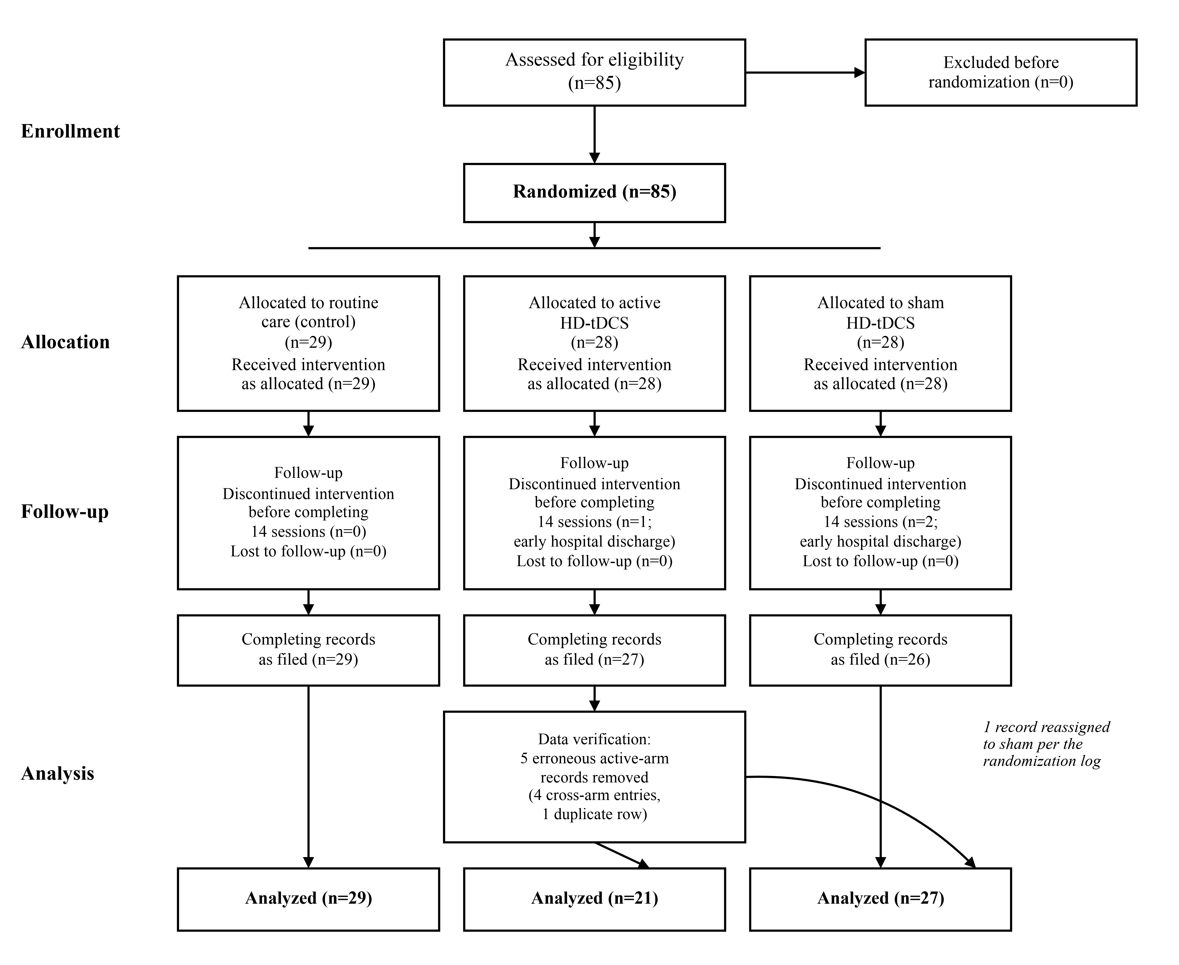
Figure 1. CONSORT participant flow diagram. Eighty-five participants were randomized (control 29, active 28, sham 28). Three discontinued before completing the intervention. Five erroneous active-arm records were removed and one retained record was reassigned to the sham arm per the randomization log, leaving 77 participants in the primary analysis (active 21, sham 27, control 29).

Figure 2
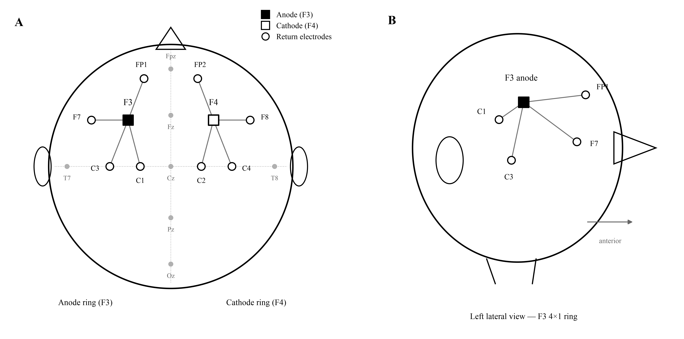
Figure 2. Bilateral 4×1 HD-tDCS montage. F3 anode with returns at FP1, F7, C1, and C3; F4 cathode with returns at FP2, F8, C2, and C4.

Figure 3
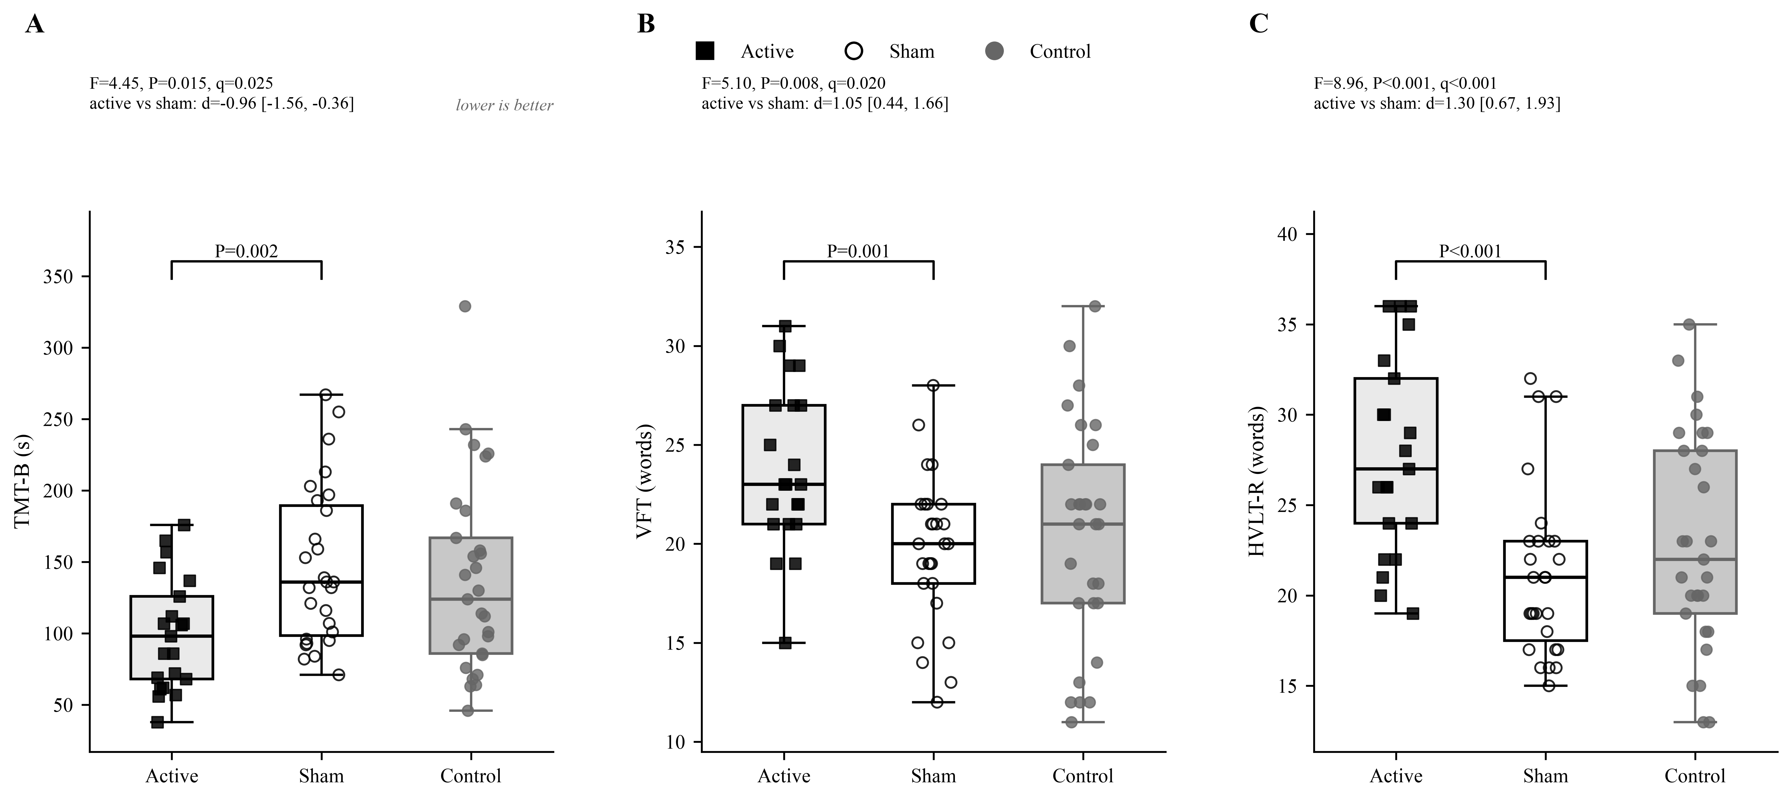
Figure 3. Post-intervention primary outcomes (box plots with individual points) for TMT-B, VFT, and HVLT-R. Lower TMT-B scores indicate better performance.

Figure 4
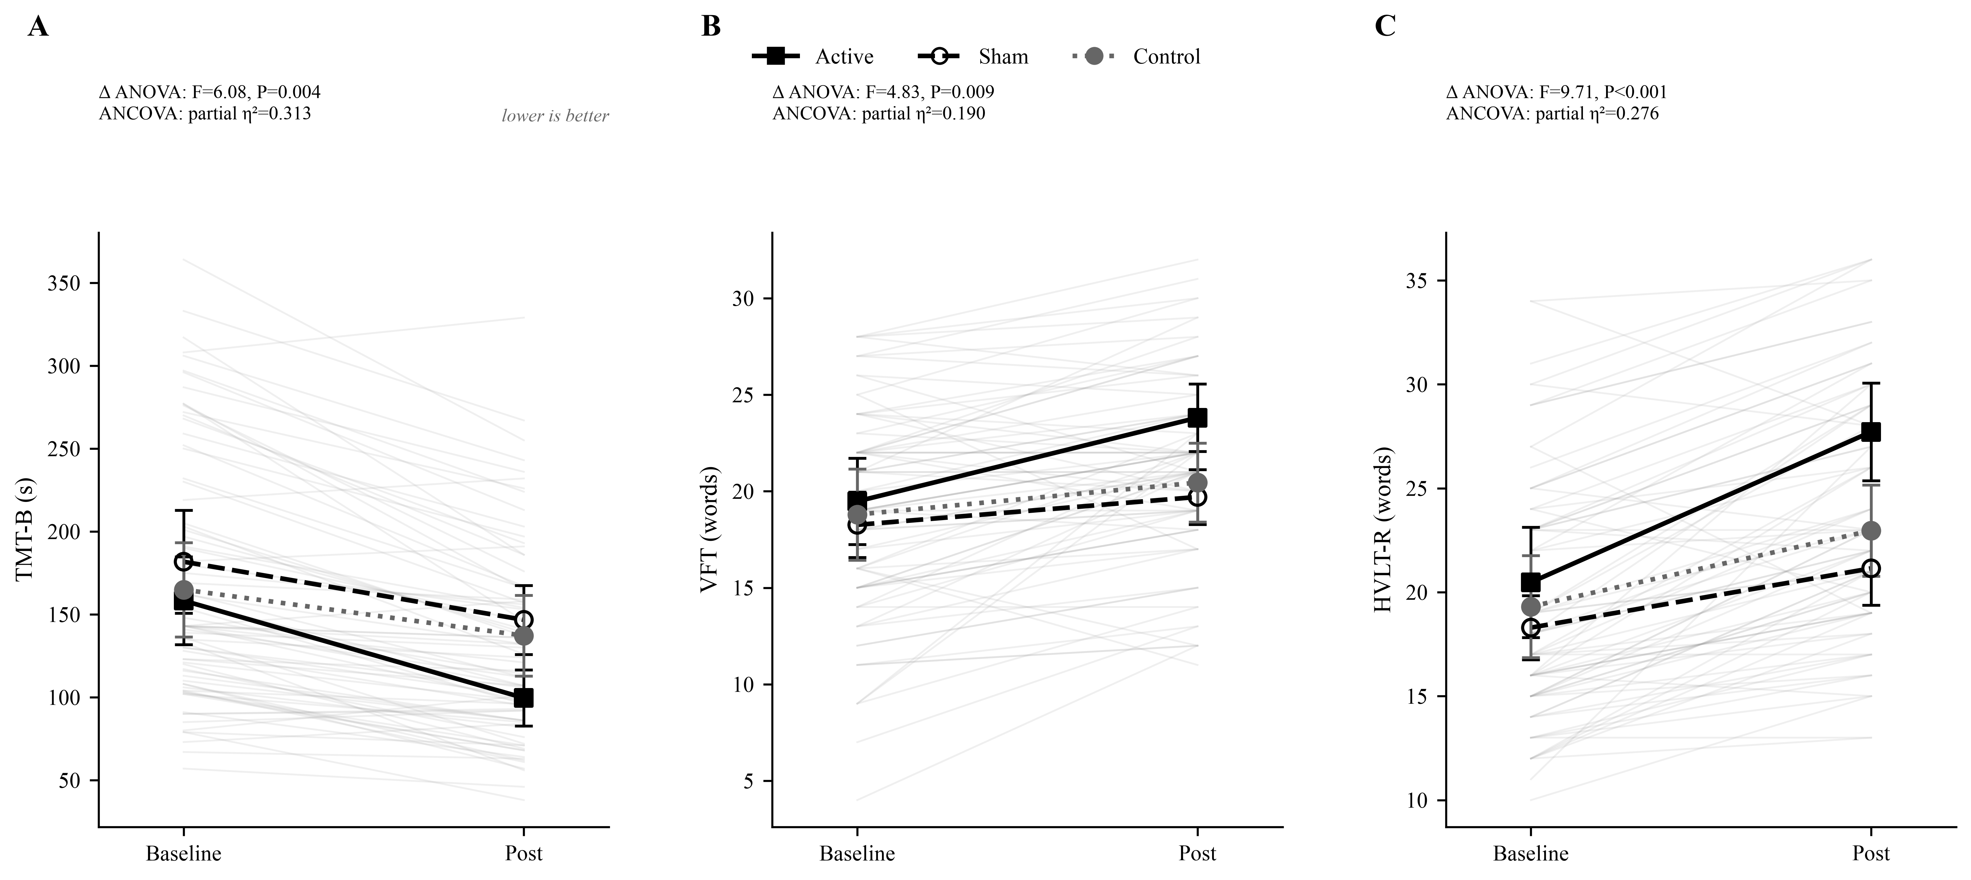
Figure 4. Baseline-to-post trajectories for the three primary outcomes (mean±95% CI with individual paths).

Results
A total of 77 participants were included in the primary analysis (Figure 1).

Baseline characteristics
The three groups did not differ in age, education, or drinking history (all P>0.05; Table 1).
Table 1. Sociodemographic and drinking characteristics (mean±SD)
Variable | Active (n=21) | Sham (n=27) | Control (n=29) | F | P
Age (years) | 36.48±6.49 | 35.52±9.12 | 38.14±7.66 | 0.78 | 0.461
Education (years) | 11.00±2.97 | 11.11±2.68 | 10.69±2.88 | 0.17 | 0.848
Age at first drink | 16.14±3.61 | 15.78±3.06 | 15.14±3.54 | 0.57 | 0.569
Duration of use (years) | 20.33±5.83 | 19.70±8.40 | 22.66±6.69 | 1.32 | 0.274
Dependence duration (years) | 7.24±5.04 | 5.19±3.48 | 7.03±5.30 | 1.52 | 0.225
Prior abstinence attempts | 3.62±2.89 | 4.44±2.68 | 4.72±3.52 | 0.82 | 0.446

Cognitive scores at baseline and post-intervention
No baseline differences were observed across groups for MMSE, TMT-B, DST, VFT, or HVLT-R (all P>0.05). Baseline and post-intervention means are summarized in Table 2.
Table 2. Cognitive scores at baseline and post-intervention (mean±SD)
Measure | Time | Active | Sham | Control | F | P
MMSE | Baseline | 27.05±1.77 | 26.11±1.45 | 26.59±1.78 | 1.87 | 0.162
 | Post | 28.62±1.40 | 27.78±1.45 | 27.76±1.50 | 2.61 | 0.080
TMT-B (s) | Baseline | 158.29±61.87 | 181.78±82.18 | 164.93±78.06 | 0.64 | 0.531
 | Post | 99.62±39.65 | 146.70±55.29 | 137.21±66.85 | 4.45 | 0.015
DST | Baseline | 12.38±1.94 | 12.22±2.24 | 12.28±2.37 | 0.03 | 0.970
 | Post | 13.95±2.06 | 13.11±2.03 | 13.34±2.72 | 0.81 | 0.450
VFT | Baseline | 19.48±5.21 | 18.26±4.49 | 18.79±6.50 | 0.29 | 0.751
 | Post | 23.81±4.09 | 19.70±3.77 | 20.45±5.62 | 5.10 | 0.008
HVLT-R | Baseline | 20.48±6.20 | 18.30±4.10 | 19.31±6.75 | 0.84 | 0.437
 | Post | 27.71±5.48 | 21.15±4.69 | 22.97±6.02 | 8.96 | <0.001

Within-group pre-post changes
Paired t-tests indicated cognitive improvement in all three groups during inpatient care, consistent with partial recovery during early abstinence. Gains were most pronounced in the active group for TMT-B, VFT, and HVLT-R. Baseline and post-intervention means are shown in Table 2; between-group change scores are reported in Table 3.

Change-score analyses
Because all groups improved during inpatient care, change-score analyses were used to determine whether the magnitude of improvement differed across groups. Significant differences were observed for TMT-B (F=6.079, P=0.004), VFT (F=4.835, P=0.009), and HVLT-R (F=9.710, P<0.001), but not for MMSE or DST (Table 3). Post hoc comparisons confirmed greater change in the active group than in the sham group on TMT-B (P=0.010), VFT (P=0.003), and HVLT-R (P<0.001), and greater change than the control group on the same measures (P=0.001, P=0.022, and P=0.002, respectively). Sham and control groups did not differ on change scores.
Table 3. Baseline-to-post-intervention change scores (mean Δ±SD) across groups
Measure | Active (n=21) | Sham (n=27) | Control (n=29) | F | P
MMSE | 1.57±1.12 | 1.67±1.33 | 1.17±1.2 | 1.27 | 0.288
TMT-B | -58.67±28.34 | -35.07±31.53 | -27.72±34.05 | 6.08 | 0.004
DST | 1.57±1.03 | 0.89±1.53 | 1.07±1.83 | 1.21 | 0.303
VFT | 4.33±3.65 | 1.44±2.12 | 1.66±4.33 | 4.83 | 0.009
HVLT-R | 7.24±3.32 | 2.85±3.1 | 3.66±4.15 | 9.71 | <0.001

Post-intervention between-group comparisons
Significant group differences were observed for TMT-B (F=4.454, P=0.015, q=0.025), VFT (F=5.099, P=0.008, q=0.020), and HVLT-R (F=8.958, P<0.001, q<0.001), but not for MMSE (P=0.080, q=0.100) or DST (P=0.450, q=0.450; Table 2). All three prespecified primary outcomes remained significant after Benjamini-Hochberg FDR correction.
Post hoc comparisons showed that the active group outperformed the sham group on TMT-B (P=0.002), VFT (P=0.001), and HVLT-R (P<0.001), and surpassed the control group on the same measures (P=0.026, P=0.024, and P=0.006, respectively). For active versus sham, Cohen's d was -0.96 [-1.56, -0.36] for TMT-B, 1.05 [0.44, 1.66] for VFT, and 1.30 [0.67, 1.93] for HVLT-R (Hedges g=-0.94, 1.03, and 1.28); versus control, d was -0.66 [-1.23, -0.08], 0.67 [0.09, 1.24], and 0.82 [0.23, 1.40], respectively (95% confidence intervals in brackets). Sham and control groups did not differ on any outcome. Levene tests for post-intervention primary outcomes were nonsignificant (all P>0.10); Kruskal-Wallis tests yielded the same significance pattern.
Sensitivity analyses that reassigned the reclassified participant to the active arm, excluded that participant, or analyzed all five ambiguous participants in the active arm as recorded preserved the primary ANCOVA conclusions for TMT-B, VFT, and HVLT-R (all ANCOVA P≤0.0003; active-versus-sham |d| range across sets 0.89–1.46). In the most conservative as-recorded set (active n=26, sham n=22), active-versus-sham d remained -1.20/1.14/0.89.

Baseline-adjusted between-group comparisons (ANCOVA)
As a confirmatory analysis, ANCOVA on post-intervention scores with baseline performance as covariate showed group effects for TMT-B (F(2,73)=16.67, P<0.001, partial η²=0.31), VFT (F(2,73)=8.55, P<0.001, partial η²=0.19), and HVLT-R (F(2,73)=13.91, P<0.001, partial η²=0.28); MMSE and DST remained nonsignificant (Table 4). Adjusted means placed the active group ahead of both comparison arms on all three primary outcomes, and homogeneity of regression slopes held for every model (all interaction P>0.11). The convergence of ANCOVA, change-score, and unadjusted post-intervention analyses indicates that the findings are not attributable to baseline imbalances.
Table 4. Analysis of covariance on post-intervention cognitive scores (adjusted means)
Measure | Active (n=21) | Sham (n=27) | Control (n=29) | F (df) | P | Partial η²
MMSE | 28.31 | 28.04 | 27.73 | 1.89 (2,73) | 0.159 | 0.05
TMT-B | 107.04 | 137.89 | 140.04 | 16.67 (2,73) | <0.001 | 0.31
DST | 13.88 | 13.16 | 13.35 | 1.41 (2,73) | 0.250 | 0.04
VFT | 23.36 | 20.05 | 20.45 | 8.55 (2,73) | <0.001 | 0.19
HVLT-R | 26.81 | 21.88 | 22.94 | 13.91 (2,73) | <0.001 | 0.28

Correlation analyses
Pearson correlation analyses examined 20 drinking-cognition pairs (four drinking characteristics x five baseline cognitive measures). Of these, 4 were nominally significant (all P<0.05), and 2 survived Benjamini-Hochberg correction across the twenty tests: longer cumulative alcohol-use duration was positively correlated with baseline TMT-B completion time (r=0.42, q=0.003); longer dependence duration was positively correlated with baseline TMT-B completion time (r=0.33, q=0.037). Because higher TMT-B completion times indicate slower set shifting, both associations reflect greater cognitive impairment with longer alcohol exposure. The remaining nominally significant associations (dependence duration with verbal fluency (r=-0.27); prior abstinence attempts with verbal fluency (r=-0.23)) did not survive correction (q=0.128, q=0.209).

Safety and tolerability
Structured adverse-event collection was not prespecified (25). No serious stimulation-related events requiring trial discontinuation were reported during routine inpatient monitoring. Clinicians asked about scalp tingling, skin redness, headache, and discomfort after sessions, but responses were not recorded in a structured database. One active and two sham participants discontinued before completing all 14 sessions (Figure 1).
Table 5. Safety monitoring and session completion
Item | Active (n=21) | Sham (n=27) | Control (n=29)
Early discontinuation before 14 sessions (study level; Figure 1) | 1 | 2 | 0
Structured adverse-event collection | No | No | No
Informal session tolerability monitoring | Yes | Yes | N/A
Routine clinical monitoring | Yes | Yes | Yes

Discussion
In this three-arm inpatient trial, bilateral 4×1 HD-tDCS over the DLPFC produced greater improvement than sham on a prespecified cognitive battery (TMT-B, VFT, and HVLT-R), with parallel advantage over routine care. Baseline characteristics were comparable. Of 85 randomized participants, 77 entered the primary complete-case analysis after removal of erroneous active-arm records and reassignment of one retained record to the sham arm according to the randomization log (Supplementary Table S1).
The active-versus-sham contrast was large and consistent across analytic frameworks. Change-score, post-intervention, and baseline-adjusted ANCOVA models all showed group effects on the three primary outcomes (partial η²=0.19-0.31), and sensitivity analyses that altered assignment of ambiguous records preserved those ANCOVA conclusions. All arms improved to some degree during detoxification and supportive care (26); the sham-controlled excess improvement therefore isolates stimulation-specific benefit from nonspecific inpatient recovery.
Sham HD-tDCS did not differ from routine care on primary outcomes. Because the control arm did not receive matched device-contact time, this equivalence indicates that the added session structure shared by the active and sham arms was insufficient, under the present dose, to produce measurable cognitive gains beyond routine treatment—rather than proving that sham current is cognitively inert.
Improvement concentrated on TMT-B, VFT, and HVLT-R, whereas MMSE and DST showed no group differences. We interpret this as a domain-selective behavioral profile under focal bilateral DLPFC HD dosing (7, 8, 22). Near-ceiling baseline MMSE scores (mean 26-27 of 30) also left little room to detect further change on that secondary screen. Psychometric endpoints were chosen a priori; the trial was not designed to localize mechanism with imaging or spectroscopy.
Neighboring HD-tDCS work in alcohol use disorder has focused on craving and prefrontal metabolites: adjunctive left-DLPFC HD-tDCS with naltrexone altered Glx without a between-group craving effect (18). Conventional sponge-electrode DLPFC tDCS trials have reported craving, relapse, P3/FAB screening, or mixed neuropsychological batteries (7, 15, 17, 20, 21), but not a full sham-controlled standardized battery under bilateral 4×1 HD dosing. The present study therefore complements those endpoints by asking whether a focal, multi-session HD montage improves prespecified neuropsychological scores during inpatient detoxification.
Exploratory correlations across twenty drinking-cognition pairs yielded two associations that survived Benjamini-Hochberg correction: longer cumulative alcohol-use duration (r=0.42, q=0.003) and longer dependence duration (r=0.33, q=0.037) tracked slower baseline TMT-B times. Cumulative exposure may therefore weigh particularly on set shifting; this pattern requires replication in larger cohorts.
Generalizability is bounded by the single-center male inpatient sample (active n=21 after verification), unblinded assessors, unmatched device-contact in the routine-care arm, and absence of prospective registration. Observed active-versus-sham effects exceeded the minimum detectable d of 0.83 at 80% power for n=21 versus n=27. Change-score and ANCOVA analyses reduce concerns about baseline imbalance but do not eliminate residual confounding.
Fourteen sessions of bilateral HD-tDCS over the DLPFC were associated with greater sham-controlled improvement on a standardized cognitive battery in male inpatients with alcohol dependence. Preregistered multicenter trials with matched attention controls, objective biomarkers, structured safety monitoring, and relapse follow-up will determine whether these cognitive gains translate into durable clinical benefit.

Acknowledgments
The authors thank the clinical staff and participants at Henan Psychiatric Hospital.

Financial Disclosures
The authors report no biomedical financial interests or potential conflicts of interest.
Funding: see Author Completion Checklist.
Author contributions: see Author Completion Checklist.
Data availability: De-identified individual-level data are not publicly available because of institutional privacy restrictions and the absence of participant consent for open sharing. Summary statistics and structured analysis outputs sufficient to reproduce the reported inferential results are provided in the Supplementary Material. De-identified data may be available from the corresponding author upon reasonable request and with appropriate institutional agreements.
Code availability: Statistical analysis and manuscript generation scripts are available from the corresponding author upon request. A permanent public repository URL has not yet been assigned.
Trial registration: This study was not prospectively registered before participant enrollment (2019). Retrospective registration with disclosure of the registration date is planned before journal submission.

Declaration of Generative AI and AI-Assisted Technologies
During preparation of this work, the authors used generative AI tools for literature monitoring, language editing, and manuscript formatting. After using these tools, the authors reviewed and edited the content as needed and take full responsibility for the published article.

References
1. Stavro K, Pelletier J, Potvin S. Widespread and sustained cognitive deficits in alcoholism: a meta-analysis. Addict Biol. 2013;18(2):203-213. doi:10.1111/j.1369-1600.2011.00418.x.
2. Ellingson JM, Fleming KA, Vergés A, et al. Working memory as a moderator of impulsivity and alcohol involvement. Addict Behav. 2014;39(11):1622-1631. doi:10.1016/j.addbeh.2014.01.004.
3. Christiansen P, Bloor JF. Individualised but not general alcohol Stroop predicts alcohol use. Drug Alcohol Depend. 2014;134:410-413. doi:10.1016/j.drugalcdep.2013.10.021.
4. Weiland BJ, Sabbineni A, Calhoun VD, et al. Reduced left executive control network functional connectivity is associated with alcohol use disorders. Alcohol Clin Exp Res. 2014;38(9):2445-2453. doi:10.1111/acer.12505.
5. Bernardin F, Maheut-Bosser A, Paille F. Cognitive impairments in alcohol-dependent subjects. Front Psychiatry. 2014;5:78. doi:10.3389/fpsyt.2014.00078.
6. 陈静, 钱敏才, 林敏, 等. 酒依赖脱瘾维持期患者复饮相关因素分析. 临床精神医学杂志. 2020;30(3):189-191.
7. da Silva MC, Conti CL, Klauss J, et al. Behavioral effects of transcranial direct current stimulation induced dorsolateral prefrontal cortex plasticity in alcohol dependence. J Physiol Paris. 2013;107(6):493-502. doi:10.1016/j.jphysparis.2013.07.003.
8. Camchong J, Roediger D, Fiecas M, et al. Frontal tDCS reduces alcohol relapse rates by increasing connections from left dorsolateral prefrontal cortex to addiction networks. Brain Stimul. 2023;16(4):1032-1040. doi:10.1016/j.brs.2023.06.011.
9. Boggio PS, Sultani N, Fecteau S, et al. Prefrontal cortex modulation using transcranial DC stimulation reduces alcohol craving: a double-blind, sham-controlled study. Drug Alcohol Depend. 2008;92(1-3):55-60. doi:10.1016/j.drugalcdep.2007.06.011.
10. Stagg CJ, Nitsche MA. Physiological basis of transcranial direct current stimulation. Neuroscientist. 2011;17(1):37-53. doi:10.1177/1073858410386614.
11. Park CH, Chang WH, Park JY, et al. Transcranial direct current stimulation increases resting state interhemispheric connectivity. Neurosci Lett. 2013;539:7-10. doi:10.1016/j.neulet.2013.01.047.
12. Fregni F, El-Hagrassy MM, Pacheco-Barrios K, et al. Evidence-based guidelines and secondary meta-analysis for the use of transcranial direct current stimulation in neurological and psychiatric disorders. Int J Neuropsychopharmacol. 2021;24(4):256-313. doi:10.1093/ijnp/pyaa051.
13. den Uyl TE, Gladwin TE, Wiers RW. Transcranial direct current stimulation, implicit alcohol associations and craving. Biol Psychol. 2015;105:37-42. doi:10.1016/j.biopsycho.2014.12.004.
14. Klauss J, Penido Pinheiro LC, Silva Merlo BL, et al. A randomized controlled trial of targeted prefrontal cortex modulation with tDCS in patients with alcohol dependence. Int J Neuropsychopharmacol. 2014;17(11):1793-1803. doi:10.1017/S1461145714000984.
15. Klauss J, Anders QS, Felippe LV, et al. Multiple sessions of transcranial direct current stimulation reduced craving and relapses for alcohol use: a randomized placebo-controlled trial in alcohol use disorder. Front Pharmacol. 2018;9:716. doi:10.3389/fphar.2018.00716.
16. Dubuson M, Kornreich C, Vanderhasselt MA, et al. Transcranial direct current stimulation combined with alcohol cue inhibitory control training reduces the risk of early alcohol relapse: a randomized placebo-controlled clinical trial. Brain Stimul. 2021;14(6):1531-1543. doi:10.1016/j.brs.2021.10.386.
17. Bollen Z, Dormal G, Maurage P. How should transcranial direct current stimulation be used in populations with severe alcohol use disorder? A clinically oriented systematic review. Clin EEG Neurosci. 2022;53(4):287-301. doi:10.1177/15500594211001212.
18. Kumar S, Khanra S, Roy C, Munda SK. Effect of adjunctive high-definition transcranial direct current stimulation (HD-tDCS) to oral naltrexone on craving, brain glutamate-glutamine (Glx) at left dorsolateral prefrontal cortex (DLPFC) in alcohol use disorder: a randomized sham-controlled HD-tDCS-fMRS study. J ECT. 2026. doi:10.1097/YCT.0000000000001257.
19. Zhang X, Huang M, Yu Y, et al. Is transcranial direct current stimulation effective for cognitive dysfunction in substance use disorders? A systematic review. Brain Sci. 2024;14(8):754. doi:10.3390/brainsci14080754.
20. Dayal P, Kaloiya G, Verma R, et al. Effects of transcranial direct-current stimulation (tDCS) treatment sessions on neuropsychological functioning among detoxified inpatients with alcohol dependence: a randomized sham-controlled clinical trial. Alcohol Treat Q. 2023;41(4):474-487. doi:10.1080/07347324.2023.2243237.
21. Nakamura-Palacios EM, de Almeida Benevides MC, da Penha Zago-Gomes M, et al. Auditory event-related potentials (P3) and cognitive changes induced by frontal direct current stimulation in alcoholics according to Lesch alcoholism typology. Int J Neuropsychopharmacol. 2012;15(5):601-616. doi:10.1017/S1461145711001040.
22. Kuo HI, Bikson M, Datta A, et al. Comparing cortical plasticity induced by conventional and high-definition 4×1 ring tDCS: a neurophysiological study. Brain Stimul. 2013;6(4):644-648. doi:10.1016/j.brs.2013.04.006.
23. 张明园, 何燕玲. 精神科评定量表手册. 长沙: 湖南科学技术出版社; 2015:280-283.
24. Cohen J. Statistical power analysis for the behavioral sciences. 2nd ed. Hillsdale (NJ): Lawrence Erlbaum Associates; 1988.
25. Brunoni AR, Amadera J, Berbel B, et al. A systematic review on reporting and assessment of adverse effects associated with transcranial direct current stimulation. Int J Neuropsychopharmacol. 2011;14(8):1133-1145. doi:10.1017/S1461145710001690.
26. 王淑静, 王传升, 张慧, 等. 酒依赖患者规范化治疗后认知功能改善分析. 精神医学杂志. 2020;33(3):214-216.

Figure and Table Legends
Figure 1. CONSORT participant flow diagram for the three-arm randomized trial (85 randomized; 77 analyzed: control n=29; active HD-tDCS n=21; sham HD-tDCS n=27).
Figure 2. Bilateral 4×1 HD-tDCS montage (F3 anode / F4 cathode with listed return electrodes).
Figure 3. Post-intervention primary outcomes (TMT-B, VFT, HVLT-R) with individual observations.
Figure 4. Baseline-to-post trajectories for primary outcomes (mean±95% CI).
Table 1. Sociodemographic and drinking characteristics (mean±SD) in active (n=21), sham (n=27), and control (n=29) groups.
Table 2. Cognitive scores at baseline and post-intervention (mean±SD) across groups.
Table 3. Baseline-to-post-intervention change scores (mean change±SD) across groups.
Table 4. Baseline-adjusted (ANCOVA) post-intervention comparisons: adjusted group means with F, P, and partial eta-squared for each outcome.
Table 5. Safety monitoring and session completion.
Supplementary Table S1. Analysis-set row reconciliation (cleaning and reassignment).

Supplementary Material

Supplementary Table S1. Analysis-set row reconciliation
Row-level cleaning followed the original randomization log: erroneous active-arm entries were removed, and one retained record was reassigned to the sham arm before the primary complete-case analysis.
Supplementary Table S1a. Sample-size flow (control / active / sham)
Step | Control | Active | Sham | Total
Randomized (allocation) | 29 | 28 | 28 | 85
Discontinued intervention (early discharge) | 0 | 1 | 2 | 3
Completing records on file | 29 | 27 | 26 | 82
Erroneous active-arm rows removed | 0 | 5 | 0 | 5
Retained record reassigned active→sham | 0 | −1 | +1 | 0
Primary analysis set | 29 | 21 | 27 | 77

Supplementary Table S1b. Records removed from or reassigned out of the active arm
Participant ID (de-identified label) | Action
P-E | 删除重复行1条，保留年龄38岁记录并归入伪刺激组
P-A | 删除真刺激组误录入行，保留伪刺激组正确记录
P-B | 删除真刺激组误录入行，保留伪刺激组正确记录
P-C | 删除真刺激组误录入行，保留伪刺激组正确记录
P-D | 删除真刺激组误录入行，保留伪刺激组正确记录

Author Completion Checklist
• Author names, degrees, affiliations, and corresponding-author contact details
• Ethics approval number
• Funding statement and CRediT contributions
• Retrospective trial registration number and registration date (enrolled 2019; not prospectively registered)
• Allocation-concealment mechanism (e.g., sealed envelopes or central allocation)
• Electrode diameter/material, current density, ramp parameters, and adherence verification
• Adverse-event counts from chart review, if available

