21337386 Aaron Abdullahi Musa-Lucas
In This project, I’ll be discussing about the specific technique related to Big Data Processing using many tools such as Hadoop/HUE, r studio and hive. Using a database such as Videogame dataset where I received my dataset from Portsmouth Research portal created by Dr. Jon Cox produce in 2013 and made available in 2015 and Called “managerial_and_decision_exconomics_2913_video_game_Dataset” I’ve renamed the File to “VideoGameDataset2013” and “vgsales” created/based from Beautifulsoup that contains a list of videogames that generated over 100,000 in sales which will be easier to identity within the files. There’s the console tabs where the game was released, the title, US Sales, year released, Genre, publisher and review score.
Reference of Dataset: https://researchportal.port.ac.uk/portal/en/datasets/video-games-dataset(d4fe28cd-1e44-4d2f-9db6-85b347bf761e).html
https://www.kaggle.com/gregorut/videogamesales
By using R studio I’ve managed to load my Dataset into R studios. Importing the dataset and setting my file. Here is the dataset I’ve uploaded which is the videogamesdataset2013

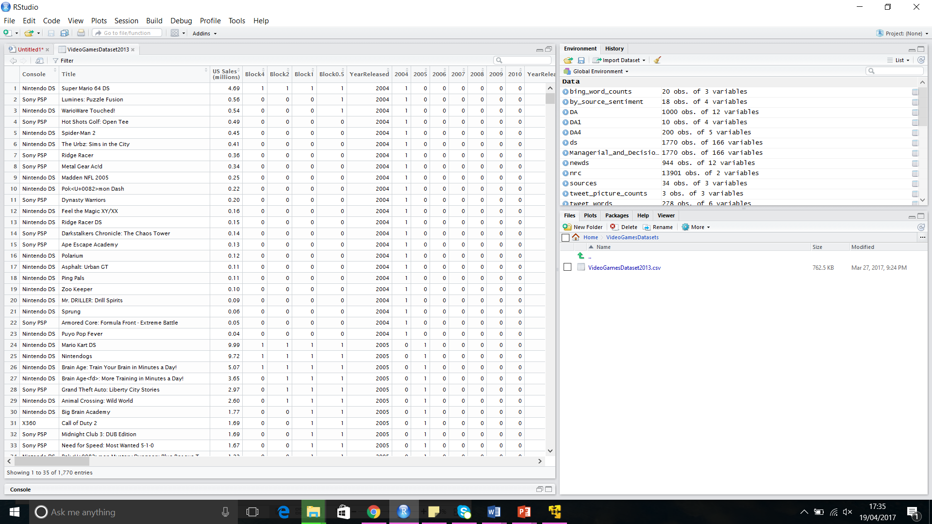
Now the game Data is loaded it can be viewed, showing a multiple of publishers. Giving me over six titles shown in the console tab only two have been shown so far such as “Nintendo DS” and “Sony PSP”
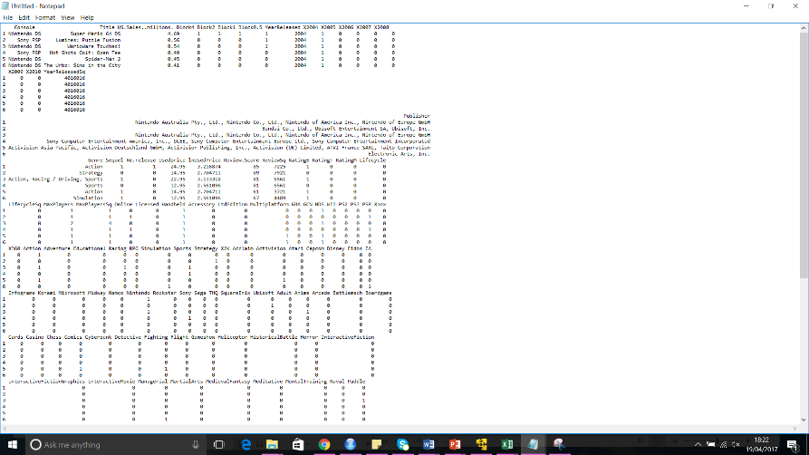
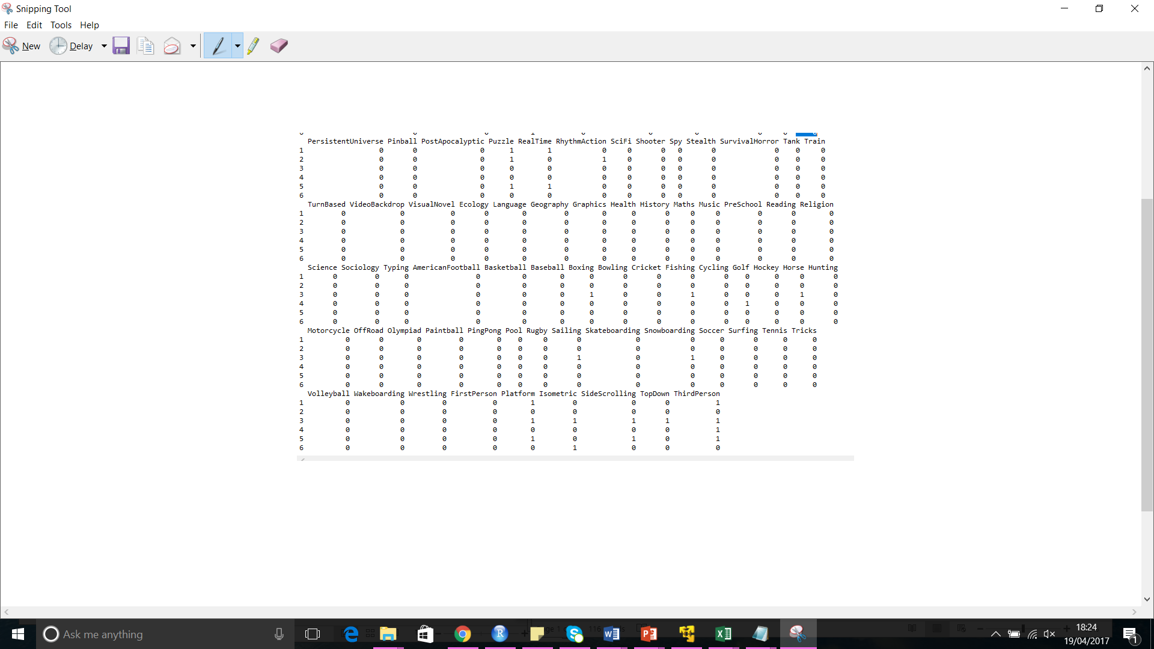
Over 166 tables for each genre found within the Colname function.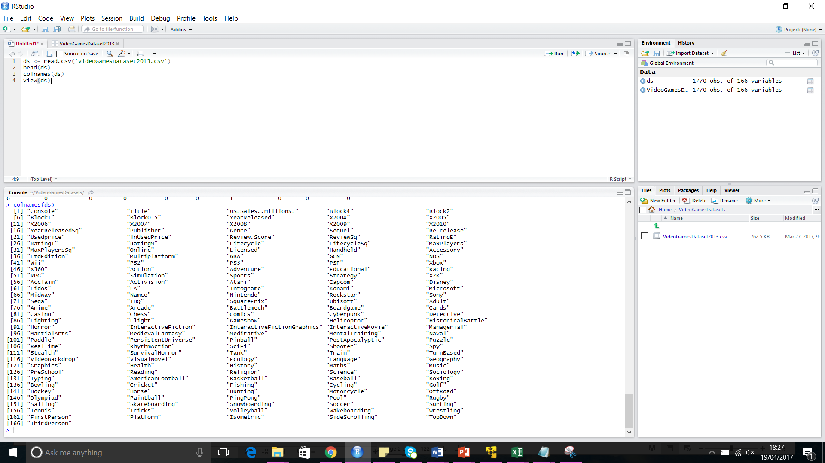
I’ve managed to get one Dataframe which is “Super Mario 64 DS” when it was made/year release, price, publisher, genre and score. The file has omitted over 770 entries referring to each genre
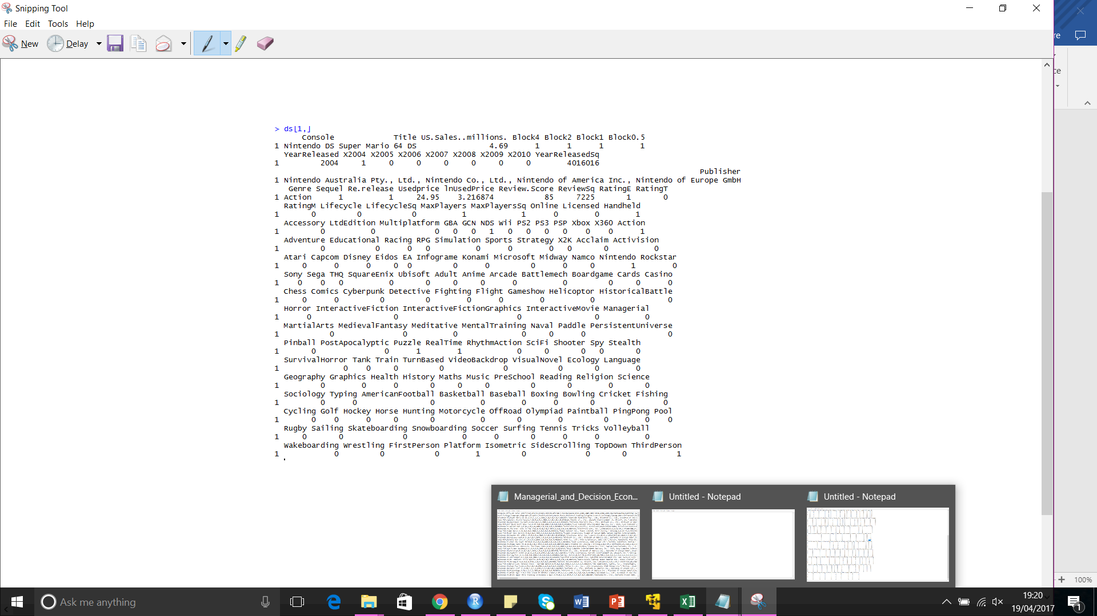
An Array has been made for each tab.
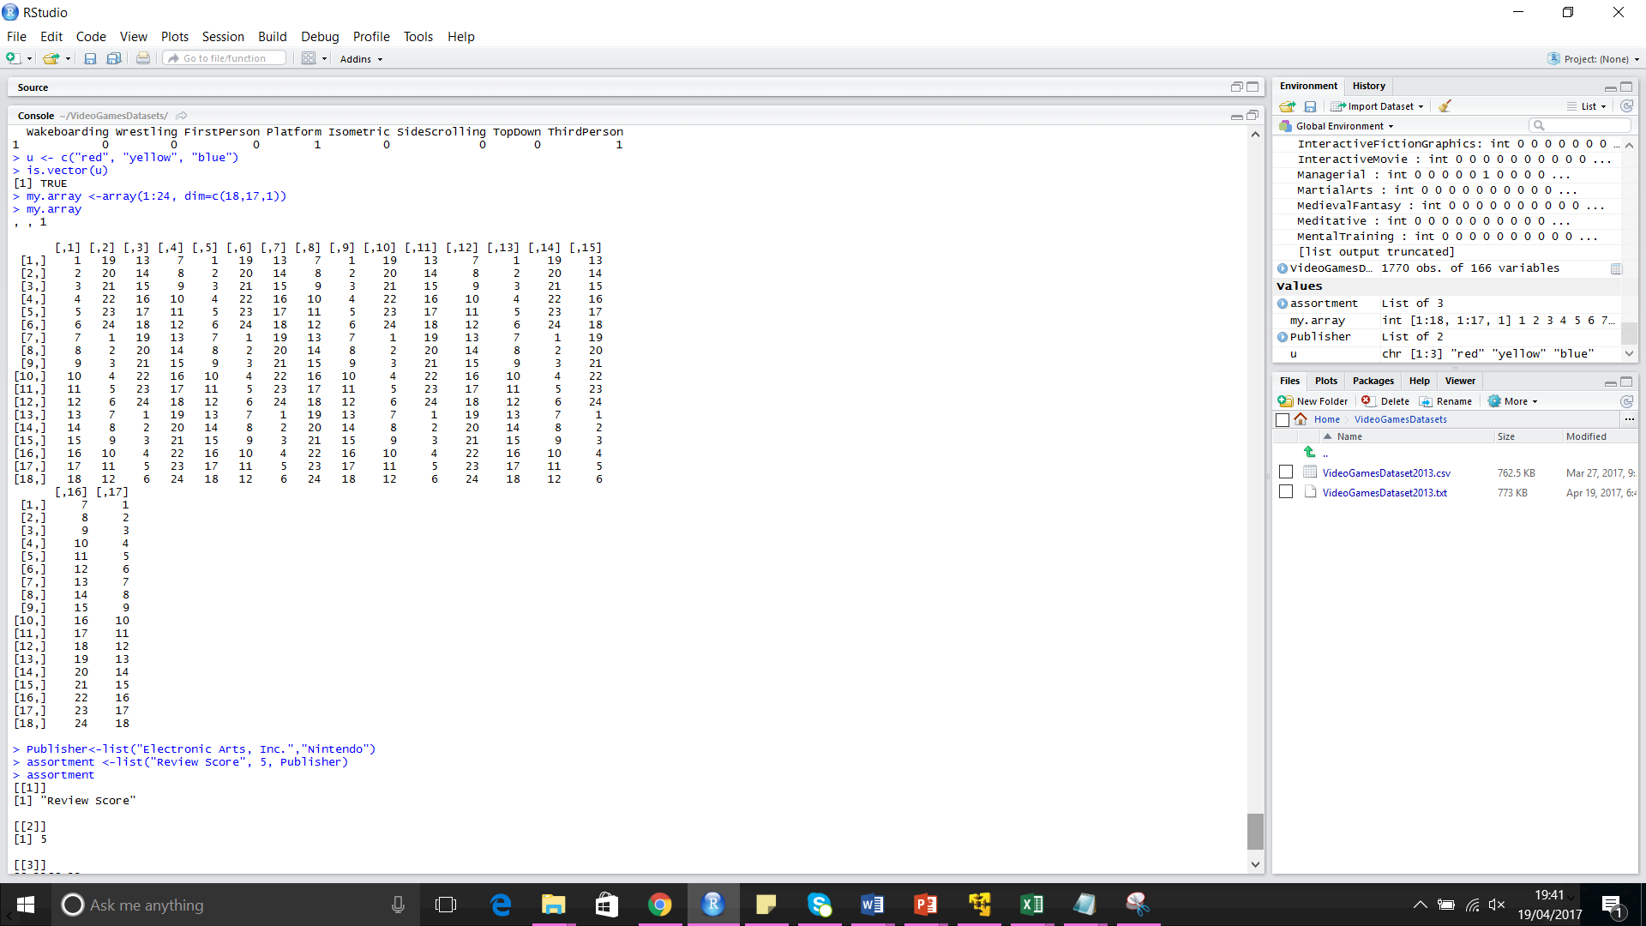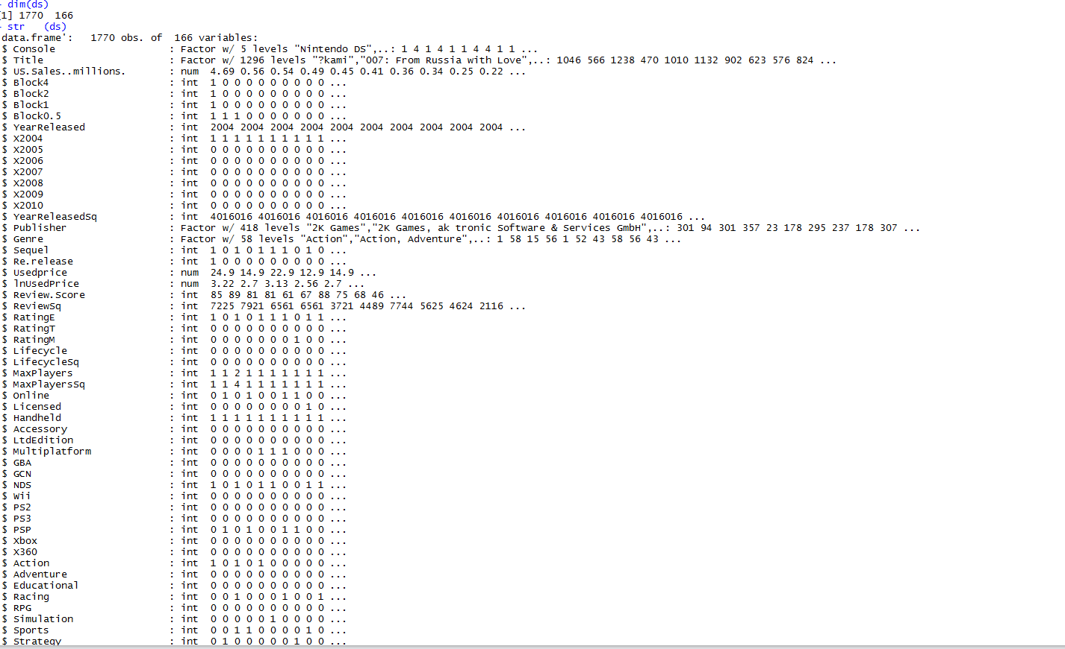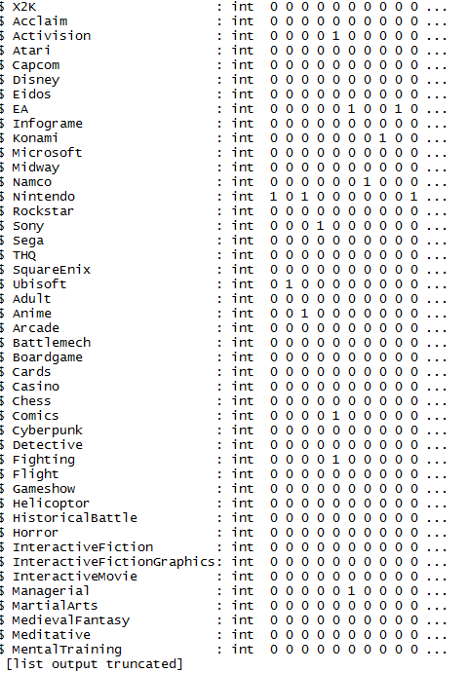
Data loaded and search through “electronic arts and Nintendo” games displaying an assortment of review and publishers for the “VideogameDataset2013.csv” file

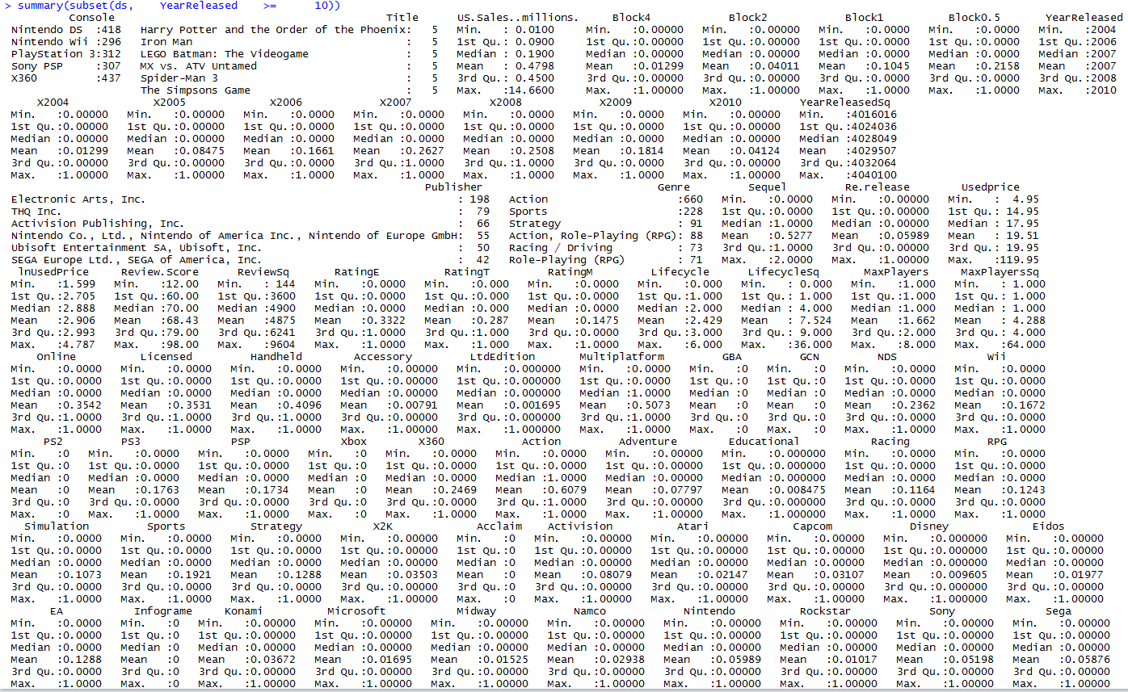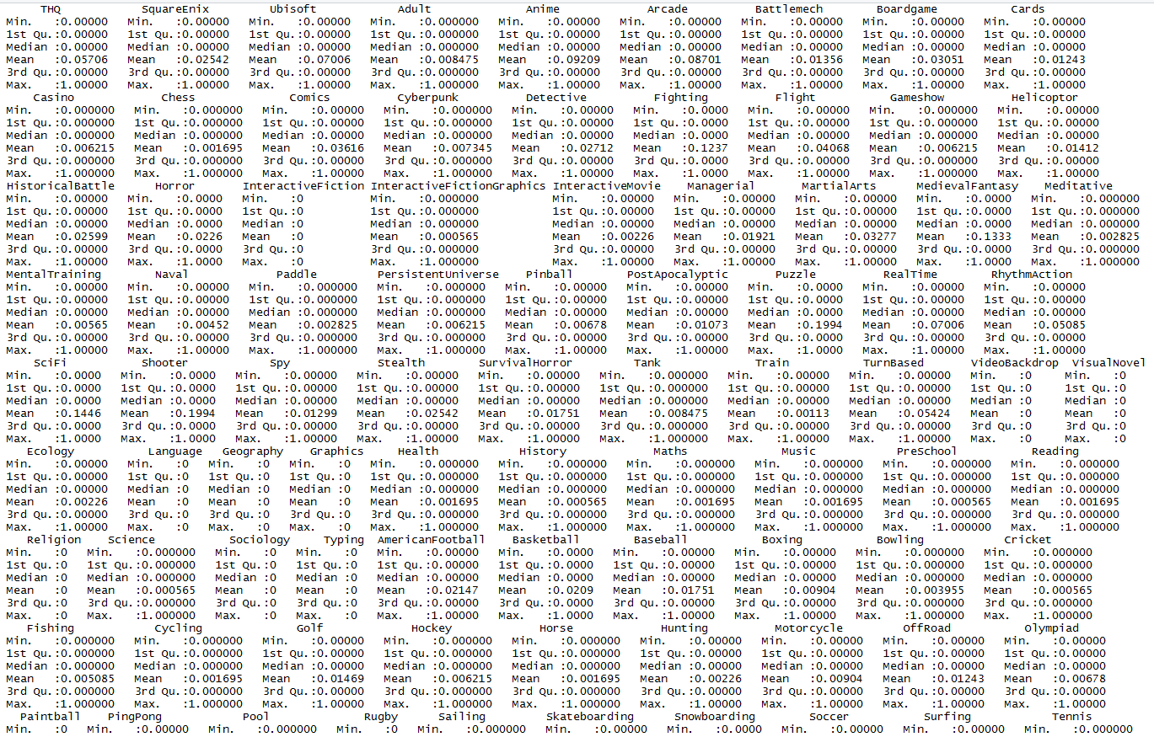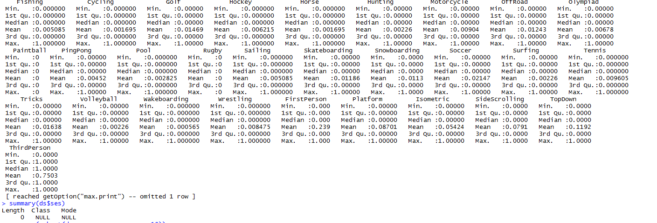
Summary of 5 games that have identified the publisher, year, genre, max players, sales etc. by using this method a table will be created to see how much has been sold within the years for this Dataset file. Finding the usedprice and the year released.
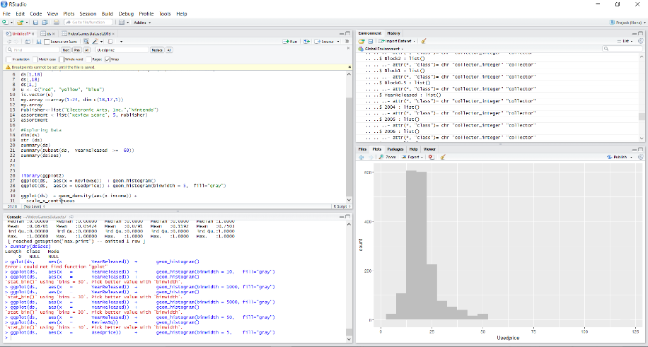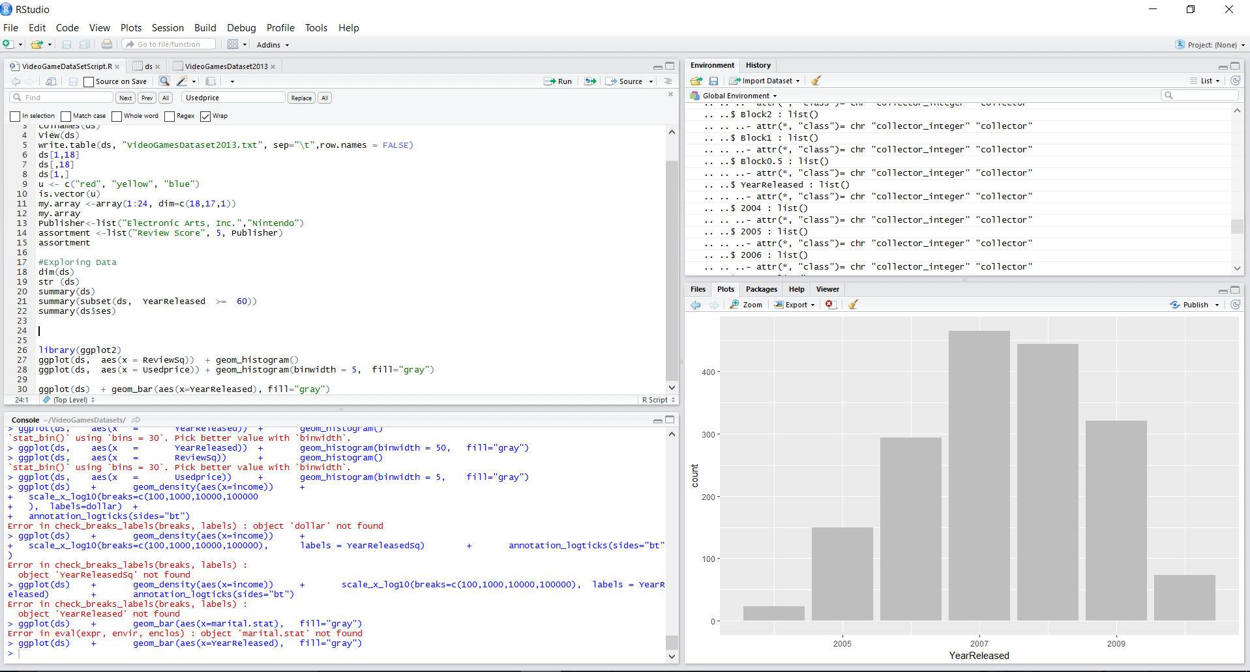
A cleaned-up version of the analysis, clearly showing what has been done. Next ill be loading a different file into Hive to get a range of 50 tables to show how much money has been made for global sales of games from 1980s until 2016.
HDFS/Hive
Logging into Cloudera Hadoop I’ll be using he file of VGSales through Hive. By going through this file, it has the data from 1980s until 2016 oct.
By uploading my CSV to file browser, I can use hive/Beeswax to create a table from the dataset
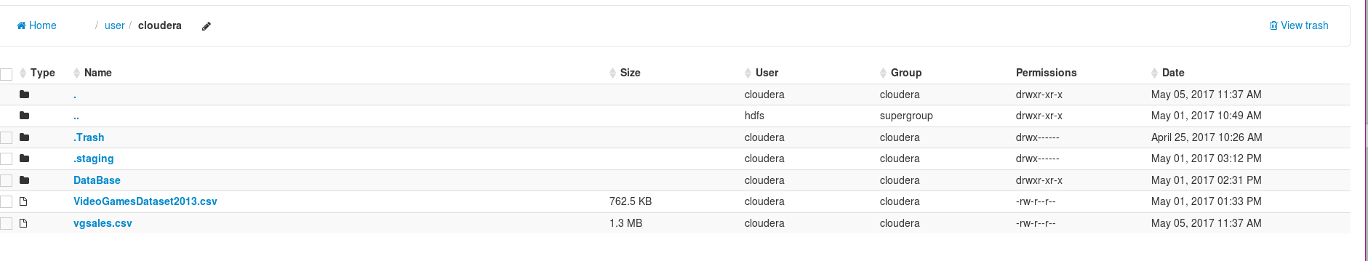
Table created and loading data into HIVE
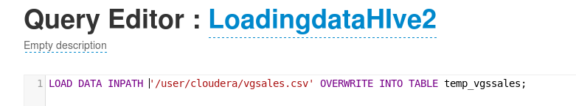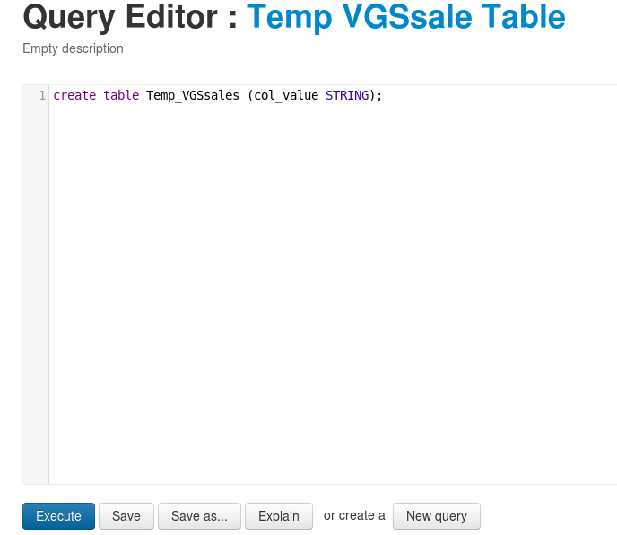
Browsing data through metastore manager. I will then create another table each year, platform, name and game sales an overall through of the data only through value
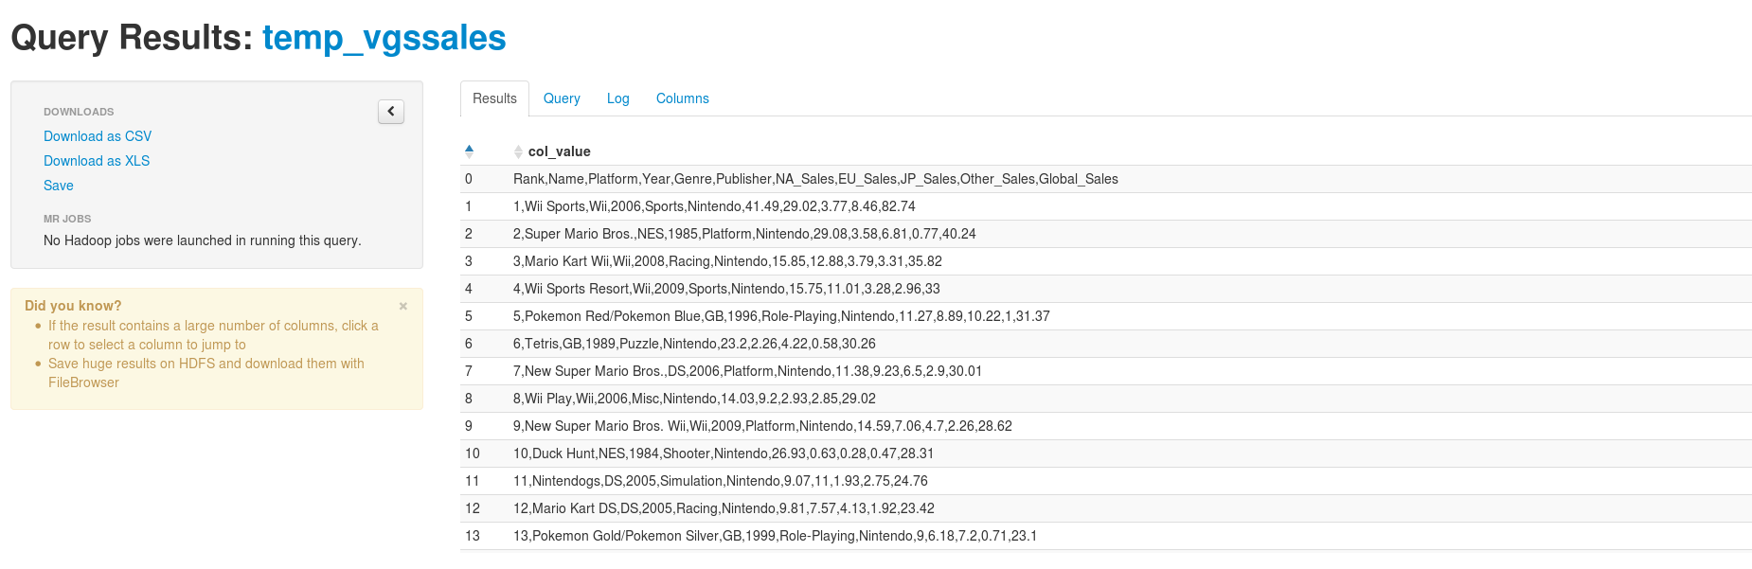

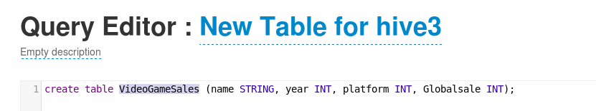
Here I will extract the data from temp_vgssales by what year, name, platform and globalsales to find the highest game sales for this dataset. Code used inside query editor

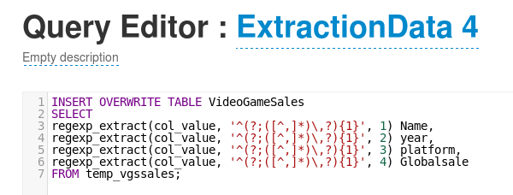
I have decided to use the name and global sale for this instead using the script as the above theory had errors this script will give the data of each game sold at his highest in millions. The “FROM vgs” table is the same dataset table I’ve used previously. I decided to reupload but still use the same techniques to load the datasets
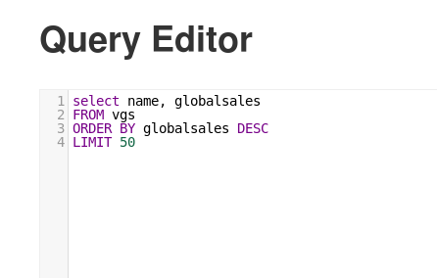
A list of games sold from 1 to 50 through global sales of all times which is up to 9 million, there’s currently 14 showing. Loaded into the metastore manager and run through Hive using query editor. The objective to find which games sold the most upto 2016 which was Halo: Reach. 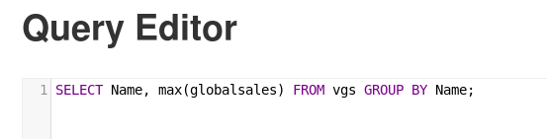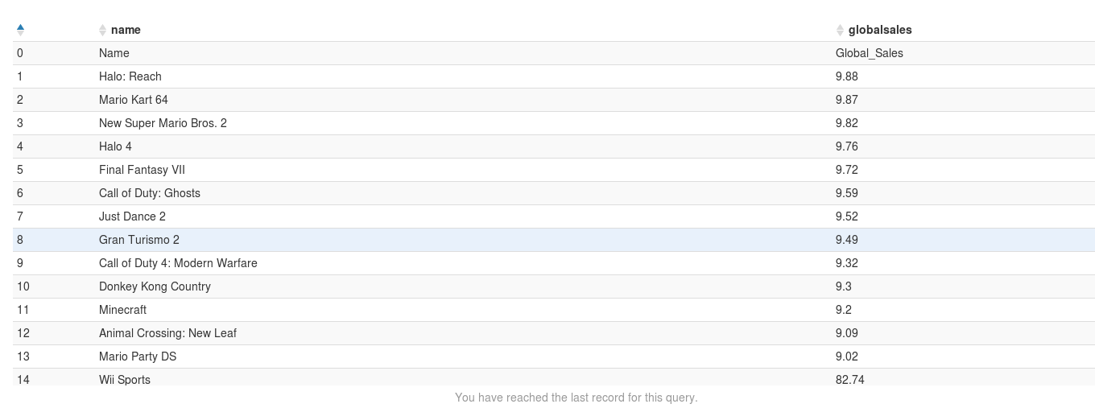
Hive/HUE gave me the possibility to transfer data and make a table for global sales which I intended to find out through quick data analytics and exploration. It doesn’t require much programming compared to R studios and install the data to then make MYSQL queries.
This will be shown through Rstudio to give the statics of 50 top games loading the datasets
Rstudio

An array has been created global sales and
Able to see the dataset of a few games that have been listed below
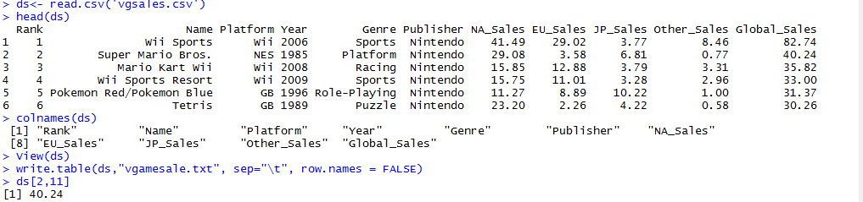
Here is a list of the global sales of 15,00 entries stored in data frames through a matrix structure that can be accessed through indexing

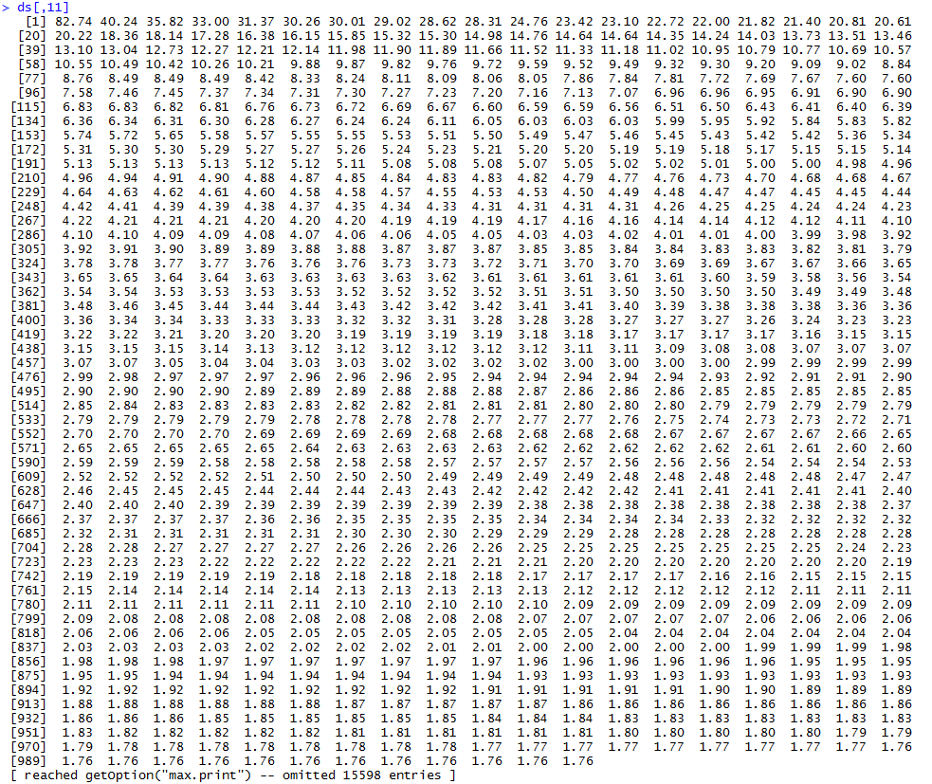
A table of super Mario bros displaying its sales and when it was made. Here the arrays and matrices are set in four tables. A list is created to collect the compoments which will allow to gather a variety of objects under “videogames” that contains the dataframes.
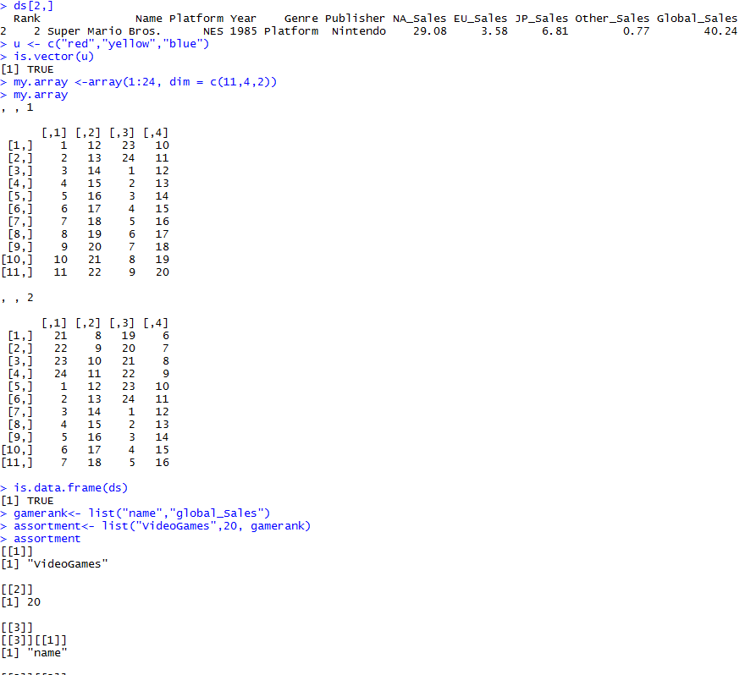
Exploring the data that shows the statistics.
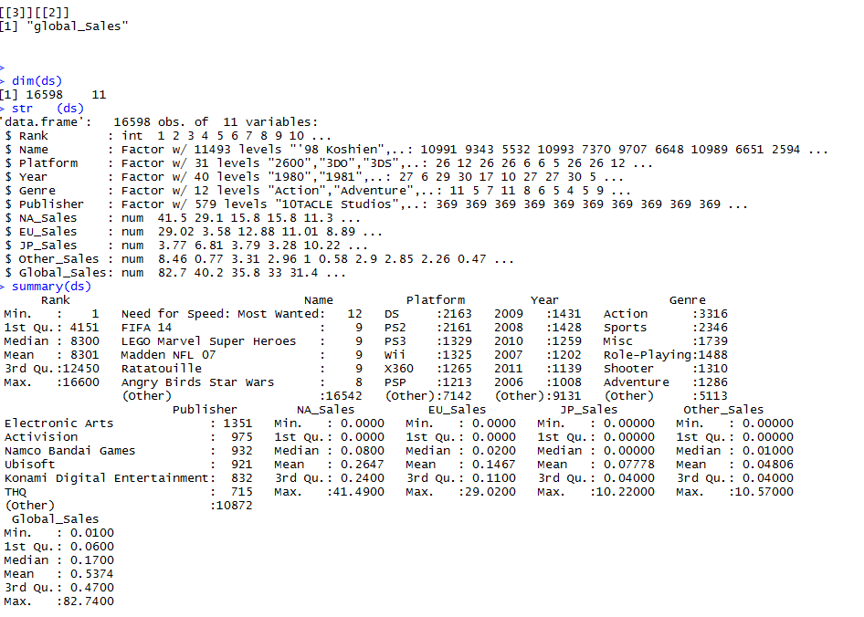
Scripts: 1 for global sales. The second a cluster of japan and global sales, apriori algorithm and third a regression table
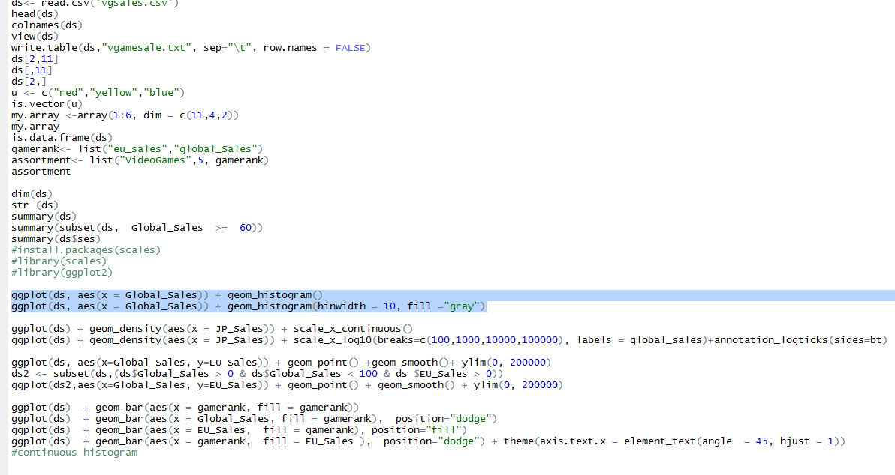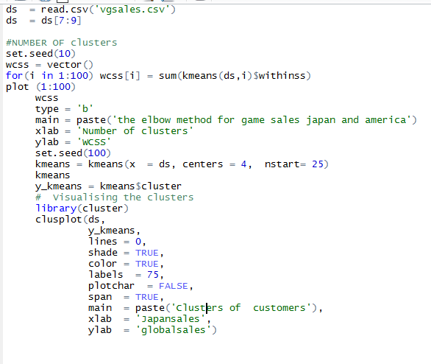
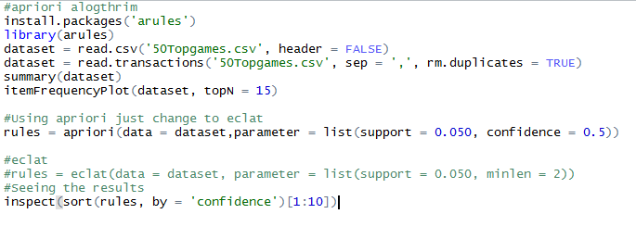
Here I was trying to load my plots but only managed to show a single bar of what looks to be the number of global sales for each and the number of objects/entries of each game that has sold finally well globally. What I intended to demonstrate was how much globally each game has made but eventually only managed to create a few things showing how much has been made. Here are some other plots that were used to gather the dataset. Loading the data into r studios I could gather the information of the data statistics and rank system of the data set for each game sold. Overall the application has helped but it requires extensive knowledge into datasets and handling them to understand the process of columns and tables needed to figure out sales, years and platforms they were made on. R studios provides the ability to visualise, add notes, model and summarise data for a data scientist, solutions, architecture etc.
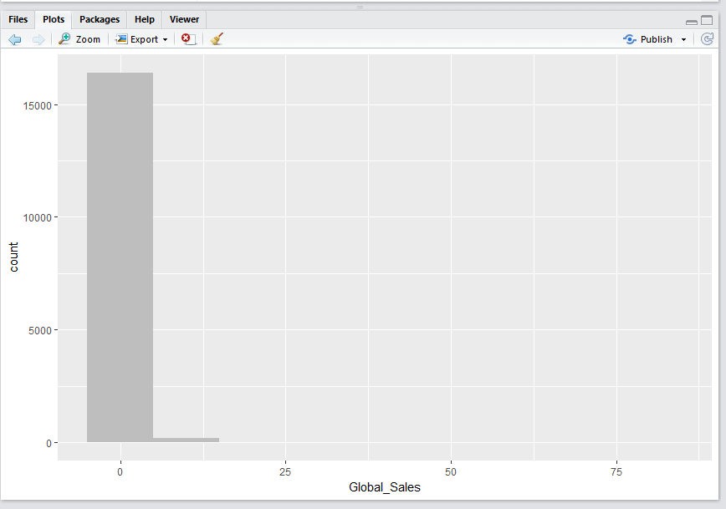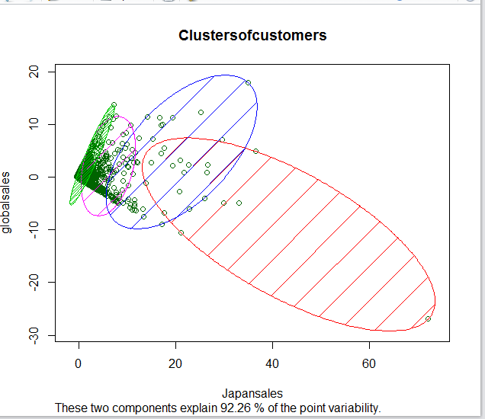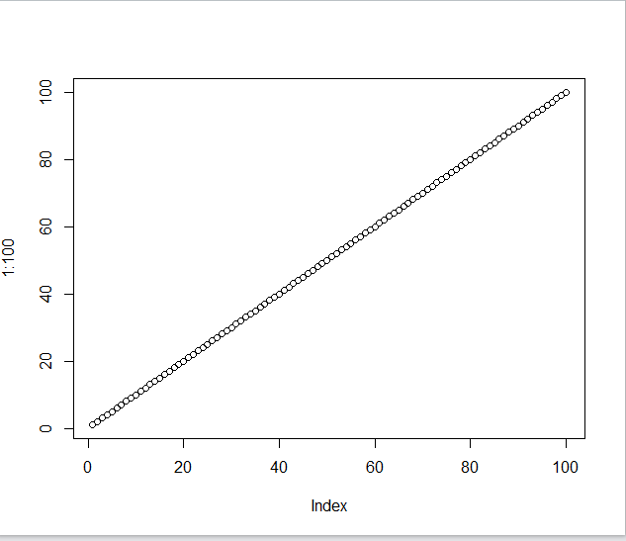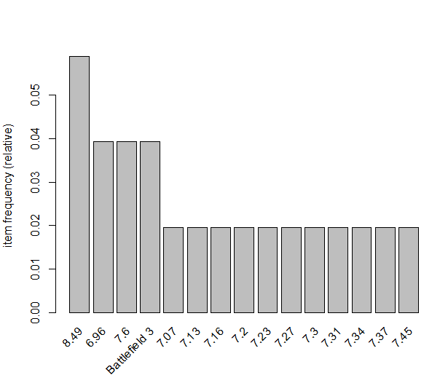

Reflective
Overall I have mixed review for project but I’ve have managed to upload using hive and loading datasets into R studio. What I could have improved in this project would have been to include other tables to compare the sales of each continent such as North American, japan and Europe. Where I could find out which of the following games made the most in their respected regions. I managed to implement the method onto my previous dataset but it didn’t show much detail into what I need to show onto the plot. There was an issue with my aporpi algorithm where it would show “battlefield 3” instead it shows what it was intended to be with each sale that was up to a million. More time was needed to complete this project that I could of implemented.

