Documentatie

Implementari
Java
- secvential
- linii
- coloane
- bloc
C++ (static si dinamic)
- secvential
- linii
- coloane
- bloc

Observatii
- implementarea Java merge mai incet decat cea C++
- varianta dinamica in C++ este un pic mai rapida decat cea statica
- varianta secventiala tinde sa mearga mai incet decat cele paralele

Distributie
Toate thread-urile primesc aceeasi parametri de intrare:
- matricea careia i se aplica convolutia
- matricea de convolutie
- matricea unde se salveaza rezultatul
- start
- stop
In functie de metoda (care se da din linia de comanda), se seteaza parametrul n (reprezentand fie numarul total de linii, fie numarul total de coloane, fie numarul total de elemente din matrice), si se alege functia care va fi rulata pe thread-uri.
Parametrul n se imparte mereu cat mai "fair" intre thread-uri (diferenta dintre volumul de munca primit de fiecare thread va fi mereu cel mult 1).

daca metoda = "linii" atunci
n <- N
daca metoda = "coloane" atunci
n <- M
daca metoda = "blocuri" atunci
n <- N*M
start <- 0
stop <- 0
pentru i <- 1,p executa
len <- n/p
daca i < n%p atunci
len <- len + 1
stop <- stop + len
daca metoda = "linii" atunci
incepeThreadPtLinii(mat, conv, dst, start, stop)
daca metoda = "coloane" atunci
incepeThreadPtColoane(mat, conv, dst, start, stop)
daca metoda = "blocuri" atunci
incepeThreadPtBlocuri(mat, conv, dst, start, stop)
start <- start + len

Diagrama UML implementare Java
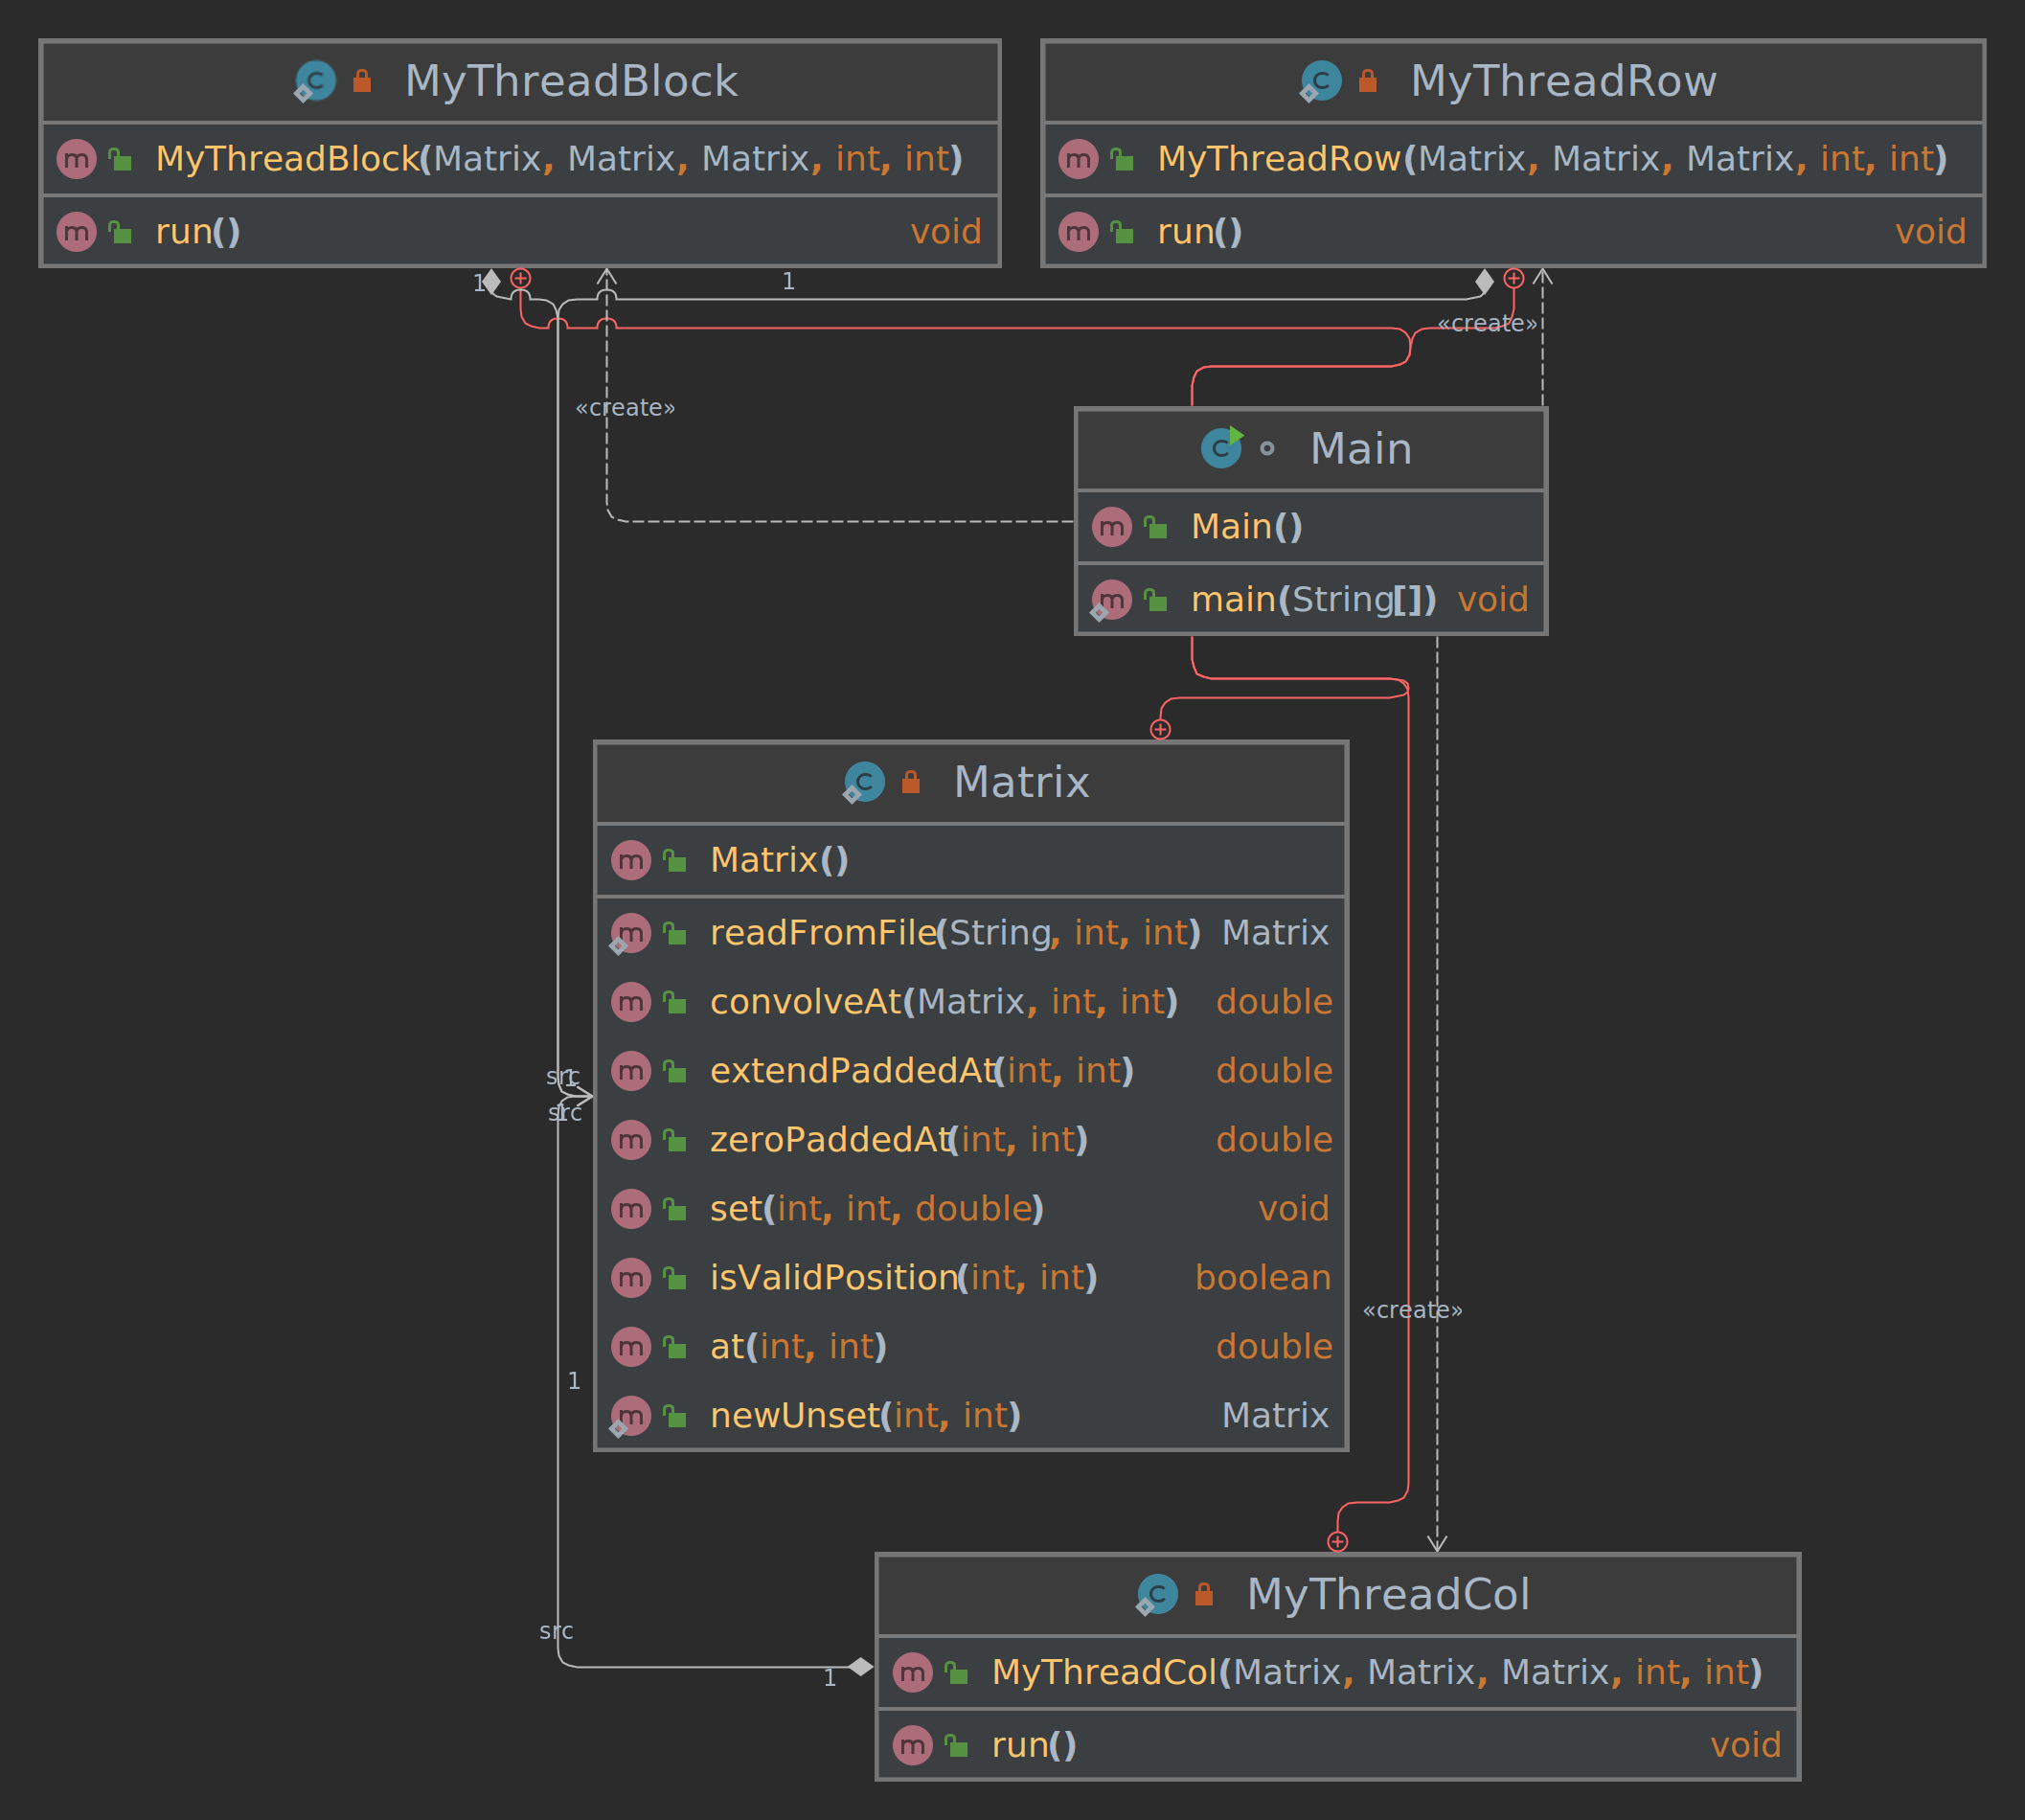

Tabel performanta
Tabelul de performanta include si metoda folosita.

runner | mat_size | conv_size | method | p | elapsed
cpp_dynamic | N=10,M=10 | N=3,M=3 | block | 4 | 0.000
cpp_dynamic | N=10,M=10 | N=3,M=3 | col | 4 | 0.002
cpp_dynamic | N=10,M=10 | N=3,M=3 | row | 4 | 0.002
cpp_dynamic | N=10,M=10 | N=3,M=3 | sequential | 0 | 0.002
cpp_dynamic | N=10,M=10000 | N=5,M=5 | block | 2 | 0.05
 |  |  |  | 4 | 0.05
 |  |  |  | 8 | 0.05
 |  |  |  | 16 | 0.05
cpp_dynamic | N=10,M=10000 | N=5,M=5 | col | 2 | 0.05
 |  |  |  | 4 | 0.04
 |  |  |  | 8 | 0.05
 |  |  |  | 16 | 0.04
cpp_dynamic | N=10,M=10000 | N=5,M=5 | row | 2 | 0.04
 |  |  |  | 4 | 0.04
 |  |  |  | 8 | 0.04
 |  |  |  | 16 | 0.05
cpp_dynamic | N=10,M=10000 | N=5,M=5 | sequential | 0 | 0.05
cpp_dynamic | N=1000,M=1000 | N=5,M=5 | block | 2 | 0.42
 |  |  |  | 4 | 0.42
 |  |  |  | 8 | 0.41
 |  |  |  | 16 | 0.41
cpp_dynamic | N=1000,M=1000 | N=5,M=5 | col | 2 | 0.42
 |  |  |  | 4 | 0.42
 |  |  |  | 8 | 0.42
 |  |  |  | 16 | 0.42
cpp_dynamic | N=1000,M=1000 | N=5,M=5 | row | 2 | 0.42
 |  |  |  | 4 | 0.41
 |  |  |  | 8 | 0.41
 |  |  |  | 16 | 0.4
cpp_dynamic | N=1000,M=1000 | N=5,M=5 | sequential | 0 | 0.71
cpp_dynamic | N=10000,M=10 | N=5,M=5 | block | 2 | 0.05
 |  |  |  | 4 | 0.04
 |  |  |  | 8 | 0.05
 |  |  |  | 16 | 0.05
cpp_dynamic | N=10000,M=10 | N=5,M=5 | col | 2 | 0.05
 |  |  |  | 4 | 0.05
 |  |  |  | 8 | 0.05
 |  |  |  | 16 | 0.05
cpp_dynamic | N=10000,M=10 | N=5,M=5 | row | 2 | 0.05
 |  |  |  | 4 | 0.05
 |  |  |  | 8 | 0.04
 |  |  |  | 16 | 0.05
cpp_dynamic | N=10000,M=10 | N=5,M=5 | sequential | 0 | 0.05
cpp_static | N=10,M=10 | N=3,M=3 | block | 4 | 0.004
cpp_static | N=10,M=10 | N=3,M=3 | col | 4 | 0.002
cpp_static | N=10,M=10 | N=3,M=3 | row | 4 | 0.002
cpp_static | N=10,M=10 | N=3,M=3 | sequential | 0 | 0.002
cpp_static | N=10,M=10000 | N=5,M=5 | block | 2 | 0.05
 |  |  |  | 4 | 0.05
 |  |  |  | 8 | 0.05
 |  |  |  | 16 | 0.05
cpp_static | N=10,M=10000 | N=5,M=5 | col | 2 | 0.05
 |  |  |  | 4 | 0.05
 |  |  |  | 8 | 0.05
 |  |  |  | 16 | 0.05
cpp_static | N=10,M=10000 | N=5,M=5 | row | 2 | 0.05
 |  |  |  | 4 | 0.05
 |  |  |  | 8 | 0.05
 |  |  |  | 16 | 0.05
cpp_static | N=10,M=10000 | N=5,M=5 | sequential | 0 | 0.06
cpp_static | N=1000,M=1000 | N=5,M=5 | block | 2 | 0.42
 |  |  |  | 4 | 0.42
 |  |  |  | 8 | 0.42
 |  |  |  | 16 | 0.42
cpp_static | N=1000,M=1000 | N=5,M=5 | col | 2 | 0.43
 |  |  |  | 4 | 0.41
 |  |  |  | 8 | 0.43
 |  |  |  | 16 | 0.41
cpp_static | N=1000,M=1000 | N=5,M=5 | row | 2 | 0.43
 |  |  |  | 4 | 0.41
 |  |  |  | 8 | 0.41
 |  |  |  | 16 | 0.41
cpp_static | N=1000,M=1000 | N=5,M=5 | sequential | 0 | 0.79
cpp_static | N=10000,M=10 | N=5,M=5 | block | 2 | 0.05
 |  |  |  | 4 | 0.05
 |  |  |  | 8 | 0.05
 |  |  |  | 16 | 0.05
cpp_static | N=10000,M=10 | N=5,M=5 | col | 2 | 0.05
 |  |  |  | 4 | 0.05
 |  |  |  | 8 | 0.05
 |  |  |  | 16 | 0.05
cpp_static | N=10000,M=10 | N=5,M=5 | row | 2 | 0.05
 |  |  |  | 4 | 0.05
 |  |  |  | 8 | 0.05
 |  |  |  | 16 | 0.05
cpp_static | N=10000,M=10 | N=5,M=5 | sequential | 0 | 0.05
java | N=10,M=10 | N=3,M=3 | block | 4 | 0.72
java | N=10,M=10 | N=3,M=3 | col | 4 | 1.01
java | N=10,M=10 | N=3,M=3 | row | 4 | 1.03
java | N=10,M=10 | N=3,M=3 | sequential | 0 | 1.01
java | N=10,M=10000 | N=5,M=5 | block | 2 | 1.77
 |  |  |  | 4 | 1.79
 |  |  |  | 8 | 1.76
 |  |  |  | 16 | 1.83
java | N=10,M=10000 | N=5,M=5 | col | 2 | 1.75
 |  |  |  | 4 | 1.75
 |  |  |  | 8 | 1.77
 |  |  |  | 16 | 1.77
java | N=10,M=10000 | N=5,M=5 | row | 2 | 1.73
 |  |  |  | 4 | 1.74
 |  |  |  | 8 | 1.77
 |  |  |  | 16 | 1.75
java | N=10,M=10000 | N=5,M=5 | sequential | 0 | 2.3
java | N=1000,M=1000 | N=5,M=5 | block | 2 | 4.85
 |  |  |  | 4 | 4.77
 |  |  |  | 8 | 4.83
 |  |  |  | 16 | 4.84
java | N=1000,M=1000 | N=5,M=5 | col | 2 | 4.81
 |  |  |  | 4 | 4.81
 |  |  |  | 8 | 5.08
 |  |  |  | 16 | 4.86
java | N=1000,M=1000 | N=5,M=5 | row | 2 | 5.11
 |  |  |  | 4 | 4.75
 |  |  |  | 8 | 4.84
 |  |  |  | 16 | 4.86
java | N=1000,M=1000 | N=5,M=5 | sequential | 0 | 8.19
java | N=10000,M=10 | N=5,M=5 | block | 2 | 1.75
 |  |  |  | 4 | 1.75
 |  |  |  | 8 | 1.77
 |  |  |  | 16 | 1.75
java | N=10000,M=10 | N=5,M=5 | col | 2 | 1.74
 |  |  |  | 4 | 1.78
 |  |  |  | 8 | 1.76
 |  |  |  | 16 | 1.77
java | N=10000,M=10 | N=5,M=5 | row | 2 | 1.78
 |  |  |  | 4 | 1.75
 |  |  |  | 8 | 1.76
 |  |  |  | 16 | 1.77
java | N=10000,M=10 | N=5,M=5 | sequential | 0 | 1.98

