RVNext Gen client guide
  - A quick walkthrough for viewing and testing | 26 October 2026
Open the test link shared by the team. Start on your phone, then repeat on a computer. Use a test account and the payment test details supplied by the team.
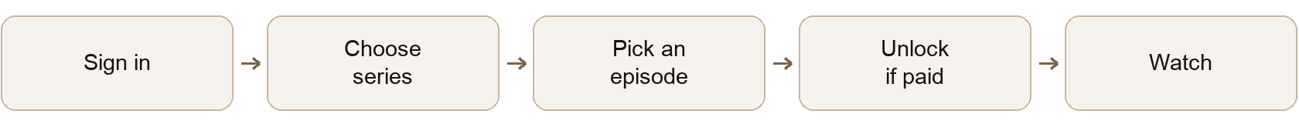

1 Get into the app
Create an account or log in. Choose Continue with Email or Continue with Google. For a new email account, open the verification email. Check that you reach the home screen after signing in.

2 Browse the series
Scroll or swipe up. On a phone, move from the opening artwork to the featured episode, More episodes, then Recently watched. On a computer, scroll to the featured details and episode rows. Use Episode number to jump to an episode; swipe the row sideways or use its arrows to see more.
Change the series. On a phone, swipe the featured card sideways. On a computer, use the arrow beside the card. Check that the title and episode list change together. If Allow motion access appears, tap it and gently tilt your phone to try the artwork movement.

3 Watch an episode
Tap a card or Play. Try play and pause, sound, the progress bar, full screen and the back button. On the custom player, also try the 10-second buttons and settings. Subtitles depend on the video.
Open a paid episode. Review its price and access period. With enough episode credits, choose Unlock. Otherwise choose Buy credits, pick a wallet pack and complete the test checkout. Return and reopen the episode to unlock it.
Check the wallet balance and History after a top-up or unlock. If a payment stays pending, check its status before trying to pay again. Episode credits and Creator Lab credits are separate.

4 Check your account and other views
Scroll to the featured card to reveal your profile icon. Open Profile, check the photo or initials, use Back, then try Log out. Reopen a video and check Recently watched. Try Save too; its current limitation is on page 3.
Older catalog view: add /old to the test link. Try Search, genre filters, a title’s details, playback and My library. This is a separate view from the new home screen.

Create a film in Creator Lab
Open Profile and choose Creator’s Lab. Start with one small project so you can follow every step.
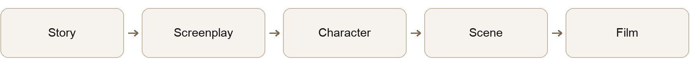

1 Start a project
Enter a project name and choose Create project. Only the Story step should appear at first. The project name also appears under Chats in the desktop sidebar.

2 Complete the five steps
Story. Describe your idea, choose a model and select Generate. Example: “A child helps a lost traveller find the way home.”
Screenplay. Once the story is ready, describe the dialogue, tone or pacing you want. Generate the screenplay.
Character. Describe the lead character’s appearance, clothes and style. Generate the image.
Scene. Describe the place, lighting and atmosphere. Generate the scene image.
Film. Describe the movement, camera and mood. Generate the clip, then play it in the preview.
At each step, check the estimated credit cost before generating. Wait for the result; if the job fails, read the message and retry. Use a different model only when needed.

3 Review and improve your work
On a computer, completed results appear on the canvas. Drag empty space to move around; pinch or use + and − to zoom. Click a card to bring it into view and select it. Use Refine for a new version, or Edit text to change text inside its card and save it.
On a phone, use the completed-step cards above the preview to revisit your work. Reopen the project from the project list to check that your results were saved.

4 Find results and submit the film
Use Templates for a starting idea, Videos for clips, Library for generated images and videos, and Avatars for image results. Archive lists projects already marked as archived. Brand Kits and Voices are coming soon.
Use the credit link or Unlock more features to open Creator Lab credit packs. After the film is ready, choose Publish film, review the title and details, then Publish. The film is submitted as a draft; it is not public until an admin publishes it.

Admin checks and demo notes
Admin checks need an admin account. Open Profile, then Admin panel. Use test content when changing prices or publishing videos.

Admin features to try
Area | What to check
Analytics and Users | View activity, filter reports, find a test user and inspect their account details.
Content and Genres | Search and edit a test title. Check its poster, description, visibility, episode details and genre labels.
Add YouTube and Add Cloudflare | Add a test video. For an upload, wait until it is ready before publishing and checking playback.
Cost and Transactions | Review model rates, generation costs and credit activity.
Wallet and Settings | Review wallet packs, payment status, episode pricing and regional rates. Confirm the viewer sees the intended price.

What is still a demo or pending
Sample content. Home episodes currently use sample clips. Final videos and the final paid offer still need to be confirmed. A ₹100 pack should not be assumed to mean a 20-episode bundle.
Account features. Apple sign-in is not connected. Forgot password, Terms and Privacy pages, profile editing and account deletion are pending.
Saved and watched items. Save on the new home screen resets when the page reloads. Recently watched stays in that browser and is updated when the player closes; it does not resume your watch position across devices.
Payments and creation. Google sign-in completion, email delivery, payment completion and AI generation depend on the connected services. Test them with the team’s test accounts. Payment receipts and a linked support flow are pending.

Send useful feedback
For each feature, mark Pass, Issue or Not tested. For an issue, send: the screen name, your phone or browser, what you clicked, what you expected, what happened, and a screenshot. Include the project or episode name; keep passwords and payment details out of screenshots.

