**Changes requested by Client**

1. On the home page, the "**Explore Momifa Store**" with the purple line next to it. Voting can be done to decide whether to keep it or not.
2. Missed our story section on the home page   
   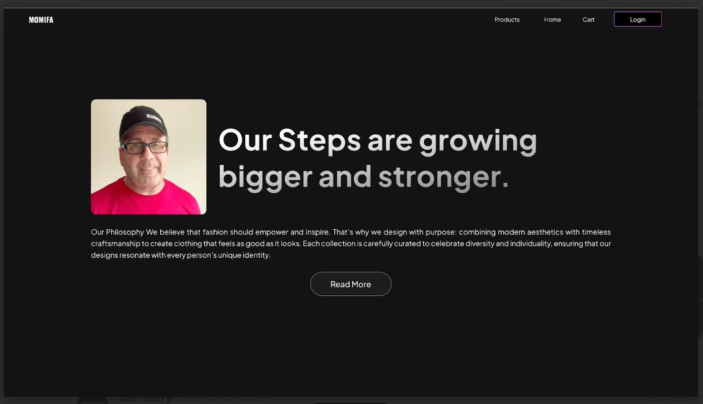
3. Add the **hoodie category**. - **Shop by Categories**
4. **Change "Branded Polo T-Shirts**" to "100% Cotton T-Shirts" or "Best in Class T-Shirts"
5. On clicking on any category, customers should be taken to that particular section like if they click on the T-shirt category, they should be taken to a section of T-shirts. These sections can also be scrolled to without clicking on the categories.
6. There should be 5 categories. These sections will be stacked- T-shirts, then Polos, then Hoodies, then branded T Shirts, then accessories.
7. Polo and T-Shirts are two different things. There is no "Polo T-Shirt".
8. Pictures need to be more clear. AI images are preferable.
9. Hoodies will not be branded.
10. Reaction time of the website is slow. Speed should be increased.
11. Hoodie content at the bottom, would be much better if there was a revolving content changing from T-Shirts to Polos to Hoodies.
12. The collections section can be taken out and the Polo T-Shirts section that is in the latest version won't be needed

