TaxCloud Connector for Odoo 20
Features and Setup Guide
US sales tax calculation, address verification and transaction reporting with the TaxCloud API v3 for Invoicing/Accounting, Sales, eCommerce and Point of Sale.
Item | Value
Modules | taxcloud_connector 20.0.1.0.1, taxcloud_connector_sale, taxcloud_connector_website_sale, taxcloud_connector_pos (20.0.1.0.0)
Odoo version | Odoo 20.0 Community and Enterprise
Publisher | Cybrosys Techno Solutions (LGPL-3)
Document date | 9 October 2026
Verified on | Odoo 20 Community (taxcloud_oct9) and Odoo 20 Enterprise (fresh database with Accounting, AvaTax, Sales, Inventory, eCommerce, Point of Sale): 130 passed, 0 failed (with the Enterprise Accounting app and AvaTax installed)

Contents
1. Overview
2. Requirements
3. Installation
4. Configuration: settings, tax template, addresses, fiscal position, TICs, customers, Sales, eCommerce, Point of Sale
5. Features in detail: tax computation, reporting, API logs
6. Scheduled actions and access rights
7. Verification on Odoo 20 Community and Enterprise
8. Troubleshooting
9. Known limitations

1. Overview
The TaxCloud Connector computes US sales tax with TaxCloud (API v3) on customer invoices, quotations and sales orders, eCommerce checkouts and Point of Sale orders. TaxCloud returns the tax per line; the connector stores it on ordinary Odoo taxes named "TaxCloud <rate>%", so totals, journal entries and tax reports work as usual. Completed sales and refunds are reported to TaxCloud for filing, and customer addresses can be verified against TaxCloud.

1.1 Modules
Module | Depends on | Adds
TaxCloud Connector | account, payment | Settings, TaxCloud fiscal position, TICs, address verification, exemption certificates, invoice tax computation, invoice and credit note reporting, API logs, payment links and portal invoices with up-to-date tax.
TaxCloud Connector - Sales | TaxCloud Connector, sale_management | Tax computation on quotations and sales orders (Compute Taxes button, on send, on confirm, on the customer portal); warehouse as ship-from address when Inventory is installed.
TaxCloud Connector - eCommerce | TaxCloud Connector - Sales, website_sale | Tax computation during checkout; payment is blocked when sales tax cannot be calculated.
TaxCloud Connector - Point of Sale | TaxCloud Connector, point_of_sale | Tax computation when the payment screen opens; payment blocked without tax; reporting of paid orders and refunds.

Install only the modules you need. The core module is required by all others.

2. Requirements

2.1 TaxCloud account
- A TaxCloud account with access to the API v3 (api.v3.taxcloud.com).
- An API key and the Connection ID of the store (test and production connections have different IDs).
- The states where you collect tax set up in TaxCloud. TaxCloud returns $0.00 for destinations where your account does not collect tax: this is a TaxCloud setting, not an Odoo error.

2.2 Odoo
- Odoo 20.0 Community or Enterprise. The Python library requests (shipped with Odoo).
- The company fiscal country is the United States. The TaxCloud settings are only shown for US companies. Companies using the US chart of accounts (generic_coa) receive the TaxCloud fiscal position automatically.
- Documents in USD or CAD. Other currencies are refused by TaxCloud.
- A complete company address (street, city, state, ZIP): it is the ship-from address.
- Outbound HTTPS access from the Odoo server to api.v3.taxcloud.com.

3. Installation
- Copy the four module folders into an addons path of the Odoo server and restart it.
- Apps > Update Apps List (developer mode).
- Install TaxCloud Connector, then the Sales, eCommerce and Point of Sale extensions you need.
On installation, every company using the US chart of accounts gets the fiscal position "Automatic Tax Mapping (TaxCloud)" (TaxCloud enabled, not auto-applied, placed before the other US fiscal positions).
Upgrade from 20.0.1.0.0: upgrading taxcloud_connector moves an existing TaxCloud fiscal position still at the old sequence (100) to the front, so that it wins over "Domestic" once auto-applied. Fiscal positions whose order you changed are left alone.

4. Configuration
Menu paths differ only by the name of the accounting app: Invoicing in Community and in Enterprise without the Accounting app, Accounting in Enterprise with the Accounting app installed. They are written Invoicing / Accounting below.

4.1 TaxCloud settings
Path: Invoicing / Accounting > Configuration > Settings > Taxes section > TaxCloud. Requires the Administration / Settings access right. The block is company dependent: configure each company.
Setting | Description
API Key | TaxCloud API key. Stored on the company, visible to system administrators only, never written to the logs.
Connection ID | TaxCloud connection (store) ID. Use the test connection while testing.
Tax Template | Sales tax (type Percentage) copied for every new TaxCloud rate. The copy keeps its tax group and accounts. Required: computation fails with "Please set the TaxCloud tax template" without it. See 4.2.
Default TIC | Taxability Information Code used when neither the product nor its category has one. Default 00000 (general goods).
Verify Addresses | Verify unverified destination addresses with TaxCloud before computing tax. The verified address is used for the request only; the contact is not changed.
Debug Logging | Also log successful API calls. Failed calls are always logged.
Log Retention (Days) | Age after which logs are deleted by the daily purge (0 = keep forever). Default 30.
Test Connection | Calls the TaxCloud ping endpoint with the saved credentials (save the settings first).
Show Logs | Opens the TaxCloud API logs.
Branches: a branch company without its own API key and Connection ID uses the credentials of its parent company.
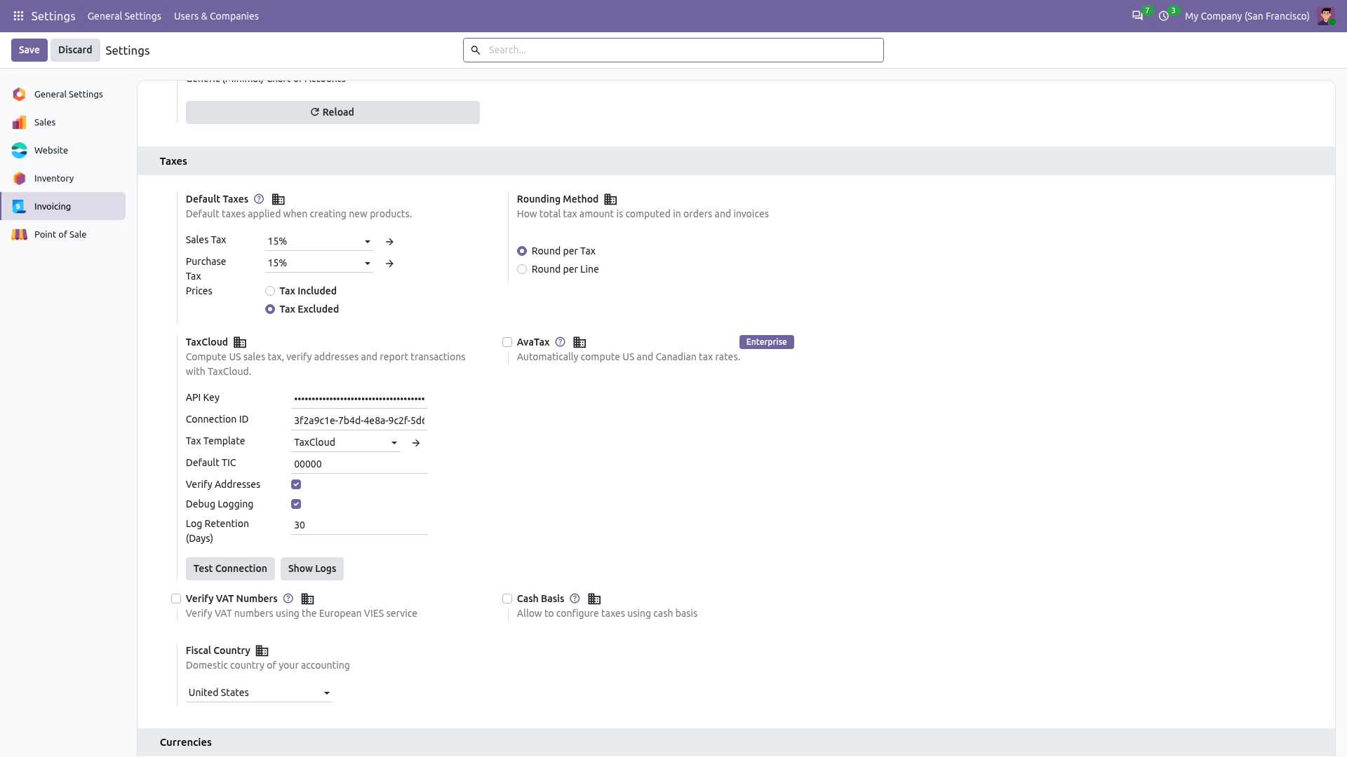
Figure 1 - TaxCloud settings (Invoicing > Configuration > Settings > Taxes)

4.2 Tax template and tax group
Each rate returned by TaxCloud becomes an Odoo tax named "TaxCloud <rate>%", copied from the Tax Template. Prepare a dedicated template:
- Invoicing / Accounting > Configuration > Accounting > Tax Groups (developer mode): create a group such as Sales Tax. Order totals show taxes by tax group, so this is the label customers see.
- Invoicing / Accounting > Configuration > Accounting > Taxes: create a sales tax "TaxCloud", type Percentage, 0%, tax group Sales Tax, with the tax account (e.g. 251000 Tax Received) on the invoice and refund tax lines.
- Select it as Tax Template in the TaxCloud settings.
Important: do not use a tax without a tax account (e.g. "0% Exports") as template: TaxCloud tax would then be booked on the income lines. Do not use a regular tax such as "15%" either: its tax group label ("Tax 15%") would appear on TaxCloud documents. Rates created before a template change keep their old group and accounts; edit them if needed.

4.3 Company and warehouse addresses
- Company: Settings > Companies: street, city, state and ZIP are required (ship-from address).
- Warehouses (Inventory installed): Inventory > Configuration > Warehouse Management > Warehouses > Address. With a complete address the warehouse is the ship-from address of sales orders, their invoices (when the goods left a single warehouse) and Point of Sale orders; otherwise the company address is used.

4.4 TaxCloud fiscal position
Path: Invoicing / Accounting > Configuration > Accounting > Fiscal Positions > Automatic Tax Mapping (TaxCloud).
Field | Value
Use TaxCloud API | Ticked. Documents with this fiscal position get their tax from TaxCloud. The field is shown for fiscal positions of US companies only.
Detect Automatically | Tick it to apply TaxCloud to all US customers automatically (required for eCommerce). Leave it unticked to choose the fiscal position per customer or per document.
Country | United States (optionally restricted to Federal States or a ZIP range).
Order in the list | Keep it above "Domestic": the first matching auto-applied fiscal position wins.
Several TaxCloud fiscal positions can exist (e.g. per state). Any fiscal position with "Use TaxCloud API" ticked works.
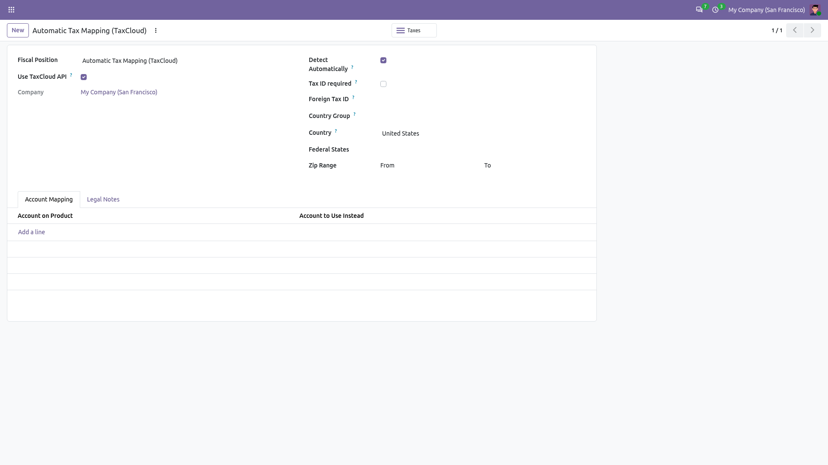
Figure 2 - The TaxCloud fiscal position

4.5 Products: Taxability Information Codes (TIC)
The TIC tells TaxCloud how a product is taxed (e.g. 00000 general goods, 20010 clothing, 30070 books). Resolution order: product, then its category and parent categories, then the company Default TIC. A TIC is a number of up to 5 digits.
- Product: product form > General Information > TaxCloud TIC (below Sales Taxes).
- Category: Invoicing / Accounting > Configuration > Invoicing > Product Categories > TaxCloud section.
Both fields are visible to every billing user (they do not require "Show Accounting Features").
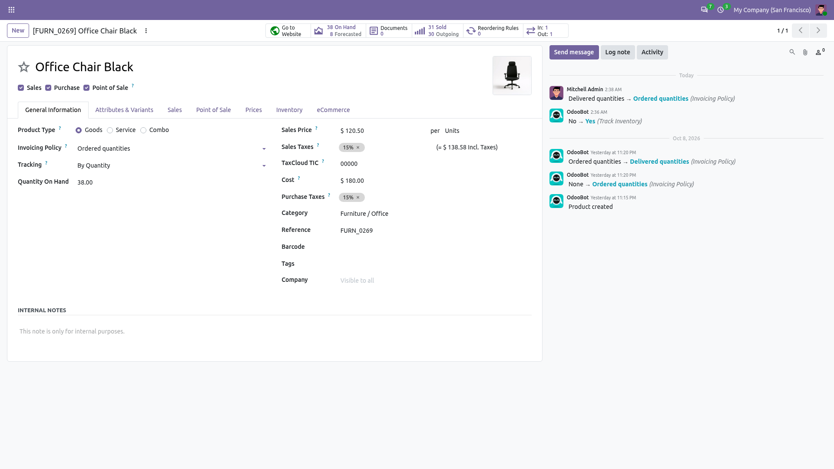
Figure 3 - TaxCloud TIC on the product form

4.6 Customers: address verification and exemptions
- Verify: on a contact with a US (or empty) country and a street, click Verify next to the address. A wizard compares the address with TaxCloud's suggestion; Apply Suggestion updates the contact and marks it Verified (or Mark as Verified when nothing changes). Changing the address later clears the flag.
- Exemption certificate: contact > Sales & Purchase > Fiscal Information > TaxCloud Exemption Certificate (companies and individual contacts, not their child addresses). The certificate ID must exist in TaxCloud; it is sent with every cart of that customer.
- Required address data: documents need a destination with street, city, state and ZIP. Destinations outside the United States are not sent to TaxCloud: no US sales tax is applied and a note is posted on the document.

4.7 Sales (taxcloud_connector_sale)
No extra setting. Quotations whose fiscal position uses TaxCloud get the Compute Taxes button below the order lines. Taxes are also computed when the quotation is sent, when it is confirmed and when the customer opens it in the portal. The delivery address is the destination.

4.8 eCommerce (taxcloud_connector_website_sale)
- Tick Detect Automatically (Country: United States) on the TaxCloud fiscal position (4.4), so website orders of US customers use TaxCloud.
- Publish at least one payment provider (Website > Configuration > Payment Providers).
- Taxes and total are shown from the payment step on, once TaxCloud computed them. If TaxCloud is unreachable, a blocking alert asks the customer to try again; if TaxCloud rejects the address, the customer is asked to check it. In both cases the order cannot be paid.

4.9 Point of Sale (taxcloud_connector_pos)
Path: Point of Sale > Configuration > Settings, select the shop.
Setup | What to set
Without presets | Accounting section > Flexible Taxes: Default = the TaxCloud fiscal position; keep it in Allowed.
With presets | "Take out / Delivery / Members" enabled hides Flexible Taxes. Click Configure Presets and set the TaxCloud fiscal position on each preset (an empty fiscal position falls back to the shop default).
Customers | A customer whose own fiscal position is in the shop's Allowed list replaces the TaxCloud one. Leave the customer fiscal position empty or set it to TaxCloud.
Counter sales | Taxed at the shop (warehouse address, else company address).
Delivered orders | Orders with a preset whose Identification is "Address", or with a ship-later date (Inventory), are taxed at the customer's delivery address, which must be complete.
Products | Available in POS; TIC as in 4.5.
When the cashier opens the payment screen, the order is saved and TaxCloud computes its tax; the register shows the Taxes line and the new total. Validation computes again if the order changed. If TaxCloud cannot be reached, a "Sales tax unavailable" dialog is shown and the order cannot be paid. The register therefore needs a working connection to the Odoo server, and the server to TaxCloud, for TaxCloud orders.
Refunds: use the Refund button on the original order. The refund returns the original tax pro rata of the quantity (no new TaxCloud cart) and can only contain items of that order. A return without original order is reported as a standalone credit.
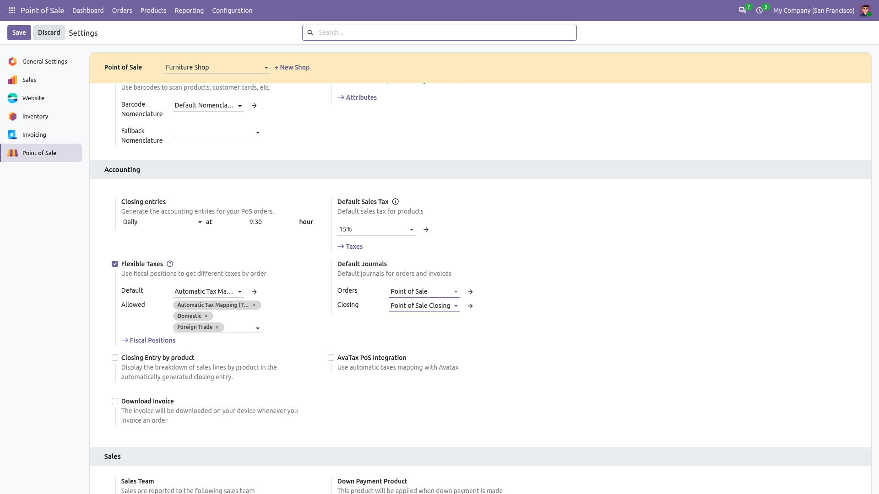
Figure 4 - Point of Sale settings: Flexible Taxes with the TaxCloud fiscal position

5. Features in detail

5.1 When taxes are computed
Document | Computed
Customer invoices and credit notes | Compute Taxes button (draft, not sent); always again when posted, as of the invoice date; when a draft invoice is shown in the portal; when a payment link is generated. Down payment invoices are not sent to TaxCloud.
Quotations and sales orders | Compute Taxes button; on send; on confirmation; when shown in the portal; when a payment link is generated. Locked or cancelled orders are not recomputed.
eCommerce cart | At the payment step and before the payment transaction; again when the delivery method changes.
Point of Sale order | When the payment screen opens and on validation, if the order changed.

- Caching: the last TaxCloud result is stored with a fingerprint of the cart and date. An unchanged document is not sent again (also when TaxCloud returned no tax).
- Discounts: line discounts are sent as percentage discounts; lines with a negative amount (rewards, global discounts) are sent as one order discount and carry no tax. Shipping and fee TICs never receive the order discount.
- Price-included taxes: the price sent to TaxCloud excludes any price-included tax still on the line.
- Credit notes: a credit note reversing a TaxCloud invoice takes the tax of the original lines, pro rata of the quantity; TaxCloud is not called.
- Rounding check: if Odoo's rounded tax total differs from TaxCloud's, a note is posted on the document.
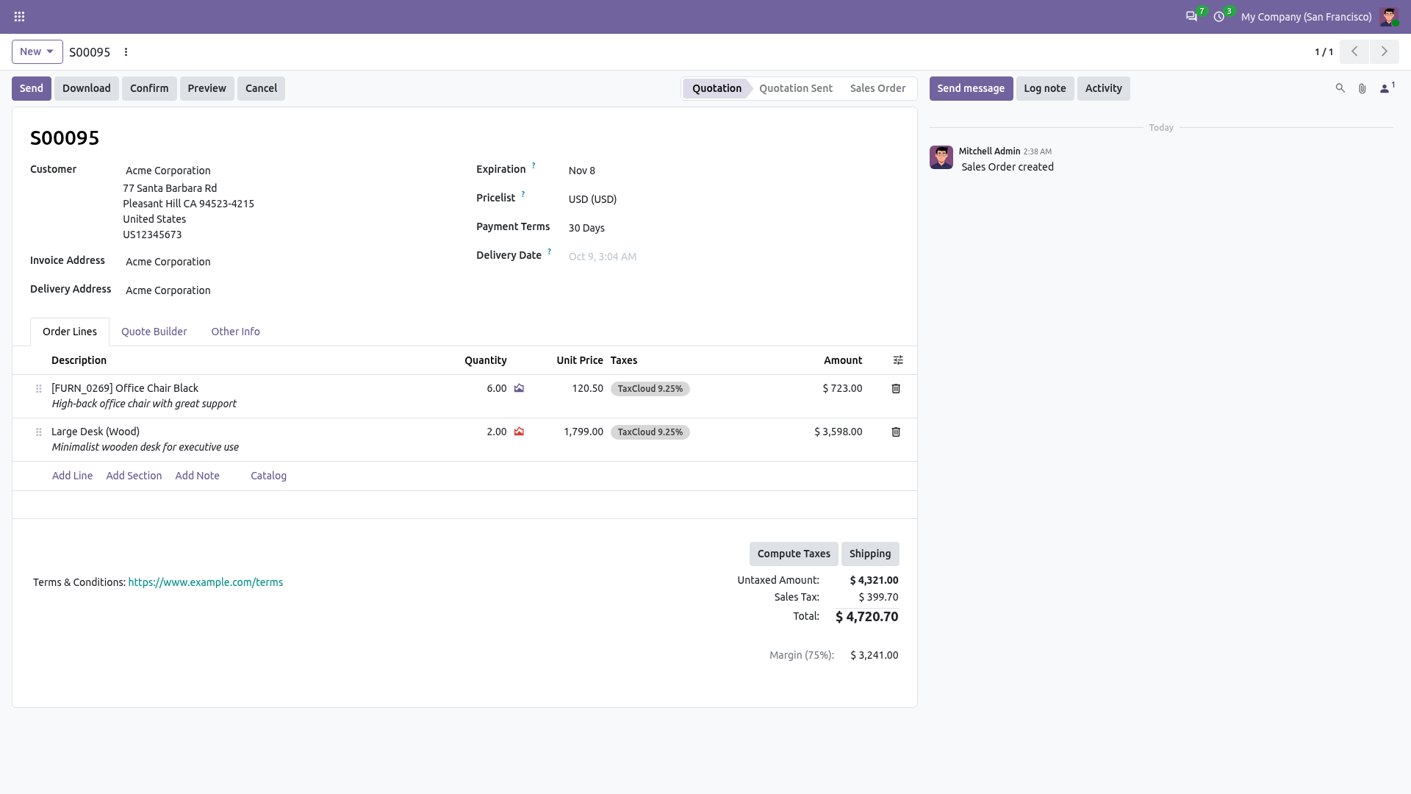
Figure 5 - Quotation with TaxCloud taxes and the Compute Taxes button

5.2 Reporting to TaxCloud
- Posted customer invoices and paid POS orders with TaxCloud taxes and a US destination are queued To Report and sent by a scheduled action every 15 minutes (triggered immediately after posting/payment when the scheduler runs).
- Before converting the cart to a completed order, the connector checks that TaxCloud still computes the posted tax; otherwise the document is set to Error with the amounts and a hint.
- Retries: timeouts, HTTP 429 and 5xx are retried up to 5 times; other errors stop immediately. The document shows a red banner with the error and a Retry button.
- Status: Other Info (invoices) or Extra Info (POS orders) shows TaxCloud Status, TaxCloud Order ID (the document number) and Reported to TaxCloud On. List filters: TaxCloud Errors and TaxCloud Pending.
- Refunds: credit notes and POS refunds are reported as full or partial refunds of the original TaxCloud order, after the original was reported. A return without origin is reported as a standalone credit.
- Reset to draft: resetting a reported invoice voids the TaxCloud order (allowed until the 10th of the month after completion), then it can be reported again. Refused when a refund of it was already reported, or for a reported refund: use a credit note instead.
- Invoices of POS orders are not reported again (the POS order is).
- Order ID safety: if TaxCloud already has an order with the same ID, it only counts as this document's when customer and items match. Otherwise the document is set to Error ("already exists with other items"), e.g. when a copy of the database reported it.
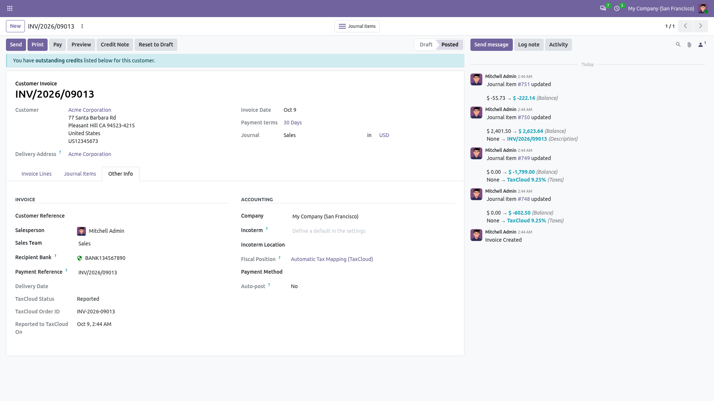
Figure 6 - Invoice reported to TaxCloud (Other Info)

5.3 API logs
Path: Invoicing / Accounting > Configuration > TaxCloud Logs (Billing Administrator), or Show Logs in the settings. Each entry has date, level, method, endpoint, HTTP status, duration, request and response bodies, error message, company, user and the related document. Entries are written on a separate transaction, so failures are logged even when the operation is rolled back. API keys and headers are never logged.

6. Scheduled actions and access rights
Scheduled actions: Settings > Technical > Automation > Scheduled Actions (developer mode). All are active after installation.
Scheduled action | Module | Interval | Purpose
TaxCloud: Report invoices and refunds | TaxCloud Connector | 15 minutes | Reports queued invoices and credit notes.
TaxCloud: Report POS orders and refunds | TaxCloud Connector - Point of Sale | 15 minutes | Reports queued POS orders and refunds.
TaxCloud: Purge old API logs | TaxCloud Connector | 1 day | Deletes logs older than the retention period.

Access | Who
TaxCloud settings (API key, Connection ID...) | Administration / Settings. The API key field is restricted to system administrators.
TaxCloud Logs menu, reading logs | Invoicing / Accounting: Billing Administrator (account.group_account_manager); deleting logs: system administrators. Logs are restricted to the user's companies.
Compute Taxes (invoices), Retry reporting | Invoicing: Billing (account.group_account_invoice); POS Retry: Point of Sale Administrator.
TIC on products and categories | Billing users who can edit products.
Verify address | Internal users.

7. Verification on Odoo 20 Community and Enterprise
Each configuration item of this guide was checked in the module source and in running Odoo 20 databases: the views were loaded for the administrator and the menus resolved from the database.
Item | Module | Odoo 20 Community | Odoo 20 Enterprise
TaxCloud settings block (7 fields, 2 buttons) | res_config_settings_views.xml | Present (Invoicing > Configuration > Settings) | Present (Accounting > Configuration > Settings)
Use TaxCloud API on fiscal positions; Detect Automatically; Country | account_fiscal_position_views.xml | Present | Present
TaxCloud TIC on products and categories | product_views.xml | Present for billing users | Present
Verify button, Exemption Certificate on contacts | res_partner_views.xml | Present | Present
TaxCloud status fields and error banner on invoices and POS orders | account_move_views.xml, pos_order_views.xml | Present | Present
Compute Taxes on quotations | sale_order_views.xml | Present | Present (alongside AvaTax's own button, each shown for its own fiscal position)
POS Flexible Taxes default fiscal position; preset fiscal position | Odoo standard | Present | Present
Warehouse address | Odoo standard (Inventory) | Present | Present
TaxCloud Logs menu | taxcloud_log_views.xml | Invoicing > Configuration | Accounting > Configuration
3 scheduled actions | ir_cron_data.xml | Active | Active
Automated tests (4 modules) | - | 130 passed, 0 failed | 130 passed, 0 failed (with the Enterprise Accounting app and AvaTax installed)

Enterprise external tax framework: AvaTax (account_avatax) installs account_external_tax, sale_external_tax and website_sale_external_tax. They were installed in the Enterprise test database together with the TaxCloud modules without conflict. TaxCloud and AvaTax are each driven by their own fiscal position flag; do not enable both on the same fiscal position.

8. Troubleshooting
Message or symptom | Cause and solution
Please configure your TaxCloud API key and connection ID | Fill both in the settings (4.1), on the company or its parent.
Please set the TaxCloud tax template | Select a Tax Template (4.1, 4.2).
The customer/ship-from address ... is incomplete. Missing: ... | Complete street, city, state and ZIP of the customer, company or warehouse.
[422] validation failed ... zip does not match state | The destination address is invalid. Correct it (Verify helps).
[400] no store was found with connection id ... | Wrong Connection ID (or a test ID used with production credentials).
Tax is $0.00 | Your TaxCloud account does not collect tax in the destination state, the customer is exempt, or the TIC is non-taxable there.
TaxCloud only supports documents in USD or CAD | Use a USD or CAD pricelist/journal.
Totals show "Tax 15%" instead of "Sales Tax" | The tax template's group is used for TaxCloud rates: see 4.2 and update existing TaxCloud taxes.
US website orders do not use TaxCloud | Tick Detect Automatically and place the TaxCloud fiscal position above Domestic (4.4).
POS order has no TaxCloud tax | Check the shop default fiscal position or the preset fiscal position, and the customer's fiscal position (4.9).
Sales tax unavailable / We could not calculate sales tax right now | TaxCloud is unreachable. See the TaxCloud Logs for the technical error; retry later.
TaxCloud order ... already exists with other items | Another document or database reported the same order ID. Check the TaxCloud dashboard; never let a copy of the production database report with the production connection.
TaxCloud no longer allows voiding order ... | The void deadline (10th of the next month) has passed: use a credit note.

9. Known limitations
- Sales tax for destinations in the United States only; documents in USD or CAD.
- TaxCloud order IDs are the document numbers. Databases sharing one TaxCloud connection (e.g. a staging copy) must not report the same numbers; the connector refuses such conflicts but cannot prevent them. Use a separate test connection for copies.
- While TaxCloud is unreachable, every eCommerce checkout refresh tries the API again (with one retry, and address verification when enabled).
- Point of Sale orders need a connection to TaxCloud at payment time (no offline TaxCloud payments).

