表x.x KMO-Bartlett球形检验结果

|  |  |
| --- | --- |
| 取样足够度的Kaiser-Meyer-Olkin度量 |  |
| Bartlett的球形度鉴定 | |  |  | | --- | --- | | 近似卡方 |  | | df |  | | Sig |  | |

表x.x 描述统计结果

|  |  |  |  |  |  |  |
| --- | --- | --- | --- | --- | --- | --- |
| 样本指标 | 最小值 | 最大值 | 均值 | 标准偏差 | 偏度 | 峰度 |
| 硫含量 | 57.0 | 392.0 | 229.549 | 65.752 | -0.25 | -0.30 |
| 辛烷值RON | 85.3 | 91.7 | 89.702 | 0.950 | -0.744 | 1.331 |
| … | … | … | … | … | … | … |
| 8.0MPa氢气至反吹氢压缩机出口 | -13900.5 | 3104.6 | 2105.032 | 1798.236 | -6.3775 | 45.70 |
| 8.0MPa氢气至反吹氢压缩机出口 | 445996.8 | 39608757.0 | 17601415.47 | 11724621.34 | 0.309 | -1.03 |
| D101原料缓冲罐压力 | -120.6 | 0.4 | -33.28 | 42.00 | -0.759 | -1.04 |

表x.x 总方差解释

|  |  |  |  |  |  |  |
| --- | --- | --- | --- | --- | --- | --- |
| 成分 | 初始特征值 | | | 旋转载荷平方和 | | |
| 总计 | 方差百分比 | 累积 % | 总计 | 方差百分比 | 累积 % |
| 1 | 112.993 | 32.284 | 32.284 | 101.944 | 29.127 | 29.127 |
| 2 | 38.905 | 11.116 | 43.399 | 29.302 | 8.372 | 37.499 |
| 3 | 23.527 | 6.722 | 50.121 | 29.000 | 8.286 | 45.784 |
| … | … | … | … | … | … | … |
| 20 | 2.505 | 0.716 | 83.106 | 3.04 | 0.868 | 80.995 |
| 21 | 2.385 | 0.681 | 84.503 | 2.888 | 0.825 | 81.820 |
| 22 | 2.295 | 0.656 | 85.159 | 2.709 | 0.774 | 82.595 |

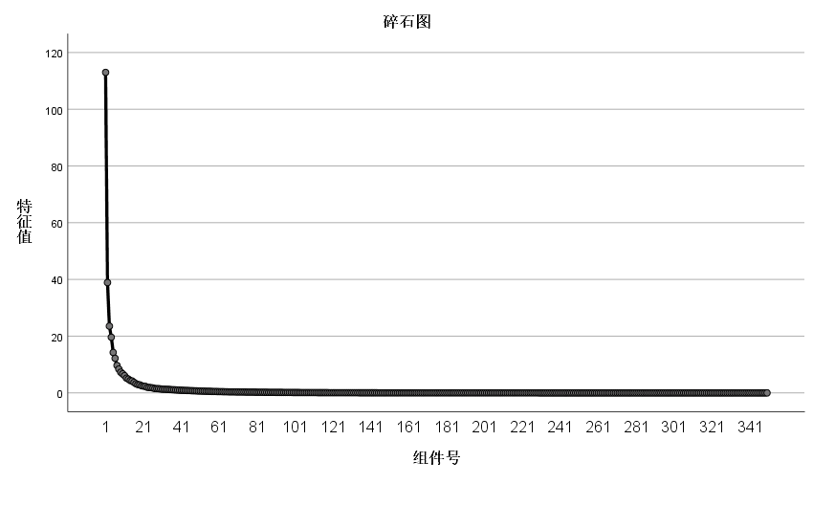

表x.x 旋转后的成分矩阵

|  |  |  |  |  |  |  |  |
| --- | --- | --- | --- | --- | --- | --- | --- |
| 因子 | 成分 | | | | | | |
| 1 | 2 | 3 | … | 20 | 21 | 22 |
| 硫含量 | 0.322 | 0.116 | 0.062 | … | -0.114 | -0.022 | -0.26 |
| 辛烷值RON | 0.166 | -0.043 | 0.007 | … | -0.021 | 0.100 | -0.033 |
| … | … | … | … | … | … | … | … |
| 8.0MPa氢气至反吹氢压缩机出口 | -0.099 | 0.087 | 0.041 | … | -0.009 | 0.002 | -0.051 |
| 8.0MPa氢气至反吹氢压缩机出口 | -0.406 | -0.813 | -0.245 | … | 0.046 | 0.027 | -0.016 |
| D101原料缓冲罐压力 | -0.901 | -0.161 | -0.195 | … | 0.31 | -0.03 | -0.02 |

表x.x 成分得分协方差矩阵

|  |  |  |  |  |  |  |  |
| --- | --- | --- | --- | --- | --- | --- | --- |
| 成分 | 1 | 2 | 3 | … | 20 | 21 | 22 |
| 1 | 1 | 0 | 0 | … | 0 | 0 | 0 |
| 2 | 0 | 1 | 0 | … | 0 | 0 | 0 |
| 3 | 0 | 0 | 1 |  | 0 | 0 | 0 |
| … | … | … | … | … | … | … | … |
| 20 | 0 | 0 | 0 | … | 1 | 0 | 0 |
| 21 | 0 | 0 | 0 | … | 0 | 1 | 0 |
| 22 | 0 | 0 | 0 | … | 0 | 0 | 1 |

表x.x 成分得分系数矩阵

|  |  |  |  |  |  |  |  |
| --- | --- | --- | --- | --- | --- | --- | --- |
|  | 成分 | | | | | | |
| 1 | 2 | 3 | … | 20 | 21 | 22 |
| 硫含量 | 0.322 | 0.116 | 0.062 | … | -0.114 | -0.022 | -0.260 |
| 辛烷值RON | 0.166 | -0.043 | 0.007 |  | -0.21 | 0.100 | -0.033 |
| 饱和烃 | -0.589 | -0.053 | -0.282 |  | 0.122 | -0.085 | -0.039 |
| … | … | … | … | … | … | … | … |
| 8.0MPa氢气至反吹氢压缩机出口 | -0.099 | 0.087 | 0.041 | … | 0.046 | 0.022 | -0.034 |
| 8.0MPa氢气至反吹氢压缩机出口 | -0.406 | -0.813 | -0.245 | … | -0.023 | -0.056 | 0.026 |
| D101原料缓冲罐压力 | -0.901 | -0.161 | -0.195 | … | -0.007 | -0.034 | 0.012 |