. Logged into github and created a new repository, surgenor_v2

. copied code locally from APP to surgenor_v2

. in CMD, git log –oneline list changes for APP, so delete current git and re-init

to establish new git directory, git init

. delete current venv then create new virtual environment

CMD, python -m venv venv

cd venv\scripts\activate to activate/start virtual environment

. now set up local machine to push to github repository.

Copy github repository URL: https://github.com/Cycledad/surgenor_v2.git

and enter following CMD git remote add origin https://github.com/Cycledad/surgenor_v2.git

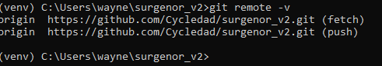

you are now ready to push code to new repository with git push ... got this with initial attempt

