**Table of Contents**

LOGIN 1

DASHBOARD 1

WEB 2

TASKS 4

FILES 5

DB_BACKUPS 7

DOWNLOAD 8

ACTIVE and INACTIVE database records 9

# LOGIN

Log onto PythonAnywhere, URL: https://www.pythonanywhere.com/login/?next=/

using userid/pw: wayneraid/Ilike2code

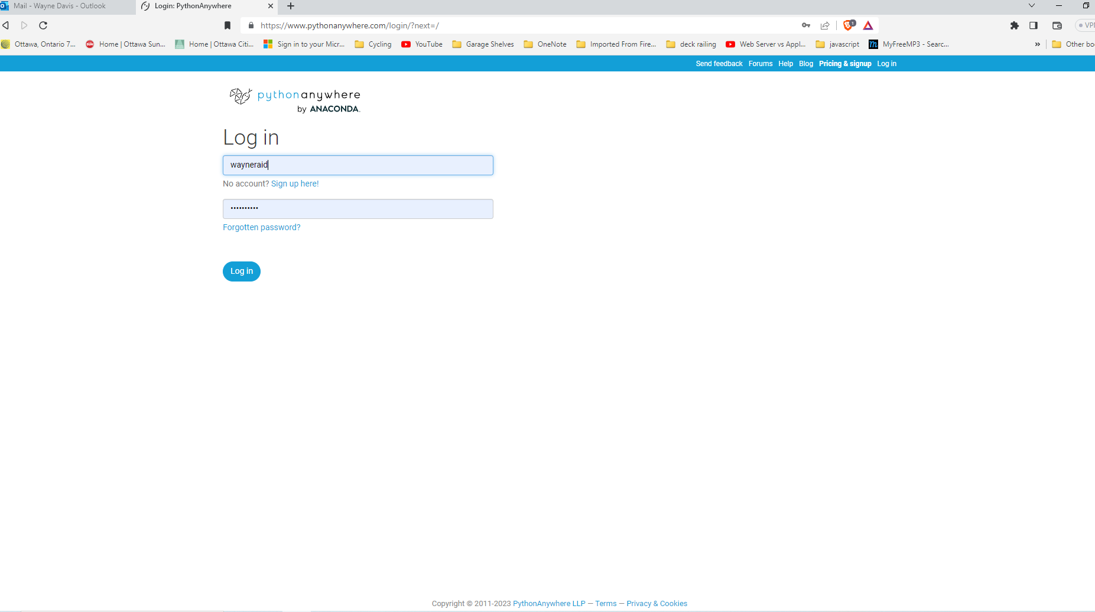

# DASHBOARD

Loging in brings you to the dashboard page

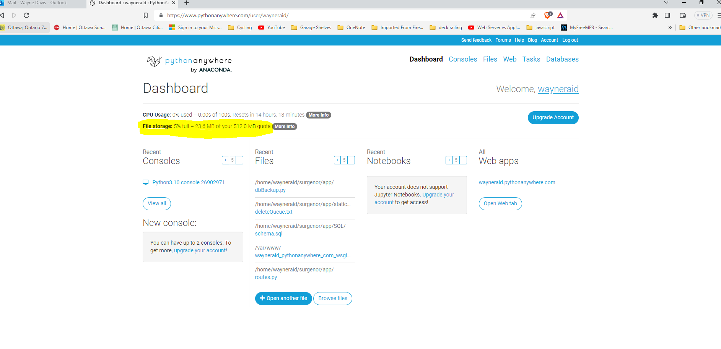

Here you can see how much disk space you have used and how much is remaining. You have used 5% of your disk space. Your usage will increase as more backups of your database file is taken. Do not use 100% of your disk space quota. When you get to about 80% of your disk space quota download some or all of the backup files into a directory/folder on your work computer for safe keeping in case you need to restore some past data. Directions on how to do this can be found later in this document under the heading.

# WEB

Click on WEB link on the dash board page

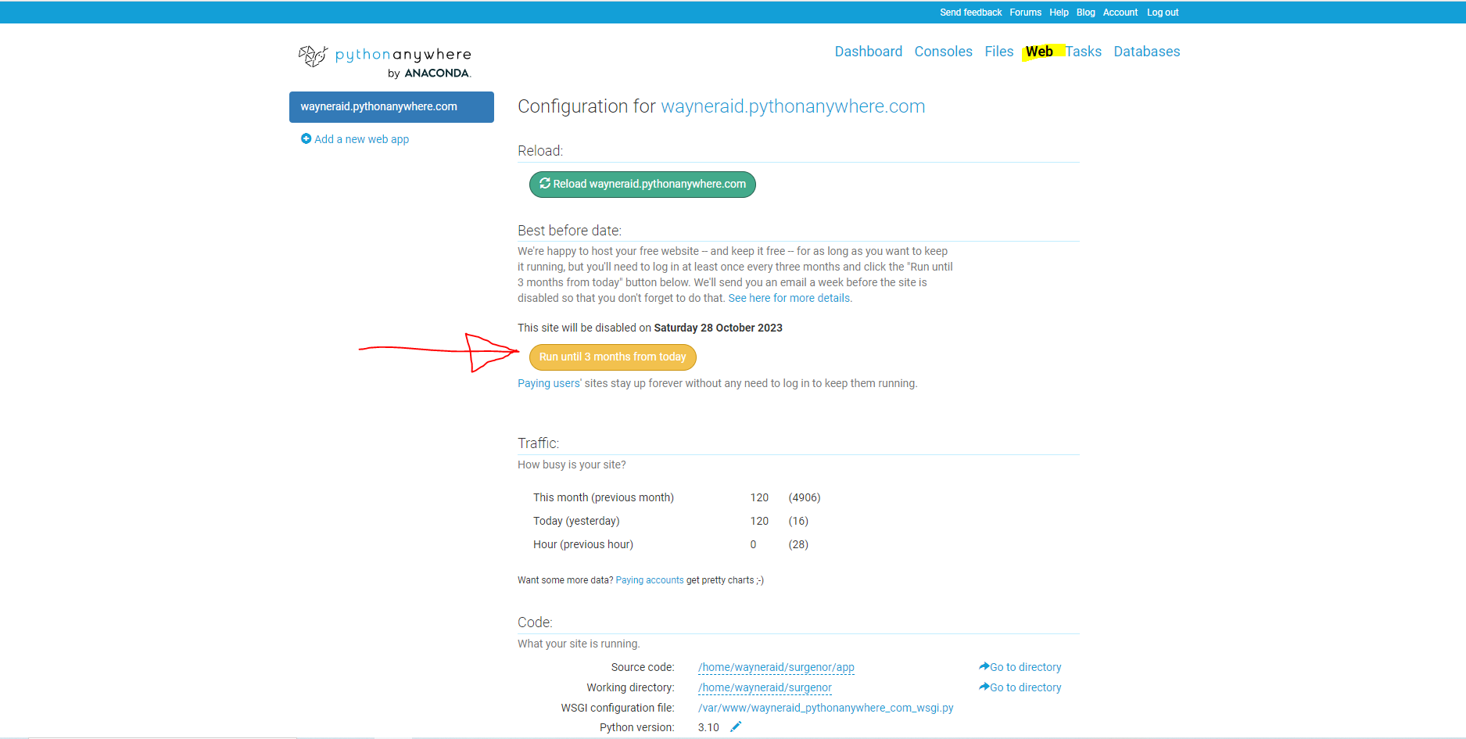

**IMPORTANT, because you have a non-paying free account you must click on the ‘Run until 3 months from today’ to ensure your website remains active. If you forget and you run past the disable date your website will be disabled.**

# TASKS

Click on the Tasks link

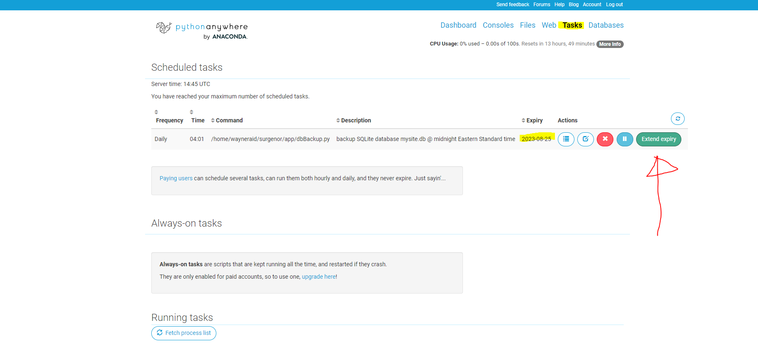

**IMPORTANT, click the ‘Extend expiry’ button to ensure yor daily, actually nightly, backup job continues to execute.** You can see here your nightly backup job filename is dbBackup.py and is found in directory/folder /home/wayneraid/surgenor/app/. The time above, 04:01, is Central time which corresponds to 12:00 midnight our time. The dbBackup.py job executes every night creating a backup database file. You can modify file dbBackup.py to take backups every other day or every 5 days or whatever you want. You may want to do this if you find you are running out of disk space quota. The other option to save/retain disk space quota is to download database files, see next section.

# FILES

Click on the Files link

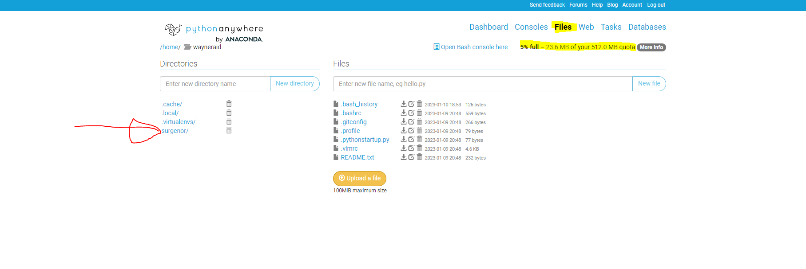On the top right hand side of the page you can see your disk space quota is repeated, 5% full – 23.6 MB of your 512 MB quota. Note the directory/folder surgenor and to the right the files contained within the folder.

Click on the surgenor/ link to display sub-folders within the surgenor folder.

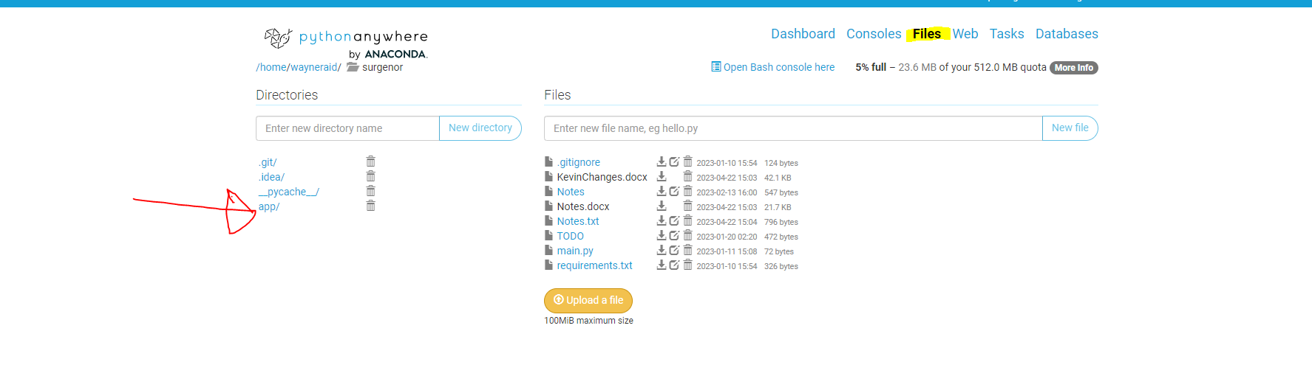

Click on the app/ link to drill down further, you will see the following

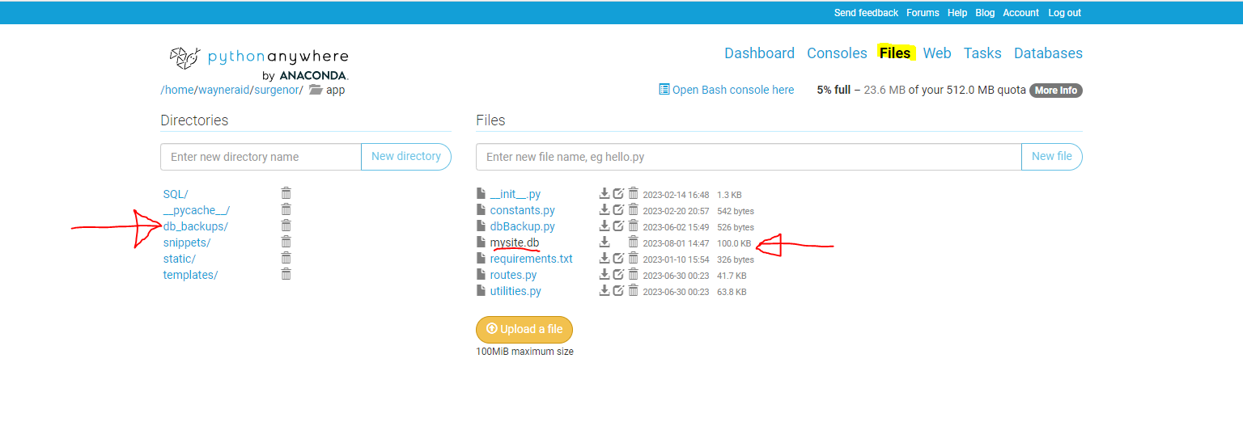

Again on the left hand side you see the directories/folders and the files are listed on the right hand side of the page. Your database file can be seen here, it is named mysite.db. This database file contains ALL your current data. It is backed up nightly with the backups written to the db_backups/ directory/folder.

# DB_BACKUPS

Click on the db_backups/ link

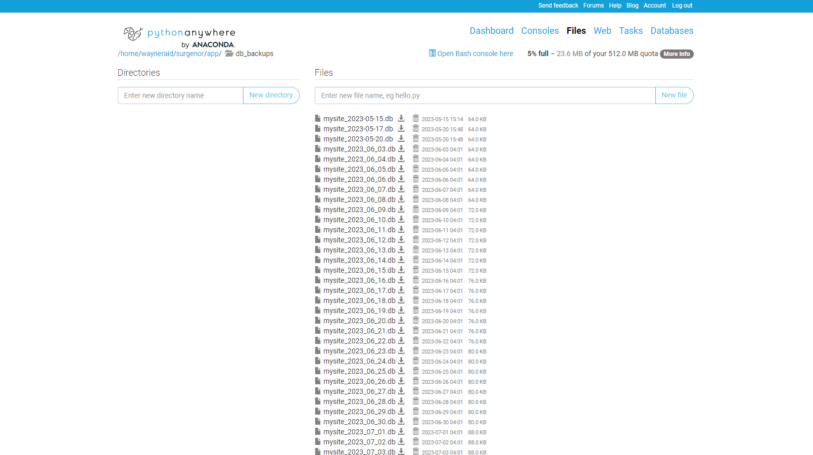

Your mysite.db database files are listed here. You can see that as you have been using the PO system the size of the mysite database file has been increasing from 64.0 KB initially to 88.0 KB as of July 3.

When you reach 80% of disk quota space you should download and save files from the web server to your work computer.

# DOWNLOAD

Click the down arrow icon to initiate the file download

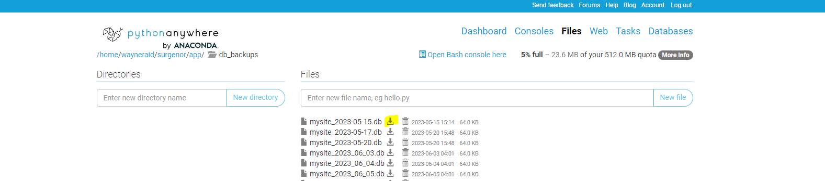

Save file to a directory/folder on your work computer. After the database file(s) have been downloaded to your local work machine delete the database files from the server. This will free up disk space.

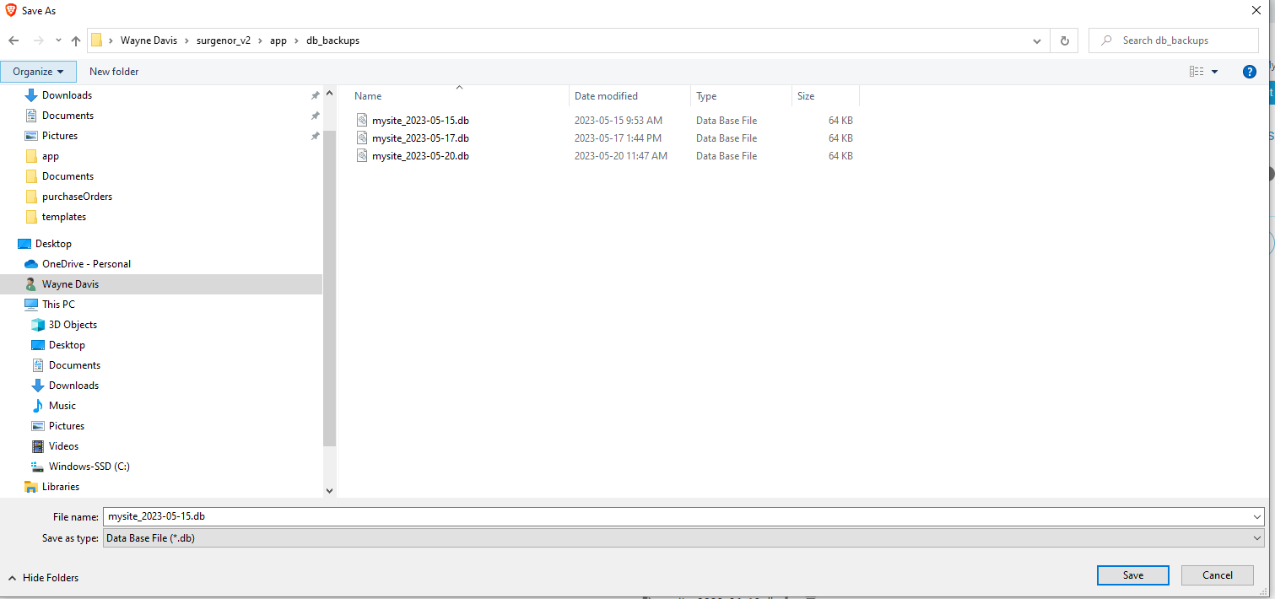

# ACTIVE and INACTIVE database records

As more and more records are added to the PO system you notice that the time to retrieve and display the records on the Purchase Order / Manage screen increases. Upon investigation, the Python Anywhere documentation states that their use of SQLite database files is NOT efficient and can cause performance issues. To overcome this it is suggested you opt for a paid account.

Another option is to decrease the number of records retrieved from the database and to this end I have added 2 new features to the ADMIN accounts, ARCHIVE ALL Inactive Accounts and Restore Purchase Order.

When a regular user goes to the Purchase Order / Manage screen, then scroll all the way right, they only see active records whereas the ADMIN user sees all records, active and inactive.

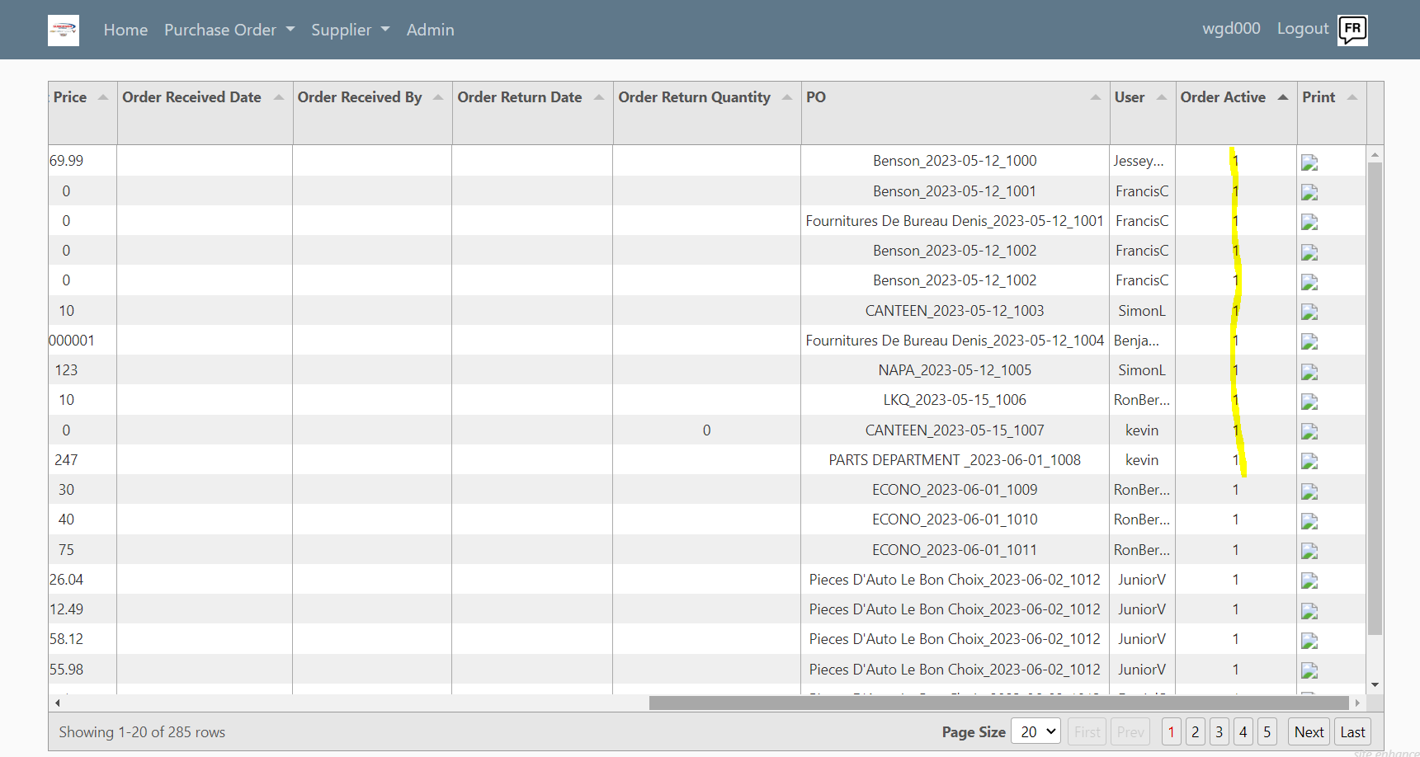

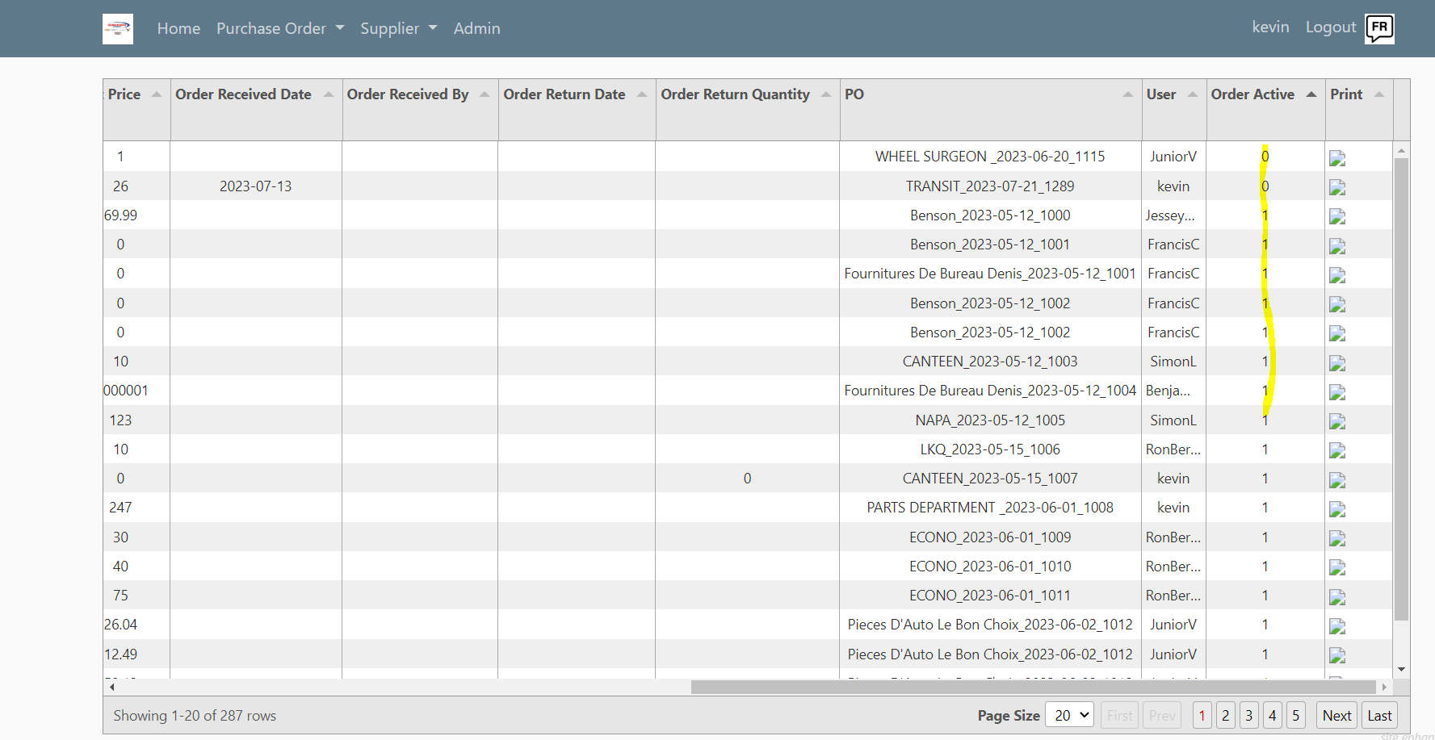

ADMIN users can change the Order Active indicator from 1 to 0 or vice versa. Regular users are not permitted.

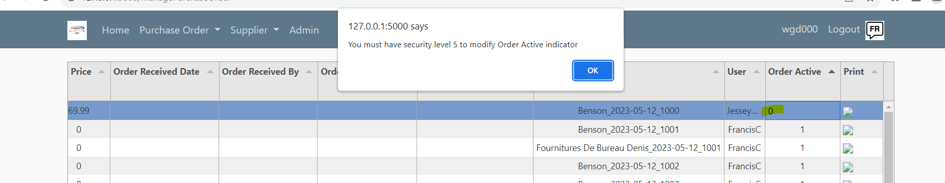

So when you find the retrieval of records is taking too long have an ADMIN user change the Order Active indicator on ALL records you feel are no longer required and then select the Archive ALL Inactive Records from the Purchase Order menu option. You are presented with the ARCHIVE Records screen. This will copy inactive records to an archive table and remove the records from the current PO table.

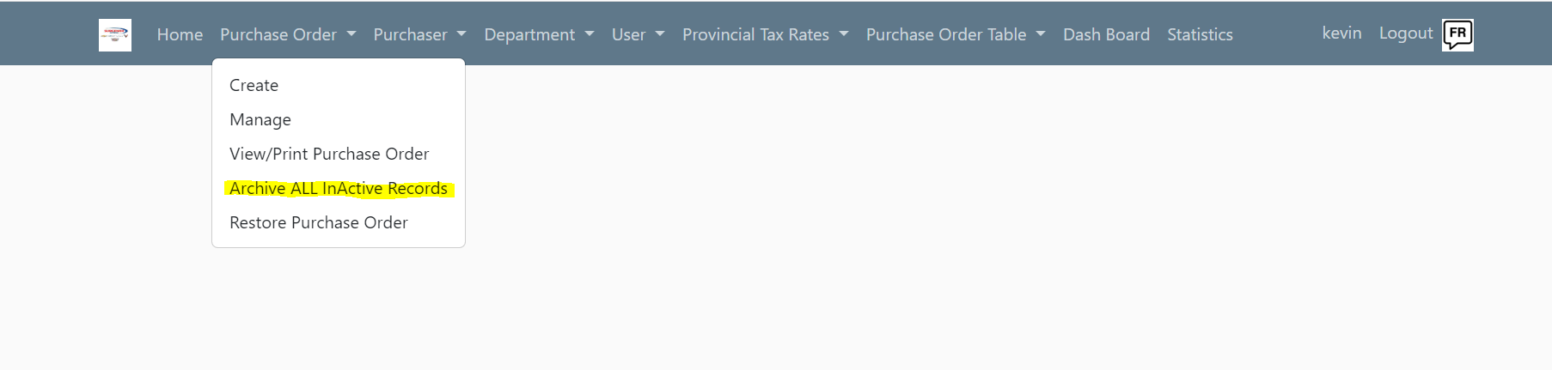

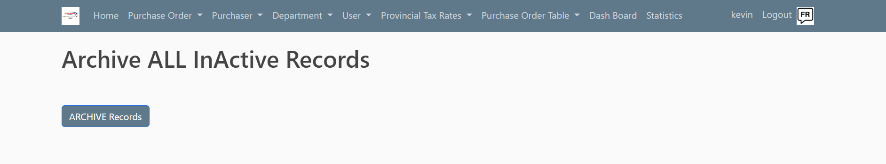

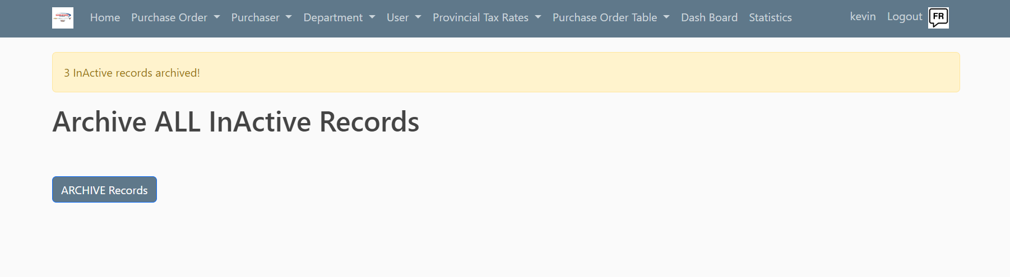

If you need to reprint a PO that has been archived you can restore the PO using the PO number.

