Suzanne Townsend

Student number: P296646

Date: 22/09/2017

Programming iii

AT1.4

|  |  |
| --- | --- |
| Does it fill the matrix? | Yes |
| Does it sort? | Yes |
| isFound working? | Yes |
| Is there duplicates | No |

**Test Table**

**Not found**

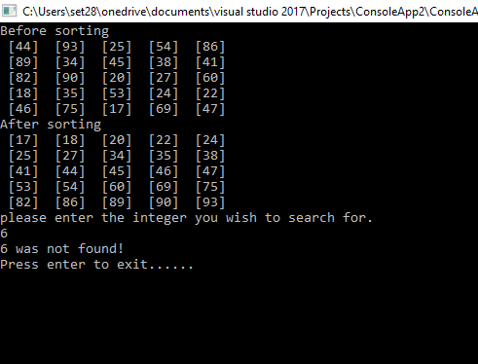

**Found**

