2/5/2025

Martinelli, Brice (marti2bc)

AEEM 6092 – Advanded aircraft Design

Substantiation Data Report

T-38A

Section I – General Data 2

Aircraft Information 2

Aircraft Dimensions 4

Aircraft Weights 4

Section II – Engine Performance Data 5

Thrust and Fuel Flow Charts 5

Maximum Afterburner Power 5

Military Power 6

Thrust and Fuel Flow Tables 7

Maximum Afterburner Power 7

Military Power 7

Section III – Aerodynamic Data 8

Drag Polar 8

Chart 8

Carpet Plot 9

Table 9

Section IV – Performance Data 10

Flight Envelope 10

Maneuver Envelope 11

Ceilings 12

Takeoff Performance 13

Landing Performance 14

Climb Performance 15

Climb Schedules 15

Military Thrust Climb 16

Maximum Thrust Climb 18

Descent Performance 20

Lift to Drag VS Mach Number 20

Time, Fuel, and Distance 20

Acceleration Performance 22

10,000 ft 22

40,000 ft 23

Deceleration Performance 25

Cruise & Endurance Performance 27

Maneuver Performance 28

# Section I – General Data

## Aircraft Information

The Northrop T-38A Talon is a twin-seat, twin-engine, mid-wing aircraft designed for high-performance jet training. It features a medium aspect ratio (~4.0), swept-wing design, and a conventional tail configuration, optimizing it for stability and efficient supersonic flight. The aircraft is powered by two General Electric J85-GE-5A turbojet engines, each producing 2,680 lbs of military thrust and up to 3,850 lbs with afterburner at static sea-level conditions. With a compact design, the J85-GE-5A has a length of 108 inches and a diameter of 20 inches and weighs 584 lbs, contributing to the aircraft's overall lightweight and agile performance. The T-38A’s high thrust-to-weight ratio of approximately 0.75 allows it to reach speeds exceeding Mach 1.2.

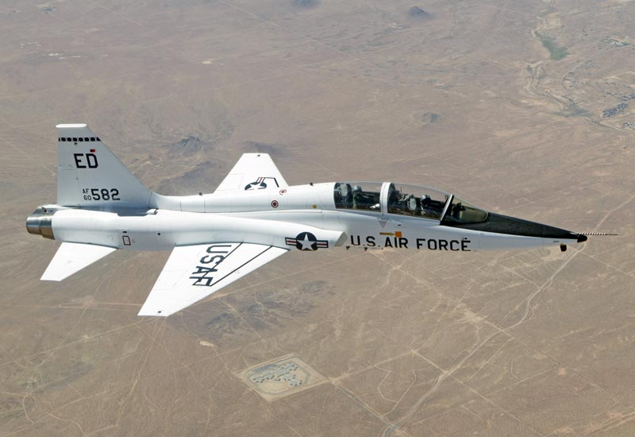

Figure : T-38A in flight (https://en.wikipedia.org/wiki/Northrop_T-38_Talon)

Figure : T-38A Three-View Drawing

## Aircraft Dimensions



## Aircraft Weights

|  |  |
| --- | --- |
| **Description** | **Weight (lbs)** |
| Empty Weight | 7,200 |
| Gross Weight | 11,820 |
| Max TOW | 12,093 |
| Fuel Capacity (600 gals) | 3,880 |

# Section II – Engine Performance Data

## Thrust and Fuel Flow Charts

### Maximum Afterburner Power

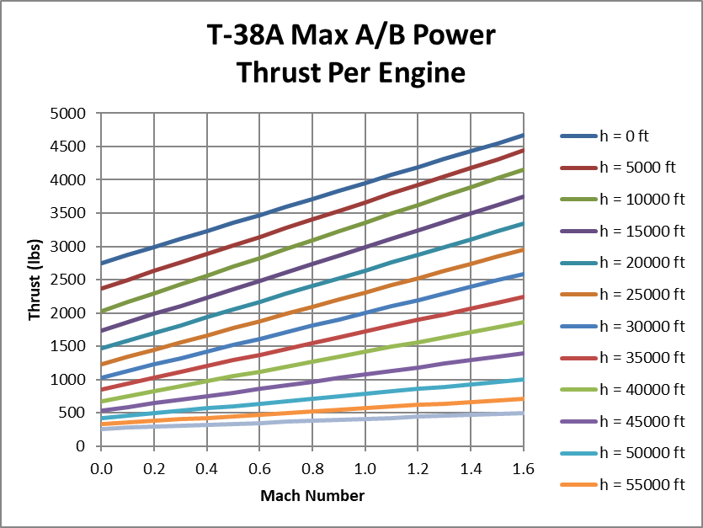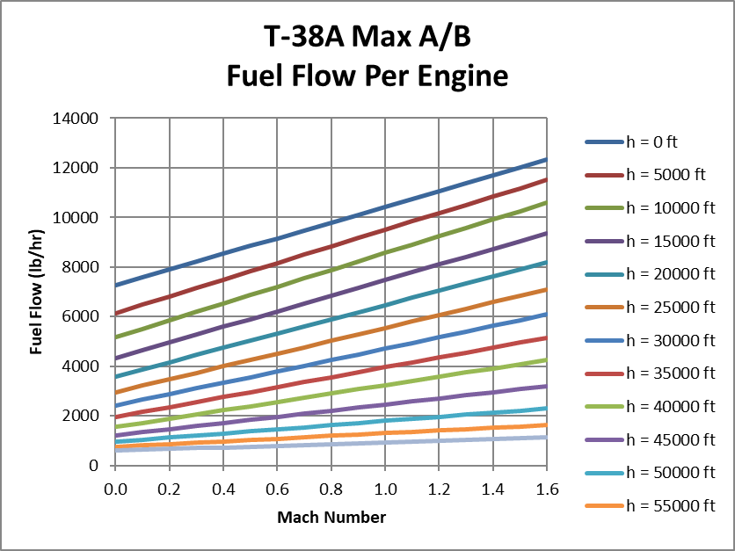

### Military Power

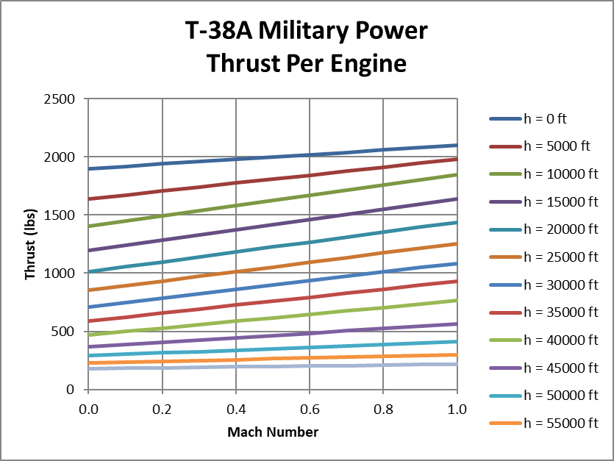

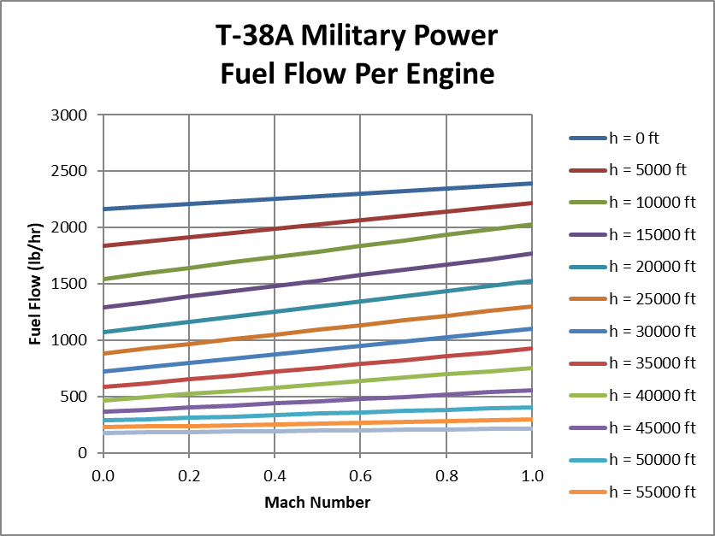

## Thrust and Fuel Flow Tables

### Maximum Afterburner Power



### Military Power



# Section III – Aerodynamic Data

Contains the Drag Polar curves of CD versus CL across different altitudes, the Drag Polar carpet plot, and the Drag Polar table from which the curves were made from.

## Drag Polar

### Chart

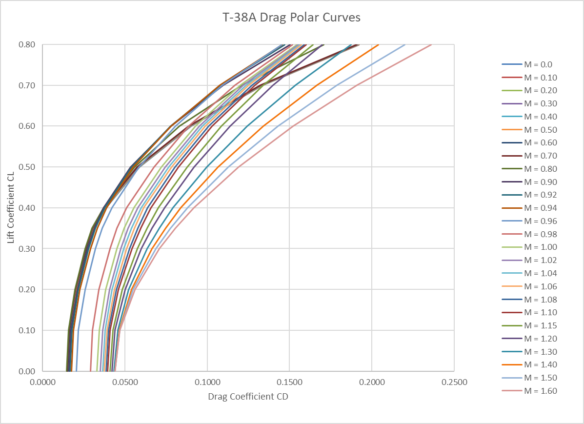

### Carpet Plot

### Table

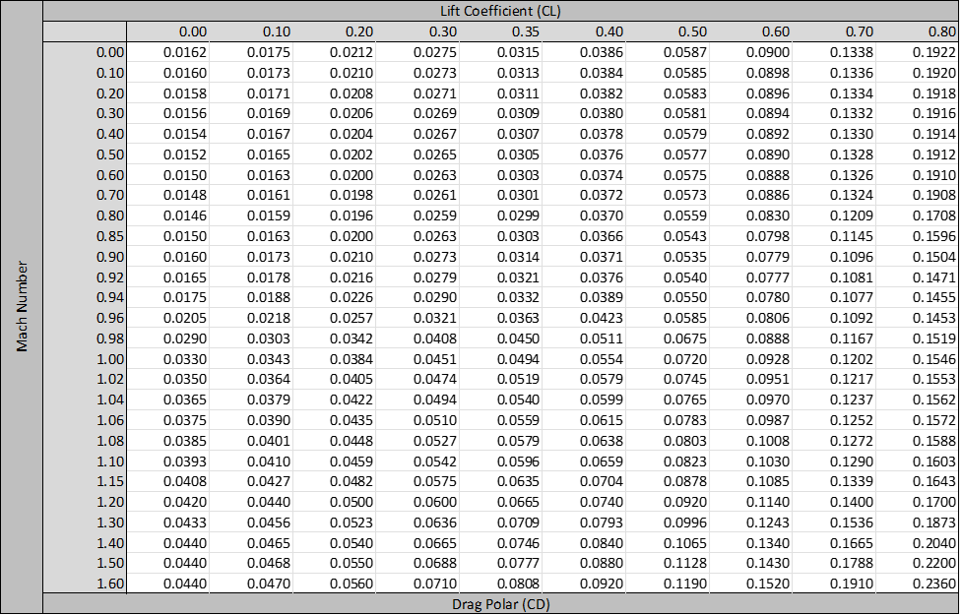

# Section IV – Performance Data

## Flight Envelope

|  |  |  |
| --- | --- | --- |
| **Parameter** | **Value** | **Units** |
|  | 0.80 | - |
|  | 1.58 | - |
|  | 700 | [knots] |
|  | 50,000 | [ft] |

Figure : T-38A Flight Envelope at 10,000 lbs

## Maneuver Envelope

|  |  |  |
| --- | --- | --- |
| **Load Factor** | **Value** | **Units** |
|  | 7.20 | g's |
|  | -2.94 | g's |
| Weight | 10,000 | lbs |

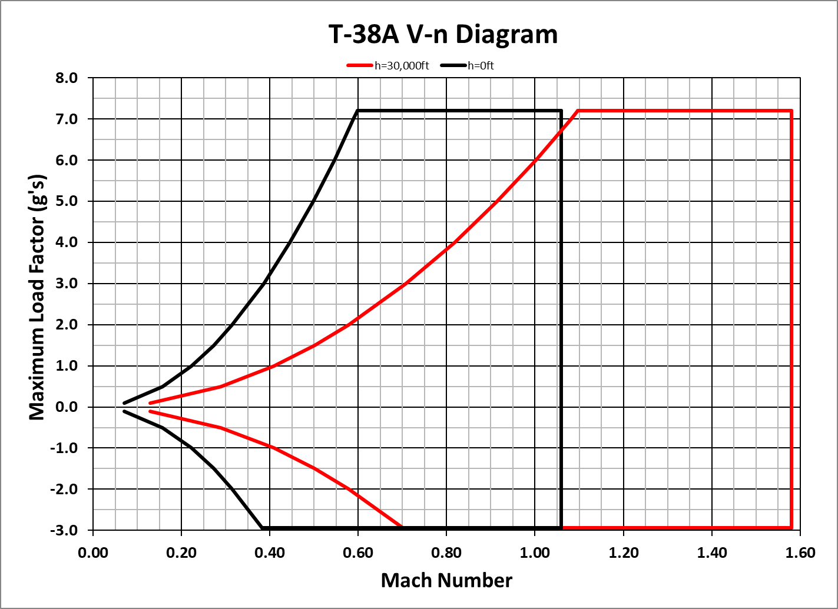

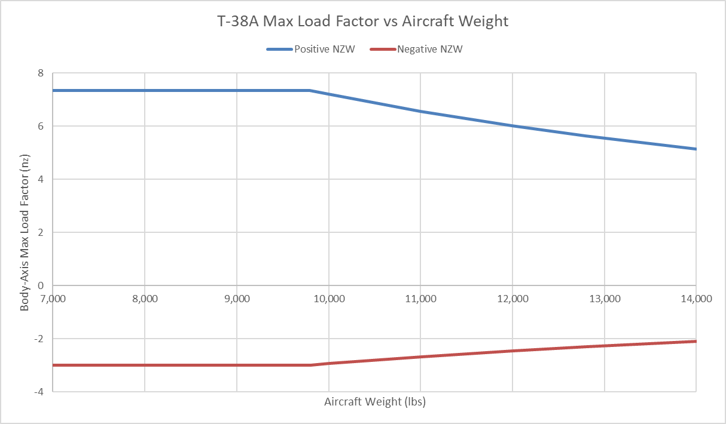

## Ceilings

|  |  |  |  |
| --- | --- | --- | --- |
| **Military Trust** | | **Maximum A/B Thrust** | |
| **Ceiling** | **Altitude (ft)** | **Ceiling** | **Altitude (ft)** |
| **Absolute** | 47,407 | **Absolute** | 54,900 |
| **Service** | 47,185 | **Service** | 54,748 |
| **Cruise** | 46,703 | **Cruise** | 54,463 |
| **Combat** | 46,130 | **Combat** | 54,155 |
| **Aircraft Weight:** 10,000 lbs | | | |

## Takeoff Performance

|  |  |  |  |
| --- | --- | --- | --- |
| **Aircraft Weight:** 11,000 lbs | | | |
|  | **Units** | **Sea Level** | **4,000 ft** |
| **Takeoff Run Velocities** |  |  |  |
| **Stall Velocity** | **ft/sec** | 244.60 | 259.56 |
| **Rotation Velocity** | **ft/sec** | 256.83 | 272.54 |
| **Takeoff Velocity** | **ft/sec** | 269.06 | 285.51 |
| **Obstacle Clearance Velocity** | **ft/sec** | 293.52 | 311.47 |
| **70% of Takeoff Velocity** | **ft/sec** | 188.34 | 199.86 |
|  |  |  |  |
| **Military Power Takeoff** |  |  |  |
| **Thrust (T) at 0.7 VTO** | **lb** | 3,867 | 3,493 |
| **Drag (D) at 0.7 VTO** | **lb** | 572 | 556 |
| **Rolling Resistance (R)** | **lb** | 275 | 275 |
| **Average Ground Roll Acceleration** | **ft/sec2** | 8.83 | 7.78 |
| **Takeoff Ground Roll Distance** | **ft** | 4,098 | 5,237 |
|  |  |  |  |
| **Maximum A/B Power Takeoff** |  |  |  |
| **Thrust (T) at 0.7 VTO** | **lb** | 5,905 | 5,347 |
| **Drag (D) at 0.7 VTO** | **lb** | 572 | 556 |
| **Rolling Resistance (R)** | **lb** | 275 | 275 |
| **Average Ground Roll Acceleration** | **ft/sec2** | 14.79 | 13.21 |
| **Takeoff Ground Roll Distance** | **ft** | 2,447 | 3,086 |

## Landing Performance

|  |  |  |  |
| --- | --- | --- | --- |
| **Aircraft Weight:** 8,500 lbs | | | |
|  | **Units** | **Sea Level** | **4,000 ft** |
| **Landing Run Velocities** |  |  |  |
| **Stall Velocity** | **ft/sec** | 210.44 | 223.31 |
| **Approach Velocity** | **ft/sec** | 231.49 | 245.64 |
| **Touchdown Velocity** | **ft/sec** | 252.53 | 267.97 |
| **Landing Distances** |  |  |  |
| **Transition ground roll distance** | **ft** | 694 | 737 |
| **Braking ground roll distance** | **ft** | 2,776 | 3,126 |
| **Total ground roll distance** | **ft** | 3,470 | 3,863 |

## Climb Performance

### Climb Schedules

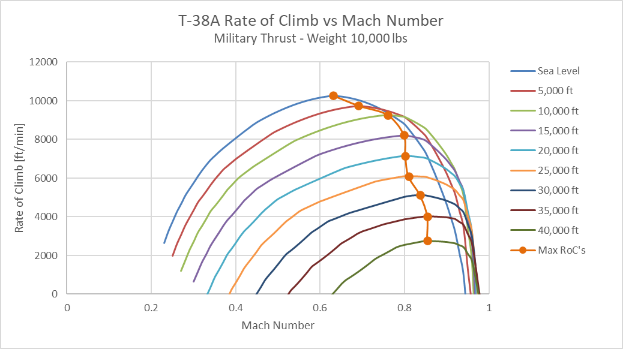

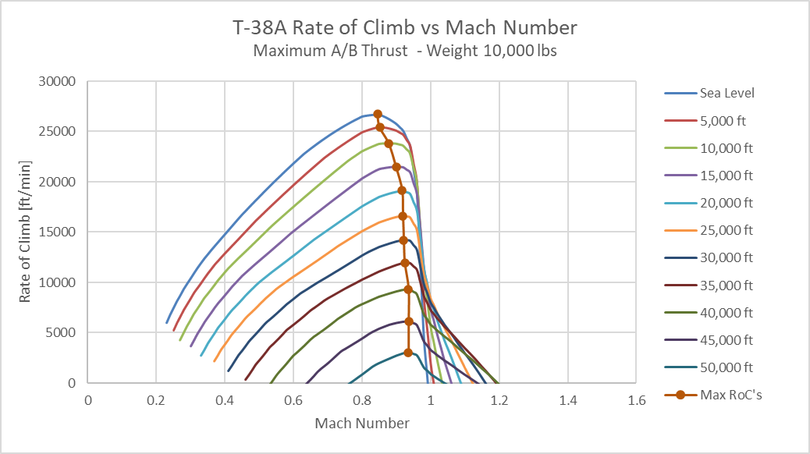

### Military Thrust Climb

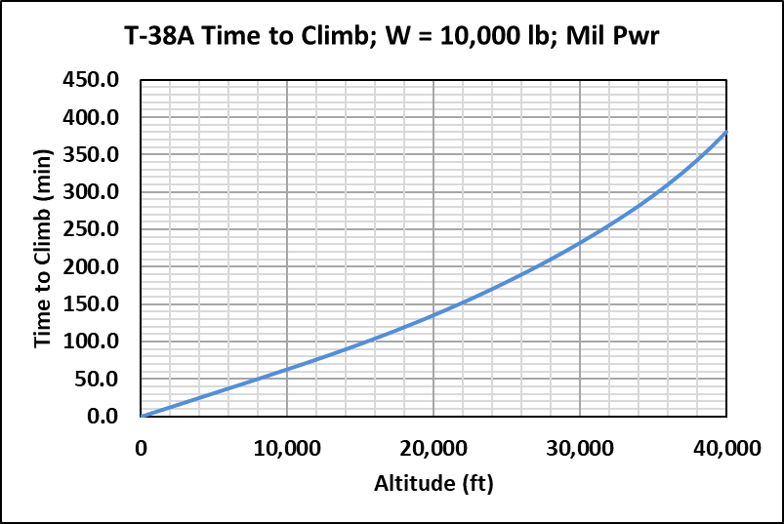

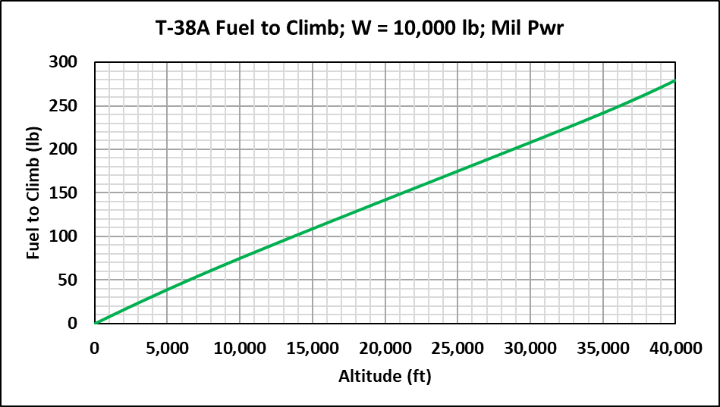

### Maximum Thrust Climb

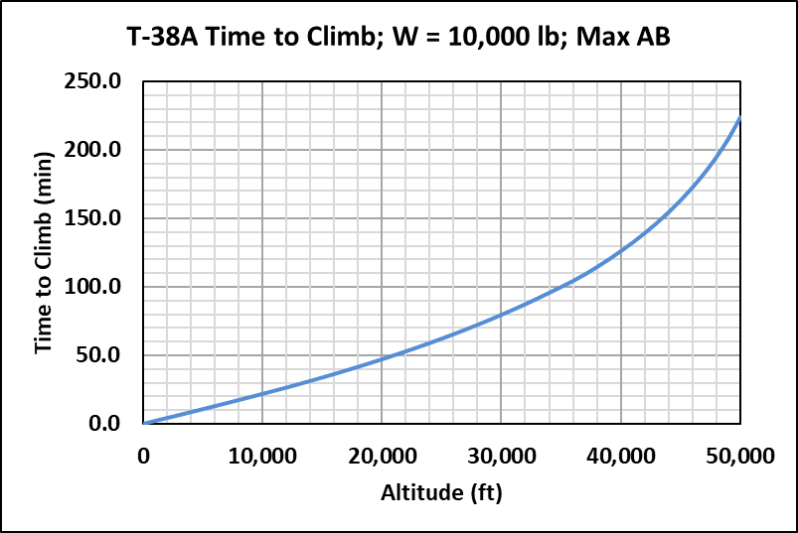

## Descent Performance

### Lift to Drag VS Mach Number

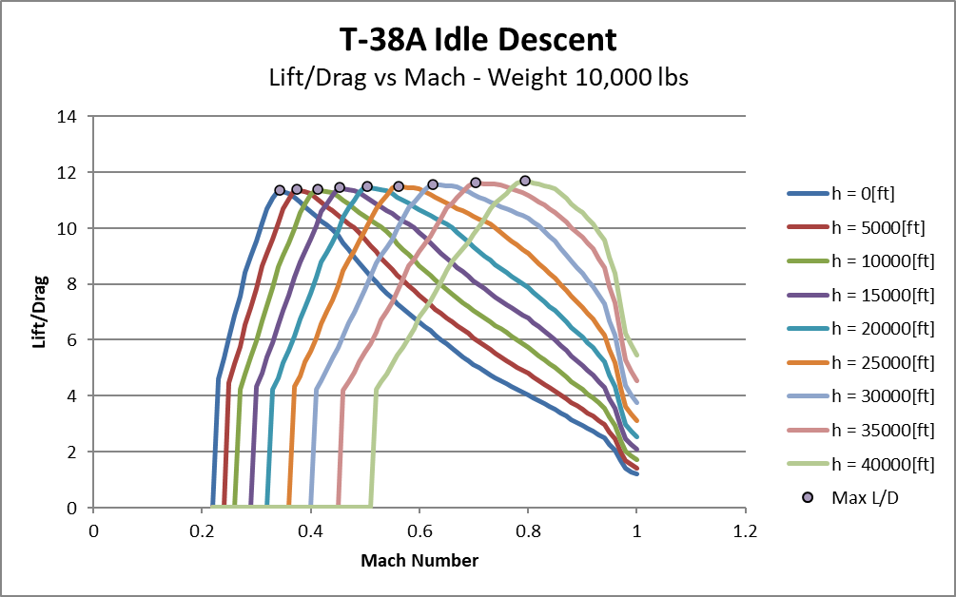

### Time, Fuel, and Distance

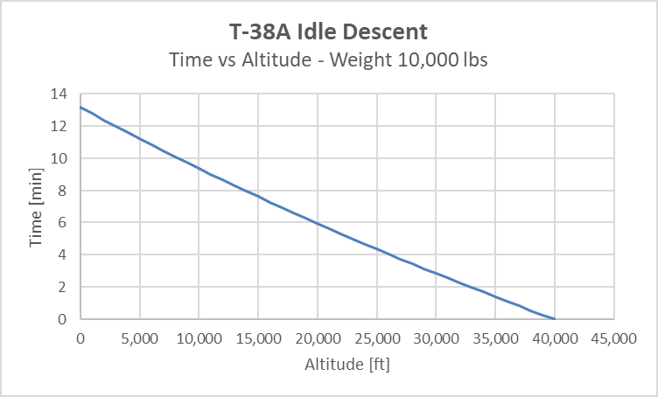

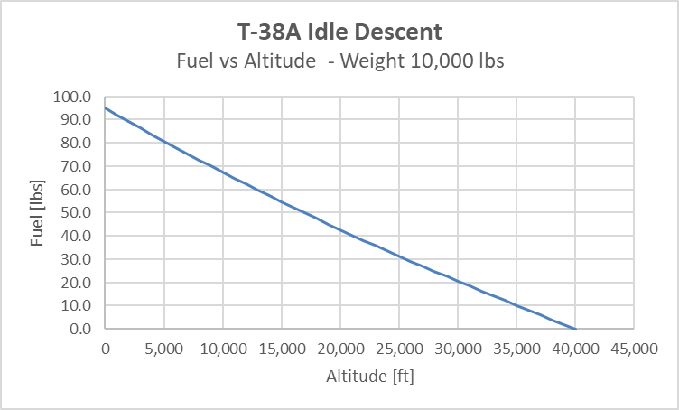

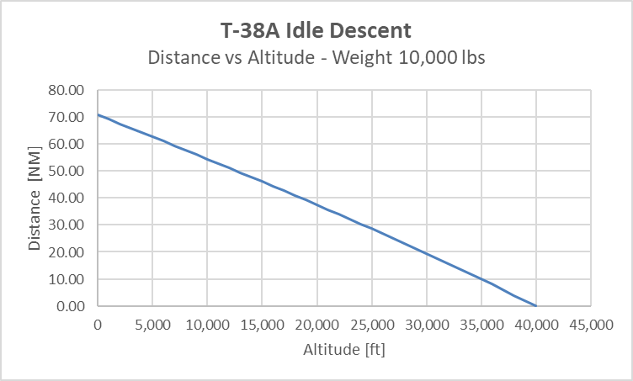

## Acceleration Performance

### 10,000 ft

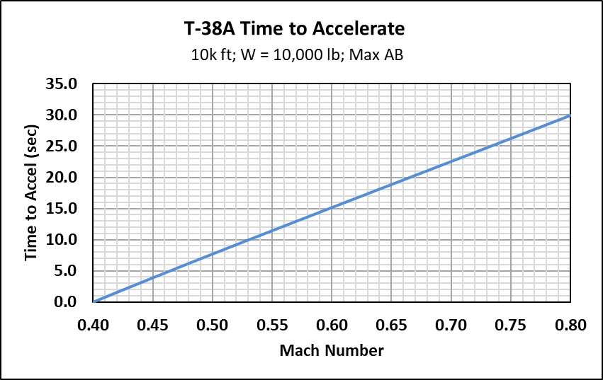

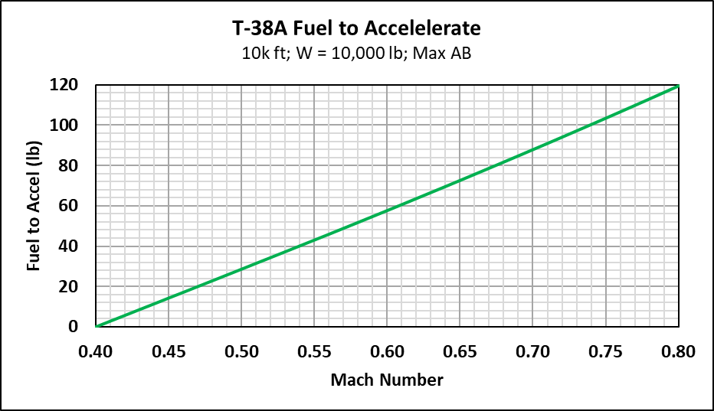

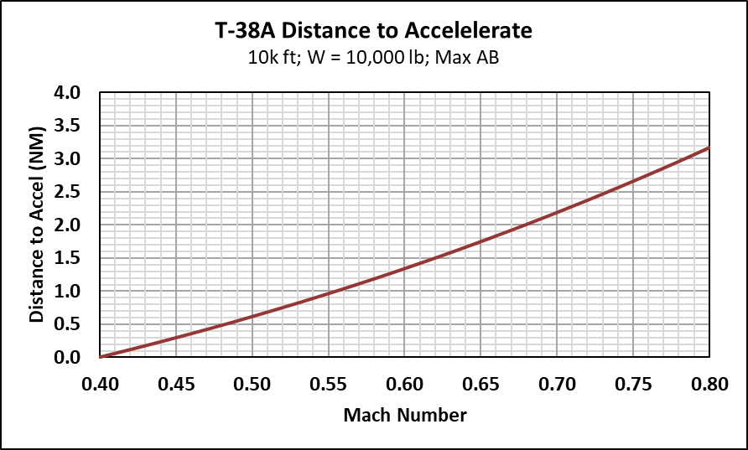

### 40,000 ft

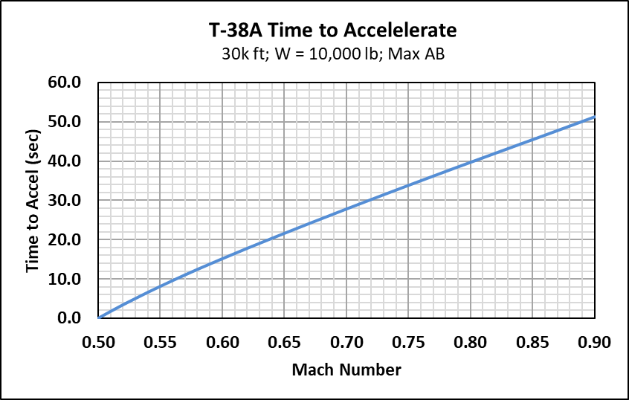

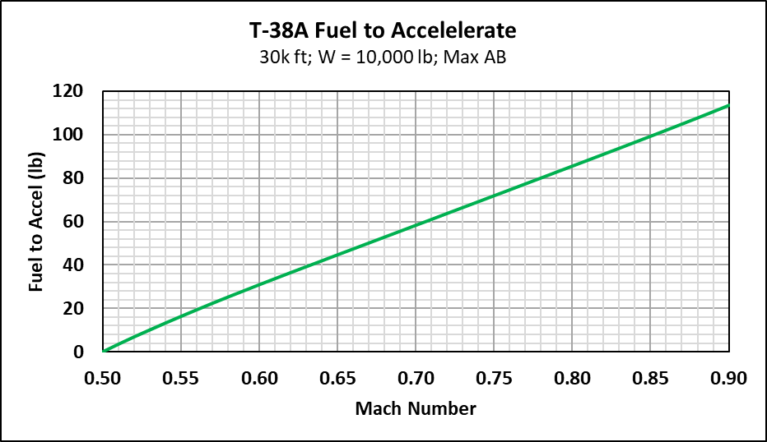

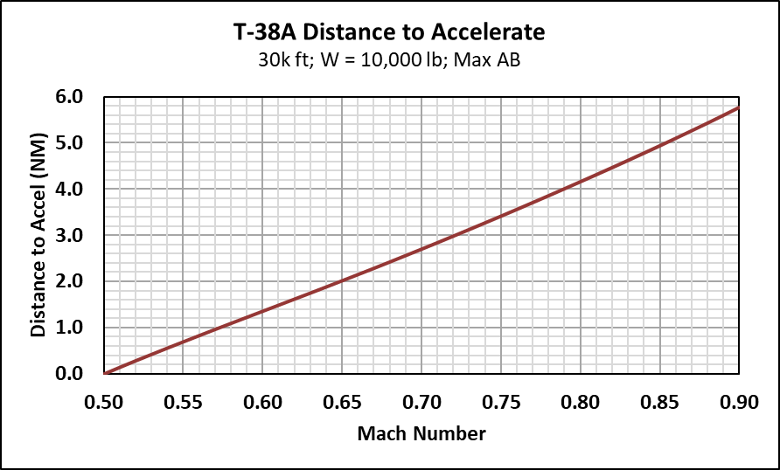

## Deceleration Performance

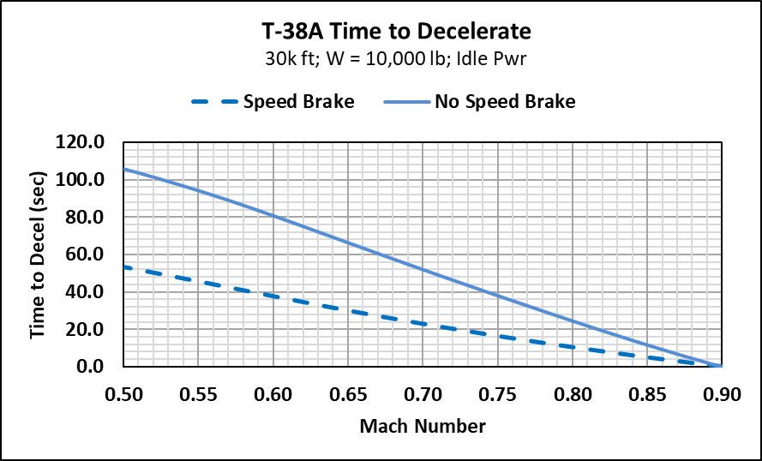

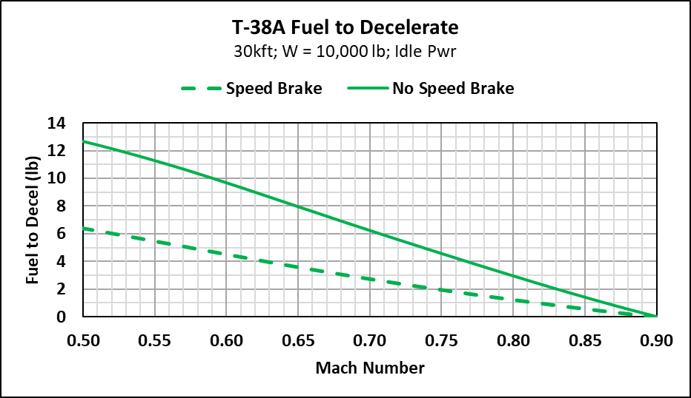

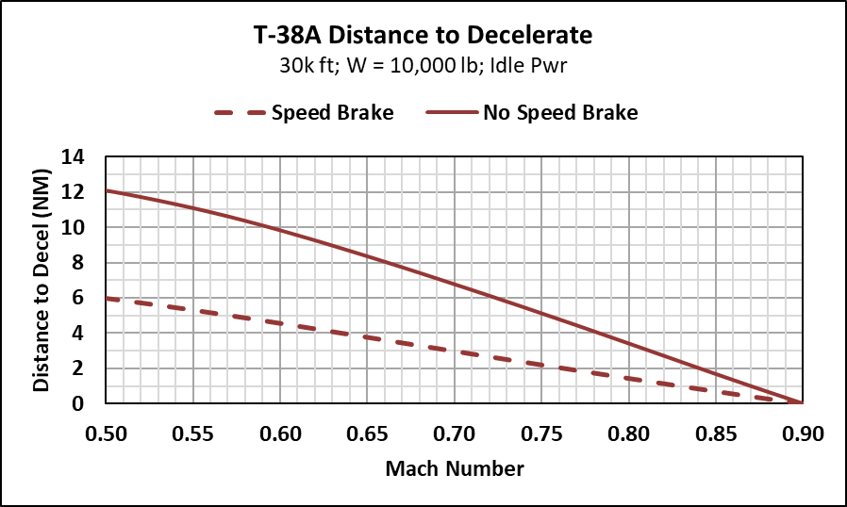

## Cruise & Endurance Performance



## Maneuver Performance

