Unwrought Bestiary Entry: Gravemarcher
“The Walking End” – Colossus Unwrought

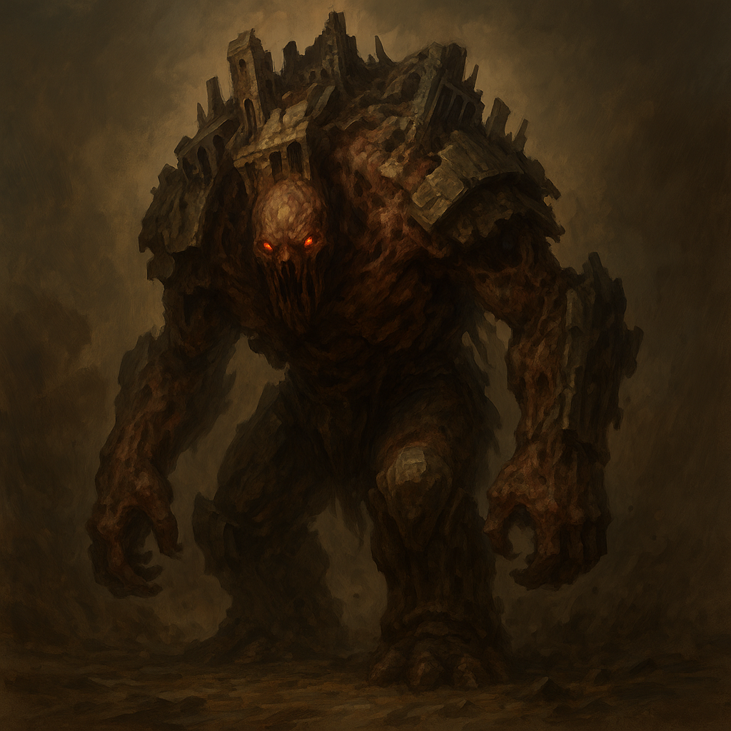

Description
Gravemarchers are towering monstrosities — living siege engines forged from warped leyline metal, crushed stone, and shattered corpses bound in void energy. They march forward endlessly, their steps quaking the ground beneath them. Their design is brutish and jagged, like fortresses with limbs.
Lacking higher thought, they are driven only by destruction and commands from higher Unwrought like the Oblivarch. Their guttural roars sound like tectonic plates grinding — a sound that resonates in the bones before the ears.

Stat Block (Base Gravemarcher – CR 6)
**Armor Class**: 18 (heavy void-armor)
**Hit Points**: 150 (12d12 + 72)
**Speed**: 30 ft.
**STR** 22 (+6) **DEX** 8 (-1) **CON** 22 (+6) **INT** 3 (-4) **WIS** 10 (+0) **CHA** 5 (-3)
**Saving Throws**: Con +9, Str +9
**Damage Resistances**: Bludgeoning, Piercing, and Slashing from nonmagical attacks
**Damage Vulnerabilities**: Force, Radiant, Thunder
**Condition Immunities**: Frightened, Charmed, Exhaustion
**Senses**: Tremorsense 60 ft., Darkvision 60 ft., passive Perception 10
**Languages**: None
**Challenge**: 6 (2,300 XP)

Abilities
**Siege Monster.** Gravemarcher deals double damage to objects and structures.
**Groundquake.** When the Gravemarcher moves more than 10 feet in a turn, it can stomp the ground at the end of its movement. All creatures within 20 feet must succeed on a DC 16 Dexterity saving throw or be knocked prone and take 10 (2d6 + 3) bludgeoning damage.
**Unstoppable.** The Gravemarcher cannot be pushed, knocked prone, or restrained by nonmagical means.
**Leyline Weakpoint.** If the Gravemarcher is struck by a Force, Radiant, or Thunder spell, it takes double damage and must make a DC 15 Constitution saving throw or become stunned until the end of its next turn.

Actions
**Massive Slam.** *Melee Weapon Attack:* +9 to hit, reach 10 ft., one target.
*Hit:* 21 (3d10 + 6) bludgeoning damage.
**Wrecking Sweep (Recharge 5–6).** The Gravemarcher swings its massive arm in a wide arc. All creatures in a 15-foot cone must make a DC 16 Strength saving throw or take 22 (4d8 + 4) damage and be pushed 10 feet.

Tactical Use
Gravemarchers are used for full-scale sieges or battlefield suppression. Introduce them stomping across terrain toward an objective, flattening everything in their path. Their vulnerability to certain magic types gives players a chance to strategize, while their raw strength threatens entire parties. Support them with Myrmidex or Morphidons to keep casters pressured.

