Unwrought Bestiary Entry: Morphidon
“The Shifting Horrors” – Monstrous Unwrought

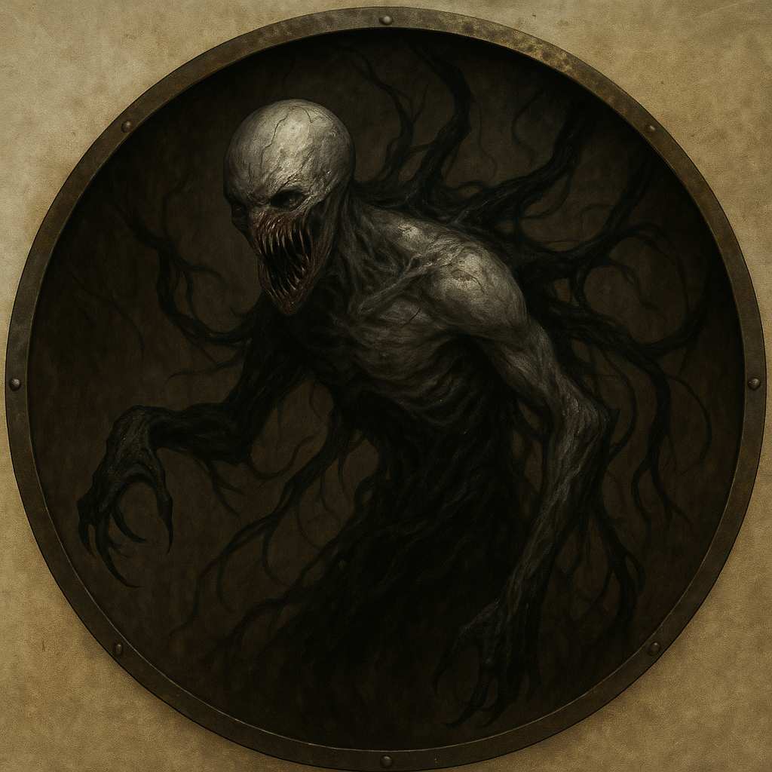

Description
Morphidons are formless nightmares — amalgamations of twisted metal, sinew, and void essence. They possess the horrifying ability to mimic fallen prey, taking on near-perfect physical illusions that unravel under scrutiny. A Morphidon might appear as a crying child, a wounded soldier, or a familiar face. Only a subtle shimmer, an odd stiffness, or a faint static crackle betrays the truth.
They stalk in silence, moving through ruins or fog, their distorted bodies twitching as they struggle to maintain form. Though speechless, their cries resemble warped attempts at language — broken, unintelligible, yet disturbingly close.

Stat Block (Base Morphidon – CR 2)
**Armor Class**: 14 (shifting flesh)
**Hit Points**: 40 (6d8 + 12)
**Speed**: 30 ft., climb 20 ft.
**STR** 15 (+2) **DEX** 14 (+2) **CON** 14 (+2) **INT** 6 (-2) **WIS** 12 (+1) **CHA** 8 (-1)
**Skills**: Deception +3, Stealth +4
**Damage Resistances**: Bludgeoning, Piercing, and Slashing from nonmagical weapons
**Senses**: Darkvision 60 ft., passive Perception 11
**Languages**: — (warped mimicry of sounds only)
**Challenge**: 2 (450 XP)

Abilities
**Mimic Kill Form.** The Morphidon can mimic the last creature it killed or touched while dying. The illusion lasts for up to 1 hour and mimics voice and physical features, though it cannot speak true language. A creature interacting with the illusion can make a DC 13 Insight or Investigation check to notice unnatural stiffness, glitches, or cold static sounds.
**Shifting Horror.** When it reverts to its true form, all creatures within 10 ft. must make a DC 13 Wisdom saving throw or be frightened until the end of their next turn.
**Voidform Limbs.** The Morphidon can reshape its body to grow tendrils, claws, or pseudopods.
**Cling to Shadows.** While in dim light or darkness, the Morphidon has advantage on Stealth checks.

Actions
**Tendril Slash.** *Melee Weapon Attack:* +4 to hit, reach 10 ft., one target.
*Hit:* 10 (2d6 + 2) slashing damage.
**Grasping Maw.** *Melee Weapon Attack:* +4 to hit, reach 5 ft., one target.
*Hit:* 8 (1d10 + 2) piercing damage, and the target must succeed on a DC 12 Strength save or be grappled.

Tactical Use
Morphidons are ambush predators. Introduce them through deception: a faint sobbing, a wounded NPC, or a familiar voice calling from the dark. They should strike when the party splits or when someone approaches without caution. When a Morphidon is revealed, amplify the horror with their shifting form and sudden, violent attacks.

