Unwrought Bestiary Entry: Myrmidex
“The Mindbound Soldiers” – Humanoid Unwrought

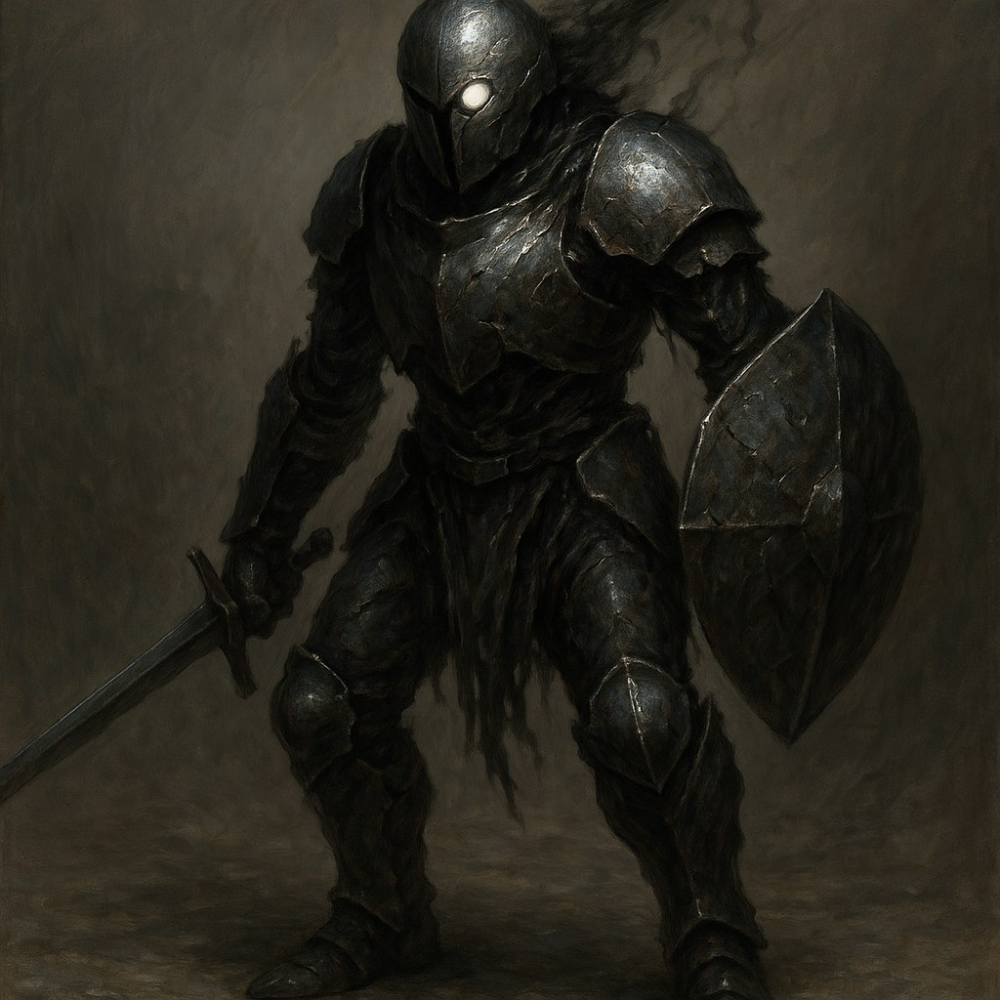

Description
Myrmidex are the Unwrought's attempt at mimicking soldiers — built from corrupted forms of humanoid anatomy, bound together with fractured metal and pulsating leylines. These constructs retain the memory of war formations and melee combat, often operating in tactical coordination even without a direct commander present.
When an Oblivarch is near, Myrmidex formations become terrifyingly precise, advancing in unison with chilling discipline. Their voices are glitching metallic growls, full of fragmented words and broken commands they no longer understand.

Stat Block (Base Myrmidex – CR 1)
**Armor Class**: 15 (shields, partial plating)
**Hit Points**: 27 (5d8 + 5)
**Speed**: 30 ft.
**STR** 14 (+2) **DEX** 12 (+1) **CON** 13 (+1) **INT** 5 (-3) **WIS** 11 (+0) **CHA** 6 (-2)
**Skills**: Athletics +4, Intimidation +2
**Senses**: Darkvision 60 ft., passive Perception 10
**Languages**: Blabbering static; understands Common but cannot speak clearly
**Challenge**: 1 (200 XP)

Abilities
**Shield Wall.** While adjacent to another Myrmidex, gain +2 AC.
**Coordinated Strike.** If a Myrmidex attacks a target that was attacked by another Myrmidex this round, it gains +2 to hit.
**Weapon Versatility.** The Myrmidex is equipped with a corrupted spear and shortbow. It can switch between weapons as a bonus action.

Actions
**Spear.** *Melee Weapon Attack:* +4 to hit, reach 5 ft., one target.
*Hit:* 6 (1d6 + 2) piercing damage.
**Shortbow.** *Ranged Weapon Attack:* +3 to hit, range 80/320 ft., one target.
*Hit:* 5 (1d6 + 1) piercing damage.

Tactical Use
Myrmidex are best deployed in pairs or squads, using their Shield Wall ability to absorb hits and their Coordinated Strikes to increase damage potential. If an Oblivarch is present, double their aggression — they will take formation, flank, and pin targets using terrain advantages. Consider using them to box players in or intercept spellcasters.

