Unwrought Bestiary Entry: Vyrethron
“The Riftwings” – Wyvernoid Unwrought

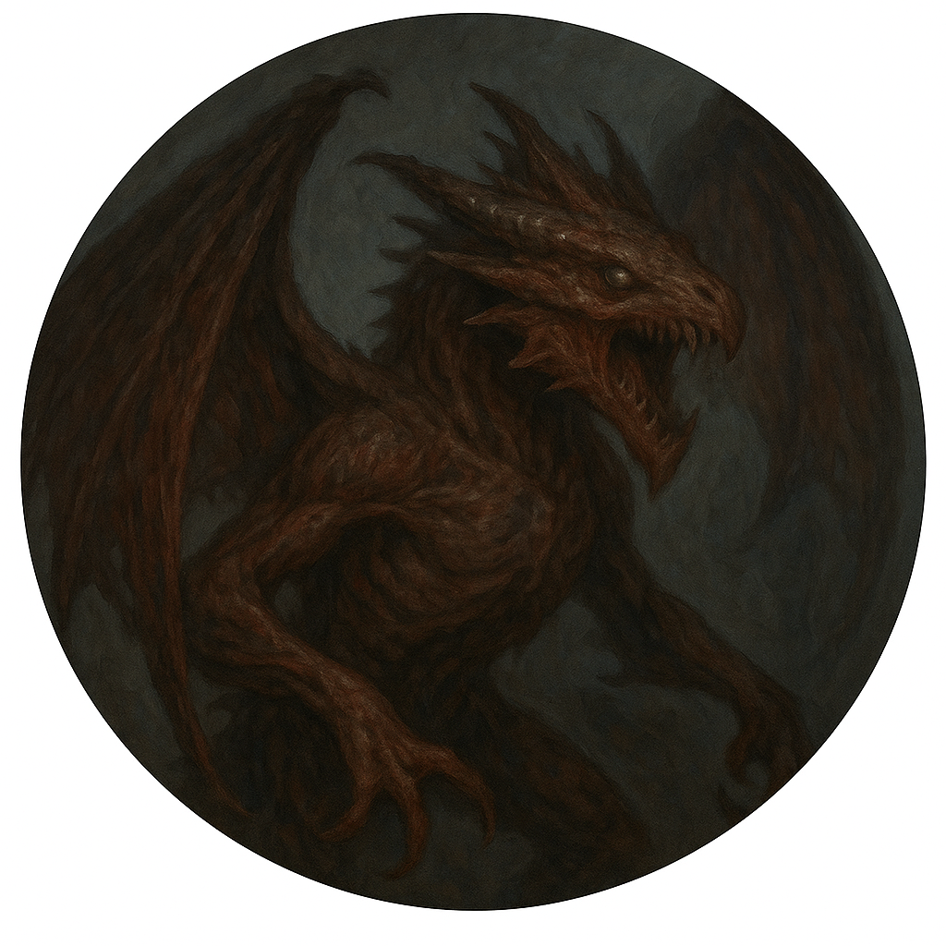

Description
Vyrethrons are monstrous airborne Unwrought that resemble twisted dragons or wyverns. Built for destruction, they soar over leyline valleys and fortress walls, unleashing devastating blasts of compressed riftfire. Their wings tear through clouds like knives, and their presence alone induces panic.
Their screeches sound like thousands of broken voices trying to speak at once, echoing across the sky in distorted waves. They are rarely seen without causing disaster — or at the vanguard of an Unwrought horde.

Stat Block (Base Vyrethron – CR 5)
**Armor Class**: 17 (void-scale plating)
**Hit Points**: 110 (13d10 + 39)
**Speed**: 40 ft., fly 80 ft.
**STR** 19 (+4) **DEX** 14 (+2) **CON** 16 (+3) **INT** 6 (-2) **WIS** 12 (+1) **CHA** 7 (-2)
**Saving Throws**: Dex +5, Wis +4
**Damage Resistances**: Fire, Lightning, Force
**Senses**: Darkvision 120 ft., passive Perception 11
**Languages**: — (screeches and distorted mimicry)
**Challenge**: 5 (1,800 XP)

Abilities
**Rift Breath (Recharge 5–6).** The Vyrethron exhales riftfire in a 60 ft. cone. Each creature in that area must make a DC 15 Dexterity saving throw, taking 42 (12d6) force damage on a failed save, or half as much on a success.
**Divebomb.** If the Vyrethron moves at least 30 feet downward in a straight line before hitting a target with a melee attack, it deals an additional 10 (3d6) damage.
**Terror Roar (1/Day).** The Vyrethron emits a bone-rattling screech. Each creature of its choice within 60 feet that can hear it must succeed on a DC 14 Wisdom saving throw or be frightened for 1 minute. Targets may repeat the save at the end of each of their turns.
**Aerial Dominance.** While flying, the Vyrethron has advantage on Dexterity saving throws and melee attacks against grounded enemies.

Actions
**Void Talons.** *Melee Weapon Attack:* +7 to hit, reach 10 ft., one target.
*Hit:* 15 (2d10 + 4) slashing damage.
**Tail Lash.** *Melee Weapon Attack:* +7 to hit, reach 15 ft., one target.
*Hit:* 13 (2d8 + 4) bludgeoning damage, and the target must succeed a DC 14 Strength saving throw or be knocked prone.

Tactical Use
Use Vyrethrons as aerial battlefield control units. They should strike from above, unleashing their Rift Breath before divebombing isolated targets or spellcasters. Ideal in large set-pieces or surprise sky ambushes. Avoid prolonged grounded combat unless wounded or pinned.

