Due Date: 05/17/2023

Option 2:  SMS chatbot with OpenAI and Twilio, following the instructions from this website:

# Description:

Experience the captivating world of GPT-3 chatbots, extraordinary software applications designed to engage in seamless conversations with human users using the power of the written or spoken word. Embark on an exploration of their fascinating capabilities, as these digital marvels showcase a wide spectrum of "intelligence." From the more rudimentary language comprehension of certain chatbots to the cutting-edge employment of advanced artificial intelligence (AI) and machine learning (ML) algorithms, witness the remarkable evolution that enables some chatbots to achieve an uncanny, near-human level of conversational prowess. Delve into the realm where technology and communication converge, and discover the awe-inspiring potential of these transformative creations.

# Python Program

# Twilio Configuration

# CMD Server Prompts

# Console Output

Attempt 1

Attempt 2

Attempt 3

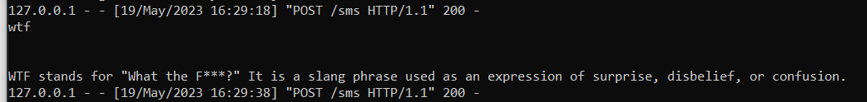

Attempt 4

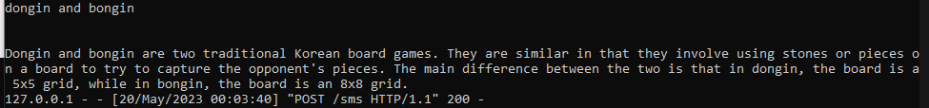

Attempt 5: Loaded After finishing Video

