AJS outbreak report

# Introduction

This is the final template used in the **sitrep** case study.

Here we would give an executive summary of the report findings and recommentations.

## Installing and loading required packages

### Person

From the start of the outbreak up until 2017-W16 there were a total of 1436 cases. There were 717 (49.9%) females and 719 (50.1%) males.

The most affected age group was 3-14 years.

#### Demographics

Cases by age group and definition

|  |  |  |  |  |  |  |  |  |  |
| --- | --- | --- | --- | --- | --- | --- | --- | --- | --- |
| Age group | Confirmed cases (n) | % | Probable cases (n) | % | Suspected cases (n) | % | Missing cases (n) | % | Total |
| 0-2 | 4 | 4.0 | 0 | 0.0 | 40 | 5.8 | 23 | 3.7 | 67 |
| 3-14 | 30 | 30.3 | 1 | 16.7 | 284 | 40.9 | 320 | 50.9 | 635 |
| 15-29 | 46 | 46.5 | 2 | 33.3 | 246 | 35.4 | 180 | 28.6 | 474 |
| 30-44 | 15 | 15.2 | 2 | 33.3 | 95 | 13.7 | 76 | 12.1 | 188 |
| 45+ | 4 | 4.0 | 1 | 16.7 | 29 | 4.2 | 30 | 4.8 | 64 |
| Total | 99 | 100.0 | 6 | 100.0 | 694 | 100.0 | 629 | 100.0 | 1428 |

Cases by age group and sex

|  |  |  |  |  |  |
| --- | --- | --- | --- | --- | --- |
| Age group | F cases (n) | % | M cases (n) | % | Total |
| 0-2 | 26 | 1.8 | 41 | 2.9 | 67 |
| 3-14 | 222 | 15.5 | 413 | 28.9 | 635 |
| 15-29 | 316 | 22.1 | 158 | 11.1 | 474 |
| 30-44 | 118 | 8.3 | 70 | 4.9 | 188 |
| 45+ | 32 | 2.2 | 32 | 2.2 | 64 |
| Total | 714 | 50.0 | 714 | 50.0 | 1428 |

Age pyramid

There were 0 (0.0%) cases missing information on sex and 8 (0.6%) missing age group.

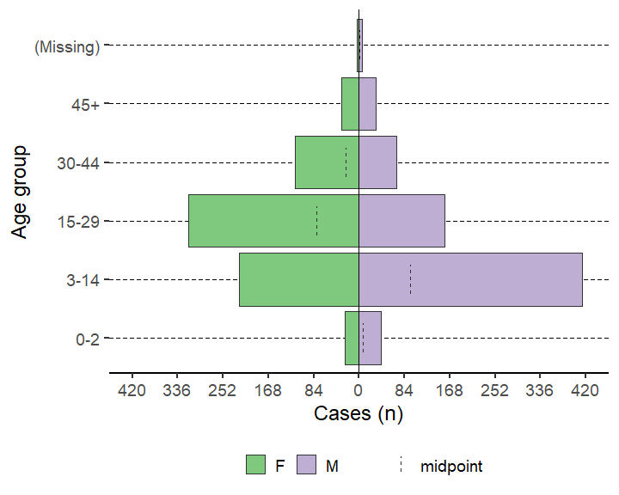

Of the patients, 691 (48.1%) were seen as outpatients and 86 (6.0%) were inpatients.

Age pyramid for under 2

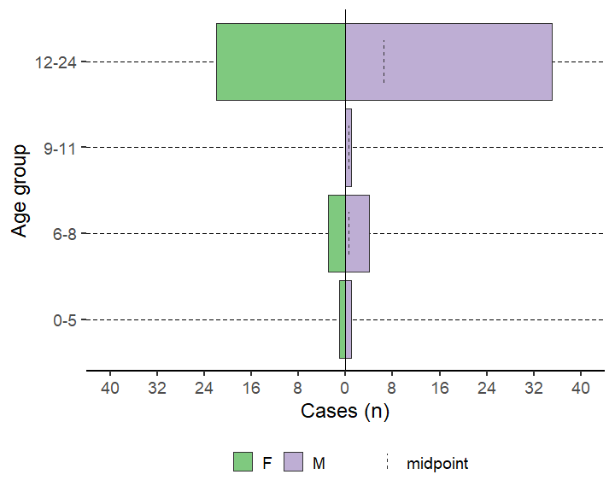

Cases by symptoms

|  |  |  |
| --- | --- | --- |
| variable | n | % |
| Fever | 668 | 84.0 |
| Nausea anorexia | 425 | 53.5 |
| Vomiting | 457 | 57.6 |
| Epigastric pain heartburn | 469 | 59.2 |
| Generalized itch | 512 | 64.6 |
| Headache | 633 | 80.0 |
| Joint pains | 240 | 30.5 |
| Diarrhoea | 112 | 14.2 |
| Bleeding | 52 | 6.6 |

Cases by lab results

|  |  |  |  |  |  |  |  |  |  |  |  |  |  |  |
| --- | --- | --- | --- | --- | --- | --- | --- | --- | --- | --- | --- | --- | --- | --- |
| Lab test | Negative (n) | % | Positive (n) | % | IgG-/IgM- (n) | % | IgG-/IgM+ (n) | % | IgG+/IgM- (n) | % | IgG+/IgM+ (n) | % | IgG±/IgM- (n) | % |
| Hep b rdt | 222 | 91.7 | 20 | 8.3 | - | - | - | - | - | - | - | - | - | - |
| Hep c rdt | 239 | 99.2 | 2 | 0.8 | - | - | - | - | - | - | - | - | - | - |
| Hep e rdt | 149 | 59.8 | 100 | 40.2 | - | - | - | - | - | - | - | - | - | - |
| Test hepatitis a | 23 | 100.0 | - | - | - | - | - | - | - | - | - | - | - | - |
| Test hepatitis b | 22 | 95.7 | 1 | 4.3 | - | - | - | - | - | - | - | - | - | - |
| Test hepatitis c | 23 | 100.0 | - | - | - | - | - | - | - | - | - | - | - | - |
| Test hepatitis e igm | 21 | 33.9 | 41 | 66.1 | - | - | - | - | - | - | - | - | - | - |
| Test hepatitis e genotype | - | - | 2 | 100.0 | - | - | - | - | - | - | - | - | - | - |
| Test hepatitis e virus | 7 | 11.3 | 1 | 1.6 | 9 | 14.5 | 14 | 22.6 | 5 | 8.1 | 26 | 41.9 | - | - |
| Malaria rdt at admission | 160 | 63.5 | 92 | 36.5 | - | - | - | - | - | - | - | - | - | - |
| Dengue | - | - | - | - | 12 | 52.2 | - | - | 10 | 43.5 | - | - | 1 | 4.3 |
| Yellow fever | - | - | - | - | 18 | 78.3 | - | - | 5 | 21.7 | - | - | - | - |
| Chikungunya onyongnyong | - | - | - | - | 20 | 87.0 | - | - | 3 | 13.0 | - | - | - | - |
| Other arthropod transmitted virus | 23 | 100.0 | - | - | - | - | - | - | - | - | - | - | - | - |

#### Case fatality ratio

Of 86 (6.0%) inpatients, there have been 13 (0.9%) deaths, of which 0 (0.0%) were dead on arrival.

The case fatality ratio among inpatients with known outcomes is below.

|  |  |  |  |
| --- | --- | --- | --- |
| Deaths | Cases | CFR (%) | 95%CI |
| 13 | 86 | 15.1 | (9.05–24.16) |

The case fatality ratio by sex among inpatients with known outcomes is below.

|  |  |  |  |  |
| --- | --- | --- | --- | --- |
| Sex | Deaths | Cases | CFR (%) | 95%CI |
| F | 11 | 55 | 20.0 | (11.55–32.36) |
| M | 2 | 31 | 6.5 | (1.79–20.72) |
| Total | 13 | 86 | 15.1 | (9.05–24.16) |

CFR by age group among inpatients with known outcomes

|  |  |  |  |  |
| --- | --- | --- | --- | --- |
| Age group | Deaths | Cases | CFR (%) | 95%CI |
| 0-2 | 4 | 11 | 36.4 | (15.17–64.62) |
| 3-14 | 1 | 17 | 5.9 | (1.05–26.98) |
| 15-29 | 5 | 36 | 13.9 | (6.08–28.66) |
| 30-44 | 2 | 17 | 11.8 | (3.29–34.34) |
| 45+ | 1 | 4 | 25.0 | (4.56–69.94) |
| (Missing) | 0 | 1 | 0.0 | (0.00–79.35) |
| Total | 13 | 86 | 15.1 | (9.05–24.16) |

|  |  |  |  |  |
| --- | --- | --- | --- | --- |
| Case definition | Deaths | Cases | CFR (%) | 95%CI |
| Confirmed | 8 | 44 | 18.2 | (9.51–31.96) |
| Suspected | 5 | 42 | 11.9 | (5.19–25.00) |
| Total | 13 | 86 | 15.1 | (9.05–24.16) |

#### Attack rate

The attack rate per 10,000 population is below (based on available population data available for the catchment area/region of interest).

Below gives the attack rate per 10,000 population (N = 62,336)

|  |  |  |
| --- | --- | --- |
| Cases (n) | AR (per 10,000) | 95%CI |
| 1436 | 230.4 | (218.88–242.44) |

Here, we can see that the attack rate for a population of 62,336 was 230.36 (CI 218.88–242.44).

Mortality rate attributable to AJS per 10,000 patients per day

### Time

There were 825 (57.5%) cases missing dates of onset.

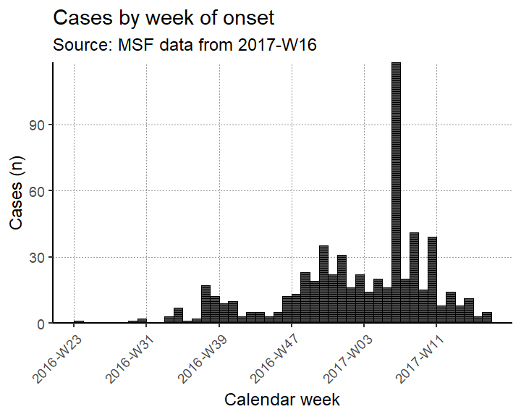

The peak of the outbreak was in 2017-W06

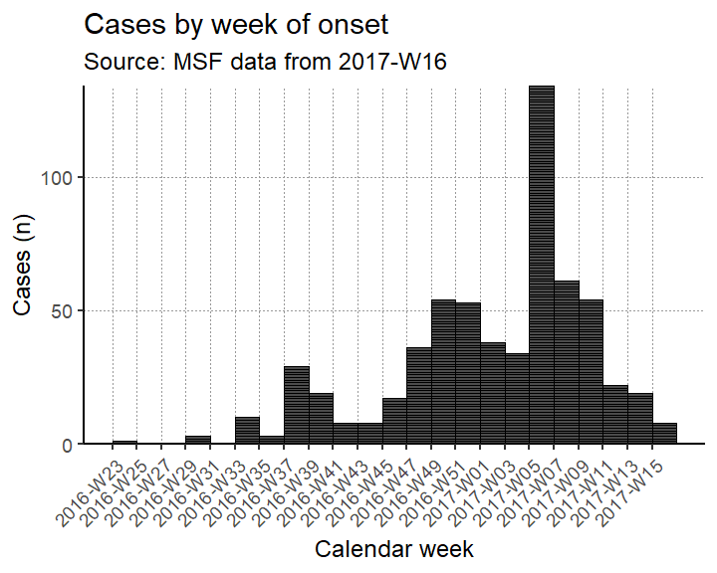

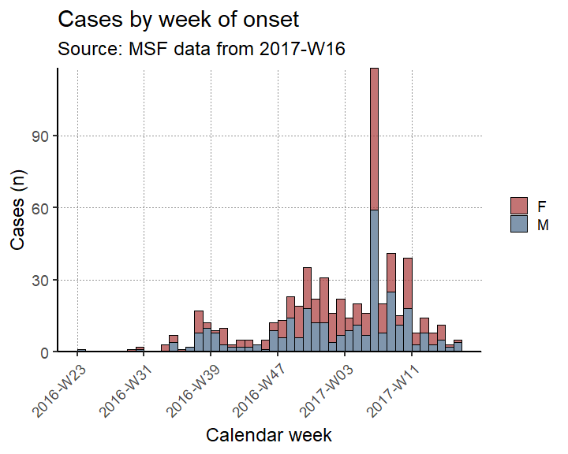

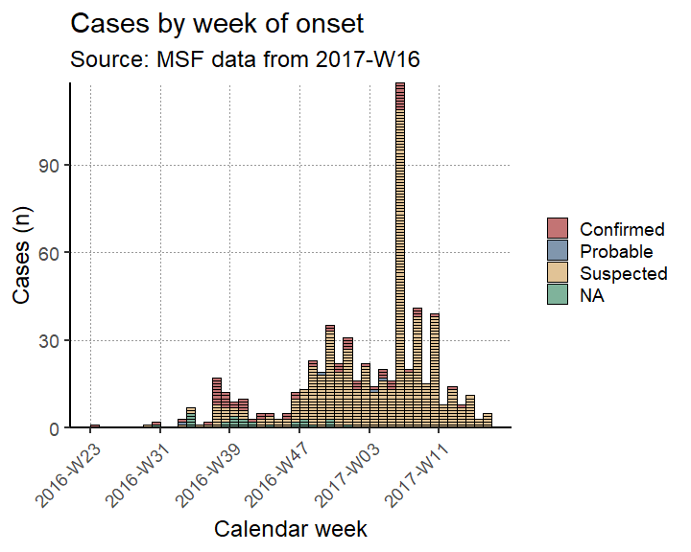

Cases by week of onset among inpatients by sex

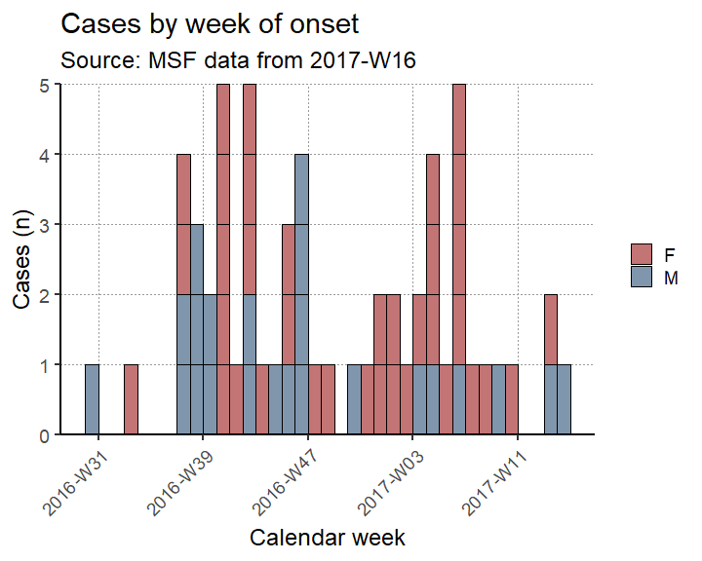

Attack rate per 10,000 population by week

|  |  |  |  |  |
| --- | --- | --- | --- | --- |
| Epiweek | Cases (n) | Population | AR (per 10,000) | 95%CI |
| 2016-W23 | 1 | 62336 | 0.2 | (0.03–0.91) |
| 2016-W24 | 0 | 62336 | 0.0 | (0.00–0.62) |
| 2016-W25 | 0 | 62336 | 0.0 | (0.00–0.62) |
| 2016-W26 | 0 | 62336 | 0.0 | (0.00–0.62) |
| 2016-W27 | 0 | 62336 | 0.0 | (0.00–0.62) |
| 2016-W28 | 0 | 62336 | 0.0 | (0.00–0.62) |
| 2016-W29 | 1 | 62336 | 0.2 | (0.03–0.91) |
| 2016-W30 | 2 | 62336 | 0.3 | (0.09–1.17) |
| 2016-W31 | 0 | 62336 | 0.0 | (0.00–0.62) |
| 2016-W32 | 0 | 62336 | 0.0 | (0.00–0.62) |
| 2016-W33 | 3 | 62336 | 0.5 | (0.16–1.42) |
| 2016-W34 | 7 | 62336 | 1.1 | (0.54–2.32) |
| 2016-W35 | 1 | 62336 | 0.2 | (0.03–0.91) |
| 2016-W36 | 2 | 62336 | 0.3 | (0.09–1.17) |
| 2016-W37 | 17 | 62336 | 2.7 | (1.70–4.37) |
| 2016-W38 | 12 | 62336 | 1.9 | (1.10–3.36) |
| 2016-W39 | 9 | 62336 | 1.4 | (0.76–2.74) |
| 2016-W40 | 10 | 62336 | 1.6 | (0.87–2.95) |
| 2016-W41 | 3 | 62336 | 0.5 | (0.16–1.42) |
| 2016-W42 | 5 | 62336 | 0.8 | (0.34–1.88) |
| 2016-W43 | 5 | 62336 | 0.8 | (0.34–1.88) |
| 2016-W44 | 3 | 62336 | 0.5 | (0.16–1.42) |
| 2016-W45 | 5 | 62336 | 0.8 | (0.34–1.88) |
| 2016-W46 | 12 | 62336 | 1.9 | (1.10–3.36) |
| 2016-W47 | 13 | 62336 | 2.1 | (1.22–3.57) |
| 2016-W48 | 23 | 62336 | 3.7 | (2.46–5.54) |
| 2016-W49 | 19 | 62336 | 3.0 | (1.95–4.76) |
| 2016-W50 | 35 | 62336 | 5.6 | (4.04–7.81) |
| 2016-W51 | 22 | 62336 | 3.5 | (2.33–5.34) |
| 2016-W52 | 31 | 62336 | 5.0 | (3.50–7.06) |
| 2017-W01 | 16 | 62336 | 2.6 | (1.58–4.17) |
| 2017-W02 | 22 | 62336 | 3.5 | (2.33–5.34) |
| 2017-W03 | 14 | 62336 | 2.2 | (1.34–3.77) |
| 2017-W04 | 20 | 62336 | 3.2 | (2.08–4.96) |
| 2017-W05 | 16 | 62336 | 2.6 | (1.58–4.17) |
| 2017-W06 | 118 | 62336 | 18.9 | (15.81–22.66) |
| 2017-W07 | 20 | 62336 | 3.2 | (2.08–4.96) |
| 2017-W08 | 41 | 62336 | 6.6 | (4.85–8.92) |
| 2017-W09 | 15 | 62336 | 2.4 | (1.46–3.97) |
| 2017-W10 | 39 | 62336 | 6.3 | (4.58–8.55) |
| 2017-W11 | 8 | 62336 | 1.3 | (0.65–2.53) |
| 2017-W12 | 14 | 62336 | 2.2 | (1.34–3.77) |
| 2017-W13 | 8 | 62336 | 1.3 | (0.65–2.53) |
| 2017-W14 | 11 | 62336 | 1.8 | (0.99–3.16) |
| 2017-W15 | 3 | 62336 | 0.5 | (0.16–1.42) |
| 2017-W16 | 5 | 62336 | 0.8 | (0.34–1.88) |
| - | 825 | 62336 | 132.3 | (123.67–141.62) |

Cumulative attack rate per 10,000 population per week

|  |  |  |  |  |
| --- | --- | --- | --- | --- |
| Epiweek | Cases (n) | Population | AR (per 10,000) | 95%CI |
| 2016-W23 | 1 | 62336 | 0.2 | (0.03–0.91) |
| 2016-W24 | 1 | 62336 | 0.2 | (0.03–0.91) |
| 2016-W25 | 1 | 62336 | 0.2 | (0.03–0.91) |
| 2016-W26 | 1 | 62336 | 0.2 | (0.03–0.91) |
| 2016-W27 | 1 | 62336 | 0.2 | (0.03–0.91) |
| 2016-W28 | 1 | 62336 | 0.2 | (0.03–0.91) |
| 2016-W29 | 2 | 62336 | 0.3 | (0.09–1.17) |
| 2016-W30 | 4 | 62336 | 0.6 | (0.25–1.65) |
| 2016-W31 | 4 | 62336 | 0.6 | (0.25–1.65) |
| 2016-W32 | 4 | 62336 | 0.6 | (0.25–1.65) |
| 2016-W33 | 7 | 62336 | 1.1 | (0.54–2.32) |
| 2016-W34 | 14 | 62336 | 2.2 | (1.34–3.77) |
| 2016-W35 | 15 | 62336 | 2.4 | (1.46–3.97) |
| 2016-W36 | 17 | 62336 | 2.7 | (1.70–4.37) |
| 2016-W37 | 34 | 62336 | 5.5 | (3.90–7.62) |
| 2016-W38 | 46 | 62336 | 7.4 | (5.53–9.84) |
| 2016-W39 | 55 | 62336 | 8.8 | (6.78–11.48) |
| 2016-W40 | 65 | 62336 | 10.4 | (8.18–13.29) |
| 2016-W41 | 68 | 62336 | 10.9 | (8.61–13.83) |
| 2016-W42 | 73 | 62336 | 11.7 | (9.32–14.72) |
| 2016-W43 | 78 | 62336 | 12.5 | (10.03–15.61) |
| 2016-W44 | 81 | 62336 | 13.0 | (10.46–16.15) |
| 2016-W45 | 86 | 62336 | 13.8 | (11.17–17.03) |
| 2016-W46 | 98 | 62336 | 15.7 | (12.90–19.15) |
| 2016-W47 | 111 | 62336 | 17.8 | (14.79–21.44) |
| 2016-W48 | 134 | 62336 | 21.5 | (18.15–25.45) |
| 2016-W49 | 153 | 62336 | 24.5 | (20.95–28.75) |
| 2016-W50 | 188 | 62336 | 30.2 | (26.15–34.78) |
| 2016-W51 | 210 | 62336 | 33.7 | (29.44–38.55) |
| 2016-W52 | 241 | 62336 | 38.7 | (34.09–43.85) |
| 2017-W01 | 257 | 62336 | 41.2 | (36.49–46.57) |
| 2017-W02 | 279 | 62336 | 44.8 | (39.81–50.31) |
| 2017-W03 | 293 | 62336 | 47.0 | (41.93–52.69) |
| 2017-W04 | 313 | 62336 | 50.2 | (44.96–56.07) |
| 2017-W05 | 329 | 62336 | 52.8 | (47.39–58.78) |
| 2017-W06 | 447 | 62336 | 71.7 | (65.38–78.64) |
| 2017-W07 | 467 | 62336 | 74.9 | (68.44–82.00) |
| 2017-W08 | 508 | 62336 | 81.5 | (74.73–88.86) |
| 2017-W09 | 523 | 62336 | 83.9 | (77.04–91.37) |
| 2017-W10 | 562 | 62336 | 90.2 | (83.03–97.89) |
| 2017-W11 | 570 | 62336 | 91.4 | (84.26–99.22) |
| 2017-W12 | 584 | 62336 | 93.7 | (86.42–101.56) |
| 2017-W13 | 592 | 62336 | 95.0 | (87.65–102.89) |
| 2017-W14 | 603 | 62336 | 96.7 | (89.35–104.73) |
| 2017-W15 | 606 | 62336 | 97.2 | (89.81–105.23) |
| 2017-W16 | 611 | 62336 | 98.0 | (90.58–106.06) |
| - | 1436 | 62336 | 230.4 | (218.88–242.44) |

Case fatality ratio as a proportion among inpatients by week

|  |  |  |  |  |
| --- | --- | --- | --- | --- |
| Epiweek | Deaths | Cases | CFR (%) | 95%CI |
| 2016-W23 | 0 | 0 | - | (NaN–NaN) |
| 2016-W24 | 0 | 0 | - | (NaN–NaN) |
| 2016-W25 | 0 | 0 | - | (NaN–NaN) |
| 2016-W26 | 0 | 0 | - | (NaN–NaN) |
| 2016-W27 | 0 | 0 | - | (NaN–NaN) |
| 2016-W28 | 0 | 0 | - | (NaN–NaN) |
| 2016-W29 | 0 | 0 | - | (NaN–NaN) |
| 2016-W30 | 0 | 1 | 0 | (0.00–79.35) |
| 2016-W31 | 0 | 0 | - | (NaN–NaN) |
| 2016-W32 | 0 | 0 | - | (NaN–NaN) |
| 2016-W33 | 0 | 1 | 0 | (0.00–79.35) |
| 2016-W34 | 0 | 0 | - | (NaN–NaN) |
| 2016-W35 | 0 | 0 | - | (NaN–NaN) |
| 2016-W36 | 0 | 0 | - | (NaN–NaN) |
| 2016-W37 | 0 | 4 | 0 | (0.00–48.99) |
| 2016-W38 | 0 | 3 | 0 | (0.00–56.15) |
| 2016-W39 | 0 | 2 | 0 | (0.00–65.76) |
| 2016-W40 | 0 | 5 | 0 | (0.00–43.45) |
| 2016-W41 | 0 | 1 | 0 | (0.00–79.35) |
| 2016-W42 | 0 | 5 | 0 | (0.00–43.45) |
| 2016-W43 | 0 | 1 | 0 | (0.00–79.35) |
| 2016-W44 | 0 | 1 | 0 | (0.00–79.35) |
| 2016-W45 | 0 | 3 | 0 | (0.00–56.15) |
| 2016-W46 | 0 | 4 | 0 | (0.00–48.99) |
| 2016-W47 | 0 | 1 | 0 | (0.00–79.35) |
| 2016-W48 | 0 | 1 | 0 | (0.00–79.35) |
| 2016-W49 | 0 | 0 | - | (NaN–NaN) |
| 2016-W50 | 0 | 1 | 0 | (0.00–79.35) |
| 2016-W51 | 0 | 1 | 0 | (0.00–79.35) |
| 2016-W52 | 0 | 2 | 0 | (0.00–65.76) |
| 2017-W01 | 0 | 2 | 0 | (0.00–65.76) |
| 2017-W02 | 0 | 1 | 0 | (0.00–79.35) |
| 2017-W03 | 0 | 2 | 0 | (0.00–65.76) |
| 2017-W04 | 0 | 4 | 0 | (0.00–48.99) |
| 2017-W05 | 0 | 1 | 0 | (0.00–79.35) |
| 2017-W06 | 0 | 5 | 0 | (0.00–43.45) |
| 2017-W07 | 0 | 1 | 0 | (0.00–79.35) |
| 2017-W08 | 0 | 1 | 0 | (0.00–79.35) |
| 2017-W09 | 0 | 1 | 0 | (0.00–79.35) |
| 2017-W10 | 0 | 1 | 0 | (0.00–79.35) |
| 2017-W11 | 0 | 0 | - | (NaN–NaN) |
| 2017-W12 | 0 | 0 | - | (NaN–NaN) |
| 2017-W13 | 0 | 2 | 0 | (0.00–65.76) |
| 2017-W14 | 0 | 1 | 0 | (0.00–79.35) |
| 2017-W15 | 0 | 0 | - | (NaN–NaN) |
| 2017-W16 | 0 | 0 | - | (NaN–NaN) |
| (Missing) | 0 | 27 | 0 | (0.00–12.46) |

## Error in stop_if_not_aweek_string(x): aweek strings must match the pattern 'YYYY-Www-d'. The first incorrect string was: '(Missing)'

Inpatient admissions by case definition and week

|  |  |  |  |  |  |
| --- | --- | --- | --- | --- | --- |
| value | Confirmed (n) | % | Suspected (n) | % | Total |
| 2016-W30 | 1 | 3.0 | 0 | 0.0 | 1 |
| 2016-W33 | 0 | 0.0 | 1 | 3.8 | 1 |
| 2016-W37 | 2 | 6.1 | 2 | 7.7 | 4 |
| 2016-W38 | 1 | 3.0 | 2 | 7.7 | 3 |
| 2016-W39 | 1 | 3.0 | 1 | 3.8 | 2 |
| 2016-W40 | 4 | 12.1 | 1 | 3.8 | 5 |
| 2016-W41 | 1 | 3.0 | 0 | 0.0 | 1 |
| 2016-W42 | 2 | 6.1 | 3 | 11.5 | 5 |
| 2016-W43 | 1 | 3.0 | 0 | 0.0 | 1 |
| 2016-W44 | 0 | 0.0 | 1 | 3.8 | 1 |
| 2016-W45 | 2 | 6.1 | 1 | 3.8 | 3 |
| 2016-W46 | 2 | 6.1 | 2 | 7.7 | 4 |
| 2016-W47 | 0 | 0.0 | 1 | 3.8 | 1 |
| 2016-W48 | 1 | 3.0 | 0 | 0.0 | 1 |
| 2016-W50 | 1 | 3.0 | 0 | 0.0 | 1 |
| 2016-W51 | 0 | 0.0 | 1 | 3.8 | 1 |
| 2016-W52 | 2 | 6.1 | 0 | 0.0 | 2 |
| 2017-W01 | 2 | 6.1 | 0 | 0.0 | 2 |
| 2017-W02 | 0 | 0.0 | 1 | 3.8 | 1 |
| 2017-W03 | 0 | 0.0 | 2 | 7.7 | 2 |
| 2017-W04 | 3 | 9.1 | 1 | 3.8 | 4 |
| 2017-W05 | 1 | 3.0 | 0 | 0.0 | 1 |
| 2017-W06 | 4 | 12.1 | 1 | 3.8 | 5 |
| 2017-W07 | 1 | 3.0 | 0 | 0.0 | 1 |
| 2017-W08 | 0 | 0.0 | 1 | 3.8 | 1 |
| 2017-W09 | 0 | 0.0 | 1 | 3.8 | 1 |
| 2017-W10 | 0 | 0.0 | 1 | 3.8 | 1 |
| 2017-W13 | 1 | 3.0 | 1 | 3.8 | 2 |
| 2017-W14 | 0 | 0.0 | 1 | 3.8 | 1 |
| Total | 33 | 100.0 | 26 | 100.0 | 59 |

Inpatient discharges by reason for exit and week

|  |  |  |  |  |  |  |  |  |  |
| --- | --- | --- | --- | --- | --- | --- | --- | --- | --- |
| Week | Dead (n) | % | Discharged (n) | % | Left (n) | % | Missing (n) | % | Total |
| 2016-W30 | 0 | 0.0 | 0 | 0.0 | 0 | 0 | 1 | 7.1 | 1 |
| 2016-W33 | 0 | 0.0 | 1 | 2.9 | 0 | 0 | 0 | 0.0 | 1 |
| 2016-W37 | 0 | 0.0 | 2 | 5.7 | 0 | 0 | 2 | 14.3 | 4 |
| 2016-W38 | 1 | 12.5 | 2 | 5.7 | 0 | 0 | 0 | 0.0 | 3 |
| 2016-W39 | 0 | 0.0 | 2 | 5.7 | 0 | 0 | 0 | 0.0 | 2 |
| 2016-W40 | 1 | 12.5 | 4 | 11.4 | 0 | 0 | 0 | 0.0 | 5 |
| 2016-W41 | 0 | 0.0 | 0 | 0.0 | 1 | 50 | 0 | 0.0 | 1 |
| 2016-W42 | 2 | 25.0 | 1 | 2.9 | 0 | 0 | 2 | 14.3 | 5 |
| 2016-W43 | 0 | 0.0 | 0 | 0.0 | 0 | 0 | 1 | 7.1 | 1 |
| 2016-W44 | 0 | 0.0 | 0 | 0.0 | 0 | 0 | 1 | 7.1 | 1 |
| 2016-W45 | 2 | 25.0 | 0 | 0.0 | 0 | 0 | 1 | 7.1 | 3 |
| 2016-W46 | 0 | 0.0 | 3 | 8.6 | 0 | 0 | 1 | 7.1 | 4 |
| 2016-W47 | 0 | 0.0 | 0 | 0.0 | 0 | 0 | 1 | 7.1 | 1 |
| 2016-W48 | 0 | 0.0 | 0 | 0.0 | 0 | 0 | 1 | 7.1 | 1 |
| 2016-W50 | 0 | 0.0 | 1 | 2.9 | 0 | 0 | 0 | 0.0 | 1 |
| 2016-W51 | 0 | 0.0 | 0 | 0.0 | 0 | 0 | 1 | 7.1 | 1 |
| 2016-W52 | 1 | 12.5 | 0 | 0.0 | 0 | 0 | 1 | 7.1 | 2 |
| 2017-W01 | 0 | 0.0 | 1 | 2.9 | 1 | 50 | 0 | 0.0 | 2 |
| 2017-W02 | 0 | 0.0 | 1 | 2.9 | 0 | 0 | 0 | 0.0 | 1 |
| 2017-W03 | 0 | 0.0 | 2 | 5.7 | 0 | 0 | 0 | 0.0 | 2 |
| 2017-W04 | 0 | 0.0 | 4 | 11.4 | 0 | 0 | 0 | 0.0 | 4 |
| 2017-W05 | 0 | 0.0 | 0 | 0.0 | 0 | 0 | 1 | 7.1 | 1 |
| 2017-W06 | 0 | 0.0 | 5 | 14.3 | 0 | 0 | 0 | 0.0 | 5 |
| 2017-W07 | 1 | 12.5 | 0 | 0.0 | 0 | 0 | 0 | 0.0 | 1 |
| 2017-W08 | 0 | 0.0 | 1 | 2.9 | 0 | 0 | 0 | 0.0 | 1 |
| 2017-W09 | 0 | 0.0 | 1 | 2.9 | 0 | 0 | 0 | 0.0 | 1 |
| 2017-W10 | 0 | 0.0 | 1 | 2.9 | 0 | 0 | 0 | 0.0 | 1 |
| 2017-W13 | 0 | 0.0 | 2 | 5.7 | 0 | 0 | 0 | 0.0 | 2 |
| 2017-W14 | 0 | 0.0 | 1 | 2.9 | 0 | 0 | 0 | 0.0 | 1 |
| Total | 8 | 100.0 | 35 | 100.0 | 2 | 100 | 14 | 100.0 | 59 |

### Place

#### Descriptive

Cases by region and facility type

|  |  |  |  |  |  |  |  |
| --- | --- | --- | --- | --- | --- | --- | --- |
| Region | Inpatient (n) | % | Outpatient (n) | % | Missing (n) | % | Total |
| AB GARA | 0 | 0.0 | 0 | 0.0 | 1 | 0.2 | 1 |
| ABLELAYE | 5 | 6.0 | 1 | 0.1 | 2 | 0.3 | 8 |
| ABOUDEA | 1 | 1.2 | 0 | 0.0 | 0 | 0.0 | 1 |
| ADAMRE | 2 | 2.4 | 22 | 3.2 | 24 | 3.7 | 48 |
| ADJABONA | 0 | 0.0 | 0 | 0.0 | 2 | 0.3 | 2 |
| AFFOUSSE | 1 | 1.2 | 1 | 0.1 | 0 | 0.0 | 2 |
| AL-FRECHE | 1 | 1.2 | 0 | 0.0 | 0 | 0.0 | 1 |
| AL-HOUGNA | 1 | 1.2 | 10 | 1.5 | 10 | 1.5 | 21 |
| AL-MOURA | 1 | 1.2 | 0 | 0.0 | 0 | 0.0 | 1 |
| AL ALAK | 0 | 0.0 | 1 | 0.1 | 0 | 0.0 | 1 |
| AL HOUA | 0 | 0.0 | 0 | 0.0 | 1 | 0.2 | 1 |
| AL KOUCK | 0 | 0.0 | 1 | 0.1 | 0 | 0.0 | 1 |
| AL MIDODIL | 1 | 1.2 | 0 | 0.0 | 0 | 0.0 | 1 |
| ALBAYADI | 1 | 1.2 | 1 | 0.1 | 0 | 0.0 | 2 |
| ALBOUKHASS | 0 | 0.0 | 6 | 0.9 | 6 | 0.9 | 12 |
| ALKASSÉ | 4 | 4.8 | 15 | 2.2 | 5 | 0.8 | 24 |
| AM-DOUMA | 0 | 0.0 | 1 | 0.1 | 0 | 0.0 | 1 |
| AM ASSALA | 0 | 0.0 | 1 | 0.1 | 0 | 0.0 | 1 |
| AM BADARO 1 | 0 | 0.0 | 1 | 0.1 | 0 | 0.0 | 1 |
| AM KIFEO | 1 | 1.2 | 0 | 0.0 | 0 | 0.0 | 1 |
| AMANASISSE | 0 | 0.0 | 1 | 0.1 | 0 | 0.0 | 1 |
| AMBARITE | 0 | 0.0 | 3 | 0.4 | 1 | 0.2 | 4 |
| AMCHOKA | 1 | 1.2 | 0 | 0.0 | 0 | 0.0 | 1 |
| AMDIREDIMAT | 1 | 1.2 | 0 | 0.0 | 0 | 0.0 | 1 |
| AMDJALAT | 0 | 0.0 | 2 | 0.3 | 2 | 0.3 | 4 |
| AMMANASIS | 0 | 0.0 | 0 | 0.0 | 2 | 0.3 | 2 |
| AMSINENE | 3 | 3.6 | 5 | 0.7 | 5 | 0.8 | 13 |
| ANALA | 2 | 2.4 | 2 | 0.3 | 4 | 0.6 | 8 |
| ANFANDOCK | 5 | 6.0 | 26 | 3.8 | 19 | 2.9 | 50 |
| ANGUITEI | 0 | 0.0 | 0 | 0.0 | 1 | 0.2 | 1 |
| ANGUITEYE | 0 | 0.0 | 0 | 0.0 | 1 | 0.2 | 1 |
| ARDO | 3 | 3.6 | 2 | 0.3 | 0 | 0.0 | 5 |
| ATETAL | 0 | 0.0 | 0 | 0.0 | 1 | 0.2 | 1 |
| ATOUA | 1 | 1.2 | 1 | 0.1 | 0 | 0.0 | 2 |
| BADINA | 0 | 0.0 | 1 | 0.1 | 0 | 0.0 | 1 |
| BANDJADID | 0 | 0.0 | 1 | 0.1 | 0 | 0.0 | 1 |
| BAUNE | 1 | 1.2 | 0 | 0.0 | 0 | 0.0 | 1 |
| BIR TAGAL | 0 | 0.0 | 1 | 0.1 | 0 | 0.0 | 1 |
| BRANO | 0 | 0.0 | 1 | 0.1 | 0 | 0.0 | 1 |
| CHATAU | 0 | 0.0 | 0 | 0.0 | 1 | 0.2 | 1 |
| COMMERCANT | 0 | 0.0 | 3 | 0.4 | 15 | 2.3 | 18 |
| COUBO ABNIMIR | 0 | 0.0 | 1 | 0.1 | 0 | 0.0 | 1 |
| DARASALAM | 0 | 0.0 | 26 | 3.8 | 25 | 3.8 | 51 |
| DARWAL | 1 | 1.2 | 0 | 0.0 | 0 | 0.0 | 1 |
| DELEBAE | 1 | 1.2 | 1 | 0.1 | 0 | 0.0 | 2 |
| DIFFIR | 2 | 2.4 | 2 | 0.3 | 0 | 0.0 | 4 |
| DIJEKHINÉ | 1 | 1.2 | 0 | 0.0 | 0 | 0.0 | 1 |
| DILEMA | 3 | 3.6 | 22 | 3.2 | 18 | 2.8 | 43 |
| DINGUESS | 2 | 2.4 | 2 | 0.3 | 3 | 0.5 | 7 |
| DJAMBALBAHAR | 0 | 0.0 | 9 | 1.3 | 6 | 0.9 | 15 |
| DJOGO | 0 | 0.0 | 1 | 0.1 | 0 | 0.0 | 1 |
| GANATIR | 5 | 6.0 | 113 | 16.5 | 102 | 15.6 | 220 |
| GANATIR 1 | 0 | 0.0 | 2 | 0.3 | 7 | 1.1 | 9 |
| GANATIR 2 | 0 | 0.0 | 7 | 1.0 | 5 | 0.8 | 12 |
| GARDOLE | 0 | 0.0 | 1 | 0.1 | 2 | 0.3 | 3 |
| GOURMOUDAY | 0 | 0.0 | 2 | 0.3 | 1 | 0.2 | 3 |
| GOZ-TAMADJA | 1 | 1.2 | 2 | 0.3 | 0 | 0.0 | 3 |
| GOZ DJARAT | 1 | 1.2 | 0 | 0.0 | 0 | 0.0 | 1 |
| GOZ MABILE | 1 | 1.2 | 7 | 1.0 | 11 | 1.7 | 19 |
| GOZ MABILE 2 | 1 | 1.2 | 5 | 0.7 | 8 | 1.2 | 14 |
| GRÉDAÏ | 0 | 0.0 | 1 | 0.1 | 0 | 0.0 | 1 |
| HABILÉ | 0 | 0.0 | 1 | 0.1 | 0 | 0.0 | 1 |
| HARAZA | 1 | 1.2 | 0 | 0.0 | 0 | 0.0 | 1 |
| HILE BARA | 2 | 2.4 | 13 | 1.9 | 5 | 0.8 | 20 |
| HILE ODAA | 0 | 0.0 | 2 | 0.3 | 0 | 0.0 | 2 |
| HIMEDA | 0 | 0.0 | 1 | 0.1 | 0 | 0.0 | 1 |
| IDETER | 0 | 0.0 | 1 | 0.1 | 0 | 0.0 | 1 |
| KACHKACHA | 3 | 3.6 | 1 | 0.1 | 2 | 0.3 | 6 |
| KOUBO AMNIMIRE | 0 | 0.0 | 0 | 0.0 | 3 | 0.5 | 3 |
| MABROUKA | 0 | 0.0 | 0 | 0.0 | 1 | 0.2 | 1 |
| MATAR | 0 | 0.0 | 2 | 0.3 | 2 | 0.3 | 4 |
| MINA | 2 | 2.4 | 3 | 0.4 | 8 | 1.2 | 13 |
| MIRÉKIKE | 1 | 1.2 | 0 | 0.0 | 0 | 0.0 | 1 |
| MIRER | 1 | 1.2 | 0 | 0.0 | 0 | 0.0 | 1 |
| MOURAY | 0 | 0.0 | 1 | 0.1 | 0 | 0.0 | 1 |
| NOUGRA KARO | 0 | 0.0 | 1 | 0.1 | 0 | 0.0 | 1 |
| OUM-ALKHOURA | 0 | 0.0 | 0 | 0.0 | 2 | 0.3 | 2 |
| PEDIS | 0 | 0.0 | 1 | 0.1 | 0 | 0.0 | 1 |
| RASSAFIL CHATEAU | 0 | 0.0 | 0 | 0.0 | 1 | 0.2 | 1 |
| RASSALFIL | 3 | 3.6 | 6 | 0.9 | 2 | 0.3 | 11 |
| RIAD | 3 | 3.6 | 37 | 5.4 | 47 | 7.2 | 87 |
| RIDINA | 0 | 0.0 | 72 | 10.5 | 75 | 11.5 | 147 |
| RIDINA 1 | 0 | 0.0 | 2 | 0.3 | 9 | 1.4 | 11 |
| RIDINA 2 | 0 | 0.0 | 5 | 0.7 | 19 | 2.9 | 24 |
| RIMELIE | 0 | 0.0 | 1 | 0.1 | 0 | 0.0 | 1 |
| SALAMAT | 2 | 2.4 | 22 | 3.2 | 23 | 3.5 | 47 |
| SIHEBA | 1 | 1.2 | 0 | 0.0 | 0 | 0.0 | 1 |
| TARADONA | 2 | 2.4 | 136 | 19.9 | 97 | 14.9 | 235 |
| TARADONA 1 | 1 | 1.2 | 14 | 2.0 | 19 | 2.9 | 34 |
| TARADONA 2 | 5 | 6.0 | 39 | 5.7 | 19 | 2.9 | 63 |
| TARADONA 3 | 1 | 1.2 | 6 | 0.9 | 26 | 4.0 | 33 |
| ZONGO | 0 | 0.0 | 3 | 0.4 | 1 | 0.2 | 4 |
| Total | 83 | 100.0 | 684 | 100.0 | 652 | 100.0 | 1419 |

Inpatient discharges by reason for exit and region

|  |  |  |  |  |  |  |  |  |  |
| --- | --- | --- | --- | --- | --- | --- | --- | --- | --- |
| Region | Dead (n) | % | Discharged (n) | % | Left (n) | % | Missing (n) | % | Total |
| ABLELAYE | 1 | 7.7 | 4 | 7.8 | 0 | 0 | 0 | 0.0 | 5 |
| ABOUDEA | 0 | 0.0 | 1 | 2.0 | 0 | 0 | 0 | 0.0 | 1 |
| ADAMRE | 0 | 0.0 | 0 | 0.0 | 1 | 50 | 1 | 5.9 | 2 |
| AFFOUSSE | 0 | 0.0 | 1 | 2.0 | 0 | 0 | 0 | 0.0 | 1 |
| AL-FRECHE | 0 | 0.0 | 1 | 2.0 | 0 | 0 | 0 | 0.0 | 1 |
| AL-HOUGNA | 1 | 7.7 | 0 | 0.0 | 0 | 0 | 0 | 0.0 | 1 |
| AL-MOURA | 0 | 0.0 | 1 | 2.0 | 0 | 0 | 0 | 0.0 | 1 |
| AL MIDODIL | 0 | 0.0 | 1 | 2.0 | 0 | 0 | 0 | 0.0 | 1 |
| ALBAYADI | 0 | 0.0 | 1 | 2.0 | 0 | 0 | 0 | 0.0 | 1 |
| ALKASSÉ | 0 | 0.0 | 4 | 7.8 | 0 | 0 | 0 | 0.0 | 4 |
| AM KIFEO | 0 | 0.0 | 1 | 2.0 | 0 | 0 | 0 | 0.0 | 1 |
| AMCHOKA | 0 | 0.0 | 1 | 2.0 | 0 | 0 | 0 | 0.0 | 1 |
| AMDIREDIMAT | 0 | 0.0 | 1 | 2.0 | 0 | 0 | 0 | 0.0 | 1 |
| AMSINENE | 1 | 7.7 | 0 | 0.0 | 0 | 0 | 2 | 11.8 | 3 |
| ANALA | 0 | 0.0 | 0 | 0.0 | 1 | 50 | 1 | 5.9 | 2 |
| ANFANDOCK | 1 | 7.7 | 4 | 7.8 | 0 | 0 | 0 | 0.0 | 5 |
| ARDO | 0 | 0.0 | 2 | 3.9 | 0 | 0 | 1 | 5.9 | 3 |
| ATOUA | 0 | 0.0 | 1 | 2.0 | 0 | 0 | 0 | 0.0 | 1 |
| BAUNE | 0 | 0.0 | 1 | 2.0 | 0 | 0 | 0 | 0.0 | 1 |
| DARWAL | 0 | 0.0 | 1 | 2.0 | 0 | 0 | 0 | 0.0 | 1 |
| DELEBAE | 1 | 7.7 | 0 | 0.0 | 0 | 0 | 0 | 0.0 | 1 |
| DIFFIR | 0 | 0.0 | 2 | 3.9 | 0 | 0 | 0 | 0.0 | 2 |
| DIJEKHINÉ | 0 | 0.0 | 1 | 2.0 | 0 | 0 | 0 | 0.0 | 1 |
| DILEMA | 0 | 0.0 | 2 | 3.9 | 0 | 0 | 1 | 5.9 | 3 |
| DINGUESS | 1 | 7.7 | 1 | 2.0 | 0 | 0 | 0 | 0.0 | 2 |
| GANATIR | 0 | 0.0 | 4 | 7.8 | 0 | 0 | 1 | 5.9 | 5 |
| GOZ-TAMADJA | 0 | 0.0 | 0 | 0.0 | 0 | 0 | 1 | 5.9 | 1 |
| GOZ DJARAT | 0 | 0.0 | 0 | 0.0 | 0 | 0 | 1 | 5.9 | 1 |
| GOZ MABILE | 1 | 7.7 | 0 | 0.0 | 0 | 0 | 0 | 0.0 | 1 |
| GOZ MABILE 2 | 0 | 0.0 | 0 | 0.0 | 0 | 0 | 1 | 5.9 | 1 |
| HARAZA | 1 | 7.7 | 0 | 0.0 | 0 | 0 | 0 | 0.0 | 1 |
| HILE BARA | 0 | 0.0 | 2 | 3.9 | 0 | 0 | 0 | 0.0 | 2 |
| KACHKACHA | 2 | 15.4 | 1 | 2.0 | 0 | 0 | 0 | 0.0 | 3 |
| MINA | 1 | 7.7 | 1 | 2.0 | 0 | 0 | 0 | 0.0 | 2 |
| MIRÉKIKE | 0 | 0.0 | 1 | 2.0 | 0 | 0 | 0 | 0.0 | 1 |
| MIRER | 0 | 0.0 | 1 | 2.0 | 0 | 0 | 0 | 0.0 | 1 |
| RASSALFIL | 0 | 0.0 | 3 | 5.9 | 0 | 0 | 0 | 0.0 | 3 |
| RIAD | 1 | 7.7 | 1 | 2.0 | 0 | 0 | 1 | 5.9 | 3 |
| SALAMAT | 0 | 0.0 | 2 | 3.9 | 0 | 0 | 0 | 0.0 | 2 |
| SIHEBA | 0 | 0.0 | 1 | 2.0 | 0 | 0 | 0 | 0.0 | 1 |
| TARADONA | 0 | 0.0 | 1 | 2.0 | 0 | 0 | 1 | 5.9 | 2 |
| TARADONA 1 | 0 | 0.0 | 0 | 0.0 | 0 | 0 | 1 | 5.9 | 1 |
| TARADONA 2 | 1 | 7.7 | 1 | 2.0 | 0 | 0 | 3 | 17.6 | 5 |
| TARADONA 3 | 0 | 0.0 | 0 | 0.0 | 0 | 0 | 1 | 5.9 | 1 |
| Total | 13 | 100.0 | 51 | 100.0 | 2 | 100 | 17 | 100.0 | 83 |

Attack rage per 10,000 population by region

|  |  |  |  |  |
| --- | --- | --- | --- | --- |
| Region | Cases (n) | Population | AR (per 10,000) | 95%CI |
| - | 17 | - | - | (NA–NA) |
| AB GARA | 1 | - | - | (NA–NA) |
| ABLELAYE | 8 | - | - | (NA–NA) |
| ABOUDEA | 1 | - | - | (NA–NA) |
| ADAMRE | 48 | - | - | (NA–NA) |
| ADJABONA | 2 | 2,350 | 8.5 | (2.33–30.98) |
| AFFOUSSE | 2 | - | - | (NA–NA) |
| AL-FRECHE | 1 | - | - | (NA–NA) |
| AL-HOUGNA | 21 | - | - | (NA–NA) |
| AL-MOURA | 1 | - | - | (NA–NA) |
| AL ALAK | 1 | - | - | (NA–NA) |
| AL HOUA | 1 | - | - | (NA–NA) |
| AL KOUCK | 1 | - | - | (NA–NA) |
| AL MIDODIL | 1 | - | - | (NA–NA) |
| ALBAYADI | 2 | - | - | (NA–NA) |
| ALBOUKHASS | 12 | - | - | (NA–NA) |
| ALKASSÉ | 24 | - | - | (NA–NA) |
| AM-DOUMA | 1 | - | - | (NA–NA) |
| AM ASSALA | 1 | - | - | (NA–NA) |
| AM BADARO 1 | 1 | - | - | (NA–NA) |
| AM KIFEO | 1 | - | - | (NA–NA) |
| AMANASISSE | 1 | - | - | (NA–NA) |
| AMBARITE | 4 | - | - | (NA–NA) |
| AMCHOKA | 1 | - | - | (NA–NA) |
| AMDIREDIMAT | 1 | - | - | (NA–NA) |
| AMDJALAT | 4 | - | - | (NA–NA) |
| AMMANASIS | 2 | - | - | (NA–NA) |
| AMSINENE | 13 | - | - | (NA–NA) |
| ANALA | 8 | - | - | (NA–NA) |
| ANFANDOCK | 50 | - | - | (NA–NA) |
| ANGUITEI | 1 | - | - | (NA–NA) |
| ANGUITEYE | 1 | - | - | (NA–NA) |
| ARDO | 5 | - | - | (NA–NA) |
| ATETAL | 1 | - | - | (NA–NA) |
| ATOUA | 2 | - | - | (NA–NA) |
| BADINA | 1 | - | - | (NA–NA) |
| BANDJADID | 1 | - | - | (NA–NA) |
| BAUNE | 1 | - | - | (NA–NA) |
| BIR TAGAL | 1 | - | - | (NA–NA) |
| BRANO | 1 | - | - | (NA–NA) |
| CHATAU | 1 | - | - | (NA–NA) |
| COMMERCANT | 18 | - | - | (NA–NA) |
| COUBO ABNIMIR | 1 | - | - | (NA–NA) |
| DARASALAM | 51 | - | - | (NA–NA) |
| DARWAL | 1 | - | - | (NA–NA) |
| DELEBAE | 2 | - | - | (NA–NA) |
| DIFFIR | 4 | - | - | (NA–NA) |
| DIJEKHINÉ | 1 | - | - | (NA–NA) |
| DILEMA | 43 | - | - | (NA–NA) |
| DINGUESS | 7 | 2,268 | 30.9 | (14.96–63.57) |
| DJAMBALBAHAR | 15 | - | - | (NA–NA) |
| DJOGO | 1 | - | - | (NA–NA) |
| GANATIR | 220 | - | - | (NA–NA) |
| GANATIR 1 | 9 | - | - | (NA–NA) |
| GANATIR 2 | 12 | - | - | (NA–NA) |
| GARDOLE | 3 | 2,286 | 13.1 | (4.46–38.51) |
| GOURMOUDAY | 3 | - | - | (NA–NA) |
| GOZ-TAMADJA | 3 | - | - | (NA–NA) |
| GOZ DJARAT | 1 | - | - | (NA–NA) |
| GOZ MABILE | 19 | - | - | (NA–NA) |
| GOZ MABILE 2 | 14 | 3,086 | 45.4 | (27.04–76.01) |
| GRÉDAÏ | 1 | - | - | (NA–NA) |
| HABILÉ | 1 | - | - | (NA–NA) |
| HARAZA | 1 | - | - | (NA–NA) |
| HILE BARA | 20 | - | - | (NA–NA) |
| HILE ODAA | 2 | - | - | (NA–NA) |
| HIMEDA | 1 | - | - | (NA–NA) |
| IDETER | 1 | - | - | (NA–NA) |
| KACHKACHA | 6 | - | - | (NA–NA) |
| KOUBO AMNIMIRE | 3 | - | - | (NA–NA) |
| MABROUKA | 1 | - | - | (NA–NA) |
| MATAR | 4 | 569 | 70.3 | (27.37–179.34) |
| MINA | 13 | - | - | (NA–NA) |
| MIRÉKIKE | 1 | - | - | (NA–NA) |
| MIRER | 1 | - | - | (NA–NA) |
| MOURAY | 1 | - | - | (NA–NA) |
| NOUGRA KARO | 1 | - | - | (NA–NA) |
| OUM-ALKHOURA | 2 | - | - | (NA–NA) |
| PEDIS | 1 | - | - | (NA–NA) |
| RASSAFIL CHATEAU | 1 | - | - | (NA–NA) |
| RASSALFIL | 11 | - | - | (NA–NA) |
| RIAD | 87 | 6,073 | 143.3 | (116.29–176.36) |
| RIDINA | 147 | - | - | (NA–NA) |
| RIDINA 1 | 11 | 2,336 | 47.1 | (26.31–84.13) |
| RIDINA 2 | 24 | 3,734 | 64.3 | (43.23–95.46) |
| RIMELIE | 1 | - | - | (NA–NA) |
| SALAMAT | 47 | - | - | (NA–NA) |
| SIHEBA | 1 | - | - | (NA–NA) |
| TARADONA | 235 | - | - | (NA–NA) |
| TARADONA 1 | 34 | 6,484 | 52.4 | (37.55–73.18) |
| TARADONA 2 | 63 | 5,250 | 120.0 | (93.91–153.23) |
| TARADONA 3 | 33 | 5,416 | 60.9 | (43.42–85.44) |
| ZONGO | 4 | 1,607 | 24.9 | (9.68–63.83) |

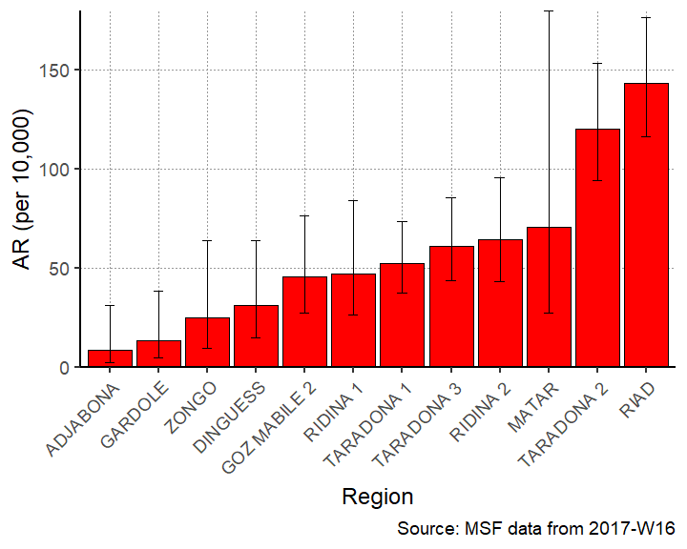

Mortality rate per 10,000 population by region

|  |  |  |  |  |
| --- | --- | --- | --- | --- |
| Region | Deaths | Population | Mortality (per 10,000) | 95%CI |
| ABLELAYE | 1 | - | - | (NA–NA) |
| AL-HOUGNA | 1 | - | - | (NA–NA) |
| AMSINENE | 1 | - | - | (NA–NA) |
| ANFANDOCK | 1 | - | - | (NA–NA) |
| BADINA | 1 | - | - | (NA–NA) |
| DELEBAE | 1 | - | - | (NA–NA) |
| DINGUESS | 1 | 2268 | 4.4 | (0.78–24.93) |
| GOZ MABILE | 1 | - | - | (NA–NA) |
| HARAZA | 1 | - | - | (NA–NA) |
| KACHKACHA | 2 | - | - | (NA–NA) |
| MINA | 1 | - | - | (NA–NA) |
| RIAD | 1 | 6073 | 1.6 | (0.29–9.32) |
| TARADONA 2 | 1 | 5250 | 1.9 | (0.34–10.78) |

#### Maps

## Coordinate Reference System:  
## EPSG: 4326   
## proj4string: "+proj=longlat +datum=WGS84 +no_defs"

