KAN PHAM

[**KOHIU.COM**](http://kohiu.com/) **| Art, Illustrations and Designs**

*2023 KOHIU Illustrations All Rights Reserved*

Member of The Cartoonist Cooperative.

Copyright Office of Artificial Intelligence Study.

**U.S. Copyright Office**

101 Independence Ave. S.E.

Washington, D.C.

To Whom It May Concern,

Thank you for the opportunity to comment on Artificial Intelligence Study. My name is Kan Pham, I am a freelance artist from Vietnam, I've been working under the pen name “Kohiu” for 13 years - my work involved with Illustrations, Designs, 2D art assets for video games and other interactive media. I am currently an active member of the organisation ‘The Cartoonist Cooperative’. My credential consists of a Bachelor of Arts in Linguistics from Ho Chi Minh City University of Foreign Languages and Information Technology (abbreviation: HUFLIT).

I would like to bring to the agency’s attention the concerns of copyright and AI.

The concerns included:

1. The use of copyrighted material in training AI
2. Full transparency: opt-in consent, compensation and credit.
3. Permissible copyright on AI generated output
4. Enforcing copyright infringement
5. Classification of AI-generated materials and/or output.

Regardless of the major points listed above, I believe the US has influenced in a rapid, massive international scale which affected artists and studios like myself in The Socialist Republic of Vietnam. Should the agency’s in concerns of its legislative relevancy to workers in such non-US country, please put into consideration of how we have taken ongoing actions in regarding to AI use.

Sincerely,

Kan Pham

(submitted on 26 October 2023, GMT+7)

## The use of copyrighted material in training AI

On August 10, 2022, Stable DIffusion first announced its Stability AI to the public [^1]. According to the company’s original pitch: “Stable Diffusion is a text-to-image model empowering billions of people to create stunning art within seconds.”

In the course of 14-months since its first launch, having to witness the art community - my community - to tear each other apart from large scale to miniscule details. While art thefts, and plagiarism has been persists from local art venue to global-scale of visual art creators, with Stability AI’s “create art within seconds” to generate even more countless images that are not only infringe on existing copyrighted works, but also exacerbated on the ongoing plagiarism problems within our community [^2].

While Stable Diffusion has failed to be full transparent on which Copyrighted materials they had trained on the Large Language Model (LLMs) on its Stability AI, as known as, “datasets”. Its generated output has proven to show up watermarks in result.

These copyrighted materials included.

1. Images from Stock photo company of Getty Images. Getty Images public statement [3]. Additional comment with The Verge [^4]
2. Artworks from prolific artists such as Greg Rutkowski.[^5] Sarah Andersen [^6] and Quentin Blake [^7]
3. 75 million galleries across the art hosting website Deviantart, many have not opted-out due to Deviantart’s default direct install of Diffusion on its website.

For Stable Diffusion to be able to create a large quantity of generative output, LAION-5B is a dataset derived from Common Crawl data scraped from the web. However, this action of data scraping has been done without consent from User-generated content platforms [^8].

In late 2022, while I was already busy with rewriting my freelance contract due to the NFT boom within the online art market. [^9] Little did I and my creative partner had anticipated another wave of we called “Generative AI art”, in which both of us had neutral feelings at the time. As a digital artist that has been working off multiple programs such as Adobe Photoshop, Adobe Illustration, Paint tool SAI, CLIP Paint Studio. I too have experimented with various art softwares have included generative tools in them. One of the examples is the Colorize (Technology preview) which is available to all version of CLIP Paint Studio [^10]

[image sample]

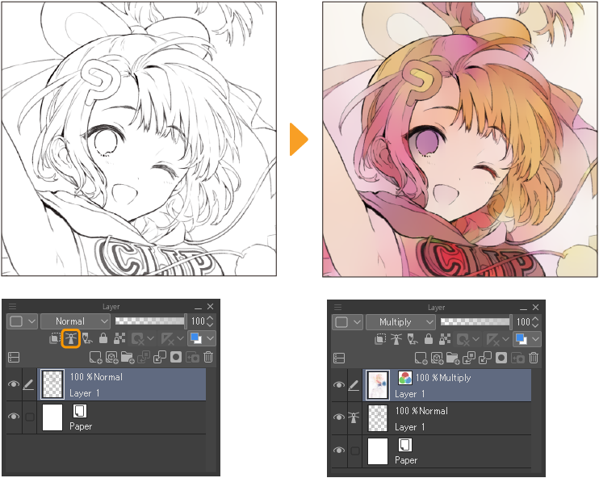

My background as a digital artist who fully endorse the innovative technology of arts, if more, we were promised that AI-generative tool could reduce the burden of repetitive stress-induced-tasks: such as line art, colouring, lettering, quality assurance and many labour intensive stress which also affected us physically and mentally speaking.

This promise has fallen flat on us, but instead, the AI-generated tools introduced by Stable Diffusion, Adobe Firefly, DALL-E and several of their copycats have created an armageddon on unregulated art thefts, plagiarism, and has raised concerns of copyright violation.

On 17 August 2023, The Japan Publishers Association has published the rights of copyright holders being violated by generative AI. Their statement [^11] included:

* As a large amount of content is generated without the value of educational use being returned to copyright holders. Creative opportunities and writing activities become hindered, which are attributed to difficult the economy.
* Unethical AI will be developed and generated using illegal means such as piracy.
* Copyright-infringing content that is highly dependent on and similar to the original work is generated and spread. AI users themselves may unintentionally commit illegal acts that infringe on rights.
* Article 30-4 of the Copyright Act was revised in 2018, but at the time, the negative impact of advanced AI such as generative AI was not fully anticipated.
* It is necessary to clarify the interpretation of the proviso to Article 30-4 and assess the need to revise the Copyright Act (in Japan).

## Full transparency: opt-in consent, compensation and credit.

These are my proposed solutions in terms of providing full transparency for copyrights holders and their company.

* It is in our best interests to mandate opt-in consent across all creative, user-generated content platforms. Abolish all forms of data scraping, ‘crawler’ technology of all domains. This includes privatised domains, individual to public domains.
* There should be no such thing as “consent by default”, if a copyright holders wish to include their works into a dataset, this should be done by the copyright holders and involved parties by full, explicit consent.
* Should a company wish to use the copyright holders’ materials for generative output: a contract with expiry date should be established, and agreed by both Parties.

## Permissible copyright on AI generated output

Under the circumstances when a human “author” has used a generative AI tool, such as Midjouney [^12]. Whether this individual’s intention is to speed up the process of intended creative output, or simply use for educational and/or personal recreation use. Only the copywriter holders of this dataset can claim “ownership” of this generative output. It is required for the party to be explicit on the generative tool, as well as full transparency on the generated process in their result.

As a non-US resident, I cannot speak on whether the Constitution, nor the justification from the current U.S. Copyright Law should permit copyright protection for AI-generated material within the U.S. However, I can only advise on the Decree 17/2023/ND-CP guiding copyright and related rights in Vietnam [^13]. Under Copyrights and Related Clause, Section 1, Article 6, which states:

“Works of applied art specified under Point g Clause 1 Article 14 of the Law on Intellectual Property are works expressed by lines, color, shapes, and compositions with **useful functions,** potentially associated with a **useful item, and manufactured manually or industrially** and include: Graphic design (presentation of product logos, identity, and packaging; presentation of characters); fashion design; aesthetic design associated with forming products; aesthetic interior design, interior and exterior decoration. Works of applied art are expressed by aesthetic shaping of products, **cannot be easily created by persons with average understanding in respective field**, and do not require aesthetic exterior in order to function.”

In Article 8. **Works not eligible for copyright protection**, has stated:

A system is a combination of factors, units of the same types or functions that are closely connected or correlated and create a unified form;

AI-generated material, which works as a system - combination of same types and functions (as known as, Collages) **can not receive copyrights protection** in the Socialist Republic of Vietnam. I believe the agency should find this clause useful, and applicable to the Article I, Section 8, Clause 8 on Intellectual Property, “To promote the Progress of Science and useful Arts”, AI-generated content can not be classified as useful arts, nor should it receive copyright protection.

## Enforcing copyright infringement

In a case of a AI-generated material is found to infringe a copyrighted work, the copyright holders and representatives have the rights to hold certain parties liable for infringement. These parties included: the developer of a generative AI model, the developer of the system incorporating said model, end users (“AI author”) of this system.

For example, in the Stable Diffusion Litigation, involved plaintiffs: Sarah Andersen, Kelly McKernan and Karla Ortiz are copyright holders of their artworks, as well as distributions via online and offline platforms. Plaintiffs have found their respective artworks appear in generated-AI works, as well as their names being used as “prompts” to complete this process without consent. The three artists should have the rights to claim, as well as to issue damage liability caused by the developers and users of this AI-generated system [^14].

## Classification of AI-generated materials and/or output.

All materials which have been processed through an AI-generated system, or materials has been created as an output from Large Language Model (LLMs), should be labelled and identified as “AI-generated” content. This requirement can be applied to:

* Copyrights, trademarks, trade secrets, patents, and other intellectual property rights;
* Programming and computer code, including both source code and object code;
* Designs, instructions, texts, and processes; art, artworks, designs, sketches, notes, or other pictorial, sculpture, choreographic, or other artistic works both finished and unfinished;
* Marketing plans, business strategies, financial information, and business techniques, processes, and procedures.

In the final note of this comment. Usually, as another public figure on an online artist sphere. I choose toI keep my AI-generated art opinion to myself. Otherwise I can choose to just, journal it away until I can sleep through the night. This AI-generated “revolution” has really reminded me of my very early (and not charitable) opinions of unregulated LLMs, how it's going to exacerbate existing digital art community's ongoing problems (plagiarism, tracing, art thefts which are already rampage on etsy and redbubble). Art community's solution to "resolve" this is creating a whispernet of bad actors, and thus making good effort to blacklist them. Evenso misinformation, while usually spread by young, competitive artists. This cause and effect has done nothing but descriptive to the creations of arts, music, and culture.

This happened a few months ago when I logged in twitter (once in a blue moon) and the first thing I opened my browser to was an ongoing accusations of a Chinese-speaking cartoonist, whose arts "looked suspiciously AI". Thankfully it was resolved, but I've seen enough of my peers tearing each other down for things like this, and with AI-generated art so indistinguishable to untrained eyes, and often to gullible every-internet-user, there's no way to prove whether the art is "organic", isn't it.

I can only hope this comment can somehow reach to an understanding party. Thank you.

# BIBLIOGRAPHY

[^1] Stable Diffusion Launch Announcement <https://stability.ai/blog/stable-diffusion-announcement>

[^2] Steven Zapata, The End of Art: An Argument Against Image AIs <https://docs.google.com/document/d/128yey0VfYhM9eUdvkvCpk5zvvoIkqXfI4hEPAYeJCHU/edit> / Video essay: <https://youtu.be/tjSxFAGP9Ss>

[^3] Getty Images Statement <https://newsroom.gettyimages.com/en/getty-images/getty-images-statement>

[^4] James Vincent, Getty Images is suing the creators of AI art tool Stable Diffusion for scraping its content <https://www.theverge.com/2023/1/17/23558516/ai-art-copyright-stable-diffusion-getty-images-lawsuit>

[^5] Melissa Heikkilä, This artist is dominating AI-generated art. And he’s not happy about it. <https://www.technologyreview.com/2022/09/16/1059598/this-artist-is-dominating-ai-generated-art-and-hes-not-happy-about-it/>

[^6] Sarah Andersen, The Alt-Right Manipulated My Comic. Then A.I. Claimed It. <https://www.nytimes.com/2022/12/31/opinion/sarah-andersen-how-algorithim-took-my-work.html>

[^7] Karla Ortiz, US. Senate Judiciary Subcommittee on Intellectual Property

“AI and Copyright. <https://www.judiciary.senate.gov/imo/media/doc/2023-07-12_pm_-_testimony_-_ortiz.pdf>

[^8] Andy Baio, Exploring 12 Million of the 2.3 Billion Images Used to Train Stable Diffusion’s Image Generator <https://waxy.org/2022/08/exploring-12-million-of-the-images-used-to-train-stable-diffusions-image-generator/>

[^9] Dan Olson, Line Goes Up – The Problem With NFTs <https://youtu.be/YQ_xWvX1n9g>

[^10] CLIP STUDIO User Guide, AI Tools <https://help.clip-studio.com/en-us/manual_en/390_filters/AI_Tools.htm>

[^11] The Japan Publishers Association, including Kodansha, has announced the rights of copyright holders are being violated in a statement regarding generative AI.

生成ＡＩに関する共同声明

<https://www.jbpa.or.jp/pdf/documents/AIseimei20230817.pdf>

[^12]NoButtholeNoUpvotes, A bunch of the posters in the starting room of "High on Life" are clearly AI generated. <https://imgur.com/gallery/XDTf3L8>

[^13] Trần Hồng Hà, Nghị định Chính phủ, Decree 17/2023/ND-CP guiding copyright and related rights in Vietnam <https://thuvienphapluat.vn/van-ban/So-huu-tri-tue/Decree-17-2023-ND-CP-elaborating-the-Law-on-Intellectual-Property-regarding-copyrights-570403.aspx>

Official Decree in Vietnamese: <https://vanban.chinhphu.vn/?pageid=27160&docid=207842>

[^14] Matthew Butterick,We’ve filed a law­suit chal­leng­ing Sta­ble Dif­fu­sion, a 21st-cen­tury col­lage tool that vio­lates the rights of artists.

Because AI needs to be fair & eth­i­cal for every­one. <https://stablediffusionlitigation.com/>