**Artificial Intelligence Assignment**

By: Rajath Rajesh(2021A1PS2117P)

Title: Alzheimer’s Disease Prediction Using Deep Learning

Domain: Different types of Disease Prediction

Abstract

Alzheimer's Disease is one of the leading causes of cognitive decline globally, significantly affecting the elderly population. Due to the lack of a definitive cure, early identification is crucial for improving patient outcomes. Traditional MRI diagnosis methods are slow and prone to errors. Machine Learning (ML) and Deep Learning (DL) techniques offer promising approaches for the early detection of Alzheimer’s Disease by analyzing MRI scans with high accuracy and speed. This report explores deep learning approaches for Alzheimer's prediction using popular datasets like OASIS and ADNI, addressing class imbalance issues, and discussing model performances.

OASIS-1 Dataset Distribution Overview

* Total Subjects: 416 individuals
* Age Range: 18 to 96 years
* Diagnosis Breakdown:
  + Dementia (probable Alzheimer's Disease): ~100 subjects
  + Non-Demented (Healthy Controls): ~316 subjects
* Classes based on Clinical Dementia Rating (CDR):
  + CDR 0: Healthy (No dementia)
  + CDR 0.5: Very Mild Dementia
  + CDR 1: Mild Dementia
  + CDR 2: Moderate Dementia (only 2 entries)

ADNI MRI Dataset Distribution Overview:

* Total Subjects: 800+ (varies by ADNI phase; ~800 in ADNI-1 baseline)
* Age Range: 55 to 90 years
* Diagnosis Breakdown:
  + Alzheimer's Disease (AD): ~200 subjects
  + Mild Cognitive Impairment (MCI): ~400 subjects
  + Healthy Controls (HC): ~200 subjects
* Imaging Modality: Primarily T1-weighted MRI scans (3D MPRAGE sequences)

Model to Use

1. Attention Based CNN (Stacked CNN) with Class Weights

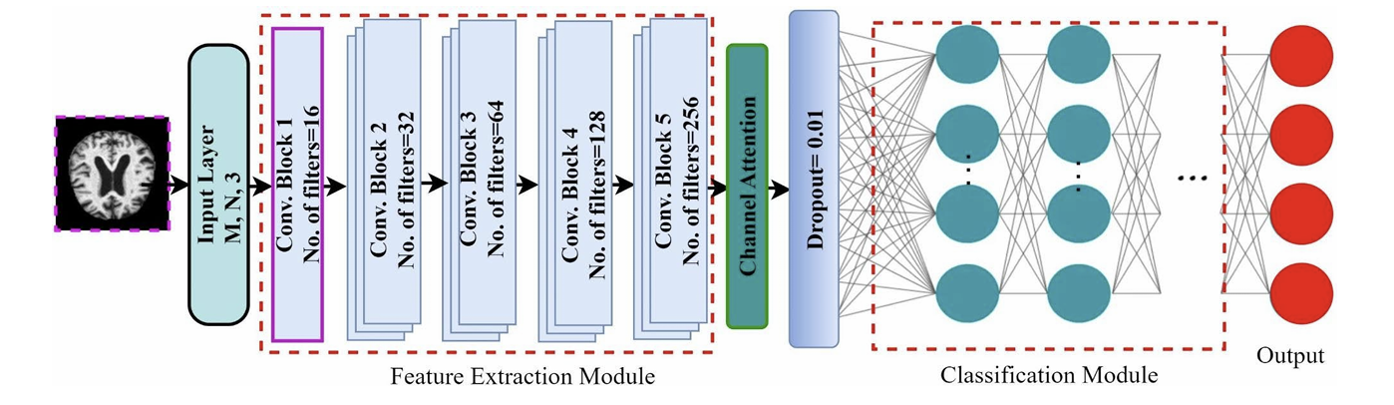

1. Resnet50 (via Transfer Learning)

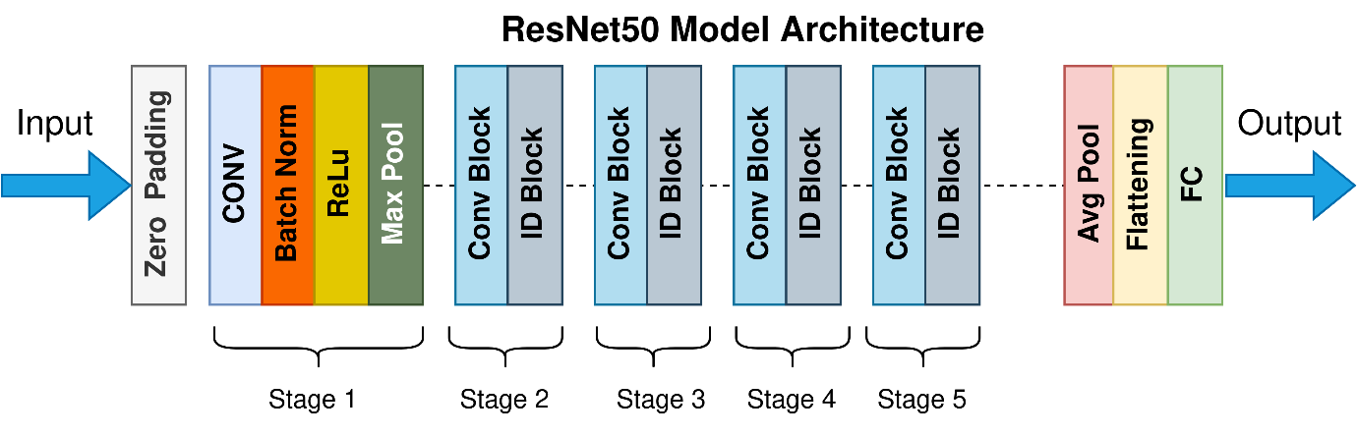

1. Basic CNN

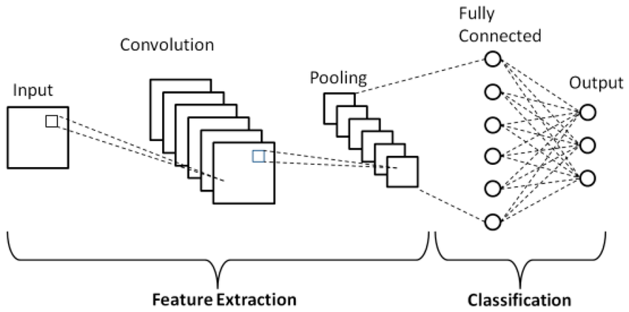

Results Achieved

* + 1. OASIS Dataset (Best Model: StackCNN)

|  |  |  |  |  |  |  |  |  |  |  |  |
| --- | --- | --- | --- | --- | --- | --- | --- | --- | --- | --- | --- |
| |  |  | | --- | --- | | Metric | Value | | **Accuracy** | 0.9931 | | **Loss** | 0.0246 | | **Precision** | 0.9937 | | **Recall** | 0.9925 | |  |

* + 1. ADNI Dataset (Best Model: BaseCNN)

|  |  |
| --- | --- |
| Metric | Value |
| **Accuracy** | 0.9138 |
| **Loss** | 0.2125 |