Top Alternative

Alt Path: |ADMS_Cyient

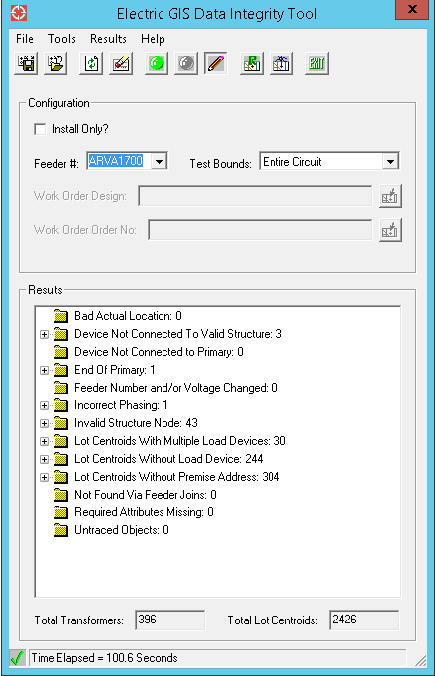

Delivered Alternative

Alt Path: |ADMS_Cyient|Extended_Pilot|ARVA1700

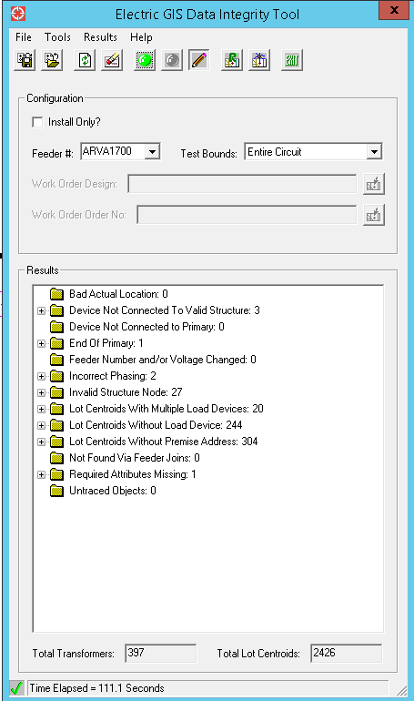

**Invalid Structure Node: 27**

* These Primaries are very small segment and both ends connected structure nodes are related to one electric xy, hence it is reported as invalid structure node.
* Remaining conductors are Pre existing errors

**Required Attributes Missing: 1**

**OH Fuse: 1**

* New Inserted features, Values not found on Field

**Incorrect Phasing: 2**

**OH Fuse: 1**

* One is pre existing error.

**OH Primary: 1**

* As per vendor provided photo one single phase fuse (527589804) is connected with this primary, and this is two phase primary.Hence it is reported as incorrect phasing.