Top Alternative

Alt Path: |ADMS_Cyient

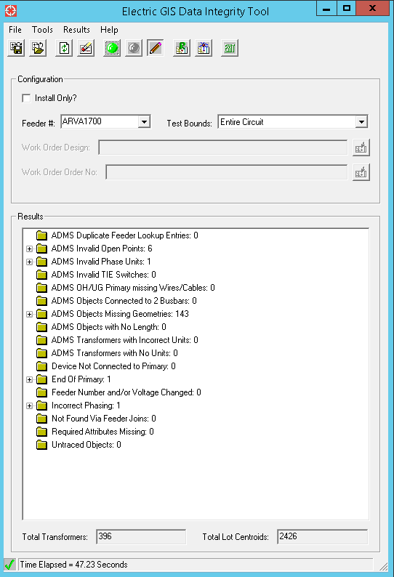

Delivered Alternative

Alt Path: |ADMS_Cyient|Extended_Pilot|ARVA1700

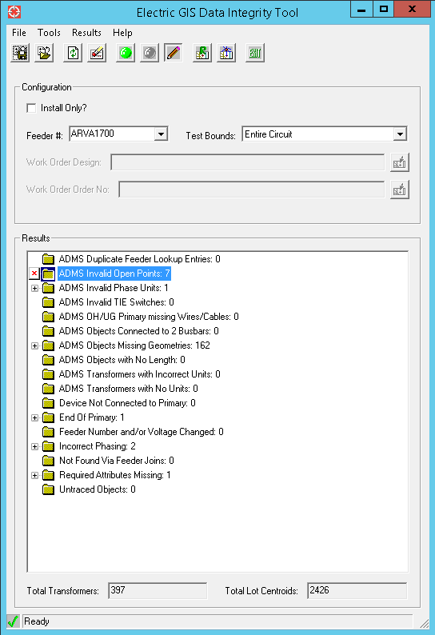

**ADMS Invalid Open Points: 7**

* As per vender photo fuse appeared as open and there is a three way junction, hence we are unavailable to coonecte at end point of the conductor.Hence this is reported as invalid opne points.
* Remianing all pre existing errors.

**ADMS Objects Missing Geometries: 162**

* Newly isnserted Primaries doesn’t actual route.

**Required Attributes Missing: 1**

**OH Fuse: 1**

* New Inserted feature, Values not found on Field

**Incorrect Phasing: 2**

**OH Fuse: 1**

* One is pre existing error.

**OH Primary: 1**

* As per vendor provided photo one single phase fuse (527589804) is connected with this primary, and this is two phase primary.Hence it is reported as incorrect phasing.